Supplementary materials
Supplementary Figure 1: Spatial distribution of occurrence data across Africa, illustrating the manual 5-fold horizontal spatial blocking strategy used for cross-validation in the diversity model. Each colored dot represents an occurrence record. The distinct colors correspond to the five different spatial folds (Fold 1 to Fold 5) used in the cross-validation process.

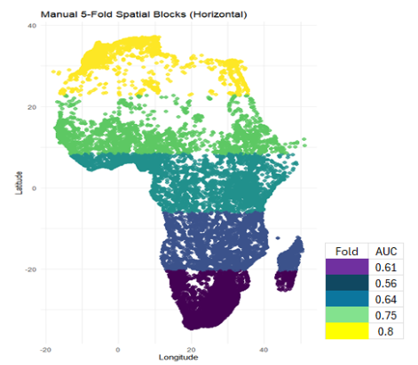

Supplementary Figure 2: Map showing the potential landcover-derived diversity biomes across the African continent and their spatial extents. This classification is based on pre-anthropogenic landcover conditions and includes seven major biomes: forest, savanna, grassland, shrubland, wetland, waterbodies, and desert. The map serves as a baseline reference for estimating biodiversity intactness under natural ecological conditions. Country boundaries are overlaid for spatial orientation.
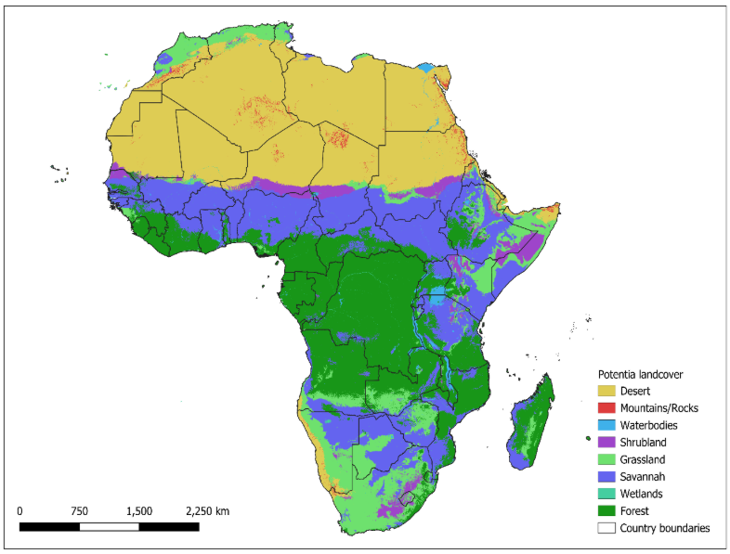
Supplementary Figure 3: The figure displays occurrence data for Coleoptera (11.522), Lepidoptera (9.723) and Odonata (6.065) across Africa. After spatial thinning, these points serve as the foundation for modeling species distribution divert, the D variable. The left map shows the distribution of butterflies, the middle map shows the distribution of dragonflies, while the right map shows beetles, whose points are often concentrated near aquatic habitats
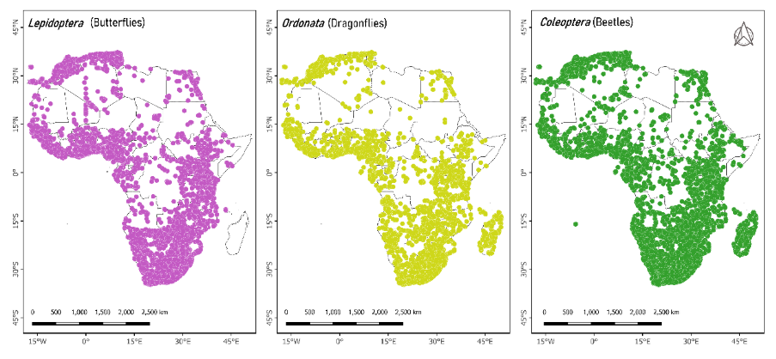
Supplementary Notes 1: Derivation of the Biodiversity Intactness Indicator.
This section provides details on how the biodiversity intactness indicator was derived. The newly developed biodiversity intactness indicator conceptually integrates model-derived current insect diversity with potential insect diversity baselines, mediated by anthropogenic modifications. Potential insect diversity was estimated from global habitat classifications, while current diversity was derived by rescaling predicted habitat suitability scores from the Random Forest model. Anthropogenic modification was represented by the normalized human footprint index (0 - 1), incorporating road density, built infrastructure, agriculture, and light pollution. The resulting biodiversity intactness values range from 0 (fully degraded) to 1 (intact). Outputs were harmonized to a 250 m resolution for computation and subsequently aggregated to 1-km per pixel for visualization and statistical analyses.
Supplementary Notes 2: Computation of potential (P) insect diversity scores
To capture uncertainty in baseline assumptions, we implemented both “high” and “low” P scoring schemes within the ranges supported by the literature. This approach enables sensitivity testing of the Insect Biodiversity Intactness (IBI) indicator to variation in potential diversity baselines.
Table S1. Habitat-specific potential insect diversity (P) scores used in intactness calculations.
Habitat type | P (low) | P (high) | Literature basis
Forest | 1 | 1 | Newbold et al. 2015;
Savanna | 0.7 | 0.8 | Habel et al. 2021
Grassland | 0.6 | 0.7 | Deguines et al. 2014
Shrubland | 0.5 | 0.6 | Habel et al. 2021
Wetland | 0.8 | 0.9 | Newbold et al. 2015
Waterbodies | 0.4 | 0.5 | Purvis et al. 2018
Desert | 0.2 | 0.3 | Habel et al. 2021

Supplementary Notes 3: Random forest modelling workflow
Details of the RF workflow included the integration of environmental predictor layers with georeferenced insect occurrence records. Multiple bootstrap samples were drawn from the training dataset, and an independent decision tree was fitted to each sample. Within each tree, a random subset of predictors was considered at each node split to reduce inter-tree correlation and improve generalization.
For classification, the final prediction was obtained by majority voting across all trees, while probability estimation was based on the proportion of trees predicting presence. These outputs were interpreted as habitat suitability scores. The RF algorithm was configured with 500 trees $n_{estimators}=500$, a minimum split size of 2 samples, and a maximum tree depth of 20. Hyperparameter tuning was performed using randomized grid search with five-fold cross-validation on the training data, optimizing the Area Under the Curve (AUC).
Formally, the RF prediction for classification is expressed as:
$\hat{y}=majority vote \left(h_{1}\left(x\right),h_{2}\left(x\right),…h_{T}(x)\right)$ (3)
Where $h_{t}\left(x\right)$) is the prediction from the $t$-th decision tree and, $T$ is the total number of trees.
When estimating the probability of presence, the RF output is calculated as:
$P\left(presence \right| x)=\frac{1}{T}\sum_{t=1}^{T}{I}\left(h_{t}\left(x\right)\right)=presence$ (4)
where $I\left(h_{t}\left(x\right)\right)$ is the indicator function

Supplementary Table S2: Characteristics of the 12 representative protected areas used for stratified sampling across Africa’s major climatic zones
Protected Area | Country / Region | Ecozone / Biome | Altitude Range | Avg Annual Rainfall
Kakamega Forest Reserve | Kenya (E. Africa) | humid | ~1,520 m | ~1,200–1,700 mm
Dja Faunal Reserve | Cameroon (W. Africa) | humid | Lowland | High rainfall
Cross River National Park | Nigeria (W. Africa) | humid | Up to ~1,700 m | ~2,000–3,000 mm
Budongo Forest Reserve | Uganda (E. Africa) | humid | ~700–1,270 m | ~1,200–2,200 mm
Udzungwa Mountains NP | Tanzania (E. Africa) | sub-humid | ~250–2,576 m | ~600–2,000 mm
Ruaha National Park | Tanzania (E. Africa) | sub-humid | Moderate | Seasonal
Amboseli National Park | Kenya (E. Africa) | Semi-arid | ~1,180 m | ~350–400 mm
Tsavo East & West National Parks | Kenya (E. Africa) | Semi-arid | ~300–1,200 m | ~300–700 mm
Kgalagadi Transfrontier Park | Botswana / South Africa | Semi-arid | ~900–1,200 m | ~200–450 mm
Etosha National Park | Namibia (S. Africa) | Arid | ~1,000–1,300 m | ~350–500 mm
Namib-Naukluft National Park | Namibia (S. Africa) | Arid | Sea level – ~2,000 m | ~20–100 mm

Table S3: Selected agroforestry landscapes for biodiversity intactness assessment
Climate Zone | Site (Country) | Approx. Area of Agroforestry Zone (km²)* | Dominant Agroforestry System
Humid | Dja Reserve – Ombessa / Mbam-Inoubou landscape (Cameroon) | ~1,500 | Shade cocoa agroforestry, multi-strata tree–crop systems
Humid | Kakamega Forest fringe (Kenya) | ~800 | Smallholder agroforestry: boundary trees, fruit/coffee with shade, Eucalyptus woodlots
Humid | Cross River State – cocoa belt (Nigeria) | ~2,000 | Shade cocoa agroforests, smallholder tree-rich farms
Sub-humid | Budongo Forest fringe (Uganda) | ~1,000 | Farm–forest interface agroforestry: woodlots, boundary trees, perennial crops
Sub-humid | Udzungwa Mountains buffer (Tanzania) | ~1,500 | Multistrata agroforests, tree–crop mosaics, woodlots
Sub-humid | Atewa Range / Cocoa Belt (Ghana) | ~3,000 | Shade cocoa, fallow agroforests, planted shade trees

