ADDITIONAL FILE 1: SUPPLEMENTARY MATERIAL

Clinical acceptance of a digital health clinical decision support algorithm for children in Tanzania and Rwanda: A mixed-method and before-after analysis from the DYNAMIC study

Contents
Supplementary Note 1: In-depth interview questions and prompts 2
Supplementary Table 1: Presenting complaints for young infants aged 1 day to 59 months 5
Supplementary Table 2: Presenting complaints for children aged 2 months to 14 years old 6
Supplementary Table 3: 10 Diagnoses most often rejected in consultations for patients aged <2 months 7
Supplementary Table 4: 10 Diagnoses most often added in patients aged <2 months 8
Supplementary Table 5: 10 Diagnoses most often rejected in consultations for patients aged 2 months to 14 years 9
Supplementary Table 6: 10 Diagnoses most often added in patients aged 2 months to 14 years 10
Supplementary Table 7: In-depth interview participant characteristics in Tanzania 11
Supplementary Figure 1: DYNAMIC project timeline and before-after quantitative analysis periods. 12
Supplementary Figure 2: Patient flow diagram (after ePOCT+ modifications) 13
Supplementary Table 8: Baseline characteristics of patients (after ePOCT+ modifications) 14
Supplementary Table 9: Overall acceptance of diagnoses (after ePOCT+ modifications) 15
Supplementary Table 10: Changes to ePOCT+ based on qualitative and quantitative findings 16

Supplementary Note 1: In-depth interview questions and prompts
Part A: Characteristics
- Are you:
A woman A man
- How old are you:
20-29 years 30-39 years 40-49 years
50-59 years
- What is your profession?
Medical Assistant Nurse/ Nurse-Midwife Clinical Officer
Assistant Medical Officer Medical Officer
- How long have you been practicing?
0-4 years 5-9 years 10-14 years
15-19 years 20-29 years
- What is your understanding in written English?
Very comfortable comfortable not comfortable
- Did you get an IMCI training?
Yes No
When was the last training? …………………………………..
What kind of IMCI training was it:
Standard IMCI training Distance learning IMCI training
- What was your personal electronic knowledge before using the Dynamic tool?
Personal use of smartphone
Computer Tablets None
- How long have you been using the Dynamic tool? …………………………………..
Part B: Broad questions
- What do you think of the tool? Why?

- A. How can we improve the tool in terms of medical content?
B. What would be the benefit of these changes?

- Digital tools can sometimes be frustrating to use, why do you think a health care worker especially would be frustrated when using this tool?

- A) Do you think there are too many questions?

B) Depending on your selection of the age group or the complaint category the tool asks you a different number of questions based on your choice.
Have you ever felt that one of the selections you made brought too many questions? (ex: children less or more than 2months, a particular complaint category)
C) To reach some diagnoses it requires additional questions, which may prolong the consultation. Do you think some diagnoses should be taken away in order to reduce the number of questions?
- Do you think some questions should be added?

- What do you think of the info button? How could it be improved?

Part C: Precise questions
- We have noticed that many health care workers don’t measure height in outpatient consultations.
Why do you think that is? Do you think it’s important?

- How do you usually assess weight? Why?

- We’ve noticed that some questions are very often answered with no.
  - Recent close contact with somebody with TB
  - Travel outside district/council within the last month
  - Chronic conditions
For each one: Do you think this is truly rare? Do you usually ask this question to the caregiver? If not, why? How do you usually aks this? Do you think it’s important to assess? Why? Do you think the caregiver always understands the question?
For b: How do you usually ask this?
- Skin lesions:
  - In the following pictures of skin lesions are there some that you never see?
  - Do you think they should be removed from the algorithm?

Diagnoses of children > 2 months:
- This is a selection of some of the most rejected diagnoses in your facility. For some of them the numbers for your facility are very low but they could help us understand what is also happening in other facilities.
Even if you never rejected them yourself, would you have any idea why other health care workers would reject them?

Diagnoses of children < 2 months:
- This is a selection of some of the most rejected diagnoses for children less than 2 months in your facility.
Even if you never rejected them yourself, would you have any idea why other health care workers would reject these diagnoses?

Supplementary Table 1: Presenting complaints for young infants aged 1 day to 59 months
Presenting complaint | n (%) | Presenting complaint | n (%)
Tanzania (n=666) |  | Rwanda (n=636)
Respiratory | 293 (44.0%) | Respiratory | 209 (32.9%)
Fever or convulsions or lethargy | 172 (25.8%) | Diarrhea, abdominal, gastro-intestinal | 135 (21.2%)
Diarrhea, abdominal, gastro-intestinal | 149 (22.4%) | Eye complaint | 134 (21.2%)
Skin | 92 (13.8%) | Skin | 125 (19.7%)
Eye complaint | 47 (7.1%) | Other | 81 (12.7%)
Other | 41 (6.2%) | Fever or convulsions or lethargy | 46 (7.2%)
Ear or mouth complaint | 17 (2.6%) | Ear or mouth complaint | 37 (5.8%)
Injuries (birth and non-birth related) | 3 (0.5%) | Malformation of birth anomaly | 24 (3.8%)
Malformation of birth anomaly | 2 (0.3%) | Feeding problem or weight concern | 15 (2.4%)
Follow-up visit for a previous problem | 2 (0.3%) | Injuries (birth and non-birth related) | 4 (0.6%)
Feeding problem or weight concern | 1 (0.2%) | Follow-up visit for a previous problem | 1 (0.2%)

Supplementary Table 2: Presenting complaints for children aged 2 months to 14 years old
Presenting complaint | n (%) | Presenting complaint | n (%)
Tanzania (n=15,078) |  | Rwanda (n=11,213)
Fever | 9,265 (61.4%) | Respiratory (cough or difficulty breathing) | 5,941 (53.0%)
Respiratory (cough or difficulty breathing) | 7,267 (48.2%) | Fever | 4,704 (42.0%)
Gastrointestinal (diarrhea, vomiting, feeding) | 3,533 (23.4%) | Gastrointestinal (diarrhea, vomiting, feeding) | 3,501 (31.2%)
Skin, hair | 1,869 (12.4%) | Ear, throat, mouth | 3,184 (28.4%)
Neuro (headache, stiff neck, neck pain) | 457 (3.0%) | Neuro (headache, stiff neck, neck pain) | 1,325 (11.8%)
Ear, throat, mouth | 394 (2.6%) | Skin, hair | 1,307 (11.7%)
Eye | 311 (2.1%) | Eye | 1,177 (10.5%)
Other | 280 (1.9%) | Other | 844 (7.5%)
Accident/Musculo-skeletal (incl. burns, wounds, poison) | 242 (1.6%) | Accident/Musculo-skeletal (incl. burns, wounds, poison) | 341 (3.0%)
Genitourinary (UTI, STI) | 210 (1.4%) | Genitourinary (UTI, STI) | 307 (2.7%)

Supplementary Table 3: 10 Diagnoses most often rejected in consultations for patients aged <2 months
Tanzania |  | Rwanda
Diagnoses in order of absolute numbers rejected | Number rejected/Total proposed (%) | Diagnoses in order of absolute numbers rejected | Number rejected/Total proposed (%)
HIV infection unlikely | 319/643 (49.6%) | HIV infection unlikely | 496/619 (80.1%)
Incomplete vaccination | 158/305 (51.8%) | Incomplete vaccination | 115/177 (65.0%)
Feeding problem (insufficient feed) | 141/287 (49.1%) | Feeding problem (insufficient feed) | 104/133 (78.2%)
Severe clinical infection or severe illness | 96/291 (33%) | Severe clinical infection or severe illness | 92/150 (61.3%)
Low weight for age | 27/62 (43.5%) | Low weight for age | 34/47 (72.3%)
Feeding problem (lack of exclusive breastfeeding) | 17/34 (50%) | Feeding problem (lactation) | 18/26 (69.2%)
Feeding problem (lactation) | 16/36 (44.4%) | Respiratory tract infection viral suspected | 18/177 (10.2%)
Severe abdominal problem | 8/45 (17.8%) | Very low weight for age | 16/23 (69.6%)
Severe skin infection | 7/30 (23.3%) | Omphalitis | 14/20 (70.0%)
Critical illness | 6/15 (40%) | Feeding problem (lack of exclusive breastfeeding) | 13/18 (72.2%)
Diagnoses in order of proportion rejected | Number rejected/Total proposed (%) | Diagnoses in order of proportion rejected | Number rejected/Total proposed (%)
Severe pneumonia | 2/2 (100%) | Physiological jaundice | 1/1 (100%)
Pathologic prolonged jaundice | 2/3 (67%) | Cleft lip | 1/1 (100%)
Pneumonia | 4/6 (67%) | Concern for congenital heart disease | 1/1 (100%)
Incomplete vaccination | 158/305 (51.8%) | HIV infection unlikely | 496/619 (80.1%)
Feeding problem (lack of exclusive breastfeeding) | 17/34 (50%) | Feeding problem (insufficient feeds) | 104/133 (78.2%)
Physiological rash | 1/2 (50%) | Critical illness | 10/13 (76.9%)
HIV infection unlikely | 319/643 (49.6%) | Low weight for age | 34/47 (72.3%)
Feeding problem (insufficient feeds) | 141/287 (49.1%) | Feeding problem (lack of exclusive breastfeeding) | 13/18 (72.2%)
Feeding problem (lactation) | 16/36 (44.4%) | HIV unknown | 5/7 (71.4%)
Low weight for age | 27/62 (43.5%) | Omphalitis | 14/20 (70.0%)

Supplementary Table 4: 10 Diagnoses most often added in patients aged <2 months
Tanzania |  | Rwanda
Diagnoses in order of absolute numbers manually added | Manually added diagnoses/Total number of children with that diagnosis (%) | Diagnoses in order of absolute numbers manually added | Manually added diagnoses/ Total number of children with that diagnosis (%)
Acute otitis media | 1/4 (25%) | Conjunctivitis | 4/89 (4.5%)
Concern for congenital syndrome or malformation | 1/1 (100%) | Pneumonia | 3/6 (50.0%)
Improved pneumonia | 1/1 (100%) | Respiratory tract infection viral suspected | 3/180 (1.7%)
Pneumonia | 1/3 (33.3%) | Abscess | 2/8 (25.0%)
Gastroenteritis | 1/1 (100%) | Local skin infection | 2/32 (6.25%)
Urinary tract infection | 1/1 (100%) | Oral thrush | 2/19 (10.5%)
Tinea corporis | 1/1 (100%) | Severe eye problem | 2/10 (20.0%)
Tongue tie | 1/1 (100%) | Acute otitis media | 1/2 (50.0%)
 |  | Congenital muscular torticollis | 1/1 (100.0%)
 |  | Diaper rash | 1/16 (6.25%)
Diagnoses in order of proportion manually added | Manually added diagnoses/Total number of children with that diagnosis (%) | Diagnoses in order of proportion manually added | Manually added diagnoses/ Total number of children with that diagnosis (%)
Concern for congenital syndrome or malformation | 1/1 (100%) | Congenital muscular torticollis | 1/1 (100%)
Improved pneumonia | 1/1 (100%) | Improved conjunctivitis | 1/1 (100%)
Gastroenteritis | 1/1 (100%) | Acute otitis media | 1/2 (50.0%)
Urinary tract infection | 1/1 (100%) | Pneumonia | 3/6 (50.0%)
Tinea corporis | 1/1 (100%) | Abscess | 2/8 (25.0%)
Tongue tie | 1/1 (100%) | Minor anomaly or malformation | 1/4 (25.0%)
Pneumonia | 1/3 (33.3%) | Scabies | 1/4 (25.0%)
Acute otitis media | 1/4 (25%) | Severe eye problem | 2/10 (20.0%)
 |  | Oral thrush | 2/19 (10.5%)
 |  | Diaper rash | 1/16 (6.3%)
 |  | Local skin infection | 2/32 (6.3&)

Supplementary Table 5: 10 Diagnoses most often rejected in consultations for patients aged 2 months to 14 years
Tanzania |  | Rwanda
Diagnoses in order of absolute numbers rejected | Number rejected/Total proposed (%) | Diagnoses in order of absolute numbers rejected | Number rejected/Total proposed (%)
Prevention and screening | 827/14,716 (5.6%) | Prevention and screening | 5,146/11,201 (45.9%)
Moderate malnutrition | 287/1,060 (27.1%) | Suspicion of tuberculosis | 1,348/1,501 (89.8%)
Mild/moderate anemia | 166/2,285 (7.3%) | Moderate malnutrition | 767/1,171 (65.5%)
Suspected malaria | 134/140 (95.7%) | Common cold | 438/5,000 (8.8%)
Non severe abdominal condition | 99/1,828 (5.4%) | Viral pneumonia | 359/1,368 (26.2%)
Common cold (URTI) | 82/6,943 (1.2%) | Non-severe abdominal condition | 316/2,028 (15.6%)
Viral pneumonia | 54/752 (7.2%) | Severe eye disease | 286/536 (53.4%)
Uncomplicated severe acute malnutrition | 48/137 (35%) | Mild moderate anemia | 248/1,173 (21.1%)
Suspicion of tuberculosis | 47/68 (69.1%) | Hyperglycemia | 205/246 (85.8%)
Fever without source (presumed bacterial) | 43/830 (5.2%) | Uncomplicated severe acute malnutrition | 165/248 (66.5%)
Diagnoses in order of proportion rejected | Number rejected/Total proposed (%) | Diagnoses in order of proportion rejected | Number rejected/Total proposed (%)
IMCI severe anemia | 1/1 (100%) | Uncomplicated suspicion of poisoning | 7/7 (100%)
Major trauma | 1/1 (100%) | Suspected severe malaria | 6/6 (100%)
Minor head injury | 3/3 (100%) | Suspicion of foreign object in airways | 5/5 (100%)
Suspected malaria | 134/140 (95.7%) | Suspicion of poisoning | 2/2 (100%)
CNS danger signs | 4/5 (80%) | Suspicion of meningitis | 2/2 (100%)
Significant hemoptysis | 6/8 (75%) | IMCI severe anemia | 1/1 (100%)
Suspected severe malaria | 3/4 (75%) | Hypoglycemia | 1/1 (100%)
Suspicion of tuberculosis | 47/68 (69.1%) | Persistent diarrhea | 1/1 (100%)
Severe abdominal condition | 28/45 (62.2%) | Severe complicated measles | 1/1 (100%)
Preseptal cellulitis | 11/18 (61.1%) | Follow up consultation | 1/1 (100%)

Supplementary Table 6: 10 Diagnoses most often added in patients aged 2 months to 14 years
Tanzania |  | Rwanda
Diagnoses in order of absolute numbers manually added | Number manually added /Total number of children with that diagnosis (%) | Diagnoses in order of absolute numbers manually added | Manually added diagnoses/Total number of children with that diagnosis (%)
Bacterial pneumonia | 52/607 (8.6%) | Bacterial pneumonia | 175/567 (30.9%)
Common cold (URTI) | 39/6,897 (0.6%) | Bacterial acute pharyngitis | 71/447 (15.9%)
Acute diarrhea | 27/1,258 (2.1%) | Allergic conjunctivitis | 49/172 (28.5%)
Bacterial acute pharyngitis | 9/36 (25%) | Bacterial conjunctivitis | 44/286 (15.4%)
Complicated chickenpox | 9/11 (81.8%) | IMCI/IMAI pneumonia | 31/94 (33.0%)
Persistent diarrhea | 8/10 (80%) | Acute diarrhea | 27/918 (2.9%)
Febrile urinary tract infection | 6/467 (1.3%) | Dental abscess | 20/157 (12.7%)
Skin infection | 5/5 (100%) | Simple abscess | 18/72 (25.0%)
Oral candidiasis | 5/59 (8.5%) | Fever without source (presumed bacterial infection) | 16/237 (6.7%)
Severe malaria | 5/29 (17.2%) | Common cold | 15/5,015 (0.3%)
Diagnoses in order of proportion manually added | Manually added diagnoses/Total number of children with that diagnosis (%) | Diagnoses in order of proportion manually added | Manually added diagnoses/Total number of children with that diagnosis (%)
Skin infection | 5/5 (100%) | Anaphylaxis | 2/2 (100%)
Septicemia | 2/2 (100%) | Carbon monoxide poisoning | 1/1 (100%)
Acute tonsillitis | 2/2 (100%) | Diarrhea with some dehydration | 1/1 (100%)
Nephrotic syndrome | 2/2 (100%) | Diarrhea with no dehydration | 1/1 (100%)
Amoebiasis | 2/2 (100%) | Known congenital heart disease | 1/1 (100%)
Confirmed fracture | 1/1 (100%) | Presumed genital HSV | 1/1 (100%)
Complicated chronic ear infection | 1/1 (100%) | Vaginal discharge syndrome | 1/1 (100%)
Eye trauma | 1/1 (100%) | Persistent diarrhea | 2/3 (66.7%)
Bacterial parotitis | 1/1 (100%) | Follow up consultation | 1/2 (50.0%)
Acute kidney injury | 1/1 (100%) | IMCI severe anemia | 1/2 (50.0%)

Supplementary Table 7: In-depth interview participant characteristics in Tanzania
Demographics | n (%)
Sex  Female  Male | 5 (38%)  8 (62%)
Age  20-29  30-39  40-49 | 2 (15%)  8 (62%)  3 (23%)
Profession  Clinical officer  Nurse  Pharmacist | 10 (77%)  2 (15%)  1 (8%)
Time practicing  0-4 years  5-9 years  10-14 years  ≥ 15 years | 5 (38%)  3 (23%)  4 (31%)  1 (8%)
Understanding of written English  Not comfortable  Comfortable  Very comfortable | 2 (15%)  10 (77%)  1 (8%)
Personal electronic knowledge before the DYNAMIC study  Smartphone only  Smartphone and computer  Smartphone, computer and tablet | 3 (23%)  8 (62%)  2 (15%)
Experience using ePOCT+  < 1 year  ≥ 1 year  Average number of months of experience | 3 (23%)  10 (77%)  11.08
Level of uptake of the ePOCT+ tool in the facility of the participants  < Average  > Average | 6 (46%)  7 (54%)

Supplementary Figure 1: DYNAMIC project timeline and before-after quantitative analysis periods.
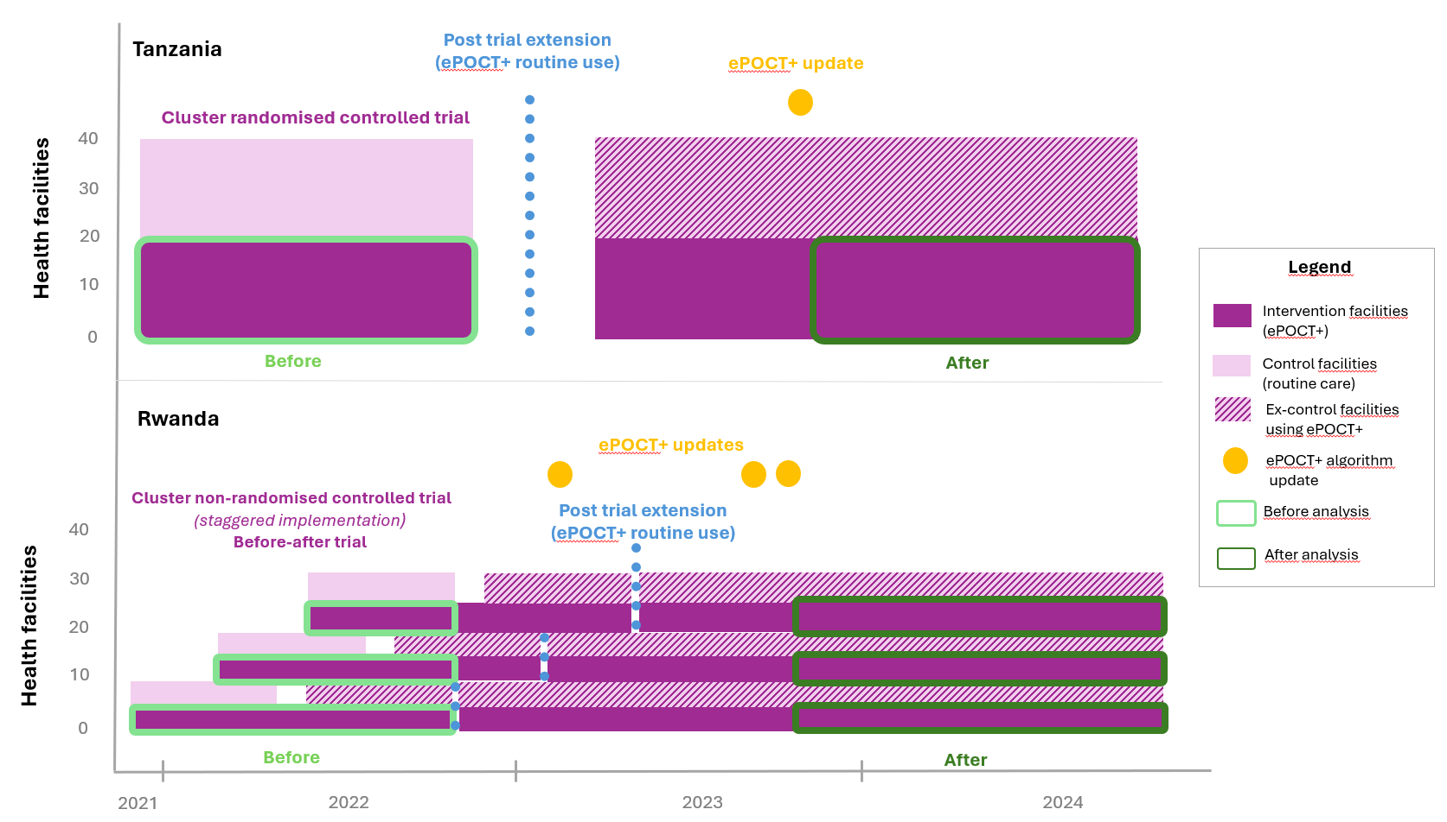

Supplementary Figure 2: Patient flow diagram (after ePOCT+ modifications)
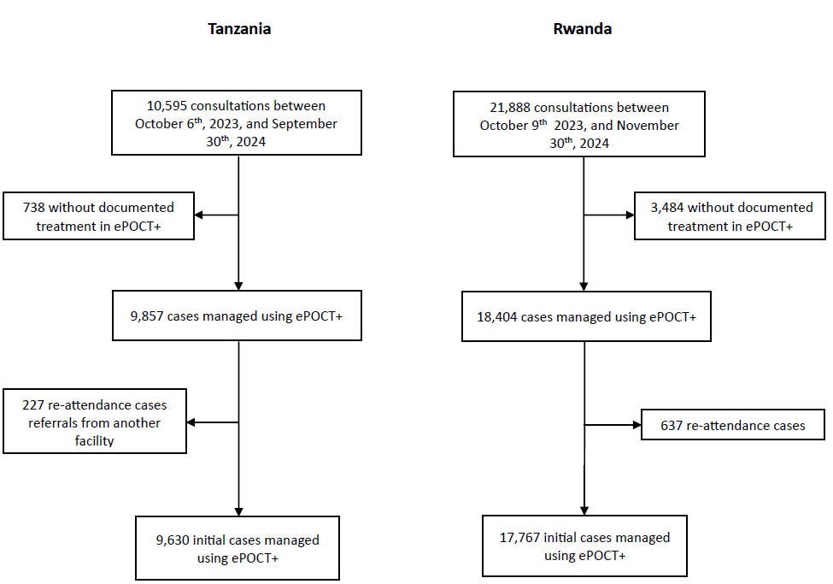

Supplementary Table 8: Baseline characteristics of patients (after ePOCT+ modifications)
 | Tanzania | Rwanda
Initial consultations, n | 9,630 | 17,697
Sex  Female, n (%)  Male, n (%) | 4,743 (49.3%)  4,887 (50.8%) | 8,863 (50.1%)  8,834 (49.9%)
Age  < 2months, n (%)  2-5 months, n (%)  6 months-4 years, n (%)  5-11 years, n (%)  12-14 years, n (%)  Unknown, n (%) | 244 (2.5%)  1,564 (16.2%)  7,298 (75.8%)  473 (4.9%)  51 (0.5%)  0 (0.0%) | 292 (1.6%)  3,153 (17.8%)  9,019 (51.0%)  4,208 (23.8%)  1023 (5.8%)  2 (0.0%)
Health facility type  Dispensary, n (%)  Health Center, n (%) | 6,456 (67.0%)  3,174 (33.0%) | 0 (0.0%)  17,697 (100.0%)
Region (TZ) or district (RW)  Nyamasheke, n (%)  Rusizi, n (%)  Morogoro, n (%)  Mbeya, n (%) | -  -  6,284 (65.3%)  3,346 (34.8%) | 9,953 (56.2%)  7,744 (43.8%)  -  -

Supplementary Table 9: Overall acceptance of diagnoses (after ePOCT+ modifications)
 | Tanzania (<2 months) | Rwanda (<2 months) | Tanzania (≥ 2 months) | Rwanda (≥ 2 months)
Initial consultations, n | 244 | 292 | 9,386 | 17,405
Total diagnoses, n | 659 | 844 | 24,420 | 48,076
Manually added diagnoses, n | 0 | 5 | 9 | 316
Diagnoses proposed by the algorithm, n | 659 | 839 | 24,411 | 47,760
Average number of diagnoses proposed by the algorithm/consultation | 2.7 | 2.9 | 2.6 | 2.7
Acceptance proportion, % (n/N) | 84.1% (554/659) | 42.0% (352/839) | 91.9% (22,432/24,411) | 72.9% (34,799/47,760)
Rejection proportion, % (n/N) | 15.9% (105/659) | 58.0% (487/839) | 8.1% (1,979/24,411) | 27.1% (12,961/47,760)
Consultations with at least one diagnosis rejected | 26.6% (65/244) | 88.7%  (259/292) | 17.1% (1,602/9,386) | 53.9% (9,373/17,405)

Supplementary Table 10: Changes to ePOCT+ based on qualitative and quantitative findings

 | Stage | Change | Rationale | Implemented in Tanzania | Implemented in Rwanda | Direct impact expected on specific final diagnoses acceptance (Tanzania) | Direct impact expected on specific final diagnoses acceptance (Rwanda)
1. | Medical history | Ask first "Convulsions in present illness" first and then "Convulsing now" conditioned by "Convulsions in present illness" = Yes | Speed up questions ("convulsing now" is rare) | Yes | No | No | NA
2. | Basic measurements | For <5yo : Propose to measure height only if WFA z-score <-1 or MUAC<12.5cm&>11.5cm | Height/length takes time, difficult to measure in young children, and only a minority of children are identified as having wasting | Yes | No | No | NA
3. | Basic measurements | For >=5yo : Propose to only use MUAC z-score (no height measurement). | Height measured in 32% of >=5 year olds;  MUAC easier to measure, and MUAC for age z-score found to be as effective as BMI for age to identify malnourished children at risk of severe outcome (Mramba et al. 2017) | Yes | No | No | NA
4. | Final diagnosis | YI - Severe clinical infection or severe illness - Align with IMCI =remove " Fever in this illness " (only axillary temperature >=37.5°C) | To align with IMCI guidelines and avoid unnecessary rejection, as clinical outcomes were the same with or without reported fever | Yes | Yes | Yes | No (not often rejected in RW)
5. | Final diagnosis | Add additional conditional logic to skin lesions: itchy, pain and fever  ! No "negative conditioning" was applied due to the possible presence of 2 conditions (malaria ith fever + molluscum contagiosum(with usually no fever))  - Creation "Itchy skin/hair lesion" and "Painful skin/hair lesion" (conditioned to age>1yo)  - "Measles rash" conditioned to fever  - "Scarlet fever rash" conditioned to fever  - "Cellulitis" & "Abcess" conditionned to pain  - "Pityriasis versicolor" conditionned to absence of pain  - "Tinea corporis", "Tinea capitis", "Oral herpes", " Impetigo", "Folliculitis", "Pediculosis", "Heat rash", "Molluscum contagiosum", "Diaper rash" unchanged  - "Eczema" conditioned to Itchy  - "Chickenpox" conditionned to fever  - "Urticaria" conditionned to itchy  - "Scabies" conditionned to itchy | To increase accuracy and help health workers differentiate between skin conditions. | Yes | No | No (not often rejected in TZ) | NA
6. | Tests | Add field “other” for additional tests & ability to add multiple tests | Request from HCWs | Yes | Yes | No | No
7. | Tests | Restrict criteria for Hb measurement | 56% of children with indication for Hb test in phase 1 (but clinical signs for anemia non reliable) | Yes | No | No | NA
8. | Final diagnosis | Revert to IMCI criteria for dehydration | To ensure consistency with widely accepted IMCI guidelines; the previous formulation was often rejected | Yes | No | Yes | NA
9. | Final diagnosis | Merge DF Mild croup and DF common cold , delete severe croup | Simplification: same treatment approach, and “mild croup” was often rejected | Yes | No | No | NA
10. | Final diagnosis | Remove cellulitis as a criteria for complicated chickenpox | Based on Rwandan data: diagnosis was frequently rejected; cellulitis is already managed separately and does not require acyclovir | Yes | Yes | No (not often rejected in TZ) | Yes
11. | Final diagnosis | Add criteria for major burn : any full-thickness burn, burn involving hand, burn presenting with other trauma | To follow international guidelines and improve identification of severe burns | Yes | No | No | NA
12. | Final diagnosis | Rename "Suspected malaria" to "Malaria test not available" | The previous label was often misunderstood and rejected; new wording emphasizes the importance of testing. | Yes | Yes | Yes | Yes
13. | Final diagnosis | Remove "negative DF" such as "HIV unlikely" | Clarification of intended use and avoids a negative formulation that was often rejected. | Yes | No | Yes | NA
14. | Medical history | YI - Rephrase "History Vaccinations incomplete for age" =>" vaccinations complete for age". | Clarification: positive formulation reduces misunderstanding and alignment with older child questions. | Yes | Yes | Yes | Yes
15. | Final diagnosis | Increase sensitivity of criteria for the DF"Concern for congenital heart disease" if YI and SpO2<94% and NO cough or difficulty breathing |  | No | No | NA | NA
16. | Final diagnosis | To directly ask in the symptoms or physical exam section for inguinal hernia / testicular torsion (more info in the info button) |  | No | No | NA | NA
17. | Medical history | Simplify, to directly have a drop down menu, asking for all symptoms of severe eye disease  PROS : Shorten the questionnaire  CONS : Less systematic approach to enquire for all symptoms related with severe eye disease |  | No | No | NA | NA
18. | Final diagnosis | Severe eye disease DF should exclude other allergic/viral/bacterial conjunctivitis ; DF corneal abrasion and DF severe eye disease should be merged | Simplification: “Corneal abrasion” often rejected with alternative selection of severe eye disease | Yes | Yes | Yes | Yes
19. | Final diagnosis | No addition of tongue tie and phimosis in the current algorithm (chronic conditions)  Addition in the list of ‘manually added diagnosis’ |  | No | No | NA | NA
20. | Final diagnosis | Merge "Constipation" and "Non Severe abdominal condition". | Simplification; not commonly rejected in Tanzania but overlap existed | Yes | Yes | No (not often rejected in TZ) | Yes
21. | Final diagnosis | Merge "Severe pneumonia", "clinicial severe infection", "critical illness" | Different labels for the same health condition might be confusing for HCWs. | Yes | No | Yes | NA
22. | Final diagnosis | "Suspicion of poisoning": An info button was added to clarify the definition of "Accidental Ingestion of a Potentially Harmful Entity," specifying that it refers to the intake of a potentially poisonous substance. | To address frequent rejection of the diagnosis in Rwanda, despite the presence of a matching medical history (misunderstanding?) | Yes | Yes | No (not often rejected in TZ) | No (not often rejected in RW)

