Supplementary material

Superiority of Bacillus velezensis and Glutamicibacter nicotianae as native non-rhizobial nodulating bacteria for enhancing legume production in low-fertility soils.

Marcelin Bahdjolbe^{1,2}, Alain-Martial Sontsa-Donhoung³, Abdouraman Hawaou ^{1,2}, Simon Thierry Okiobe^{4*} and Dieudonne Nwaga^{1*}

¹ Soil Microbiology Laboratory, Biotechnology Center, Faculty of Sciences, University of Yaounde I, PO Box 812 Yaounde, Cameroon
² National Veterinary Laboratory, PO Box 503 Garoua, Cameroon
³ Laboratory of Regional Biological Control and Applied Microbiology, Institute of Agricultural Research for Development (IRAD), PO Box 2123 Yaounde, Cameroon
⁴ Department of Technology Assessment, Leibniz Institute for Agricultural Engineering and Bioeconomy (ATB), Potsdam, Germany

* Corresponding author email: dnwaga@yahoo.fr, sokiobe@atb-potsdam.de

Table S1. Significance levels of treatments compared to control for plant growth parameters in greenhouse experiment with P adjusted values. For all analyses, significance levels were denoted as follows:
p < 0.05 (*), p < 0.01 (**), p < 0.001 (***), and p < 0.0001 (****).
Treatments | Plant height | Number of leaves | Foliar surface | Number of pods
Control | – | – | – | –
VUID1 | * | ns | ns | ns
Aba4 | *** | ns | ns | ns
Aba5 | ns | ns | ns | ns
Nks5 | ** | ** | ns | **
Nks4 | ns | ns | ns | ns
Nka11 | **** | **** | * | ****
Nka10 | ns | ns | ns | **
Nga2 | **** | ns | ns | ns
Nga6 | **** | ns | ns | ns

Table S2. Significance levels of treatments compared to control for plant growth parameters and yield in greenhouse experiment with P adjusted values. For all analyses, significance levels were denoted as follows: p < 0.05 (*), p < 0.01 (**), p < 0.001 (***), and p < 0.0001 (****).
Treatments | Pod Biomass | Plant Biomass | Grain Yield
Control | – | – | –
VUID1 | ns | ** | *
Aba4 | ns | **** | ns
Aba5 | ns | *** | ns
Nks5 | *** | *** | ****
Nks4 | ns | **** | ns
Nka11 | **** | **** | ****
Nka10 | ns | * | ns
Nga2 | ns | **** | ns
Nga6 | * | **** | **

Parameters | Intercept (Control) | Rhizo Effect (vs. Control) | NRE+Rhizobia Effect (vs. Control) | F-values | p-values
Root nodules | 9.56 ± 0.74 | +12.33 ± 0.31 (*** ) | +9.90 ± 0.31 (*** ) | 896.0 | < 2.2e-16 ***
Nodule biomass | 1.32 ± 0.22 | +0.71 ± 0.05 (*** ) | +0.75 ± 0.05 (*** ) | 143.7 | < 2.2e-16 ***
Plant biomass | 37.78 ± 1.41 | +16.67 ± 0.75 (*** ) | +27.67 ± 0.75 (*** ) | 686.4 | < 2.2e-16 ***
Plant height | 40.21 ± 5.26 | +4.41 ± 0.71 (*** ) | +9.87 ± 0.71 (*** ) | 97.2 | < 2.2e-16 ***
Grain yield | 1.63 ± 0.14 | +1.33 ± 0.20 (*** ) | +0.67 ± 0.20 (** ) | 21.9 | 2.9e-08 ***
Table S3. Summary of mixed-effects model results (fixed effects estimates) for cowpea growth parameters and yield in the field trial.
Treatments: Control, non-rhizobial endophytes (NREs), and NRE+Rhizobia treatments.
For all analyses, significance levels were denoted as follows: p < 0.05 (*), p < 0.01 (**), p < 0.001 (***), and p < 0.0001 (****).

Table S4. Characteristics of the soil used in the field experiment. The soil pH was weakly acidic and the organic carbon content was low, in accordance with the rates of organic carbon assessment of the soil. Total nitrogen was 0.14%, this indicates an average capacity to provide available nitrogen which is a key nutrient for crop growth and health. and the level of available phosphorus was low in the soil (table 2). The levels of calcium and magnésium as for them also remain low, in accordance with the appreciation rate of these nutrients, while the level of available potassium in soil was high.
Soil Parameters |  | Soil Analysis
pH water |  | 6.23
OC (%) |  | 1.92
OM (%) |  | 3.31
Total N (%) |  | 0.14
Available P (mg/kg) |  | 6.50
C/N |  | 6.50
Exchangeables cations meq/100g | Ca | 2.40
Exchangeables cations meq/100g | Mg | 0.80
Exchangeables cations meq/100g | K | 0.71
Exchangeables cations meq/100g | Na | 0.05
Soil texture (%) | Sand | 52
Soil texture (%) | Silt | 17
Soil texture (%) | Clay | 21
Soil type |  | Loamy

Nka11
Nka10
Nks5
Nks4
Aba4
Aba5
Control
VUID1
Nga2
Nga6

Figure S1A: Greenhouse experimental design. The main factor was the cowpea variety, and the secondary factor included ten treatments replicated eight times: VUID1, Aba4, Aba5, Nks4, Nks5, Nka10, Nka11, Nga2, Nga6, and an uninoculated control. Each treatment consisted of eight individual plants with a total of 80 plants across all treatments.

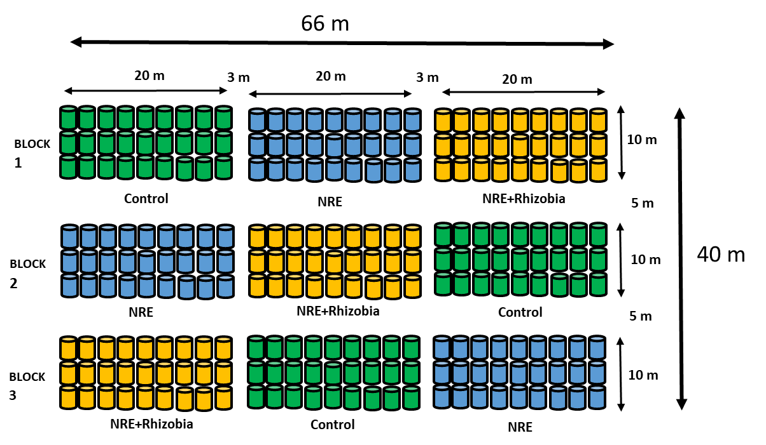
Figure S1B: The field trial followed a randomized complete block design to test three inoculation treatments on soybean: (i) Control (no inoculation), (ii) NRE (non-rhizobial endophyte consortium: Glutamicibacter nicotianae Nks5 + Bacillus velezensis Nka11), and (iii) NRE + Rhizobia (reference rhizobium strain VUID1). The site (≈66 m × 40 m) was arranged in three blocks. Each block contained three plots (20 m × 10 m) separated by 3 m alleys within blocks and 5 m alleys between blocks. Within every plot, 27 seed subplots were established in a 3 × 9 grid, and one subpot represented one soybean plant. Treatments were randomly assigned to plots within each block (one plot per treatment per block), giving 3 replicated lines per treatment. In total, 243 individual plants were grown (3 blocks × 3 plots per block × 27 plants per plot).

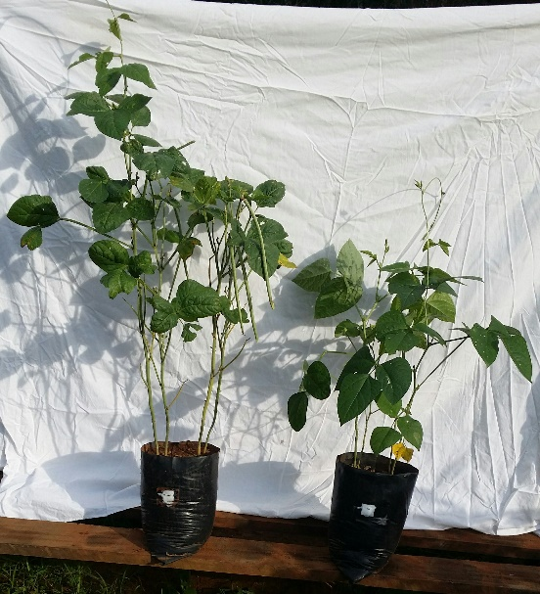
Figure S2: Effect of LNB isolate on cowpea growth parameters after sowing in pots. To: control without ioculation, Nka11 : inoculated plant with Bacillus velezensis
T0
Nka11

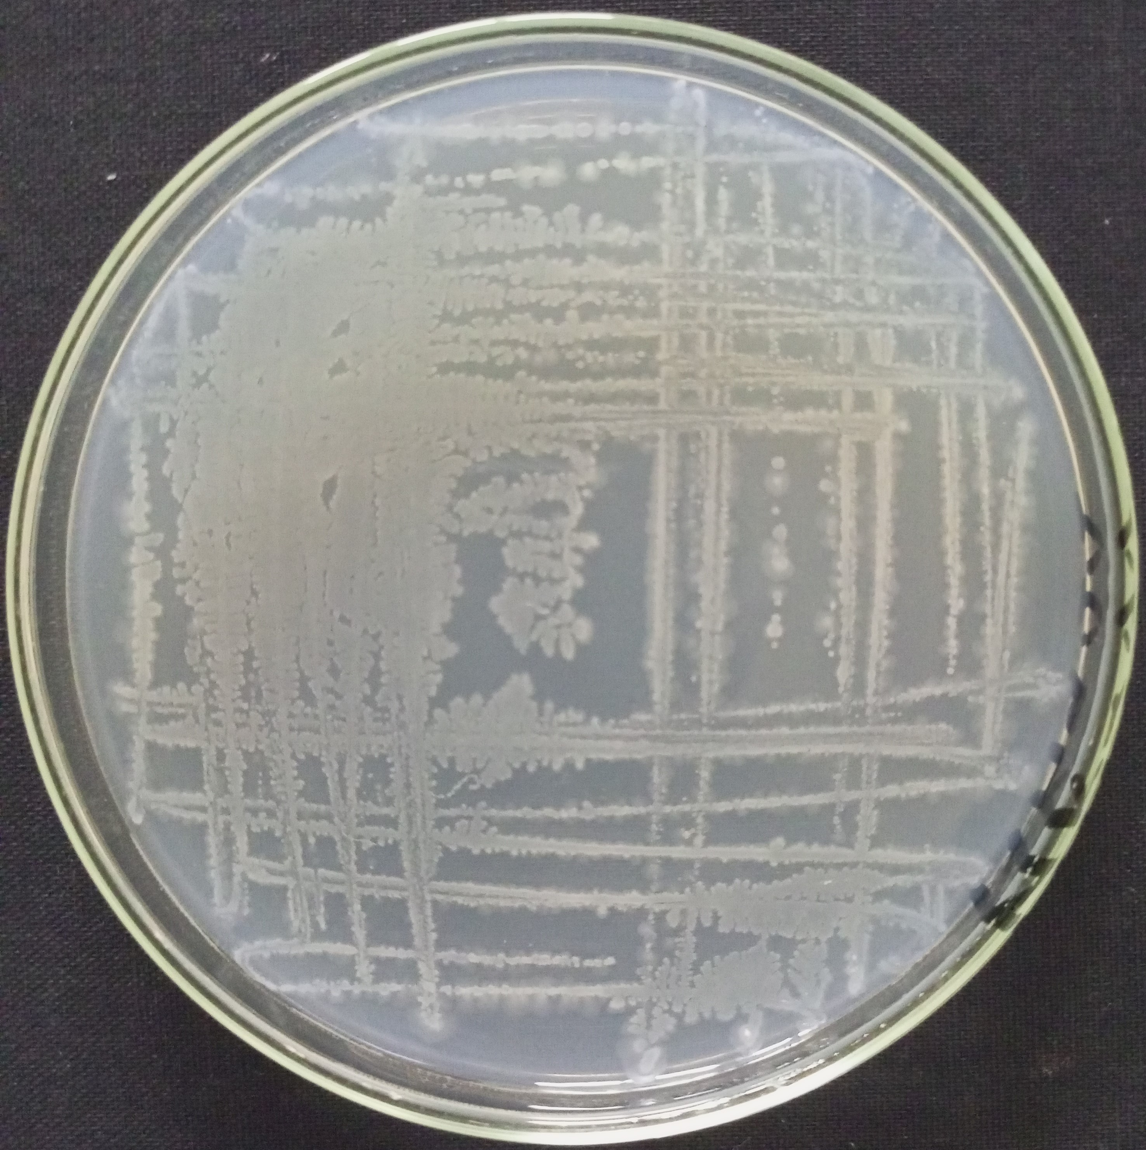
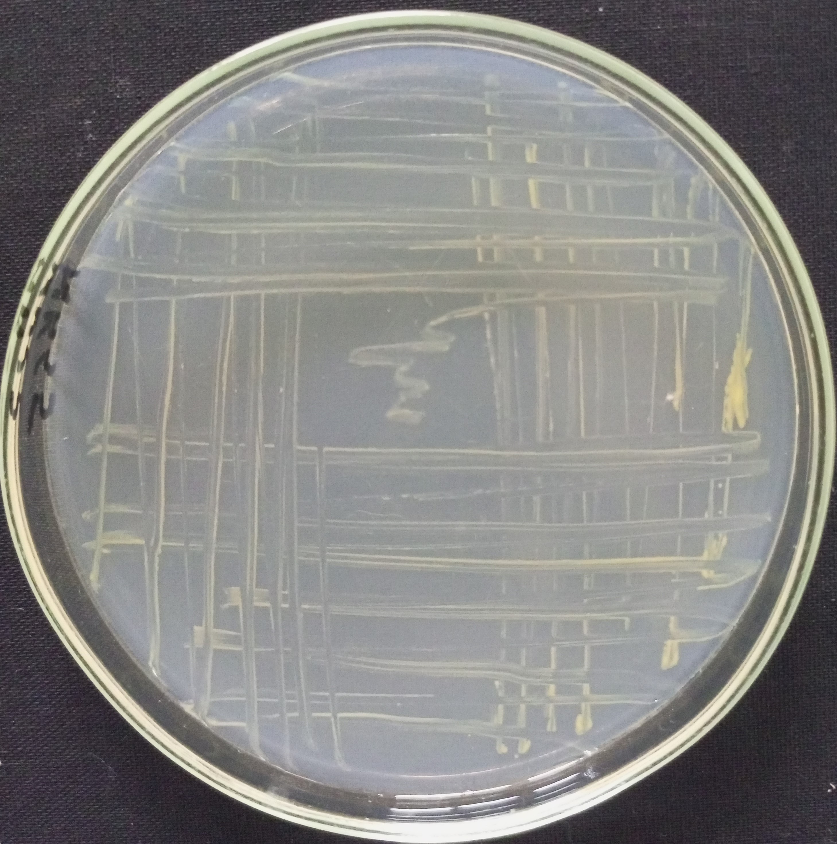

Nka11
Nks5

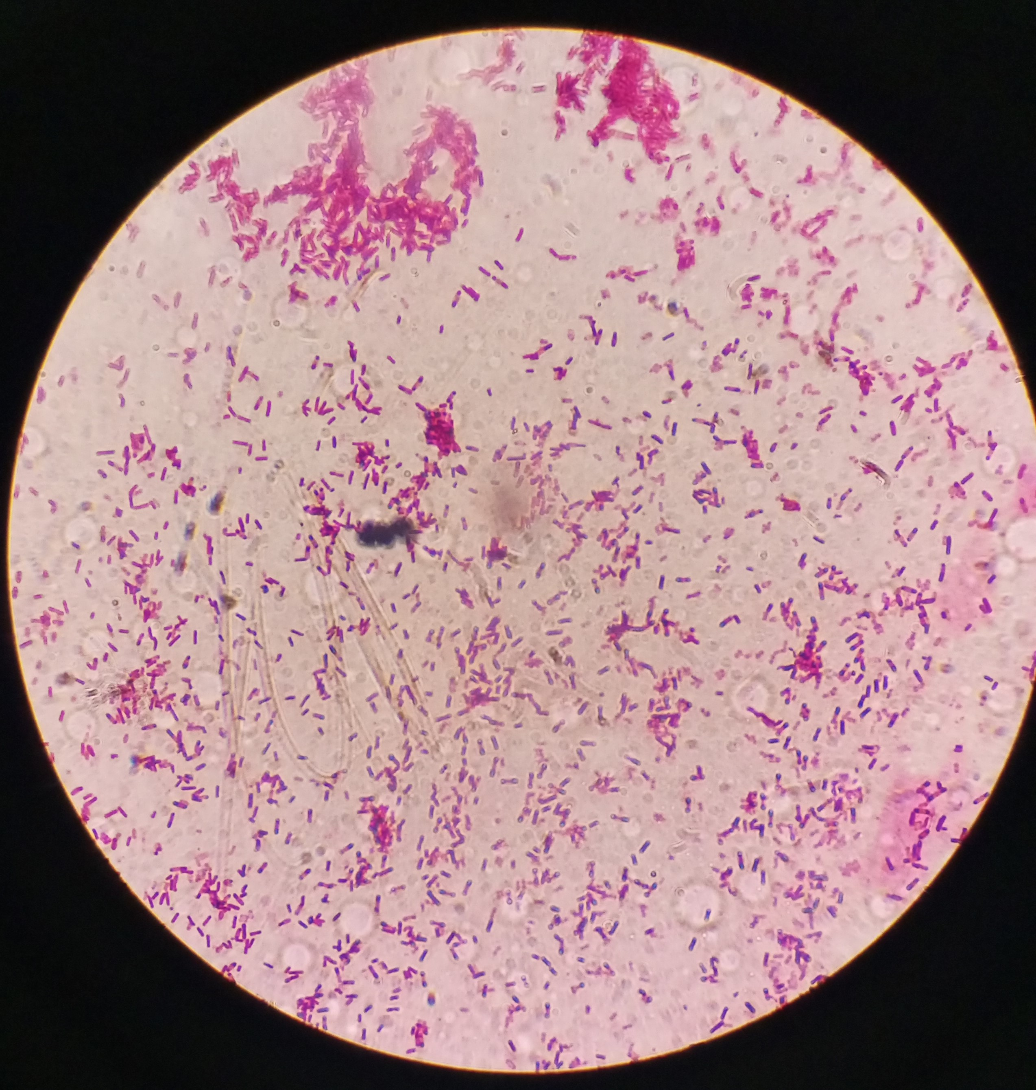
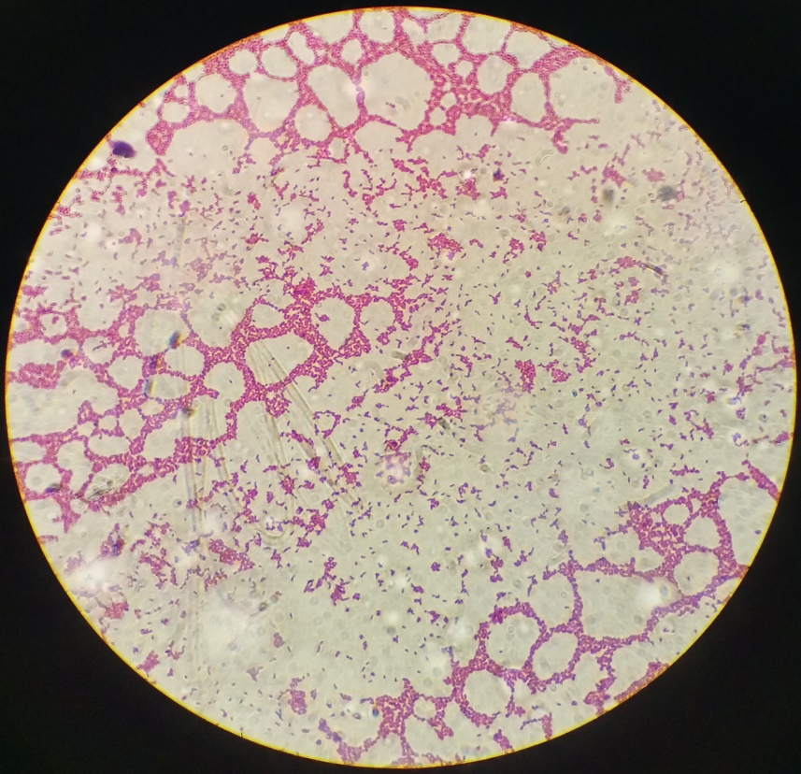
Figure S3: NRE isolates.
Nka11
Nks5
Figure 3: Non-rhizobial endophyte strains.

