Supplementary Material

Microglia integrated neural spheroids enable neuroinflammatory responses and correct network dysfunction induced by alpha-synuclein mutation

Jiajing Zhang¹, Yi Wei Lim¹, Angelica Medina¹, Yu-Chi Chen¹, Martin Carrasco Carvajal¹, Marc Ferrer¹*, & Emily M. Lee¹*

¹Division of Preclinical Innovation, National Center for Advancing Translational Sciences (NCATS), National Institutes of Health, 9800 Medical Center Drive, Rockville, MD, 20850, USA

*Author to whom any correspondence should be addressed.

E-mail: Marc.ferrer@nih.gov, Emily.lee@nih.gov

Supplementary Figures S1 – S13
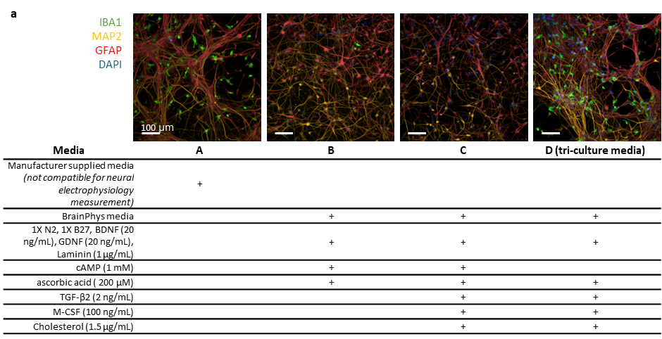
Figure S1. Media optimization for tri-culturing human iPSC-derived neurons, astrocytes, and microglia. (a) Representative images (20X) of 21 days tri-cultures seeded with glutamatergic neurons, astrocytes, and microglia in flat bottom plates as 2D cultures and maintained in A, B, C, D, four different media. Immunostaining against microglia marker (IBA1), neuron marker (MAP2), astrocyte marker (GFAP), as well as DAPI counterstaining were performed to visualize the present of all three cell types in media tested. Scale bar = 100 µm.

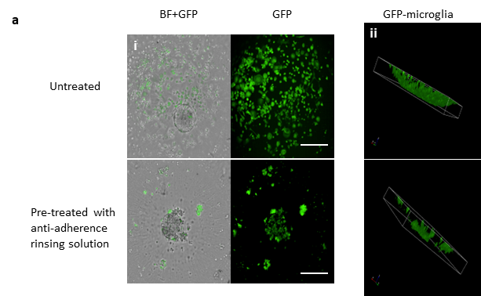
Figure S2. Reduction of surface tension with anti-adherence rinsing solutions facilitate microglial aggregation into neural spheroids. (a) Representative bright field (BF) or GFP-channel images of tri-culture spheroids 7 days after seeded in (top) untreated 384w ULA round bottom plates or (bottom) same microplate pre-treated with anti-adherence rinsing solution prior to seeding. (a-i) showing maximum projections of representative wells showing the localization of GFP-tagged microglia with reference to the cell aggregation shown in bright field images. (a-ii) 3D rendering from the same confocal z-stacks showing GFP-microglia attached to the bottom of the untreated well but aggregated in the pre-treated well. 10X objective was used. Scale bar = 500 µm.

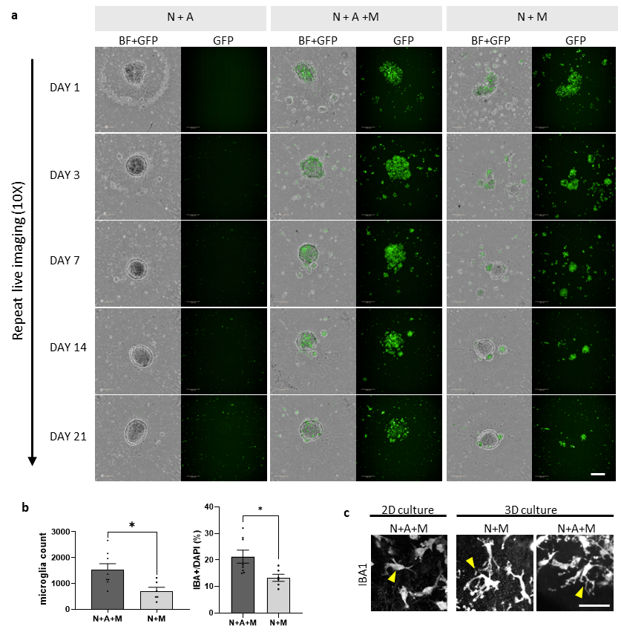
Figure S3. The presence of astrocytes facilitates microglial integration into neural spheroids. (a) Representative bright field (BF) or GFP-channel images of co-culture or tri-culture spheroids generated using mostly glutamatergic neurons (10k/spheroid), together with astrocytes (1k/spheroids) and/or GFP-tagged microglia (2k/spheroid), captured via confocal live imaging using a 10X objective on DAY 1, 3, 7, 14, and 21. Each column shows images from the same spheroid well over time. Each image was presented as maximum projection of a 150 µm z-stack. Scale bar = 200 µm. (b) Left: Quantification of IBA1+ cells in tri-culture (N+A+M) and neuron-microglia co-culture (N+M) spheroids. Right: Comparison of the percentage of microglia in total cell population between tri-culture (N+A+M) and neuron-microglia co-culture (G+M) spheroids. Data were collected from two independent experiments and four biological replicates on each experiment. Percentage was calculated by dividing the total number of IBA1+ cells by the total number of nuclei and presented as mean ± SEM. Mann–Whitney unpaired t test was used. Asterisk symbol represents *P < 0.05. (c) Confocal images (25X) of IBA1+ cells in 2D and 3D cell cultures. For 2D cultures, microglia (M) were seeded with glutamatergic neurons (N) and astrocytes (A) in coated 96w flat bottom plates as tri-cultures. For 3D cultures, microglia were seeded as glutamatergic neuron-microglia co-culture spheroids or tri-culture spheroids together with astrocytes. Representative images are presented as maximum projection of z-stacks covering the entire depth of the arrow pointed IBA1+ cells. Scale bar = 50 µm.

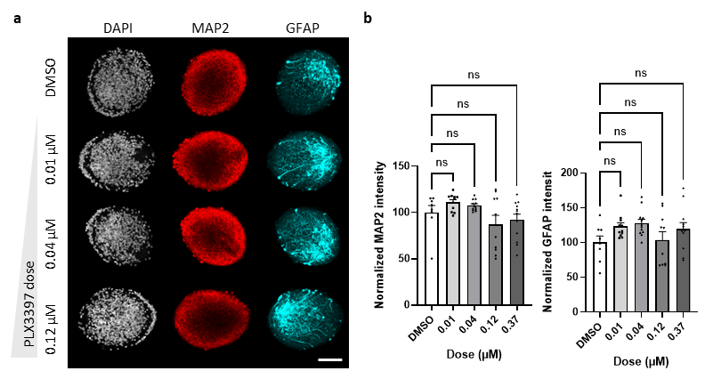
Figure S4. PLX3397 treatment does not affect neuron or astrocyte viability in tri-culture spheroids. (a) Confocal images (25X) of tri-culture spheroids after 96 hours of treatment with DMSO or PLX3397 (0.01, 0.04, or 0.12 µM). Spheroids were immunostained for MAP2 and GFAP, followed by DAPI counterstaining. Representative images are presented as maximum projections of 25 µm z-stacks. Scale bar = 100 µm. (b) Quantification of MAP2 and GFAP signals in tri-culture spheroids treated with DMSO or PLX3397 (0.01, 0.04, or 0.12 µM) for 96 hours. Total integrated intensity over total volume was calculated and subsequently normalized to the DMSO group average. Statistical analysis was done using one-way ANOVA followed by Dunn’s multiple comparisons test. Data were collected from three independent experiments with 4-8 biological replicates in each experiment and presented as mean ± SEM. ns = not significant.

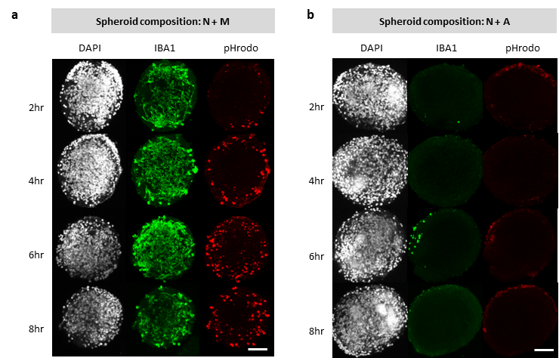
Figure S5. Phagocytosis in co-culture spheroids following pHrodo red S. aureus bioparticles exposure is mediated by microglia. (a) Confocal images (25X) of DAY 21 neuron-microglia “N+M” co-culture spheroids fixed after a 2-, 4-, 6-, or 8-hour exposure to pHrodo red S. aureus bioparticles (100 µg/ml) and immunostained for IBA1 and counterstained for DAPI. Scale bar = 100 µm. (b) Confocal images (25X) of DAY 21 neuron-astrocyte “N+A” co-culture spheroids fixed after a 2-, 4-, 6-, or 8-hour exposure to pHrodo red S. aureus bioparticles (100 µg/ml) and immunostained for IBA1 and counterstained for DAPI. Representative images are presented as maximum projections of 150 µm z-stacks. Scale bar = 100 µm.

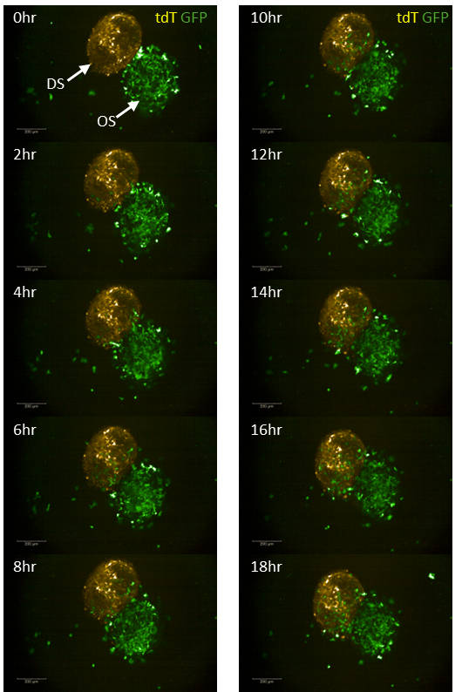
Figure S6. Migration of microglia in “origin spheroids” into “destination spheroids” in the assembloid-migration assay. Repeat live imaging of an assembloid made with one tdTomato (tdT)-expressing “destination spheroid (DS)” without microglia and one “origin spheroid (OS)” with GFP-tagged microglia. A single-plane image of the assembloid was taken using a Phenix spinning disk confocal with a 10X objective every 2 hours immediately following the generation of the assembloid. Scale bar = 200 µm.
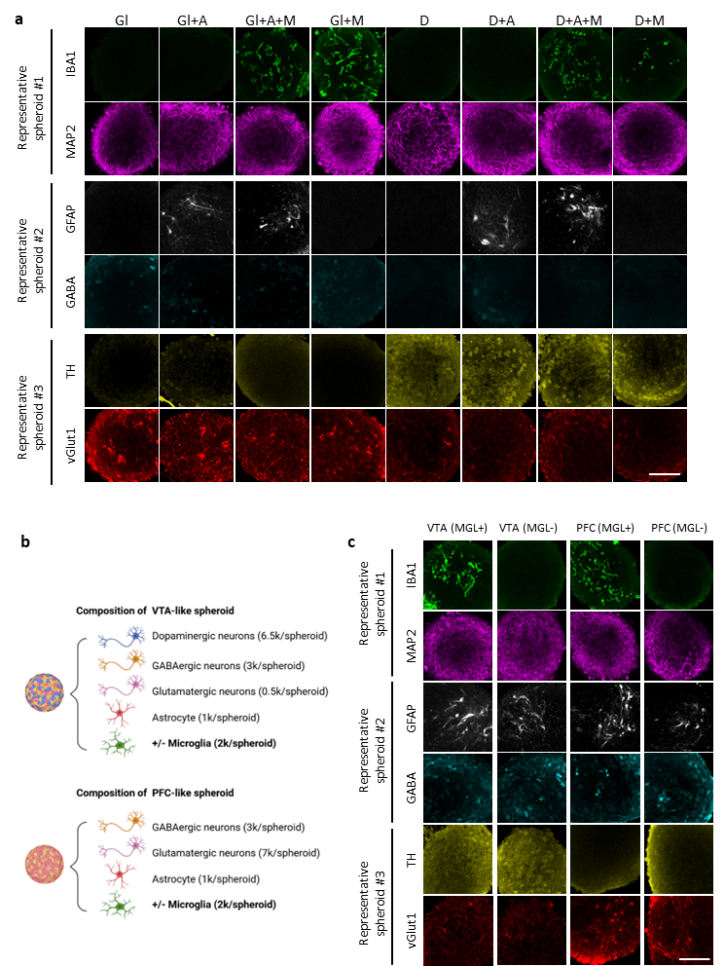
Figure S7. Immunofluorescence-based characterization of neural spheroids seeded with different cell-type compositions. (a) Representative images (25X) of DAY 21 neural spheroids seeded with different cell-type compositions: mono-cultures of glutamatergic neurons (Gl) or dopaminergic neurons (D); co-cultures of neurons with astrocytes (A) or microglia (M); or tri-cultures of neurons, astrocytes, and microglia. Seeding numbers were kept the same for all spheroid types with neuron = 10k cells/spheroid, astrocytes = 1k cells/spheroid, and microglia = 2k cells/spheroid when included. Immunostaining of six cell-type markers were done in three separate groups of spheroids (top to bottom: spheroid group #1 stained for IBA1 and MAP2, spheroid group #2 stained for GFAP and GABA, spheroid group #3 stained for TH and vGlut1). Single-plane confocal images were taken using a 25X water objective and image acquisition settings were kept the same between samples. Scale bar = 100 µm. (b) Schematic showing the cell-type compositions of VTA-like spheroids and PFC-like spheroids used in (c). (c) Representative images (25X) of DAY 21 brain-region-like spheroids seeded with or without 2k cells/spheroid of microglia: PFC-like spheroids (each seeded with 7k glutamatergic neurons + 3k GABAergic neurons + 1k astrocytes); VTA-like spheroids (each seeded with 6.5k dopaminergic neurons + 3k GABAergic neurons + 0.5k glutamatergic neurons + 1k astrocytes). Immunostaining of six cell-type markers were done in three separate groups of spheroids (top to bottom: spheroid group #1 stained for IBA1 and MAP2, spheroid group #2 stained for GFAP and GABA, spheroid group #3 stained for TH and vGlut1). Single-plane confocal images were taken using a 25X water objective and image acquisition settings were kept the same between samples. Scale bar = 100 µm.

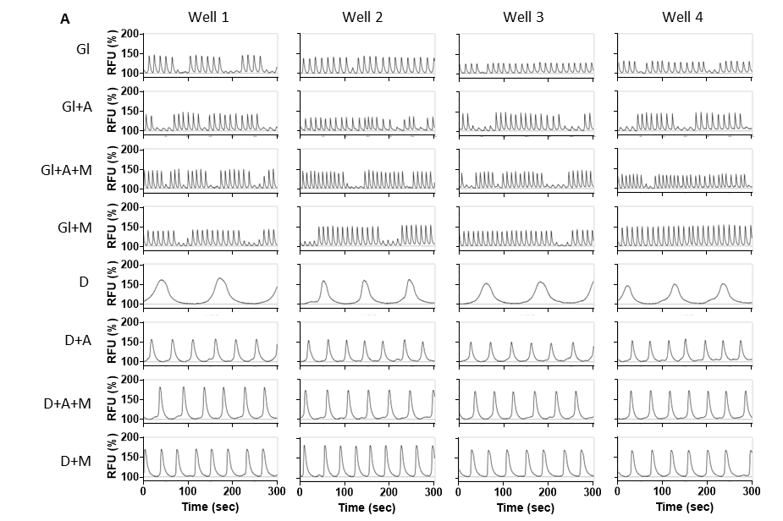
Figure S8. Calcium oscillation profiles in single neuronal type spheroids cultured in tri-culture media. Spontaneous calcium oscillation traces of 4 spheroids generated in the same batch were shown for glutamatergic neurons only spheroids (Gl), dopaminergic neurons only spheroids (D), co-culture spheroids with astrocytes (Gl+A, D+A) or microglia (Gl+M, D+A), and tri-culture with astrocytes and microglia (Gl+A+M, D+A+M). Compared to dopaminergic spheroids which steady oscillation patterns, glutamatergic spheroids exhibit periodic changes in peak amplitude and such pattern presents to be different between wells.

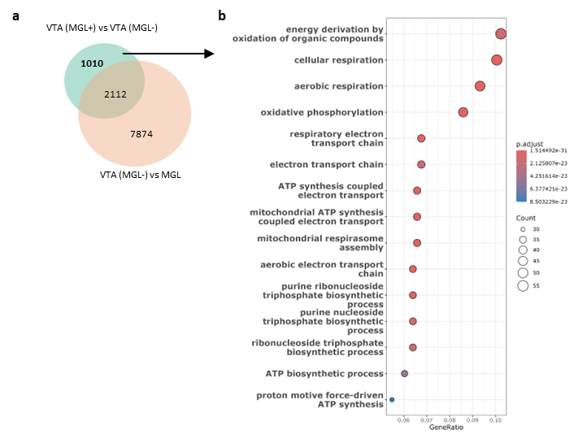
Figure S9. Gene set enrichment analysis (GSEA) of a subset of DEGs between VTA-like spheroids with or without microglia. (a) Venn diagrams showing significantly differentially expressed genes (DEGs) between VTA-like spheroids with (MGL+) or without (MGL-) microglia, using a threshold of log2 fold change >1 and p < 0.05 significance. (b) Top 15 pathways identified using GSEA associated with genes that are differentially expressed in VTA-like spheroids due to microglia present, excluding genes that are also differentially expressed between VTA only and MGL only samples.

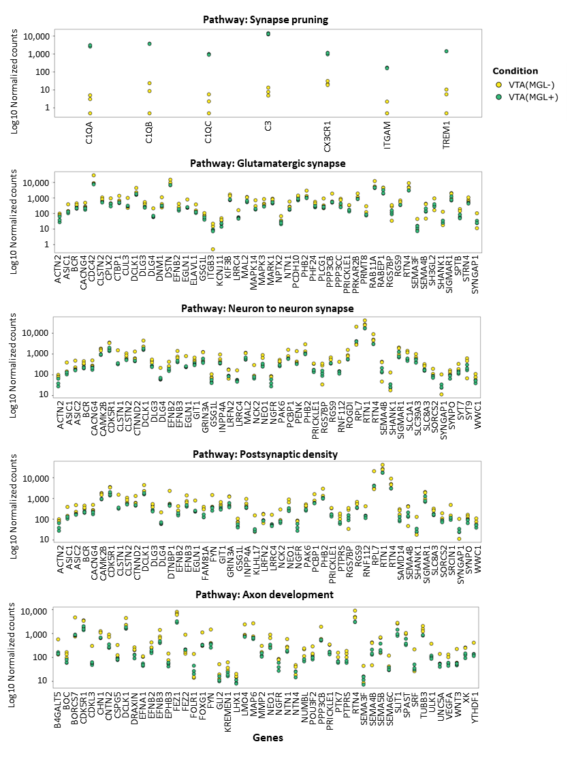
Figure S10. Gene panels enriched in GSEA of selected pathways between VTA-like spheroids and microglia only cultures. Top identified genes in selected GSEA pathways shown in Figure 4D.
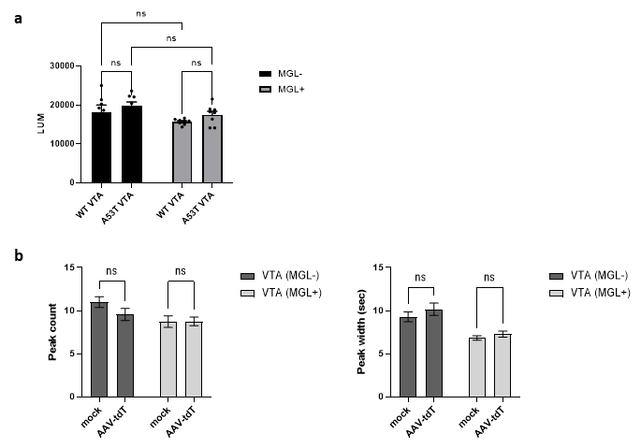
Figure S11. Phenotypic changes in disease-like spheroids calcium oscillation is not due to viability changes or AAV-mediated protein overexpression. (a) Viabilities of DAY 21 WT or A53T VTA-like spheroids were measured using the Cell Titer Glo-3D assay; LUM = luminescence units. Data were collected from one experiment with 8 biological replicates and presented as mean ± SEM. (b) WT VTA with or without microglia were transduced with AAV2-CAG-tdTomato (MOI=5e5) as a control for AAV-mediated overexpression of A53T-alpha-synuclein on DAY 5 and their calcium oscillation was evaluated using Cal6-FLIPR assay on DAY 21. Data were collected from two independent experiments with 4-8 biological replicates in each experiment and presented as mean ± SEM. Two-way ANOVA followed by Šídák's multiple comparisons test was used. ns = not significant.

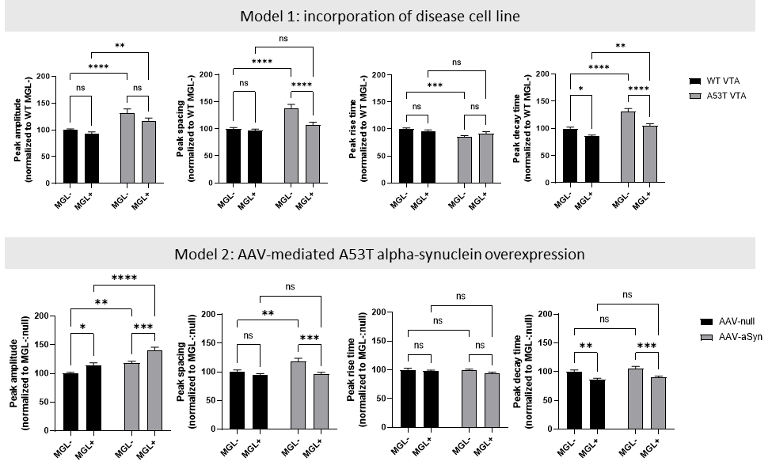
Figure S12. Analysis of key peak parameters changes associated with disease-induction and microglial incorporation. Data matching those used in Figure 6d and 6i to generate radar plots. Quantification of peak amplitude, peak spacing, peak rise time, and peak decay time using data collected from three independent experiments and 16 biological replicates in each experiment, and presented as mean ± SEM. Two-way ANOVA followed by Šídák's multiple comparisons test were used. Asterisk symbol represents *P < 0.05, **P < 0.01, ***P < 0.001, ****P < 0.0001, and ns = not significant.

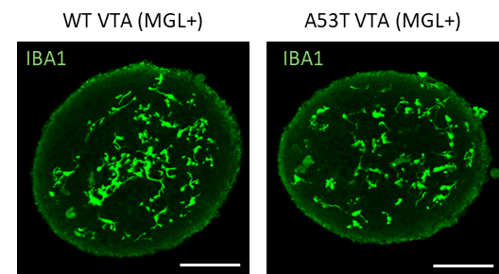
Figure S13. Integrated microglia exhibit homeostasis morphology in DAY 21 wildtype (WT) and A53T VTA-like spheroids. Representative images (25X) showing maximum projections of a 10 µm sections z-stack in the middle of a WT VTA (MGL+) spheroid and a A53T VTA (MGL+) after 21 days in culture. Scale bar = 100 µm.

Tables S1- S2
Table S1. Average coefficient of variations (%CV) for neural spheroids.

Table S2. List of primary and secondary antibodies.

