SYNTHESIS OF AMMONIUM SALTS OF ARYLAZOSALICYLIC ACID, STUDY OF THEIR OPTICAL PROPERTIES, ANTICANCER AND ANTIMICROBIAL ACTIVITIES

N.O. Sonin¹,
D.M. Egorov^{1,2}, https://orcid.org/0000-0003-3744-9306, *e-mail: diavoly@mail.ru
I.L. Kuzikova ², https://orcid.org/0000-0001-6199-3104
Т.B. Zaytseva², https://orcid.org/0000-0003-1617-0971
Z.A. Zhakovskaya², https://orcid.org/0000-0002-5620-1317
G.I. Bikbaeva³, https://orcid.org/0009-0005-2208-8255
O.A. Mammeri⁴,
A.S. Drachuk⁵,
V.М. Boitsov⁵ https://orcid.org/0000-0002-4857-2046

¹St. Petersburg State Institute of Technology (Technical University), 26, Moskovski ave., St. Petersburg, 190013, Russia
²St. Petersburg Federal Research Center of the Russian Academy of Sciences (SPC RAS),
39, 14th Line V.O., St. Petersburg, 199178, Russia
³Saint-Petersburg State University, 7-9, Universitetskaya Embankment, St. Petersburg, 199034, Russia
⁴Chemical Analysis and Materials Research Centre, Saint Petersburg State University, Saint Petersburg, 198504, Russia
⁵Saint-Petersburg National Research Academic University of the Russian Academy of Sciences, Saint Petersburg 194021, Russia

Figure S1. ¹H and ¹³C spectra of compound 7a | 4
Figure S2. ¹H and ¹³C spectra of compound 8a | 5
Figure S3. ¹H and ¹³C spectra of compound 7b | 6
Figure S4. ¹H and ¹³C spectra of compound 8b | 7
Figure S5. ¹H and ¹³C spectra of compound 7c | 8
Figure S6. ¹H and ¹³C spectra of compound 8c | 9
Figure S7. ¹H and ¹³C spectra of compound 7d | 10
Figure S8. ¹H and ¹³C spectra of compound 8d | 11
Figure S9. ¹H and ¹³C spectra of compound 7e | 12
Figure S10. ¹H and ¹³C spectra of compound 8e | 13
Figure S11. ¹H and ¹³C spectra of compound 7f | 14
Figure S12. ¹H and ¹³C spectra of compound 8f | 15
Figure S13. ¹H and ¹³C spectra of compound 7g | 16
Figure S14. ¹H and ¹³C spectra of compound 8g | 17
Figure S15. ¹H and ¹³C spectra of compound 7h | 18
Figure S16. ¹H and ¹³C spectra of compound 8h | 19
Figure S17. ¹H and ¹³C spectra of compound 7i | 20
Figure S18. ¹H and ¹³C spectra of compound 8i | 21
Figure S19. ¹H and ¹³C spectra of compound 7j | 22
Figure S20. ¹H and ¹³C spectra of compound 8j | 23
Figure S21. ESI-MS spectra of compound 7a | 24
Figure S22. ESI-MS spectra of compound 8a | 25
Figure S23. ESI-MS spectra of compound 7b | 26
Figure S24. ESI-MS spectra of compound 8b | 27
Figure S25. ESI-MS spectra of compound 7c | 28
Figure S26. ESI-MS spectra of compound 8c | 29
Figure S27. ESI-MS spectra of compound 7d | 30
Figure S28. ESI-MS spectra of compound 8d | 31
Figure S29. ESI-MS spectra of compound 7e | 32
Figure S30. ESI-MS spectra of compound 8e | 33
Figure S31. ESI-MS spectra of compound 7f | 34
Figure S32. ESI-MS spectra of compound 8f | 35
Figure S33. ESI-MS spectra of compound 7g | 36
Figure S34. ESI-MS spectra of compound 8g | 37
Figure S35. ESI-MS spectra of compound 7h | 38
Figure S36. ESI-MS spectra of compound 8h | 39
Figure S37. ESI-MS spectra of compound 7i | 40
Figure S38. ESI-MS spectra of compound 8i | 41
Figure S39. ESI-MS spectra of compound 7j | 42
Figure S40. ESI-MS spectra of compound 8j | 43
Figure S41. UV-Vis spectra of compound 7a | 44
Figure S42. UV-Vis spectra of compound 8a | 44
Figure S43. UV-Vis spectra of compound 7b | 45
Figure S44. UV-Vis spectra of compound 8b | 45
Figure S45. UV-Vis spectra of compound 7c | 46
Figure S46. UV-Vis spectra of compound 8c | 46
Figure S47. UV-Vis spectra of compound 7d | 47
Figure S48. UV-Vis spectra of compound 8d | 47
Figure S49. UV-Vis spectra of compound 7e | 48
Figure S50. UV-Vis spectra of compound 8e | 48
Figure S51. UV-Vis spectra of compound 7f | 49
Figure S52. UV-Vis spectra of compound 8f | 49
Figure S53. UV-Vis spectra of compound 7g | 50
Figure S54. UV-Vis spectra of compound 8g | 50
Figure S55. UV-Vis spectra of compound 7h | 51
Figure S56. UV-Vis spectra of compound 8h | 51
Figure S57. UV-Vis spectra of compound 7i | 52
Figure S58. UV-Vis spectra of compound 8i | 52
Figure S59. UV-Vis spectra of compound 7j | 53
Figure S60. UV-Vis spectra of compound 8j | 53

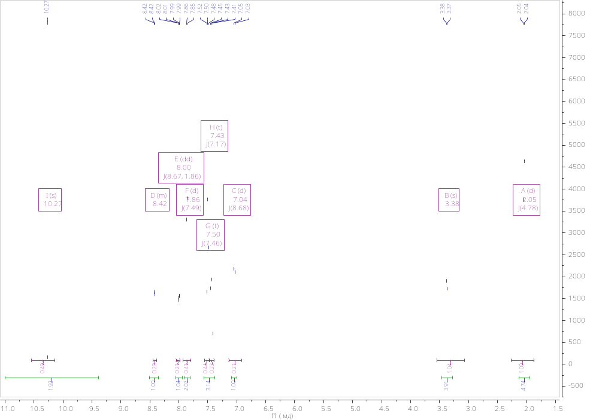
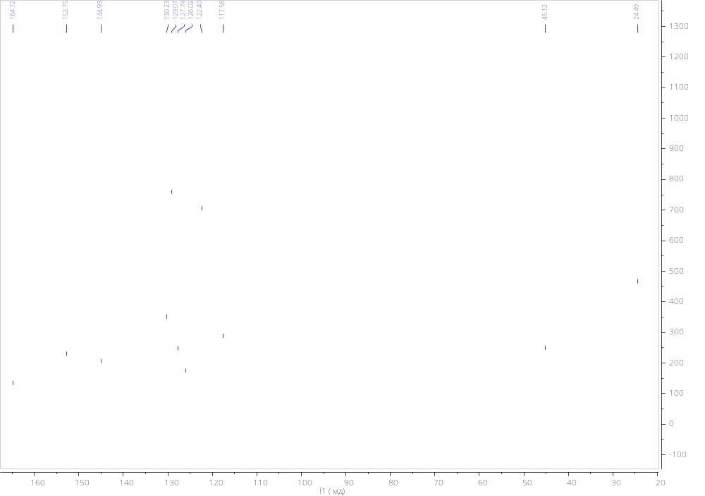
Figure S1. ¹H and ¹³C spectra of compound 7a

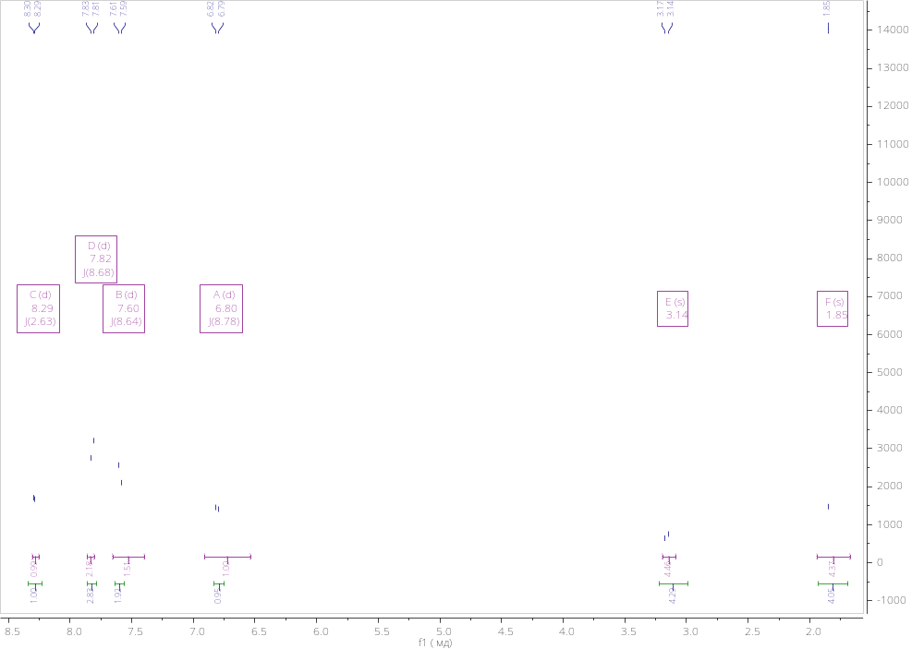
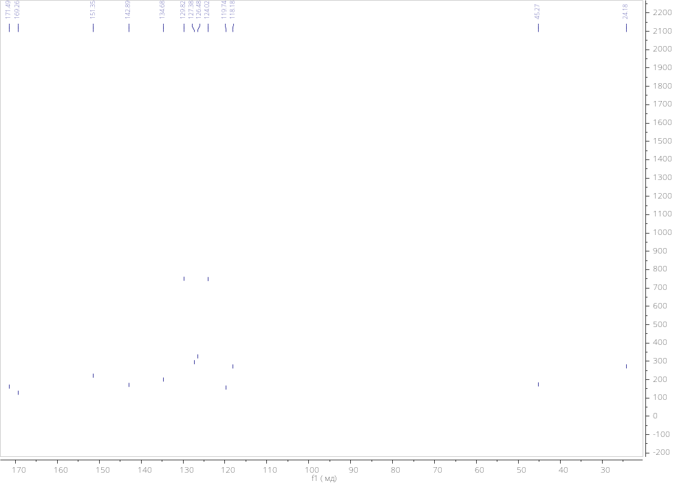
Figure S2. ¹H and ¹³C spectra of compound 8a

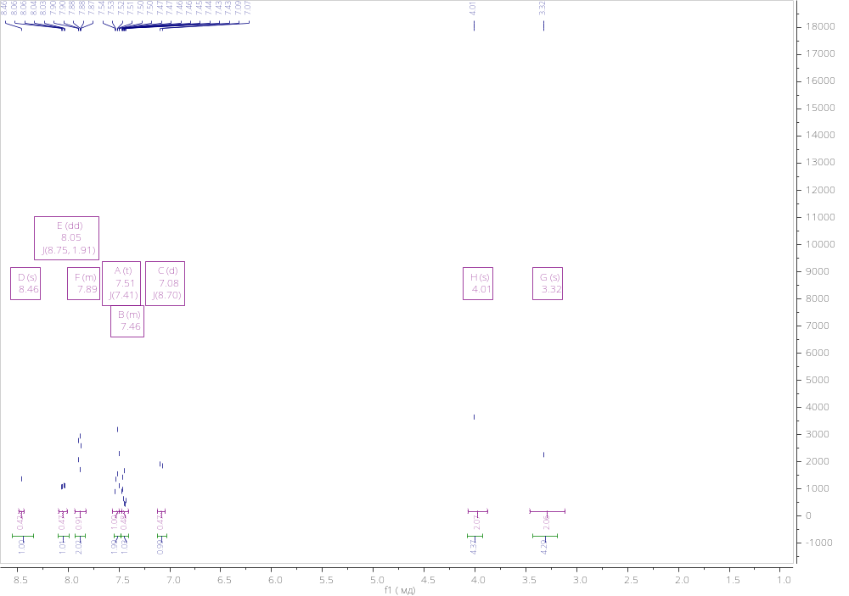
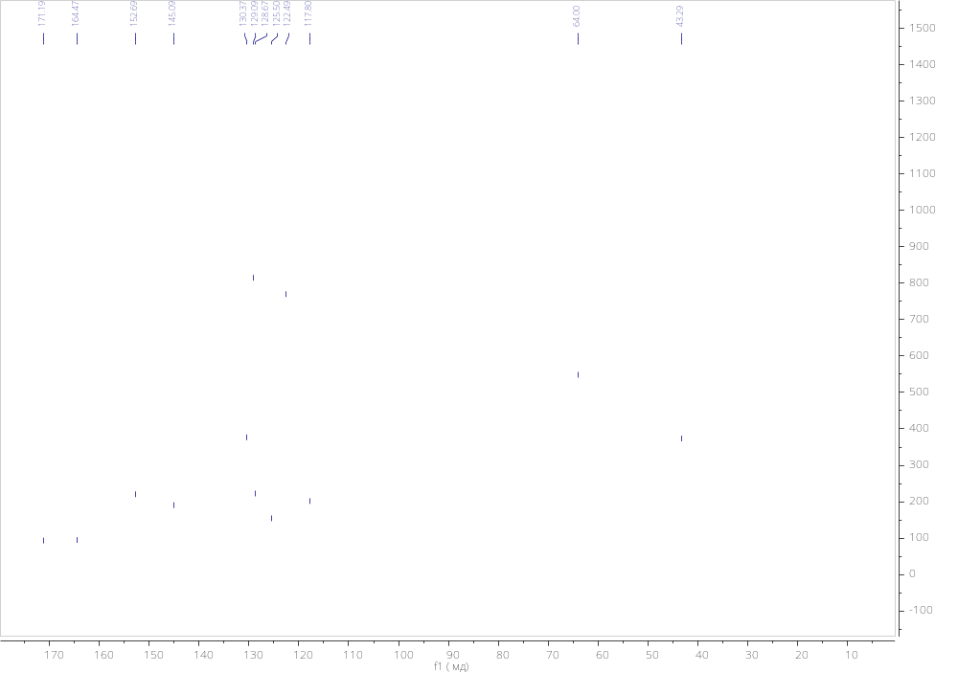
Figure S3. ¹H and ¹³C spectra of compound 7b

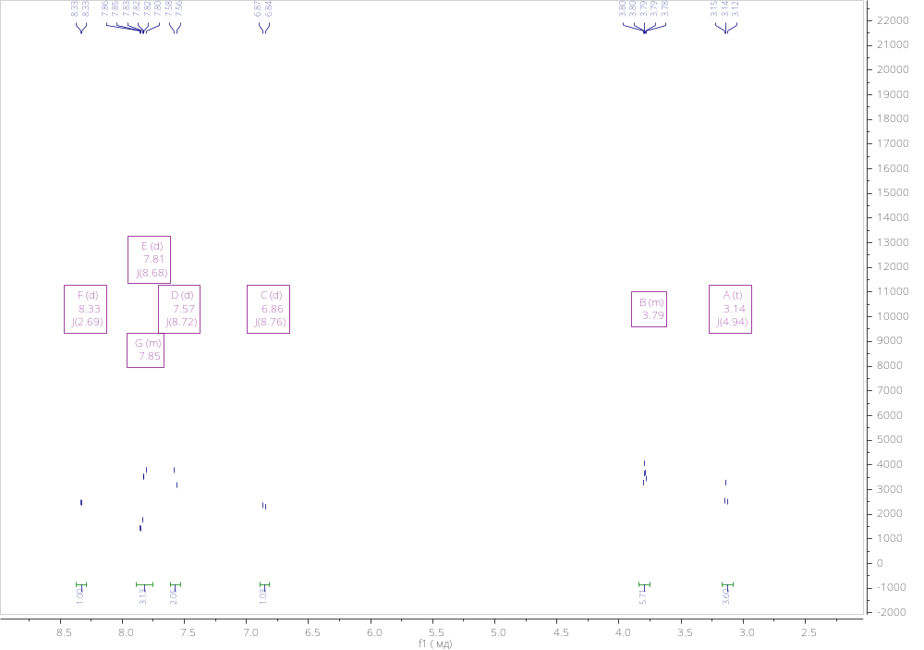
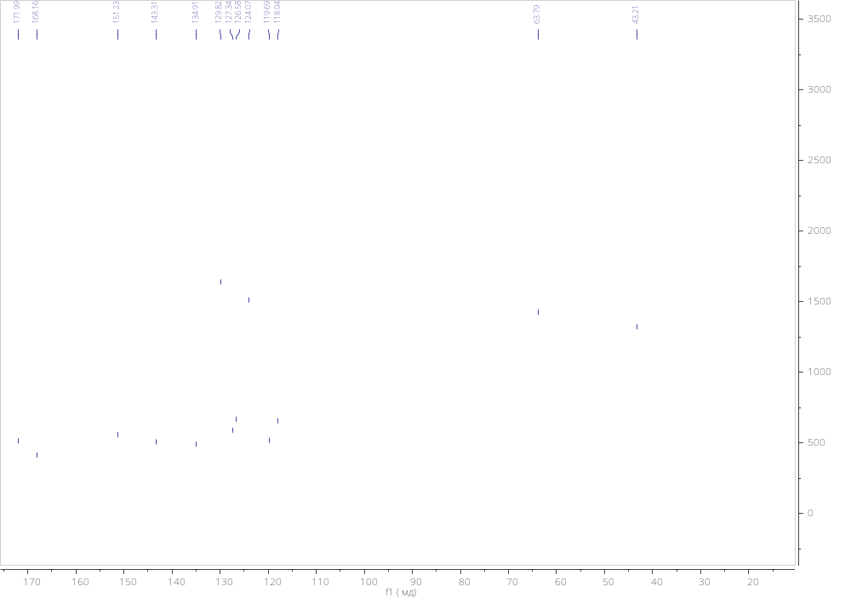Figure S4. ¹H and ¹³C spectra of compound 8b

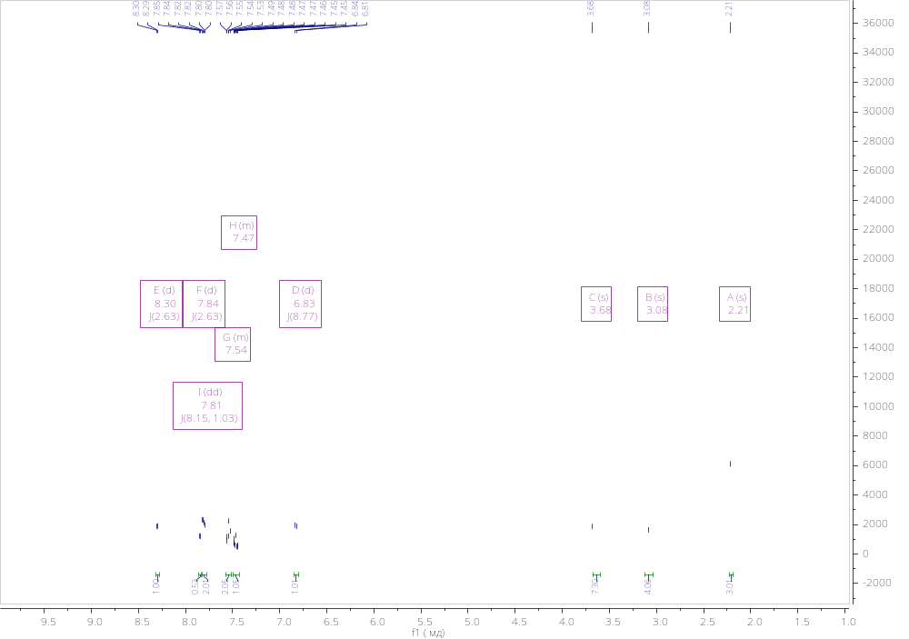
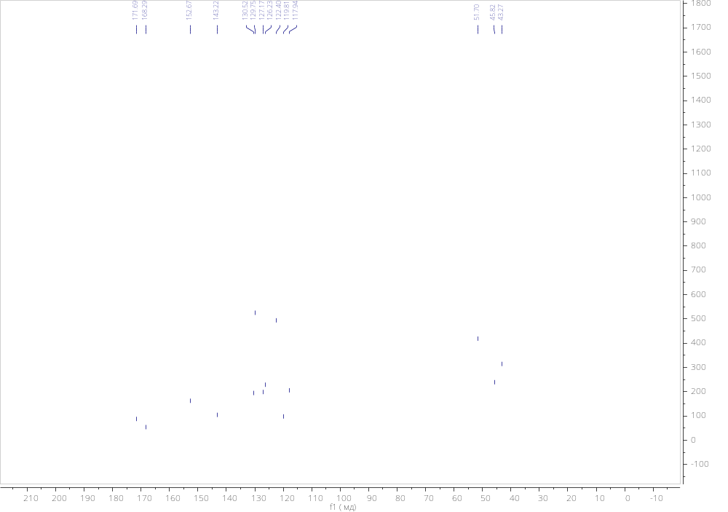
Figure S5. ¹H and ¹³C spectra of compound 7c
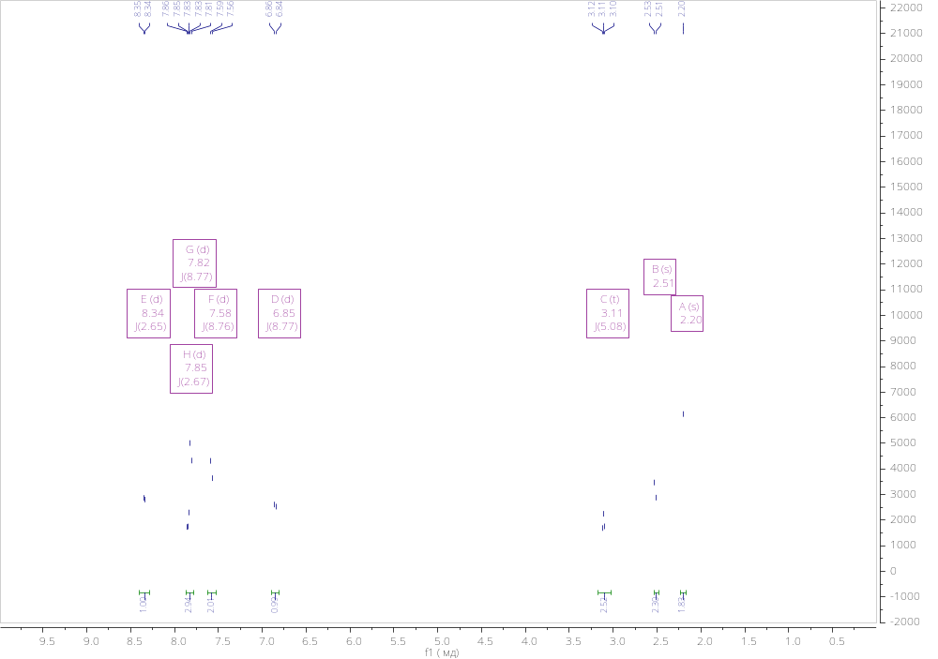
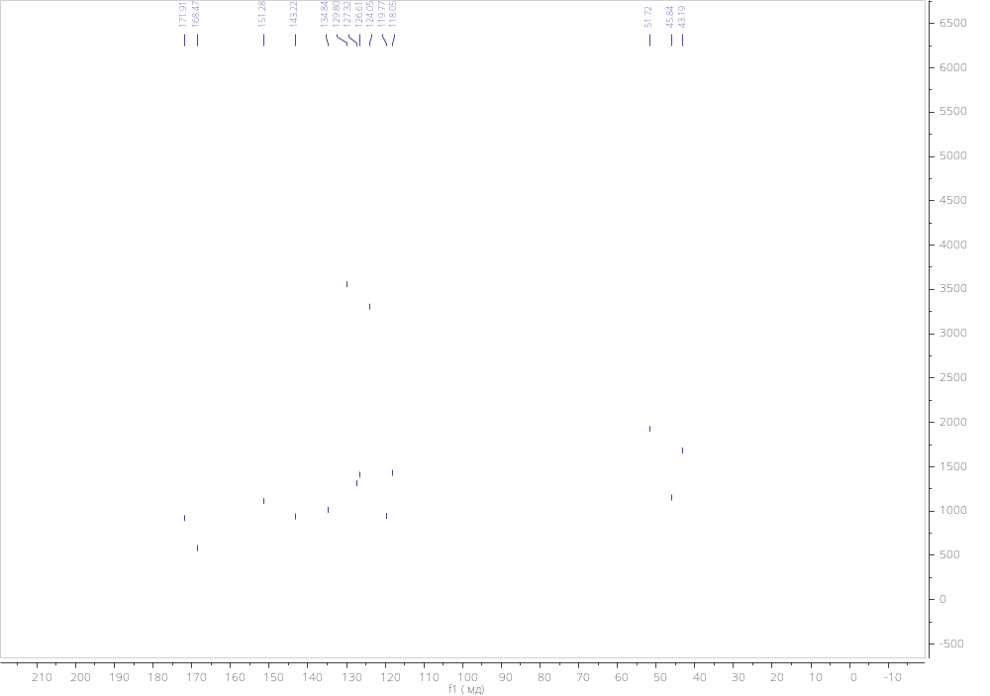
Figure S6. ¹H and ¹³C spectra of compound 8c
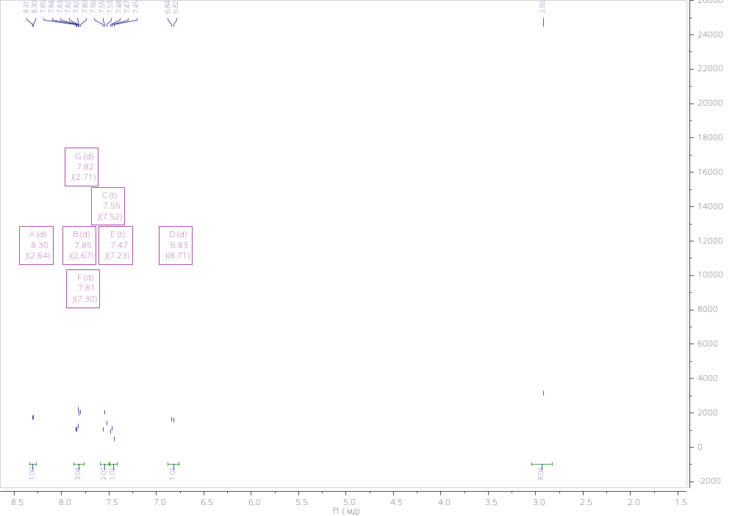
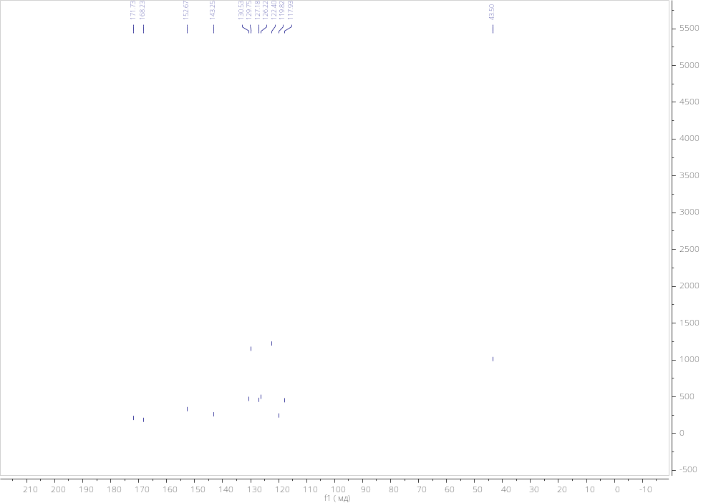
Figure S7. ¹H and ¹³C spectra of compound 7d
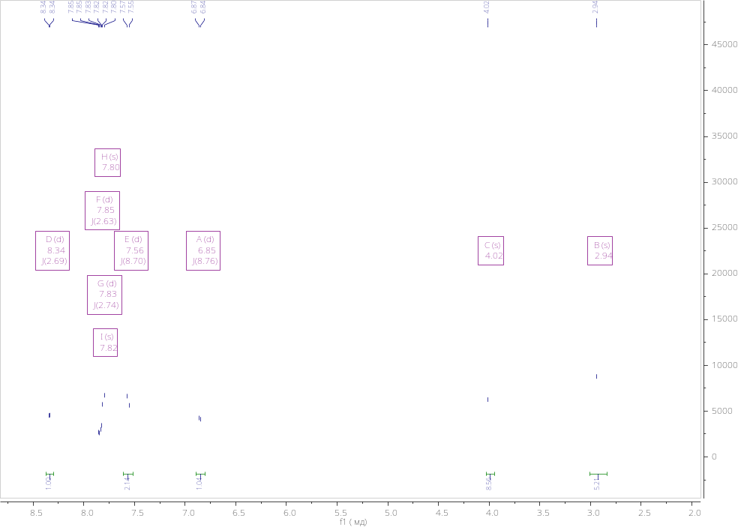
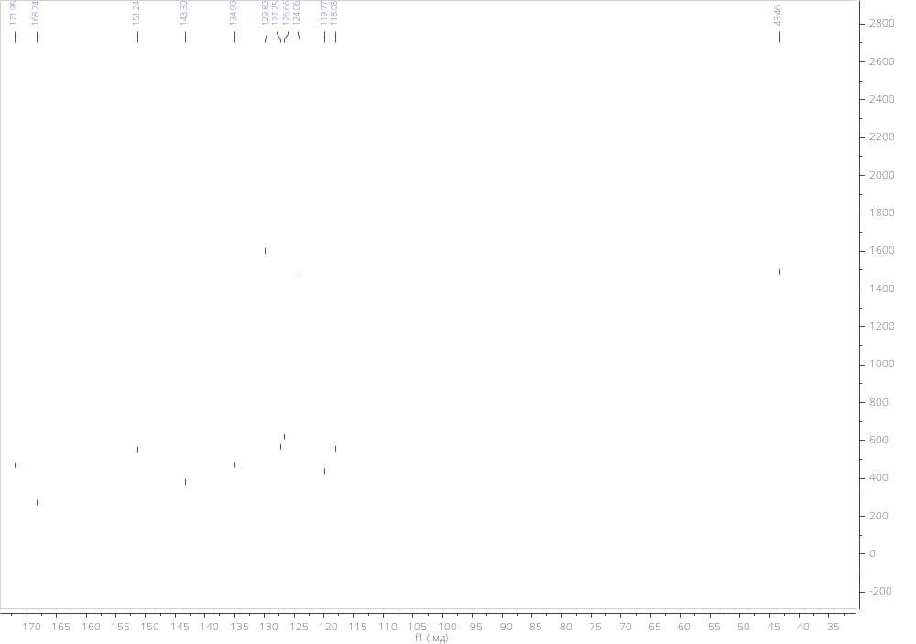
Figure S8. ¹H and ¹³C spectra of compound 8d
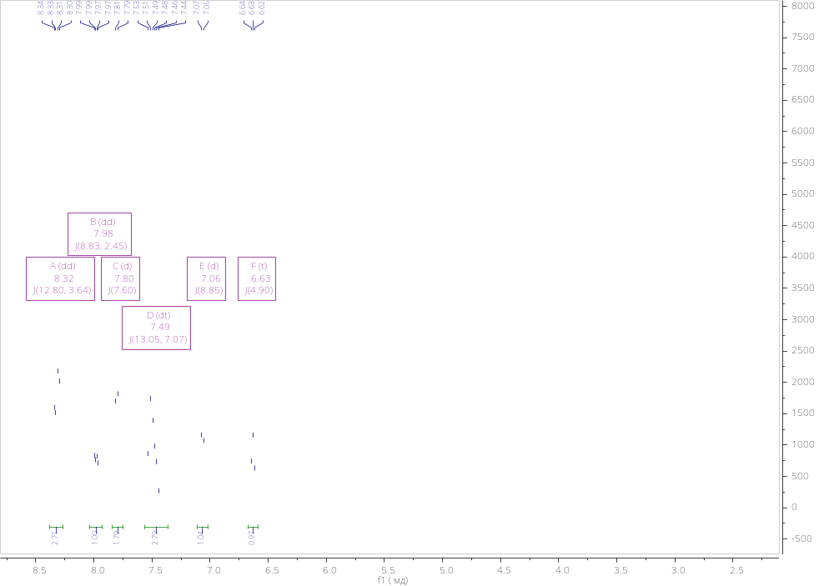
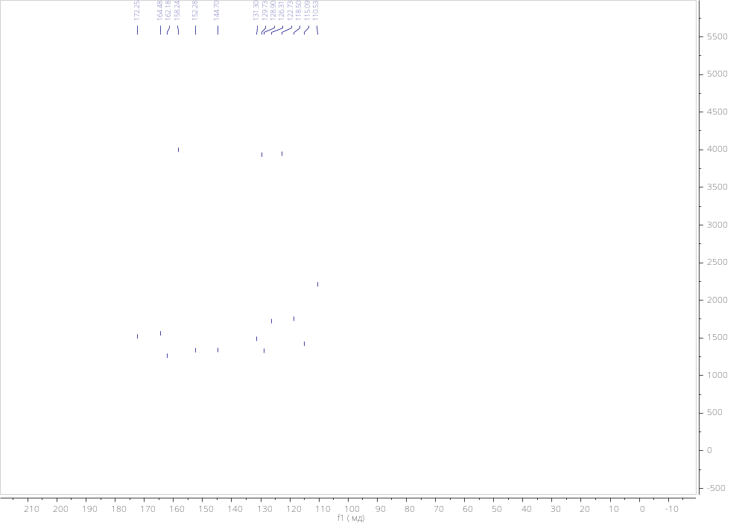
Figure S9. ¹H and ¹³C spectra of compound 7e
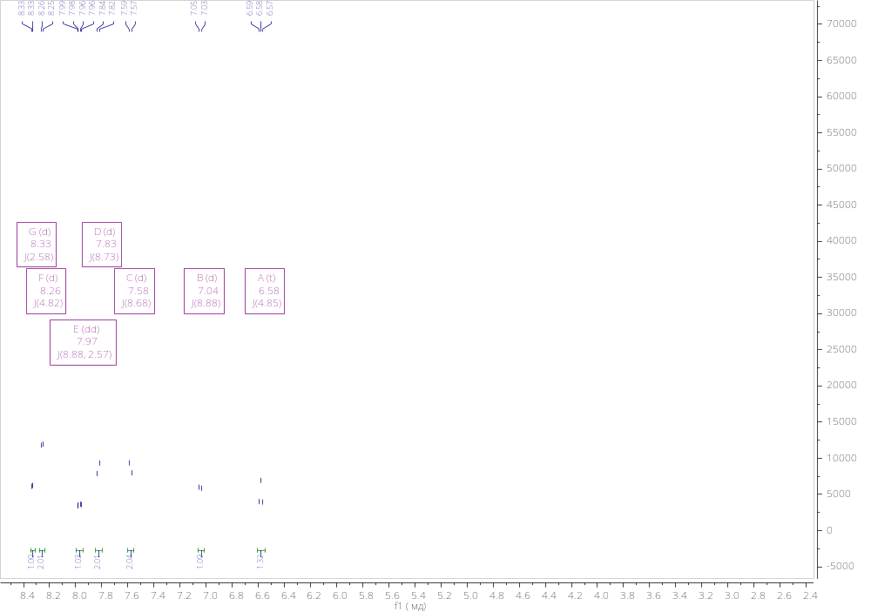
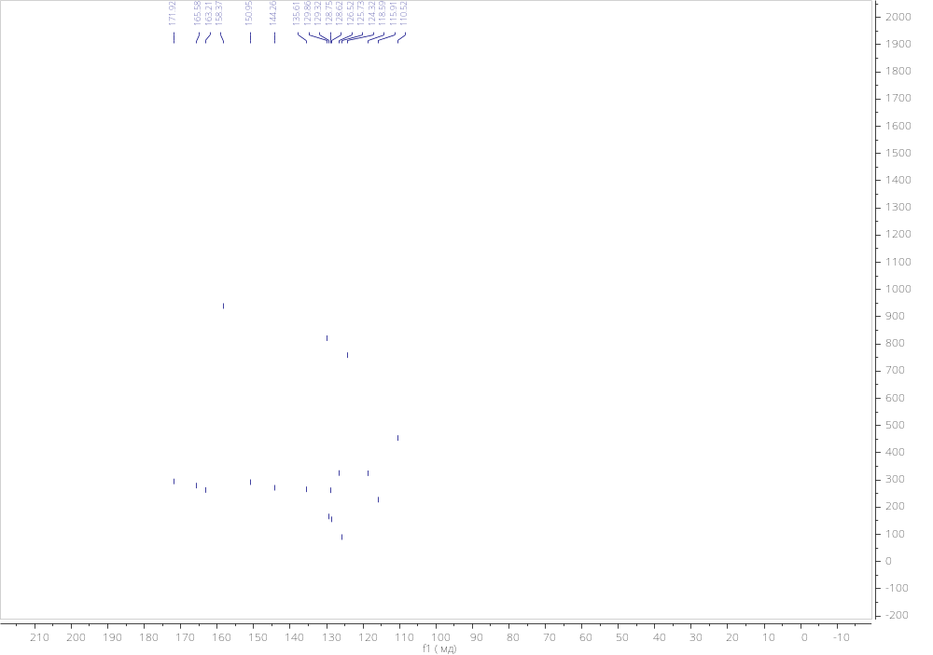
Figure S10. ¹H and ¹³C spectra of compound 8e
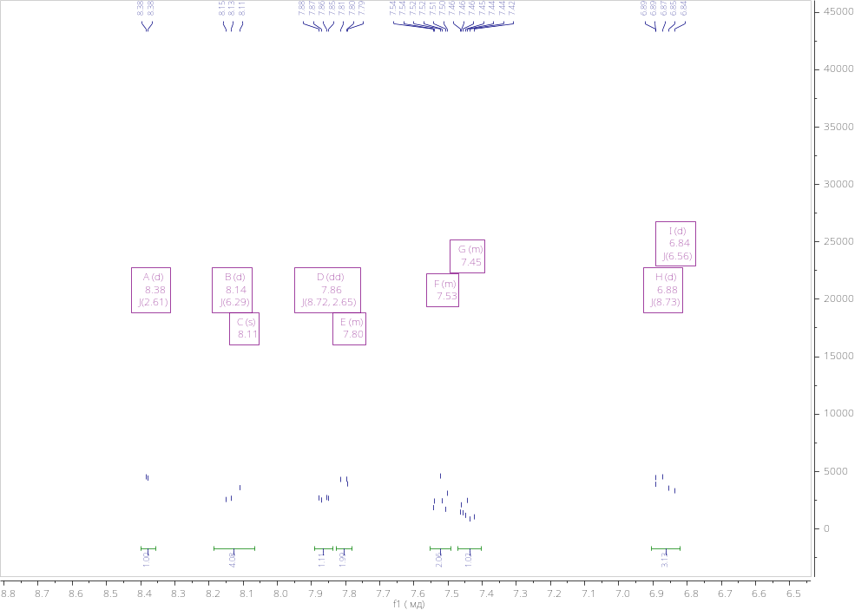
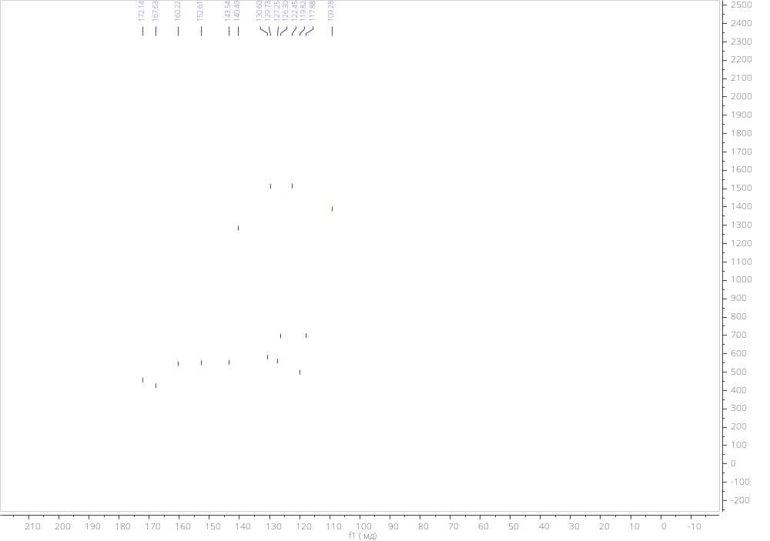
Figure S11. ¹H and ¹³C spectra of compound 7f
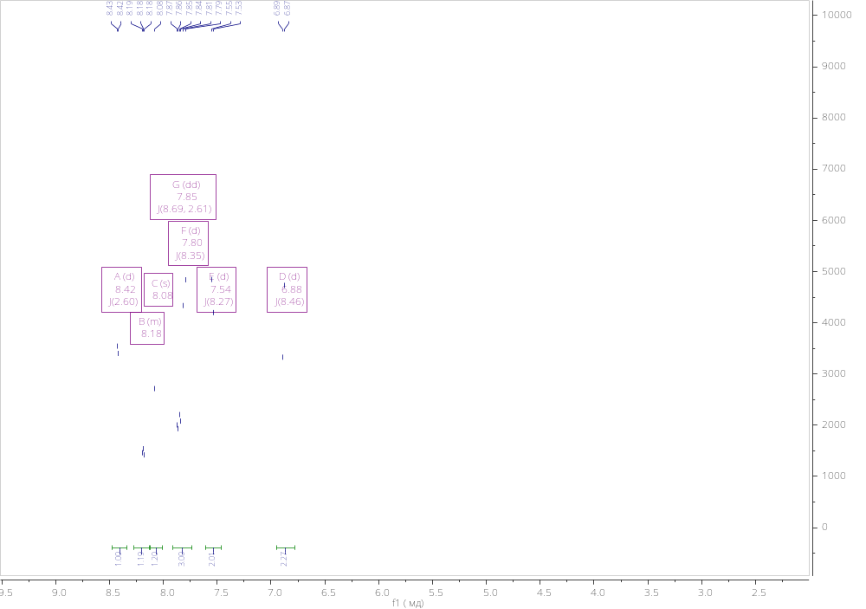
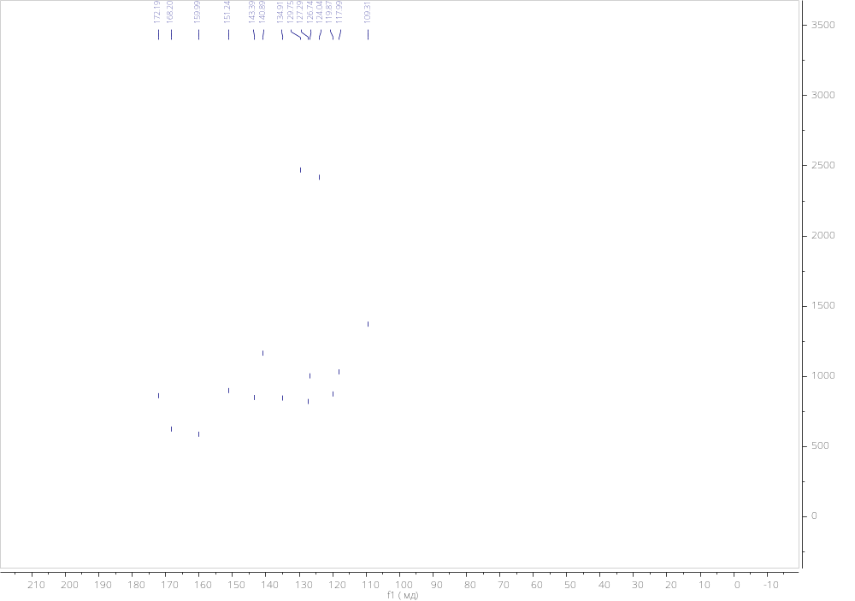
Figure S12. ¹H and ¹³C spectra of compound 8f
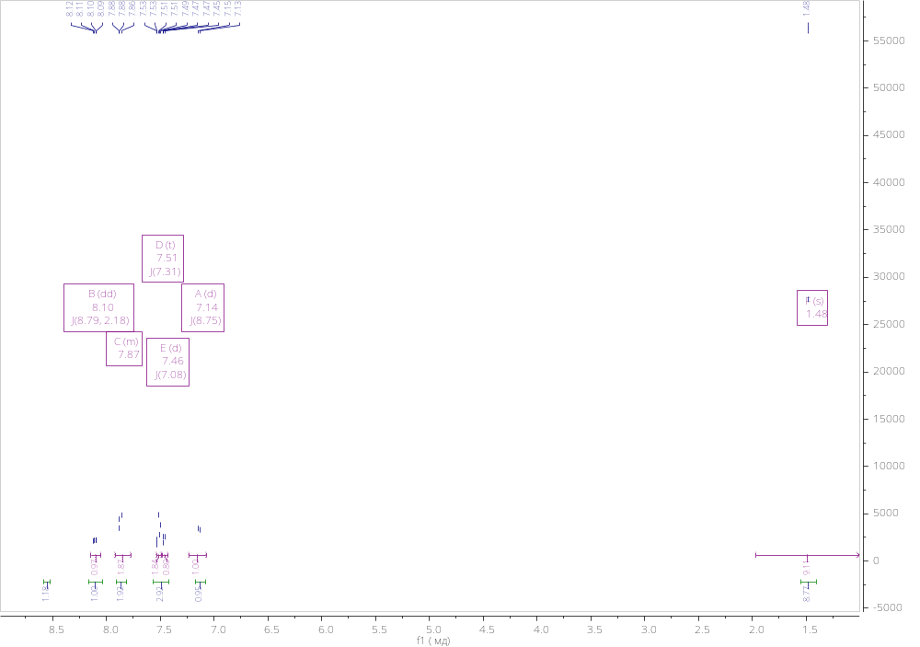
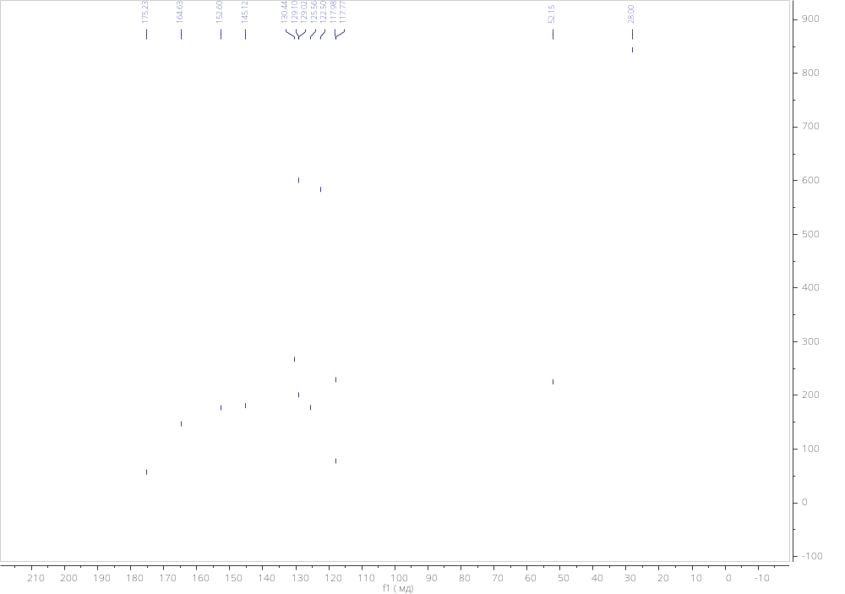
Figure S13. ¹H and ¹³C spectra of compound 7g
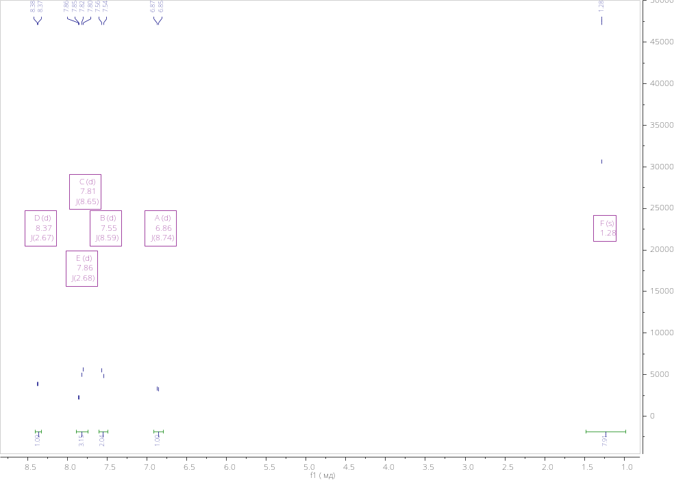
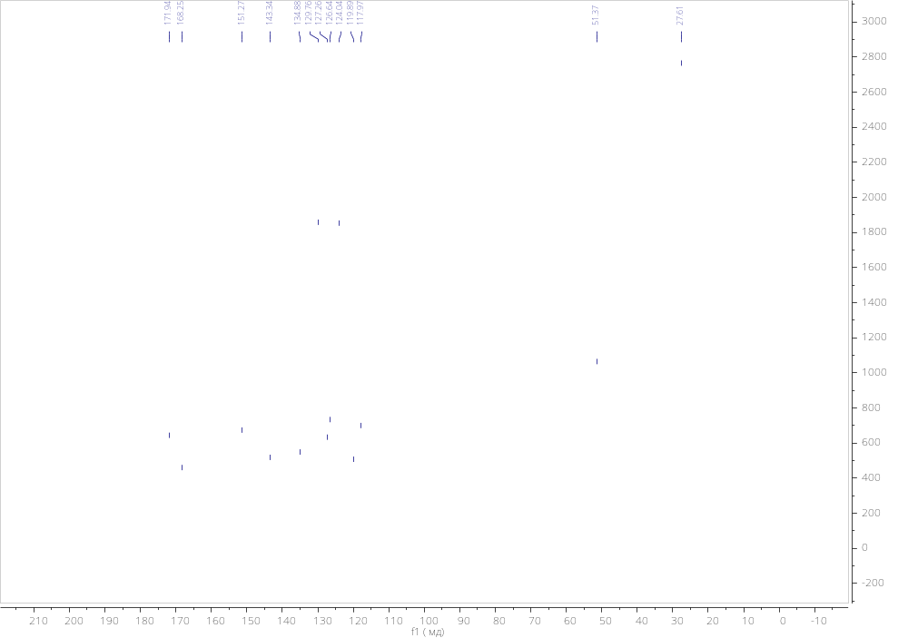
Figure S14. ¹H and ¹³C spectra of compound 8g
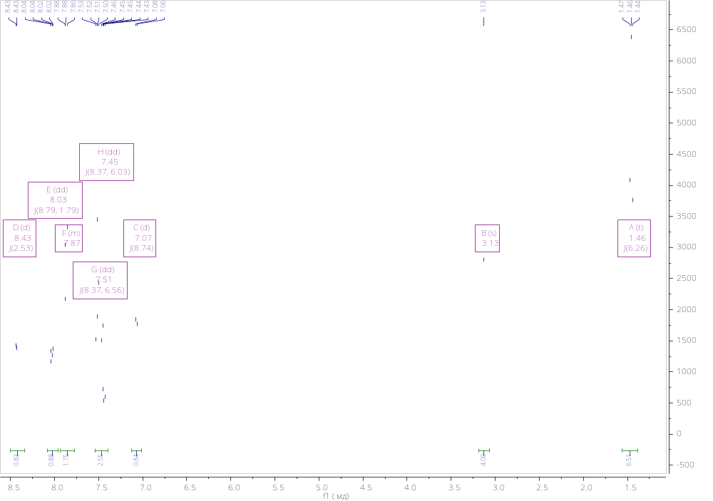
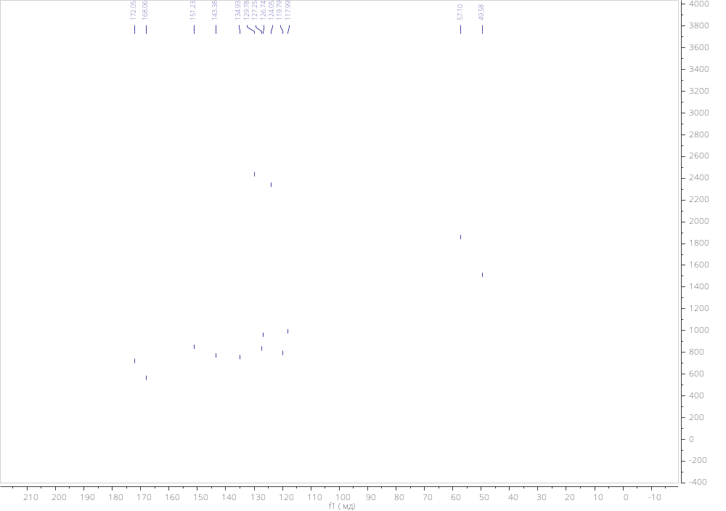
Figure S15. ¹H and ¹³C spectra of compound 7h

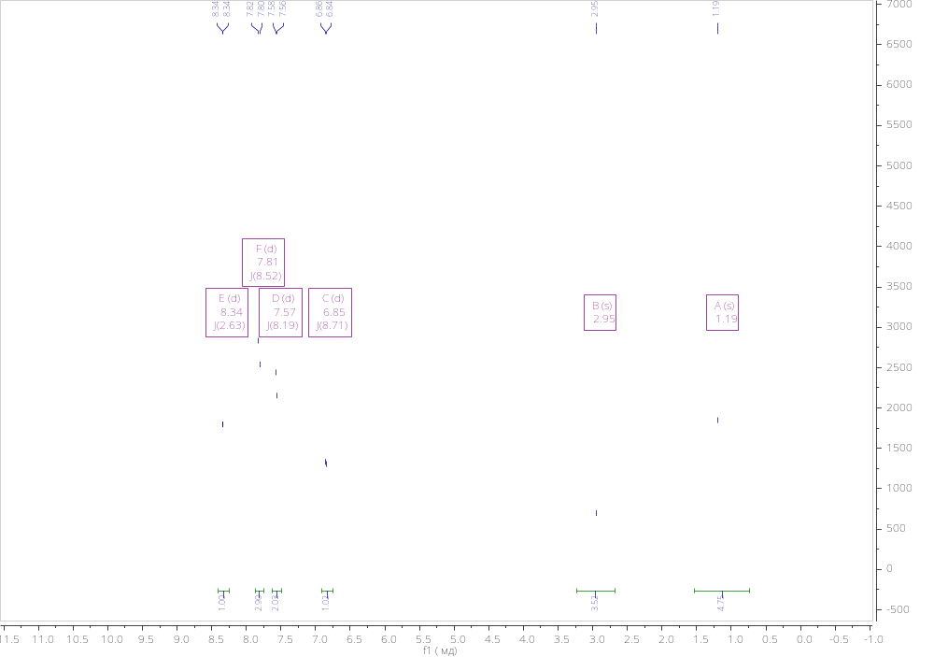
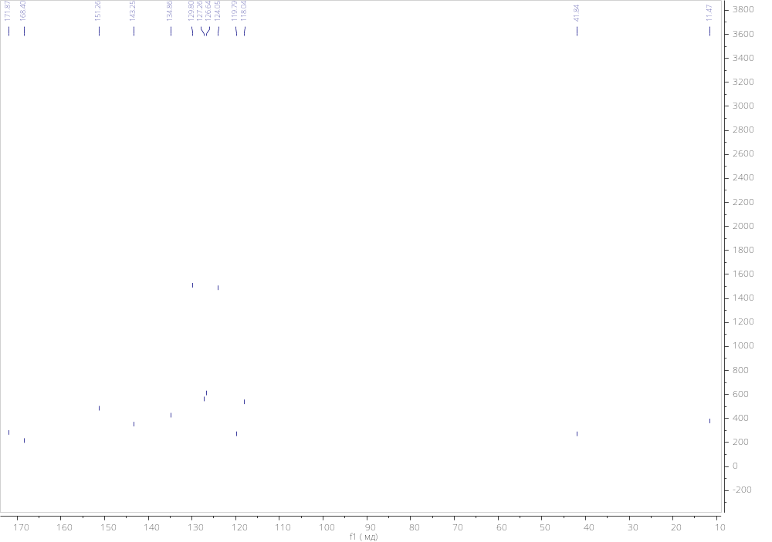
Figure S16. ¹H and ¹³C spectra of compound 8h

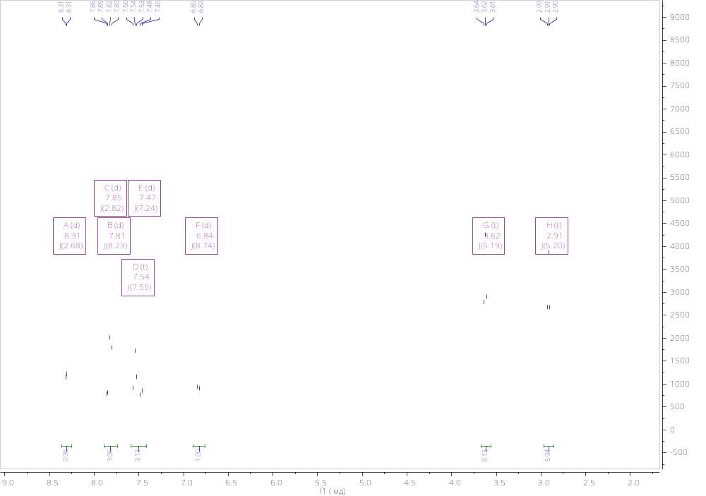
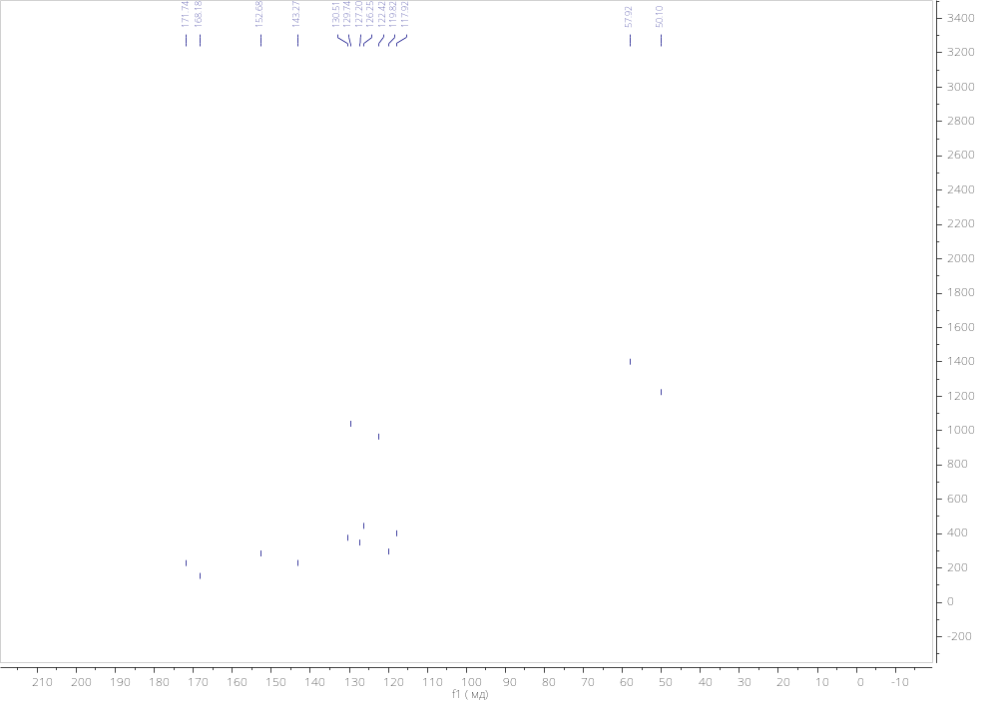
Figure S17. ¹H and ¹³C spectra of compound 7i

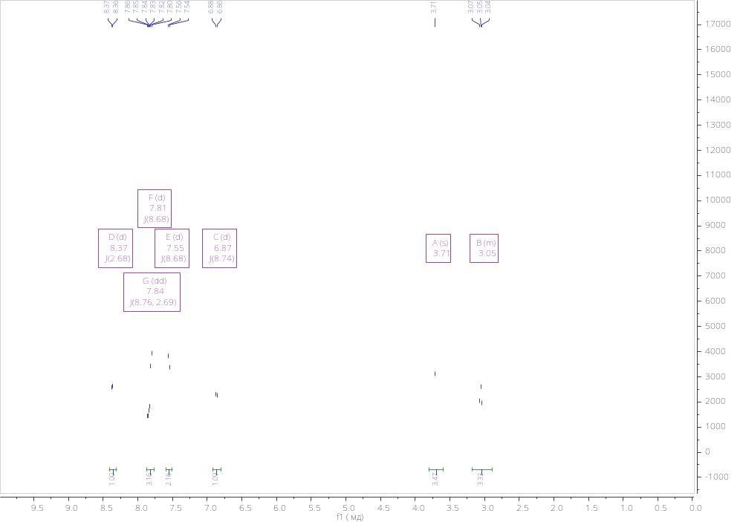
Figure S18. ¹H and ¹³C spectra of compound 8i

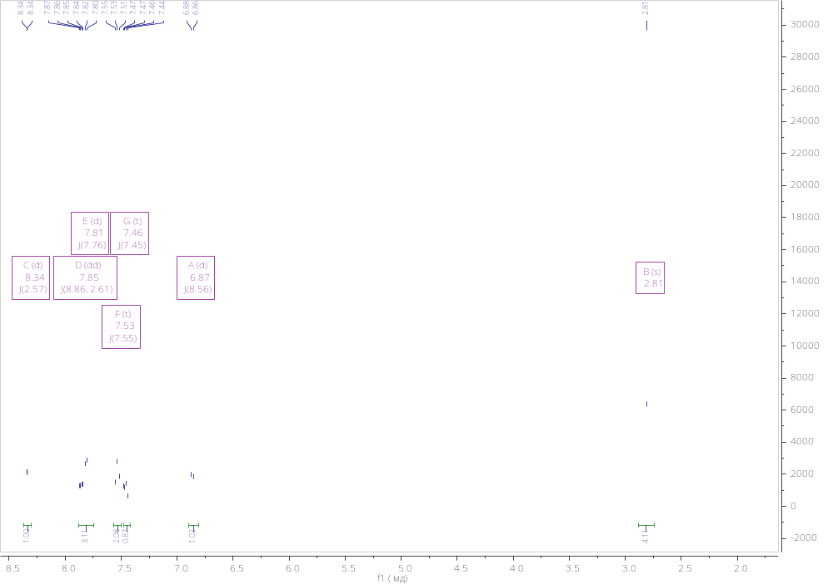
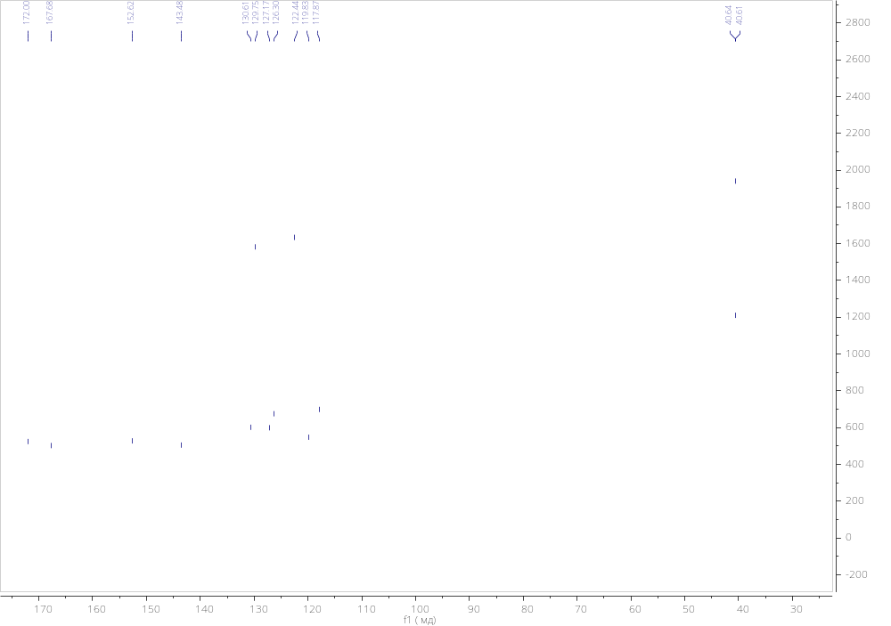
Figure S19. ¹H and ¹³C spectra of compound 7j

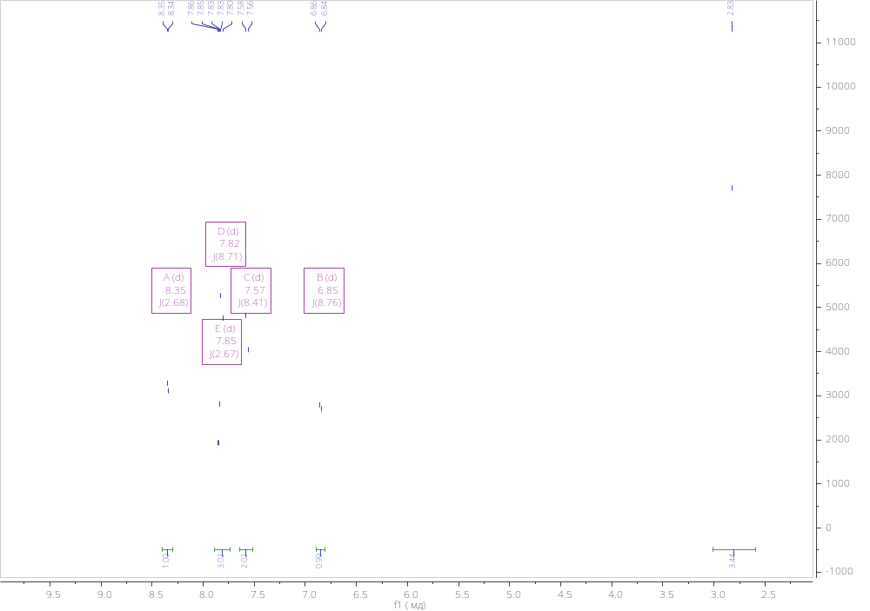
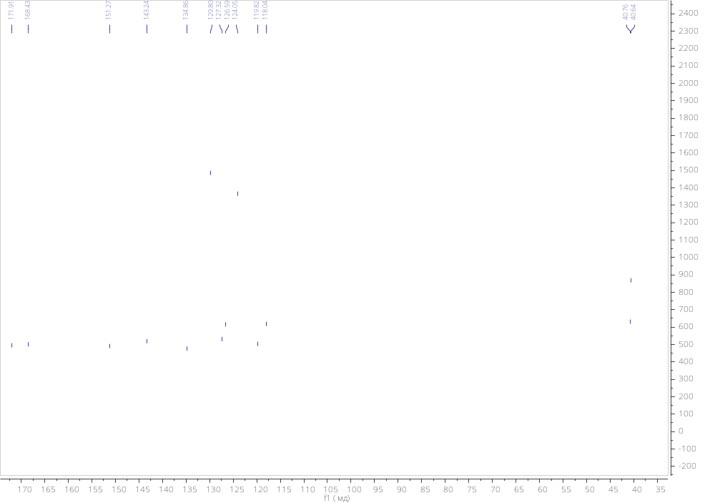
Figure S20. ¹H and ¹³C spectra of compound 8j

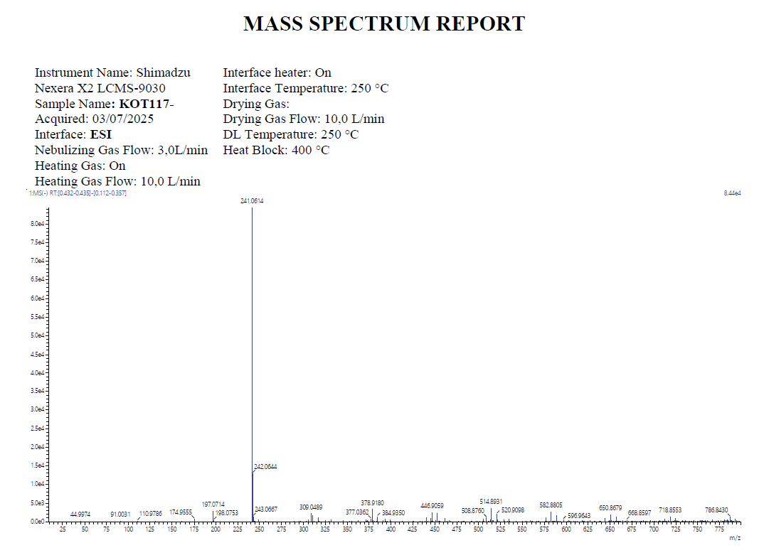
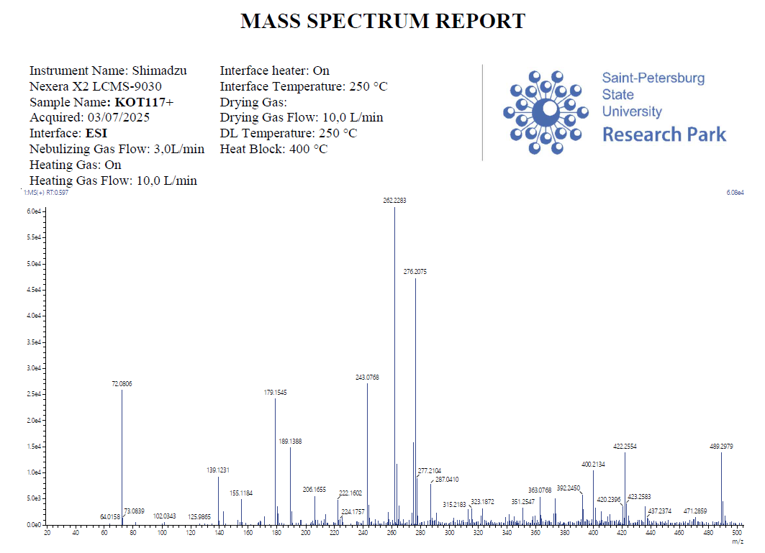
Figure S21. ESI-MS spectra of compound 7a
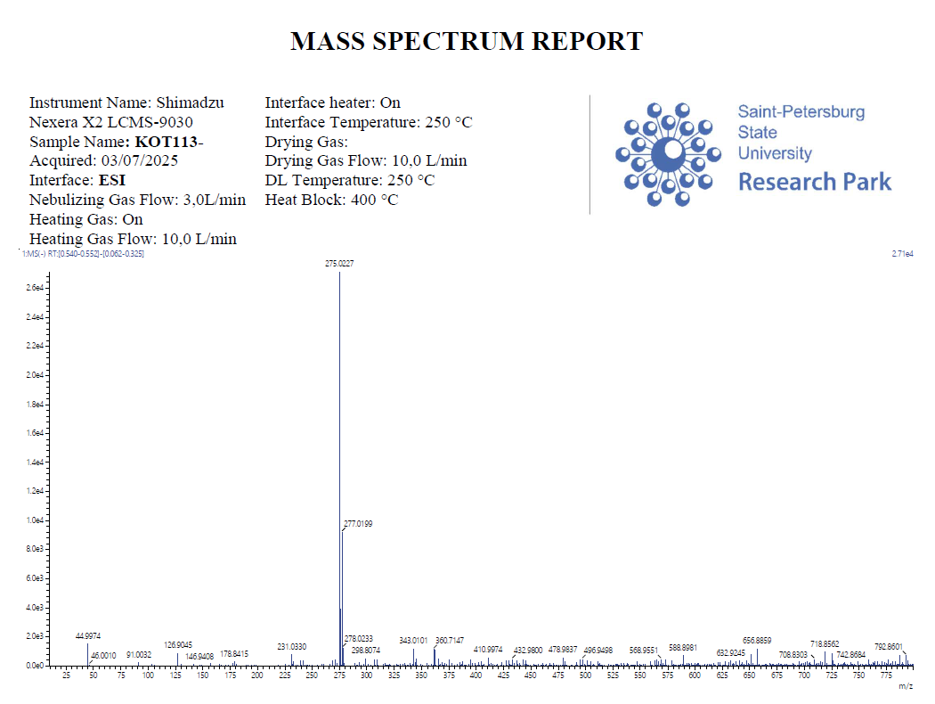
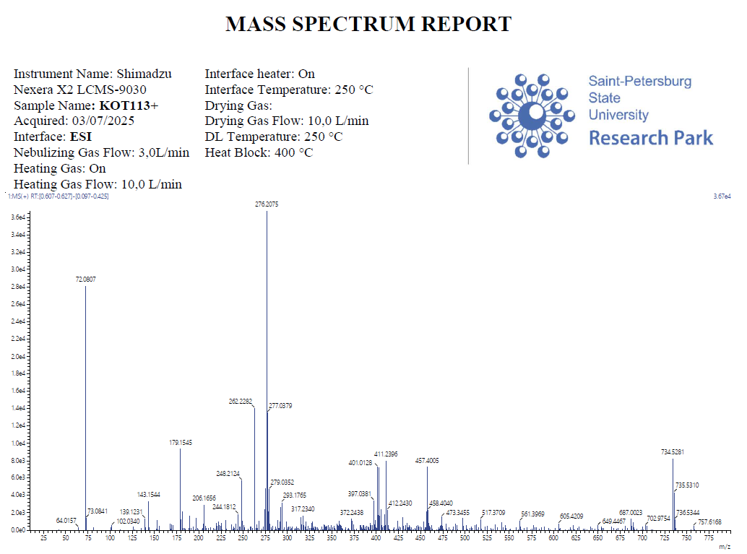
Figure S22. ESI-MS spectra of compound 8a
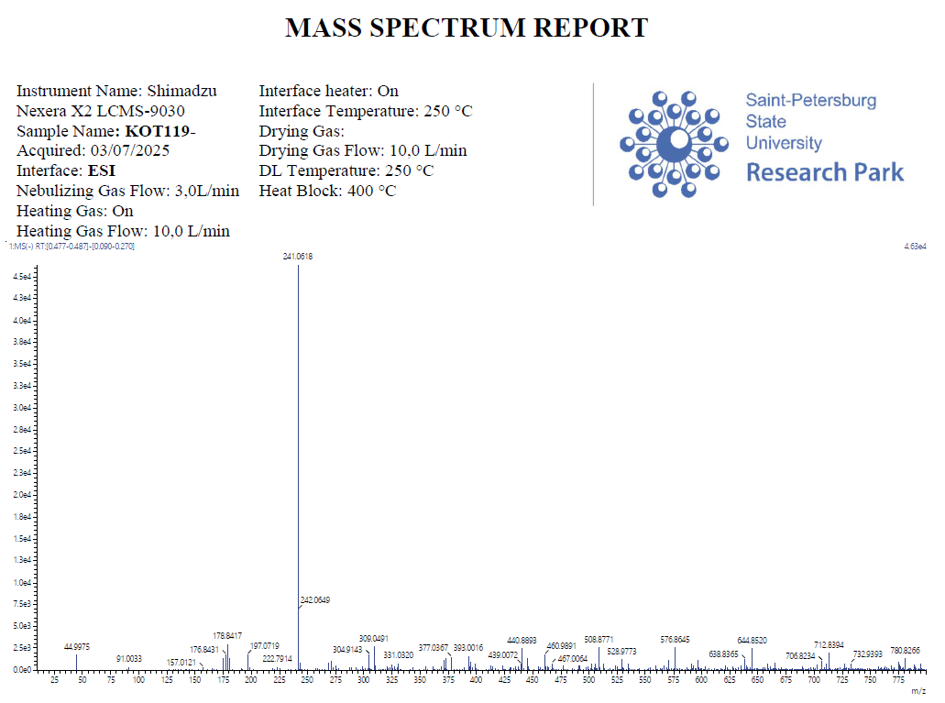
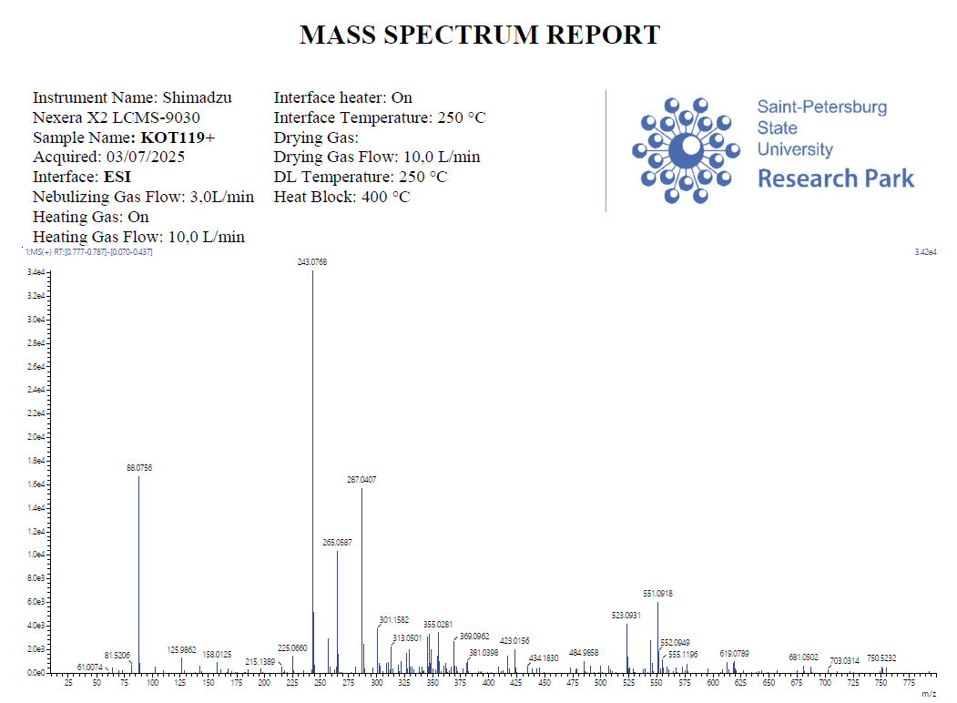
Figure S23. ESI-MS spectra of compound 7b
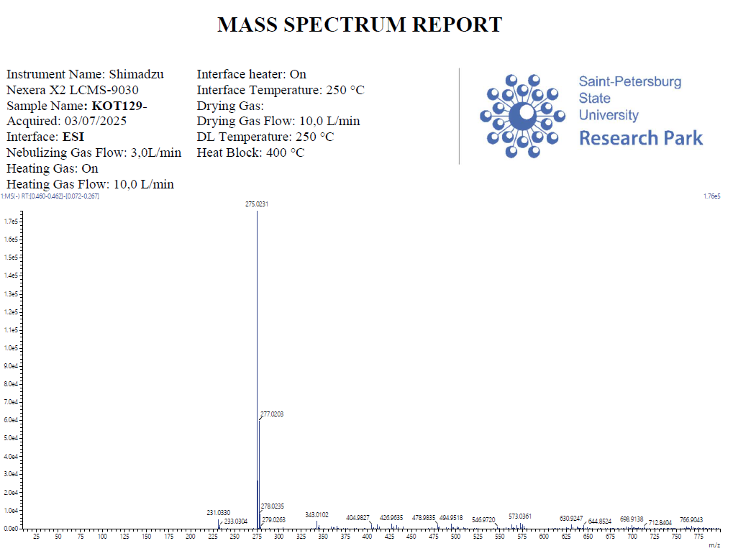
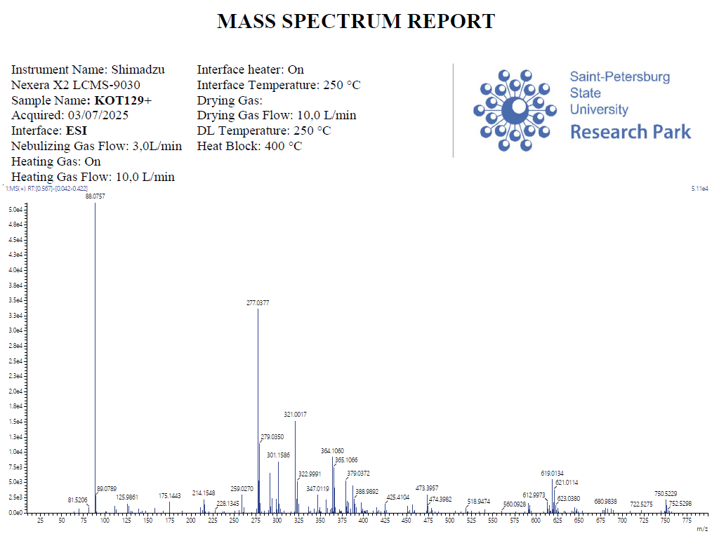
Figure S24. ESI-MS spectra of compound 8b
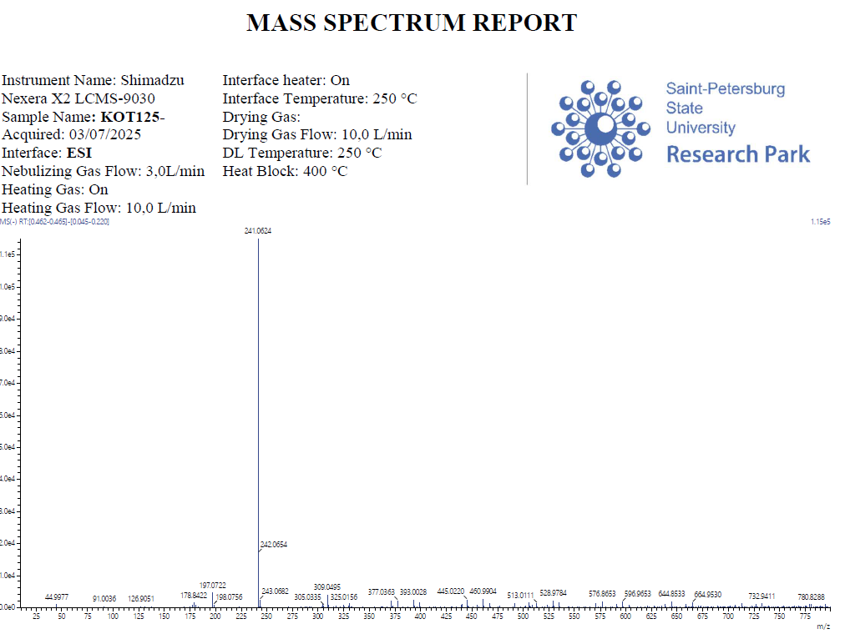
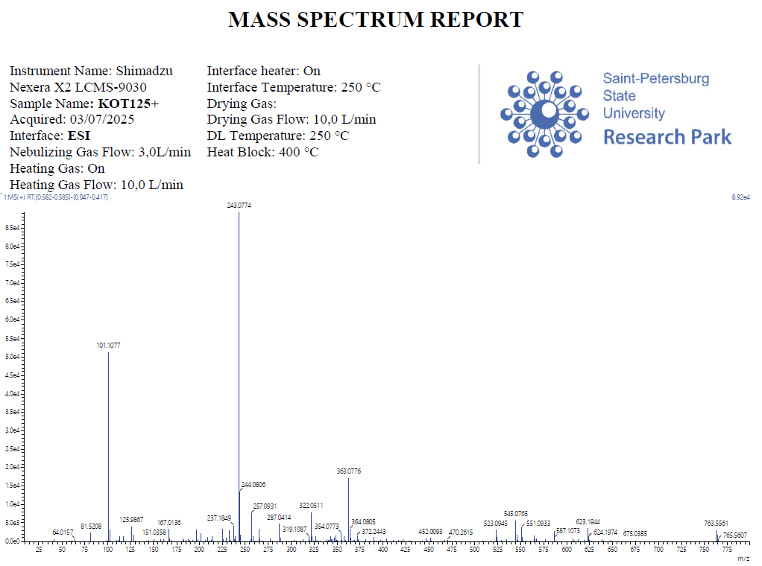
Figure S25. ESI-MS spectra of compound 7c
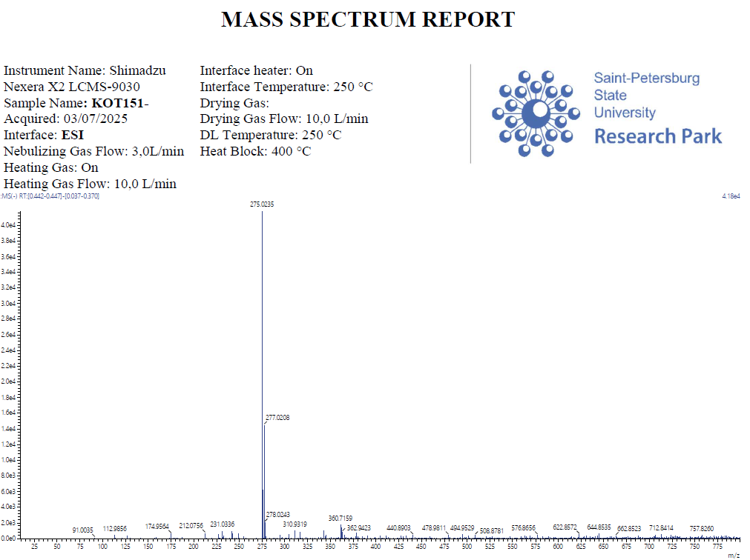
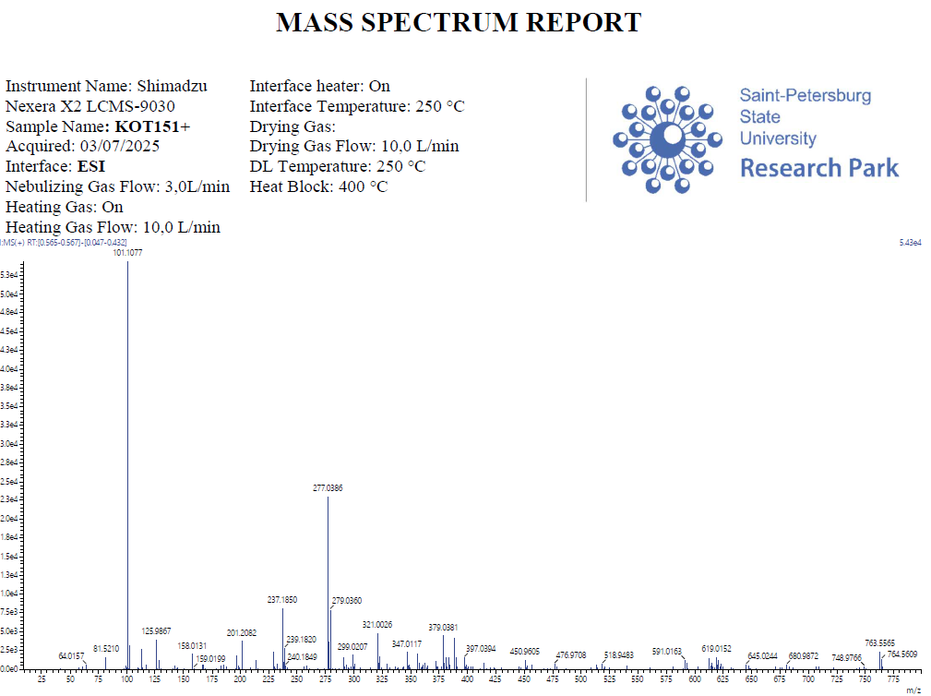
Figure S26. ESI-MS spectra of compound 8c
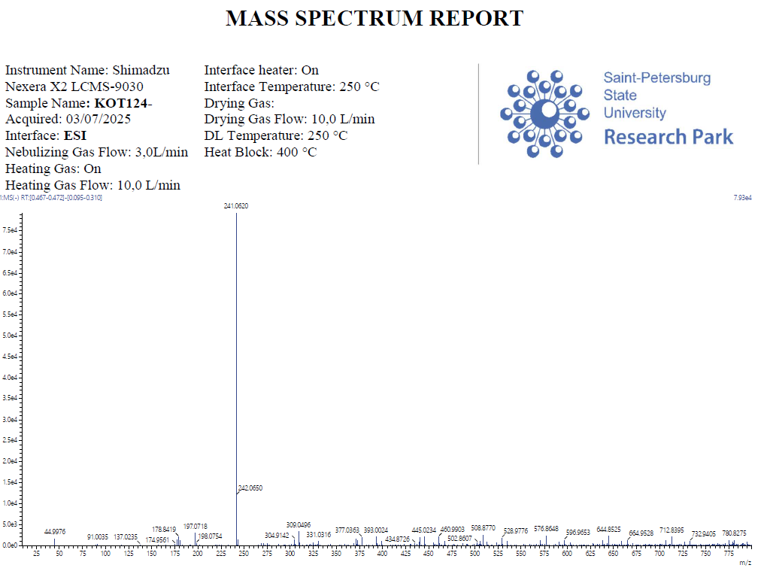
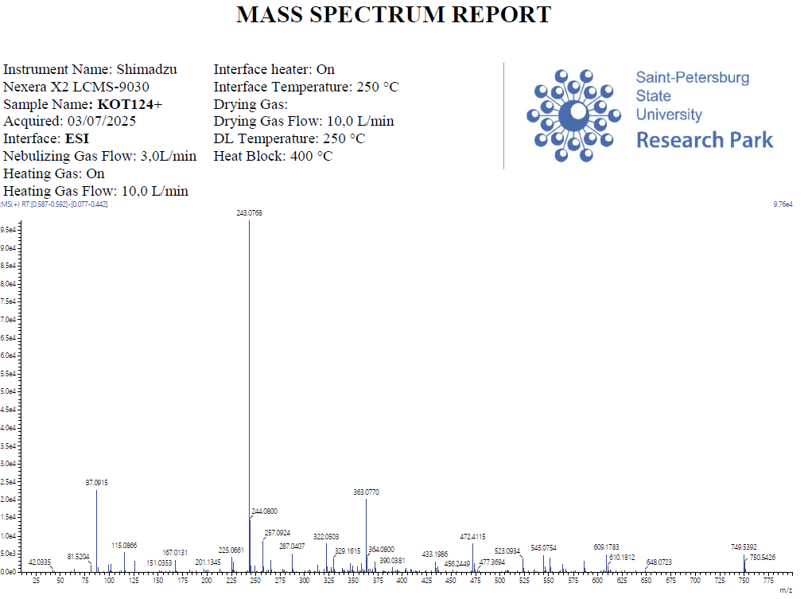
Figure S27. ESI-MS spectra of compound 7d
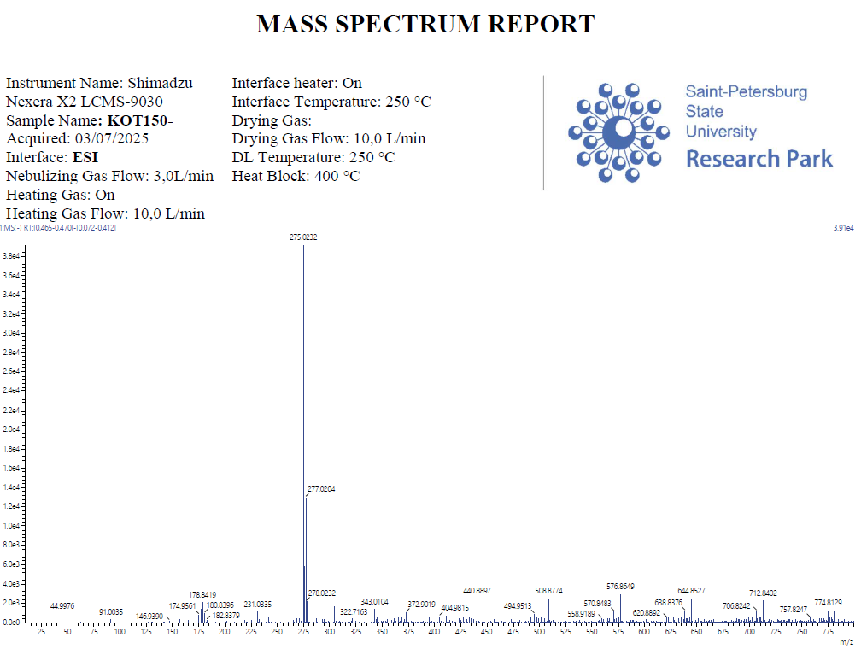
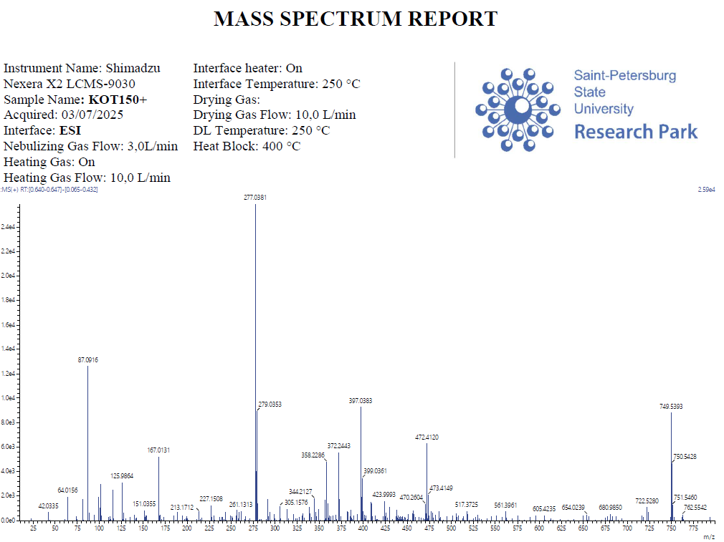
Figure S28. ESI-MS spectra of compound 8d
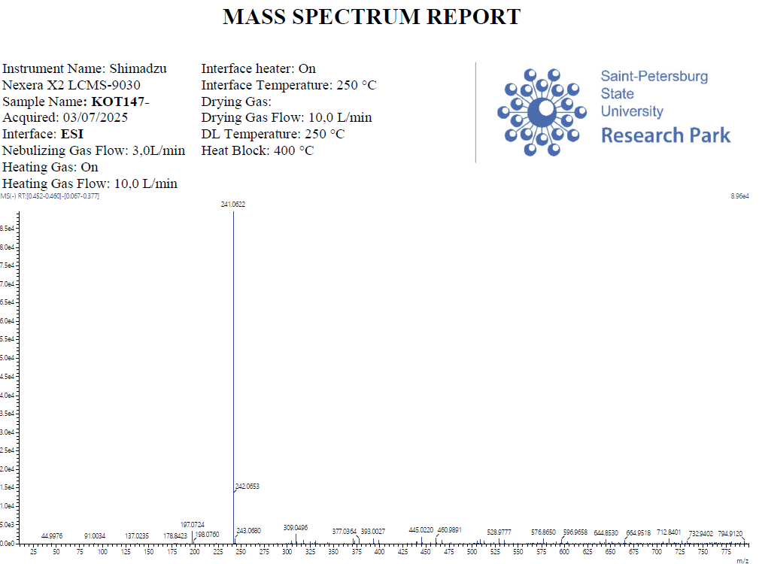
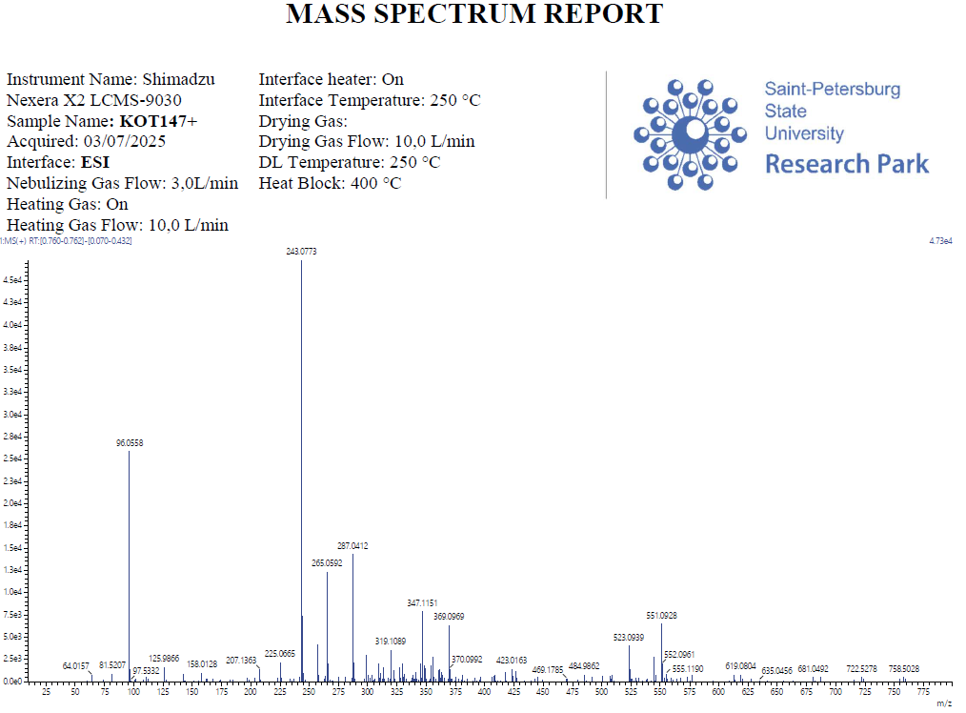
Figure S29. ESI-MS spectra of compound 7e
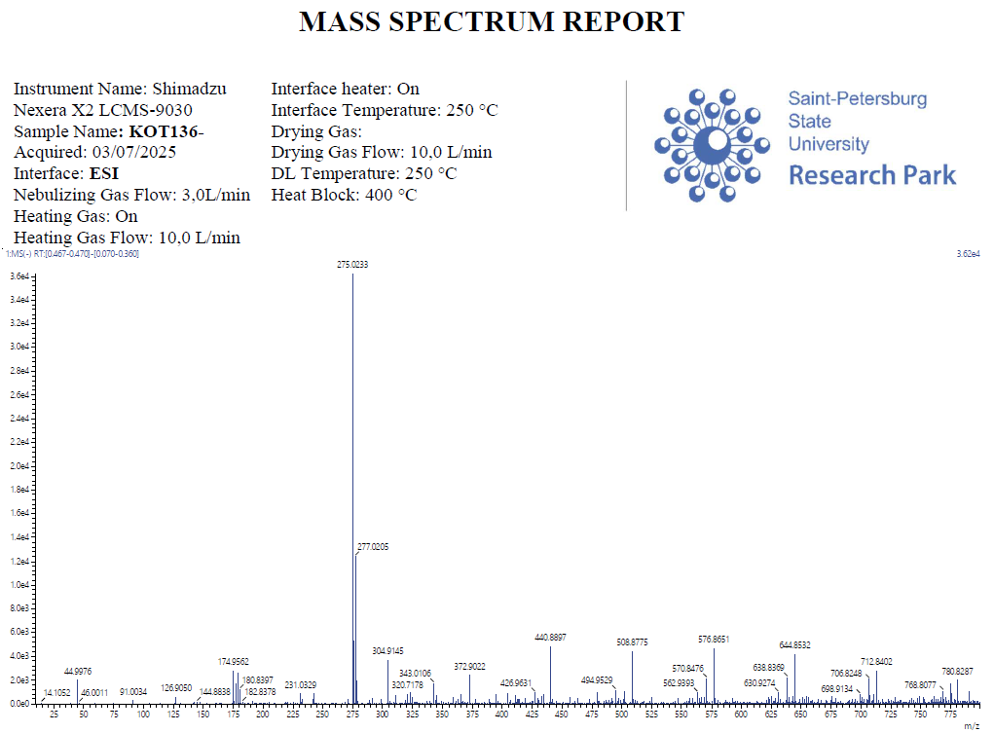
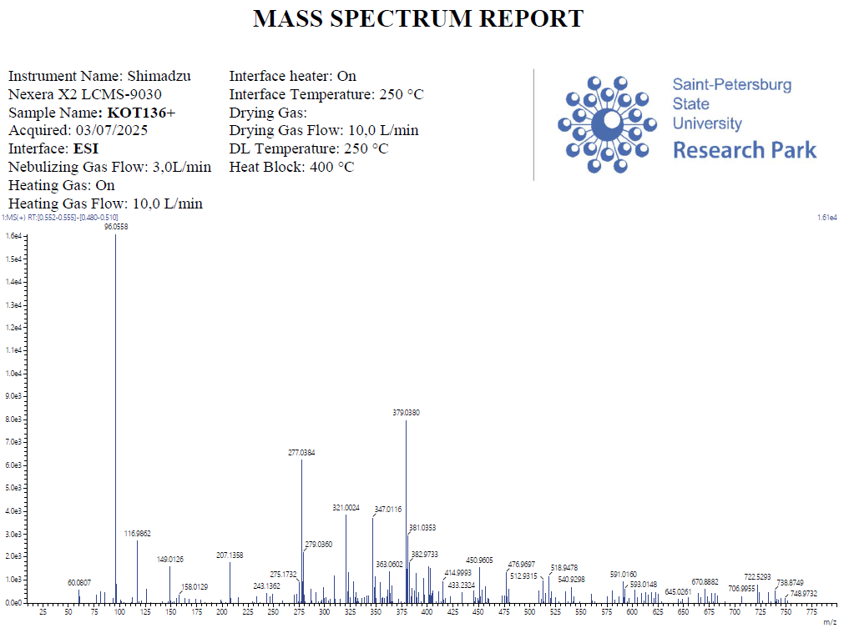
Figure S30. ESI-MS spectra of compound 8e
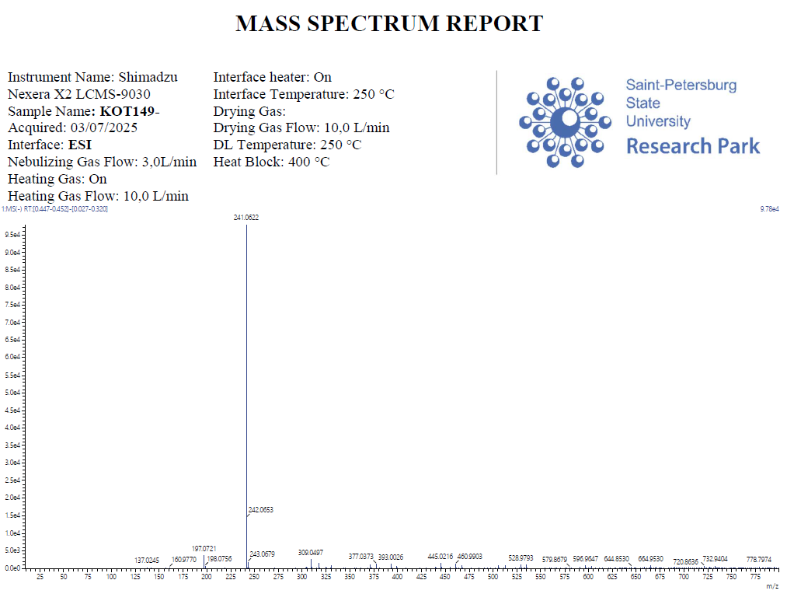
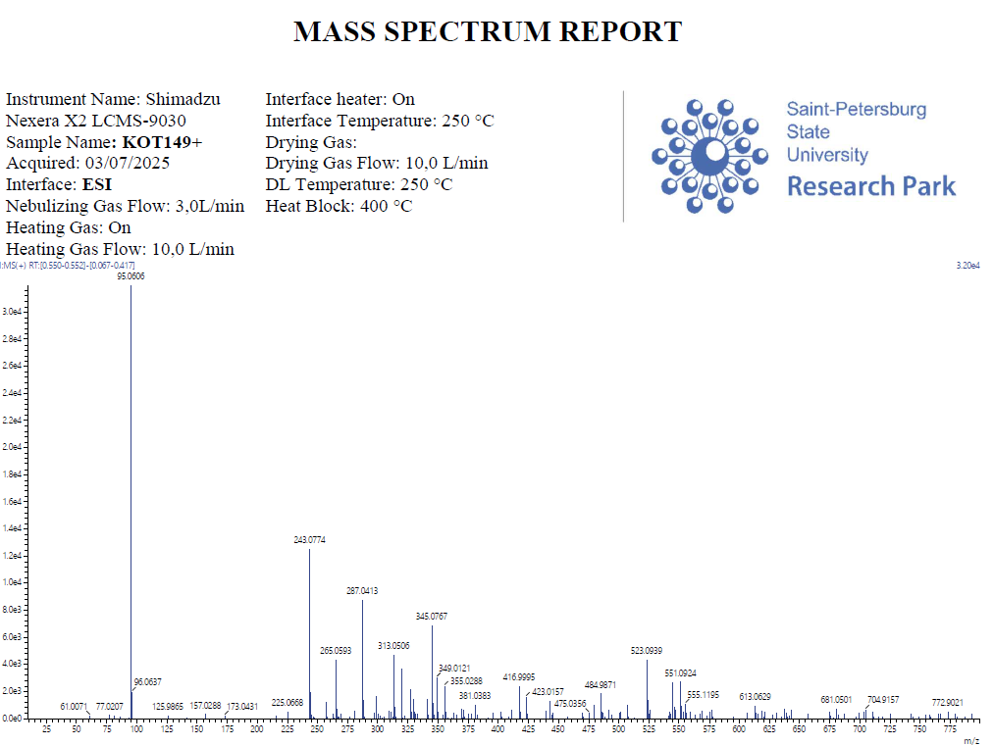
Figure S31. ESI-MS spectra of compound 7f
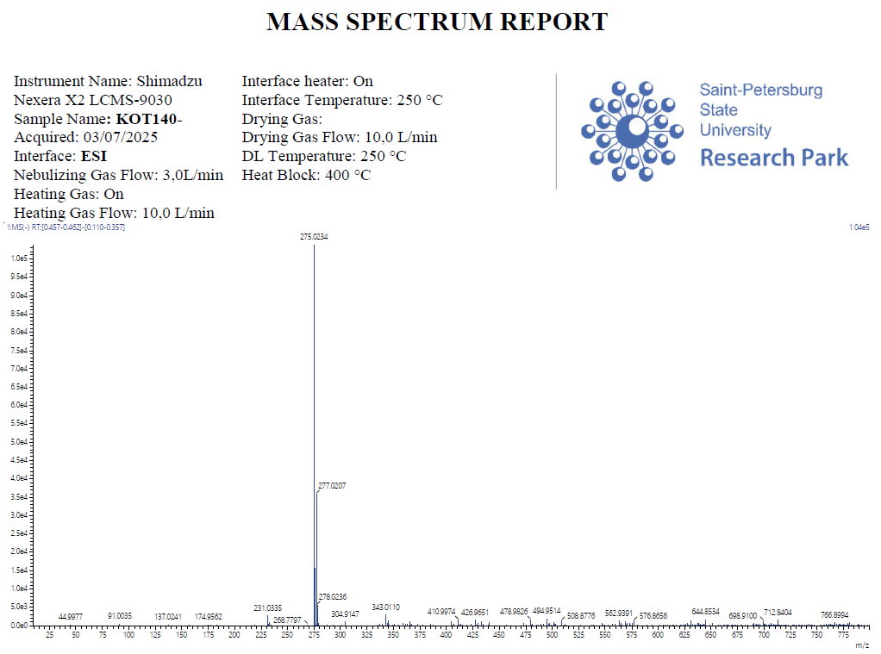
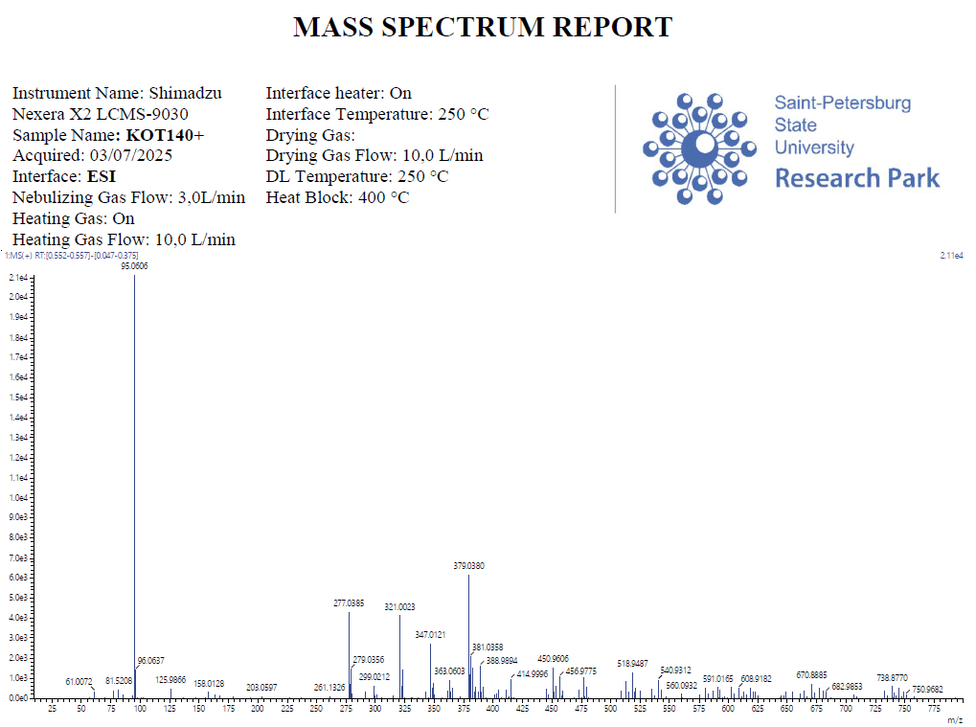
Figure S32. ESI-MS spectra of compound 8f
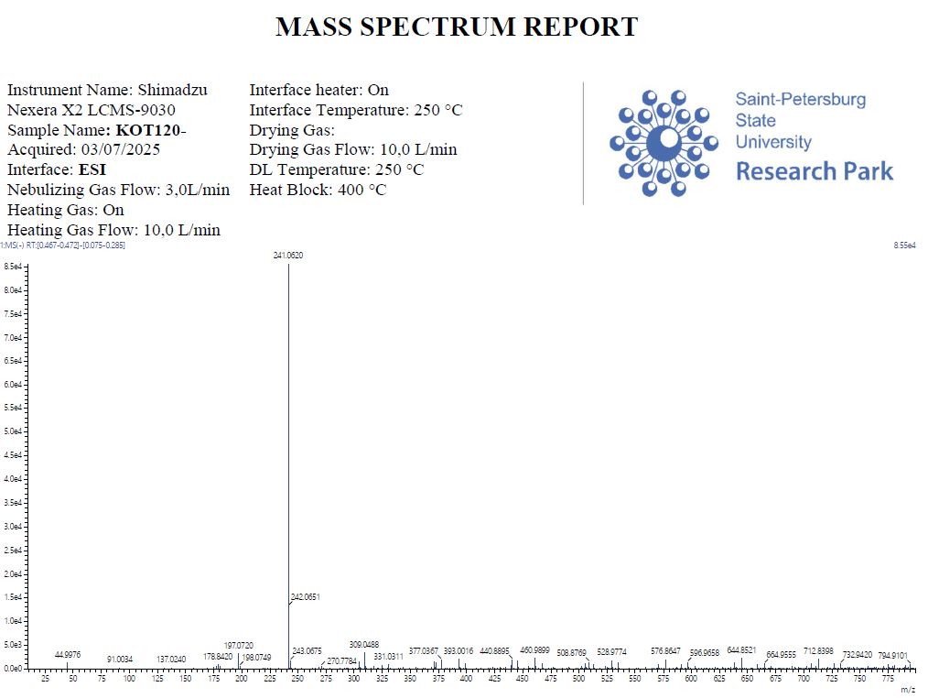
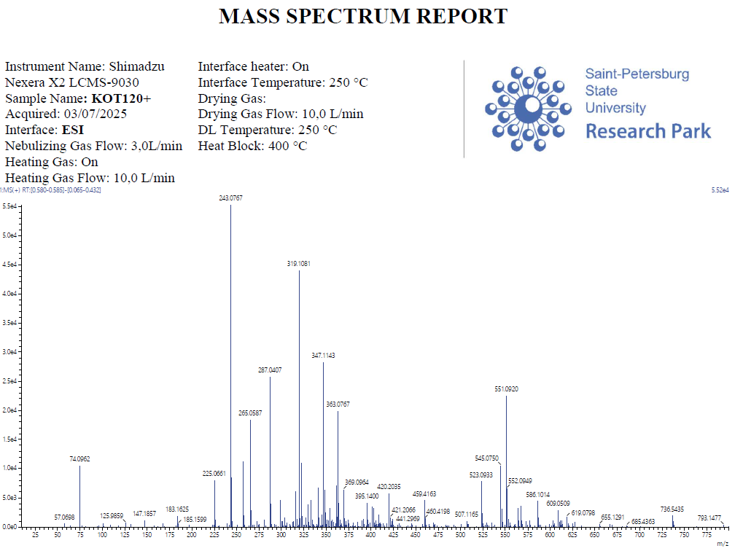
Figure S33. ESI-MS spectra of compound 7g
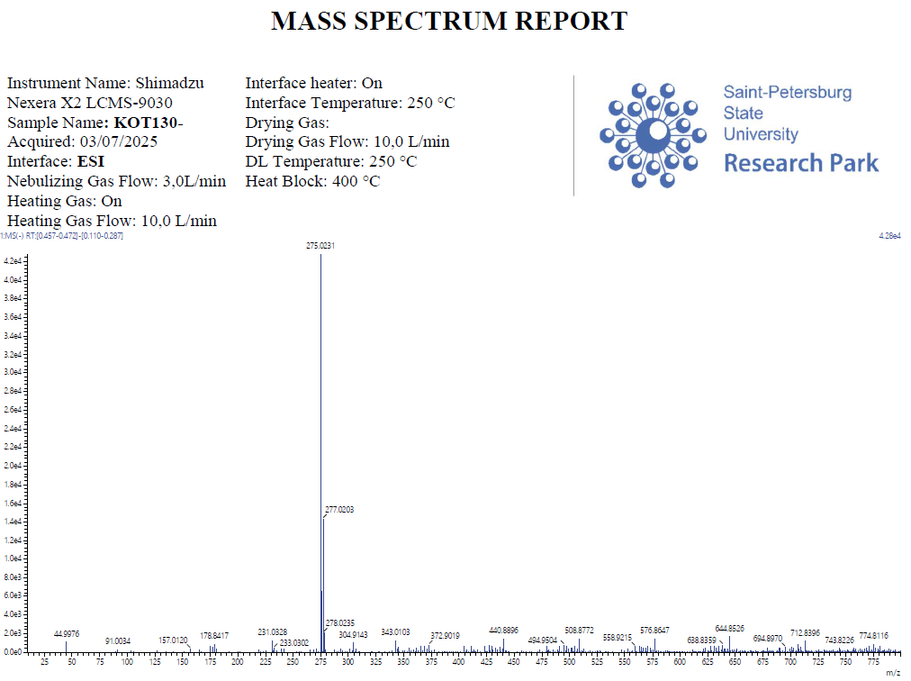
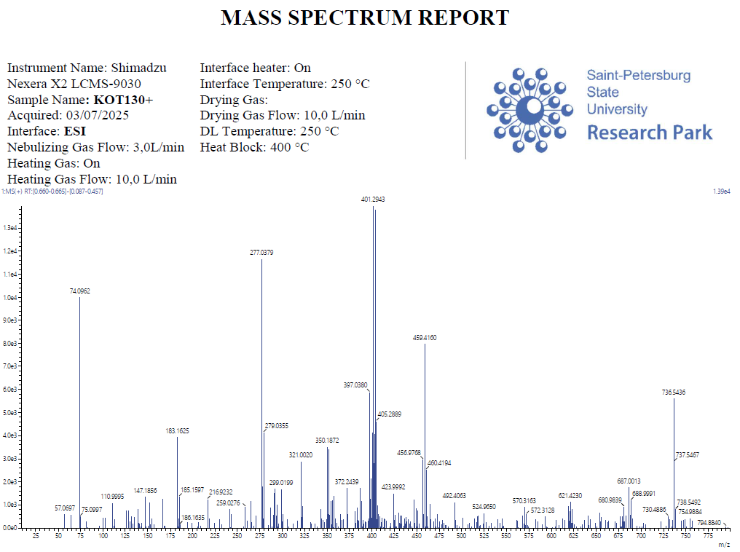
Figure S34. ESI-MS spectra of compound 8g
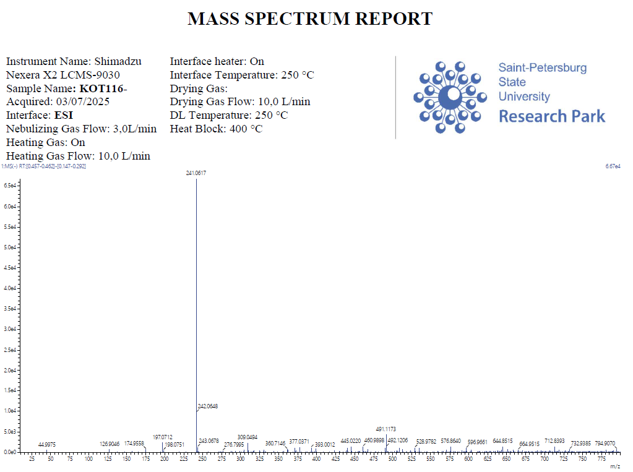
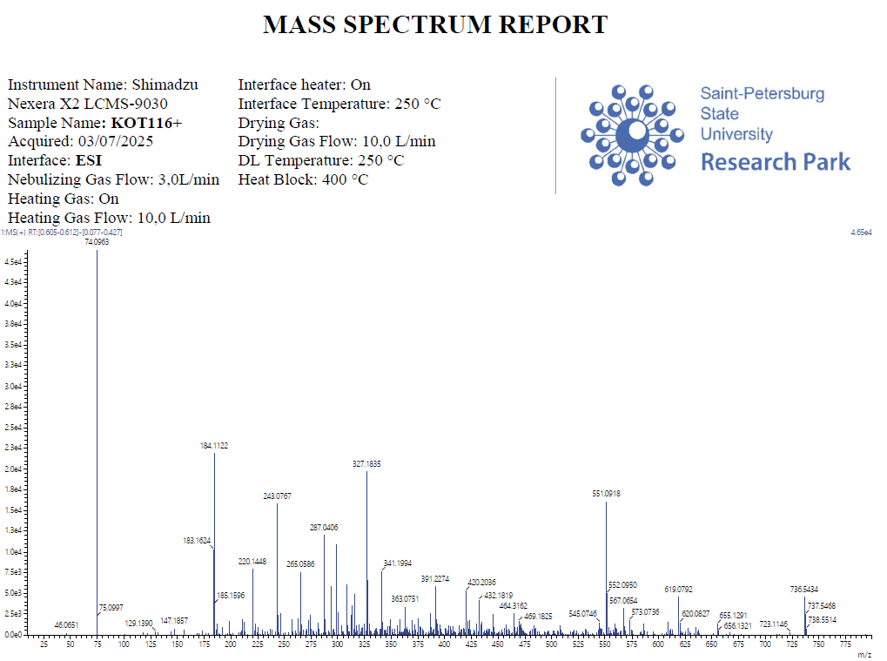
Figure S35. ESI-MS spectra of compound 7h
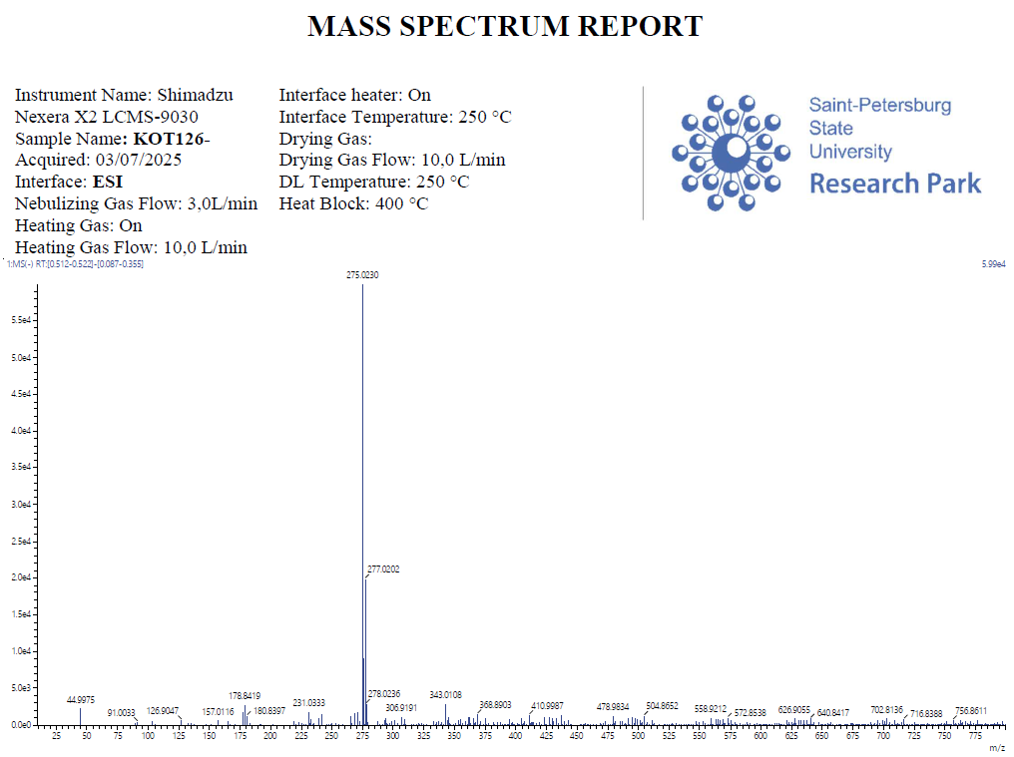
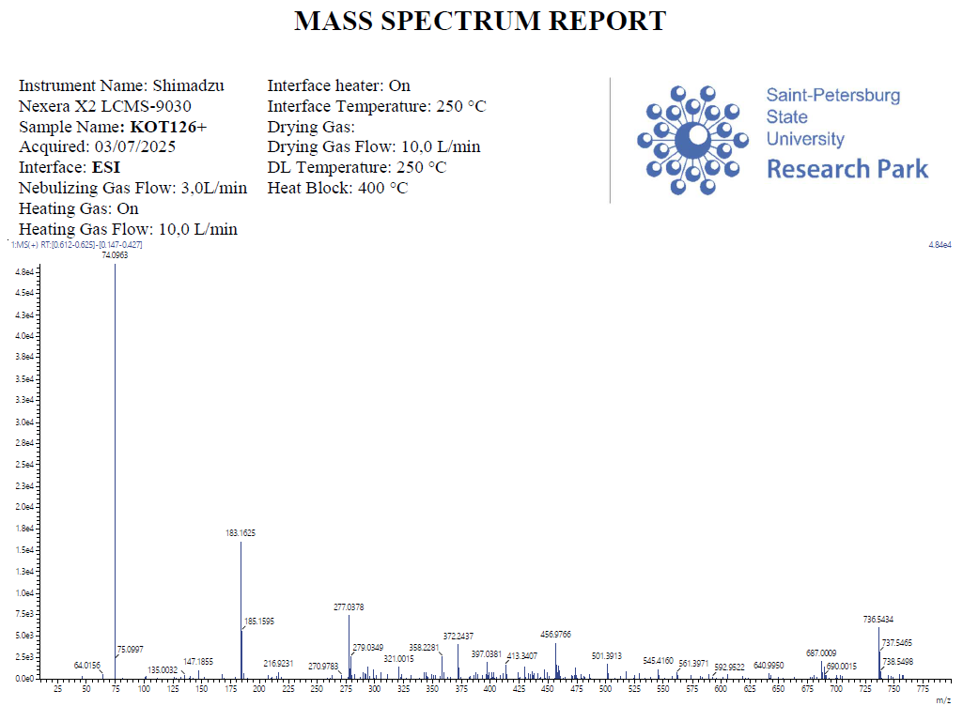
Figure S36. ESI-MS spectra of compound 8h
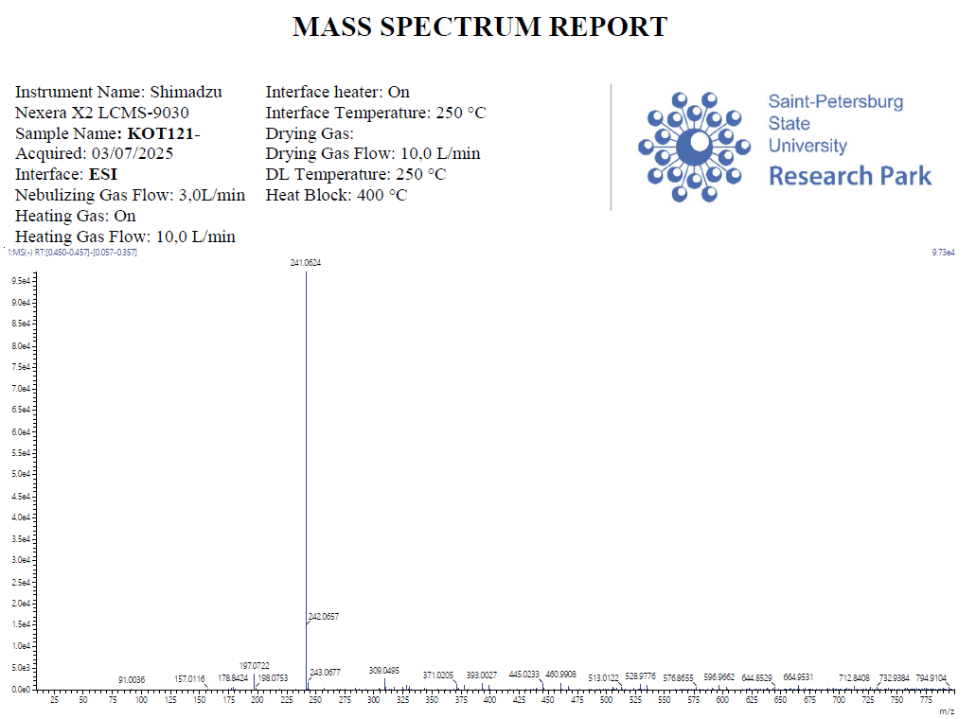
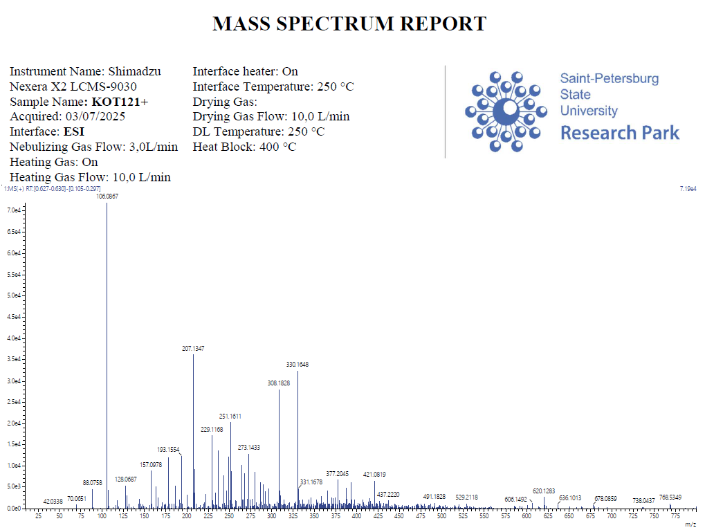
Figure S37. ESI-MS spectra of compound 7i
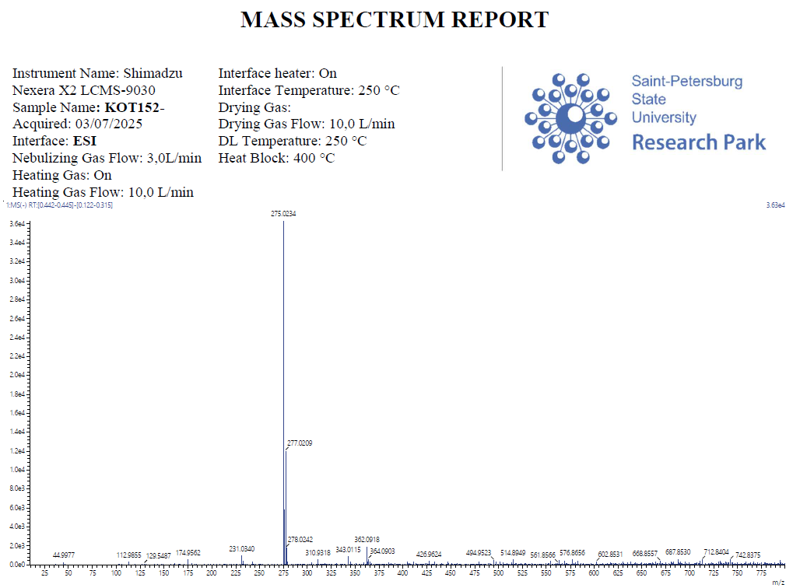
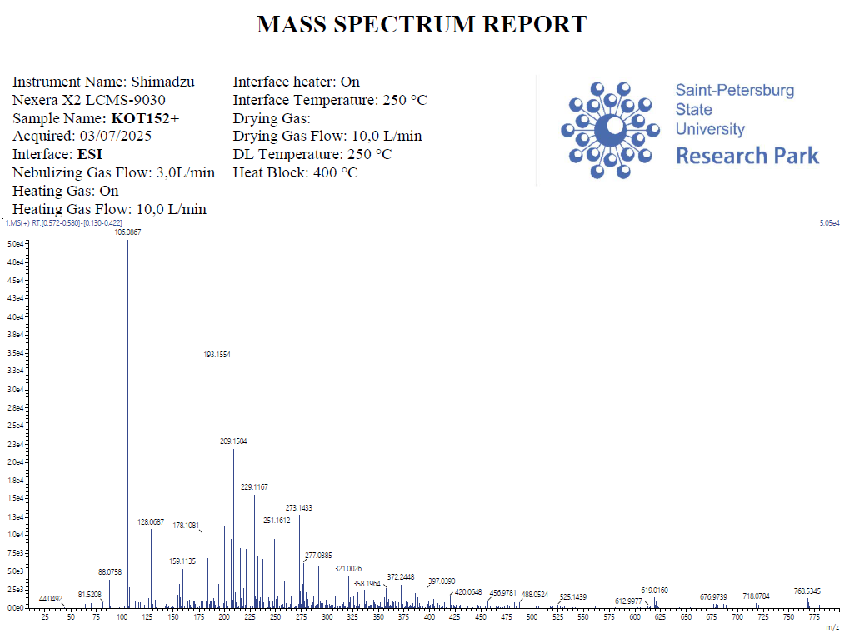
Figure S38. ESI-MS spectra of compound 8i
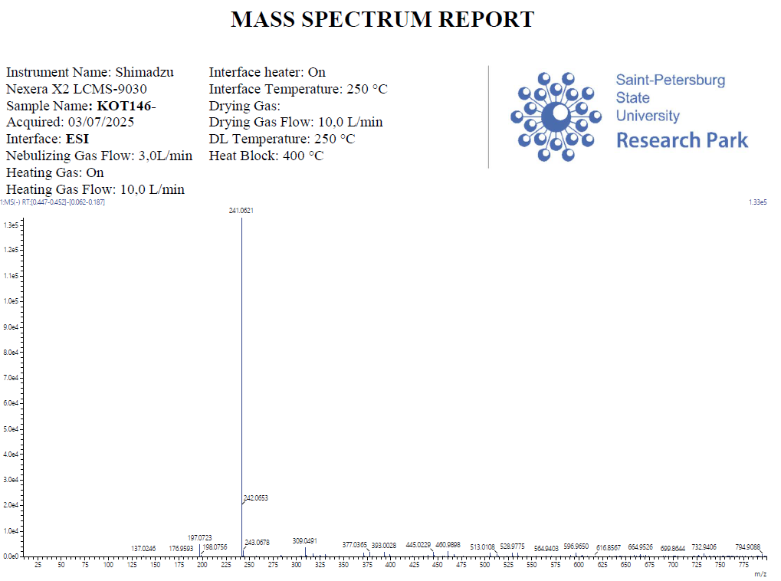
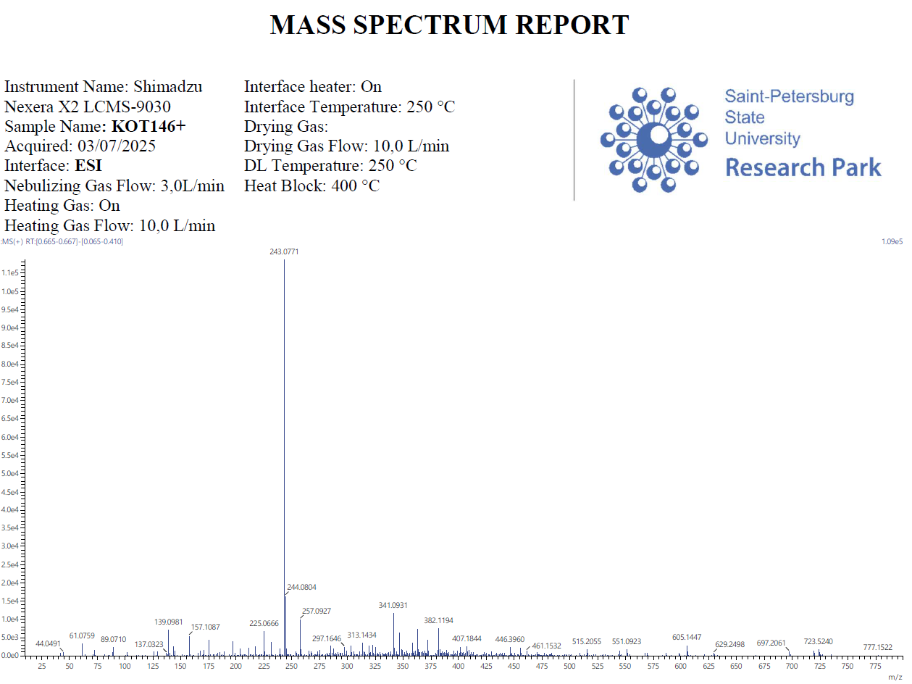
Figure S39. ESI-MS spectra of compound 7j
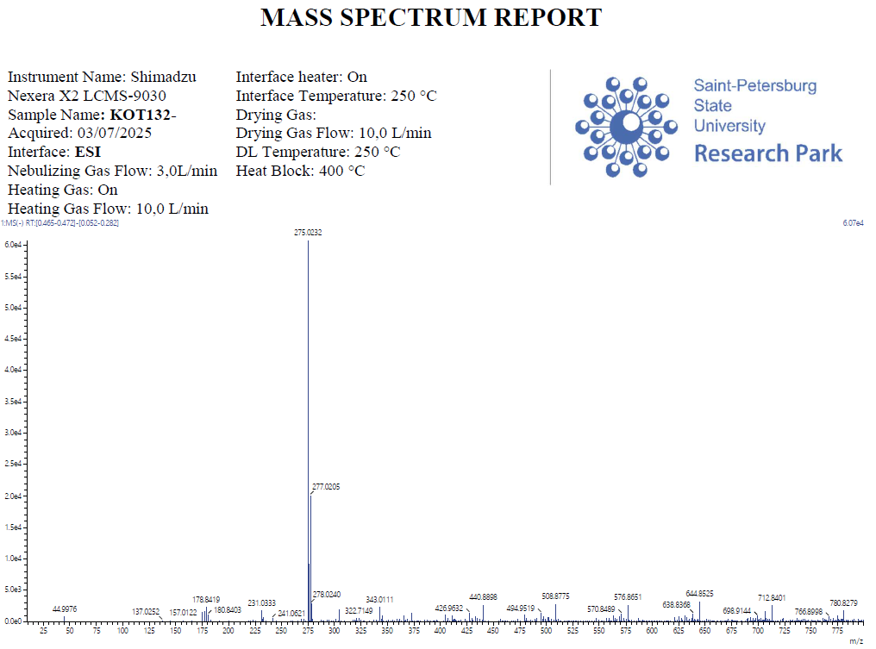
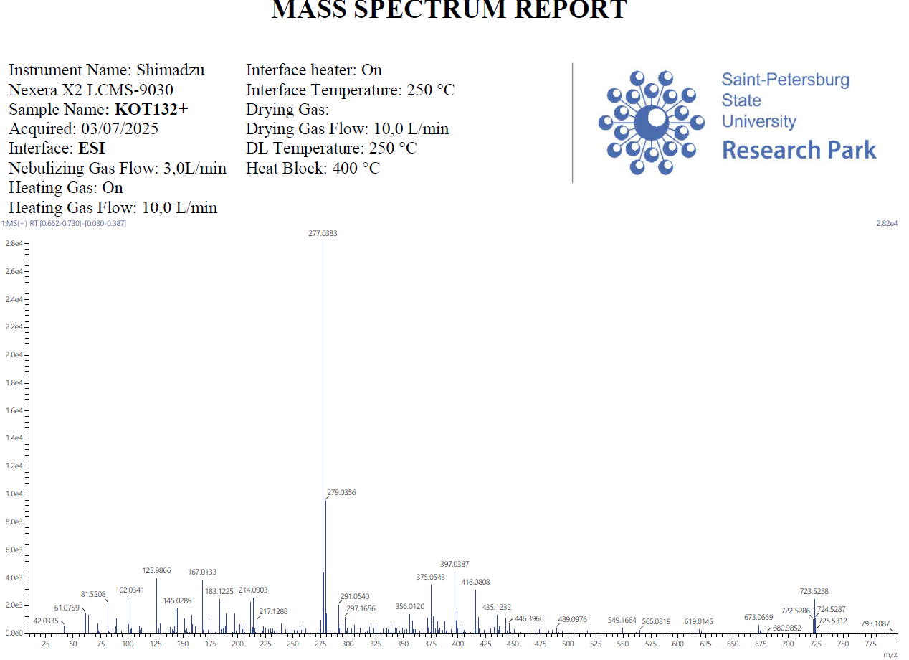
Figure S40. ESI-MS spectra of compound 8j
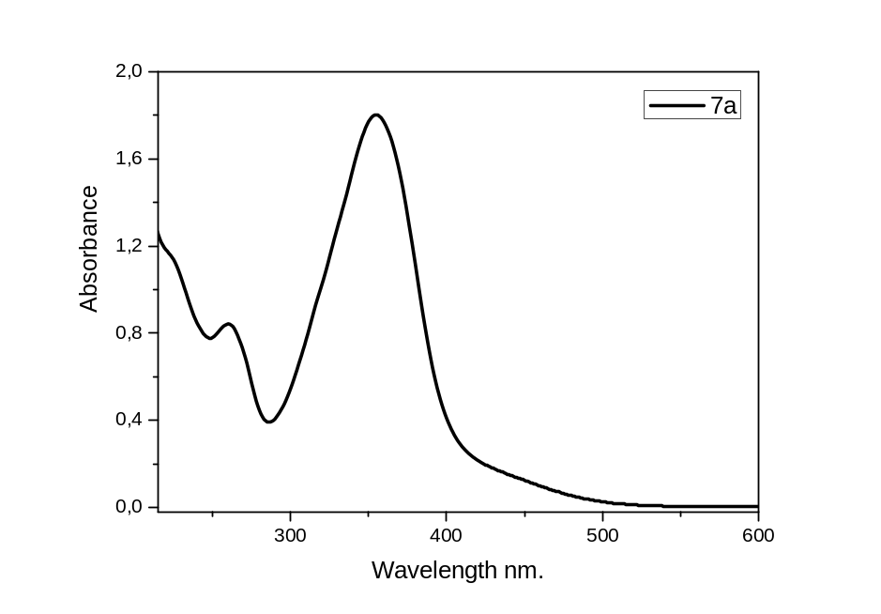
Figure S41. UV-Vis spectra of compound 7a in IPS, concentration 10⁻⁴ M
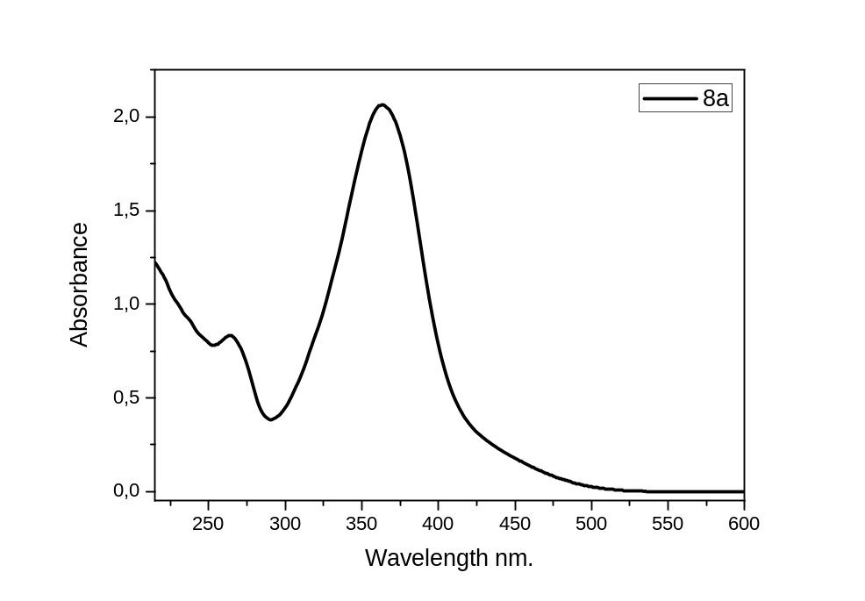
Figure S42. UV-Vis spectra of compound 8a in IPS, concentration 10⁻⁴ M
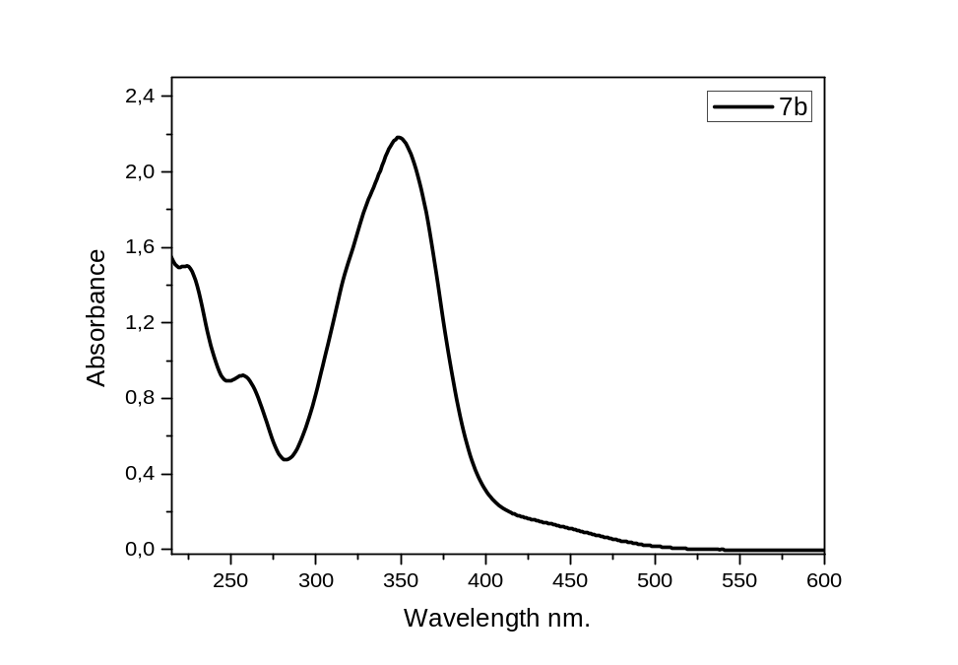
Figure S43. UV-Vis spectra of compound 7b in IPS, concentration 10⁻⁴ M
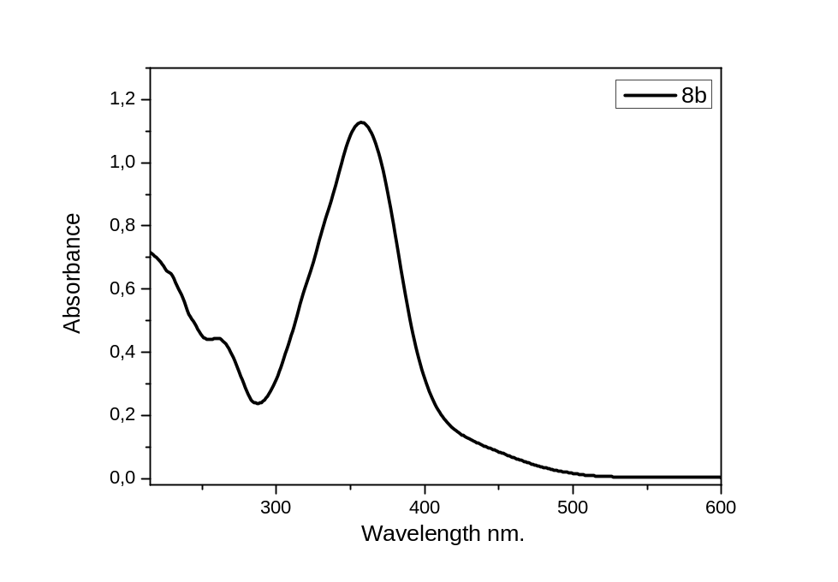
Figure S44. UV-Vis spectra of compound 8b in IPS, concentration 10⁻⁴ M
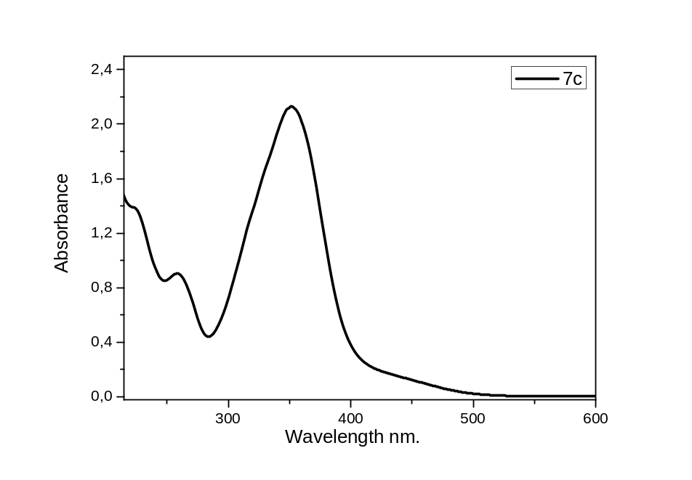
Figure S45. UV-Vis spectra of compound 7c in IPS, concentration 10⁻⁴ M
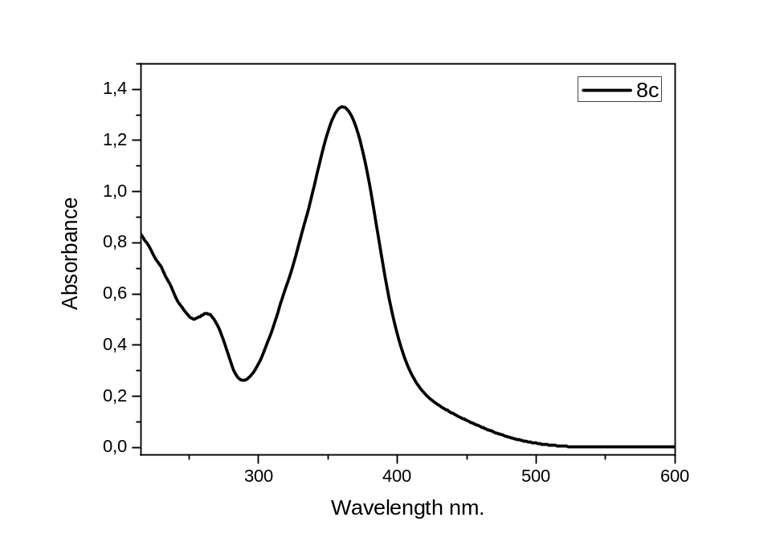
Figure S46. UV-Vis spectra of compound 8c in IPS, concentration 10⁻⁴ M
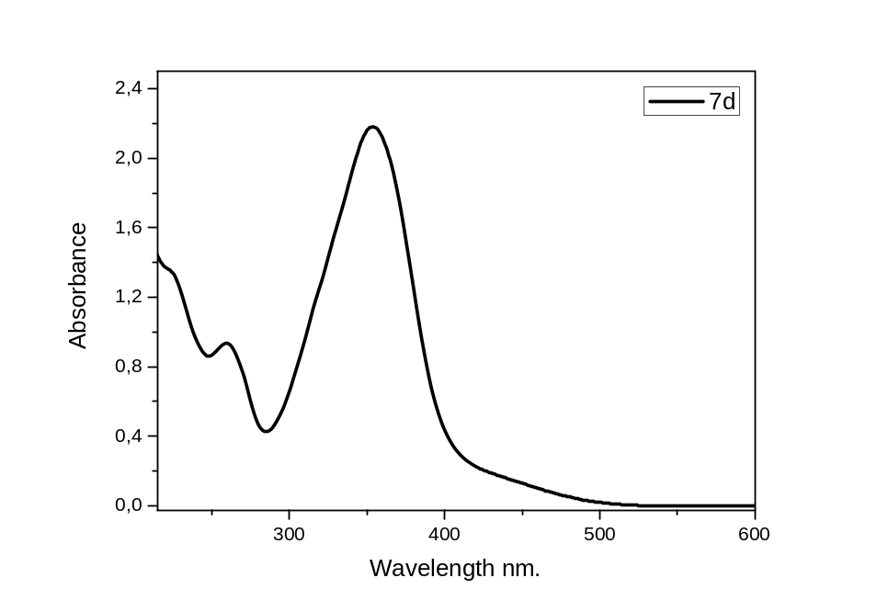
Figure S47. UV-Vis spectra of compound 7d in IPS, concentration 10⁻⁴ M
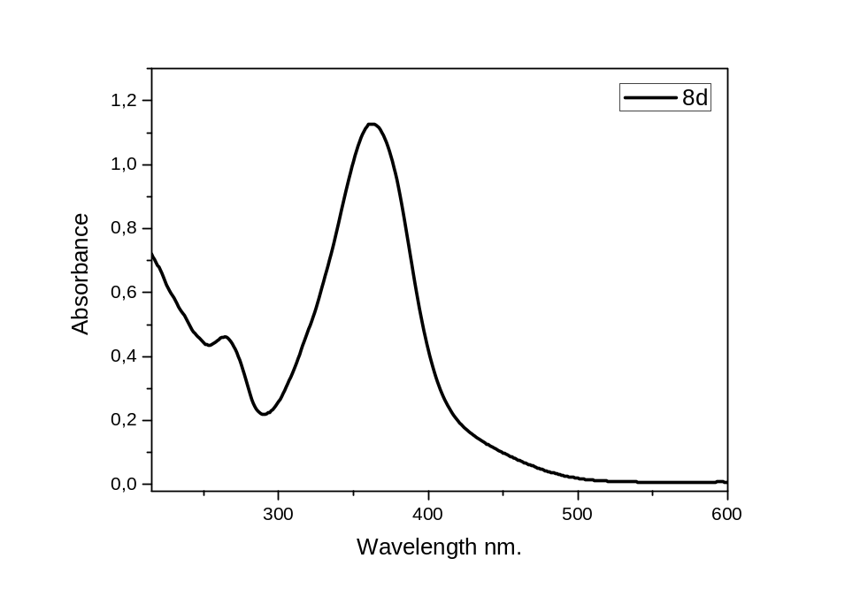
Figure S48. UV-Vis spectra of compound 8d in IPS, concentration 10⁻⁴ M
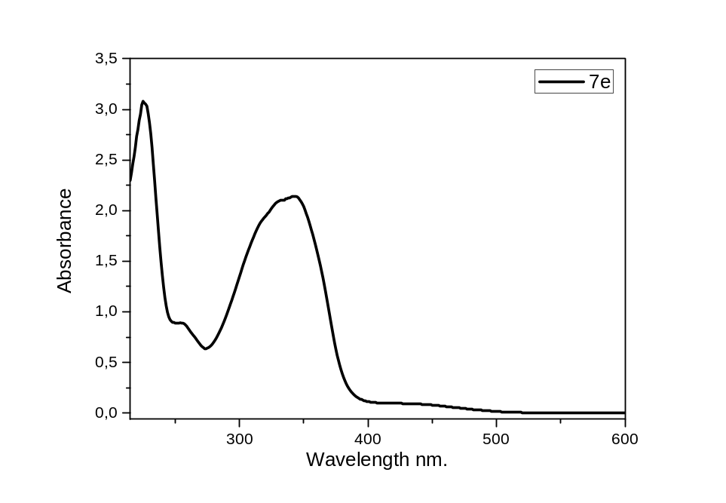
Figure S49. UV-Vis spectra of compound 7e in IPS, concentration 10⁻⁴ M
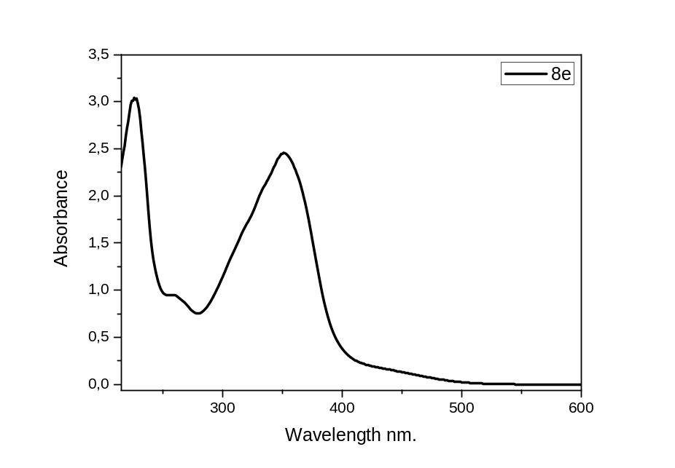
Figure S50. UV-Vis spectra of compound 8e in IPS, concentration 10⁻⁴ M
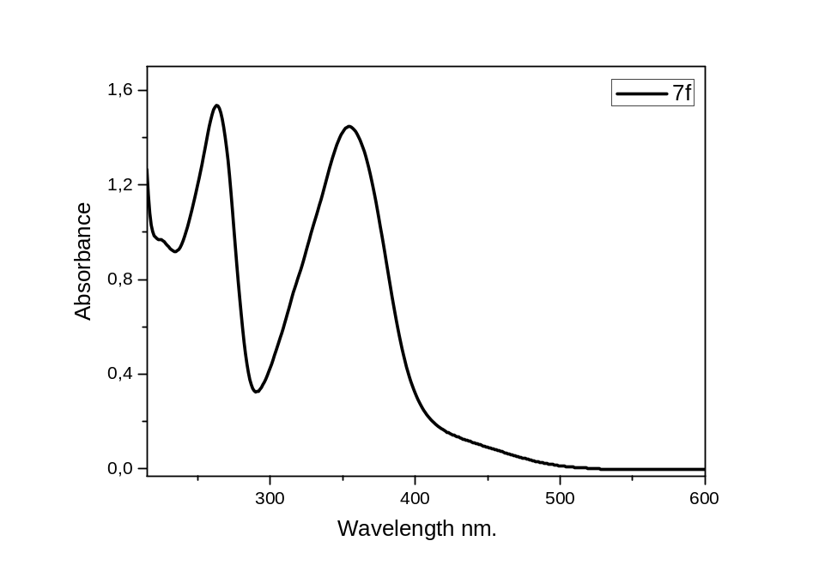
Figure S51. UV-Vis spectra of compound 7f in IPS, concentration 10⁻⁴ M
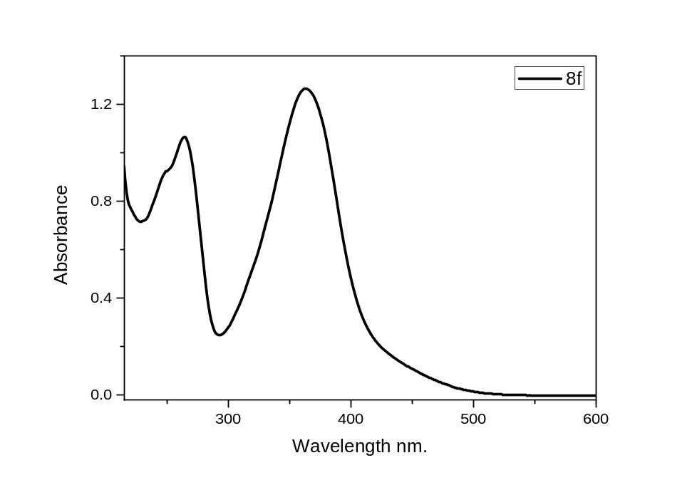
Figure S52. UV-Vis spectra of compound 8f in IPS, concentration 10⁻⁴ M
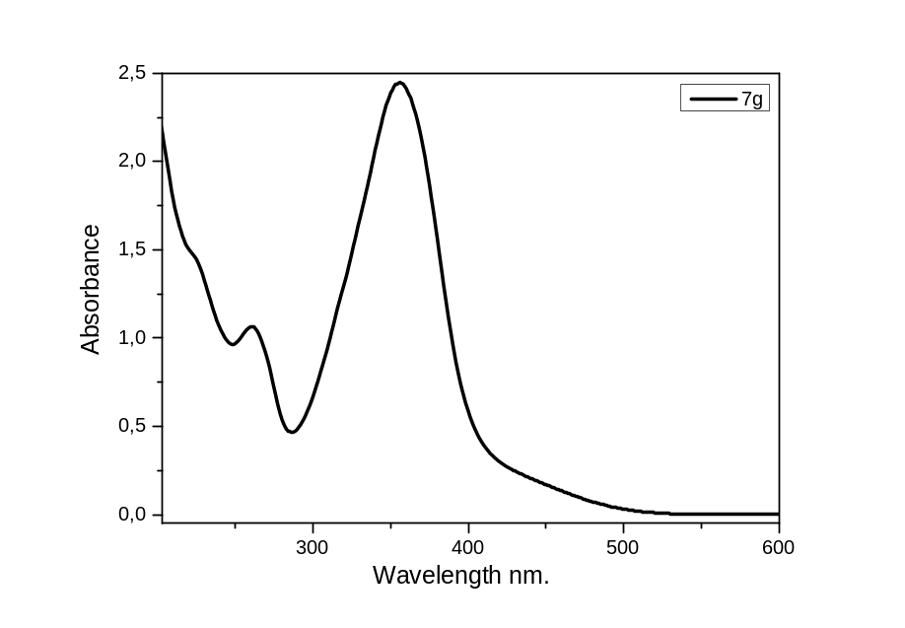
Figure S53. UV-Vis spectra of compound 7g in IPS, concentration 10⁻⁴ M
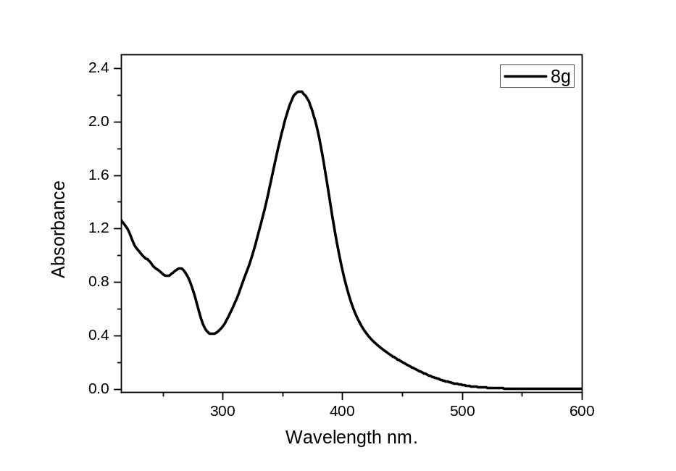
Figure S54. UV-Vis spectra of compound 8g in IPS, concentration 10⁻⁴ M
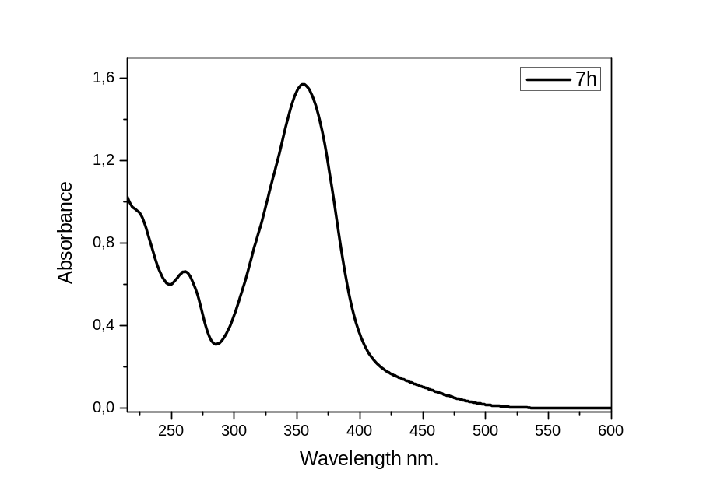
Figure S55. UV-Vis spectra of compound 7h in IPS, concentration 10⁻⁴ M
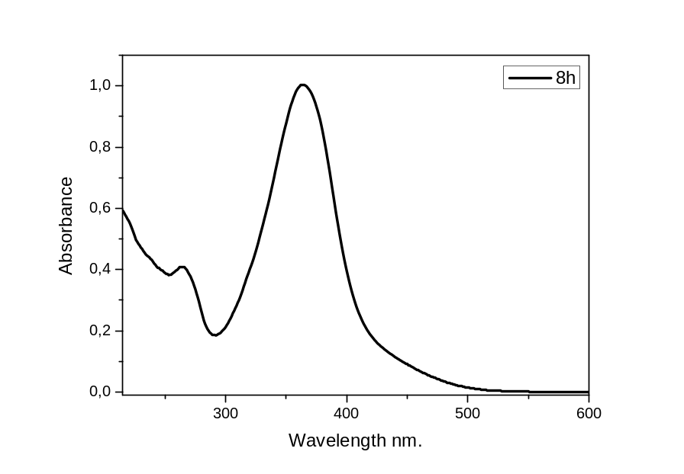
Figure S56. UV-Vis spectra of compound 8h in IPS, concentration 10⁻⁴ M
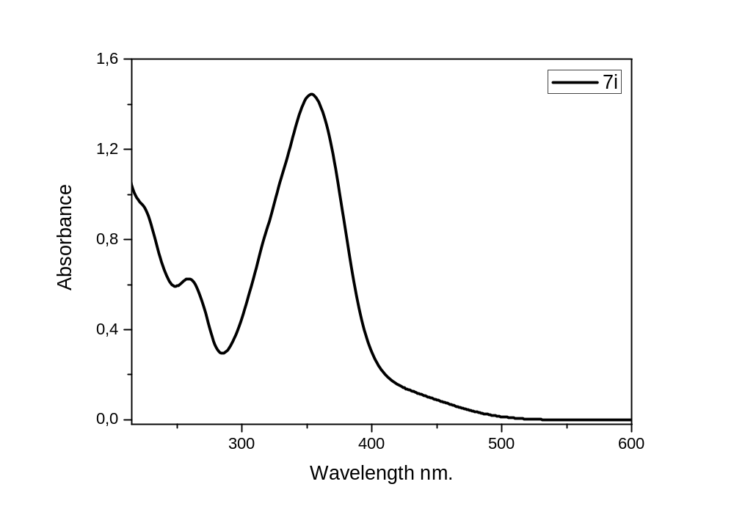
Figure S57. UV-Vis spectra of compound 7i in IPS, concentration 10⁻⁴ M
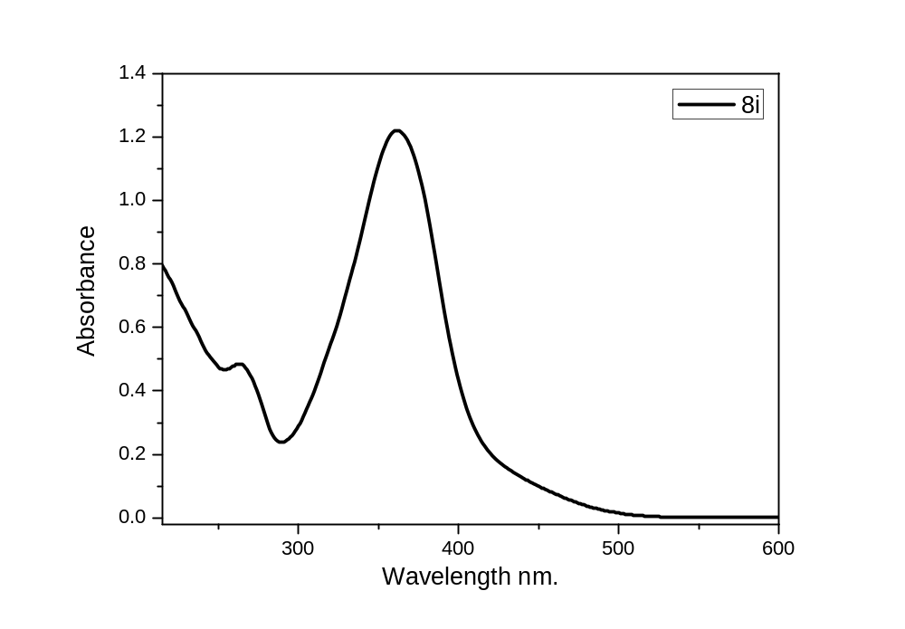
Figure S58. UV-Vis spectra of compound 8i in IPS, concentration 10⁻⁴ M
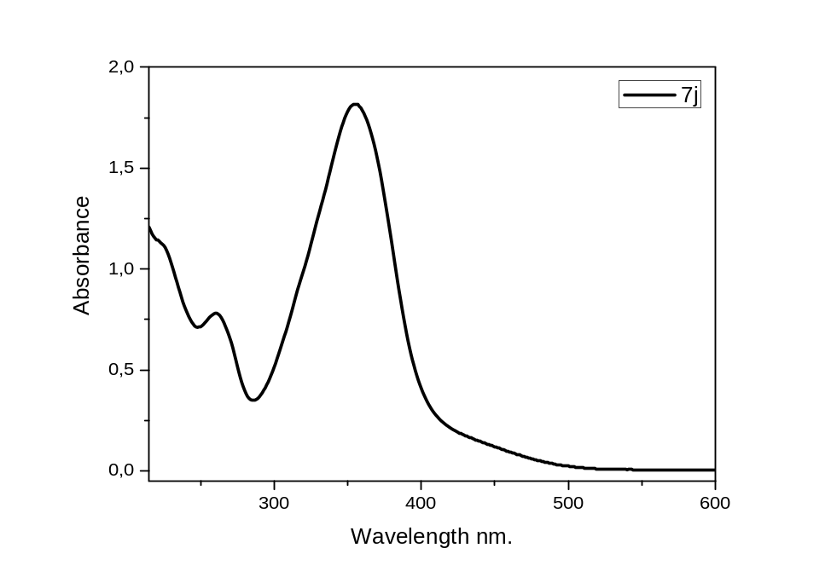
Figure S59. UV-Vis spectra of compound 7j in IPS, concentration 10⁻⁴ M
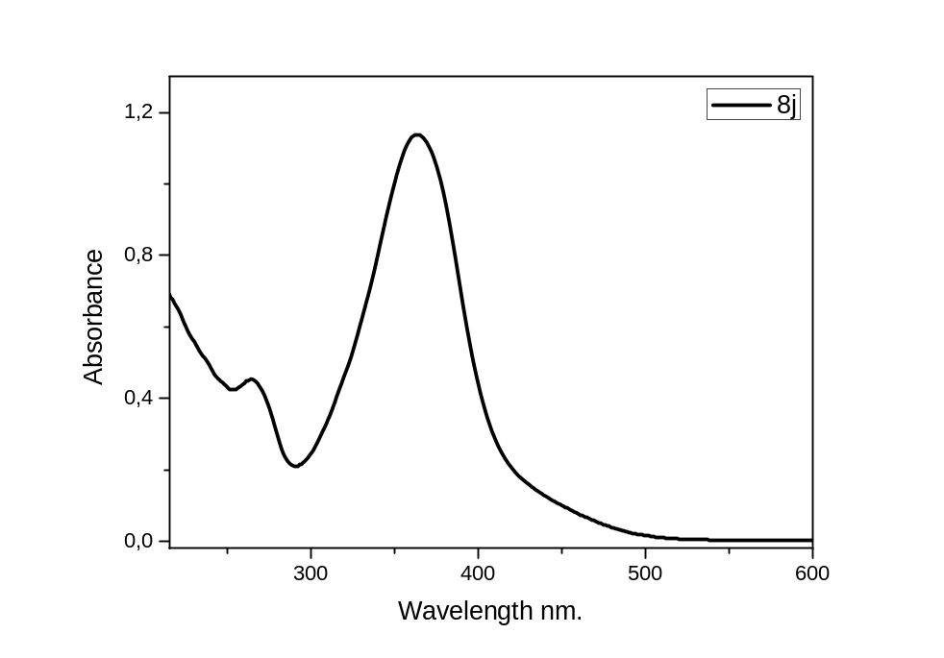
Figure S60. UV-Vis spectra of compound 8j in IPS, concentration 10⁻⁴ M

