Supplementary Material

Supplementary Fig.1. Comparison between the total lenses produced and the resulting ophthalmic waste in 2023.

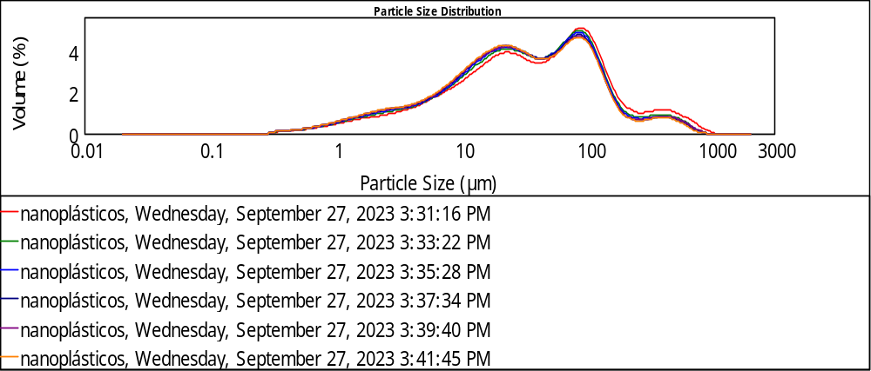
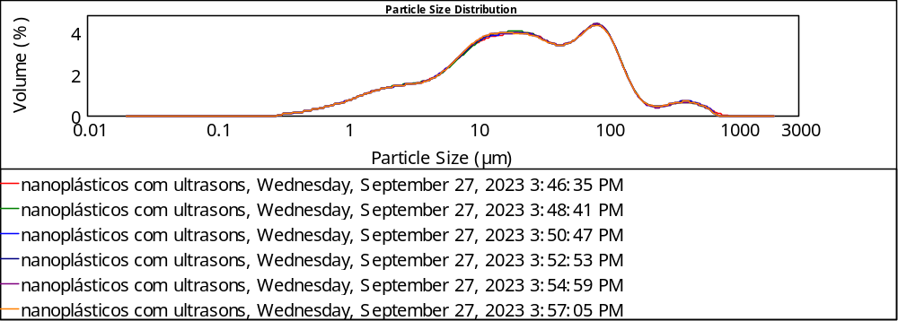
Supplementary Fig.2. Particle size distribution of lens-grinding waste before and after undergoing ultrasound treatment obtained using laser diffraction. Each curve represents a different measurement for the specified condition.

Supplementary Table 1. Particle size distribution parameters (span and characteristic diameters) of lens-grinding waste, determined by laser diffraction using the Fraunhofer approximation. Values represent the average of multiple measurements.
 | D[3,2]µm | D[4,3]µm | d[0.9]µm | d[0.5]µm | d[0.1]µm | span
Lens-grinding waste | 9.14 (±0.48) | 70.52 (±7.94) | 153.03 (±20.65) | 33.38 (±3.16) | 4.02 (±0.33) | 4.45  (±0.18)
Lens-grinding waste after submitting to ultrasounds | 7.119 (±0.008) | 53.260 (±0.897) | 118.286 (±0.953) | 23.530 (±0.121) | 2.730 (±0.008) | 4.911 (±0.018)

Supplementary Table 2. Quantification of heavy metals in ophthalmic waste by atomic absorption spectroscopy.
Sample | mg Cu/g | mg Cd/g | mg Cr/g | mg Pb/g
Ophthalmic waste | 0.0069 | ≤0.0001 | 0.0063 | 0.0116

Supplementary Table 3. Elemental analysis by EDS of ophthalmic residues of edging lenses.
Element | Normalized Content (wt. %) | Error (wt. %)
Carbon | 59.17 | 16.27
Nitrogen | 9.13 | 4.53
Oxygen | 11.66 | 4.26
Silicon | 0.36 | 0.12
Sulfur | 19.68 | 1.49

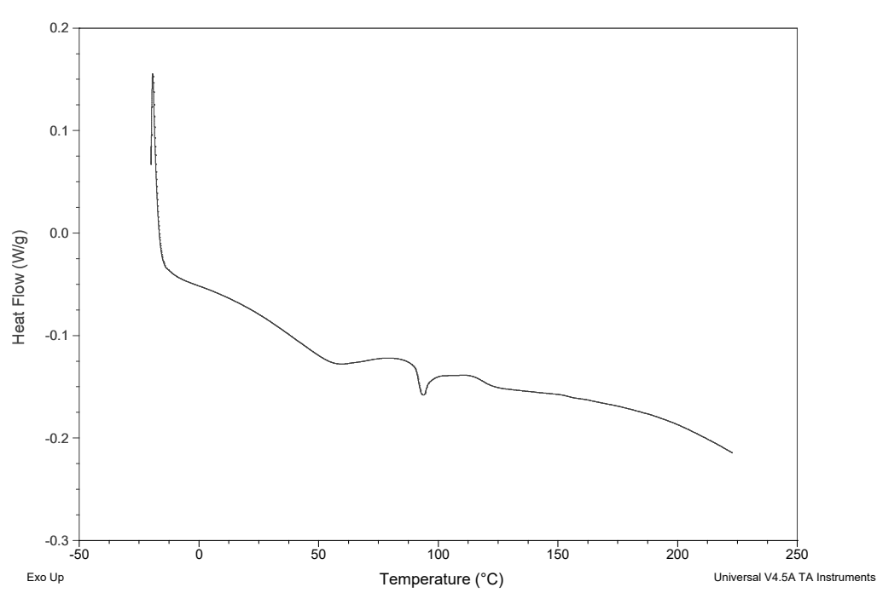
Supplementary Fig. 3. Differential scanning calorimetry characterisation of lens-grinding waste.

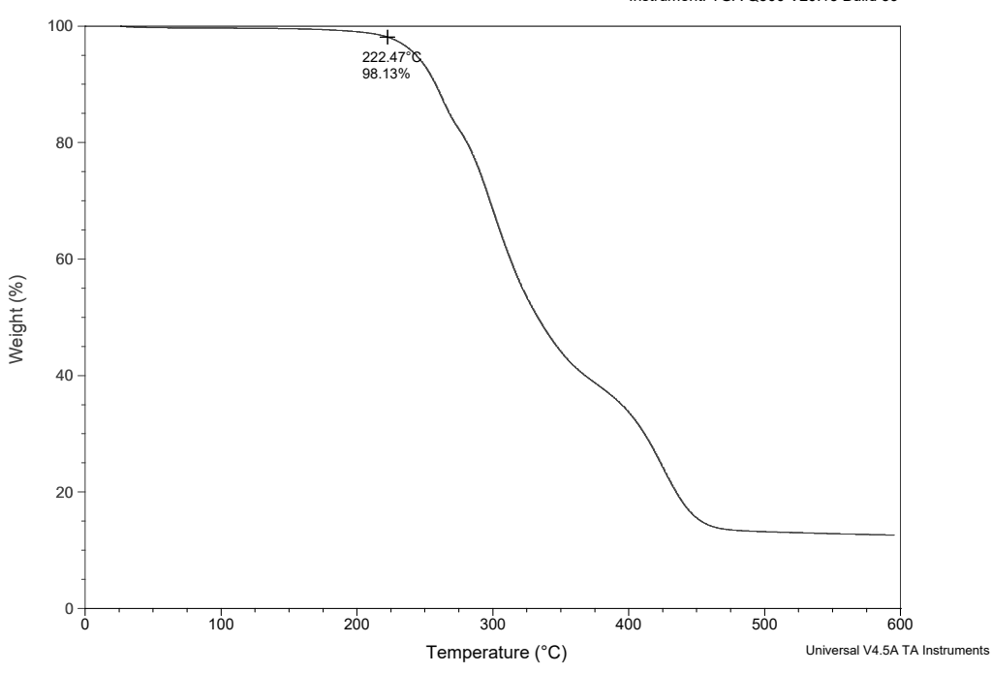
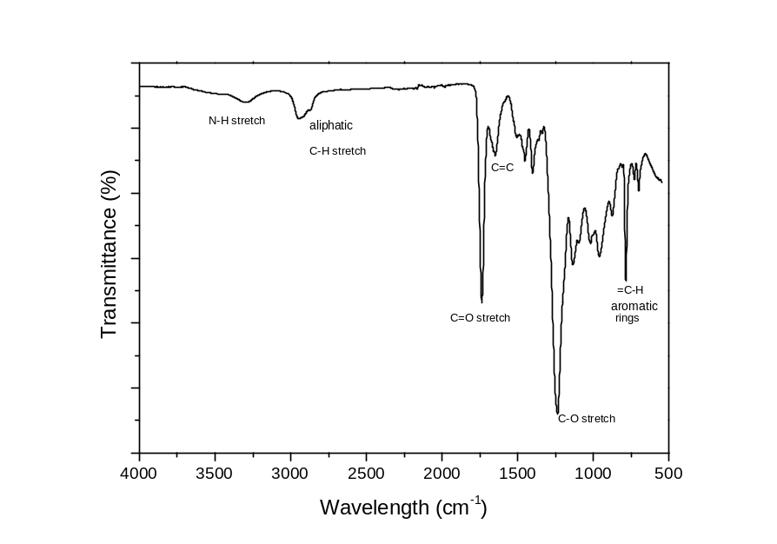
Supplementary Fig. 4. TGA characterisation of lens-grinding waste.

Supplementary Fig. 5. FTIR characterisation of lens waste.
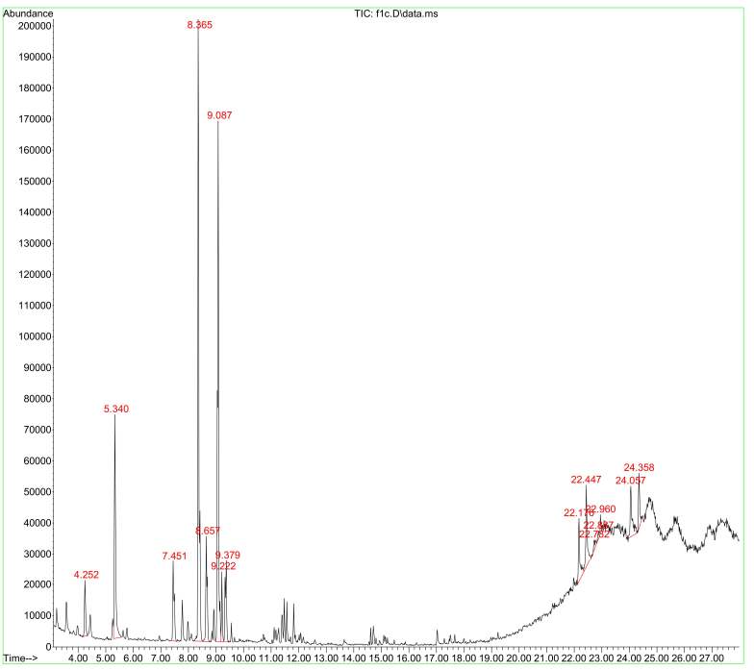
Supplementary Fig. 6. GC-MS chromatogram of the ophthalmic lens wastewater obtained in the final stage of 187 eyeglass lens grinding.

Supplementary Table 4. Compounds identified by GC-MS in ophthalmic wastewater.
Retention time | Name of Compound | MW in g/mol | Formula | % Similarity
4.252 | Formyl pyruvyl urea | 158.11 | C₅H₆N₂O₄ | 64
5.340 | 4-methyl-2-pentanol | 102.17 | C₆H₁₄O | 59
7.471 | 2,4-dimethyl-3-hexene | 112.21 | C₈H₁₆ | 43
8.365 | Trans-2-pentenal | 84.12 | C₅H₈O | 64
8.657 | Diisoamyl ether | 158.28 | C₁₀H₂₂O | 64
9.087 | 1-Methyl-2-propylcyclohexane | 140.27 | C₁₀H₂₀ | 80
9.222 | 3,3,4-trimethyl-hexane | 128.25 | C₉H₂₀ | 53
9.379 | 3-ethyl-3-heptanol | 144.25 | C₉H₂₀O | 38
22.176 | Heptadecyl pentafluoropropionate | 402.49 | C₂₀H₃₅F₅O₂ | 76
22.447 | 2-(methoxymethyl)-1,1,3,3-tetramethyl-1,3-disilacyclohexane | 216.47 | C₁₀H₂₃OSi₂ | 72
22.782 | Sulfurous acid, butyl octadecyl ester | 390.7 | C₂₂H₄₆O₃S | 83
22.887 | Nonahexacontanoic acid | 999.83 | C₆₉H₁₃₈O₂ | 76
22.960 | Nonahexacontanoic acid | 999.83 | C₆₉H₁₃₈O₂ | 64
24.057 | HAHNFETT  Phytol acetate | ---  338.57 | ---  C₆₉H₁₃₈O₂ | 81  72
24.358 | Heptadecyl heptafluorobutyrate | 452.5 | C₂₁H₃₅F₇O₂ | 76

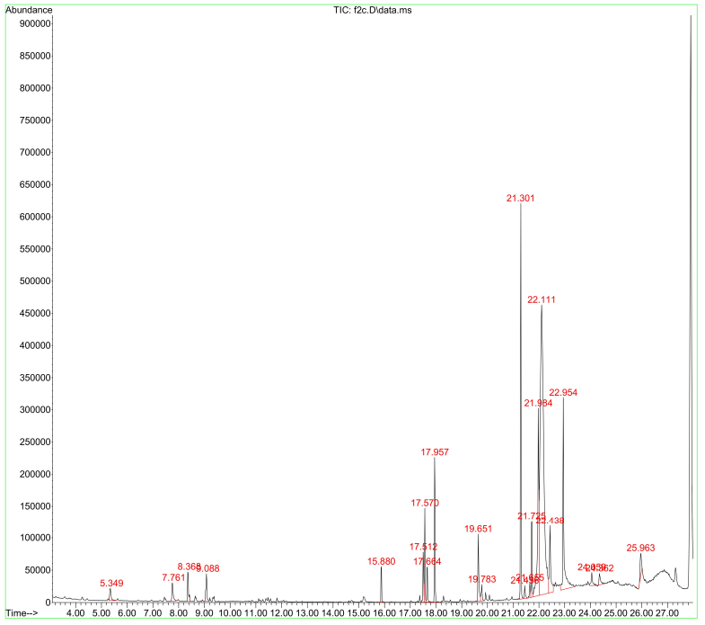
Supplementary Fig. 7. GS-MS chromatogram represents the analysis of the solid ophthalmic waste in the final stage of 187 eyeglass lens grinding.

Supplementary Table 5. Compounds identified by GC-MS in solid ophthalmic waste.
Retention time | Name of Compound | MW in g/mol | Formula | % Similarity
5.349 | 2-Hexanol | 102.17 | C₆H₁₄O | 59
7.761 | Styrene | 104.15 | C₈H₈ | 95
8.368 | 3,4-Dihydropyran | 84.12 | C₅H₈O | 59
9.088 | Sulfurous acid, cyclohexylmethyl pentadecyl ester | 388.60 | C₂₂H₄₄O₃S | 64
15.880 | Octanoic acid-tert bytyl ester | 200.32 | C12H24O2 | 37
17.512 | meso-2,3-Diisobutyl-2,3-dimethylsuccinic acid dinitrile | --- | --- | 72
17.570 | 2,6-di-t-butyl-4-methylene-2,5-cyclohexadiene-1-one | 218.33 | C₁₅H₂₂O | 99
17.664 | meso-2,3-Diisobutyl-2,3-dimethylsuccinic acid dinitrile | 219.37 | C₁₃H₂₄N₂ | 72
17.957 | 2,6-bis(1,1-dimethylethyl)-4-methyl-phenol | 220.35 | C₁₆H₂₄O | 97
19.651 | 2H-Imidazole-2-thione, 1,3-dihydro-1-methyl- | 114.17 | C₄H₆N₂S | 50
19.783 | 6,6-Dimethylcycloocta-2,4-dienone | 150.22 | C₁₀H₁₄O | 43
21.301 | 2,4-diphenyl-4-methyl-1-pentene | 236.35 | C₁₇H₁₈ | 96
21.436 | Cis-para-methane | 140.27 | C₁₀H₂₀ | 30
21.655 | Diallyl terephthalate | 260.29 | C₁₄H₁₄O₄ | 74
21.725 | 2,4-Diphenyl-4-methyl-2(E)-pentene | 236.35 | C₁₈H₂₀ | 97
21.984 | N-(Anilinocarbothioyl)valine | --- | --- | 46
22.111 | 2-(2H-benzotriazol-2-yl)-4-(1,1,3,3-tetramethylbutyl)phenol (ultraviolet absorvent UV-329) | 323.43 | C₂₀H₂₅N₃O | 86
22.438 | 1,1,2,2-tetramethyl-1,2-digermacyclopentane | 247.50 | C₇H₁₈Ge₂ | 56
22.954 | Dibutyl phthalate | 278.34 | C₁₆H₂₂O₄ | 93
24.056 | 11,13-Dimethyl-12-tetradecen-1-ol acetate  9-Decen-1-ol, trifluoroacetate | 282.46  252.27 | C₁₈H₃₄O₂  C₁₂H₁₉F₃O₂ | 74  68
24.662 | 3-(2,5-Dimethyl-1H-pyrrole-3-yl)-1,3-dihydro-indol-2-one | --- | --- | 90
25.968 | Bisphenol A | 228.29 | C₁₅H₁₆O₂ | 98

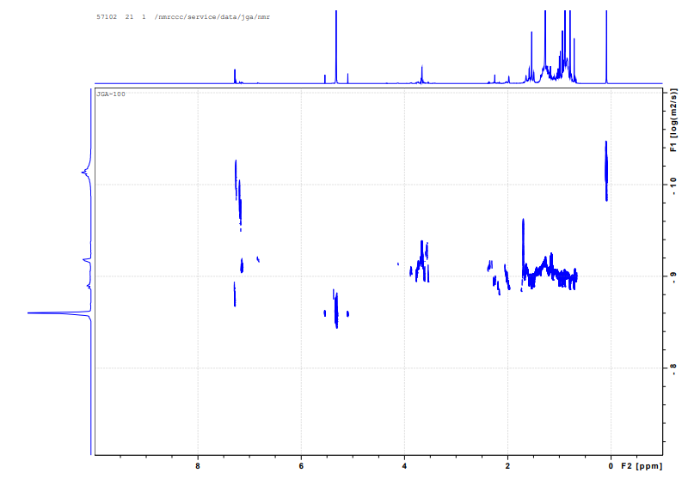
E
D
C
B
A

Supplementary Fig. 8. ¹H DOSY NMR of ophthalmic wastewater obtained in the final stage of 187 eyeglass lens grinding.

Supplementary Table 6. The measurement of ophthalmic wastewater was done at 25ºC in deuterated chloroform. ^{a 1}H DOSY NMR experiment. ^{b} Hydrodynamic radius calculated via the Stokes-Einstein equation D = k_{B}T/6πƞr_{H} (k_{B,} Boltzmann constant; T, absolute temperature; ƞ, viscosity of CDCl₃ at 298 K); * Molecular weights above 1000 g/mol suggest aggregation in solution.
Compound | Diffusion coefficient (10-10 m2/s) a | Hydrodynamic radius (nm)b | Molecular weight (g/mol)
A | 8.8 | 1.58 × 10-9 | 173
B | 9.1 | 7.94 × 10-10 | 413
C | 9.17 | 6.76 × 10-10 | 944
D | 9.7 | 1.99 × 10-10 | 18296*
E | 10.01 | 9.77 × 10-11 | 129031*

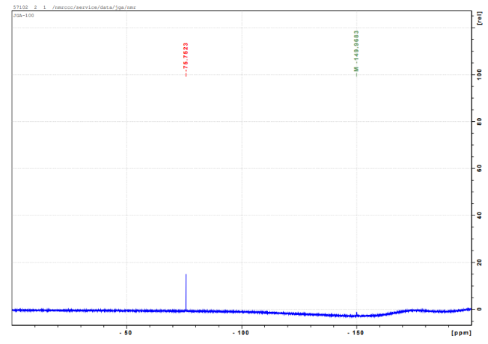

Supplementary Fig. 9. ¹⁹F NMR of ophthalmic wastewater obtained in the final stage of 187 eyeglass lens grinding.

Supplementary Fig. 10. ¹H DOSY NMR of solid ophthalmic waste obtained in the final stage of 187 eyeglass lens grinding.

Supplementary Table 7. The measurement of solid ophthalmic waste was done at 25ºC in deuterated chloroform. ^{a 1}H DOSY NMR experiment. ^{b} Hydrodynamic radius calculated via the Stokes-Einstein equation D = k_{B}T/6πƞr_{H} (k_{B,} Boltzmann constant; T, absolute temperature; ƞ, viscosity of CDCl₃ at 298 K); * Molecular weights above 1000 g/mol suggest aggregation in solution.
Compound | Diffusion coefficient (10⁻¹⁰ m²/s) ª | Hydrodynamic radius (nm) ^{b} | Molecular weight (g/mol)
F | 8.8 | 1.58 × 10⁻⁹ | 246
G | 9.06 | 8.71 × 10⁻¹⁰ | 550
H | 9.13 | 7.41 × 10⁻¹⁰ | 773
I | 9.8 | 1.58 × 10⁻¹⁰ | 33991*
J | 9.9 | 1.26 × 10⁻¹⁰ | 64703*
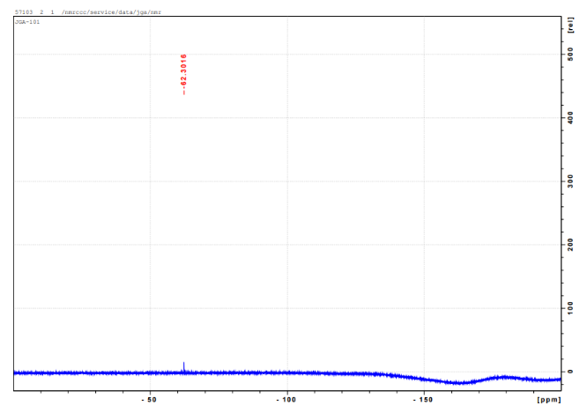

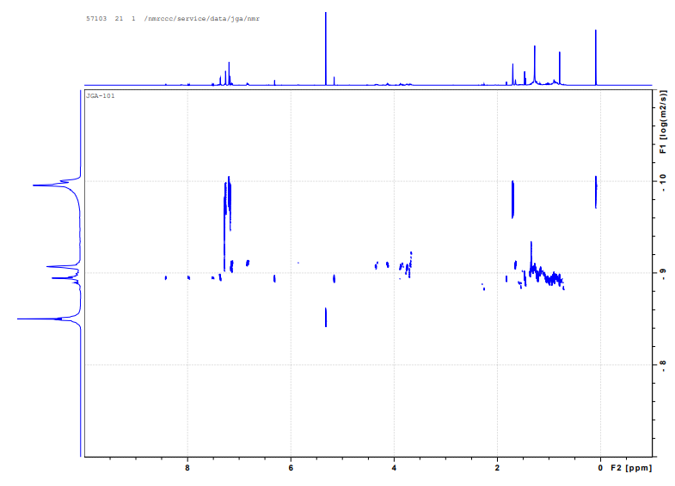
Supplementary Fig. 11. ¹⁹F NMR of solid ophthalmic waste obtained in the final stage of 187 eyeglass lens grinding.
J
I
H
G
F
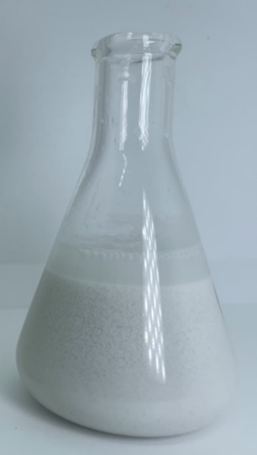
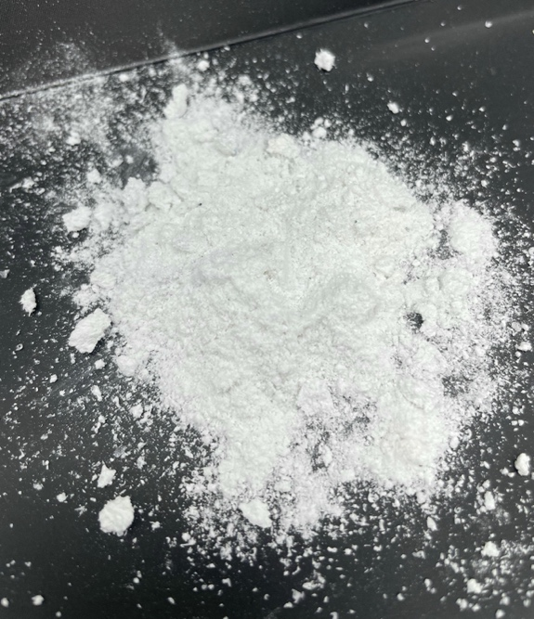
A
B

Supplementary Fig. 12. Optic industry wastewater supernatant obtained in the final stage of eyeglass lens grinding (A) and solids from ophthalmic spectacle lens wastewater (B).

