Figure S1 Soil carbon, soil nitrogen, and plant shoot biomass changes as affected by (A) (log-linearized) plant species richness, (B) plant functional group richness and (C) different plant functional identities. Colors in (AB) indicate the sampling block (B1 to B4), green dashed lines are based on the linear regression of each individual block, while the black line and shaded area represent the linear regression and 95% confidence interval independent of block. SOC: soil organic Carbon, TN: soil total nitrogen.
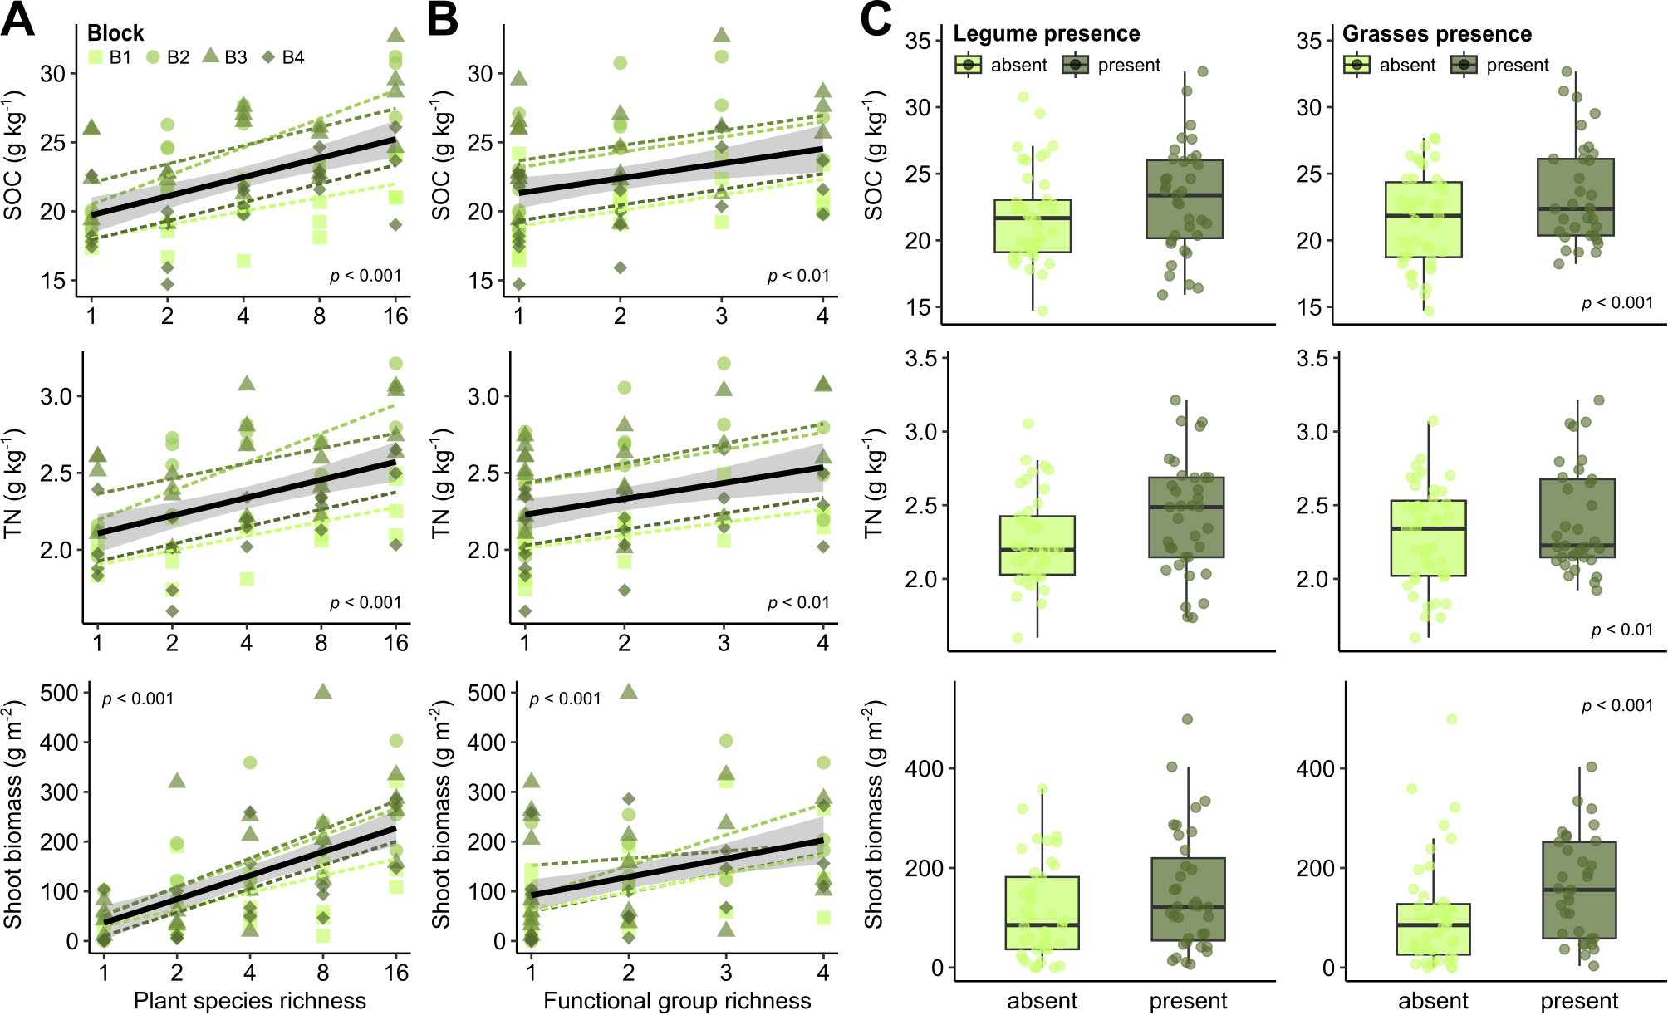
Figure S2 Differentially abundant ASVs at low and high plant diversity, based on DESeq2. (A) Sum of differentially abundant ASVs in bacterial (16S-ASVs) and fungal (ITS-ASVs) communities at high plant species richness (PSR ≥ 4), and in plots containing grasses and/or legumes. Colors indicate significant (p < 0.05) upregulation (blue) or downregulation (red). (B) Differential abundance of individual ASVs for bacteria and fungi on Phyla level, based on DESeq2 (log2 fold changes). Differential abundances were tested between plots with low (PSR ≤ 2) and high plant diversity (PSR ≥ 4), between plots with and without grasses, and with and without legumes. Significant ASVs are colored in red, others in grey. FC: fold change.
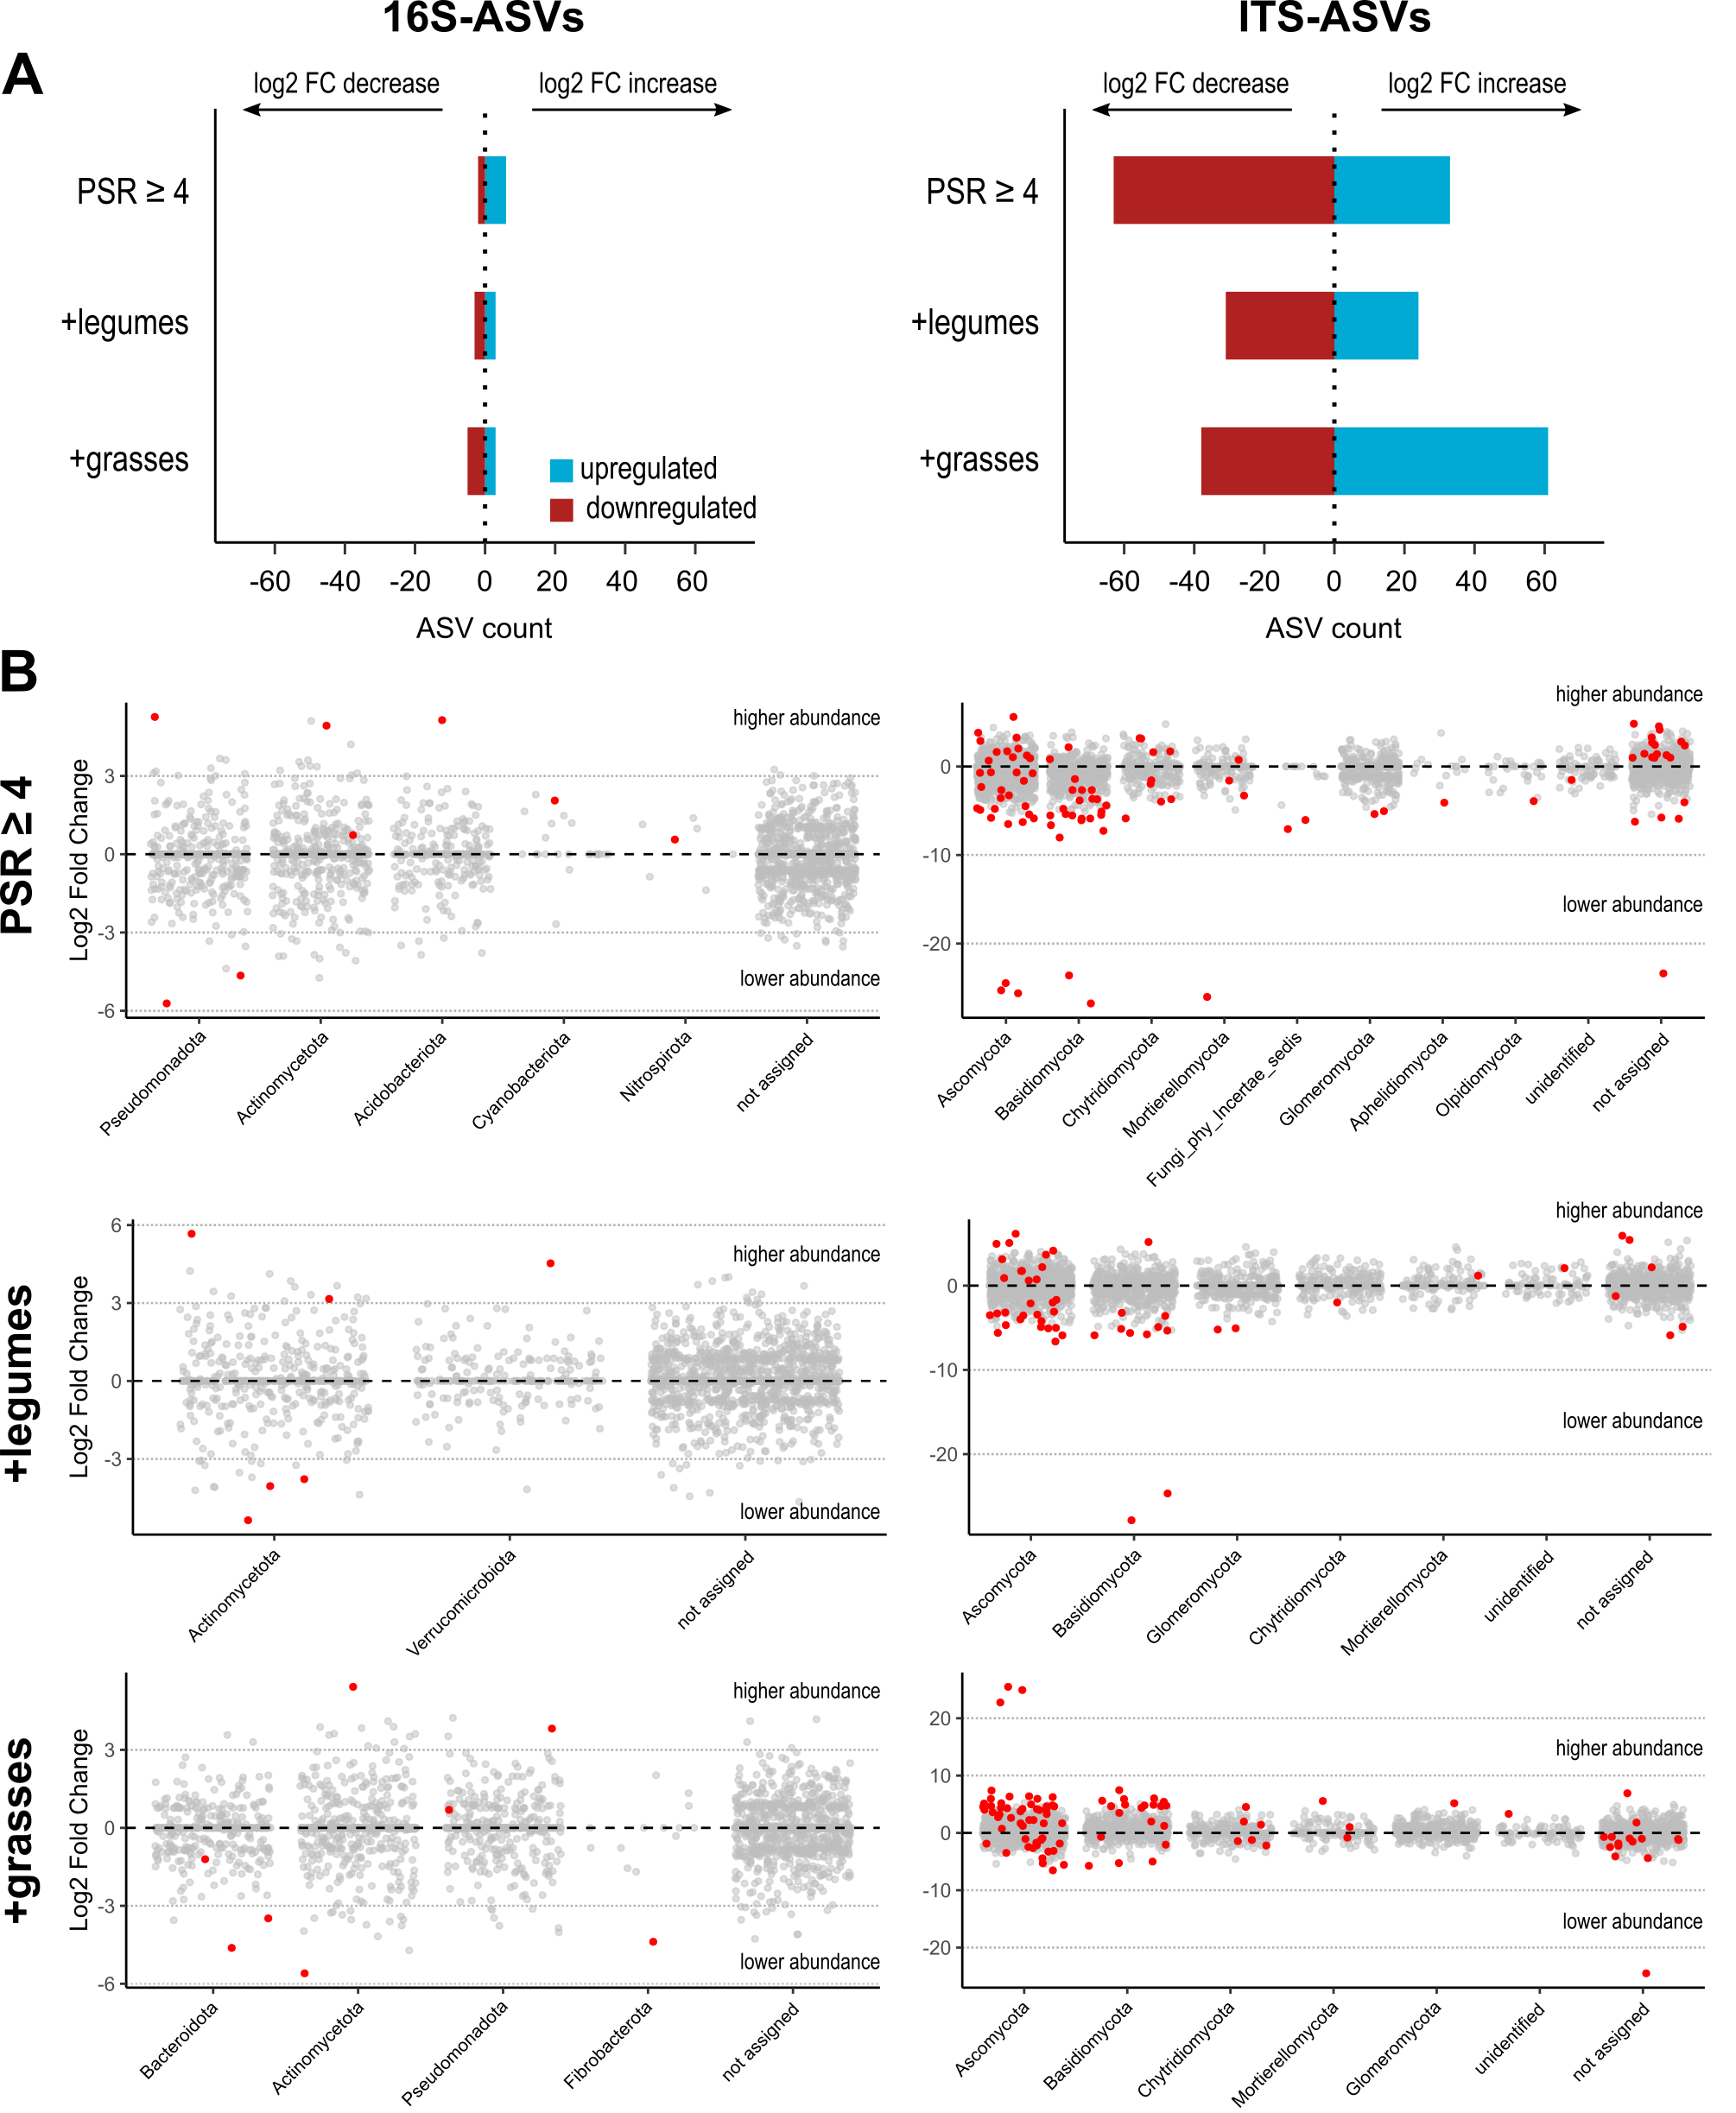
Figure S3 Interspecies correlations of the bacterial and fungal communities along the plant diversity gradient. Co-occurrence network analysis derived from the bacterial (16S-ASVs) and fungal (ITS-ASVs) communities. Topological properties of the networks are given in Table S6. Each node represents a microbial taxon at ASV level, with edges depicting significant (p < 0.01) positive and negative correlations. Node size is proportional to betweenness centrality, and node color is proportional to the number of connections (degree), with darker color indicating a higher degree. Edges are colored based on their source node. Number of samples per network is 14.
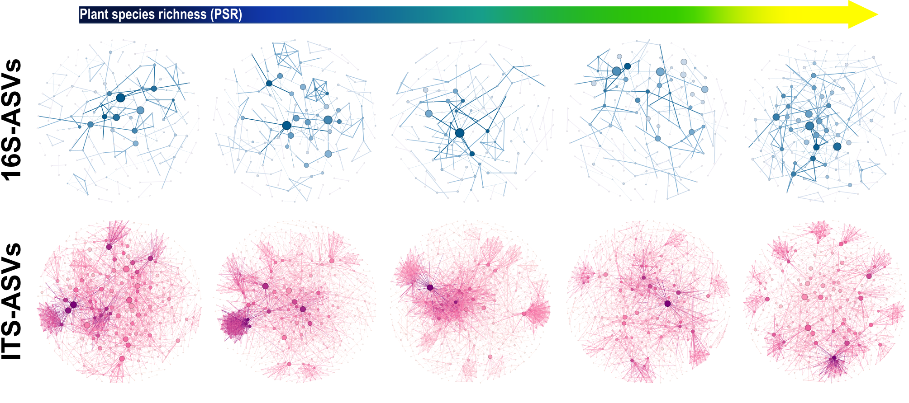
Figure S4 Plant functional group identity as a potential driver of microbial specialization. Multinomial species classification method for niche occupancy based on pairwise comparison between habitats with and without grasses and/or legumes for bacterial (16S-ASVs) and fungal (ITS-ASVs) communities. Generalists (grey), specialists (green and purple), and rare taxa (black) are indicated by their respective percentages.
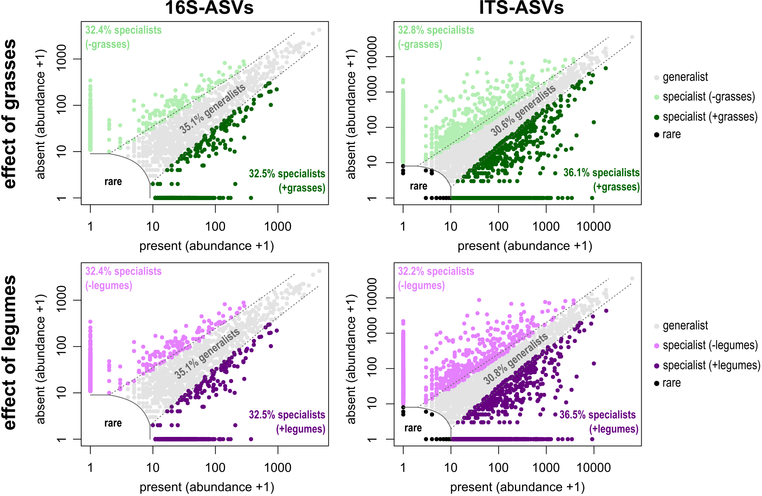
Table S1. ANOVA modeling of the effect of plant explanatory variables on microbial alpha diversity measures of the (A) bacterial (16S) and (B) fungal (ITS)communities. Significant p-values (p < 0.05) and trends (p < 0.1) have been emboldened and underscored, respectively. PSR: plant species richness, FG: functional group, df: degrees of freedom, F: F-value, p: p-value, %SS: percentage of the total sum of squares.
Source of variation | df | Species richness |  |  | Effective richness |  |  |  |  | Pielou’s Evenness
Source of variation | df | F | p | %SS |  | F | p | %SS | F |  |  | p | %SS
(A) Bacteria (16S)
block | 3 | 1.020 | 0.390 | 3.863 |  | 0.621 | 0.604 | 2.408 |  | 10.963 | < 0.001 |  |  | 31.087
PSR | 1
before |  | 0.097 | 0.756 | 0.123 |  | 0.040 | 0.842 | 0.052 |  | 0.932 | 0.338 |  |  | 0.881
after |  | 0.032 | 0.858 | 0.041 |  | 0.031 | 0.862 | 0.040 |  | 0.001 | 0.972 |  |  | 0.001
FG richness | 1
before |  | 1.090 | 0.300 | 1.376 |  | 0.619 | 0.434 | 0.800 |  | 4.265 | 0.043 |  |  | 4.032
after |  | 1.025 | 0.315 | 1.294 |  | 0.610 | 0.438 | 0.787 |  | 3.334 | 0.072 |  |  | 3.152
legumes present | 1 | 8.756 | 0.004 | 11.054 |  | 8.784 | 0.004 | 11.348 |  | 0.123 | 0.727 |  |  | 0.116
grasses present | 1 | 0.269 | 0.606 | 0.340 |  | 0.081 | 0.777 | 0.105 |  | 2.243 | 0.139 |  |  | 2.121
PSR × FG richness | 1 | 0.002 | 0.962 | 0.003 |  | 0.025 | 0.874 | 0.033 |  | 0.272 | 0.604 |  |  | 0.257
(B) Fungi (ITS)
block | 3 | 1.161 | 0.332 | 5.185 |  | 0.274 | 0.844 | 1.220 |  | 0.381 | 0.767 |  |  | 1.664
PSR | 1
before |  | 0.508 | 0.479 | 0.756 |  | 0.099 | 0.754 | 0.147 |  | 0.621 | 0.434 |  |  | 0.903
after |  | 0.011 | 0.917 | 0.016 |  | 1.104 | 0.298 | 1.637 |  | 1.598 | 0.211 |  |  | 2.323
FG richness | 1
before |  | 1.956 | 0.167 | 2.912 |  | 2.016 | 0.161 | 2.989 |  | 0.611 | 0.437 |  |  | 0.889
after |  | 1.459 | 0.232 | 2.172 |  | 3.021 | 0.087 | 4.480 |  | 1.588 | 0.212 |  |  | 2.309
legumes present | 1 | 0.059 | 0.809 | 0.088 |  | 1.963 | 0.166 | 2.911 |  | 3.368 | 0.071 |  |  | 4.897
grasses present | 1 | 0.070 | 0.792 | 0.104 |  | 0.294 | 0.590 | 0.436 |  | 0.169 | 0.682 |  |  | 0.246
PSR × FG richness | 1 | 0.590 | 0.446 | 0.878 |  | 0.231 | 0.632 | 0.343 |  | 0.884 | 0.351 |  |  | 1.285
Table S2. Permutational multivariate analysis of variance (PERMANOVA) of dissimilarities, based on UniFrac distances of the (A) bacterial (16S) and (B) fungal (ITS) community compositions. Significant p-values (p < 0.05) and trends (p < 0.1) have been emboldened and underscored, respectively. PSR: plant species richness, FG: functional group, df: degrees of freedom, F: F-value, p: p-value, %SS: percentage of the total sum of squares.
Source of variation | df | Community composition
Source of variation | df | F | p | %SS
(A) Bacteria (16S)
block | 3 | 2.141 | < 0.001 | 4.107
PSR | 1
before |  | 1.441 | 0.008 | 0.921
after |  | 1.174 | 0.130 | 0.751
FG richness | 1
before |  | 1.176 | 0.106 | 0.752
after |  | 0.909 | 0.712 | 0.581
legumes present | 1 | 1.314 | 0.029 | 0.840
grasses present | 1 | 1.167 | 0.115 | 0.746
PSR × FG richness | 1 | 0.945 | 0.618 | 0.604
(B) Fungi (ITS)
block | 3 | 1.857 | < 0.001 | 3.709
PSR | 1
before |  | 2.100 | < 0.001 | 1.398
after |  | 1.552 | 0.002 | 1.033
FG richness | 1
before |  | 1.930 | < 0.001 | 1.285
after |  | 1.382 | 0.008 | 0.920
legumes present | 1 | 2.157 | < 0.001 | 1.436
grasses present | 1 | 1.653 | 0.002 | 1.100
PSR × FG richness | 1 | 1.240 | 0.030 | 0.826

Table S3. P-values of the ANOVA modeling of the effect of plant explanatory variables on select (A) bacterial and (B) fungal functional potential. Significant p-values (p < 0.05) and trends (p < 0.1) have been emboldened and underscored, respectively. PSR: plant species richness, FG: functional group, AMF: arbuscular mycorrhizal fungi, ECM: ectomycorrhizal fungi, C: Carbon, N: Nitrogen.
Source of variation | p-value
(A) Bacteria (16S) | Multifunctionalityª | Chemoheterotrophy^{b} | Aromatic C compound degradation |  | Fermentation |  |  | C fixation^{c} |  | N mobilization^{d}
block | 0.802 | < 0.001 | < 0.001 |  | 0.581 |  |  | 0.036 |  | 0.806
PSR
before | 0.479 | 0.113 | 0.917 |  | 0.022 |  |  | 0.058 |  | 0.546
after | 0.988 | 0.143 | 0.800 |  | 0.021 |  |  | 0.075 |  | 0.961
FG richness
before | 0.126 | 0.533 | 0.465 |  | 0.616 |  |  | 0.485 |  | 0.154
after | 0.174 | 0.913 | 0.444 |  | 0.539 |  |  | 0.850 |  | 0.195
legumes present | 0.015 | 0.564 | 0.630 |  | 0.030 |  |  | 0.429 |  | 0.012
grasses present | 0.659 | 0.673 | 0.459 |  | 0.006 |  |  | 0.382 |  | 0.387
PSR × FG richness | 0.528 | 0.478 | 0.230 |  | 0.965 |  |  | 0.329 |  | 0.168
(B) Fungi (ITS) | Multifunctionalityª | Agonistic lifestyles^{e} | Mutualistic lifestyles^{f} | ECM |  | AMF | Litter saprotroph |  | Plant saprotroph
block | 0.222 | 0.178 | 0.098 | 0.576 |  | 0.442 | 0.133 |  | 0.762
PSR
before | 0.187 | 0.020 | 0.042 | 0.023 |  | 0.090 | 0.084 |  | 0.374
after | 0.731 | 0.228 | 0.454 | 0.047 |  | 0.208 | 0.038 |  | 0.925
FG richness
before | 0.029 | 0.006 | 0.003 | 0.260 |  | 0.203 | 0.013 |  | 0.082
after | 0.072 | 0.054 | 0.020 | 0.938 |  | 0.578 | 0.221 |  | 0.131
legumes present | 0.009 | < 0.001 | 0.152 | < 0.001 |  | 0.149 | 0.013 |  | 0.235
grasses present | 0.828 | 0.031 | 0.077 | 0.592 |  | 0.555 | 0.155 |  | 0.820
PSR × FG richness | 0.500 | 0.008 | 0.723 | 0.033 |  | 0.682 | 0.075 |  | 0.389
ª Number of functions or fungal lifestyles, inferred by PICRUSt2 and FungalTraits, respectively
^{b} Sum of functional abundances of chemoheterotrophy, excluding fermentation, cellulolysis, and aromatic compound degradation (inferred by FAPROTAX)
^{c} Sum of functional abundances of Carbon fixation, comprising phototrophy (inferred by FAPROTAX)
^{d} Sum of functional abundances of Nitrogen mobilization, comprising Nitrogen fixation, nitrate reduction, and ureolysis (inferred by FAPROTAX)
^{e} Sum of fungal guild abundances of agonistic lifestyles, including parasitism of fungi, plants, bryophytes, and lichens (inferred by FUNGuild)
^{f} Sum of fungal guild abundances of mutualistic lifestyles, comprising endomycorrhizal fungi, ECM, AMF, endophytes, epiphytes, symbiotrophs, and lichens (inferred by FUNGuild)

Table S4. Topological properties of the co-occurrence network analysis, derived from the combined 16S rRNA gene and ITS gene sequencing data, across the five plant species richness levels. Upwards (▲) and downwards (▼) arrows indicate the overall trend along the plant diversity gradient.
Network properties | Plant species richness
Network properties | 1 | 2 | 4 | 8 | 16
Number of nodesª | 782 | 925 | 880 | 826 | 887
Number of edges^{b} | 2936 | 3767 | 3944 | 2885 | 4159 | ▲
Positive edges | 1638 (56%) | 2292 (61%) | 2400 (61%) | 1633 (57%) | 2525 (61%) | ▲
Negative edges | 1298 (44%) | 1475 (39%) | 1544 (39%) | 1252 (43%) | 1634 (39%) | ▲
Bacteria-Bacteria | 296 (10%) | 246 (7%) | 211 (5%) | 223 (8%) | 249 (6%) | ▼
Bacteria-Fungi | 997 (34%) | 1093 (29%) | 1001 (25%) | 1016 (35%) | 1235 (30%) | ▲
Fungi-Fungi | 1643 (56%) | 2428 (64%) | 2732 (70%) | 1646 (57%) | 2675 (64%) | ▲
Modularity^{c} | 0.684 | 0.685 | 0.670 | 0.687 | 0.670
Number of communities^{d} | 20 | 21 | 21 | 19 | 16
Network diameter^{e} | 11 | 14 | 12 | 11 | 9
Clustering coefficient^{f} | 0.371 | 0.385 | 0.418 | 0.379 | 0.402 | ▲
Path length^{g} | 4.597 | 4.533 | 4.600 | 4.526 | 4.199
Connectivity^{h} | 7.509 | 8.145 | 8.964 | 6.985 | 9.378 | ▲
Weighted degree^{i} | 4.999 | 5.405 | 5.944 | 4.600 | 6.243 | ▲
ª Microbial taxon with at least one significant (p < 0.01) strong (SparCC >0.7 or <−0.7) correlation
^{b} Number of correlations obtained by SparCC analysis, with positive and negative correlations featuring a magnitude of >0.7 and <−0.7, respectively
^{c} Capability of nodes to form highly connected communities (inferred by Gephi)
^{d} Groups of internally densely connected nodes (inferred by Gephi)
^{e} Longest distance between nodes in the network, measured in number of edges (inferred by Gephi)
^{f} Average tendency of nodes to form tightly-knit clusters (inferred by Gephi)
^{g} Average length of all edges in the network (inferred by Gephi)
^{h} Average number of connections per node (inferred by Gephi)
^{i} Average number of connections per node, weighted by their connectivity distribution
Table S5. Known carbon compound (CC) utilization by top key nodes identified in table 2 at the lowest taxonomic classification based on literature. Fungal key nodes are shaded grey. sCC: simple carbon compounds (Carbon atoms < 9); cCC: complex carbon compounds (Carbon atoms ≥ 10).
Taxa | Ecological role | Carbon compound utilization | References
Actinobacteria | Metabolically diverse degraders of plant-derived complex CC | - Various cCC (i.e., chitin, cellulose)  - Various sCC (i.e., maltose, sorbitol) | [1]
Agromyces | Metabolically diverse carbohydrate degraders | - Various sCC (i.e., glucose, xylose)  - aromatic & aliphatic hydrocarbons | [2, 3]
Blastocatellaceae | Protein degraders | - Various cCC (i.e., cellulose, chitin, starch)  - Complex proteinaceous compounds | [4, 5]
Blastococcus | Metabolically diverse degraders of various simple & complex CC | - Various sCC (i.e., malate, sucrose)  - Various cCC (i.e., arbutin, trehalose)  - Organic acids | [6, 7]
Candidatus Alysiosphaera | Metabolically diverse degraders easily available CC | - Short-chain fatty acids  - sCC  - Amino acids  - Alcohols | [8]
Chitinophagaceae | Degraders of wood & hydrocarbons | - Various cCC (i.e., chitin, cellulose)  - Various sCC (i.e., glucose, sucrose) | [9, 10]
Dongia | Metabolically diverse degraders simple sugars, carbohydrates | - Various sCC (i.e., glucose, xylose)  - cCC: cellobiose | [4, 11]
Gaiellales | Degraders of exclusively simple sugars & amino acids | - P-containing compounds  - sCC  - amino acids (i.e., alanine, asparagine) | [12, 13]
Gitt-GS-136 | Degraders of dissolved organic matter | - Dissolved organic carbon  - Byproducts of photosynthetic activity | [14]
MB-A2-108 | Degraders of dissolved organic matter | - high molecular weight organic carbon compounds | [15]
Methyloligellaceae | Methane cycling | - Methane | [16]
Nocardioides | Degraders of wood & plant-derived CC | - Aromatic compounds & lignocelluloses | [17, 18]
Reyranella | Metabolically diverse degraders of various simple & complex CC | - Various sCC (i.e., fructose, malate)  - Various cCC (i.e., inosine, trehalose)  - Organic acids | [4, 19]
Rubrobacter | Metabolically diverse degraders of various simple & complex CC | - Various sCC (i.e., malate, arabinose)  - Various cCC (i.e., cellobiose, trehalose)  - Amino acids (i.e., glutamate, proline) | [20, 21]
Subgroup 11 | Degraders of dissolved organic matter | - high molecular weight organic CC | [15, 22]
Vicinamibacteraceae | Degraders of simple sugars, complex proteinaceous compounds | - sCC  - Complex proteinaceous compounds  - Organic acids | [23, 24]
Xanthobacteraceae | Metabolically diverse degraders of organic acids & alcohols | - Alcohols  - Organic & amino acids  - cCC: raffinose  - sCC: glucose | [25, 26]
Ascobolus | Metabolically diverse saprotrophs, plant parasites | - cCC: cellulose, chitin, lignin  - sCC: xylan, sucrose  - Amino acids (i.e., cysteine, isoleucine) | [27, 28]
Botryotrichum | Degraders of plant- & animal-derived complex CC | - Various cCC (i.e., cellulose, keratin) | [29]
Chrysosporium | Degraders of keratin & litter | - Various cCC (i.e., cellulose, mucilage, keratin) | [30, 31]
Clavaria | Degraders of plant-derived CC | - Various cCC (i.e., starch, cellulose) | [32]
Fusarium | Metabolically diverse degraders of plant-derived CC, plant pathogens | - Various cCC (i.e., cellulose)  - Various sCC  - Amino acids | [33–35]
Mortierella | Metabolically diverse degraders of wood, plant-derived CC, and simple sugars | - Various cCC (i.e., lignin, hemicellulose)  - Various sCC | [35, 36]
Periconia | Metabolically diverse degraders of plant-derived CC | - Various cCC (i.e., starch, cellulose, lignin-derived compounds) | [37, 38]
Phizophlyctis | Saprotroph | - sCC: glucose  - cCC: cellulose | [39, 40]
Pyronemataceae | Degraders of plant-derived CC | - Pyrolyzed cCC, ash, charcoal | [41]
Rhizophydiales | Degraders of pollen, plant parasite | - Various cCC (i.e., pollen, chitin, cellulose) | [39, 42]
Solicoccozyma | Degraders of simple sugars, promote plant growth | - Various sCC (i.e., lactose, maltose)  - cCC: starch  - Glyphosates | [43, 44]
Sordariales | Degraders of litter | - Various cCC (i.e., lignocellulose) | [45]
Tetracladium | Degraders of wood & litter, root-associated endophyte | - Various cCC (i.e., lignin, cellulose)  - Various sCC (i.e., xylan, sucrose) | [46, 47]
Thelebolaceae | Degraders of animal dung | - Various cCC found in dung | [48]
Table S6. Topological properties of the co-occurrence network analysis, derived from the (A) 16S rRNA and (B) ITS gene sequencing data, across the five plant species richness levels.
Network properties | Plant species richness
Network properties | 1 | 2 | 4 | 8 | 16
(A) Bacteria (16S)
Number of nodesª | 171 | 172 | 152 | 159 | 186
Number of edges^{b} | 185 | 208 | 154 | 165 | 248
Positive edges | 69 (37%) | 135 (65%) | 99 (64%) | 106 (64%) | 125 (50%)
Negative edges | 116 (63%) | 73 (35%) | 55 (36%) | 59 (38%) | 123 (50%)
Modularity^{c} | 0.864 | 0.863 | 1.013 | 0.862 | 0.796
Number of communities^{d} | 32 | 27 | 31 | 32 | 25
Network diameter^{e} | 13 | 14 | 17 | 17 | 11
Clustering coefficient^{f} | 0.372 | 0.428 | 0.289 | 0.303 | 0.312
Path length^{g} | 4.730 | 5.723 | 6.571 | 6.742 | 4.846
Connectivity^{h} | 2.164 | 2.419 | 2.026 | 2.075 | 2.667
Weighted degree^{i} | 0.381 | 0.507 | 0.391 | 0.393 | 0.033
(B) Fungi (ITS)
Number of nodesª | 551 | 623 | 619 | 654 | 643
Number of edges^{b} | 2489 | 2926 | 3555 | 2518 | 2458
Positive edges | 1496 (40%) | 1939 (66%) | 2354 (66%) | 1645 (65%) | 1659 (68%)
Negative edges | 993 (60%) | 987 (34%) | 1201 (34%) | 873 (35%) | 799 (32%)
Modularity^{c} | 0.671 | 0.689 | 0.650 | 0.701 | 0.764
Number of communities^{d} | 15 | 11 | 15 | 15 | 18
Network diameter^{e} | 10 | 11 | 11 | 10 | 11
Clustering coefficient^{f} | 0.384 | 0.419 | 0.466 | 0.4011 | 0.439
Path length^{g} | 4.018 | 4.226 | 4.153 | 4.496 | 4.699
Connectivity^{h} | 9.034 | 9.393 | 11.486 | 7.700 | 7.645
Weighted degree^{i} | 6.119 | 6.266 | 7.685 | 5.101 | 5.065
ª Microbial taxon with at least one significant (p < 0.01) strong (SparCC >0.7 or <−0.7) correlation
^{b} Number of correlations obtained by SparCC analysis, with positive and negative correlations featuring a magnitude of >0.7 and <−0.7, respectively
^{c} Capability of nodes to form highly connected communities (inferred by Gephi)
^{d} Groups of internally densely connected nodes (inferred by Gephi)
^{e} Longest distance between nodes in the network, measured in number of edges (inferred by Gephi)
^{f} Average tendency of nodes to form tightly-knit clusters (inferred by Gephi)
^{g} Average length of all edges in the network (inferred by Gephi)
^{h} Average number of connections per node (inferred by Gephi)
^{i} Average number of connections per node, weighted by their connectivity distribution
Table S7. List of plant species sown in the Jena Experiment, classified into 4 functional groups.
Legumes | Grasses | Tall herbs | Small herbs
Lathyrus pratensis | Alopecurus pratensis | Achillea millefolium | Ajuga reptans
Lotus corniculatus | Anthoxanthum odoratum | Anthriscus sylvestris | Bellis perennis
Medicago lupulina | Arrhenaterum elatius | Campanula patula | Glechoma hederacea
Medicago x varia | Avenula pubescens | Carum carvi | Leontodon autumnalis
Onobrychnis viciifolia | Bromus erectus | Cardamine pratensis | Leontodon hispidus
Trifolium campestre | Bromus hordeaceus | Centaurea jacea | Plantago lanceolata
Trifolium dubium | Cynosurus cristatus | Cirsium olearaceum | Plantago media
Trifolium fragiferum | Dactylis glomerata | Crepis biennis | Primula veris
Trifolium hybridum | Festuca pratensis | Daucus carota | Prunella vulgaris
Trifolium pratense | Festuca rubra | Galium mollugo | Ranunculus repens
Trifolium repens | Holcus lanatus | Geranium pratense | Taraxacum officinale
Vicia cracca | Luzula campestris | Heracleum sphondylium | Veronica chamaedrys
 | Phleum pratense | Knautia arvensis
 | Poa pratensis | Leucanthemum vulgare
 | Poa trivialis | Pastinacea sativa
 | Trisetum flavescens | Pimpinella major
 |  | Ranunculus acris
 |  | Rumex acetosa
 |  | Sanguisorba officinalis
 |  | Tragopogon pratensis
Table S8. Primers used for Illumina MiSeq amplicon sequencing, along with their respective sequences and references.
Target gene | Primer | Sequence (5’-3’) | Amplified Region | Reference
Bacterial 16S rRNA gene | Bact_341F | CCTACGGGAGGCAGCAG | V3 and V4 regions | [49, 50]
 | Bact_806R | GGACTACHVGGGTWTCTAAT | V3 and V4 regions | [49, 50]
Fungal ITS gene | fITS7f | GTGARTCATCGAATCTTTG | ITS subregion 2 | [51]
 | ITS4r | TCCTCCGCTTATTGATATGC | ITS subregion 2 | [51]
W = A or T; V = A, C or G; H = A, C or T.
References
1. Lewin GR, Carlos C, Chevrette MG, Horn HA, McDonald BR, Stankey RJ, et al. Evolution and Ecology of Actinobacteria and Their Bioenergy Applications. Annu Rev Microbiol. 2016;70:235. https://doi.org/10.1146/ANNUREV-MICRO-102215-095748.
2. Lee M, Ten LN, Woo SG, Park J. Agromyces soli sp. nov., isolated from farm soil. Int J Syst Evol Microbiol. 2011;61:1286–92. https://doi.org/10.1099/IJS.0.021568-0.
3. Dastager SG, Qiang ZL, Damare S, Tang SK, Li WJ. Agromyces indicus sp. nov., isolated from mangroves sediment in Chorao Island, Goa, India. Antonie Van Leeuwenhoek. 2012;102:345–52. https://doi.org/10.1007/S10482-012-9744-9.
4. Dueholm MKD, Andersen KS, Korntved A-KC, Rudkjøbing V, Alves M, Bajón-Fernández Y, et al. MiDAS 5: Global diversity of bacteria and archaea in anaerobic digesters. Nat Commun. 2024;15:5361. https://doi.org/10.1038/S41467-024-49641-Y:
5. Huber KJ, Pascual J, Foesel BU, Overmann J. Blastocatellaceae. Bergey’s Manual of Systematics of Archaea and Bacteria. 2017;:1–4. https://doi.org/10.1002/9781118960608.FBM00290.
6. Carro L, Trujillo ME. Blastococcus. Bergey’s Manual of Systematics of Archaea and Bacteria. 2019;:1–15. https://doi.org/10.1002/9781118960608.GBM00043.PUB2.
7. Chouaia B, Crotti E, Brusetti L, Daffonchio D, Essoussi I, Nouioui I, et al. Genome Sequence of Blastococcus saxobsidens DD2, a Stone-Inhabiting Bacterium. J Bacteriol. 2012;194:2752. https://doi.org/10.1128/JB.00320-12.
8. Kragelund C, Kong Y, van der Waarde J, Thelen K, Eikelboom D, Tandoi V, et al. Ecophysiology of different filamentous Alphaproteobacteria in industrial wastewater treatment plants. Microbiology (N Y). 2006;152:3003–12. https://doi.org/10.1099/MIC.0.29249-0.
9. Wieczorek AS, Schmidt O, Chatzinotas A, Von Bergen M, Gorissen A, Kolb S. Ecological functions of agricultural soil bacteria and microeukaryotes in chitin degradation: A case study. Front Microbiol. 2019;10 JUN. https://doi.org/10.3389/fmicb.2019.01293.
10. Rosenberg E. The family chitinophagaceae. The Prokaryotes: Other Major Lineages of Bacteria and The Archaea. 2014;9783642389542:493–5. https://doi.org/10.1007/978-3-642-38954-2_137.
11. Liu Y, Jin JH, Liu YH, Zhou YG, Liu ZP. Dongia mobilis gen. nov., sp. nov., a new member of the family Rhodospirillaceae isolated from a sequencing batch reactor for treatment of malachite green effluent. Int J Syst Evol Microbiol. 2010;60:2780–5. https://doi.org/10.1099/IJS.0.020347-0.
12. Pan Y, Kang P, Qu X, Zhang H, Li X. Response of the soil bacterial community to seasonal variations and land reclamation in a desert grassland. Ecol Indic. 2024;165:112227. https://doi.org/10.1016/J.ECOLIND.2024.112227.
13. Albuquerque L, Da Costa MS. The family Gaiellaceae. The Prokaryotes: Actinobacteria. 2014;:357–60. https://doi.org/10.1007/978-3-642-30138-4_394.
14. Cherbunina MY, Karaevskaya ES, Vasil’chuk YK, Tananaev NI, Shmelev DG, Budantseva NA, et al. Microbial and Geochemical Evidence of Permafrost Formation at Mamontova Gora and Syrdakh, Central Yakutia. Front Earth Sci (Lausanne). 2021;9:739365. https://doi.org/10.3389/feart.2021.739365.
15. Coskun ÖK, Pichler M, Vargas S, Gilder S, Orsi WD. Linking uncultivated microbial populations and benthic carbon turnover by using quantitative stable isotope probing. Appl Environ Microbiol. 2018;84:1083–101. https://doi.org/10.1128/AEM.01083-18.
16. Harirforoush M, Shavandi M, Amoozegar MA, Saffarian P, Hasrak S, Midgley D, et al. Molecular identification of methane-consuming bacteria in the Persian Gulf: a study for microbial gas exploration. Front Microbiol. 2024;15:1435037. https://doi.org/10.3389/FMICB.2024.1435037.
17. Araujo ASF, de Pereira AP de A, Antunes JEL, Oliveira LM de S, de Melo WJ, Rocha SMB, et al. Dynamics of bacterial and archaeal communities along the composting of tannery sludge. Environmental Science and Pollution Research. 2021;28:64295–306. https://doi.org/10.1007/s11356-021-15585-9.
18. Kimbrel JA, Chang J, Arp DJ, Sayavedra-Soto LA. The Draft Genome Sequence of Nocardioides sp. Strain CF8 Reveals the Scope of Its Metabolic Capabilities. Genome Announc. 2013;1:439–52. https://doi.org/10.1128/GENOMEA.00439-13.
19. Kim SJ, Ahn JH, Lee TH, Weon HY, Hong SB, Seok SJ, et al. Reyranella soli sp. nov., isolated from forest soil, and emended description of the genus Reyranella Pagnier et al. 2011. Int J Syst Evol Microbiol. 2013;63:3164–7. https://doi.org/10.1099/ijs.0.045922-0.
20. Egas C, Barroso C, Froufe HJC, Pacheco J, Albuquerque L, da Costa MS. Complete genome sequence of the Radiation-Resistant bacterium Rubrobacter radiotolerans RSPS-4. Stand Genomic Sci. 2014;9:1062. https://doi.org/10.4056/SIGS.5661021.
21. Kouřilová X, Schwarzerová J, Pernicová I, Sedlář K, Mrázová K, Krzyžánek V, et al. The First Insight into Polyhydroxyalkanoates Accumulation in Multi-Extremophilic Rubrobacter xylanophilus and Rubrobacter spartanus. Microorganisms. 2021;9:909. https://doi.org/10.3390/MICROORGANISMS9050909.
22. Okano H, Hermsen R, Hwa T. Hierarchical and simultaneous utilization of carbon substrates: mechanistic insights, physiological roles, and ecological consequences. Curr Opin Microbiol. 2021;63:172. https://doi.org/10.1016/J.MIB.2021.07.008.
23. Huber KJ, Overmann J. Vicinamibacteraceae fam. Nov., the first described family within the subdivision 6 Acidobacteria. Int J Syst Evol Microbiol. 2018;68:2331–4. https://doi.org/10.1099/ijsem.0.002841.
24. Fu Y, Luo Y, Tang C, Li Y, Guggenberger G, Xu J. Succession of the soil bacterial community as resource utilization shifts from plant residues to rhizodeposits. Soil Biol Biochem. 2022;173:108785. https://doi.org/10.1016/J.SOILBIO.2022.108785.
25. M Soltysiak MP, Jalihal AP, Christophersen CE, H AL, Lee AD, Boulton J, et al. Expansion and revision of the genus Xanthobacter and proposal of Roseixanthobacter gen. nov. bioRxiv. 2024;:2024.07.11.603134. https://doi.org/10.1101/2024.07.11.603134.
26. Tikhonova EN, Grouzdev DS, Kravchenko IK. Xanthobacter oligotrophicus sp.nov., isolated from paper mill sewage. Int J Syst Evol Microbiol. 2021;71. https://doi.org/10.1099/IJSEM.0.004972.
27. Nsele NN, Padayachee T, Nelson DR, Syed K. Pezizomycetes Genomes Reveal Diverse P450 Complements Characteristic of Saprotrophic and Ectomycorrhizal Lifestyles. Journal of Fungi. 2023;9:830. https://doi.org/10.3390/JOF9080830/S1.
28. Barua BS, Suzuki A, Hoang PND. Effects of different nitrogen sources on interactions between ammonia fungi and non-ammonia fungi. Mycology. 2012;3:36–53. https://doi.org/10.1080/21501203.2011.654352.
29. Elkhateeb WA, Daba GM. Botryotrichum and Scopulariopsis Secondary Metabolites and Biological Activities. Biotechnology and Bioprocessing. 2022;3:01–4. https://doi.org/10.31579/2766-2314/067.
30. Konan D, Ndao A, Koffi E, Elkoun S, Robert M, Rodrigue D, et al. Biodecomposition with Phanerochaete chrysosporium: A review. AIMS Microbiology 2024 4:1068. 2024;10:1068–101. https://doi.org/10.3934/MICROBIOL.2024046.
31. Zacchi L, Burla G, Zuolong D, Harvey PJ. Metabolism of cellulose by Phanerochaete chrysosporium in continuously agitated culture is associated with enhanced production of lignin peroxidase. J Biotechnol. 2000;78:185–92. https://doi.org/10.1016/S0168-1656(00)00209-1.
32. Birkebak JM, Mayor JR, Martin Ryberg K, Brandon Matheny P. A systematic, morphological and ecological overview of the Clavariaceae (Agaricales). Mycologia. 2013;105:896–911. https://doi.org/10.3852/12-070.
33. Koyyappurath S, Atuahiva T, Le Guen R, Batina H, Le Squin S, Gautheron N, et al. Fusarium oxysporum f. sp. radicis-vanillae is the causal agent of root and stem rot of vanilla. Plant Pathol. 2016;65:612–25. https://doi.org/10.1111/PPA.12445.
34. Khalil S, Alsanius BW. Utilisation of Carbon Sources by Pythium, Phytophthora and Fusarium Species as Determined by Biolog® Microplate Assay. Open Microbiol J. 2009;3:9–14. https://doi.org/10.2174/1874285800903010009.
35. Sun R, Yi Z, Fu Y, Liu H. Dynamic changes in rhizosphere fungi in different developmental stages of wheat in a confined and isolated environment. Appl Microbiol Biotechnol. 2022;106:441–53. https://doi.org/10.1007/S00253-021-11698-W.
36. Ozimek E, Hanaka A. Mortierella Species as the Plant Growth-Promoting Fungi Present in the Agricultural Soils. Agriculture 2021, Vol 11, Page 7. 2020;11:7. https://doi.org/10.3390/AGRICULTURE11010007.
37. Mandyam K, Loughin T, Jumpponen A. Isolation and morphological and metabolic characterization of common endophytes in annually burned tallgrass prairie. Mycologia. 2010;102:813–21. https://doi.org/10.3852/09-212.
38. Knapp DG, Kovács GM. Interspecific metabolic diversity of root-colonizing endophytic fungi revealed by enzyme activity tests. FEMS Microbiol Ecol. 2016;92:fiw190. https://doi.org/10.1093/FEMSEC/FIW190.
39. Gleason FH, Marano A V., Digby AL, Al-Shugairan N, Lilje O, Steciow MM, et al. Patterns of utilization of different carbon sources by Chytridiomycota. Hydrobiologia. 2011;659:55–64. https://doi.org/10.1007/s10750-010-0461-y.
40. Wang Y, Wilhelm RC, Swenson TL, Silver A, Andeer PF, Golini A, et al. Substrate Utilization and Competitive Interactions Among Soil Bacteria Vary With Life-History Strategies. Front Microbiol. 2022;13:914472. https://doi.org/10.3389/FMICB.2022.914472.
41. Fischer MS, Stark FG, Berry TD, Zeba N, Whitman T, Traxler MF. Pyrolyzed Substrates Induce Aromatic Compound Metabolism in the Post-fire Fungus, Pyronema domesticum. Front Microbiol. 2021;12:729289. https://doi.org/10.3389/fmicb.2021.729289.
42. Kagami M, De Bruin A, Ibelings BW, Van Donk E. Parasitic chytrids: Their effects on phytoplankton communities and food-web dynamics. Hydrobiologia. 2007;578:113–29. https://doi.org/10.1007/s10750-006-0438-z.
43. Shafiee R, Nahvi I, Emtiazi G. Bioconversion of Raw Starch to SCP by Coculture of Cryptococcus aerius and Saccharomyces cerevisiae. Journal of Biological Sciences. 2005;5:717–23. https://doi.org/10.3923/JBS.2005.717.723.
44. Stosiek N, Terebieniec A, Ząbek A, Młynarz P, Cieśliński H, Klimek-Ochab M. N-phosphonomethylglycine utilization by the psychrotolerant yeast Solicoccozyma terricola M 3.1.4. Bioorg Chem. 2019;93:102866. https://doi.org/10.1016/J.BIOORG.2019.03.040.
45. Charria-Girón E, Surup F, Marin-Felix Y. Diversity of biologically active secondary metabolites in the ascomycete order Sordariales. Mycological Progress 2022 21:4. 2022;21:1–33. https://doi.org/10.1007/S11557-022-01775-3.
46. Klaubauf S, Inselsbacher E, Zechmeister-Boltenstern S, Wanek W, Gottsberger R, Strauss J, et al. Molecular diversity of fungal communities in agricultural soils from Lower Austria. Fungal Divers. 2010;44:65–75. https://doi.org/10.1007/S13225-010-0053-1.
47. Anderson JL, Marvanová L. Broad geographical and ecological diversity from similar genomic toolkits in the ascomycete genus Tetracladium. bioRxiv. 2020;:2020.04.06.027920. https://doi.org/10.1101/2020.04.06.027920.
48. Zhang Z, Dong C, Chen W, Mou Q, Lu X, Han Y, et al. The Enigmatic Thelebolaceae (Thelebolales, Leotiomycetes): One New Genus Solomyces and Five New Species. Front Microbiol. 2020;11:572596. https://doi.org/10.3389/FMICB.2020.572596.
49. Muyzer G, De Waal EC, Uitterlinden AG. Profiling of complex microbial populations by denaturing gradient gel electrophoresis analysis of polymerase chain reaction-amplified genes coding for 16S rRNA. Appl Environ Microbiol. 1993;59:695–700. https://doi.org/10.1128/AEM.59.3.695-700.1993.
50. Caporaso JG, Lauber CL, Walters WA, Berg-Lyons D, Lozupone CA, Turnbaugh PJ, et al. Global patterns of 16S rRNA diversity at a depth of millions of sequences per sample. Proc Natl Acad Sci U S A. 2011;108:4516–22. https://doi.org/10.1073/pnas.1000080107.
51. Ihrmark K, Bödeker ITM, Cruz-Martinez K, Friberg H, Kubartova A, Schenck J, et al. New primers to amplify the fungal ITS2 region – evaluation by 454-sequencing of artificial and natural communities. FEMS Microbiol Ecol. 2012;82:666–77. https://doi.org/10.1111/J.1574-6941.2012.01437.X.

