Are European Diets Healthy and Sustainable? Evidence from Nine Countries Using the Planetary Health Diet Framework
Authors: Agustin R. Miranda, Joseph M.M. Meunier, Eric O. Verger

Supplementary Materials
Figure S1. Sampling flow chart and sample size. 2
Table S1. Number of Participants Excluded Due to Implausible Energy Intakes, by Country, Sex, and Age Group 3
Table S2. Survey Respondent Distribution by Country, Sex, and Age Group: Counts, Within-Group Proportions, and Country Weights 4
Table S3. Weighted proportions 7
Figure S2. Daily individual food consumption (g/day). 8
Table S4. EAT-Lancet reference diet, with possible ranges, for an intake of 2,500 kcal/day 9
Figure S3. Correlation and agreement between indices. 10
Figure S4. PHD indices according to sex in nine European countries. 11
Figure S5. PHD indices according to age in nine European countries. 12
Figure S6. PHD indices according to education level in nine European countries. 13
Extended discussion: Heterogeneity in European food consumption 14
Table S5. Example multi-level and -sectoral actions that can promote healthier and more sustainable food choice architecture 16

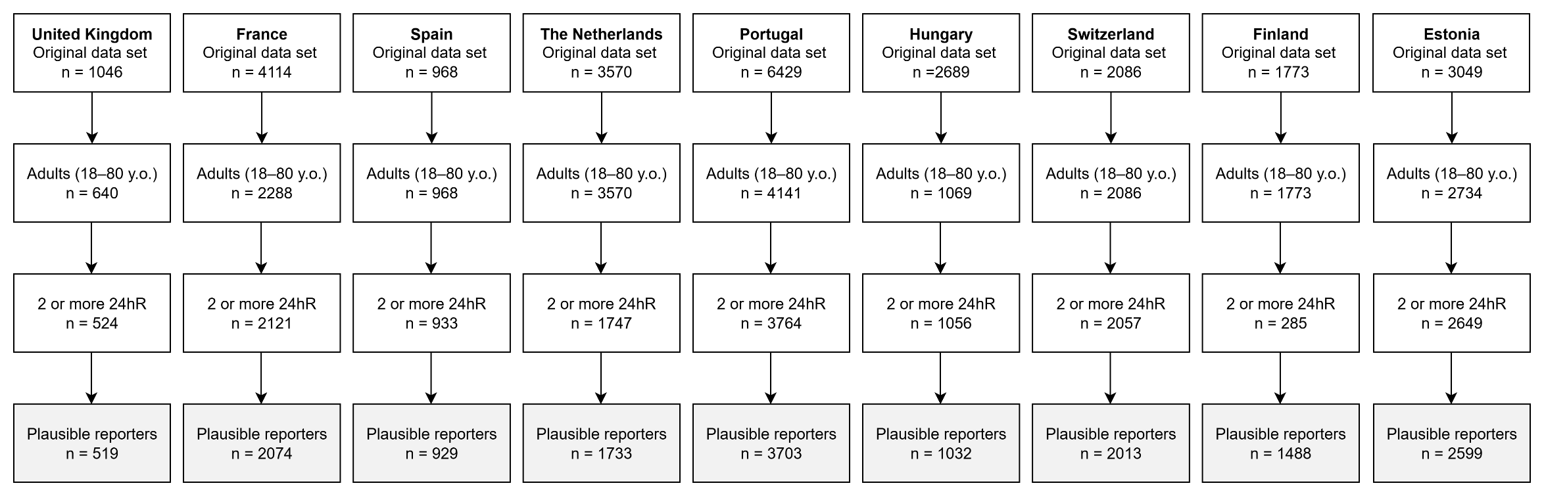

Figure S1. Sampling flow chart and sample size. Participants reporting extreme energy intakes (<800 or >4200 kcal/day for men; <600 or >3500 kcal/day for women) were considered as mis-reporters. 24hR = non-consecutive 24-hour dietary recalls.

Table S1. Number of Participants Excluded Due to Implausible Energy Intakes, by Country, Sex, and Age Group
 | Europe | UK | France | Spain | Netherlands | Portugal | Hungary | Switzerland | Finland | Estonia
Women/Age group [18:45[ | 47 | 1 | 8 | 0 | 4 | 5 | 4 | 8 | 0 | 17
Women/Age group [45:65[ | 40 | 1 | 7 | 0 | 2 | 11 | 2 | 4 | 1 | 12
Women/Age group [65:80[ | 18 | 0 | 2 | 1 | 1 | 8 | 1 | 1 | 1 | 3
Men/Age group [18:45[ | 79 | 1 | 14 | 2 | 3 | 23 | 10 | 17 | 2 | 7
Men/Age group [45:65[ | 47 | 0 | 11 | 1 | 3 | 11 | 5 | 9 | 2 | 5
Men/Age group [65:80[ | 25 | 2 | 5 | 0 | 1 | 3 | 2 | 5 | 1 | 6
Total | 256 | 5 | 47 | 4 | 14 | 61 | 24 | 44 | 7 | 50

Table S2. Survey Respondent Distribution by Country, Sex, and Age Group: Counts, Within-Group Proportions, and Country Weights
 | Europe | UK | France | Spain | Netherlands | Portugal | Hungary | Switzerland | Finland | Estonia
Total – Count | 16083 | 519 | 2074 | 929 | 1733 | 3703 | 1032 | 2013 | 1481 | 2599
Total – Survey Proportion | 100% | 3.23% | 12.90% | 5.78% | 10.78% | 23.02% | 6.42% | 12.52% | 9.21% | 16.16%
Total – Country Weight | 100% | 28.30% | 27.91% | 20.52% | 7.50% | 4.59% | 4.43% | 3.77% | 2.41% | 0.58%
Women – Count | 9025 | 301 | 1217 | 531 | 860 | 1970 | 521 | 1115 | 778 | 1732
Women – Survey Proportion | 100% | 3.34% | 13.48% | 5.88% | 9.53% | 21.83% | 5.77% | 12.35% | 8.62% | 19.19%
Women – Country Weight | 100% | 28.13% | 28.20% | 20.36% | 7.38% | 4.74% | 4.52% | 3.70% | 2.37% | 0.60%
Men – Count | 7058 | 218 | 857 | 398 | 873 | 1733 | 511 | 898 | 703 | 867
Men – Survey Proportion | 100% | 3.09% | 12.14% | 5.64% | 12.37% | 24.55% | 7.24% | 12.72% | 9.96% | 12.28%
Men – Country Weight | 100% | 28.47% | 27.62% | 20.69% | 7.62% | 4.44% | 4.34% | 3.83% | 2.44% | 0.56%
Age group [18:45[ – Count | 6397 | 193 | 761 | 449 | 433 | 1730 | 236 | 903 | 508 | 1184
Age group [18:45[ – Survey Proportion | 100% | 3.02% | 11.90% | 7.02% | 6.77% | 27.04% | 3.69% | 14.12% | 7.94% | 18.51%
Age group [18:45[ – Country Weight | 100% | 29.10% | 27.52% | 20.62% | 7.18% | 4.36% | 4.51% | 3.80% | 2.31% | 0.59%
Age group [45:65[ – Count | 5738 | 195 | 809 | 217 | 695 | 1322 | 272 | 776 | 553 | 899
Age group [45:65[ – Survey Proportion | 100% | 3.40% | 14.10% | 3.78% | 12.11% | 23.04% | 4.74% | 13.52% | 9.64% | 15.67%
Age group [45:65[ – Country Weight | 100% | 27.39% | 28.04% | 21.08% | 7.80% | 4.68% | 4.28% | 3.83% | 2.34% | 0.56%
Age group [65:80[ – Count | 3948 | 131 | 504 | 263 | 605 | 651 | 524 | 334 | 420 | 516
Age group [65:80[ – Survey Proportion | 100% | 3.32% | 12.77% | 6.66% | 15.32% | 16.49% | 13.27% | 8.46% | 10.64% | 13.07%
Age group [65:80[ – Country Weight | 100% | 28.07% | 28.65% | 19.14% | 7.73% | 5.01% | 4.50% | 3.54% | 2.78% | 0.60%
Women/Age group [18:45[ – Count | 3713 | 126 | 451 | 286 | 209 | 973 | 108 | 523 | 275 | 762
Women/Age group [18:45[ – Survey Proportion | 100% | 3.39% | 12.15% | 7.70% | 5.63% | 26.21% | 2.91% | 14.09% | 7.41% | 20.52%
Women/Age group [18:45[ – Country Weight | 100% | 29.06% | 27.89% | 20.42% | 7.15% | 4.46% | 4.42% | 3.76% | 2.25% | 0.57%
Women/Age group [45:65[ – Count | 3200 | 107 | 474 | 113 | 356 | 685 | 150 | 422 | 276 | 617
Women/Age group [45:65[ – Survey Proportion | 100% | 3.34% | 14.81% | 3.53% | 11.13% | 21.41% | 4.69% | 13.19% | 8.63% | 19.28%
Women/Age group [45:65[ – Country Weight | 100% | 27.34% | 28.29% | 20.88% | 7.65% | 4.84% | 4.36% | 3.75% | 2.31% | 0.58%
Women/Age group [65:80[ – Count | 2112 | 68 | 292 | 132 | 295 | 312 | 263 | 170 | 227 | 353
Women/Age group [65:80[ – Survey Proportion | 100% | 3.22% | 13.83% | 6.25% | 13.97% | 14.77% | 12.45% | 8.05% | 10.75% | 16.71%
Women/Age group [65:80[ – Country Weight | 100% | 27.43% | 28.75% | 19.22% | 7.43% | 5.20% | 5.02% | 3.49% | 2.78% | 0.70%
Men/Age group [18:45[ – Count | 2684 | 67 | 310 | 163 | 224 | 757 | 128 | 380 | 233 | 422
Men/Age group [18:45[ – Survey Proportion | 100% | 2.50% | 11.55% | 6.07% | 8.35% | 28.20% | 4.77% | 14.16% | 8.68% | 15.72%
Men/Age group [18:45[ – Country Weight | 100% | 29.14% | 27.15% | 20.82% | 7.20% | 4.27% | 4.60% | 3.84% | 2.36% | 0.60%
Men/Age group [45:65[ – Count | 2538 | 88 | 335 | 104 | 339 | 637 | 122 | 354 | 277 | 282
Men/Age group [45:65[ – Survey Proportion | 100% | 3.47% | 13.20% | 4.10% | 13.36% | 25.10% | 4.81% | 13.95% | 10.91% | 11.11%
Men/Age group [45:65[ – Country Weight | 100% | 27.43% | 27.79% | 21.29% | 7.95% | 4.51% | 4.20% | 3.92% | 2.37% | 0.54%
Men/Age group [65:80[ – Count | 1836 | 63 | 212 | 131 | 310 | 339 | 261 | 164 | 193 | 163
Men/Age group [65:80[ – Survey Proportion | 100% | 3.43% | 11.55% | 7.14% | 16.88% | 18.46% | 14.22% | 8.93% | 10.51% | 8.88%
Men/Age group [65:80[ – Country Weight | 100% | 28.80% | 28.54% | 19.05% | 8.07% | 4.79% | 3.90% | 3.59% | 2.78% | 0.48%

Table S3. Weighted proportions
 | Sex |  | Age |  |  | Education
Country | Women | Men | 18-44 | 45-64 | 65-80 | Lower | Higher
Europe | 50.84 | 49.16 | 46.72 | 35.52 | 17.76 | 58.02 | 41.98
United Kingdom | 50.56 | 49.44 | 46.89 | 34.92 | 18.18 | n/a | n/a
France | 51.34 | 48.66 | 46.32 | 36.16 | 17.52 | 56.65 | 43.35
Spain | 50.39 | 49.61 | 48.87 | 34.86 | 16.27 | 58.24 | 41.76
The Netherlands | 50.07 | 49.93 | 43.96 | 36.88 | 19.16 | 52.15 | 47.85
Portugal | 52.48 | 47.52 | 44.43 | 36.28 | 19.30 | 77.29 | 22.71
Hungary | 51.77 | 48.23 | 46.59 | 34.79 | 18.62 | 63.50 | 36.50
Switzerland | 50.04 | 49.96 | 46.53 | 36.56 | 16.91 | 50.97 | 49.03
Finland | 50.19 | 49.81 | 44.21 | 34.99 | 20.80 | n/a | n/a
Estonia | 53.01 | 46.99 | 47.88 | 34.50 | 17.62 | 43.66 | 56.34

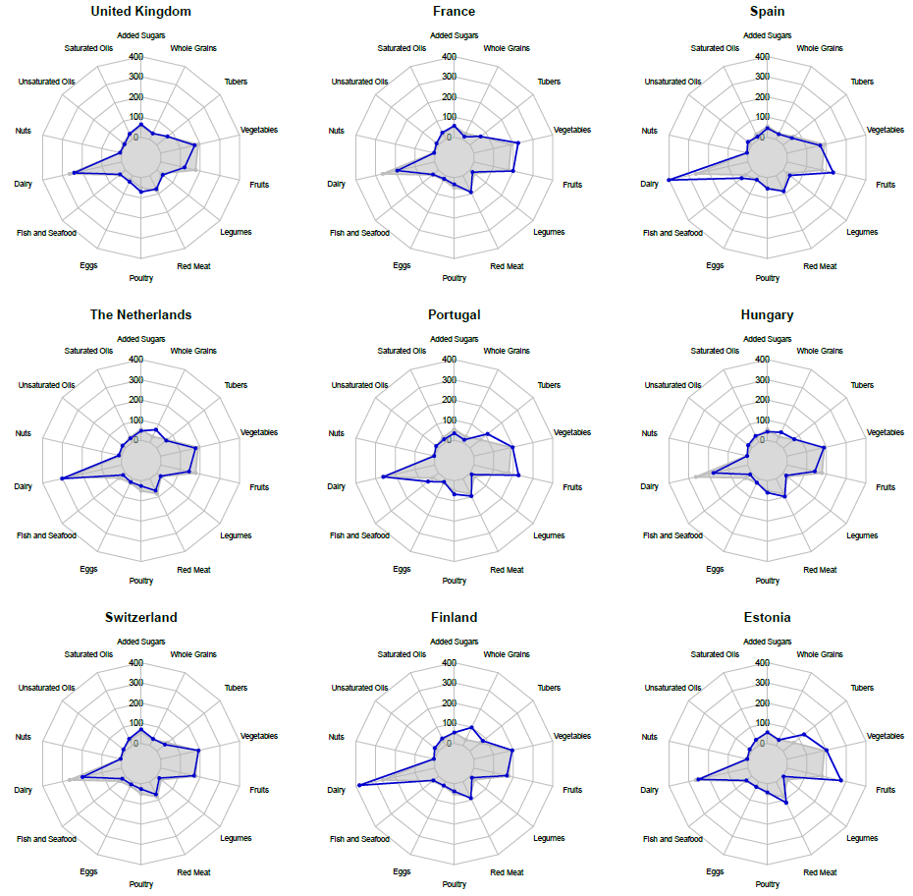
Figure S2. Daily individual food consumption (g/day). The grey area indicated in the figure corresponds to the aggregated European mean.

Table S4. EAT-Lancet reference diet, with possible ranges, for an intake of 2,500 kcal/day
Food components | Macronutrient intake (possible range), g/day | Caloric intake, kcal/day
Whole grains
Rice, wheat, corn, and other† | 232 (total gains 0–60% of energy) | 811
Tubers or starchy vegetables
Potatoes and cassava | 50 (0–100) | 39
Vegetables
All vegetables | 300 (200–600)
Dark green vegetables | 100 | 23
Red and orange vegetables | 100 | 30
Other vegetables | 100 | 25
Fruits
All fruit | 200 (100–300) | 126
Dairy foods
Whole milk or derivative equivalents (eg, cheese) | 250 (0–500) | 153
Protein sources
Beef and lamb | 7 (0–14) | 15
Pork | 7 (0–14) | 15
Chicken and other poultry | 29 (0–58) | 62
Eggs | 13 (0–25) | 19
Fish | 28 (0–100) | 40
Legumes
Dry beans, lentils, and peas | 50 (0–100) | 172
Soy foods | 25 (0–50) | 112
Peanuts | 25 (0–75) | 142
Tree nuts | 25 | 149
Added fats
Palm oil | 6.8 (0–6.8) | 60
Unsaturated oils | 40 (20–80) | 354
Dairy fats (included in milk) | 0 | 0
Lard or tallow | 5 (0–5) | 36
Added sugars
All sweeteners | 31 (0–31) | 120
Willett W, et al. Food in the Anthropocene: the EAT-Lancet Commission on healthy diets from sustainable food systems. Lancet. 2019;393(10170):447-492.

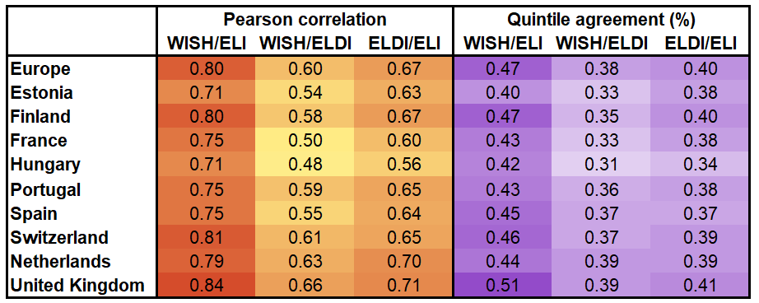

Figure S3. Correlation and agreement between indices.

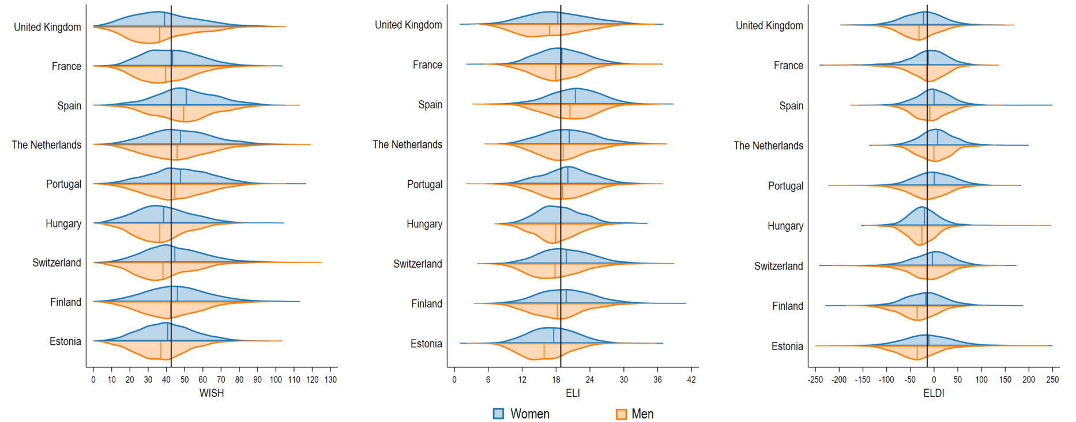
Figure S4. PHD indices according to sex in nine European countries. Lines inside the violins denotes means. Black lines represent European means.

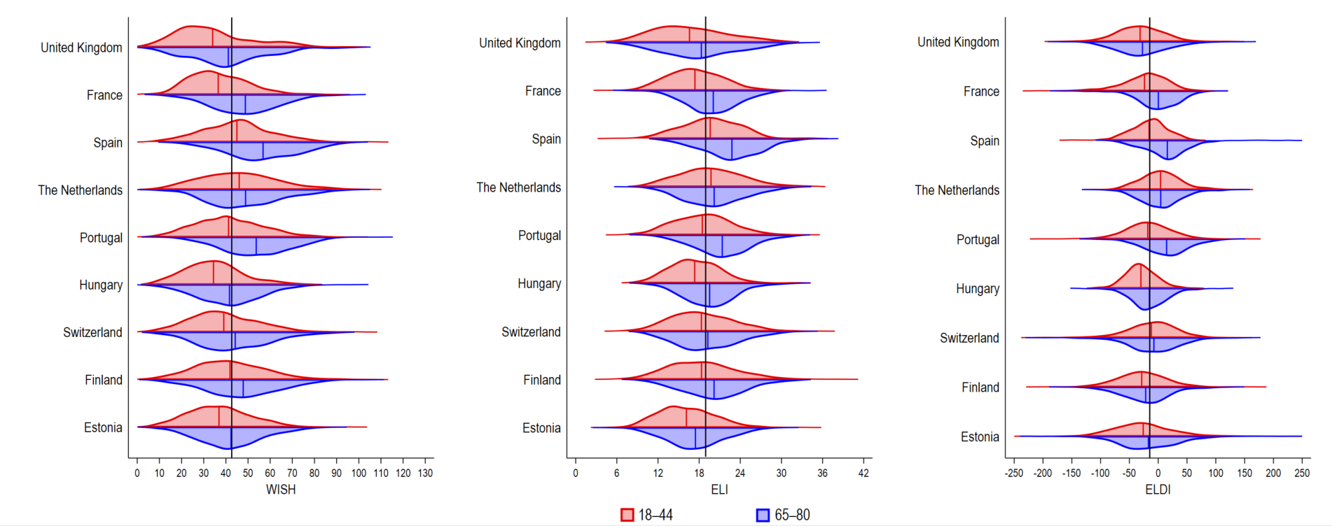
Figure S5. PHD indices according to age in nine European countries. Lines inside the violins denotes means. Black lines represent European means.

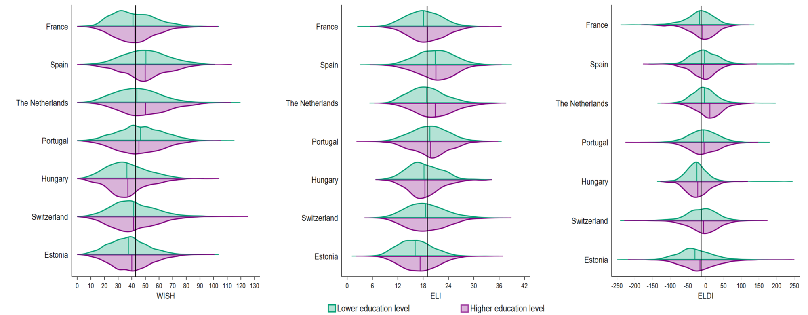
Figure S6. PHD indices according to education level in nine European countries. Lines inside the violins denotes means. Black lines represent European means.

Extended discussion: Heterogeneity in European food consumption
Marked heterogeneity in food consumption patterns across countries was found in the current study. For example, our findings reflect those of Price et al., who reported whole grain intakes ranging from 4.7 g/d in France to 63 g/d in Finland [1]. The high consumption in Finland is attributable to traditional foods such as rye bread and oatmeal, which are linked to improved health outcomes [2]. In contrast, nearly half of the French adults reported zero whole grain intake in previous research [3]. Regular whole grain intake is associated with improved health outcomes [4], supporting the value of interventions such as the French national promotion campaign of whole grains and legumes, which has shown particular benefits among lower socioeconomic groups [5].
Legume consumption was low in all countries, consistent with Hughes et al., who reported that no European country met the legume target, with more than one-third of countries reporting median intakes of less than 10 g/d [6]. Spain and the UK showed the highest legume intakes, likely reflecting the traditional dietary patterns [7]. Nuts were the least consumed food group, with a mean intake of 5.2 g/d, however the Netherlands reported more than double this average. These findings are consistent with those of the EPIC cohort [8] and recent data from Daas et al. [9], underscoring the importance of promoting nut intake, given its strong association with reduced risks of cardiovascular disease, cancer, and all-cause mortality [10].
Spain had the highest consumption of unsaturated oils and the lowest levels of saturated fats, whereas the UK and Switzerland exhibited low consumption of unsaturated oils and high levels of saturated fats. These patterns reflect regional differences, with Mediterranean countries favoring vegetable oils and Northern/Central Europe relying more on animal fats [11]. Replacing saturated fats with polyunsaturated fats reduces cardiovascular risk [12], and the environmental benefits of plant-based oils support the promotion of oilseed crops in dietary policies, considering ecological and economic factors [13].
Although fruit and vegetable consumption exceeded the global intake [14], they remained below the PHD targets [15]. The European vegetable intake (189.6 g/d) covered only 63% of the 300 g/d benchmark, and fruit intake (177.1 g/d) was also insufficient. The UK had the largest deficits, with previous estimates showing only 88 g of fruit and 140 g of vegetables consumed daily [16]. In Spain, low vegetable intake contrasted with relatively adequate fruit consumption, reflecting patterns observed in the ENRICA cohort, where only 2.75% of adults met the recommendation of three daily servings of vegetables [17].
Spain and Portugal rank among the highest in Europe for fish consumption, showing substantial adherence to the PHD recommendations [18]. In contrast, Hungary and the Netherlands have the lowest intakes, below the PHD benchmark. Fish consumption is especially low in Central and Eastern Europe, less than half the European average, and lowest in Hungary, where only 20% of adults eat fish monthly [19]. Low intake in the Netherlands reflects traditional diets favoring meat and potatoes [20], while limited access to the sea also contributes to the low intake in Central and Eastern Europe [19].
Overconsumption of foods to limit was common across countries. The average red meat intake was 82.5 g/d—nearly six times the recommended 14 g/d—with Estonia and Hungary having particularly high intakes. In Estonia, pork alone exceeded the PHD threshold by over 1,100%, reflecting the cultural preferences and agricultural policies. Traditional diets in both countries emphasize red meat, potatoes, refined grains, and processed fats [21,22]. Reducing red meat consumption remains challenging due to entrenched cultural, economic, and political factors, including subsidies that lower meat prices relative to plant-based foods [23,24]. In 2020, European per capita meat consumption was more than double the global average and is expected to remain stable until 2030 [25]. Addressing this requires integrated policies that align public health, environmental, and agricultural goals, such as the Farm-to-Fork strategy, although fragmented national dietary guidelines hinder implementation [26].
Intake of added sugars (54.6 g/d) and saturated fats (28.2 g/d) exceeded the PHD targets across all countries. Switzerland and the UK showed particularly high added sugar intake, consistent with reports of total and added sugars two to three times above the recommended limits [27,28]. In the UK, soft drinks account for roughly one-third of sugar intake, compared to 12% in Portugal [29]. Conversely, in Switzerland, sweets and pastries are the main sources of sugar [30]. Nearly 90% of Portuguese adults meet the WHO guideline of <10% energy from added sugars, explaining their closer alignment with the PHD targets [29]. Despite regulatory efforts, interventions such as taxation, front-of-pack labeling, and marketing restrictions remain inconsistently implemented across Europe, highlighting persistent systemic challenges and the need for stronger public health policies [31-33].
Transforming Europe’s food systems toward healthier and more sustainable diets requires coordinated cultural, structural, and behavioral changes, supported by multi-level and multi-sectoral governance with policy playing a central role. Coordinated action across all levels and sectors remains essential to overcome entrenched power imbalances and achieve meaningful change. Table S4 summarizes examples of actions that can support this transformation.

Table S5. Example multi-level and -sectoral actions that can promote healthier and more sustainable food choice architecture
 | Example Multi-Sectoral Actions
Micro-Level (community) | Utilising participatory governance approaches where communities can actively shape their food environments based on principles of food sovereignty.  - Supporting Local Solidarity-based Partnerships for Agroecology and Community Supported Agriculture [34]  - Territorial markets [35]
Meso-level (regional/national government) | Public bodies at a regional level as well as Member States can implement context-sensitive initiatives and policies to support local, healthier and more sustainable food systems.  - Disincentivising farming practices that deliver agroecosystem disservices, such as the use of chemical pesticides  - Incentivising farmers to adopt environmentally friendly practices that deliver agri-environment-climate public goods [36], including through the use of innovative land tenure agreements [37]  - Implementing innovative/dynamic public procurement approaches in public facilities such as providing healthier and more sustainable school meals [38]  - Designing zoning laws and providing governments the legal tools to create healthier food environments, such as the ‘No-Fry Zone’ policy at a local level in Ireland [103]  - Policies to protect vulnerable population groups from the harmful impact of food marketing [39]  - Removing VAT on fruits and vegetables [40]
Macro-level (EU) | Promote fairness and transparency in policy-making processes that ensures a level playing field for all key food system stakeholders to prevent corporate/regulatory capture [41].  - Disincentivising and preventing land grabbing [42]  - Phasing out incentives for red meat and dairy production  - Phasing out and disincentivizing farming practices that deliver agroecosystem disservices, such as the use of chemical pesticides in agriculture [43]  - Incentivisation of farming practices that deliver agri-environment-climate public goods [36,37]  - Universal free school meals that are healthy/sustainable  - Regulations against harmful food products, especially ultraprocessed foods (analogous to regulations for trans fats) [44]

Supplementary References
- Price EJ, Barrett EM, Batterham MJ, Beck EJ (2024) Exploring the reporting, intake and recommendations of primary food sources of whole grains globally: a scoping review. Br J Nutr. https://doi.org/10.1017/S0007114524002678
- Tammi R, Männistö S, Maukonen M, Kaartinen NE (2024) Whole grain intake, diet quality and risk factors of chronic diseases: results from a population-based study in Finnish adults. Eur J Nutr. https://doi.org/10.1007/s00394-023-03272-z
- Bellisle F, Hébel P, Colin J, Reyé B, Hopkins S (2014) Consumption of whole grains in French children, adolescents and adults. Br J Nutr. https://doi.org/10.1017/S0007114514002670
- Langmann F et al (2025) Plant-based diets, legumes, and prevalence of cardiometabolic risk factors in the NutriNet-Santé cohort. Eur J Nutr. https://doi.org/10.1007/s00394-025-03722-w
- Fassier P, Rabès A, Ducrot P, Serry AJ (2023) Impact of a French social marketing campaign promoting pulse and whole grain consumption: results from a longitudinal cohort study. Front Nutr. https://doi.org/10.3389/fnut.2023.1208824
- Hughes J, Pearson E, Grafenauer S (2022) Legumes-A Comprehensive Exploration of Global Food-Based Dietary Guidelines and Consumption. Nutrients. https://doi.org/10.3390/nu14153080
- Henn K, Goddyn H, Olsen SB, Bredie WL (2022) Identifying behavioral and attitudinal barriers and drivers to promote consumption of pulses: A quantitative survey across five European countries. Food Qual Prefer. https://doi.org/10.1016/j.foodqual.2021.104455
- Jenab M et al (2006) Consumption and portion sizes of tree nuts, peanuts and seeds in the European Prospective Investigation into Cancer and Nutrition (EPIC) cohorts from 10 European countries. Br J Nutr. https://doi.org/10.1017/bjn20061859
- Daas MC, van 't Veer P, Temme EHM, Kuijsten A, Gurinović M, Biesbroek S (2025) Diversity of dietary protein patterns across Europe - Impact on nutritional quality and environmental sustainability. Curr Res Food Sci. https://doi.org/10.1016/j.crfs.2025.101019
- Balakrishna R, Bjørnerud T, Bemanian M, Aune D, Fadnes LT (2022) Consumption of Nuts and Seeds and Health Outcomes Including Cardiovascular Disease, Diabetes and Metabolic Disease, Cancer, and Mortality: An Umbrella Review. Adv Nutr. https://doi.org/10.1093/advances/nmac077
- Bajželj B, Laguzzi F, Röös E (2021) The role of fats in the transition to sustainable diets. Lancet Planet Health. https://doi.org/10.1016/S2542-5196(21)00194-7
- Maki KC, Dicklin MR, Kirkpatrick CF (2021) Saturated fats and cardiovascular health: Current evidence and controversies. J Clin Lipidol. https://doi.org/10.1016/j.jacl.2021.09.049
- Meijaard E, Abrams JF, Slavin JL, Sheil D (2022) Dietary Fats, Human Nutrition and the Environment: Balance and Sustainability. Front Nutr. https://doi.org/10.3389/fnut.2022.878644
- Micha R, Khatibzadeh S, Shi P, Andrews KG, Engell RE, Mozaffarian D (2015) Global, regional and national consumption of major food groups in 1990 and 2010: a systematic analysis including 266 country-specific nutrition surveys worldwide. BMJ Open. https://doi.org/10.1136/bmjopen-2015-008705
- Willett W et al (2019) Food in the Anthropocene: the EAT–Lancet Commission on healthy diets from sustainable food systems. Lancet. https://doi.org/10.1016/s0140-6736(18)31788-4
- Eustachio Colombo P et al (2021) Pathways to "5-a-day": modeling the health impacts and environmental footprints of meeting the target for fruit and vegetable intake in the United Kingdom. Am J Clin Nutr. https://doi.org/10.1093/ajcn/nqab076
- Vega-Cabello V et al (2025) Adherence to the healthy and sustainable dietary recommendations for the Spanish population and all-cause mortality. Rev Esp Cardiol. https://doi.org/10.1016/j.rec.2024.11.008
- Miller V et al (2022) Global, regional, and national consumption of animal-source foods between 1990 and 2018: findings from the Global Dietary Database. Lancet Planet Health. https://doi.org/10.1016/S2542-5196(21)00352-1
- Shivarov A (2023) Fish and Seafood Markets in Central and Eastern Europe. Izvestia J Union Scientists-Varna Econ Sci Series. https://doi.org/10.56065/IJUSV-ESS/2023.12.1.123
- Waijers PM et al (2006) Dietary patterns and survival in older Dutch women. Am J Clin Nutr. https://doi.org/10.1093/ajcn/83.5.1170
- Mõttus R, Realo A, Allik J, Deary IJ, Esko T, Metspalu A (2012) Personality traits and eating habits in a large sample of Estonians. Health Psychol. https://doi.org/10.1037/a0027041
- Bárdos H et al (2022) Diet quality as assessed by Healthy Eating Index-2015 among Hungarian Roma living in settlements of Northeast Hungary. Sci Rep. https://doi.org/10.1038/s41598-022-23670-3
- Rust NA et al (2020) How to transition to reduced-meat diets that benefit people and the planet. Sci Total Environ. https://doi.org/10.1016/j.scitotenv.2020.137208
- Gu X, Bui LP, Wang F, Wang DD, Springmann M, Willett WC (2024) Global adherence to a healthy and sustainable diet and potential reduction in premature death. Proc Natl Acad Sci U S A. https://doi.org/10.1073/pnas.2319008121
- OECD, FAO (2021) OECD-FAO Agricultural Outlook 2021–2030. OECD Publishing, Paris. https://doi.org/10.1787/19428846-en
- Cué Rio M et al (2022) The elephant in the room is really a cow: using consumption corridors to define sustainable meat consumption in the European Union. Sustain Sci. https://doi.org/10.1007/s11625-022-01235-7
- Watson F, Modi M (2018) Fresh start: A framework for healthy and sustainable diets in the UK-Situational analysis. UK Health Forum 2018. https://ukhealthforum.org.uk/wp-content/uploads/2019/01/UKHF_situational_analysis_FINAL.pdf
- Linzmajer M, Eggenschwiler M, Bally L (2022) Der Schweizer Ernährungsatlas – Eine Schätzmethodik des Ernährungsverhaltens der Schweizer Bevölkerung basierend auf Einkaufsdaten. St.Gallen: Forschungszentrum für Handelsmanagement, Universität St.Gallen. https://www.alexandria.unisg.ch/server/api/core/bitstreams/b1adb76a-5d60-4755-bf70-ad214f19d4df/content
- Marinho AR et al (2020) Total, added and free sugar intakes, dietary sources and determinants of consumption in Portugal: the National Food, Nutrition and Physical Activity Survey (IAN-AF 2015-2016). Public Health Nutr. https://doi.org/10.1017/S1368980019002519
- Chatelan A, Gaillard P, Kruseman M, Keller A (2019) Total, Added, and Free Sugar Consumption and Adherence to Guidelines in Switzerland: Results from the First National Nutrition Survey menuCH. Nutrients. https://doi.org/10.3390/nu11051117
- Bottari F, Mark-Herbert C (2022) Development of uniform food information -the case of front of package nutrition labels in the EU. Arch Public Health. https://doi.org/10.1186/s13690-022-00915-1
- Leibinger A et al (2025) The impact of tiered soft drink taxes in Europe on mean sales-weighted sugar content of soft drinks: a quasi-experimental study. BMC Public Health. https://doi.org/10.1186/s12889-025-23331-w
- Royo-Bordonada MÁ, Capellán LM, Junquera-Abaitua C, López JV, Gómez SF (2023) Spain facing the challenge of regulating unhealthy food advertising. Lancet. https://doi.org/10.1016/S0140-6736(23)00724-9
- Stapleton SC (2019) Urgenci: international Network of community supported agriculture (urgenci.Net). J Agric Food Inf. 20, 196-205. https://doi.org/10.1080/10496505.2019.1630788
- IPES-Food (2024) Food from somewhere: Building food security and resilience through territorial markets. Brussels: International panel of experts on sustainable food systems. https://ipes-food.org/wp-content/uploads/2024/06/FoodFromSomewhere.pdf. Accessed 24 September 2025.
- Kam H, Potter C (2024) Who should deliver agri-environmental public goods in the UK? New land managers and their future role as public good providers. Land Use Policy, 139, 107072. https://doi.org/10.1016/j.landusepol.2024.107072
- European Commission (2019) Contracts 2.0. Co-Design of Novel Contract Models for Innovative Agri-Environment Climate Measures and Valorisation of Environmental Public Goods. https://cordis.europa.eu/article/id/442659-incentivising-farmers-to-adopt-greener-agriculture. Accessed 24 September 2025.
- Springmann M et al (2025) The health, environmental, and cost implications of providing healthy and sustainable school meals for every child by 2030: a global modelling study. Lancet Planet Health. https://doi.org/10.1016/j.lanplh.2025.06.002.
- No Fry Zone 4 Kids (2018) https://data.oireachtas.ie/ie/oireachtas/committee/dail/32/joint_committee_on_children_and_youth_affairs/submissions/2018/2018-08-22_submission-no-fry-zone-4-kids-committee_en.pdf. Accessed 24 September 2025.
- World Health Organization (2023) Launch of the WHO guideline on Policies to protect children from the harmful impact of food marketing. https://www.who.int/news-room/events/detail/2023/07/03/default-calendar/launch-of-the-who-guideline-on-policies-to-protect-children-from-the-harmful-impact-of-food-marketing. Accessed 24 September 2025.
- Springmann M et al (2025) A reform of value-added taxes on foods can have health, environmental and economic benefits in Europe. Nat Food, 6(2):161-169. https://doi.org/10.1038/s43016-024-01097-5.
- Kay S, Peuch J, Franco J (2015) Extent of Farmland Grabbing in the EU. European Parliament. https://www.europarl.europa.eu/RegData/etudes/STUD/2015/540369/IPOL_STU(2015)540369_EN.pdf. Accessed 24 September 2025.
- Liu et al (2022) Agroecosystem services: A review of concepts, indicators, assessment methods and future research perspectives. Ecological Indicators, 142:109218. https://doi.org/10.1016/j.ecolind.2022.109218
- European Commission (2019) Commission Regulation (EU) 2019/649 of 24 April 2019 amending Annex III to Regulation (EC) No 1925/2006 of the European Parliament and of the Council as regards trans fat, other than trans fat naturally occurring in fat of animal origin. https://eur-lex.europa.eu/legal-content/EN/TXT/?uri=CELEX:32019R0649. Accessed 24 September 2025.

