Genomic enabled two-stage analysis of high-throughput phenotyping data in crop variety trials using adaptive splines
J. De Faveri, A.M. Kelly, M.V. Paccapelo, J.T. Christopher, A.P Verbyla

Supplementary Material

Variance components from best models:

The variance components from the best models for each type of model fitted as presented below, in the format of asreml output. The best model, adaptive B-splines at both the genetic and Plot levels with a diagonal or unconstrained set of smoothing parameters (or variance parameters) is given in Table 4 of the paper.

NCSS
Translation invariant form: summary(CSS16cor2.asr)$varcomp
component std.error z.ratio bound %ch
spl(times, 16) 7.091157e-01 3.667794e-01 1.933357 P 0
Times 4.320309e-02 2.163532e-02 1.996878 P 0
ide+ide:idv(times)!corh(2)!cor -8.901158e-01 3.327623e-02 -26.749299 U 0
ide+ide:idv(times)!corh(2)_1 4.472821e-02 1.002817e-02 4.460257 P 0
ide+ide:idv(times)!corh(2)_2 9.880297e-06 1.799946e-06 5.489220 P 0
Plot+Plot:times!corh(2)!cor -6.906517e-01 6.255086e-02 -11.041442 U 0
Plot+Plot:times!corh(2)_1 1.351623e-02 3.171947e-03 4.261179 P 0
Plot+Plot:times!corh(2)_2 2.738167e-06 4.641084e-07 5.899844 P 0
vm(id, GRM1)+vm(id, GRM1):idv(times)!corh(2)!cor -8.600408e-01 4.341415e-02 -19.810151 U 0
vm(id, GRM1)+vm(id, GRM1):idv(times)!corh(2)_1 1.068879e-01 2.500703e-02 4.274314 P 0
vm(id, GRM1)+vm(id, GRM1):idv(times)!corh(2)_2 1.476824e-05 3.410520e-06 4.330201 P 0
ide:spl(times, 16)!spl(times, 16) 2.973763e-02 2.228946e-03 13.341568 P 0
Plot:spl(times, 16) 2.318400e-04 4.417231e-05 5.248536 P 0
vm(id, GRM1):spl(times, 16)!spl(times, 16) 1.784606e-02 1.381280e-03 12.919946 P 0
units!R 1.000000e+00 NA NA F 0

Not translation invariant form: summary(CSS16.asr)$varcomp
component std.error z.ratio bound %ch
spl(times, 16) 7.105996e-01 3.674945e-01 1.933633 P 0
Times 4.322267e-02 2.164844e-02 1.996572 P 0
id5 3.931267e-02 6.857866e-03 5.732493 P 0
id5:times!times 7.999711e-06 1.241625e-06 6.442938 P 0
Plot 1.915560e-03 9.431530e-04 2.031017 P 0
Plot:times 1.025087e-06 1.475760e-07 6.946163 P 0
vm(id, GRM1) 3.547402e-02 7.985456e-03 4.442329 P 0
vm(id, GRM1):times!times 5.770850e-06 1.153759e-06 5.001780 P 0
id5:spl(times, 16)!spl(times, 16) 2.997383e-02 2.242904e-03 13.363846 P 0
Plot:spl(times, 16) 2.315630e-04 4.286003e-05 5.402773 P 0
vm(id, GRM1):spl(times, 16)!spl(times, 16) 1.754377e-02 1.360163e-03 12.898284 P 0
units!R 1.000000e+00 NA NA F 0

Bspline (non adaptive)
summary(Bspl10.asr)$varcomp
#component std.error z.ratio bound %ch
#mbf(times) 12.19044185 6.253928278 1.949246 P 0
#Times 0.05330672 0.025608425 2.081609 P 0
#ide:mbf(times) 0.09151969 0.007778809 11.765257 P 0
#Plot:mbf(times) 0.04243100 0.002585017 16.414205 P 0
#vm(id, GRM1):mbf(times)!mbf(times) 0.23610193 0.018901154 12.491403 P 0
#units!R 1.00000000 NA NA F 0

Pspline (non adaptive)
Non translation invariant form: summary(Pspl13.asr)$varcomp

component std.error z.ratio bound %ch
mbf(times) 2.243709e+00 1.254417e+00 1.788647 P 0
Times 3.755593e-02 1.785670e-02 2.103184 P 0
id5 1.841290e-02 3.735631e-03 4.928993 P 0
id5:times!times 2.214434e-06 4.911194e-07 4.508952 P 0
Plot 1.835684e-03 9.187452e-04 1.998034 P 0
Plot:times 8.142891e-07 1.174505e-07 6.933042 P 0
vm(id, GRM1) 1.763218e-02 5.389935e-03 3.271317 P 0
vm(id, GRM1):times!times 2.203757e-06 5.976674e-07 3.687263 P 0
id5:mbf(times)!mbf(times) 6.736974e-02 5.489236e-03 12.273065 P 0
Plot:mbf(times) 5.392360e-04 9.445234e-05 5.709080 P 0
vm(id, GRM1):mbf(times)!mbf(times) 4.582684e-02 3.423634e-03 13.385439 P 0
units!R 1.000000e+00 NA NA F 0

Bspline (adaptive at Plot level)
summary(Bspl11diag.asr)$varcomp
# component std.error z.ratio bound %ch
#mbf(times) 1.080544e+01 5.127258698 2.1074491 P 0
#Times 3.849056e-02 0.019064782 2.0189352 P 0
#ide:mbf(times) 2.636018e-02 0.003018465 8.7329758 P 0
#Plot:mbf(times)!mbf(times)_times.1 1.278956e-03 NA NA B 0
#Plot:mbf(times)!mbf(times)_times.2 4.551242e-08 NA NA B NA
#Plot:mbf(times)!mbf(times)_times.3 6.330521e-01 0.096263342 6.5762534 P 0
#Plot:mbf(times)!mbf(times)_times.4 1.946243e-01 0.024202693 8.0414296 P 0
#Plot:mbf(times)!mbf(times)_times.5 3.235531e-07 NA NA B 0
#Plot:mbf(times)!mbf(times)_times.6 6.466371e-03 0.002813621 2.2982386 P 0
#Plot:mbf(times)!mbf(times)_times.7 7.953474e-02 0.015705811 5.0640323 P 0
#Plot:mbf(times)!mbf(times)_times.8 1.529655e-02 0.004902717 3.1200143 P 0
#Plot:mbf(times)!mbf(times)_times.9 1.476729e-01 0.013018705 11.3431333 P 0
#Plot:mbf(times)!mbf(times)_times.10 8.627045e-01 0.052573198 16.4095877 P 0
#Plot:mbf(times)!mbf(times)_times.11 5.721238e-03 0.003036504 1.8841532 P 0
#Plot:mbf(times)!mbf(times)_times.12 3.925702e-03 0.004398091 0.8925922 P 0
#Plot:mbf(times)!mbf(times)_times.13 6.350521e-02 0.088113356 0.7207217 P 0
#vm(id, GRM1):mbf(times)!mbf(times) 5.411785e-02 0.006127752 8.8315998 P 0
#units!R 1.000000e+00 NA NA F 0

The following Figures provide additional information on the data and the models fitted.

Figure S1 presents the raw data, but in addition colours the profiles according to the family in the NAM population. Figure S2 separates out the raw data into family groups.

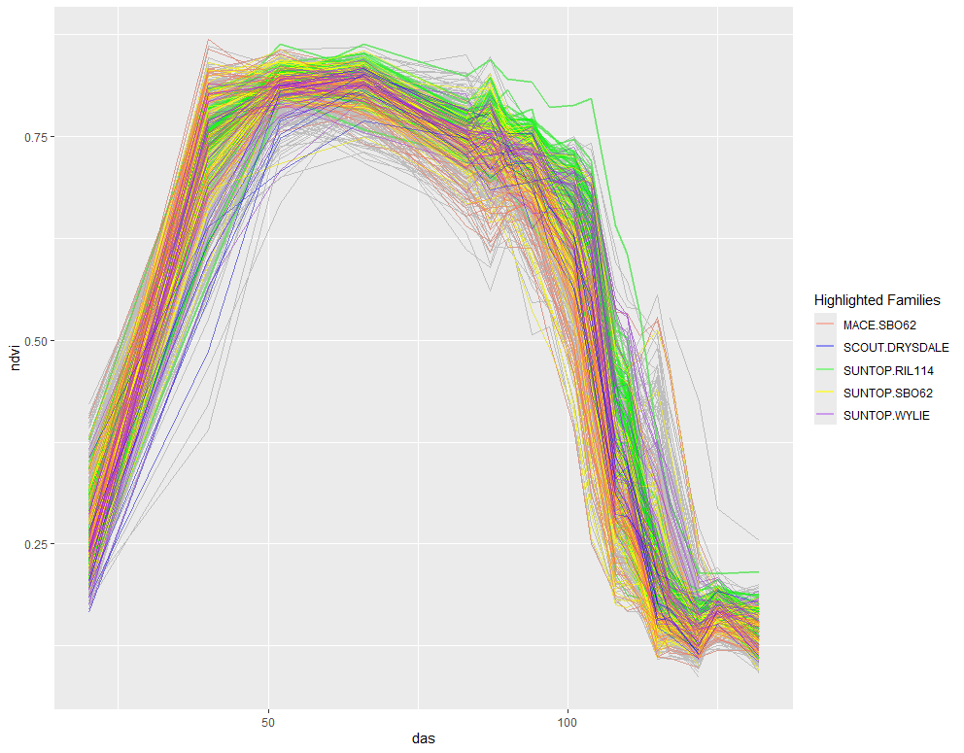

Fig S1: Raw ndvi data for each Plot with the same families highlighted as in Figures 8 & 9.

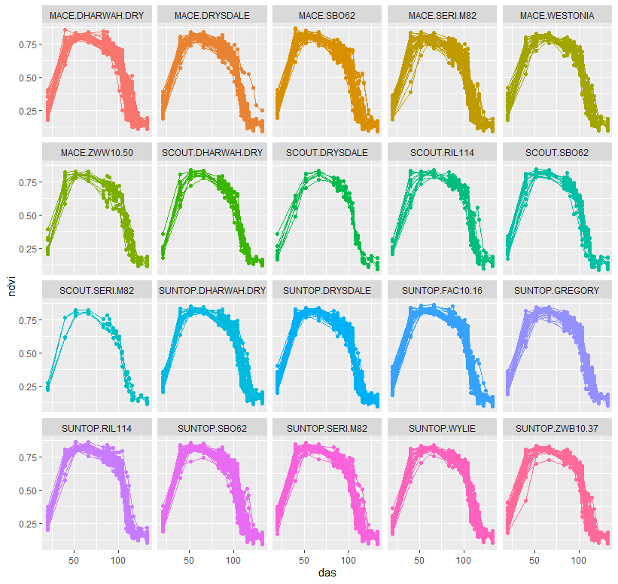
Fig S2: Raw ndvi profiles for each Plot in Family groups

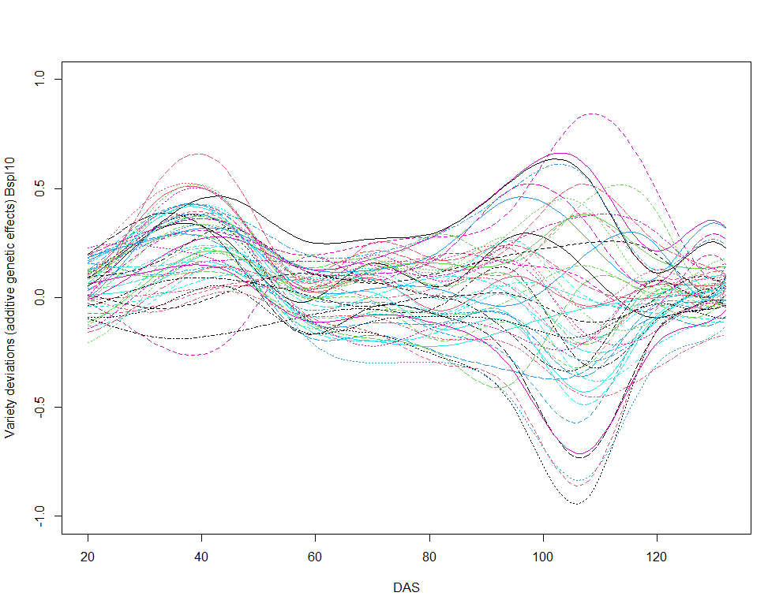
Fig S3: Bspline10 for 50 randomly selected varieties
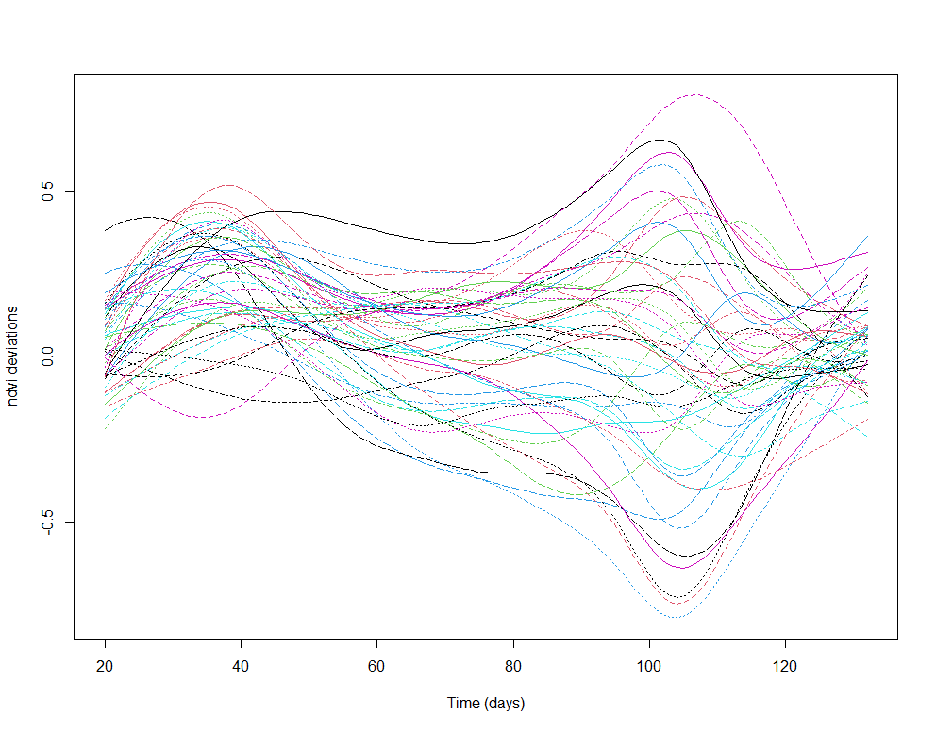
Fig S4: Pspl13 for the same 50 randomly selected varieties
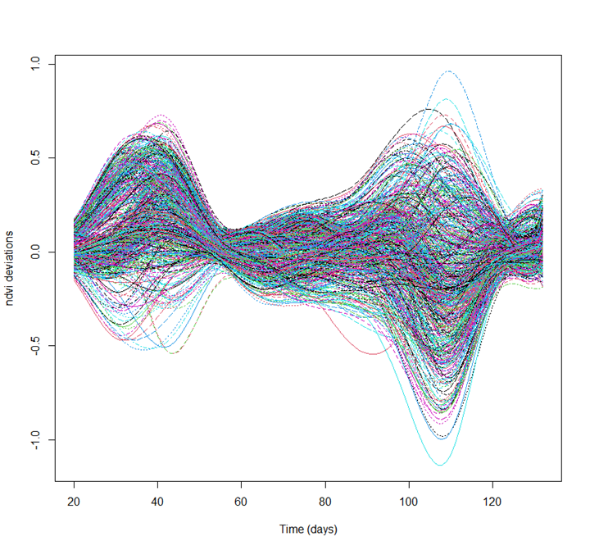
Fig S5: Bspl11diag_all for all 589 NAM varieties adaptive for all genetic and Plot components
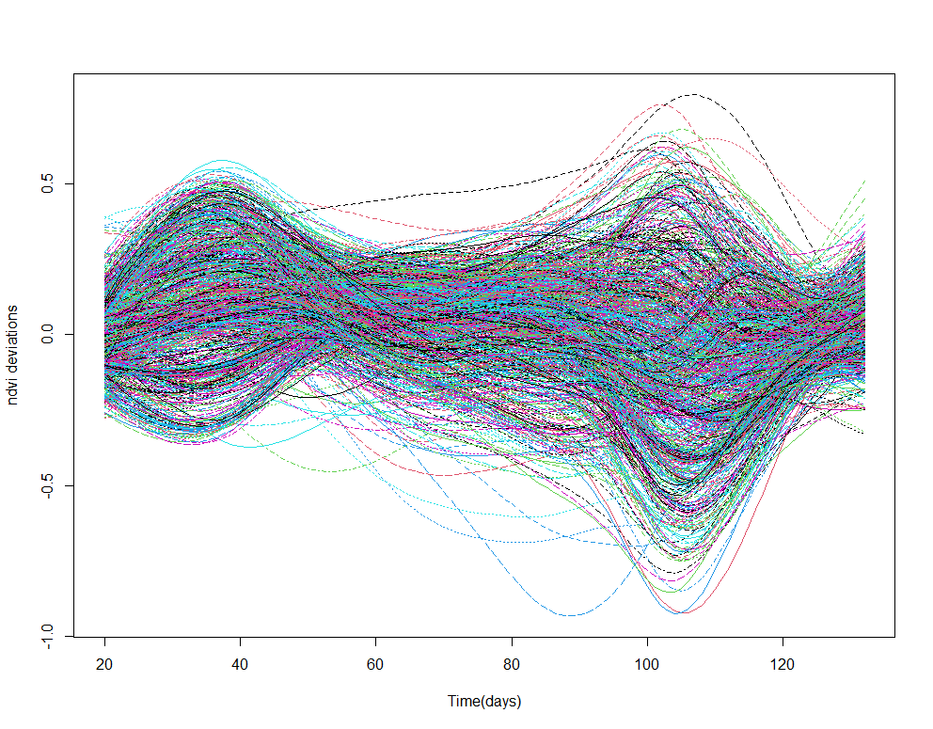
Fig S6: Pspl13 for all 589 NAM varieties

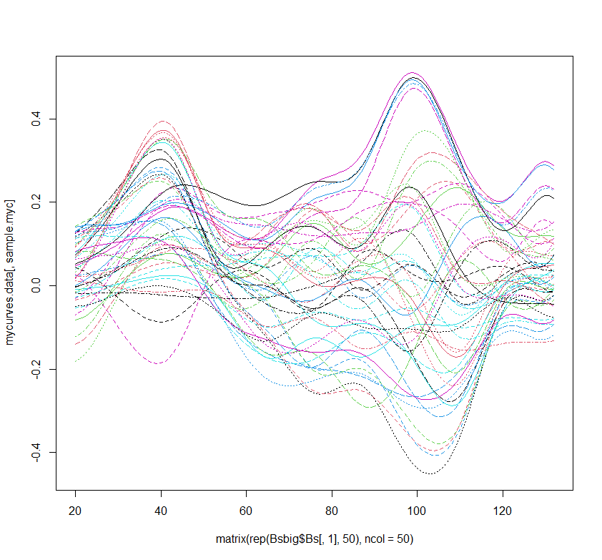
Fig S7: Bspldiag11 for same 50 randomly selected varieties adaptive only for the Plot level
This plot shows the issues with just allowing the residual or Plot spline variances to be adaptive (and not all components)– this clearly is causing the genetic components to differ in variance and value from both the Bspl10 non-adaptive and the Bspline11diag_all fully adaptive model. Because we have modelled the genetic effects using non-adaptive splines with common variance this is affecting the genetic effect estimates.

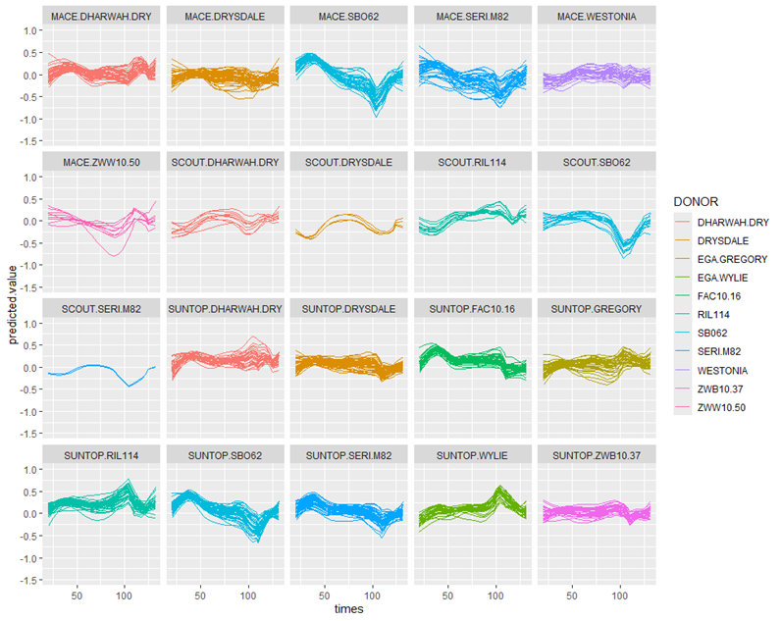

Fig S8: Predictions from best NCSS CSS16cor.asr in family groups coloured by Donor

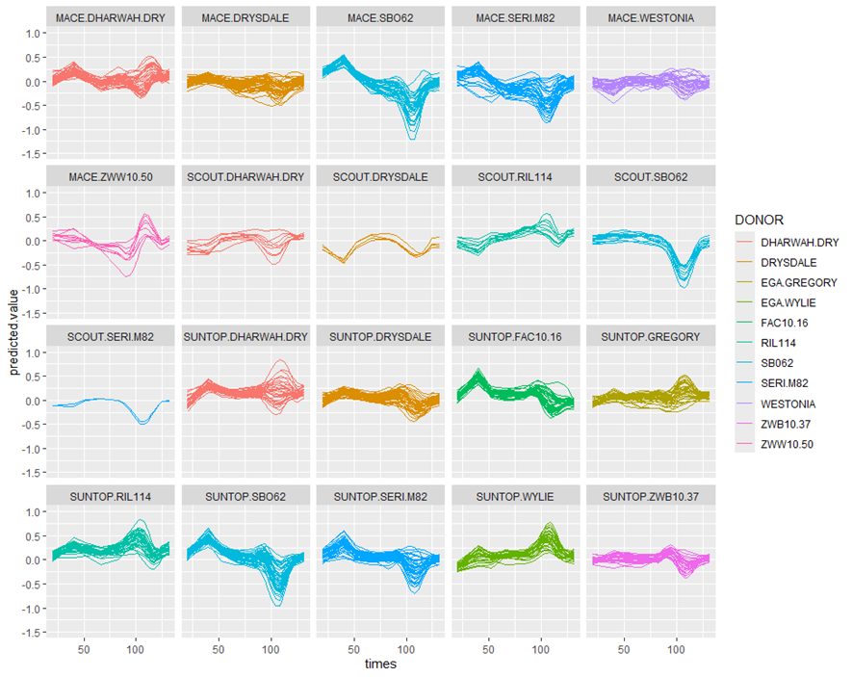
Fig S9: Bspl10 (best non adaptive)
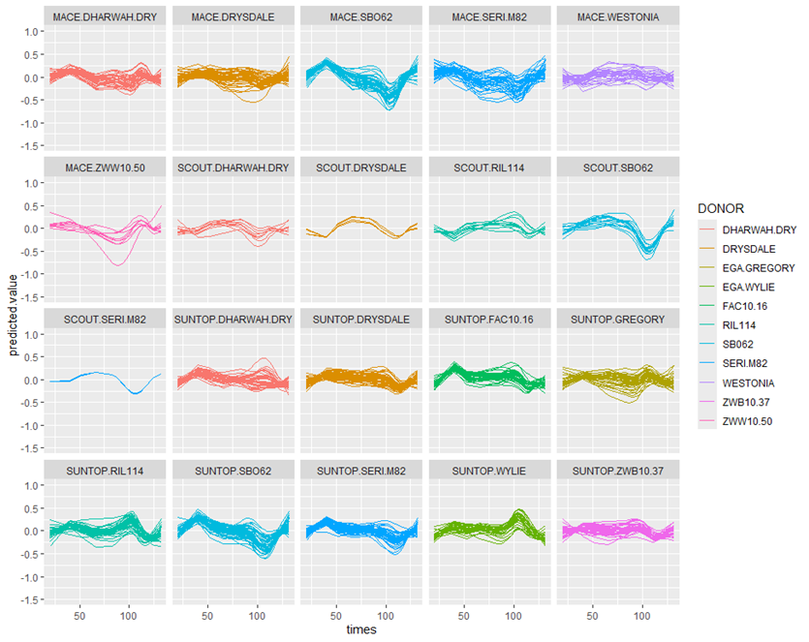
Fig S10: Pspl13 (best non adaptive Pspline)

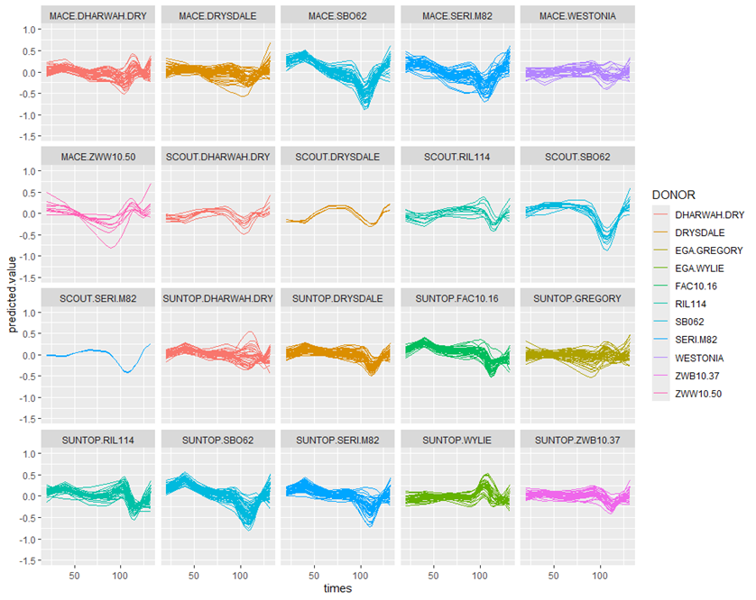
Fig S11: Pspl18diag_all (best adaptive Pspline)

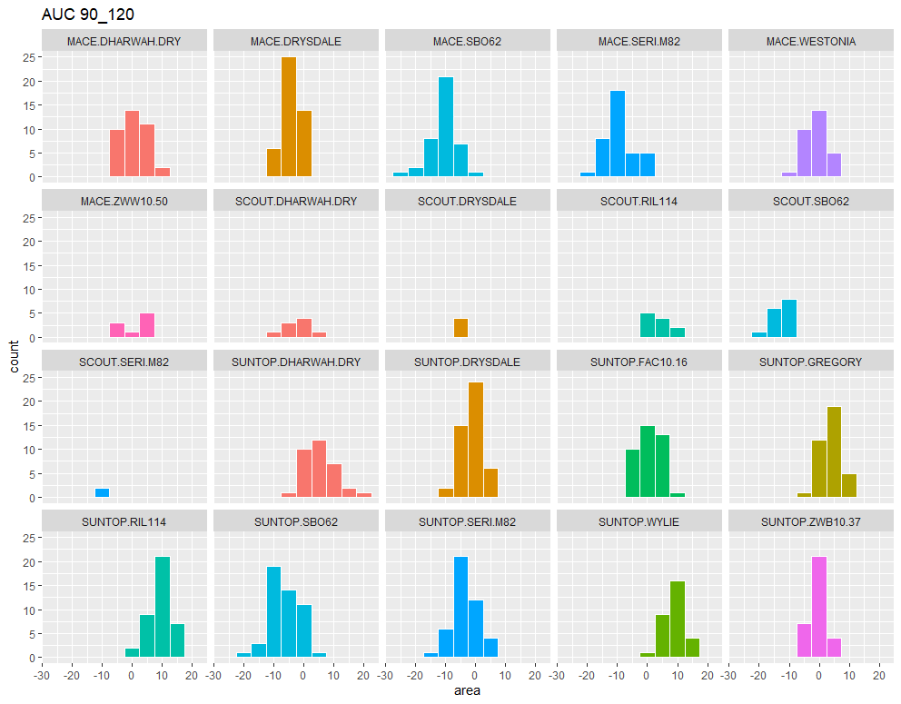
Fig S12: AUC for DAS 90_120
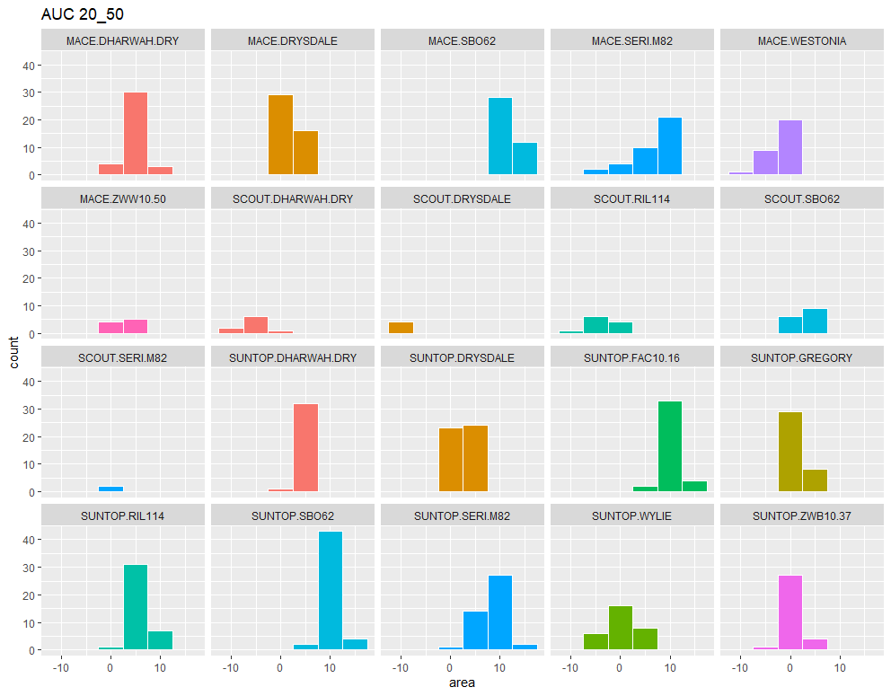
Fig S13: AUC for DAS 20_50

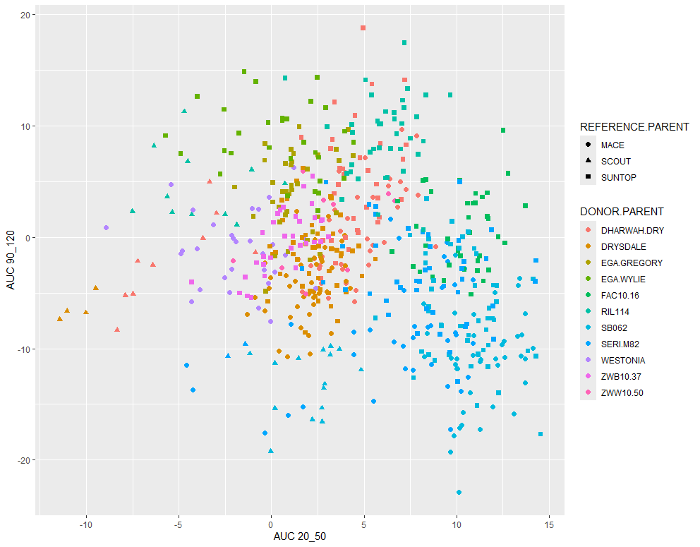
Fig S14: AUC for late (DAS 90-120) vs early (DAS 20-50)

