Supplementary Tables

Patient/sample characteristics | Solid  Tumours  (n=31) | Haematological  Malignancies (n=23)
Age (years)  Range  Mean (SD) | 0-17.5  6.6 (5.3) | 0-15.3  7.3 (4.7)
Sex  Male  Female | 17 (55%)  14 (45%) | 17 (74%)  6 (26%)
Collection  Prospective  Retrospective | 14 (45%)  17 (55%) | 21 (91%)  2 (9%)
Timepoint  Diagnosis  Relapse  Remission | 29 (94%)  2 (6%) | 19 (86%)  2 (7%)  2 (7%)
Sample  Paired tumour +  germline  Tumour only  Germline only | 30 (97%)  1 (3%) | 2 (9%)  20 (87%)  1 (4%)

Supplementary Table 1: Study recruitment. (A) Demographics of the overall cohort by solid and haematological malignancies. SD, standard deviation.

Pt ID | Diagnosis | Discrepant variant | VAF | Detected by | Reason for discrepancy
29 | Colorectal carcinoma | APC: c.2413C>T; p.(Arg805Ter) | 0.37 | UF | Intratumoural heterogeneity, different slices sequenced by each platform
29 | Colorectal carcinoma | APC: c.3340C>T; p.(Arg1114Ter) | 0.33 | UF
29 | Colorectal carcinoma | PIK3CA: c.1357G>A; p.(Glu453Lys) | 0.24 | UF
29 | Colorectal carcinoma | PIK3CA: c.1633G>A; p.(Glu545Lys) | 0.31 | UF
29 | Colorectal carcinoma | KRAS: c.38G>A; p.(Gly13Asp) | 0.26 | UF
29 | Colorectal carcinoma | APC: c.875dupT; p.Leu292PhefsTer4 | 0.2 | GMS
29 | Colorectal carcinoma | APC: c.3814dupT; p.Ser1272PhefsTer4 | 0.23 | GMS
29 | Colorectal carcinoma | TP53: c.527G>A; p.Cys176Tyr | 0.27 | GMS
1 | B-ALL | NRAS: c.182A>T;p.Gln61Leu | 7.00E-02 | GMS | Low VAF, different pulls from bone marrow sample
1 | B-ALL | ETV6: c.1193_1195delinsCGGAG; p.Leu398ProfsTer8 | 0.06 | GMS | Low VAF, different pulls from bone marrow sample
3 | B-ALL | NRAS: c.35G>A;p.Gly12Asp | 0.06 | GMS | Low VAF, different pulls from bone marrow sample
8 | B-ALL | NRAS: c.38G>A;p.(Gly13Asp) | 0.05 | UF | Low VAF, different pulls from bone marrow sample
10 | B-ALL | PTEN: c.517C>T;p.Arg173Cys | 0.08 | GMS | Low VAF, different pulls from bone marrow sample
15 | B-ALL (relapsed) | U2AF1: c.104G>T;p.Arg35Leu | 0.19 | UF | Low VAF, different pulls from bone marrow sample
17 | AML | U2AF1: c.101C>T;p.Ser34Phe | 0.19 | UF | Low VAF, different pulls from bone marrow sample
Supplementary Table 2: List of the 15 variants from 7 patients that were discordantly identified between UF and GMS. B-ALL, B-cell acute lymphoblastic leukaemia; AML, acute myeloid leukaemia; VAF, variant allele frequency.

 | Pt ID | Clinical presentation | Time-point | UF-WGS-guided potential change in management
Avoidance of harmful treatment | Treatment de-escalation/avoidance
Avoidance of harmful treatment | 22 | Soft tissue lesions | Diagnosis | Normal genome (somatic and germline)  Diagnosis: fat necrosis, would allow observation only
Avoidance of harmful treatment | 49 | Soft tissue lesion,  interscapular | Diagnosis | Germline ACVR1 variant  Diagnosis: Fibrodysplasia Ossificans Progressiva, could avoid surgery and chemotherapy, both potentially mutilating
Avoidance of harmful treatment | 8 | B-ALL | Diagnosis | IGH-Dux4 rearrangement  Could have non-escalation of treatment with positive MRD at end of induction
Avoidance of harmful treatment | 16 | Leukaemia &  renal mass | Diagnosis | No germline Wilms Tumour predisposition  Renal mass could be treated as leukemic deposit, avoiding biopsy
Rapid molecular data driving precision medicine | Accelerated diagnosis and guided treatment
Rapid molecular data driving precision medicine | 59 | Renal tumour | Relapse | Molecular features of RCC and Wilms  Could allow early Wilms directed treatment only, avoiding nephrectomy
Rapid molecular data driving precision medicine | 66 | Mediastinal mass,  patient in extremis | Diagnosis | T-lymphoblastic lymphoma diagnosed on pleural fluid  Could permit lymphoma directed treatment, with rapid excellent clinical response expected, avoiding toxicity
Rapid molecular data driving precision medicine | 68 | Neonate with  myeloid blasts | Diagnosis | GATA1 somatic and Trisomy21 germline mutations  Could have TAM directed treatment rather than AML
Rapid molecular data driving precision medicine | Improved risk stratification to guide treatment
Rapid molecular data driving precision medicine | 9 | AML | Diagnosis | KMT2A rearrangement  Would stratify as high-risk at presentation, plan for early HSCT
Rapid molecular data driving precision medicine | 13 | MPAL | Relapse
Rapid molecular data driving precision medicine | Targeted treatment
Rapid molecular data driving precision medicine | 24 | Papillary thyroid  carcinoma | Diagnosis | BRAF V600E and PIK3CA variants  Would allow targeted treatment of incompletely resected tumour
Rapid molecular data driving precision medicine | 28 | Pilocytic astrocytoma | Diagnosis | BRAF fusion  Could enrol on targeted therapy trial (Tovorafenib, Firefly2)
Rapid molecular data driving precision medicine | 52 | Pancreatic acinic  cell carcinoma | Diagnosis | BRAF fusion with novel partner  Would be eligible for targeted treatment with MEK inhibitor
Rapid molecular data driving precision medicine | 60 | B-ALL | Diagnosis | BCR-ABL fusion  Tyrosine kinase inhibtor could be initiated very early in treatment
Rapid molecular data driving precision medicine | Germline analysis
Rapid molecular data driving precision medicine | 14 | MPAL | Diagnosis | No germline bone marrow failure variants  Would have standard HSCT conditioning (not reduced-intensity)
Rapid molecular data driving precision medicine | 21 | Renal tumour | Diagnosis | Radiologically consistent with Wilms Tumour  No germline predisposition,  would allow non-biopsy and complete nephrectomy post neo-adjuvant chemotherapy
Rapid molecular data driving precision medicine | 27 | Nasopharyngeal  carcinoma | Diagnosis | No variant in DPYD gene  5-fluorouracil dosing would be pharmacogenomically guided
Rapid molecular data driving precision medicine | 26 | Pineoblastoma | Diagnosis | Germline DICER1 variant | Would avoid ionising radiation from diagnosis where feasible
Rapid molecular data driving precision medicine | 29 | Colorectal carcinoma | Diagnosis | CMMRD  Germline MSH6 variant | Would avoid ionising radiation from diagnosis where feasible

Supplementary Table 3: Clinical impact of UF-WGS. List of prospectively analysed patients with a potential change in management guided by rapid molecular information from UF-WGS.
Abbreviations: Pt ID, patient identification, B-ALL, B-cell acute lymphoblastic leukaemia; MRD, minimal residual disease; RCC, renal cell carcinoma; TAM, transient abnormal myelopoiesis; AML, acute myeloid leukaemia; MPAL, mixed phenotype acute leukaemia; HSCT, haematopoietic stem cell transplant; CMMRD, congenital mismatch repair defect

Supplementary Table 4: All patients with a potential for change in clinical management as a result of rapid precision molecular diagnostics

Supplementary Table 5: All patients in the cohort, including demographics, diagnosis, clinically actionable variants and the platforms by which they were detected.

Supplementary Table 6: Gene lists applied for prioritisation of variants in the UF-WGS workflow for solid tumours (Supp Table 6A), haematological malignancies (Supp Tabel 6B) and germline variants (Supp Table 6C).

Supplementary Figures
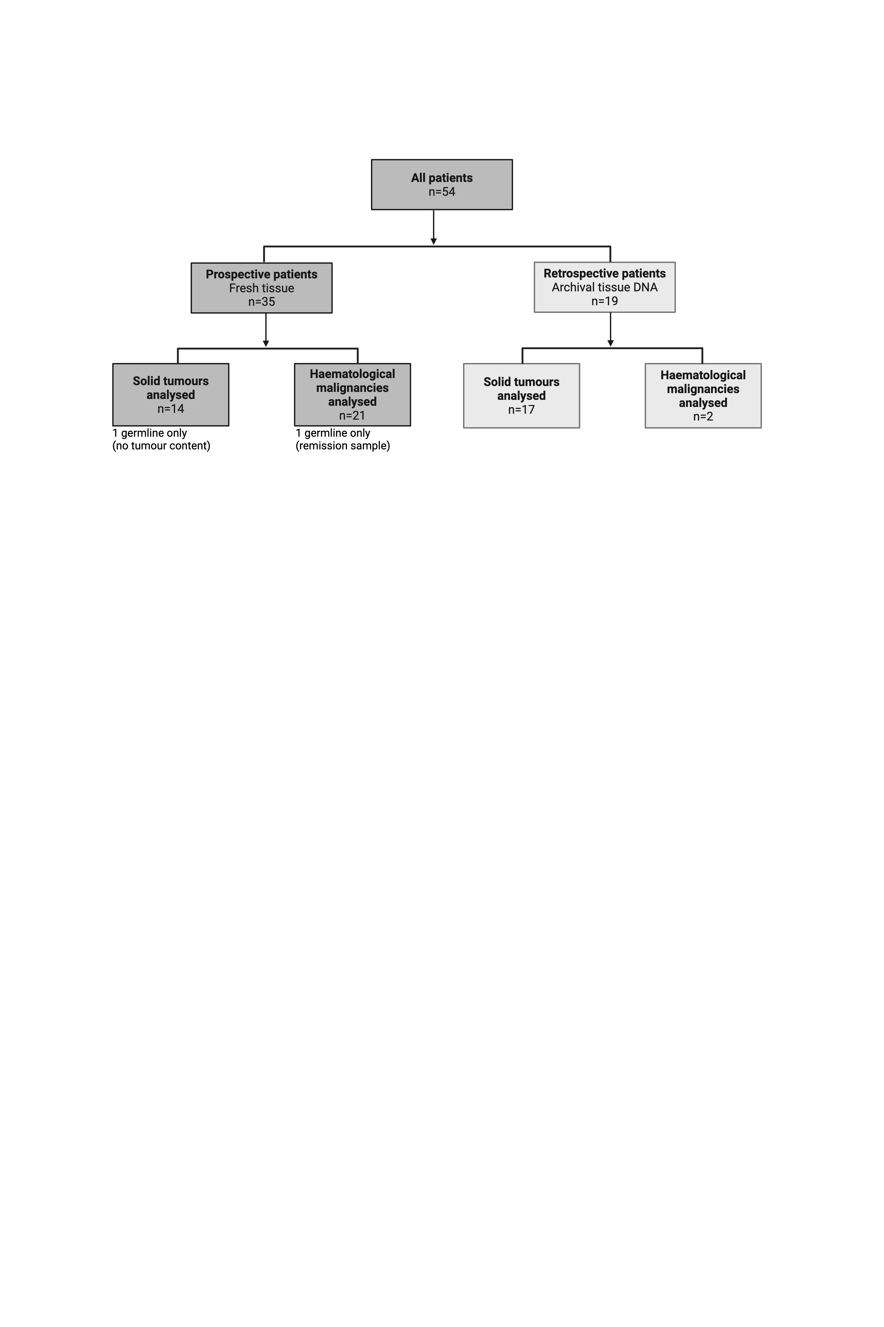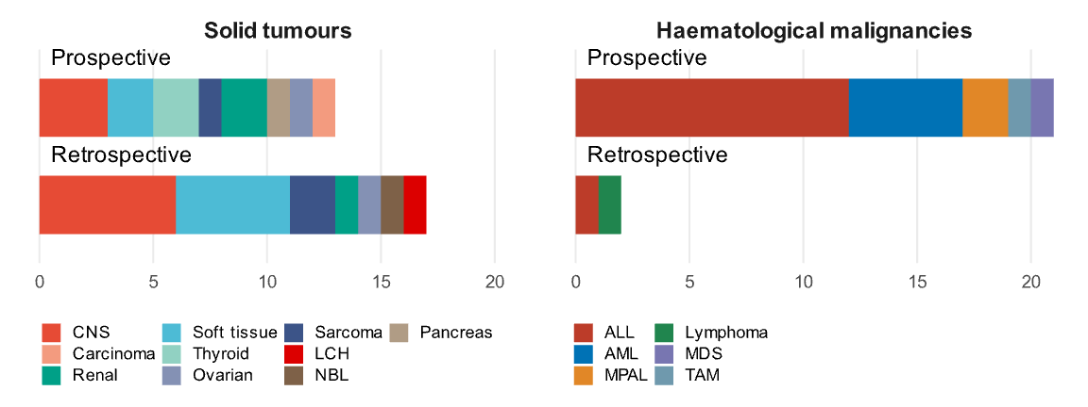
B
A

Supplementary Figure 1: Study design, with 54 patients recruited overall. (A) Prospective patients were recruited at presentation and retrospective patients were selected for availability of archival DNA and GMS-WGS results. (B) Bar plots showing a range of diagnostic groups represented in patients with solid tumours and haematological malignancies in prospective and retrospectively recruited patients. Individual patient information available in Supplementary Table 1. CNS, central nervous system; LCH, Langerhans cell histiocytosis; ALL, acute lymphoblastic leukaemia; AML, acute myeloid leukaemia; MPAL, mixed phenotype acute leukaemia; TAM, transient abnormal myelopoiesis; MDS, myelodysplastic syndrome.

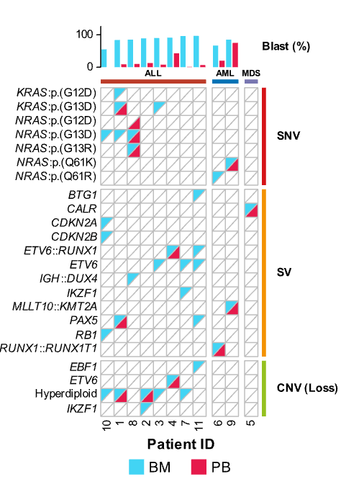
Supplementary Figure 2: Oncoplot showing clinically actionable variants (left) grouped by variant type (right) detected by UF-WGS in the bone marrow (BM) and peripheral blood (PB) from 11 children with haematological malignancies. Blast % is shown in the top bar and is calculated based on flow cytometry of BM samples.

Supplementary Figure 3: Additional insights specific to novel Illumina Constellation technology.
(A) Using an experimental somatic proximity pipeline, Constellation closes coverage gaps in high homology NUTM2D gene. Reads with mapping quality >20 are shown. IDPF, Illumina DNA PCR-free library preparation protocol (standard). (B) Reciprocal ATXN1::NUTM2D fusion in Patient 46 confirmed with long range interactions obtained from flowcell proximity data. Fused regions in both derivative chromosomes are represented as darker-shaded areas of the plot. Breakpoint positions: chr6:16303813-chr10:87364730 (ATXN1::NUTM2), chr10:87362944-chr6:16303450 (NUTM2::ATXN1).

