Supplementary Information
Nano-spectroscopy of excitons in atomically thin transition metal dichalcogenides

Shuai Zhang, Baichang Li, Xinzhong Chen, Francesco L. Ruta, Yinming Shao, Aaron J. Sternbach, A. S. McLeod, Zhiyuan Sun, Lin Xiong, S. L. Moore, Xinyi Xu, Wenjing Wu, Sara Shabani, Lin Zhou, Zhiying Wang, Fabian Mooshammer, Essance Ray, Nathan Wilson, P.J Schuck, C. R. Dean, A. N. Pasupathy, Michal Lipson, Xiaodong Xu, Xiaoyang Zhu, A. J. Millis, Mengkun Liu, James C. Hone, D.N. Basov*

* Corresponding email: db3056@columbia.edu
This file includes:
Materials and Methods
Supplementary Note
Supplementary Figs. 1-6
References

Materials and Methods
- Sample preparation
Monolayers of WSe₂, MoSe₂ and 30 nm thick BN were exfoliated onto SiO₂/Si using the standard scotch tape method. To prepare the heterostructure sample, a polydimethylsiloxane (PDMS) stamp was coated with thin polypropylene carbonate (PPC) film and subsequently attached onto a glass slide. Inverted stacking was performed on a dry transfer station with a rotatable heating stage. Thick BN and monolayers of WSe₂ and MoSe₂ were picked up subsequently, with controlled alignment. Finally, the heterostructure with PPC was peeled off from the PDMS and transferred to a clean SiO₂/Si substrate at 120 °C. The twist angle of the heterostructure is determined by the second harmonic generation spectra from individual layers and their overlap region.
- Near-field measurement
The nano-imaging was performed using a commercial scattering-type scanning near-field optical microscope (s-SNOM) (www.neaspec.com) based on a tapping-mode atomic force microscope (AFM). The tapping frequency and amplitude of the AFM are about 75 kHz and 50 nm, respectively. The light source is a tunable continuous laser from M Squared, including single frequency CW-532 nm module (EQUINOX), continuous-wave Ti-sapphire model with output range 700 nm-1000 nm (SolsTiS), and frequency mixing module with tunable output range 1100 nm-2200 nm (DFG-532). By focusing the laser beam onto the metallized AFM tip, we were able to probe the optical properties with subwavelength resolution. To this end, the back-scattered light is registered by pseudo-heterodyne interferometric detection and then demodulated at the n-th harmonics of the tapping frequency yielding background-free images. To eliminate the background, we chose n = 5 in this work. In addition to the background elimination, the high harmonic signal can also reduce the detection depth, which is essential to detect the atomically thin TMDs.
Supplementary Note 1: The analytical relation between the near-field signal and the permittivity
In this section, we derive a simplified, yet intuitive relation between the scattering response and the permittivity of the TMDs before performing the numerical simulation in the next section. The sample structure includes three regions: air (denoted by subscript “a”), TMDs with thickness d, and semi-infinite substrate (denoted by subscript “s”).
The Fresnel reflection coefficient for p-polarized electric field servers as an estimate for the scattering response in this section and is given by
$$r_{p}=\frac{\frac{ε_{s}^{t}}{k_{s}^{z}}-\frac{ε_{a}^{t}}{k_{a}^{z}}+\frac{σ}{ω}}{\frac{ε_{s}^{t}}{k_{s}^{z}}+\frac{ε_{a}^{t}}{k_{a}^{z}}+\frac{σ}{ω}}$$
Here, $σ_{s}=-idε_{0}(ε-1)ω$ is the sheet conductivity of van der Waals TMDs. For atomically thin TMDS, only the in-plane conductivity contributes to the reflectivity¹. For other materials, to take the anisotropy of materials into consideration, we use both in-plane and out-of-plane permittivity. $ε_{s}^{t}, ε_{a}^{t}$ are the in-plane permittivities of the substrate and air, respectively. $ε_{s}^{z}, ε_{a}^{z}$ are the out-of-plane permittivities of the substrate BN and air, respectively.
$k_{j}^{z}$ is the wave vector along out-of-plane direction, which is given by $k_{j}^{z}=\sqrt{ε_{j}^{t}\left(\frac{ω^{2}}{c^{2}}-\frac{q^{2}}{ε_{j}^{z}}\right)}$, where q is the in-plane wave vector and $ε_{j}=\sqrt{ε_{j}^{t}∙ε_{j}^{z}}$.
From these definition, we can get,
$$r_{p}=\frac{ε_{s}-ε_{a}+i\frac{σ}{ω}q}{ε_{s}+ε_{a}+i\frac{σ}{ω}q}$$
We denote ${Δr}_{p}$as the difference in reflection coefficients for structures including and excluding the TMDs.
$${Δr}_{p}=\frac{ε_{s}-ε_{a}+i\frac{σ}{ω}q}{ε_{s}+ε_{a}+i\frac{σ}{ω}q}-\frac{ε_{s}-ε_{a}}{ε_{s}+ε_{a}}=\frac{ε_{s}-ε_{a}}{ε_{s}+ε_{a}}\left(\frac{i2ε_{a}σq/ω}{(ε_{s}-ε_{a})(ε_{s}+ε_{a})+\frac{i\left({ε_{s}-ε}_{a}\right)σq}{ω}}\right)$$
Here, the term $\frac{iσq}{ω}$ encodes the properties of the TMDs and determines the near-field signal
Using $\frac{i2ε_{a}σq}{ω}=2{ε_{0}^{2}ε}_{a}\left(ε_{r}-1\right)dq$ and $r_{0}=\frac{ε_{s}-ε_{a}}{ε_{s}+ε_{a}}$, we finally obtain:
$${Δr}_{p}=r_{0}\left(\frac{2ε_{a}\left(ε_{r}-1\right)dq}{\left(ε_{s}-ε_{a}\right)(ε_{s}+ε_{a})+\left(ε_{s}-ε_{a}\right)\left(ε_{r}-1\right)dq}\right)$$
This is the key result of this part.
At the far-field limit and in the near-infrared spectral range, the large damping at the room temperature makes that the real dielectric function remains positive and the imaginary dielectric function has a finite positive value. . With a layer thickness of 0.7 nm, this yields $ε_{ar}d\left(ε_{r}-1\right)q≪1$.
At the near-field limit, q is determined by the tip. The dominant momentum is about 1/R, where R is the tip radius (~25 nm). When the thickness of the material is smaller than the tip radius, $\left(ε_{s}-ε_{a}\right)\left(ε_{r}-1\right)dq$ remains marginal compared to $\left(ε_{s}-ε_{a}\right)$ $(ε_{s}+ε_{a})$. We can evaluate the two terms in the denominator using $ε_{s}$= 3.8,$ε_{a}$ = 1, the terms $(ε_{s}-ε_{a})\left(ε_{s}+ε_{a}\right)$ is about 16.24, while the second term $\left(ε_{s}-ε_{a}\right)\left(ε_{r}-1\right)dq$is about 0.8. Here we take d = 0.7 nm, q = $4×{10}^{5} {cm}^{-1}$, and $ε_{r}=10$.
From the above discussion, we find that in the few-layer TMD case,
$${Δr}_{p}≈r_{0}\left(\frac{2ε_{a}(ε-1)dq}{(ε_{s}-ε_{a})(ε_{s}+ε_{a})}\right)$$
Here, $r_{0}$ is the complex reflection without TMDs. From the formula, we can clearly see that TMDs permittivity is proportional to ${Δr}_{p}$.
The near-field signal can be denoted as^{2,3},
$$s≈\int{ω(k)r_{p}dk}$$
where the weighting function $ω(k)$ denotes the momentum $k$ distribution in the energy space $ω$ and is determined by the tip geometry. Here all the data can be normalized to the substrate (h-BN). In weak resonance limit, $r_{p}$ of the substrate and the TMDs do not have much dependence on the $q$.
$$s_{normalized}=\frac{s_{TMDs}e^{iφ_{TMDs}}}{s_{BN}e^{iφ_{BN}}}$$
$$=\frac{\int{{ω(k)}_{Tip}{r_{p}}_{TMDs}dk}}{\int{{ω(k)}_{Tip}{r_{p}}_{BN}dk}}≈\frac{{r_{p}}_{TMDs}\int{{ω(k)}_{Tip}dk}}{{r_{p}}_{BN}\int{{ω(k)}_{Tip}dk}}∝\frac{Δr_{p}}{r_{0}}$$
Therefore, the normalized near-field single is approximately proportional to $Δr_{p}$.
The key results derived from this formula can be summarized as follows:
- When the excitation energy is far away from the excitonic resonance energies, the imaginary part of permittivity is zero. So the phase signal for the sample with and without TMDs are the same. Generally, the phase signal peaks around the exciton resonance energy, where the imaginary part of the permittivity is maximum.
- The near field signal is proportional to the layer thickness if the change of the permittivity is negligible. So the near field amplitude linearly increases as a function of the layer numbers (see Fig. S5).
- The reflectivity is proportional to the momentum q. Therefore, the large momentum given by the sharp tip in the near-field experiment boosts the light-TMDs interaction. This is one of the factors that give raise to strong near-field interaction at nanometer scale.
We note that in this section we focus on the case that the dielectric function has large damping. When damping is reduced, such as through low-temperature experiments, the real dielectric function will go across zero and $r_{p}$ will strongly depend on the momentum q. These consequences give rise to different relation between the near-field signal and the dielectric function.
Supplementary Note 2: Point dipole model of s-SNOM scattering amplitude and phase
The point dipole model³ is used to interpret the data as it is well documented to capture the response of atomically thin samples transferred on thick substrates^{3,4}. The short detection depth in our experiment also justifies the point dipole as a good model description of our experiment. The near-field signals are almost the same across regions with different h-BN thickness, 30 and 40 nm (Fig. 2 and Fig. S3). This negligible contrast indicates that the near-field detection depth is no more than 30 nm, consistent with the recent simulation results, which show that the high harmonics demodulation and the short wavelength reduce the s-SNOM detection depth^{5,6}. Furthermore, recently both the transverse electric (TE) and transverse magnetic (TM) waveguide modes were observed in TMDs flakes by s-SNOM at NIR frequency, which is in contrast to mid-IR experiments where only the TM model can be detected⁷. The observation of the TE model at the NIR frequency further confirms that the tip effective length is comparable to its horizontal scale, and thus the tip can be treated as a point dipole.
Thus, the calculation is performed using the well-established point-dipole model framework for multi-layered sample³, where the AFM tip is approximated by a point dipole located at its apex. The tip radius is $a=25 nm$. The harmonic motion of the tip can be described by $z\left(t\right)=h_{0}+A(1-\cos\left(Ωt\right))$, where $A=50 nm$ is the tip tapping amplitude and $Ω$ is the tip tapping frequency. $h_{0}$ is set to be $23 nm$. The near-field interaction of the tip and the sample manifest itself via the modified dipole moment $p$, which is directly proportional to the far-field scattering. The complex-valued scattered field demodulated at $n$-th harmonics of $Ω$ is thus given by
$s_{n}e^{iϕ_{n}}∝\int_{0}^{\frac{2π}{Ω}}{\frac{e^{inΩt}dt}{1-Ga^{3}}}$, (1)
where $G=\int_{0}^{∞}{q^{2}e^{-2qz}r_{p}(ω,q)}dq$ is the tip-sample coupling function and $r_{p}(ω,q)$ is the frequency- and momentum-dependent p-polarized reflection coefficient. In the following calculation we concentrate specifically on $n=5$ as in the main text.
The sample consists of three layers, a TMD top layer, a $30 nm$ h-BN middle layer, and a thick PPC bottom layer. Due to the large thickness of PPC, it can be safely considered as infinitely thick in the model. The thickness for monolayer TMD is $0.7 nm$. Therefore, the thickness for the hetero-bilayer case is $1.4 nm$ and $2.1 nm$ for the tri-layer case. The dielectric constants of h-BN and PPC are nondispersive in the relevant frequency range and take the values of 3.8 and 3, respectively. The dispersive dielectric function of the TMDs around the exciton resonance frequency can be described by a Lorentz oscillator (eq. 1 in the main text). Once the dielectric function of each layer is known, $r_{p}(ω,q)$ can be calculated following the transfer matrix formalism and $s_{n}e^{iϕ_{n}}$ can be evaluated using equation (1).
In our case, we aim to solve the reverse problem where $s_{n}e^{iϕ_{n}}$ is experimentally measured and the TMD dielectric function is to be solved. This problem can be approached using various techniques⁸⁻¹¹. Here we employ a fitting procedure: the parameters in equation 1 in the main text are used as free parameters. Staring with estimated initial values for these fitting parameters, iterative optimization algorithms such as the BFGS or the Powell methods are then used to minimize the error function, which is defined as the sum of squared differences, in the parameter space. The parameters that give the best fit is considered as the extracted value and the corresponding $ε\left(ω\right)$ for the TMD is calculated using equation 1 in main text.
We note that although the point-dipole might seem like an oversimplification of the realistic tip geometry, its validity has been demonstrated in numerous studies^{3,12,13}. Recent simulation study has also demonstrated that the radiation pattern from a realistic tip geometry is very reminiscent of the point-dipole located at the tip apex⁵. Furthermore, we have implemented other models such as the finite dipole model where the elongated tip shank is taken into consideration^{14,15}. The conclusion is largely similar. Therefore, we believe the point-dipole model provides sufficient quantitative description of our TMD system in the near-infrared and visible spectral range.

Supplementary Figures
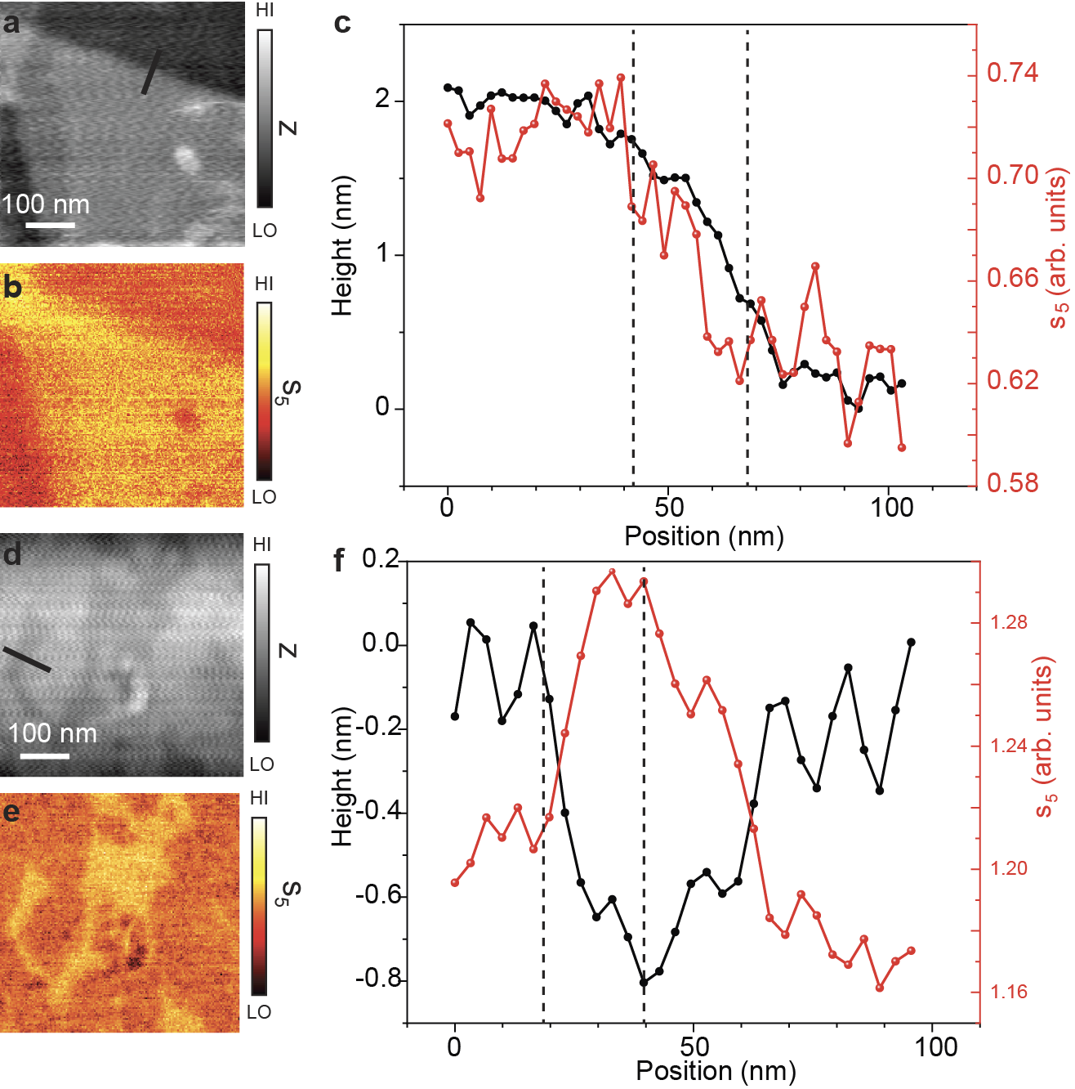
Supplementary Figure 1 | The resolution of the near-field signals. a, AFM topography of WSe₂ trilayer on h-BN. b, Near-field images of the amplitude $s_{5}$ taken at the excitation energy of 1.66 eV. c, Height profile and the near-field amplitude $s_{5}$ along the line trace shown in the AFM topography a. d, AFM topography of close zero degree stacked WSe₂ bilayer on h-BN. e, Near-field images of the amplitude $s_{5}$ taken at the excitation energy of 1.65 eV. f, Height profile and the near-field amplitude $s_{5}$ along the line trace shown in the AFM topograph d. By comparing the topographic images with the near-field images, we can conclude that the resolution of the near-field image is about 20 nm (estimated within a 10% to 90% contrast).
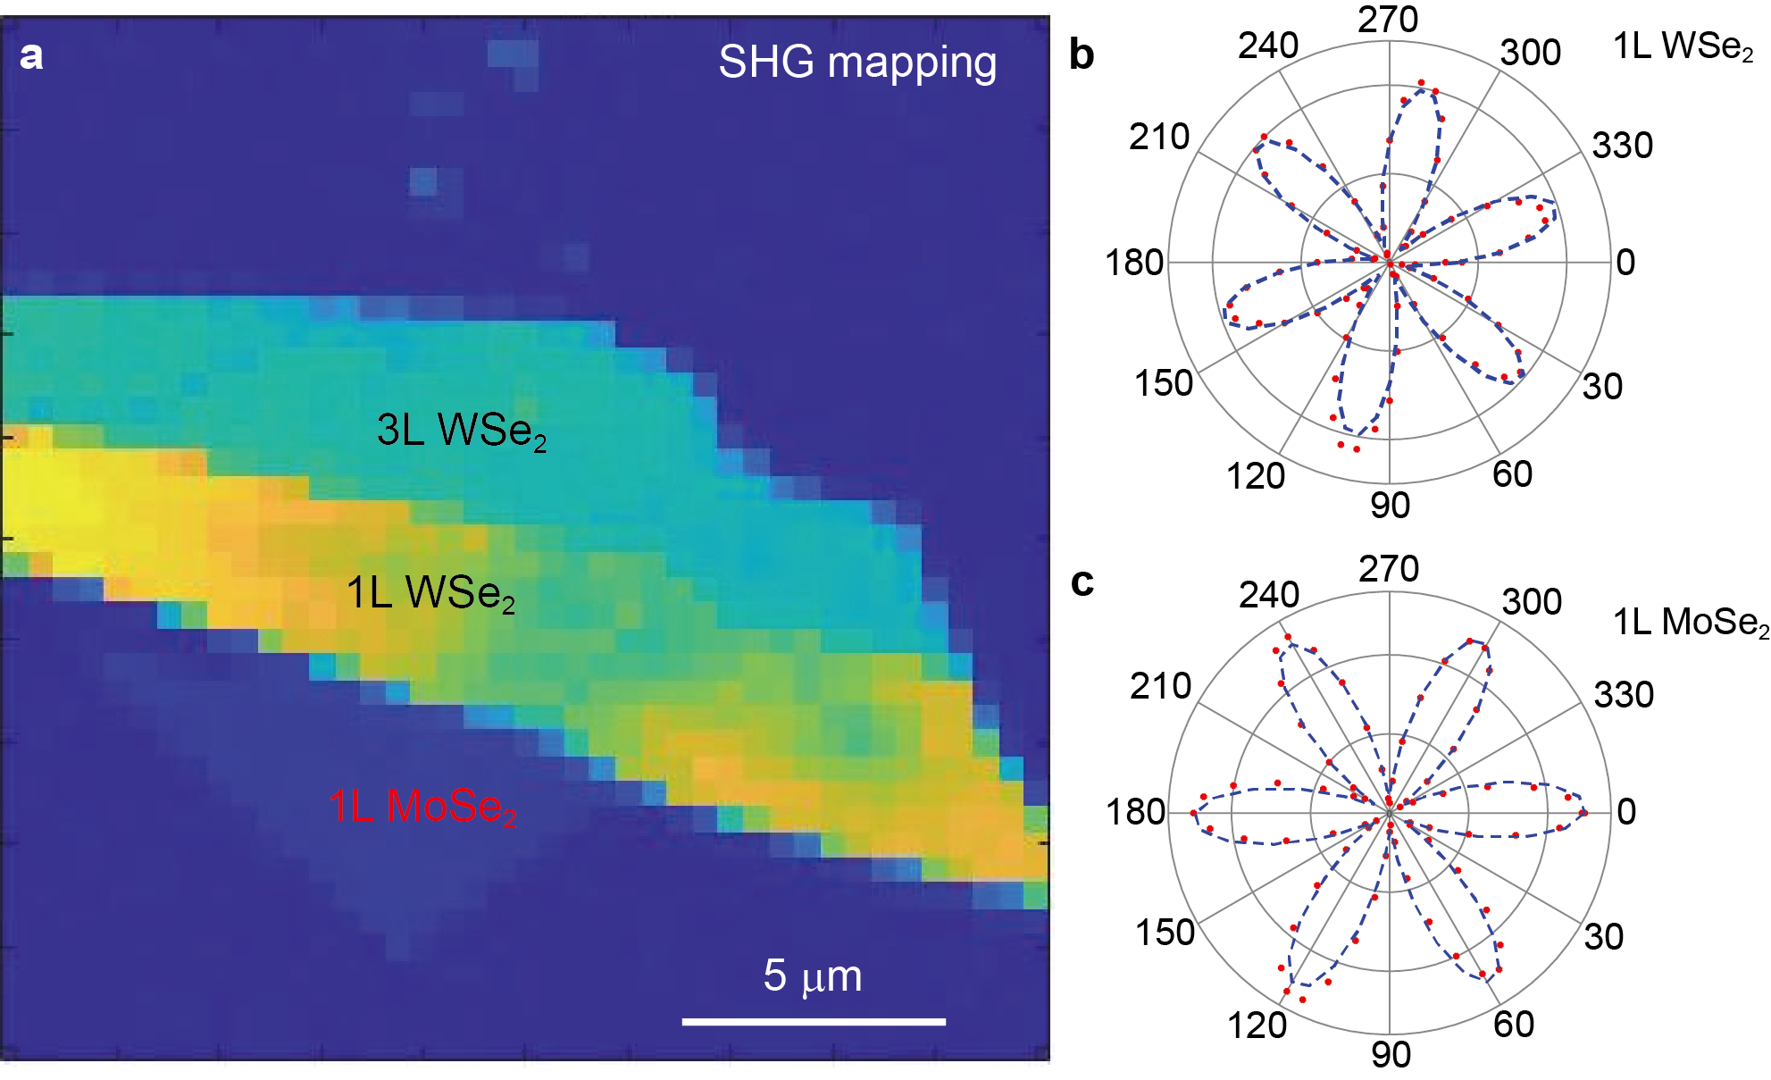
Supplementary Figure 2 | Second harmonic generation (SHG) characterization of the sample. a SHG mapping of the sample. The strong SHG intensity indicates that all the sample regions have odd layer numbers. The inversional symmetry is broken. b, c Polarization pattern of SHG intensity of WSe₂ monolayer (b) and MoSe₂ monolayer (c), respectively.
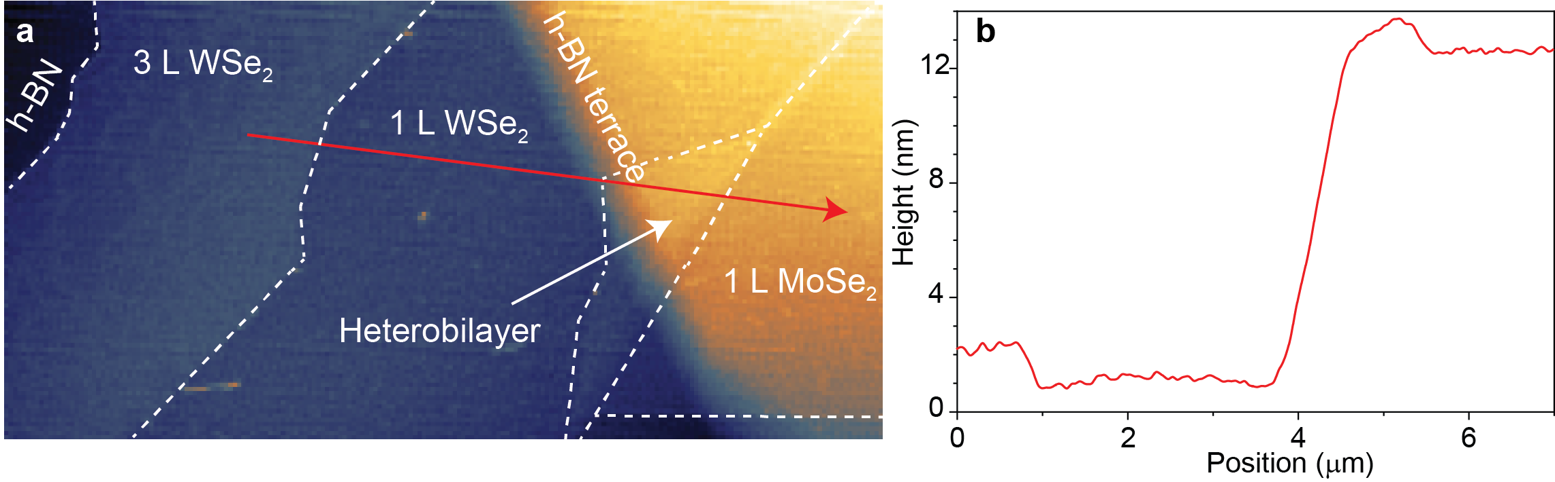
Supplementary Figure 3 | AFM topography. a, AFM topography of the sample region in Fig. 2 in the main text. b, Topographic height profile along the red arrow in a.

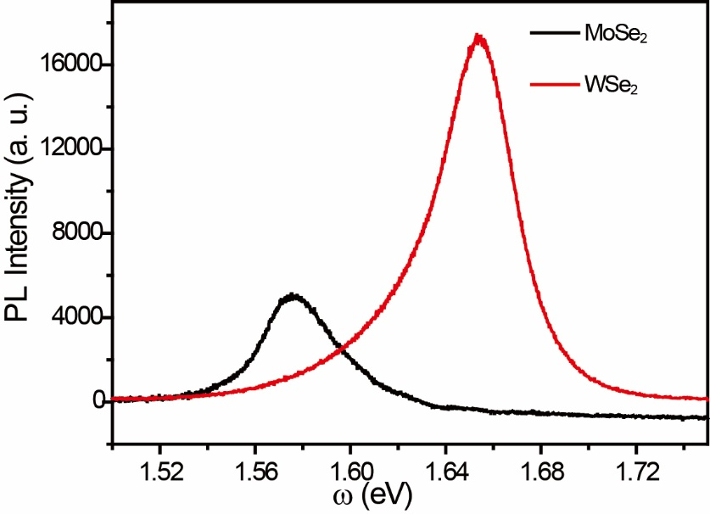
Supplementary Figure 4 | Intralayer exciton photoluminescence (PL) spectra from monolayer MoSe₂ and monolayer WSe₂.
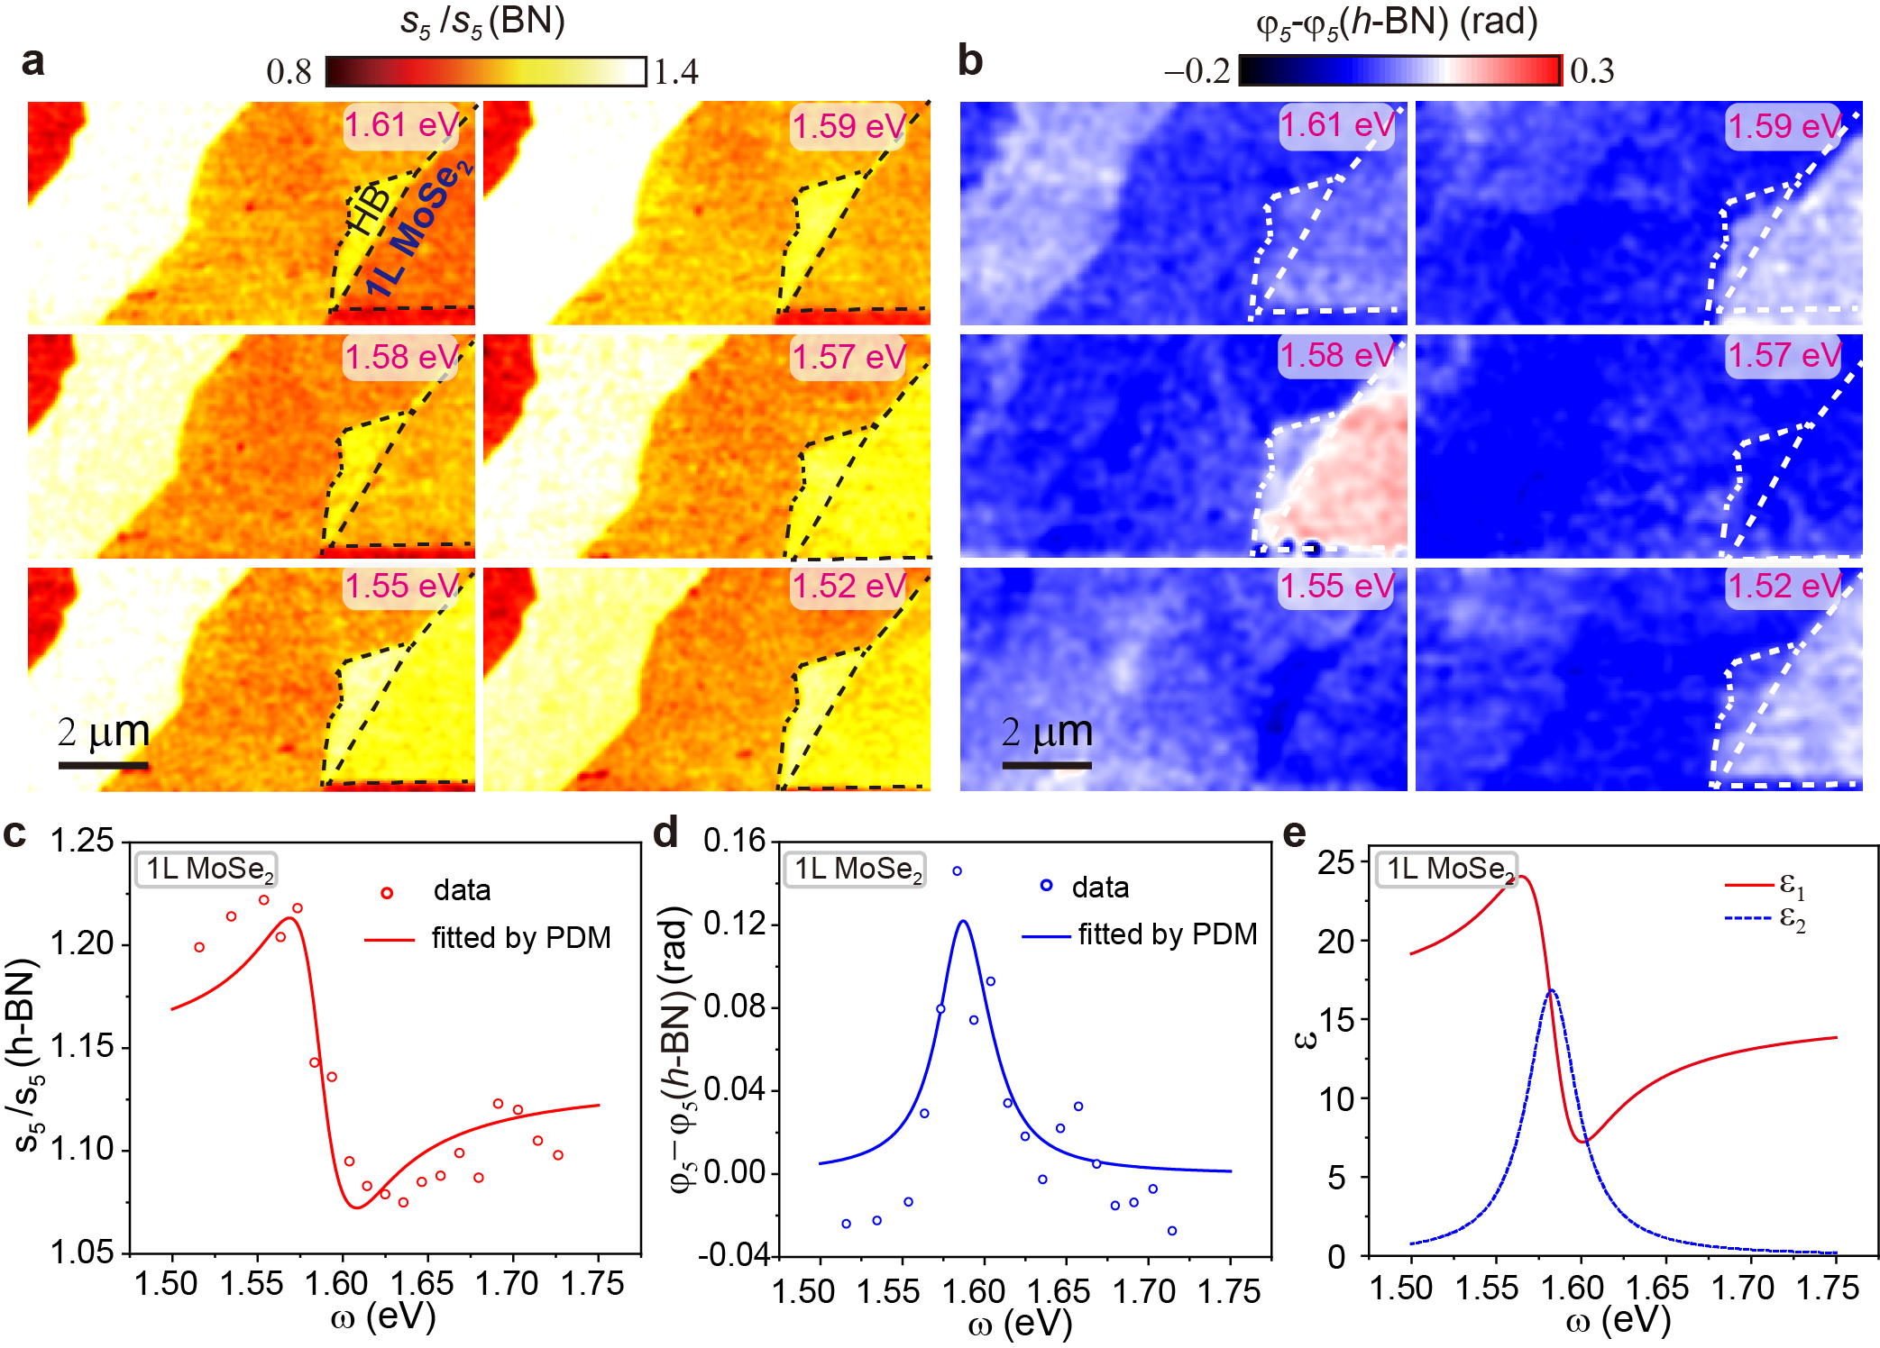
Supplementary Figure 5 | Evolution of the scattering amplitude and phase for the monolayer MoSe₂ as a function of the excitation energy. a, Representative near-field images of the normalized scattering amplitude $s_{5}(ω)/s_{5}(h˗BN)$. The excitation energies are indicated in the images. The images are acquired by scanning over the rectangular area marked with the dashed lines in Fig. 1 d. Boundaries of the monolayer MoSe₂ region are displayed with black dashed lines in the upper left panel of a. b, Near-field images of the normalized phase $φ_{5}(ω)$. The images with the same energy in a and b are acquired simultaneously. c and d, Normalized near-field amplitude $s_{5}(ω)/s_{5}(h˗BN)$ and phase $φ_{5}(ω)$ spectra for MoSe₂ (data points). The spectra fitted by the point dipole model (PDM) are shown as solid curves. e, Dielectric function of MoSe₂ monolayer extracted from the point dipole model.

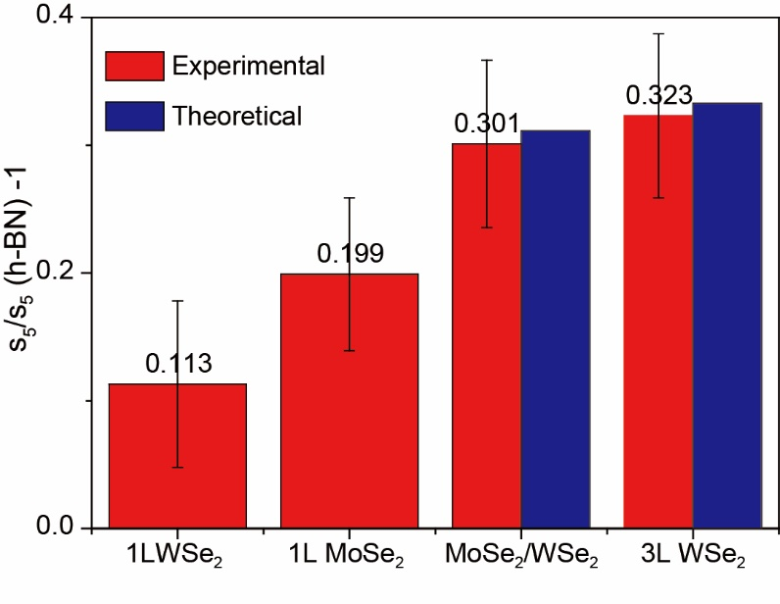
Supplementary Figure 6 | Normalized amplitude dependence on layer numbers. The theoretical values of bilayer and trilayer samples are obtained by adding the signals in monolayers.

References
1 Li, Y. et al. Measurement of the optical dielectric function of monolayer transition-metal dichalcogenides: MoS2, MoSe2, WS2, WSe2. Physical Review B 90, 205422, doi:10.1103/PhysRevB.90.205422 (2014).
2 Woessner, A. et al. Highly confined low-loss plasmons in graphene–boron nitride heterostructures. Nature Materials 14, 421-425, doi:10.1038/nmat4169 (2015).
3 Fei, Z. et al. Infrared Nanoscopy of Dirac Plasmons at the Graphene–SiO2 Interface. Nano Letters 11, 4701-4705, doi:10.1021/nl202362d (2011).
4 Zhang, L. M. et al. Near-field spectroscopy of silicon dioxide thin films. Physical Review B 85, 075419, doi:10.1103/PhysRevB.85.075419 (2012).
5 Mooshammer, F. et al. Quantifying Nanoscale Electromagnetic Fields in Near-Field Microscopy by Fourier Demodulation Analysis. ACS Photonics 7, 344-351, doi:10.1021/acsphotonics.9b01533 (2020).
6 Mester, L., Govyadinov, A. A., Chen, S., Goikoetxea, M. & Hillenbrand, R. Subsurface chemical nanoidentification by nano-FTIR spectroscopy. Nature Communications 11, 3359, doi:10.1038/s41467-020-17034-6 (2020).
7 Hu, D. et al. Probing optical anisotropy of nanometer-thin van der waals microcrystals by near-field imaging. Nature Communications 8, 1471, doi:10.1038/s41467-017-01580-7 (2017).
8 Mooshammer, F. et al. Nanoscale Near-Field Tomography of Surface States on (Bi0.5Sb0.5)2Te3. Nano Letters 18, 7515-7523, doi:10.1021/acs.nanolett.8b03008 (2018).
9 Govyadinov, A. A. et al. Recovery of Permittivity and Depth from Near-Field Data as a Step toward Infrared Nanotomography. ACS Nano 8, 6911-6921, doi:10.1021/nn5016314 (2014).
10 Govyadinov, A. A., Amenabar, I., Huth, F., Carney, P. S. & Hillenbrand, R. Quantitative Measurement of Local Infrared Absorption and Dielectric Function with Tip-Enhanced Near-Field Microscopy. The Journal of Physical Chemistry Letters 4, 1526-1531, doi:10.1021/jz400453r (2013).
11 McLeod, A. S. et al. Model for quantitative tip-enhanced spectroscopy and the extraction of nanoscale-resolved optical constants. Physical Review B 90, 085136, doi:10.1103/PhysRevB.90.085136 (2014).
12 Bechtel, H. A., Muller, E. A., Olmon, R. L., Martin, M. C. & Raschke, M. B. Ultrabroadband infrared nanospectroscopic imaging. Proceedings of the National Academy of Sciences 111, 7191, doi:10.1073/pnas.1400502111 (2014).
13 Javier Aizpurua, T. T., F. Javier García de Abajo, Markus Brehm, and Rainer Hillenbrand. Substrate-enhanced infrared near-field spectroscopy. Opt. Express 16, 1529-1545, doi:10.1364/OE.16.001529 (2008).
14 A. Cvitkovic, N. O., and R. Hillenbrand. Analytical model for quantitative prediction of material contrasts in scattering-type near-field optical microscopy. Opt. Express 15, 8550-8565, doi:10.1364/OE.15.008550 (2007).
15 Benedikt Hauer, A. P. E., and Thomas Taubner. Quasi-analytical model for scattering infrared near-field microscopy on layered systems. Opt. Express 20, 13173-13188, doi:10.1364/OE.20.013173 (2012).

