Supplementary Material

Supplementary Figures
Supplementary figure 1 Expression profile of NSUN6 in different stages of HCC patients. A: pathological stage I-IV. B: T stage 1-4. FPKM: Fragments Per Kilobase Million.

Supplementary figure 2 Survival curve of OS (A) and DSS (B) for high group and low group of HCC patients. Median expression value of NSUN6 was selected as the threshold to divide HCC patients into high expression group and low expression group. OS: overall survival. DFS: disease free survival.

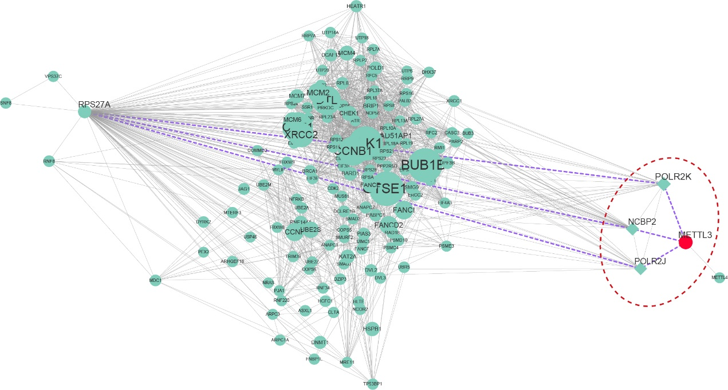
Supplementary figure 3 Interaction network between RPS27A and METTL3. Purple dotted line indicated the connections among the five nodes.

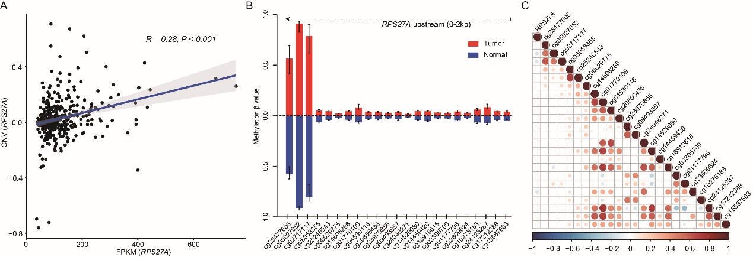
Supplementary figure 4 A: Correlation of the expression profiles of RPS27A with copy number variations. The correlation coefficient was calculated by Spearman method. B: Methylation levels of the upstream (0-2kb) of RPS27A. The infinium methylation 450k beadchip of TCGA HCC was used for this analysis. Probes within 2kb of the upstream of RPS27A were selected and the β values between normal and tumor samples were presented. Error bars indicated the interquartile. C: Correlation matrix of the expression profiles of RPS27A with the β values of each probes. The circle size and color represented correlation coefficient. Red color, blue color, and white color indicated positive, negative and no correlation respectively. FPKM: Fragments Per Kilobase Million.

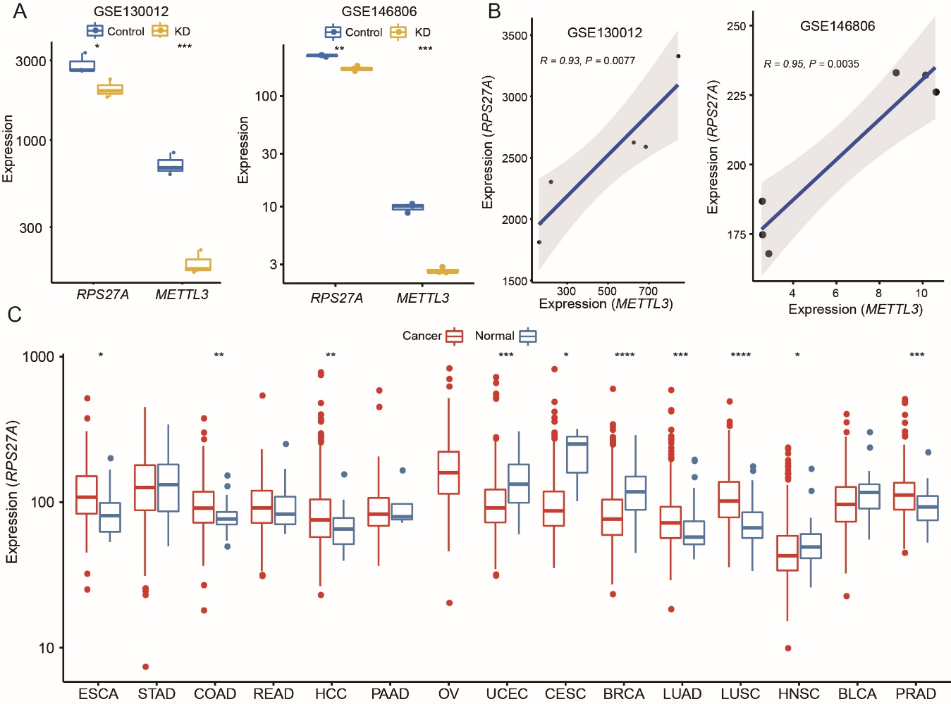
Supplementary figure 5 A: Expressions of RPS27A and METTL3 in KD and control groups in colorectal cancer cell lines and pancreatic cancer cell lines. B: Correlation of the expressions between RPS27A and METTL3 in colorectal cancer cell lines and pancreatic cancer cell lines. C: Expression of PRS27A in normal and tumor samples in 15 cancer types. ESCA: Esophageal carcinoma, STAD: Stomach adenocarcinoma, COAD: Colon adenocarcinoma, READ: Rectum adenocarcinoma, HCC: Hepatocellular carcinoma, PAAD: Pancreatic adenocarcinoma, OV: Ovarian serous cystadenocarcinoma, UCEC: Uterine Corpus Endometrial Carcinoma, CESC: Cervical and endocervical cancers, BRCA: Breast invasive carcinoma, LUAD: Lung adenocarcinoma, LUSC: Lung squamous cell carcinoma, HNSC: Head and Neck squamous cell carcinoma, BLCA: Bladder urothelial carcinoma, PRAD: Prostate adenocarcinoma.

Supplementary figure 6 Melt peaks (A) and amplification curves (B) of the qPCR. Three melt peaks refers to the three genes, GAPDH (86.0℃), METTL3 (81.0℃) and RPS27A (82.0℃). RFU: relative fluorescence unit.
Supplementary figure 7 A: Expression profile of RPS27A in pathological stages of HCC patients. B: Expression profile of RPS27A in virus infected and non-virus infected HCC samples. FPKM: Fragments Per Kilobase Million, Nov: non-virus infected, HBV: Hepatitis B virus, HCV: Hepatitis C virus.

Supplementary Tables
Supplementary table 1 Overlapped 35 DEGs identified in GSE39791 and GSE57957
Symbol | GSE39791 |  | GSE57957 |  | Regulated direction
Symbol | logFC | P.value | logFC | P.value | Regulated direction
ADAT2 | 0.9936 | 0.0171 | 0.9418 | 0.0247 | Up
ALKBH8 | 0.9821 | 0.0005 | 0.9012 | 0.0107 | Up
CDK5RAP1 | 0.9554 | <0.001 | 0.7358 | <0.001 | Up
CDKAL1 | 0.9741 | <0.001 | 0.7385 | <0.001 | Up
DKC1 | 0.9393 | <0.001 | 0.7239 | <0.001 | Up
FBL | 0.9637 | <0.001 | 0.7196 | 0.0006 | Up
FTO | 0.9866 | 0.0110 | 0.8508 | 0.0057 | Up
JMJD6 | 0.9801 | <0.001 | 0.8580 | 0.0060 | Up
METTL1 | 0.9765 | 0.0021 | 0.6974 | 0.0002 | Up
METTL3 | 0.9514 | <0.001 | 0.7743 | <0.001 | Up
METTL6 | 0.9783 | <0.001 | 0.8393 | 0.0001 | Up
NAT10 | 0.9712 | <0.001 | 0.8002 | 0.0009 | Up
NSUN3 | 0.9920 | 0.0237 | 0.9414 | 0.0325 | Up
NSUN5 | 0.9554 | <0.001 | 0.7117 | <0.001 | Up
PCIF1 | 0.9811 | <0.001 | 0.8837 | 0.0005 | Up
PUS1 | 0.9445 | <0.001 | 0.7187 | 0.0003 | Up
PUS7 | 0.9566 | <0.001 | 0.7197 | <0.001 | Up
RBM15B | 0.9652 | <0.001 | 0.7088 | <0.001 | Up
RNMT | 0.9696 | <0.001 | 0.8605 | 0.0002 | Up
TRMT1 | 0.9783 | 0.0173 | 0.7454 | 0.0009 | Up
TRMT10C | 0.9598 | <0.001 | 0.7850 | <0.001 | Up
TRMT12 | 0.9811 | 0.0133 | 0.6971 | <0.001 | Up
TRMT5 | 0.9133 | <0.001 | 0.6798 | <0.001 | Up
TRMT6 | 0.9736 | <0.001 | 0.8947 | 0.0006 | Up
TUT4 | 0.9548 | <0.001 | 0.8794 | 0.0276 | Up
VIRMA | 0.9465 | <0.001 | 0.6975 | <0.001 | Up
WDR4 | 0.9686 | 0.0003 | 0.7204 | <0.001 | Up
WTAP | 0.9587 | <0.001 | 0.8297 | 0.0002 | Up
YTHDC1 | 0.9734 | <0.001 | 0.8662 | 0.0007 | Up
YTHDC2 | 0.9764 | <0.001 | 0.8733 | 0.0037 | Up
YTHDF1 | 0.9659 | <0.001 | 0.8543 | 0.0028 | Up
YTHDF3 | 0.9836 | 0.0051 | 0.8099 | 0.0001 | Up
DIS3L2 | 1.0267 | 0.0006 | 1.2956 | 0.0247 | Down
NSUN6 | 1.0669 | <0.001 | 1.5118 | <0.001 | Down
ZCCHC6 | 1.1241 | <0.001 | 1.7733 | <0.001 | Down
Supplementary table 2 Thirty-four DEGs verified in the dataset of TCGA HCC
Type of RNA modification | Symbol | Type of enzyme | Main target | Role | Regulated
m5C | ADAT2 | Writer | tRNA |  | up
m5C | ALKBH8 | Writer | tRNA/mRNA |  | up
ms2i6A | CDK5RAP1 | Writer | tRNA |  | up
m1G | CDKAL1 | Writer | tRNA |  | up
Uridylation | DIS3L2 | Reader | mRNA | Tumour suppressor | up
Pseudouridylase | DKC1 | Writer | rRNA/mRNA | Tumour suppressor | up
Nm | FBL | Writer | rRNA |  | up
m6A | FTO | Eraser | mRNA | Oncogene | up
m7A | JMJD6 | Eraser | mRNA |  | up
m7G | METTL1 | Writer | tRNA | Tumor suppressor | up
m6A | METTL3 | Writer | tRNA/mRNA | Oncogene | up
m3C | METTL6 | Writer | tRNA/mRNA |  | up
ac4C | NAT10 | Writer | tRNA/mRNA |  | up
m5C | NSUN3 | Writer | tRNA |  | up
 | NSUN5 | Writer | rRNA |  | up
m5C | NSUN6 | Writer | tRNA |  | down
m6Am | PCIF1 | Writer | mRNA |  | up
Pseudouridylase | PUS1 | Writer | tRNA |  | up
Pseudouridylase | PUS7 | Writer | tRNA |  | up
m6A | RBM15B | Writer | mRNA |  | up
m7Gpp(pN) | RNMT | Writer | mRNA |  | up
m2,2G | TRMT1 | Writer | tRNA |  | up
m1G | TRMT10C | Writer | tRNA |  | up
m1G | TRMT12 | Writer | tRNA |  | up
m1G | TRMT5 | Writer | tRNA |  | up
m1A | TRMT6 | Writer | tRNA/mRNA |  | up
Uridylation | TUT4 | Writer | miRNA | Oncogene | up
m6A | VIRMA | Writer | mRNA |  | up
m7G | WDR4 | Writer | tRNA |  | up
m6A | WTAP | Writer | mRNA |  | up
m6A | YTHDC1 | Reader | mRNA |  | up
m6A | YTHDC2 | Reader | mRNA | Oncogene | up
m6A | YTHDF1 | Reader | mRNA |  | up
m6A | YTHDF3 | Reader | mRNA |  | up

Supplementary table 3 Relative expression of METTL3 and RPS27A in three HCC cell lines.
Cell line | Symbol | Control |  |  | si-Normal control |  |  | si-METTL3
 |  | R1 | R2 | R3 | R1 | R2 | R3 | R1 | R2 | R3
SNU398 | METTL3 | 1.0000 | 0.9251 | 0.9421 | 0.8463 | 0.7025 | 0.8967 | 0.1095 | 0.1280 | 0.1704
SNU398 | RPS27A | 1.0000 | 0.9150 | 0.9037 | 0.7892 | 0.7328 | 0.8450 | 0.0691 | 0.0716 | 0.0549
SNU449 | METTL3 | 1.0000 | 1.1482 | 1.4704 | 1.6284 | 1.1292 | 1.1002 | 0.0977 | 0.0887 | 0.1115
SNU449 | RPS27A | 1.0000 | 0.9072 | 1.0794 | 1.3589 | 1.0394 | 0.8857 | 0.1521 | 0.1818 | 0.3070
SNU475 | METTL3 | 1.0000 | 0.8094 | 0.9142 | 0.8568 | 0.7430 | 0.7081 | 0.1128 | 0.1021 | 0.1148
SNU475 | RPS27A | 1.0000 | 0.8251 | 0.9078 | 0.9123 | 0.7984 | 0.9677 | 0.3250 | 0.2879 | 0.5089
Note: Each treatment repeats three times.

