Supplementary Information for:
Exploring the feedback limits of quantum dot lasers for isolator-free photonic integrated circuits
Ying Shi,^{1,3} Bozhang Dong,^{1,3} Xiangpeng Ou,^{1,3} Artem Prokoshin,¹ Chen Shang,² John E. Bowers,² and Yating Wan^{1,*}
¹Integrated Photonics Lab, King Abdullah University of Science and Technology (KAUST), Thuwal, 23955-6900, Kingdom of Saudi Arabia
²Institute for Energy Efficiency, University of California Santa Barbara, Santa Barbara, CA 93106, USA
³These authors contributed equally
*yating.wan@kaust.edu.sa

- Slope efficiency for all lasers
Supplementary Figure 1. Slope efficiency for all lasers with (a) width and (b) length as independent variables.
Figure S1. shows the slope efficiency for all lasers with width and length as independent variables. The waveguide width has only a minor influence on slope efficiency, and no systematic trend with cavity length is observed. The individual slope efficiencies cluster tightly around 0.15 W/A, confirming that the “best-fit” value of 0.152 W/A quoted in the main text is indeed a conservative average representative of our device set.
- RF spectra under different feedback conditions
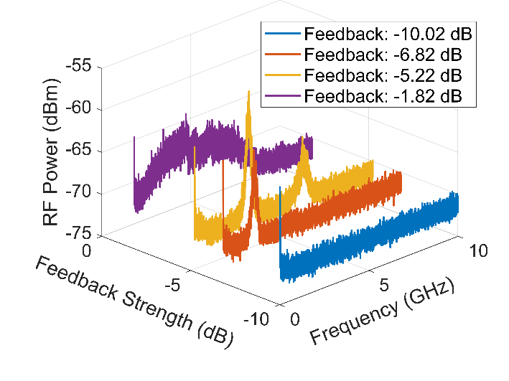
Supplementary Figure 2. Representative RF spectra extracted from Fig. 2(c3) of the main text.
The traces in Figure S2 are extracted from the mapping plot in Fig. 2(c3) of the main text, highlighting representative feedback regimes. At the onset of instabilities, periodic oscillations emerge, driven by undamped relaxation oscillations, with the relaxation oscillation frequency (ROF) and its higher harmonics clearly observed. With further increase in feedback strength, the system evolves into the coherence collapse regime, where the laser output becomes dominated by broadband chaotic oscillations.
- Measured critical feedback strength with different cavity lengths
Supplementary Figure 3. Measured critical feedback strength with different cavity lengths.
As shown in Eq. (1) of the main text, the critical feedback (CC) threshold is directly related to the laser cavity length (photon cavity roundtrip time), linewidth enhancement factor, and damping factor. To assess reproducibility, we tested multiple devices with the same dimensions as those reported in the manuscript (2100 μm×3 μm). All exhibited CC thresholds consistently around –6.7 dB, with device-to-device variation of only ~±0.3 dB. This confirms that the reported –6.7 dB value is representative of this device geometry. We also measured devices with different cavity lengths (1350–2100 μm) and a fixed width of 3 μm. As summarized in Fig. S3, the CC threshold ranged from –6.4 to –6.9 dB for L = 2100 μm (centered at –6.7 dB), –5.5 to –7.5 dB for L = 1850 μm, –6.2 to –8.0 dB for L = 1600 μm, and –7.5 to –8.0 dB for L = 1350 μm.
Despite the limited sample size, the results reveal a clear cavity-length dependence of the CC threshold, consistent with the theoretical model. To establish more comprehensive statistics, we will investigate larger sets of devices fabricated with improved process uniformity (e.g., tighter control of threshold currents).
- Measured operating voltage under optical feedback

Supplementary Figure 4. Measured operating voltage at different feedback levels under a fixed bias current of 44 mA.
We investigated the electrical characteristics of our device across the full optical feedback. At a fixed injection current of 44 mA, the operating voltage decreases slightly but systematically as feedback increases from –33 dB to 0 dB (from ~1.321 V to ~1.317 V). This trend can be explained by feedback-induced reduction in threshold carrier density, leading to lower junction voltage and marginally reduced electrical power consumption. In practical terms, this indicates that optical feedback not only affects the laser’s optical dynamics but also reduces its thermal load, leading to improved operating stability in isolator-free PICs.

