Graphical Abstract
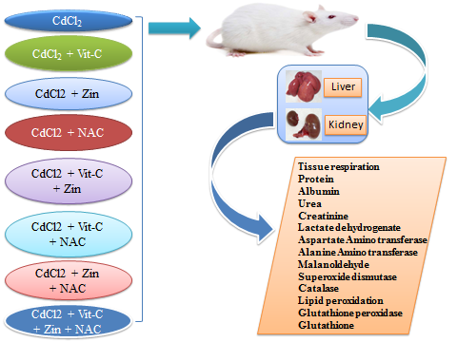
Toxicological Mechanism Of Vitamin C, Zinc and N-Acetylcysteine

