Supplementary Material

1. List of 13 Tidal Constituents data and their Influence
Table 1 Tidal Constituent
Sr. No. | Constituent | Type | Primary Astronomical Influence
1 | M2 | Principal lunar semi-diurnal | Moon's gravitational pull
2 | S2 | Principal solar semi-diurnal | Sun's gravitational pull
3 | N2 | Larger lunar elliptic semi-diurnal | Lunar elliptical orbit variation
4 | K2 | Lunisolar semi-diurnal | Combined lunar/solar declination
5 | K1 | Lunisolar diurnal | Earth's rotation & celestial declination
6 | O1 | Principal lunar diurnal | Lunar declination effects
7 | P1 | Principal solar diurnal | Solar declination effects
8 | Q1 | Larger lunar elliptic diurnal | Lunar perigee influence
9 | 2N2 | Lunar elliptical semi-diurnal | Second-order lunar elliptic component
10 | L2 | Smaller lunar elliptic semi-diurnal | Lunar nodal modulation
11 | MU2 | Lunar-solar semi-diurnal | Shallow-water interaction (M2+O1)
12 | NU2 | Lunar elliptic semi-diurnal | Lunar nodal cycle variation
13 | T2 | Solar elliptic semi-diurnal | Solar radiation pressure effects

2. River Discharge for Naraj and Jagatpur Station

Table 2 River Discharge
Date and time | Naraj (m³/sec) | Jagatpur (m³/sec)
02/05/2019 0800 | 168.29 | 61.50
03/05/2019 0800 | 182.78 | 66.50
04/05/2019 0800 | 299.49 | 82.50
05/05/2019 0800 | 385.80 | 91.28

3. MODIS-Derived LULC Data and Assigned Mannings N value
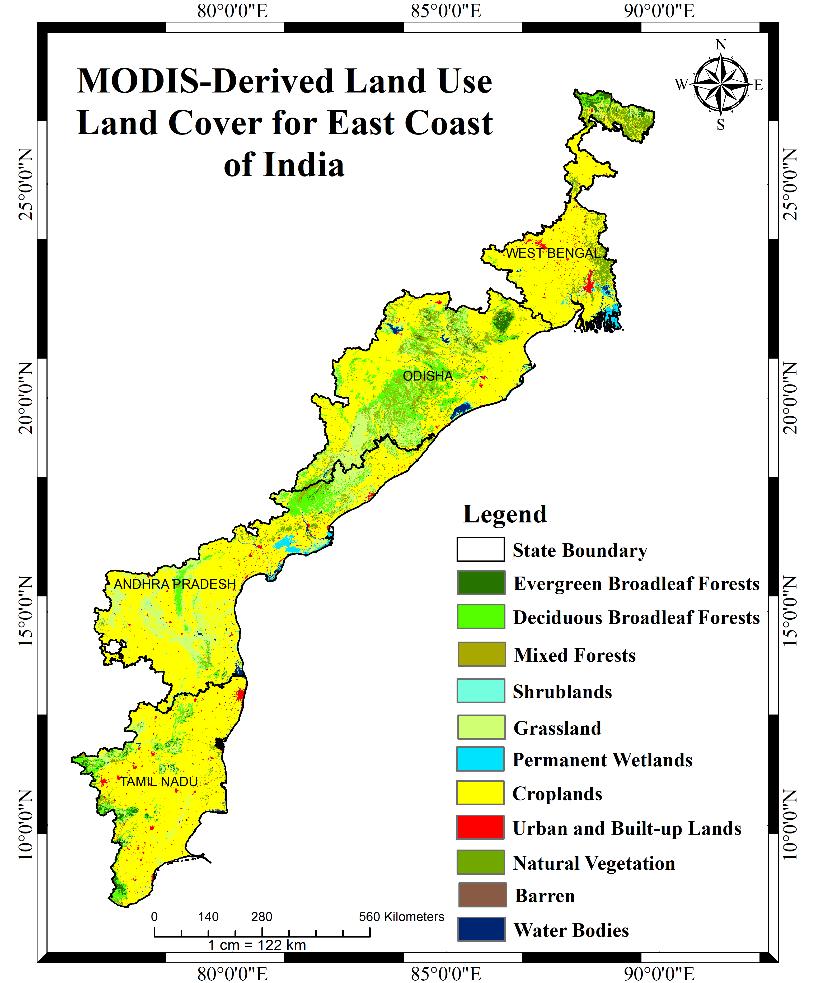
  Class | Manning's n  Coefficient | Surface Roughness  Length
  Evergreen broad leaf forest | 0.12 | 0.5
  Deciduous broad leaf forest | 0.10 | 0.5
  Mixed forest | 0.10 | 0.35
  Shrublands | 0.05 | 0.03
  Grasslands | 0.05 | 0.10
  Permanent wetlands | 0.05 | 0.30
  Croplands | 0.04 | 0.30
  Urban and built-up areas | 0.03 | 0.50
  Natural Vegetation | 0.035 | 0.055
  Barren | 0.30 | 0.02
  Water bodies | 0.0035 | 0.0001
Figure 1 MODIS LULC Map Year 2018 | Table 3 Manning’s ‘n Coefficients and Surface Roughness Length for Land Cover Classes

4. Sentinel-2 Classified LULC and Assigned Mannings N Value
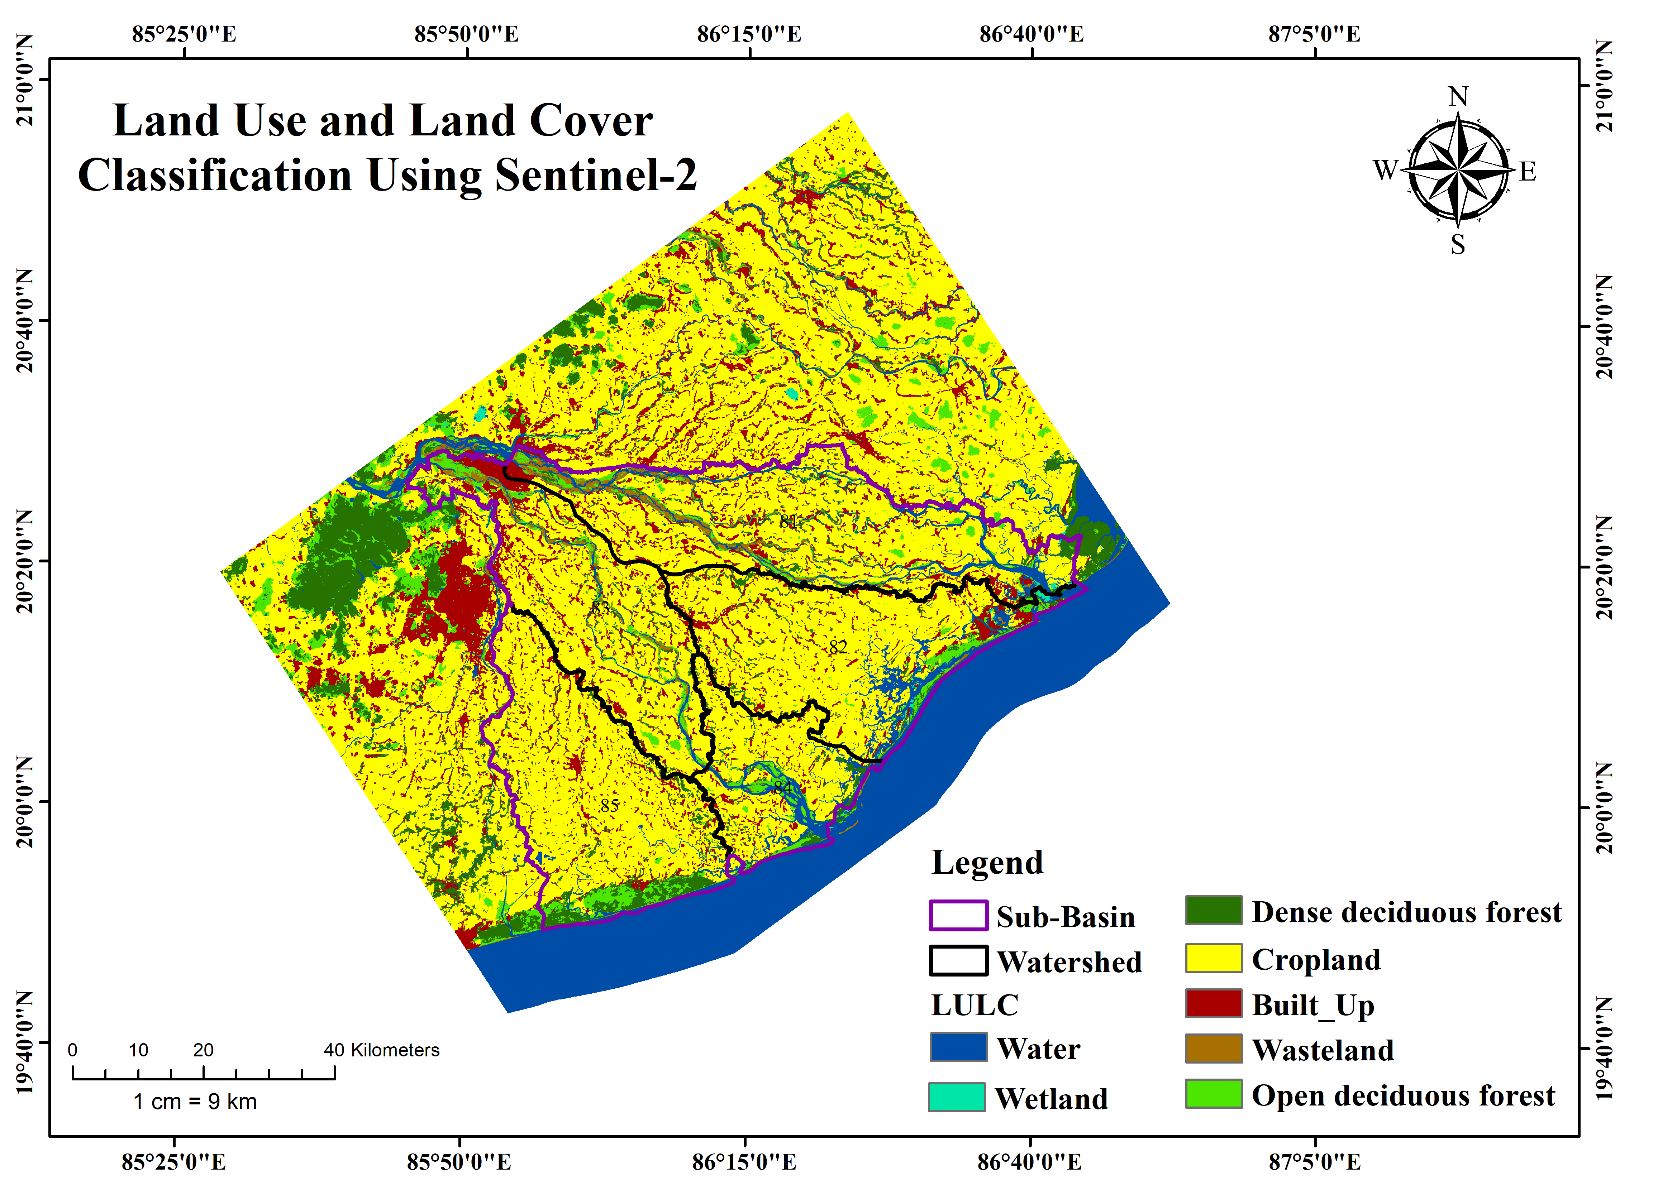
  Class | Manning's n | Impervious Percentage (%)
  Dense Deciduous Forest | 0.1 | 5
  Open Deciduous Forest | 0.15 | 3
  Cropland | 0.04 | 2
  Water | 0.02 | 0
  Wetland | 0.05 | 0
  Built-up | 0.1 | 85
  Wasteland | 0.025 | 10
Figure 2 Sentinel 2 LULC Map Year 2018 | Table 4 Manning’s ‘n Coefficients for Land Cover Classes of Sentinel 2

(a)  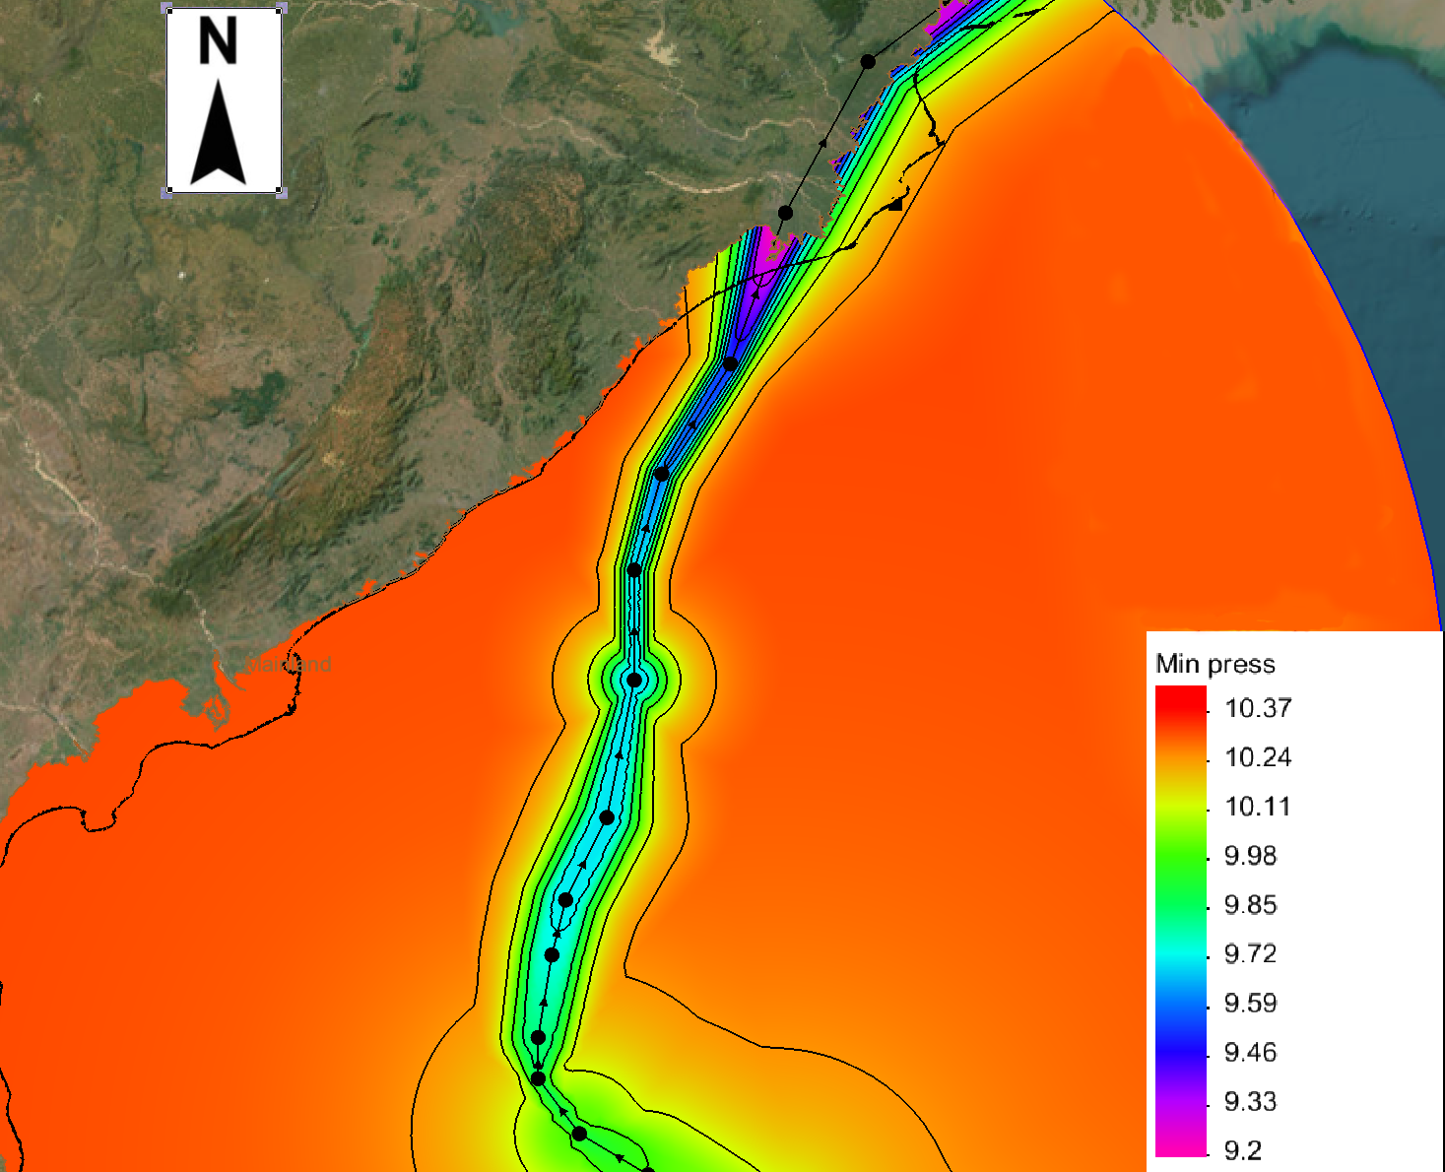 | (b)  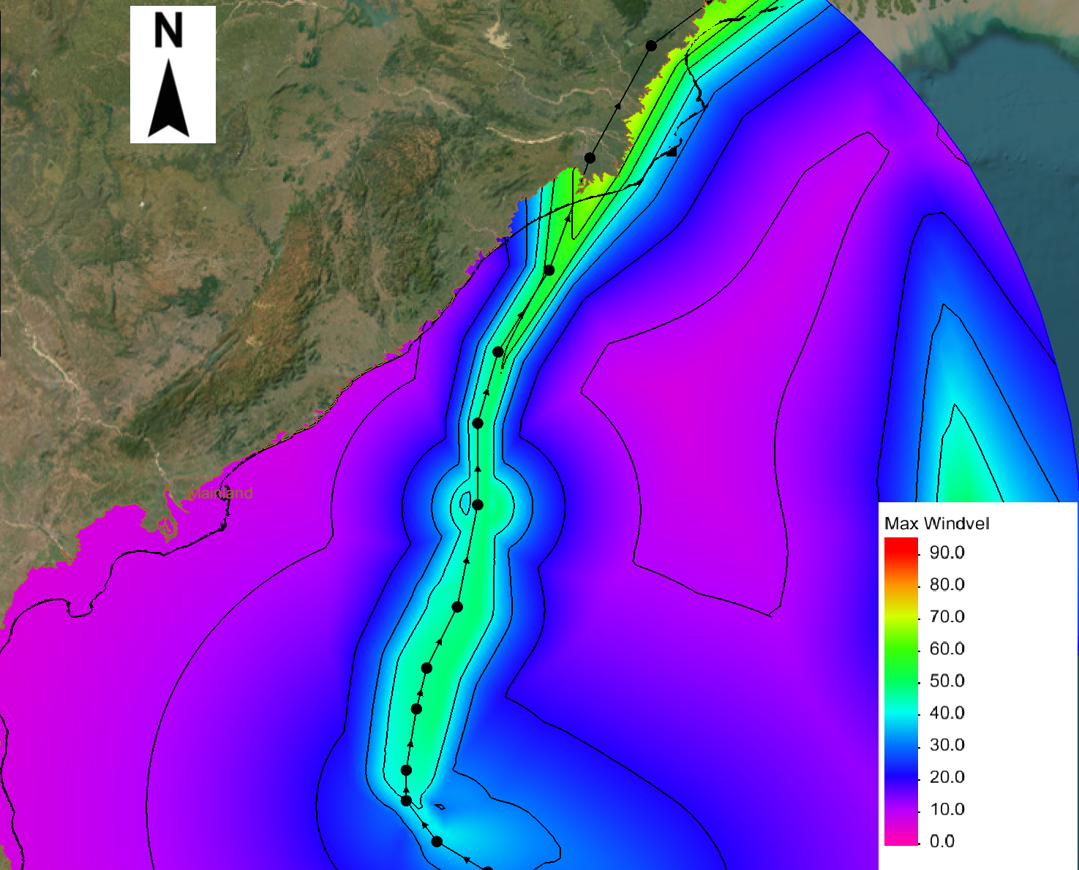
Figure 3 Simulated (a) Atmospheric Pressure and (b) Wind Speed Distribution in Optimized model
5. Simulated Atmospheric Pressure and Wind Speed for the ADCIRC Domain Region

