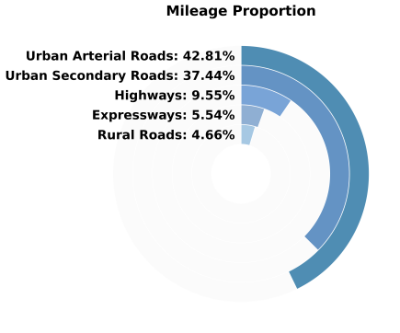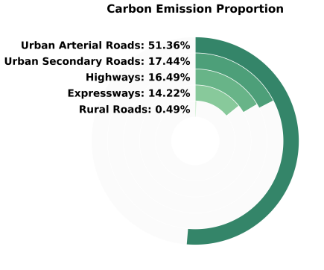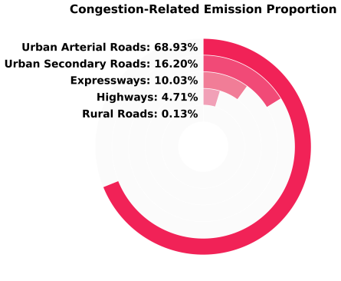
(a) (b) (c)
Supplementary Figure 1 Proportional Ring Charts of (a) Road Length, (b) Carbon Emissions, and (c) Congestion-Induced Emissions by Road Hierarchy

Supplementary Figure 2 Road Traffic Flow Distribution (a)Morning Peak (b)Evening Peak

Supplementary Figure 3 Results of Road Carbon Emission Tracing
- (b)
Supplementary Figure 4 Distribution of Origin Grid Carbon Emission Contributions (a)Morning Peak
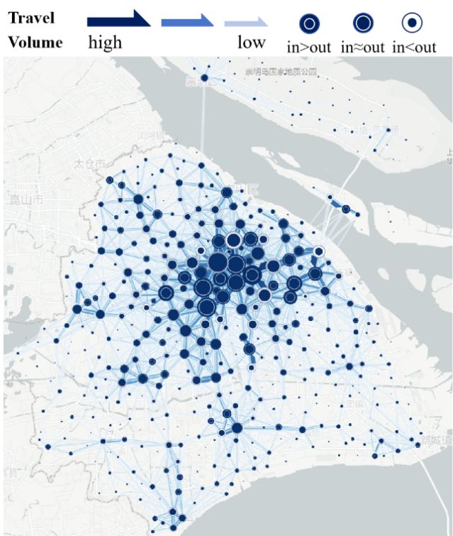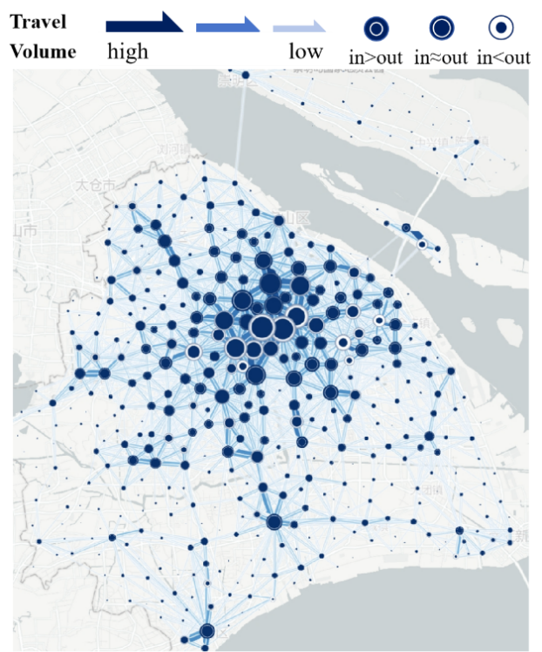
- (b)
Supplementary Figure 5 Distribution of OD-based Travel Volumes (a)Morning Peak (b)Evening Peak

- (b)
Supplementary Figure 6 Distribution of Incremental Road Carbon Emissions Ratios
(a)Morning Peak (b)Evening Peak
Supplementary Figure 7 Distribution of Land Use Types in Shanghai
Supplementary Table 1 pollutant-specific parameters ¹
 | a | b | c | d | e
FC | 217 | 9.6×10⁻² | 0.253 | -4.12×10⁻⁴ | 9.65×10⁻³

1. Yan, L. et al. Quantifying and analyzing traffic emission reductions from ridesharing: A case study of Shanghai. Transportation Research Part D: Transport and Environment 89, 102629 (2020).

