Appendix: 1
Detailed Methodology:

1 Setting and Study Design
Since 2021, NephroCare clinics across several European countries have implemented electronic Patient Reported Outcome Measures (ePROMs) to individualize medical and nursing care within a continuous quality improvement (CQI) framework. This program, previously described (Titapiccolo et al., 2023), involves the periodic administration of selected PROMs aligned with core SONG-HD outcome domains (Tong et al., 2015). PROM frequency is based on clinical judgment, and data are collected either during dialysis sessions or at home using a dedicated digital interface. Information is directly integrated into patients’ clinical records in real-time to support individualized care.
A total of 170 Fresenius Medical Care (FME) NephroCare clinics in France, Ireland, Italy, Spain, the United Kingdom, and the Czech Republic have participated in the ePROM-CQI program since January 2021. This retrospective analysis included adult patients receiving maintenance dialysis who completed the KDQoL-36 as part of the program and consented to secondary data analysis. Nurses and physicians were trained to administer the instrument and interpret results to support clinical decision-making.
2 Measures
2.1 Data Handling
Medical and Health-related Quality of Life (HRQoL) data were retrospectively abstracted from the EuCliD® database. EuCliD is the Health Information System (HIS) adopted in NephroCare FME outpatient dialysis facilities in multiple European countries which is routinely used for medical practice documentation as an electronic chart system. Data collected in EuCliD can be retrospectively extracted for secondary analysis upon patients consenting their data be used for scientific, retrospective, research. For the purpose of this retrospective analysis, the date of survey administration is the index date for the study. All time measurements were calculated from this index date.
2.2 Health-Related Quality of Life
The Kidney Disease Quality of Life (KDQoL-36) questionnaire (Hays et al., 1994; Peipert et al., 2018; Ricardo et al., 2013) includes 36 items. It comprises the SF-12 Health Survey (12 items) and 24 kidney disease-specific items covering three domains: Burden of Kidney Disease (KDQoL-36_{BKD}), Symptoms (KDQoL-36_{SKD}) and Problems, and Effects of Kidney Disease (KDQoL-36_{SKD}). The SF-12 generates Physical (SF12_{PCS}) and Mental (SF12_{MCS}) Component Summary scores. All scores are standardized from 0 to 100, with higher scores indicating better health or quality of life and lower scores in burden and effects domains reflect greater disease impact. For the purpose of Item Response Theory (IRT) modelling and the implementation of CAT, the two sections of the KDQoL-36 questionnaire (SF-12 and the kidney disease-specific domains) were analysed separately to ensure an optimized measurement approach tailored to both generic and disease-specific aspects of patient-reported quality of life.
To avoid confusion with the original PHC and MHC scores derived using classical test theory (CTT) weights, we refer to the IRT-based recalculated physical and mental component scores as PHC_{IRT} and MHC_{IRT}, respectively. These scores are conceptually aligned with SF12_{PHC} and SF12_{MHC} but derived from domain-specific theta estimates using IRT-based scoring procedures. For the kidney disease-specific domains of the questionnaire, we adopt the labels BKD (Burden of Kidney Disease), SKD (Symptoms of Kidney Disease), and EKD (Effect of Kidney Disease) to denote the IRT-based scores calculated for each respective construct. In the classical scoring framework, these kidney-related domains correspond to: KDQoL-Burden, KDQoL-Symptoms/Problems, and KDQoL-Effects, respectively based on the original scoring approach from the KDQoL-36 instrument.
2.3 Clinical and Demographic characteristics
We abstracted clinical and demographic information from the European Clinical Database. We obtained the last biochemical biomarker essay results recorded up to 12 months prior to survey data collection. Vascular access and dialysis modality were defined as the most frequently used options during the three months prior to the survey completion date. Etiology of kidney disease was categorized in four classes: metabolic syndrome if renal impairment was due to diabetes and/or hypertension; glomerulonephritis if renal impairment was due to inflammatory diseases; polycystic syndrome; all other causes. Finally, comorbidities were evaluated by the occurrence of International Classification of Diseases, Tenth Revision (ICD-10) codes any time before survey date. The full list of all variables included in the analyses is provided in Table 1 in the paper.
2.4. Clinical Outcomes
We assessed all cause hospitalization in the 12-month follow up period after survey completion date.
3 Analysis
3.1 Analytic Approach
We randomly partitioned the overall sample in a training (70%) and validation sets (30%). We used the training set for IRT model construction, including parameter estimation and model fit evaluation; we used the validation set for invariance tests, CAT simulation and criterion validity testing. We computed mean (standard deviation) and absolute (relative) frequencies of patients’ characteristics where appropriate, to characterize both the training and validation set.
3.2 Psychometric Evaluation
3.2.1 Basic Psychometric properties
We computed the floor and ceiling effect of each item, the inter-item correlation matrix to examine the relationships between questionnaire item and the item-total correlation matrix coefficients to evaluate the strength of association between items and their hypothesized total subscale scores. Internal consistency was assessed using Cronbach’s alpha.
We then conducted a confirmatory IRT factor analysis approach to assess the response pattern observed in the data. Only complete responses (no missing values) were included to ensure data integrity. Analyses were conducted in R (version 4.4.2) using the mirt and mirtCAT packages (Chalmers, 2012, 2016).
3.2.2 Factor Analysis
We adopted the root mean square error of approximation (RMSEA), the Standardized Root Mean Square Residual (SRMSR), the comparative fit index (CFI), and the Tucker-Lewis Index (TLI) for evaluating model fit: RMSEA<0.10; SRMSR<0.10; CFI>0.90 and TLI>0.90 are considered to indicate acceptable fit (Hu & Bentler, 1999). To compare the fit of the hypothesized models, we used the Akaike information criteria (AIC), the Bayesian Information Criterion (BIC) and the Sample-Size Adjusted Bayesian Information Criterion (SABIC).
To evaluate the adequacy of the bifactor models, we examined multiple psychometric indicators. Specifically, we analysed factor loadings and item-level parameters, including discrimination and threshold values, to assess the contribution of each item to both the general and group-specific factors. Model-based reliability and dimensionality were evaluated through Explained Common Variance (ECV), omega hierarchical (ωH), and omega coefficients for the specific subscales. The Percentage of Uncontaminated Correlations (PUC) was also computed to further assess the appropriateness of the bifactor structure. In addition, Test Information Functions (TIFs) were analysed to inspect the precision of the trait estimation across the latent continuum for both the general and specific factors.
To assess the generalization properties of the final selected models, we tested their fit into the previously described validation sets.
3.2.3 Tested models SF-12 Domains
To evaluate the measurement structure of the SF-12, four IRT-based models were developed and compared to determine their ability to capture patients’ responses. Model fit indices were used to identify the structure offering the best measurement precision for the SF12_{PHC} and SF12_{MHC} scores.
Model 1a (Appendix 2) served as the baseline, reflecting a two-dimensional uncorrelated structure. All items were allowed to load on both dimensions, except item 9, which loading on SF12_{PHC} was set to nil. This model was based on the structure showing the best fit in Forero et al. (2013) (Forero et al., 2013).
Model 2a (Appendix 2) retains the two-dimensional structure of Model 1a (see Appendix 1), where all items load on both dimensions except item 9, which does not load on the SF12_{PHC} dimension. The key difference is that Model 2 allows the two latent dimensions to correlate freely, relaxing the assumption of independence imposed in the baseline model.
Model 3a (Appendix 2) further modified the two-factor correlated structure, aligning more closely with a second model proposed by Forero et al. (2013) (Forero et al., 2013). In this configuration, items 1, 2, 3, 4, 5, and 8 loaded onto SF12_{PHC}, while items 6, 7, 9, 10, 11, and 12 loaded onto SF12_{MHC}.
Model 4a (Appendix 2) employed a Bifactor structure (Chen et al., 2006; Reise et al., 2007), incorporating a general health factor (SF12_{G}) alongside two specific subscale factors (SF12_{PHC} and SF12_{MHC}), with free covariance between the subscales. Item loadings for SF12_{PHC} and SF12_{MHC} matched those used in Model 3a.
Kidney Disease-Specific Domains
To assess the factor structure of patients’ response patterns to the kidney disease-specific domains of the KDQoL-36, three alternative models were contrasted by comparing model fit indexes:
Model 1b (see Appendix 2): Knowing which items are used to calculate each score in this section of the questionnaire, each item was loaded onto its respective factor. The first tested model was a three-factor model with not-intercorrelated factors.
Model 2b (see Appendix 2): A three-factor model with a structure similar to Model 1b, but with intercorrelated factors, was fitted to the data.
Model 3b (see Appendix 2): A Bifactor-Model was considered, assuming that the three subscale scores provide unique information beyond the general factor (General Kidney Disease Scale KDS_{G}) – representing the overall impact of Kidney Disease on patient’s life.
3.2.3 Computerized Adaptive Testing (CAT) simulation
CAT was applied using the final selected model structures with the mirtCAT package in R.
CAT was applied to both selected models to enhance the efficiency of questionnaire administration while maintaining score accuracy. CAT parameters were optimized by evaluating, for each factor of the models, the differences between scores obtained through full IRT and those generated via CAT using Bland-Altman plots.
Item Selection details:
SF12:
Initial Item: Selected using the Expected Posterior (EP) Rule to maximize expected precision at baseline.
Subsequent Items: Chosen using the Expected Information (E) Rule to optimize information gain per response.
Stopping Criteria:
Delta-theta thresholds: SF12_{G} < 0.03; SF12_{PHC} < 0.035; SF12_{MHC} < 0.03
Minimum Standard Error (min_SEM): SF12_{G} and SF12_{PHC} < 0.65; SF12_{MHC} < 0.70
KIDNEY DISEASE-SPECIFIC DOMAINS:
Initial Item: Selected using the Expected Posterior (EP) Rule to maximize expected precision at baseline.
Subsequent Items: Chosen using the Expected Information (E) Rule to optimize information gain per response.
Stopping Criteria:
Delta-theta thresholds: KDS_{G} < 0.035; KDQoL-36_{BKD} < 0.035; KDQoL-36_{SKD} < 0.03; KDQoL-36_{EKD} < 0.03
Minimum Standard Error (min_SEM): KDS_{G} and KDQoL-36_{BKD} < 0.1; KDQoL-36_{SKD} and KDQoL-36_{EKD} < 0.65
Minimum number of items to be administered: 12 items
Content Proportion: KDQoL-36_{BKD} = 15%; KDQoL-36_{SKD} = 50%; KDQoL-36_{EKD} = 35% (given the different number of items loading on each factor, to ensure adequate content coverage, the test aims to maintain the outlined proportions across the administered items: this helps maintain a balanced distribution of items across the different dimensions)
Latent traits were estimated via Maximum A Posteriori (MAP) estimation. These thresholds were tuned to balance precision and response burden.
3.2.4 Construct Validity
Construct validity was evaluated by examining the relationship between scores derived from different measurement approaches. Specifically, Pearson correlations were calculated between the scores obtained through CAT and those from the full IRT-based model, to assess the consistency and accuracy of the adaptive method. Additionally, construct validity was further explored by analysing the parameters of linear regressions mapping CAT and CTT scores onto IRT-based scores. This combined approach allowed for a comprehensive assessment of whether the CAT scores effectively represent the same underlying constructs measured by traditional and full-model methods.
3.2.5 Criterion Validity
To assess criterion validity, composite scores for each scale were derived by computing a weighted average of the general and specific factor scores, with weights based on the corresponding omega coefficients. This approach allowed each subscale score to reflect the shared variance with the general factor while retaining its specific contribution. Pearson correlations were then calculated between these weighted latent scores and the corresponding classical scale scores (SF12_{PHC} and SF12_{MHC}). Higher correlations were interpreted as evidence of good criterion validity, indicating convergence between the IRT-based scores and traditional scoring methods.

The validation phase included in addition the examination of score correlations with clinical outcomes, particularly adverse events (hospitalizations) within 12 months after survey completion, to assess the predictive validity of the generated scores.
Known-group analysis: Although no predefined clinical subgroups were identified for this analysis, we explored criterion validity by examining the relationship between health-related quality of life (HRQoL) scores and patients’ clinical condition.
To operationalize patients’ overall health status, we computed an Outcome Risk Score (ORS) using a multivariable logistic regression model predicting 1-year hospitalization as the dependent variable. The model included the following demographic and clinical predictors: age, Charlson comorbidity index, sex, BMI, albumin, phosphate, calcium, haemoglobin, KT/V, parathyroid hormone (Pth), calcium-phosphate product (CAP product), C-reactive protein (CRP), percentage of hemodiafiltration treatments over one year, vascular access type (venous central catheter or arterio-venous fistula), and comorbid conditions such as cancer, diabetes, cardiovascular disease, congestive heart failure, hypertension, hepatitis B, hepatitis C, Chronic Obstructive Pulmonary Disease (COPD), and liver disease. The model was estimated using a binomial family with a logit link function.
To assess the relationship between HRQoL and this composite measure of clinical risk, we computed Pearson correlation coefficients between the HRQoL scores (derived from both IRT-based and CAT-based methods) and the ORS. Furthermore, the ORS was stratified into quintiles to approximate gradations of clinical severity. HRQoL scores were then examined across these quintiles using trend analyses, including ANOVA-based tests and estimation of effect sizes (η²), to evaluate whether the scores varied systematically with increasing risk levels.
Predictive validity: To assess the predictive validity of the HRQoL scores, we conducted a series of logistic regression analyses using hospitalization within 12 months from the survey completion date as the clinically relevant endpoint. Each HRQoL score (derived from both IRT and CAT approaches) was added individually to a baseline model that included only the clinical Outcome Risk Score (ORS). We then evaluated whether the inclusion of each HRQoL score resulted in a statistically significant improvement in the model’s predictive performance. This approach enabled us to assess the incremental prognostic value of patient-reported HRQoL in predicting clinically meaningful outcomes (Rincon Bello et al., 2024)].
3.2.6 Calculation of T-scores
IRT-based theta scores were converted into standardized T-scores (mean = 50, SD = 10) using domain-specific transformations aligned with PROMIS norms. Importantly, each T-score was derived from the theta value estimated within the corresponding domain model—i.e., thetas from the SF-12 model were used to compute the T-score _{PHC} and the T-score _{MHC}, and likewise thetas from the kidney disease-domain model were used to compute the T-scores _{BKD}, T-scores _{SKD}, T-scores _{EKD}. Example transformations include: a theta of –0.572 in the SF12_{PHC} domain corresponds to a T-score _{PHC} of 40, whereas a theta of 0.28 in the KDQoL-26_{SKD} domain yields a T-score _{SKD} of 55. Full domain-specific mapping tables are provided in Appendix 8.

Appendix 2
Figure 1. Graphic representation of the Model 1a-Uncorrelated two-factor model of the SF12 questionnaire.
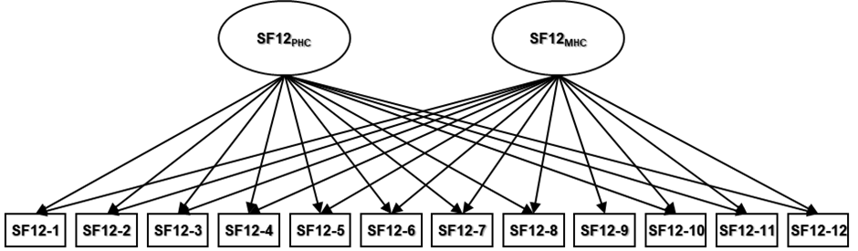
Model 1a: Uncorrelated Two-Factor Model

Table 1. Factor loadings, communalities (h²), variance explained, and factor correlations for the Model 1a-Uncorrelated two-factor model of the SF12 questionnaire.
 | Loadings |  |  |  |  | Variance
 | SF12_{PHC} | SF12_{MHC} | h2 |  |  | SF12_{PHC} |  | SF12_{MHC}
SF12-1 | 0.29 | 0.49 | 0.33 |  | SS loadings | 2.75 |  | 3.43
SF12-2 | 0.65 | 0.36 | 0.55 |  | Proportion variation | 0.23 |  | 0.29
SF12-3 | 0.65 | 0.34 | 0.54
SF12-4 | 0.71 | 0.44 | 0.70 |  | Factor correlations | SF12_{PHC} |  | SF12_{MHC}
SF12-5 | 0.76 | 0.45 | 0.78 |  | SF12_{PHC} | 1 |  | 0
SF12-6 | 0.47 | 0.60 | 0.57 |  | SF12_{MHC} | 0 |  | 1
SF12-7 | 0.43 | 0.34 | 0.30
SF12-8 | 0.41 | 0.56 | 0.48
SF12-9 |  | 0.73 | 0.53
SF12-10 | 0.28 | 0.56 | 0.39
SF12-11 | 0.09 | 0.74 | 0.55
SF12-12 | 0.28 | 0.62 | 0.46
SF12_{PHC}: SF12 Physical Health Composite; SF12_{MHC}: SF12 Mental Health Composite; h2: Communalities (Communalities of an item in IRT and factor analysis represents the proportion of variance in that item which is explained by the latent traits (factors or dimensions) estimated in the model).

Figure 2. Graphic representation of the Model 2a-Correlated two-factor model of the SF12 questionnaire.
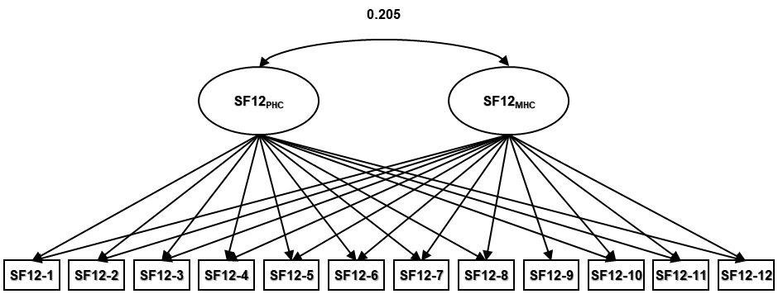
Model 2a -Correlated Two-Factor Model

Table 2. Factor loadings, communalities (h²), variance explained, and factor correlations for the Model 2a-Correlated two-factor model of the SF12 questionnaire.
 | Loadings |  |  |  |  | Variance
 | SF12_{PHC} | SF12_{MHC} | h2 |  |  | SF12_{PHC} |  | SF12_{MHC}
SF12-1 | 0.30 | 0.45 | 0.30 |  | SS loadings | 3.01 |  | 2.83
SF12-2 | 0.68 | 0.25 | 0.51 |  | Proportion variation | 0.25 |  | 0.24
SF12-3 | 0.67 | 0.23 | 0.51
SF12-4 | 0.76 | 0.32 | 0.68 |  | Factor correlations | SF12_{PHC} |  | SF12_{MHC}
SF12-5 | 0.81 | 0.32 | 0.76 |  | SF12_{PHC} | 1 |  | 0.205
SF12-6 | 0.49 | 0.54 | 0.53 |  | SF12_{MHC} | 0.205 |  | 1
SF12-7 | 0.44 | 0.27 | 0.27
SF12-8 | 0.42 | 0.51 | 0.41
SF12-9 |  | 0.72 | 0.52
SF12-10 | 0.28 | 0.53 | 0.36
SF12-11 | 0.08 | 0.73 | 0.55
SF12-12 | 0.28 | 0.59 | 0.43
SF12_{PHC}: SF12 Physical Health Composite; SF12_{MHC}: SF12 Mental Health Composite; h2: Communalities (Communalities of an item in IRT and factor analysis represents the proportion of variance in that item which is explained by the latent traits (factors or dimensions) estimated in the model).
Figure 3. Graphic representation of the Model 3a-Alternative Correlated two-factor model of the SF12 questionnaire.
Model 3a -Alternative Correlated Two-Factor Model
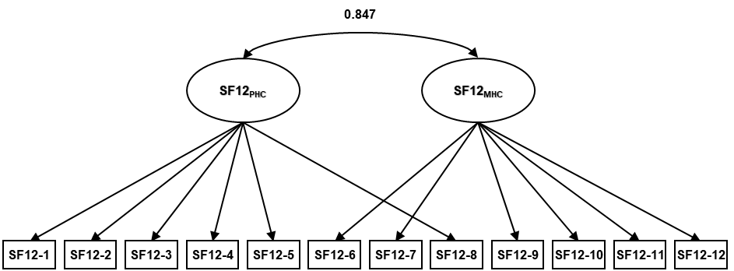

Table 3. Factor loadings, communalities (h²), variance explained, and factor correlations for the Model 3a-Alternative Correlated two-factor model of the SF12 questionnaire.
 | Loadings |  |  |  |  | Variance
 | SF12_{PHC} | SF12_{MHC} | h2 |  |  | SF12_{PHC} |  | SF12_{MHC}
SF12-1 | 0.57 |  | 0.32 |  | SS loadings | 3.28 |  | 2.60
SF12-2 | 0.74 |  | 0.54 |  | Proportion variation | 0.27 |  | 0.22
SF12-3 | 0.72 |  | 0.52
SF12-4 | 0.82 |  | 0.67 |  | Factor correlations | SF12_{PHC} |  | SF12_{MHC}
SF12-5 | 0.88 |  | 0.73 |  | SF12_{PHC} | 1 |  | 0.847
SF12-6 |  | 0.79 | 0.63 |  | SF12_{MHC} | 0.847 |  | 1
SF12-7 |  | 0.54 | 0.30
SF12-8 | 0.70 |  | 0.49
SF12-9 |  | 0.60 | 0.36
SF12-10 |  | 0.60 | 0.37
SF12-11 |  | 0.69 | 0.48
SF12-12 |  | 0.69 | 0.48
SF12_{G}: SF12 General Factor, SF12_{PHC}: SF12 Physical Health Composite; SF12_{MHC}: SF12 Mental Health Composite; h2: Communalities (Communalities of an item in IRT and factor analysis represents the proportion of variance in that item which is explained by the latent traits (factors or dimensions) estimated in the model).
Figure 4. Graphic representation of the Model 4a-Bi-factor model of the SF12 questionnaire.
Model 4a Bi-Factor Model
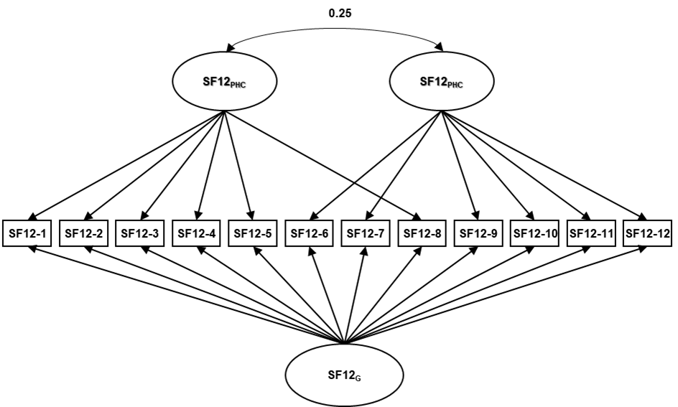
Table 4. Factor loadings, communalities (h²), variance explained, and factor correlations for the Model 4a-Bi-factor model of the SF12 questionnaire.
 |  | Loadings |  |  |  |  |  | Variance
 | SF12_{G} | SF12_{PHC} | SF12_{MHC} | h2 |  |  | SF12_{G} | SF12_{PHC} | SF12_{MHC}
SF12-1 | 0.54 | 0.11 |  | 0.31 |  | SS loadings | 5.14 | 0.62 | 0.93
SF12-2 | 0.66 | 0.54 |  | 0.73 |  | Proportion variation | 0.43 | 0.05 | 0.08
SF12-3 | 0.65 | 0.55 |  | 0.72
SF12-4 | 0.85 | -0.04 |  | 0.73 |  | Factor correlations | SF12_{G} | SF12_{PHC} | SF12_{MHC}
SF12-5 | 0.90 | -0.30 |  | 0.80 |  | SF12_{G} | 1 | 0 | 0
SF12-6 | 0.75 |  | 0.27 | 0.63 |  | SF12_{PHC} | 0 | 1 | 0.25
SF12-7 | 0.56 |  | 0.04 | 0.32 |  | SF12_{MHC} | 0 | 0.25 | 1
SF12-8 | 0.67 | 0.11 |  | 0.47
SF12-9 | 0.47 |  | 0.39 | 0.37
SF12-10 | 0.57 |  | 0.13 | 0.35
SF12-11 | 0.50 |  | 0.74 | 0.79
SF12-12 | 0.54 |  | 0.11 | 0.31
SF12_{G}: SF12 General Factor, SF12_{PHC}: SF12 Physical Health Composite; SF12_{MHC}: SF12 Mental Health Composite; h2: Communalities (Communalities of an item in IRT and factor analysis represents the proportion of variance in that item which is explained by the latent traits (factors or dimensions) estimated in the model).
Figure 5. Graphic representation of the Model 1b- Correlated Two-Factor model of the KDQoL-36 disease specific scale questionnaire
Model 1b Correlated Two-Factor Model
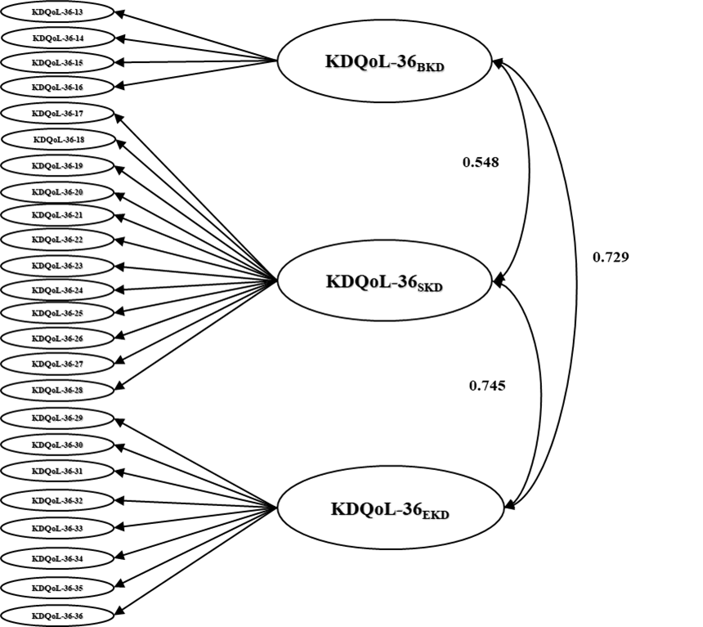
.

Table 5. Factor loadings, communalities (h²), variance explained, and factor correlations of the Model 1b- Correlated Two-Factor model of the KDQoL-36 disease specific scale questionnaire
 | Loadings |  |  |  |  |  | Variance
 | BKD | SKD | EKD | h2 |  |  | BKD | SKD | EKD
KDQoL-36-13 | 0.84 |  |  | 0.70 |  | SS loadings | 2.49 | 4.31 | 3.38
KDQoL-36-14 | 0.83 |  |  | 0.68 |  | Proportion variation | 0.10 | 0.18 | 0.14
KDQoL-36-15 | 0.84 |  |  | 0.71 |  | Factor correlations | BKD | SKD | EKD
KDQoL-36-16 | 0.63 |  |  | 0.40 |  | BKD | 1 | 0.548 | 0.729
KDQoL-36-17 |  | 0.62 |  | 0.38 |  | SKD | 0.548 | 1 | 0.745
KDQoL-36-18 |  | 0.62 |  | 0.38 |  | EKD | 0.729 | 0.745 | 1
KDQoL-36-19 |  | 0.53 |  | 0.28
KDQoL-36-20 |  | 0.52 |  | 0.28
KDQoL-36-21 |  | 0.56 |  | 0.31
KDQoL-36-22 |  | 0.65 |  | 0.42
KDQoL-23 |  | 0.65 |  | 0.43
KDQoL-36-24 |  | 0.56 |  | 0.32
KDQoL-36-25 |  | 0.75 |  | 0.56
KDQoL-36-26 |  | 0.61 |  | 0.37
KDQoL-36-27 |  | 0.66 |  | 0.43
KDQoL-36-28 |  | 0.40 |  | 0.16
KDQoL-36-29 |  |  | 0.54 | 0.29
KDQoL-36-30 |  |  | 0.56 | 0.32
KDQoL-36-31 |  |  | 0.70 | 0.49
KDQoL-36-32 |  |  | 0.65 | 0.42
KDQoL-36-33 |  |  | 0.68 | 0.46
KDQoL-36-34 |  |  | 0.79 | 0.62
KDQoL-36-35 |  |  | 0.55 | 0.30
KDQoL-36-36 |  |  | 0.70 | 0.49
BKD: KDQoL-36 Burden Kidney Disease, SKD: KDQoL-36 Symptom Kidney Disease, EKD: KDQoL-36 Effect Kidney Disease: h2: Communalities (Communalities of an item in IRT and factor analysis represents the proportion of variance in that item which is explained by the latent traits (factors or dimensions) estimated in the model).
Figure 6. Graphic representation of the Model 2b- UnCorrelated Two-Factor model of the KDQoL-36 disease specific scale questionnaire.
Model 2b Uncorrelated Two-Factor Model
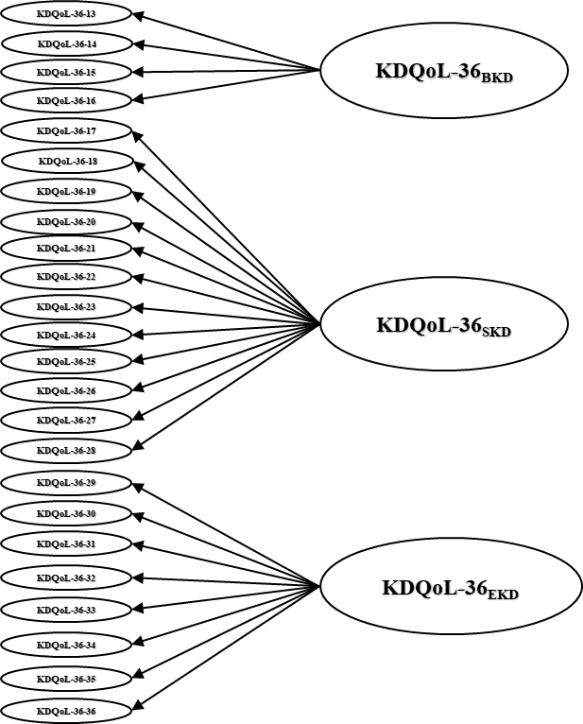

Table 6. Factor loadings, communalities (h²), variance explained, and factor correlations of the Model 2b- UnCorrelated Two-Factor model of the KDQoL-36 disease specific scale questionnaire
 | Loadings |  |  |  |  |  | Variance
 | BKD | SKD | EKD | h2 |  |  | BKD | SKD | EKD
KDQoL-36-13 | 0.85 |  |  | 0.72 |  | SS loadings | 2.48 | 4.35 | 3.43
KDQoL-36-14 | 0.85 |  |  | 0.72 |  | Proportion variation | 0.10 | 0.18 | 0.14
KDQoL-36-15 | 0.83 |  |  | 0.69 |  | Factor correlations | BKD | SKD | EKD
KDQoL-36-16 | 0.59 |  |  | 0.35 |  | BKD | 1 | 0 | 0
KDQoL-36-17 |  | 0.62 |  | 0.38 |  | SKD | 0 | 1 | 0
KDQoL-36-18 |  | 0.63 |  | 0.40 |  | EKD | 0 | 0 | 1
KDQoL-36-19 |  | 0.54 |  | 0.30
KDQoL-36-20 |  | 0.54 |  | 0.29
KDQoL-36-21 |  | 0.558 |  | 0.31
KDQoL-36-22 |  | 0.66 |  | 0.44
KDQoL-23 |  | 0.66 |  | 0.43
KDQoL-36-24 |  | 0.56 |  | 0.31
KDQoL-36-25 |  | 0.72 |  | 0.52
KDQoL-36-26 |  | 0.63 |  | 0.40
KDQoL-36-27 |  | 0.66 |  | 0.43
KDQoL-36-28 |  | 0.39 |  | 0.15
KDQoL-36-29 |  |  | 0.56 | 0.32
KDQoL-36-30 |  |  | 0.60 | 0.36
KDQoL-36-31 |  |  | 0.67 | 0.45
KDQoL-36-32 |  |  | 0.66 | 0.43
KDQoL-36-33 |  |  | 0.687 | 0.47
KDQoL-36-34 |  |  | 0.764 | 0.58
KDQoL-36-35 |  |  | 0.566 | 0.32
KDQoL-36-36 |  |  | 0.709 | 0.50
BKD: KDQoL-36 Burden Kidney Disease, SKD: KDQoL-36 Symptom Kidney Disease, EKD: KDQoL-36 Effect Kidney Disease: h2: Communalities (Communalities of an item in IRT and factor analysis represents the proportion of variance in that item which is explained by the latent traits (factors or dimensions) estimated in the model).

Figure 7. Graphic representation of the Model 2c- Bi-Factor model of the KDQoL-36 disease specific scale questionnaire.
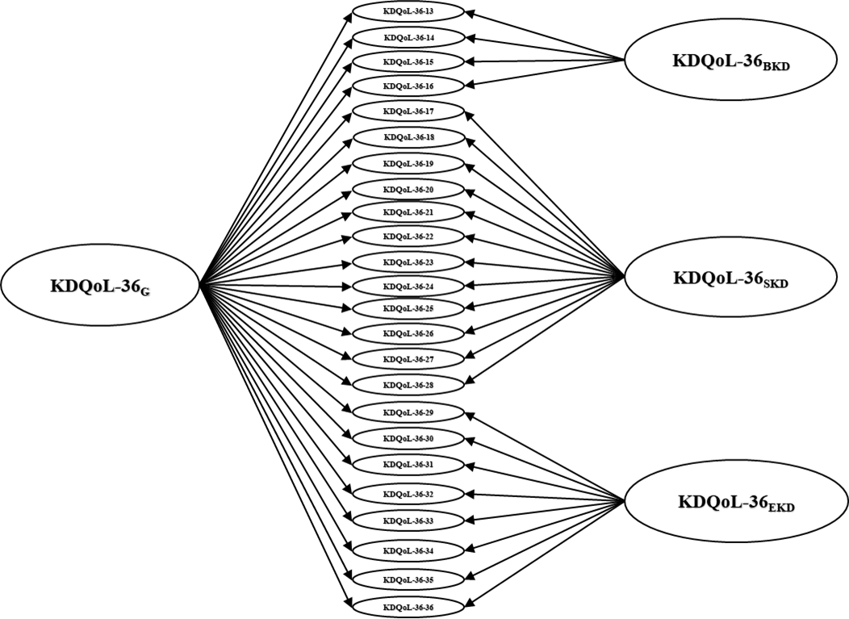
Model 2c Bi-Factor Model

Table 7. Factor loadings, communalities (h²), variance explained, and factor correlations of the Model 2b- Bi-Factor model of the KDQoL-36 disease specific scale questionnaire
 |  | Loadings |  |  |  |  |  | Variance
 | KDQoL-36_{G} | BKD | SKD | EKD | h2 |  | KDQoL-36_{G} | BKD | SKD | EKD
KDQoL-36-13 | 0.60 | 0.61 |  |  | 0.72 | SS loadings | 7.14 | 1.12 | 1.96 | 0.88
KDQoL-36-14 | 0.56 | 0.66 |  |  | 0.72 | Proportion variation | 0.30 | 0.05 | 0.04 | 0.04
KDQoL-36-15 | 0.63 | 0.53 |  |  | 0.70 | Factor correlations | KDQoL-36_{G} | BKD | SKD | EKD
KDQoL-36-16 | 0.61 | 0.21 |  |  | 0.35 | KDQoL-36_{G} | 1 | 0 | 0 | 0
KDQoL-36-17 | 0.49 |  | 0.38 |  | 0.38 | BKD | 0 | 1 | 0 | 0
KDQoL-36-18 | 0.43 |  | 0.46 |  | 0.40 | SKD | 0 | 0 | 1 | 0
KDQoL-36-19 | 0.34 |  | 0.44 |  | 0.30 | EKD | 0 | 0 | 0 | 1
KDQoL-36-20 | 0.34 |  | 0.44 |  | 0.29
KDQoL-36-21 | 0.41 |  | 0.40 |  | 0.31
KDQoL-36-22 | 0.47 |  | 0.47 |  | 0.44
KDQoL-23 | 0.49 |  | 0.42 |  | 0.43
KDQoL-36-24 | 0.45 |  | 0.31 |  | 0.31
KDQoL-36-25 | 0.66 |  | 0.34 |  | 0.52
KDQoL-36-26 | 0.40 |  | 0.50 |  | 0.40
KDQoL-36-27 | 0.52 |  | 0.39 |  | 0.43
KDQoL-36-28 | 0.35 |  | 0.19 |  | 0.16
KDQoL-36-29 | 0.46 |  |  | 0.57 | 0.54
KDQoL-36-30 | 0.48 |  |  | 0.73 | 0.76
KDQoL-36-31 | 0.73 |  |  | -0.01 | 0.53
KDQoL-36-32 | 0.64 |  |  | 0.05 | 0.41
KDQoL-36-33 | 0.67 |  |  | 0.09 | 0.46
KDQoL-36-34 | 0.78 |  |  | 0.10 | 0.62
KDQoL-36-35 | 0.54 |  |  | 0.39 | 0.29
KDQoL-36-36 | 0.70 |  |  | 0.06 | 0.49

KDQoL-36_{G:} KDQoL-36 General Factor, BKD: KDQoL-36 Burden Kidney Disease, SKD: KDQoL-36 Symptom Kidney Disease, EKD: KDQoL-36 Effect Kidney Disease: h2: Communalities (Communalities of an item in IRT and factor analysis represents the proportion of variance in that item which is explained by the latent traits (factors or dimensions) estimated in the model).

Appendix 3
Table 1: Ceiling and Floor Effect for the individual items on SF12 questionnaire.

Item | N levels | Minimum % | Maximum % | Mean | STD | %
SF12-1 | 5 | 4.53 | 15.47 | 3.47 | 1.01 | 0.86
SF12-2 | 3 | 32.45 | 27.77 | 1.95 | 0.77 | 0.91
SF12-3 | 3 | 36.46 | 26.23 | 1.9 | 0.79 | 1
SF12-4 | 2 | 58.42 | 41.58 | 1.42 | 0.49 | 1.18
SF12-5 | 2 | 64.43 | 35.57 | 1.36 | 0.48 | 1.15
SF12-6 | 2 | 49.89 | 50.11 | 1.5 | 0.5 | 1
SF12-7 | 2 | 45.2 | 54.8 | 1.55 | 0.5 | 1.72
SF12-8 | 5 | 33.17 | 6.23 | 2.39 | 1.26 | 0.88
SF12-9 | 6 | 22.63 | 3.48 | 2.77 | 1.42 | 0.71
SF12-10 | 6 | 9.35 | 10.59 | 3.68 | 1.47 | 0.72
SF12-11 | 6 | 4.11 | 28.18 | 4.4 | 1.42 | 0.6
SF12-12 | 5 | 7.98 | 32.71 | 3.54 | 1.29 | 1.09

Minimum % and Maximum % indicate floor and ceiling effects, respectively. N levels = number of response categories; Mean and STD = item mean and standard deviation; % = missing responses.

Table 2: Ceiling and Floor Effect for the KDQoL-36 disease specific scale questionnaire

Item | N levels | Minimum % | Maximum % | Mean | STD | %
KDQoL-36-13 | 5 | 29.63 | 7.77 | 2.29 | 1.24 | 0.72
KDQoL-36-14 | 5 | 25.18 | 9.11 | 2.48 | 1.29 | 0.67
KDQoL-36-15 | 5 | 18.97 | 15.83 | 2.84 | 1.39 | 0.9
KDQoL-36-16 | 5 | 12.8 | 34.26 | 3.41 | 1.46 | 1.27
KDQoL-36-17 | 5 | 36.89 | 5.28 | 2.19 | 1.2 | 0.61
KDQoL-36-18 | 5 | 78.56 | 0.87 | 1.33 | 0.74 | 0.55
KDQoL-36-19 | 5 | 46.66 | 3.07 | 1.91 | 1.08 | 0.48
KDQoL-36-20 | 5 | 51.07 | 3.5 | 1.86 | 1.11 | 0.55
KDQoL-36-21 | 5 | 40.45 | 5.1 | 2.11 | 1.2 | 0.52
KDQoL-36-22 | 5 | 57.69 | 2.58 | 1.73 | 1.05 | 0.44
KDQoL-36-23 | 5 | 55.5 | 1.65 | 1.71 | 0.96 | 0.47
KDQoL-36-24 | 5 | 60.82 | 2.6 | 1.68 | 1.03 | 0.62
KDQoL-36-25 | 5 | 31.71 | 6.28 | 2.3 | 1.21 | 0.52
KDQoL-36-26 | 5 | 50.3 | 2.85 | 1.86 | 1.08 | 0.61
KDQoL-36-27 | 5 | 68.69 | 1.44 | 1.51 | 0.9 | 0.61
KDQoL-36-28 | 5 | 72.4 | 1.64 | 1.46 | 0.88 | 3.59
KDQoL-36-29 | 5 | 32.97 | 9.08 | 2.38 | 1.31 | 0.86
KDQoL-36-30 | 5 | 40.25 | 4.95 | 2.12 | 1.19 | 0.67
KDQoL-36-31 | 5 | 35.09 | 7.86 | 2.31 | 1.28 | 1.13
KDQoL-36-32 | 5 | 29.43 | 18.87 | 2.8 | 1.51 | 1.51
KDQoL-36-33 | 5 | 51.3 | 5.47 | 1.96 | 1.22 | 1.19
KDQoL-36-34 | 5 | 37.87 | 6.02 | 2.17 | 1.21 | 0.86
KDQoL-36-35 | 5 | 53.16 | 10.97 | 2.1 | 1.42 | 24.47
KDQoL-36-36 | 5 | 57.14 | 3.87 | 1.81 | 1.14 | 2.74

Minimum % and Maximum % indicate floor and ceiling effects, respectively. N levels = number of response categories; Mean and STD = item mean and standard deviation; % = missing responses.

Appendix 4
Table 1: Model fit evaluation of different models for the SF12 questionnaire and testing of the bifactor structure on testing set.
Model Fit Evaluation
 | RMSEA [RMSEA_5-RMSEA_95] | SRMSR | TLI | CFI | AIC | BIC | SABIC
Model 1a  Uncorrelated Two-Factor) | 0.064 [0.059-0.068] | 0.053 | 0.934 | 0.966 | 126984.1 | 127340.4 | 127168.8
Model 2a  Correlated Two-Factor | 0.065 [0.061-0.07] | 0.053 | 0.931 | 0.966 | 126986.1 | 127349 | 127174.2
Model 3a  Alternative Correlated Two-Factor | 0.072 [0.068-0.076] | 0.067 | 0.915 | 0.939 | 127824 | 128114.4 | 127974.5
Model 4a  Bi-Factor | 0.058 [0.054-0.063] | 0.056 | 0.945 | 0.974 | 126587.5 | 126957 | 126779.1
Fitting parameters on the testing set
 | RMSEA [RMSEA_5-RMSEA_95] | SRMSR | TLI | CFI | AIC | BIC | SABIC
Model Test Fit | 0.058 [0.051-0.066] | 0.055 | 0.944 | 0.974 | 54420.41 | 54742.5 | 54564.57

RMSEA = root mean square error of approximation with 90% CI; SRMSR = standardized root mean square residual; TLI = Tucker–Lewis Index; CFI = comparative fit index; AIC = Akaike information criterion; BIC = Bayesian information criterion; SABIC = sample-size–adjusted BIC. Lower RMSEA, SRMSR, AIC, BIC, and SABIC and higher TLI and CFI indicate better model fit

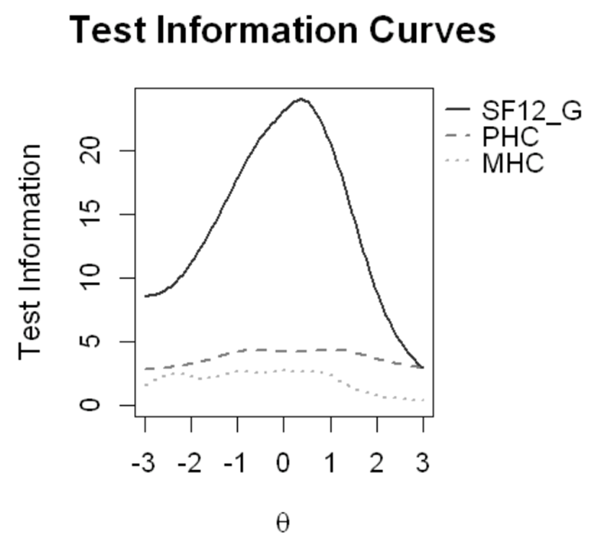
Figure 1: Test Information curves of the General, Physical and Mental scores of the SF12 questionnaire
SF12_{G}
SF12_{PHC}
SF12_{MHC}

Figure 1: Test Information curves of the General, Physical and Mental scores of the SF12 questionnaire
The graph displays the test information curves across the latent trait (θ) for the SF12_{G}, solid line), physical health component (PHC, dashed line), and mental health component (MHC, dotted line). The SF12_{G}, provides the highest measurement precision, peaking around θ = 0, while PHC and MHC contribute relatively lower levels of information across the trait continuum.

Table 2: Dimensionality and reliability indices of the bifactor structure model for SF12 questionnaire.
 | SF12_{G} | SF12_{PHC} | SF12_{MHC}
ECV_SS | 0.77 | 0.17 | 0.32
ECV_SG | 0.77 | 0.09 | 0.14
ECV_GS | 0.77 | 0.84 | 0.69
ω | 0.92 | 0.90 | 0.84
ωH | 0.85 | 0.07 | 0.20
PUC | 0.55
*ECV_SS: Explained Common Variance of the SF12_{G} over the total common variance (Structure Specific) explains how much of the total common variance is accounted for by the SF12_{G} and provides a global interpretation of the dominance of the general dimension.
ECV_SG: Explained Common Variance of the Specific factor after controlling for the SF12_{G} (Specific-to-General) reflects how much of the residual variance (after accounting for the SF12_{G} ) is explained by the specific factors and assesses the unique strength of specific domains, independent of the SF12_{G} factor.
ECV_GS: Explained Common Variance of the SF12_{G} after controlling for the specific factors (General-to-Specific) indicates how much of the residual variance (after removing the effect of specific factors) is explained by the SF12_{G} and is useful for evaluating the dominance of the SF12_{G} at the subscale level.

Reported indices include explained common variance (ECV), omega (ω), omega hierarchical (ωH), and percentage of uncontaminated correlations (PUC). ECV_SS represents the proportion of the total common variance accounted for by SF12_{G}, indicating the dominance of the general dimension. ECV_SG reflects the variance explained by the specific factors after controlling for SF12_{G}, assessing their unique contributions. ECV_GS represents the variance explained by SF12_{G} after accounting for specific factors, supporting evaluation of the SF12_{G} at the subscale level. Omega coefficients indicate reliability of the total and subscale scores, while ωH reflects the proportion of reliable variance attributable to SF12_{G}. PUC quantifies the proportion of correlations uncontaminated by multidimensionality.

Appendix 5
Table 1: Model fit evaluation of different models for KDQoL-36 Disease specific scales questionnaire and testing of the bifactor structure on testing set.
Model Fit Evaluation
Models | RMSEA [RMSEA_5-RMSEA_95] | SRMSR | TLI | CFI | AIC | BIC | SABIC
Model 2a  Correlated Two-Factor Model | 0.047 [0.045-0.049] | 0.044 | 0.937 | 0.945 | 230568.3 | 231345.4 | 230954.6
Model 2b  Uncorrelated Two-Factor Model | 0.079 [0.077-0.081] | 0.192 | 0.82 | 0.841 | 234310.7 | 235068.9 | 234687.6
Model 3b  Bifactorial model | 0.037 [0.035-0.04] | 0.033 | 0.96 | 0.969 | 229367.1 | 230276.9 | 229819.3
Fitting parameters on the testing set
Bifactorial model | RMSEA  [RMSEA_5-  RMSEA_95] | SRMSR | TLI | CFI | AIC | BIC | SABIC
Model test fit | 0.042 [0.039-0.046] | 0.04 | 0.952 | 0.963 | 100092.6 | 100880.4 | 100422.9

RMSEA = root mean square error of approximation with 90% CI; SRMSR = standardized root mean square residual; TLI = Tucker–Lewis Index; CFI = comparative fit index; AIC = Akaike information criterion; BIC = Bayesian information criterion; SABIC = sample-size–adjusted BIC. Lower RMSEA, SRMSR, AIC, BIC, and SABIC and higher TLI and CFI indicate better model fit

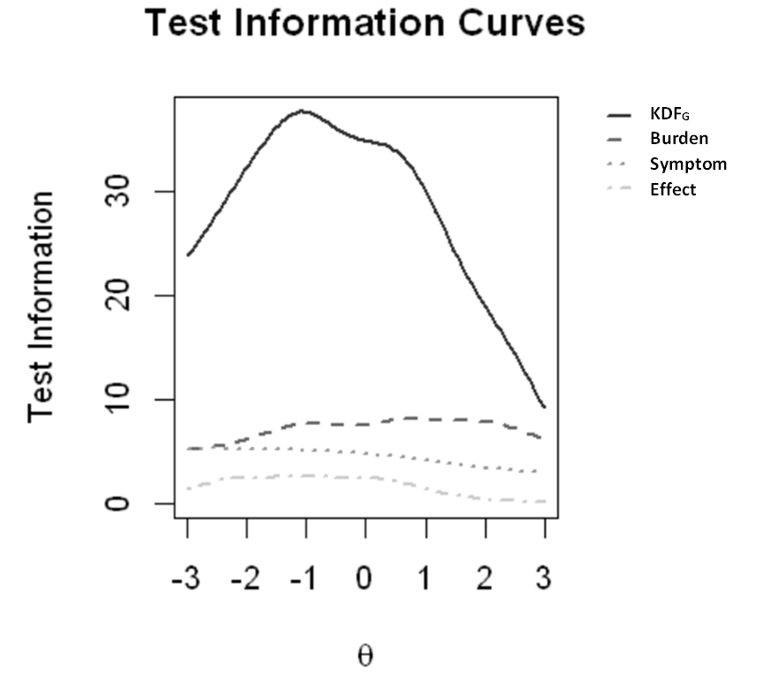
Figure 1: Test Information curves of the Bifactor-Model for the KDQoL-36 disease specific scale questionnaire
KDS_{G}
KDQoL-36_{BKD}
KDQoL-36_{SKD}
KDQoL-36_{EKD}

Figure 1: Test Information curves of the Bifactor-Model for the KDQoL-36 disease specific scale questionnaire
The plot shows the test information curves across the latent trait (θ) for the general Kidney Disease Scale (KDS_{G}, solid line), Burden kidney disease (BKD, dashed line), symptom kidney disease (SKD, dotted line), and effect kidney disease (EKD, dash-dotted line). The KDS_{G} provides the highest measurement precision, peaking around the mean trait level (θ ≈ 0), whereas the domain-specific scales (BKD, SKD, EKD) contribute relatively lower test information across the continuum.

Table 2: Dimensionality and reliability indices of the bifactor structure model for the KDQoL-36 disease specific scale questionnaire
Reported indices include explained common variance (ECV), omega (ω), omega hierarchical (ωH), and percentage of uncontaminated correlations (PUC). ECV_SS reflects the proportion of the total common variance explained by the KDS_{G} factor, indicating the overall dominance of the general dimension. ECV_SG shows the unique variance explained by each specific domain after accounting for the general factor, while ECV_GS represents the residual variance explained by the KDS_{G} after controlling for specific domains. Omega coefficients indicate the overall reliability of total and subscale scores, with ωH representing the proportion of reliable variance attributable specifically to KDS_{G}. PUC provides the percentage of correlations uncontaminated by multidimensionality.
General Kidney Disease Scale (KDS_{G}), Burden kidney disease (BKD), Symptom kidney disease (SKD), and Effect kidney disease (EKD)
 | KDS_{G} | KDQoL-36_{BKD} | KDQoL-36_{SKD} | KDQoL-36_{EKD}
ECV_SS | 0.64 | 0.44 | 0.44 | 0.22
ECV_SG | 0.64 | 0.10 | 0.18 | 0.08
ECV_GS | 0.64 | 0.56 | 0.56 | 0.78
Omega | 0.98 | 0.87 | 0.87 | 0.88
OmegaH | 0.79 | 0.36 | 0.38 | 0.08
PUC | 0.64
*ECV_SS: Explained Common Variance of the General Factor KDS_{G} over the total common variance (Structure Specific) explains how much of the total common variance is accounted for by KDS_{G} factor and provides a global interpretation of the dominance of the general dimension.
ECV_SG: Explained Common Variance of the Specific factor after controlling for General factor KDS_{G} (Specific-to-General) reflects how much of the residual variance (after accounting for the general factor) is explained by the specific factors and assesses the unique strength of specific domains, independent of the general factor.
ECV_GS: Explained Common Variance of the general factor KDS_{G} after controlling for the specific factors (General-to-Specific) indicates how much of the residual variance (after removing the effect of specific factors) is explained by the general factor and is useful for evaluating the dominance of the general factor at the subscale level.

Appendix 6
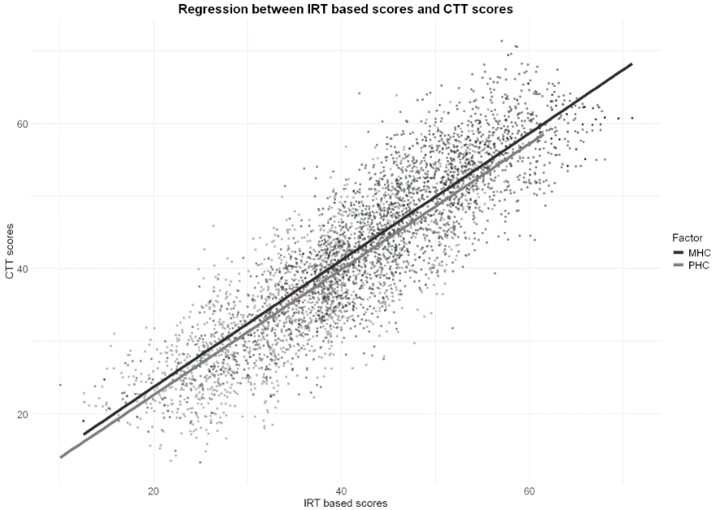
Figure 1: Plot showing regression analysis between standardized IRT based scores and SF12_{PHC}/SF12_{MHC} Classical scores

Factor
SF12_{PHC}
SF12_{MHC}

Figure 1: Plot showing regression analysis between standardized IRT based scores and SF12_{PHC}/SF12_{MHC} Classical scores
Scatterplot with regression lines for the Mental Health Component (MHC) and Physical Health Component (PHC) shows strong linear associations, indicating close agreement between Item Response Theory (IRT)- and Classical Test Theory (CTT)-derived scores

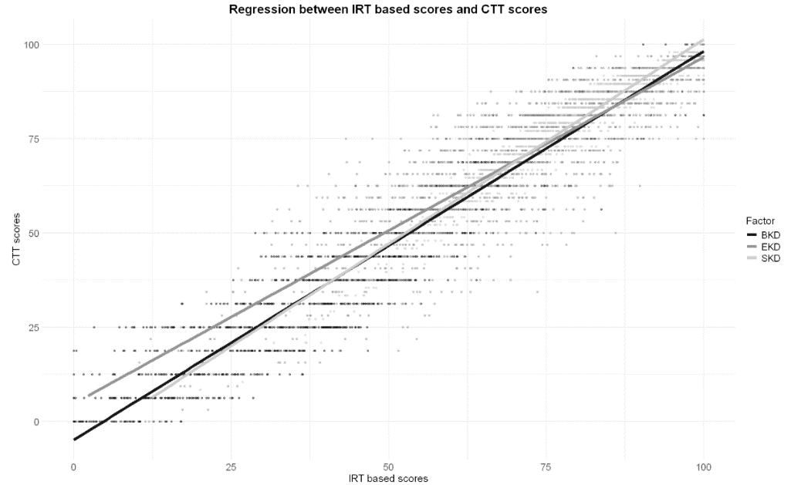
Figure 2: Plot showing regression analysis between standardized IRT based scores and KDQoL-36 Disease specific Scale Classical scores
Factor
KDQoL-36_{BKD}
KDQoL-36_{SKD}
KDQoL-36_{EKD}
Figure 2: Plot showing regression analysis between standardized IRT based scores and KDQoL-36 Disease specific Scale Classical scores
Scatterplots with regression lines for Burden (BKD), Effect (EKD), and Symptom (SKD) domains demonstrate strong linear associations, supporting agreement between Item Response Theory (IRT)- and Classical Test Theory (CTT)-derived scores

Appendix 7
Table 1. Score conversion tables for SF12_{PHC}, SF12_{MHC}, KDQoL-36_{BKD}, KDQoL-36_{SKD}, and KDQoL-36_{EKD} scales.
SF12_{PHC} |  |  | SF12_{MHC} |  |  | KDQoL-36_{BKD} |  |  | KDQoL-36_{SKD} |  |  | KDQoL-36_{EKD}
θ |  | Tscore | θ |  | Tscore | θ |  | Tscore | θ |  | Tscore | θ |  | Tscore
-2.27 |  | 10 | -2.77 |  | 5 | -1.27 |  | 30 | -2.90 |  | 5 | -2.22 |  | 15
-1.98 |  | 15 | -2.46 |  | 10 | -0.96 |  | 35 | -2.58 |  | 10 | -1.91 |  | 20
-1.70 |  | 20 | -2.15 |  | 15 | -0.65 |  | 40 | -2.26 |  | 15 | -1.60 |  | 25
-1.42 |  | 25 | -1.85 |  | 20 | -0.34 |  | 45 | -1.94 |  | 20 | -1.29 |  | 30
-1.14 |  | 30 | -1.54 |  | 25 | -0.03 |  | 50 | -1.62 |  | 25 | -0.98 |  | 35
-0.86 |  | 35 | -1.23 |  | 30 | 0.28 |  | 55 | -1.31 |  | 30 | -0.68 |  | 40
-0.57 |  | 40 | -0.92 |  | 35 | 0.59 |  | 60 | -0.99 |  | 35 | -0.37 |  | 45
-0.29 |  | 45 | -0.62 |  | 40 | 0.90 |  | 65 | -0.67 |  | 40 | -0.06 |  | 50
-0.01 |  | 50 | -0.31 |  | 45 | 1.21 |  | 70 | -0.35 |  | 45 |  |  | 55
0.27 |  | 55 | 0.00 |  | 50 | 1.52 |  | 75 | -0.04 |  | 50 |  |  | 60
0.56 |  | 60 | 0.31 |  | 55 |  |  |  | 0.28 |  | 55 |  |  | 65
0.84 |  | 65 | 0.61 |  | 60 |  |  |  | 0.60 |  | 60
1.12 |  | 70 | 0.92 |  | 65 |  |  |  | 0.92 |  | 65
1.40 |  | 75 | 1.23 |  | 70
1.69 |  | 80 | 1.54 |  | 75
1.97 |  | 85 | 1.84 |  | 80
2.25 |  | 90 | 2.15 |  | 85
2.53 |  | 95 | 2.46 |  | 90
 |  |  | 2.77 |  | 95

Values provide reference conversions from θ to raw and T-score metrics for each domain.
( θ = latent trait estimate; Tscore = standardized T-score (mean = 50, SD = 10). PHC = Physical Health Composite; MHC = Mental Health Composite; BKD = Burden of Kidney Disease; SKD = Symptoms/Problems of Kidney Disease; EKD = Effects of Kidney Disease)
Appendix 8
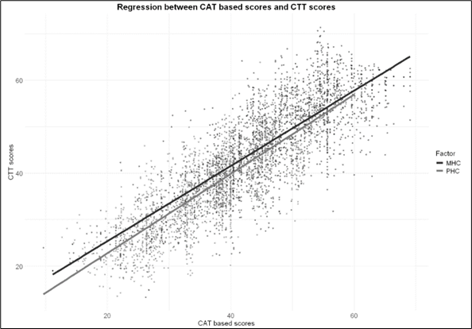
Figure 1: Plot showing regression analysis between standarized CAT and the SF12_{PHC/MHC} Classical scores

Factor
SF12_{PHC}
SF12_{MHC}

Figure 1: Plot showing regression analysis between standarized CAT and the SF12_{PHC/MHC} Classical scores Scatterplots with regression lines for the Mental Health Component (MHC) and Physical Health Component (PHC) demonstrate strong linear associations, indicating close agreement between Computer Adaptive Test (CAT)- and Classical Test Theory (CTT)-derived scores.

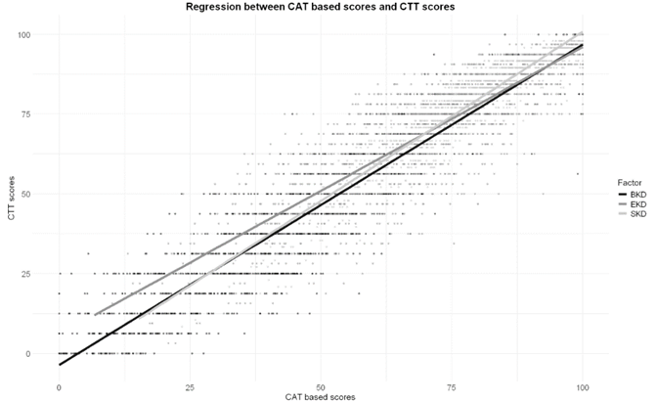
Figure 2: Plot showing regression analysis between standarized CAT and Classical Test Theory (CTT)-derived KDQoL-36 Disease specific scale scores
Factor
KDQoL-36_{BKD}
KDQoL-36_{SKD}
KDQoL-36_{EKD}

Figure 2: Plot showing regression analysis between standarized CAT and Classical Test Theory (CTT)-derived KDQoL-36 Disease specific scale scores
Scatterplots with regression lines for Burden (BKD), Effect (EKD), and Symptom (SKD) domains demonstrate strong linear associations, supporting agreement between Computer Adaptive Test (CAT)- and Classical Test Theory (CTT)-derived scores

Appendix 9
Table 1: Multivariable Logistic Regression predicting 1-year hospitalization after SF12 questionnaire completion.
Variable | Coefficient Estimate | Standard Error | p-value
(Intercept) | 0.11 | 0.89 | 0.90
Age | 0.00 | 0.00 | 0.24
Charlson Index Score | 0.09 | 0.04 | 0.02 *
Male | -0.13 | 0.09 | 0.17
BMI >25 | -0.23 | 0.09 | 0.02 *
BMI (Missing) | -1.11 | 0.96 | 0.24
Albumin >3.5 | -0.25 | 0.12 | 0.04 *
Albumin (Missing) | -0.21 | 0.46 | 0.65
Phosphate >5.5 | -0.01 | 0.33 | 0.99
Phosphate 2.5-5.5 | -0.28 | 0.26 | 0.28
Phosphate (Missing) | -2.06 | 1.23 | 0.09
Calcium >10 | -0.40 | 0.29 | 0.17
Calcium 8.4-10 | 0.06 | 0.14 | 0.66
Calcium (Missing) | 2.10 | 1.49 | 0.16
Hemoglobin >12 | -0.25 | 0.17 | 0.14
Hemoglobin 10-12 | -0.37 | 0.15 | 0.01 *
Hemoglobin (Missing) | -0.09 | 0.60 | 0.88
OCM_{KTV} >1.4 | -0.17 | 0.18 | 0.34
OCM_{KTV} 1.2-1.4 | 0.12 | 0.20 | 0.55
OCM_{KTV} (Missing) | -1.71 | 0.96 | 0.07
Pth >575 | -0.27 | 0.16 | 0.09
Pth 130-575 | -0.20 | 0.11 | 0.08
Pth (Missing) | -0.04 | 0.26 | 0.88
CAP product >55 | -0.08 | 0.24 | 0.76
CAP product 45-55 | -0.25 | 0.14 | 0.07
CAP product (Missing) | 0.04 | 0.99 | 0.97
CRP >10 | -0.09 | 0.10 | 0.36
CRP 5-10 | -0.01 | 0.79 | 0.99
CRP (Missing) | -0.37 | 0.16 | 0.02 *
Percentage of HDF treatments (1 year) | 0.002 | 0.001 | 0.04 *
Fistula | -0.04 | 0.26 | 0.89
Catheter | 0.08 | 0.27 | 0.77
Cancer | -0.03 | 0.16 | 0.85
Diabetes | 0.19 | 0.12 | 0.11
Cardiovascular Disease | 0.35 | 0.16 | 0.03 *
Congestive Heart Failure | -0.04 | 0.12 | 0.75
Hypertension | -0.20 | 0.14 | 0.17
Hepatitis-B | -0.95 | 0.54 | 0.07
Hepatitis-C | -0.61 | 0.40 | 0.13
COPD | 0.41 | 0.21 | 0.05
Liver Disease | 0.33 | 0.21 | 0.12
Albumin – Serum Albumin; BMI – Body Mass Index;CAP product – Calcium–Phosphate Product; Calcium – Serum Calcium; Catheter – Central Venous Catheter; Charlson Index Score – Charlson Comorbidity Index Score; CHF – Congestive Heart Failure; COPD – Chronic Obstructive Pulmonary Disease; CRP – C-Reactive Protein; CVD – Cardiovascular Disease; Fistula – Arteriovenous Fistula; Hb – Hemoglobin concentration in blood; HDF – Hemodiafiltration; HBV – Hepatitis B Virus; HCV – Hepatitis C Virus; HTN – Hypertension; OCM_{KTV} – Online Clearance Monitoring Kt/V (dialysis adequacy); Phosphate – Serum Phosphate; PTH – Parathyroid Hormone

Estimates represent log-odds coefficients (β) for each predictor, with standard errors (SE), and p-values of Wald z statistics. Positive coefficients indicate higher odds of hospitalization; negative coefficients indicate lower odds. Significance codes: ***p < 0.001, **p < 0.01, *p < 0.05

Table 2: Multivariable logistic regression predicting 1-year hospitalization after questionnaire completion for the disease specific KDQoL-36 scales dataset.
Variable | Coefficient Estimate | Standard Error | p-value
(Intercept) | 1.94 | 1.06 | 0.07
Age | 0.01 | 0.00 | 0.14
Charlson Index Score | 0.16 | 0.05 | 0.00 ***
Male | 0.28 | 0.12 | 0.02 *
BMI >25 | 0.02 | 0.11 | 0.86
BMI (Missing) | -16.87 | 307.10 | 0.96
Albumin >3.5 | 0.07 | 0.15 | 0.66
Albumin (Missing) | 0.98 | 0.50 | 0.05
Phosphate >5.5 | -1.01 | 0.40 | 0.01 *
Phosphate 2.5-5.5 | -0.87 | 0.32 | 0.01 *
Phosphate (Missing) | 0.17 | 1.38 | 0.90
Calcium >10 | -0.47 | 0.34 | 0.16
Calcium 8.4-10 | -0.31 | 0.16 | 0.05
Calcium (Missing) | -17.3 | 1691.0 | 0.99
Hemoglobin >12 | -0.57 | 0.20 | 0.00 **
Hemoglobin 10-12 | -0.52 | 0.17 | 0.00 **
Hemoglobin (Missing) | -0.84 | 0.72 | 0.25
OCM_{KTV} >1.4 | -0.66 | 0.22 | 0.00 **
OCM_{KTV} 1.2-1.4 | -0.68 | 0.25 | 0.01 *
OCM_{KTV} (Missing) | -1.51 | 1.19 | 0.20
Pth >575 | -0.18 | 0.19 | 0.37
Pth 130-575 | -0.36 | 0.14 | 0.01 *
Pth (Missing) | -0.21 | 0.29 | 0.47
CAP product >55 | 0.50 | 0.29 | 0.09
CAP product 45-55 | -0.12 | 0.16 | 0.47
CAP product (Missing) | 16.2 | 1691.0 | 0.99
CRP >10 | 0.24 | 0.13 | 0.06
CRP 5-10 | -0.07 | 1.05 | 0.95
CRP (Missing) | -0.39 | 0.19 | 0.03 *
Percentage of HDF treatments (1 year) | 0.002 | 0.001 | 0.66
Fistula | -0.41 | 0.31 | 0.19
Catheter | -0.29 | 0.32 | 0.37
Cancer | -0.40 | 0.19 | 0.03 *
Diabetes | -0.09 | 0.14 | 0.51
Cardiovascular Disease | 0.03 | 0.19 | 0.88
Congestive Heart Failure | -0.04 | 0.14 | 0.79
Hypertension | 0.10 | 0.18 | 0.57
Hepatitis-B | -0.33 | 0.56 | 0.56
Hepatitis-C | 0.01 | 0.43 | 0.97
COPD | -0.23 | 0.24 | 0.35
Liver Disease | -0.67 | 0.27 | 0.01 *
Albumin – Serum Albumin; BMI – Body Mass Index;CAP product – Calcium–Phosphate Product; Calcium – Serum Calcium; Catheter – Central Venous Catheter; Charlson Index Score – Charlson Comorbidity Index Score; CHF – Congestive Heart Failure; COPD – Chronic Obstructive Pulmonary Disease; CRP – C-Reactive Protein; CVD – Cardiovascular Disease; Fistula – Arteriovenous Fistula; Hb – Hemoglobin concentration in blood; HDF – Hemodiafiltration; HBV – Hepatitis B Virus; HCV – Hepatitis C Virus; HTN – Hypertension; OCM_{KTV} – Online Clearance Monitoring Kt/V (dialysis adequacy); Phosphate – Serum Phosphate; PTH – Parathyroid Hormone
Estimates represent log-odds coefficients (β) for each predictor, with standard errors (SE), and p-values of Wald z statistics. Positive coefficients indicate higher odds of hospitalization; negative coefficients indicate lower odds. Significance codes: ***p < 0.001, **p < 0.01, *p < 0.05

Appendix 10
Table 1. Multidimensional Item Response Theory parameters (slopes and thresholds) for SF12 questionnaire (Items 1-12 graded response model).
 | Slope |  |  | Thresholds
 | a1 | a2 | a3 | d1 | d2 | d3 | d4
SF12-1 | 1.1064 | 0.2252 | 0 | 2.0610 | -0.0191 | -2.2350 | -3.5661
SF12-2 | 2.1551 | 1.7752 | 0 | 1.4064 | -1.9299 | NA | NA
SF12-3 | 2.0762 | 1.7494 | 0 | 1.0732 | -2.0249 | NA | NA
SF12-4 | 2.8057 | -0.1414 | 0 | -0.7247 | NA | NA | NA
SF12-5 | 3.4349 | -0.1130 | 0 | -1.4827 | NA | NA | NA
SF12-6 | 2.0765 | 0 | 0.7480 | -0.0254 | NA | NA | NA
SF12-7 | 1.1639 | 0 | 0.0822 | 0.2322 | NA | NA | NA
SF12-8 | 1.5724 | 0.2567 | 0.0000 | 3.7165 | 1.8167 | -1.0586 | NA
SF12-9 | 1.0117 | 0 | 0.8344 | 4.1164 | 2.4688 | 0.9132 | -1.6192
SF12-10 | 1.2048 | 0 | 0.2701 | 2.6501 | 0.9331 | -0.5654 | -2.8256
SF12-11 | 1.8292 | 0 | 2.7124 | 6.5219 | 2.8333 | 0.2089 | -2.1448
SF12-12 | 1.3818 | 0 | 0.8965 | 3.4067 | 1.8446 | 0.0698 | -1.0921
Slopes (a1–a3) represent discrimination for General Factor (SF12_{G}), a2 = Physical health composite (PHC), a3 = Mental health composite (MHC) factors. Thresholds (d1–d4) denote step difficulties between adjacent response categories.
Notes
Slopes (a1, a2, a3) are item discrimination parameters on three latent factors: a1 = SF12_{G}, a2 = PHC (physical health composite), a3 = MHC (mental health composite). The number of “a” columns equals the number of factors (three here). Larger absolute values indicate stronger discrimination; values fixed at 0 denote no loading on that factor.
Thresholds (d1, d2, d3, d4 …) are step (category) difficulty parameters marking the transition between adjacent ordered response categories. The number of “d”s for a given item equals (# response categories − 1)—e.g., a yes/no item has only d1; items with 3, 4, or 5 categories have 2, 3, or 4 thresholds, respectively. NA = not applicable (the item has fewer categories than additional thresholds).
More positive threshold values indicate that a higher level of the latent trait (θ) is required to endorse the higher category; more negative thresholds indicate the opposite.
Parameter estimates are reported on a standardized latent‐trait metric (θ mean = 0, SD = 1). Signs reflect the coding of categories; cross-loadings (non-zero slopes on >1 factor) indicate multidimensional sensitivity of an item.

Table 2. Multidimensional Item Response Theory parameters for the KDQoL-36 Disease-specific scale (Items 13–36; graded response model).
 | Slope |  |  |  | Thresholds
 | a1 | a2 | a3 | a4 | d1 | d2 | d3 | d4
KDQoL-36-13 | 1.9305 | 1.9782 | 0 | 0 | 1.7141 | -1.6122 | -2.3016 | -4.5730
KDQoL-36-14 | 1.8877 | 2.2011 | 0 | 0 | 2.2742 | -1.0508 | -1.7854 | -4.4018
KDQoL-36-15 | 1.8713 | 1.5626 | 0 | 0 | 2.5442 | -0.2334 | -0.8198 | -2.8403
KDQoL-36-16 | 1.3706 | 0.4587 | 0 | 0 | 2.5563 | 0.8235 | 0.2622 | -0.8641
KDQoL-36-17 | 1.0524 | 0 | 0.8194 | 0 | 3.6225 | 2.2088 | 0.9583 | -0.6375
KDQoL-36-18 | 0.9488 | 0 | 1.0070 | 0 | 5.8836 | 4.5847 | 3.1136 | 1.7343
KDQoL-36-19 | 0.7005 | 0 | 0.9012 | 0 | 4.0462 | 2.6041 | 1.3758 | -0.2058
KDQoL-36-20 | 0.7013 | 0 | 0.9104 | 0 | 3.9771 | 2.6131 | 1.5401 | 0.0347
KDQoL-36-21 | 0.8483 | 0 | 0.8254 | 0 | 3.5326 | 2.1537 | 1.0733 | -0.5064
KDQoL-36-22 | 1.0552 | 0 | 1.0592 | 0 | 4.7147 | 3.1384 | 1.8687 | 0.3642
KDQoL-36-23 | 1.1059 | 0 | 0.9393 | 0 | 5.1577 | 3.4303 | 1.9525 | 0.1847
KDQoL-36-24 | 0.9261 | 0 | 0.6405 | 0 | 4.1576 | 2.9993 | 1.8892 | 0.5997
KDQoL-36-25 | 1.6906 | 0 | 0.8712 | 0 | 4.1672 | 2.3810 | 0.9412 | -1.0755
KDQoL-36-26 | 0.8881 | 0 | 1.1198 | 0 | 4.4604 | 2.8208 | 1.6297 | 0.0124
KDQoL-36-27 | 1.1739 | 0 | 0.8875 | 0 | 5.3486 | 3.6538 | 2.3997 | 0.9378
KDQoL-36-28 | 0.6582 | 0 | 0.3445 | 0 | 4.5272 | 3.2214 | 2.2784 | 1.0693
KDQoL-36-29 | 1.1429 | 0 | 0 | 1.4388 | 3.3943 | 1.9065 | 0.6721 | -1.0901
KDQoL-36-30 | 1.6343 | 0 | 0 | 2.4998 | 5.8441 | 3.6228 | 1.6627 | -0.7508
KDQoL-36-31 | 1.8085 | 0 | 0 | -0.0217 | 3.7934 | 2.1309 | 0.8434 | -0.8579
KDQoL-36-32 | 1.4148 | 0 | 0 | 0.1153 | 1.9703 | 0.7483 | -0.0435 | -1.1204
KDQoL-36-33 | 1.5490 | 0 | 0 | 0.2097 | 3.9893 | 2.5586 | 1.3714 | 0.1151
KDQoL-36-34 | 2.1534 | 0 | 0 | 0.2622 | 4.4785 | 2.8024 | 1.2382 | -0.8284
KDQoL-36-35 | 1.0929 | 0 | 0 | 0.0782 | 2.5239 | 1.6069 | 0.9006 | 0.1388
KDQoL-36-36 | 1.6626 | 0 | 0 | 0.1433 | 4.3328 | 2.8629 | 1.6743 | 0.3520
Slopes (a1–a4) represent discrimination for KDS_{G}, BKD, SKD, and EKD factors. Thresholds (d1–d4) denote step difficulties between adjacent response categories.
Notes
Slopes (a1–a4) are item discrimination parameters. The number of a columns equals the number of latent factors (here 4): a1 = KDS_{G} (kidney-disease–specific global factor) a2 = BKD (Burden of Kidney Disease) a3 = SKD (Symptoms/Problems of Kidney Disease) a4 = EKD (Effects of Kidney Disease). Larger absolute slope values indicate stronger ability of the item to differentiate respondents along that factor. Values fixed at 0 indicate no loading on that factor (constrained). Non-zero loadings on more than one a column indicate cross-factor sensitivity.
Thresholds (d1–d4) are category (step) difficulty parameters that mark the transition points between adjacent ordered response categories. The number of d columns per item equals (# response categories − 1). In this table all items have four thresholds (i.e., five ordered categories). More positive thresholds mean a higher level of the underlying trait (θ) is required to endorse the higher response category; more negative thresholds mean the opposite (direction depends on item coding).
Parameter estimates are reported on a standardized latent-trait metric (θ mean = 0, SD = 1).

