Figures
Table 1: Baseline characteristics of the study population (N = 8,325).
Characteristics | Mean (SD) or N (%)
 | N = 8325
Age | 68.1 (14.2)
Female | 5278 (63.4)
Ethnicity
Caucasian | 4455 (53.5)
Missing | 3603 (43.3)
Other | 267 (3.2)
Vintage > 1 year | 6840 (82.2)
Etiology
Diabetes | 1375 (16.5)
Hypertension | 940 (11.3)
Glomerulonephritis | 790 (9.5)
Polycystic Kidney Disease | 487 (5.8)
Tubulointerstitial nephritis and related renal tubulointerstitial disorders | 414 (5.0)
Missing/Unknown/Other causes | 4319 (51.9)
Tobacco Use
Missing | 4697 (56.4)
current/past smoker | 1549 (18.6)
non smoker | 2079 (25.0)
BMI | 26.96 (6.10)
Charlson Index Score | 3.81 (1.94)
Dialysis Modality
HD | 2931 (36.4)
HDF | 5125 (63.6)
Vascular Access
Fistula | 5328 (66.1)
Catheter | 2521 (31.3)
Graft or other | 476 (5.7)
Hemoglobin | 11.34 (1.32)
Calcium | 9.01 (0.66)
Phosphate | 4.49 (1.42)
Albumin | 3.80 (0.75)
iPTH | 322.6 (315.5)
Kt/V | 1.72 (0.41)
Diabetes | 3024 (37.5)
Hypertension | 4194 (52.0)
Congestive Heart Failure | 2111 (26.2)
Chronic Obstructive Pulmonary Disease | 427 (5.3)
Peripheral Vascular Disease | 1462 (18.1)
Cerebro-vascular Disease | 916 (11.4)
Cancer (%) | 1140 (14.1)
Burden | 43.8 (26.3)
Effect | 69.7 (20.9)
Symptom | 79.8 (15.0)
Physical Health Composite | 38.0 (10.1)
Mental Health Composite | 46.5 (10.6)

Table 1: Baseline characteristics of the study population (N = 8,325).
Values are presented as mean (SD) for continuous variables and as n (%) for categorical variables. BMI – Body Mass Index; Catheter – Central Venous Catheter; Charlson Index Score – Charlson Comorbidity Index Score; Fistula – Arteriovenous Fistula; HDF – Hemodiafiltration; Kt/V dialysis adequacy; PTH – Parathyroid Hormo
Table 2A: Multi-trait matrix of SF12 questionare: Item convergent and divergent validity
Dimension | Inter-item correlation coefficients |  |  |  |  |  |  |  |  |  |  |  |  | Item-subscale correlation coefficients
Dimension | Items | SF12_{PHC} |  |  |  |  |  | SF12_{MHC}
SF12_{PHC} | Items | SF12-1 | SF12-2 | SF12-3 | SF12-4 | SF12-5 | SF12-8 | SF12-6 | SF12-7 | SF12-9 | SF12-10 | SF12-11 | SF12-12 | SF12_{PHC} | SF12_{MHC}
SF12_{PHC} | SF12-1 | - | - | - | - | - | - | - | - | - | - | - | - | 0.66 | 0.43
SF12_{PHC} | SF12-2 | 0.33 | - | - | - | - | - | - | - | - | - | - | - | 0.73 | 0.42
SF12_{PHC} | SF12-3 | 0.32 | 0.59 | - | - | - | - | - | - | - | - | - | - | 0.72 | 0.40
SF12_{PHC} | SF12-4 | 0.28 | 0.39 | 0.37 | - | - | - | - | - | - | - | - | - | 0.62 | 0.43
SF12_{PHC} | SF12-5 | 0.29 | 0.42 | 0.41 | 0.59 | - | - | - | - | - | - | - | - | 0.65 | 0.44
SF12_{PHC} | SF12-8 | 0.27 | 0.31 | 0.28 | 0.48 | 0.47 | - | - | - | - | - | - | - | 0.48 | 0.58
SF12_{MHC} | SF12-6 | 0.16 | 0.24 | 0.25 | 0.31 | 0.35 | 0.37 | - | - | - | - | - | - | 0.35 | 0.42
SF12_{MHC} | SF12-7 | 0.35 | 0.39 | 0.39 | 0.35 | 0.38 | 0.34 | 0.26 | - | - | - | - | - | 0.76 | 0.52
SF12_{MHC} | SF12-9 | 0.30 | 0.21 | 0.21 | 0.21 | 0.23 | 0.30 | 0.20 | 0.36 | - | - | - | - | 0.39 | 0.74
SF12_{MHC} | SF12-10 | 0.40 | 0.35 | 0.36 | 0.30 | 0.32 | 0.27 | 0.19 | 0.39 | 0.43 | - | - | - | 0.52 | 0.68
SF12_{MHC} | SF12-11 | 0.28 | 0.25 | 0.23 | 0.27 | 0.26 | 0.43 | 0.22 | 0.32 | 0.42 | 0.28 | - | - | 0.39 | 0.75
SF12_{MHC} | SF12-12 | 0.26 | 0.34 | 0.30 | 0.34 | 0.33 | 0.38 | 0.25 | 0.39 | 0.31 | 0.29 | 0.48 | - | 0.47 | 0.70
Table 2A: Multi-trait matrix of SF12 questionare: Item convergent and divergent validity
Inter-item and item–subscale Pearson’s correlation coefficients for the Physical Health Composite (SF12_{PHC}) and Mental Health Composite Score (SF12_{MHC}) dimensions. Values above the diagonal represent inter-item correlations, while the last two columns show item-total correlations with SF12_{PHC} and SF12_{MHC}, respectively.

Table 2B: Multi-trait analysis of of KDQoL-36 disease specific scales questionare :Item convergent and divergent validity
Inter-item correlation coefficients
DIMENSION |  | KDQoL-36_{BKD} |  |  |  | KDQoL-36_{SKD} |  |  |  |  |  |  |  |  |  |  |  | KDQoL-36_{EKD} |  |  |  |  |  |  |  | Item-subscale correlation coefficients
ITEM |  | I13 | I14 | I15 | I16 | I17 | I18 | I19 | I20 | I21 | I22 | I23 | I24 | I25 | I26 | I27 | I28 | I29 | I30 | I31 | I32 | I33 | I34 | I35 | I36 | BKD | SKD | EKD | α
KDQoL-36_{BKD} | I13 | - | - | - | - | - | - | - | - | - | - | - | - | - | - | - | - | - | - | - | - | - | - | - | - | 0.79 | 0.32 | 0.44 | 0.89
KDQoL-36_{BKD} | I14 | 0.62 | - | - | - | - | - | - | - | - | - | - | - | - | - | - | - | - | - | - | - | - | - | - | - | 0.80 | 0.31 | 0.43 | 0.89
KDQoL-36_{BKD} | I15 | 0.55 | 0.57 | - | - | - | - | - | - | - | - | - | - | - | - | - | - | - | - | - | - | - | - | - | - | 0.83 | 0.35 | 0.46 | 0.88
KDQoL-36_{BKD} | I16 | 0.37 | 0.35 | 0.48 | - | - | - | - | - | - | - | - | - | - | - | - | - | - | - | - | - | - | - | - | - | 0.72 | 0.38 | 0.44 | 0.89
KDQoL-36_{SKD} | I17 | 0.23 | 0.22 | 0.24 | 0.24 | - | - | - | - | - | - | - | - | - | - | - | - | - | - | - | - | - | - | - | - | 0.30 | 0.61 | 0.37 | 0.89
KDQoL-36_{SKD} | I18 | 0.12 | 0.12 | 0.17 | 0.21 | 0.27 | - | - | - | - | - | - | - | - | - | - | - | - | - | - | - | - | - | - | - | 0.20 | 0.51 | 0.28 | 0.89
KDQoL-36_{SKD} | I19 | 0.14 | 0.16 | 0.17 | 0.17 | 0.31 | 0.25 | - | - | - | - | - | - | - | - | - | - | - | - | - | - | - | - | - | - | 0.20 | 0.56 | 0.27 | 0.89
KDQoL-36_{SKD} | I20 | 0.16 | 0.16 | 0.17 | 0.18 | 0.24 | 0.21 | 0.26 | - | - | - | - | - | - | - | - | - | - | - | - | - | - | - | - | - | 0.21 | 0.57 | 0.29 | 0.89
KDQoL-36_{SKD} | I21 | 0.20 | 0.18 | 0.17 | 0.20 | 0.29 | 0.19 | 0.26 | 0.49 | - | - | - | - | - | - | - | - | - | - | - | - | - | - | - | - | 0.24 | 0.61 | 0.35 | 0.89
KDQoL-36_{SKD} | I22 | 0.19 | 0.18 | 0.20 | 0.24 | 0.30 | 0.39 | 0.31 | 0.28 | 0.27 | - | - | - | - | - | - | - | - | - | - | - | - | - | - | - | 0.26 | 0.63 | 0.35 | 0.89
KDQoL-36_{SKD} | I23 | 0.21 | 0.19 | 0.26 | 0.22 | 0.30 | 0.30 | 0.27 | 0.25 | 0.28 | 0.37 | - | - | - | - | - | - | - | - | - | - | - | - | - | - | 0.28 | 0.61 | 0.37 | 0.89
KDQoL-36_{SKD} | I24 | 0.17 | 0.14 | 0.19 | 0.24 | 0.22 | 0.20 | 0.15 | 0.20 | 0.24 | 0.26 | 0.28 | - | - | - | - | - | - | - | - | - | - | - | - | - | 0.24 | 0.53 | 0.30 | 0.89
KDQoL-36_{SKD} | I25 | 0.32 | 0.30 | 0.33 | 0.34 | 0.41 | 0.27 | 0.31 | 0.29 | 0.35 | 0.42 | 0.42 | 0.39 | - | - | - | - | - | - | - | - | - | - | - | - | 0.41 | 0.70 | 0.51 | 0.88
KDQoL-36_{SKD} | I26 | 0.18 | 0.16 | 0.18 | 0.22 | 0.39 | 0.26 | 0.31 | 0.28 | 0.32 | 0.31 | 0.33 | 0.24 | 0.36 | - | - | - | - | - | - | - | - | - | - | - | 0.24 | 0.62 | 0.33 | 0.89
KDQoL-36_{SKD} | I27 | 0.17 | 0.17 | 0.20 | 0.23 | 0.26 | 0.29 | 0.25 | 0.25 | 0.26 | 0.32 | 0.35 | 0.36 | 0.36 | 0.30 | - | - | - | - | - | - | - | - | - | - | 0.25 | 0.59 | 0.37 | 0.89
KDQoL-36_{SKD} | I28 | 0.12 | 0.12 | 0.15 | 0.14 | 0.16 | 0.19 | 0.17 | 0.15 | 0.15 | 0.17 | 0.18 | 0.14 | 0.18 | 0.19 | 0.19 | - | - | - | - | - | - | - | - | - | 0.17 | 0.39 | 0.26 | 0.89
KDQoL-36_{EKD} | I29 | 0.26 | 0.23 | 0.24 | 0.19 | 0.19 | 0.13 | 0.16 | 0.17 | 0.20 | 0.19 | 0.20 | 0.10 | 0.24 | 0.18 | 0.18 | 0.13 | - | - | - | - | - | - | - | - | 0.29 | 0.30 | 0.61 | 0.89
KDQoL-36_{EKD} | I30 | 0.23 | 0.22 | 0.24 | 0.23 | 0.19 | 0.16 | 0.16 | 0.18 | 0.17 | 0.17 | 0.21 | 0.15 | 0.26 | 0.19 | 0.21 | 0.15 | 0.54 | - | - | - | - | - | - | - | 0.30 | 0.32 | 0.62 | 0.89
KDQoL-36_{EKD} | I31 | 0.33 | 0.30 | 0.33 | 0.39 | 0.37 | 0.24 | 0.22 | 0.24 | 0.32 | 0.32 | 0.31 | 0.29 | 0.50 | 0.30 | 0.28 | 0.18 | 0.27 | 0.31 | - | - | - | - | - | - | 0.43 | 0.52 | 0.67 | 0.88
KDQoL-36_{EKD} | I32 | 0.34 | 0.34 | 0.28 | 0.26 | 0.23 | 0.13 | 0.16 | 0.17 | 0.22 | 0.21 | 0.21 | 0.16 | 0.34 | 0.20 | 0.21 | 0.15 | 0.29 | 0.28 | 0.45 | - | - | - | - | - | 0.39 | 0.35 | 0.69 | 0.89
KDQoL-36_{EKD} | I33 | 0.25 | 0.27 | 0.30 | 0.31 | 0.24 | 0.22 | 0.19 | 0.21 | 0.23 | 0.27 | 0.24 | 0.23 | 0.34 | 0.21 | 0.28 | 0.18 | 0.27 | 0.31 | 0.38 | 0.37 | - | - | - | - | 0.36 | 0.41 | 0.65 | 0.88
KDQoL-36_{EKD} | I34 | 0.39 | 0.38 | 0.47 | 0.40 | 0.32 | 0.24 | 0.25 | 0.23 | 0.28 | 0.26 | 0.31 | 0.26 | 0.43 | 0.26 | 0.30 | 0.23 | 0.33 | 0.36 | 0.43 | 0.39 | 0.46 | - | - | - | 0.53 | 0.48 | 0.71 | 0.88
KDQoL-36_{EKD} | I35 | 0.21 | 0.19 | 0.22 | 0.22 | 0.16 | 0.15 | 0.11 | 0.13 | 0.16 | 0.15 | 0.20 | 0.13 | 0.23 | 0.16 | 0.17 | 0.16 | 0.19 | 0.20 | 0.29 | 0.32 | 0.26 | 0.30 | - | - | 0.27 | 0.27 | 0.58 | 0.89
KDQoL-36_{EKD} | I36 | 0.26 | 0.27 | 0.31 | 0.32 | 0.23 | 0.21 | 0.17 | 0.18 | 0.23 | 0.23 | 0.27 | 0.23 | 0.33 | 0.21 | 0.29 | 0.21 | 0.27 | 0.29 | 0.37 | 0.37 | 0.35 | 0.46 | 0.39 | -- | 0.37 | 0.40 | 0.66 | 0.88

Table 2B: Multi-trait analysis of of KDQoL-36 disease specific scales questionare: Item convergent and divergent validity
Inter-item Pearson’s correlation coefficients and item–subscale correlation coefficients for the Burden Kidney Disease (BKD) (I13–I16), Symptom Kidney Disease (I17–I28), and Effect Kidney Disease (I29–I36) dimensions. The table presents inter-item correlations among all items, correlations of each item with its respective dimension (BKD, SKD, EKD), and Cronbach’s α (α) values indicating internal consistency reliability.

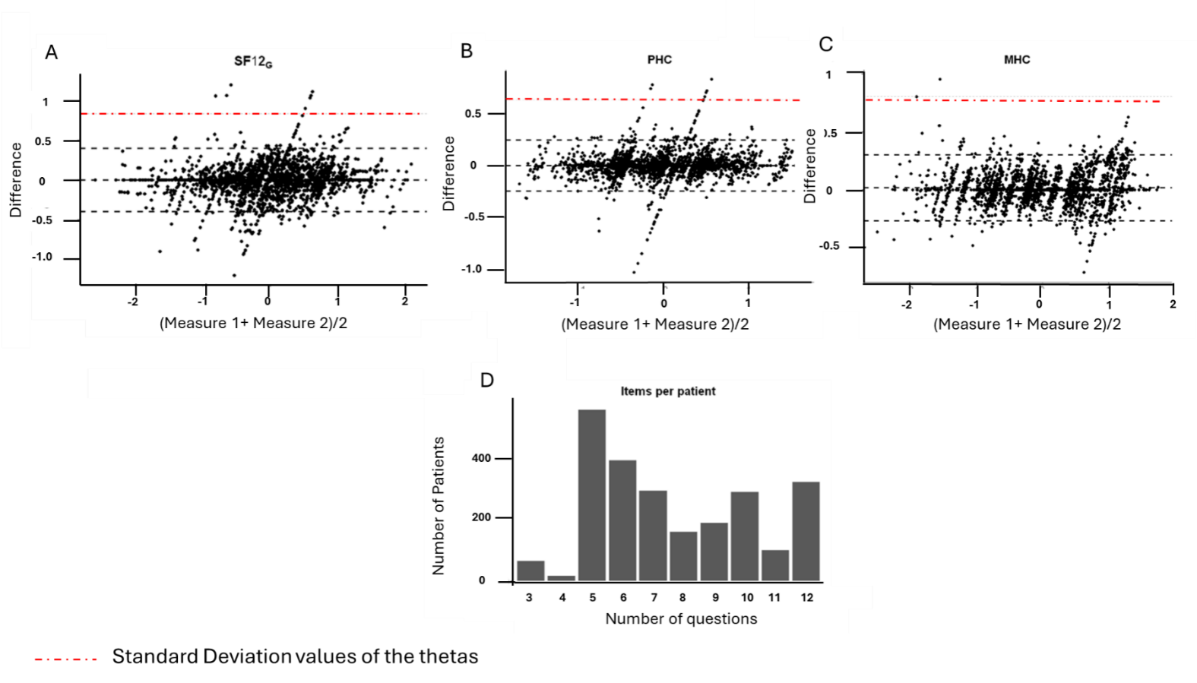
Figure 1: Agreement between two measurements of SF-12 scores and distribution of item burden

Figure 1: Agreement between two measurements of SF-12 scores and distribution of item burden
(A–C) Bland–Altman plots comparing two administrations/measurements of the same construct (“Measure 1” and “Measure 2”) for three SF-12 outcomes: (A) SF12G (General health), (B) Physical Health Composite(PHC), and (C) Mental Health Composite(MHC). The x-axis shows the average of the pair for each patient, (Measure 1+Measure 2)/2; the y-axis shows the within-patient difference, Measure 1−Measure 2. Each point represents one patient. The solid horizontal line denotes the mean difference (bias). Flanking grey dashed lines depict the limits of agreement (mean difference ± 1.96 SD of the differences). Where shown, a sloped dashed fit illustrates the trend of the difference across the measurement range (assessment of proportional bias). The red dot-dash horizontal reference line marks the standard deviation values of Measure 1, a clinically important difference value for context. Positive values indicate higher scores on Measure 1 than on Measure (D) Histogram of questionnaire length per patient used to derive the SF-12 scores. Bars show the number of patients by the count of items completed (3–12 items), illustrating the distribution of response burden in the sample.

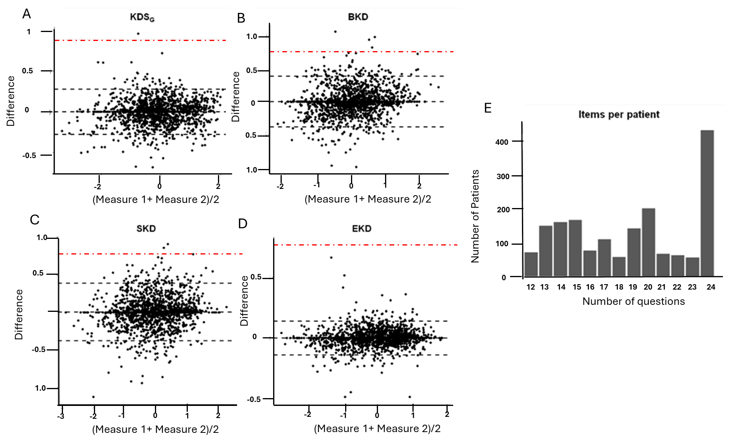
Figure 2 Agreement between two administrations of the KDQOL-36 kidney-disease–targeted scores, and respondent item burden.

Figure 2 Agreement between two administrations of the KDQOL-36 kidney-disease–targeted scores, and respondent item burden.
(A–D) Bland–Altman plots for paired measurements (“Measure 1” vs “Measure 2”) of the KDQOL-36 disease-specific scales: (A) Kidney-disease–specific General score), (B) Burden of Kidney Disease(BKD), (C) Symptoms of Kidney Disease (SKD), and (D) Effects of Kidney Disease (EKD). The x-axis shows the within-patient average (Measure 1+Measure 2)/2; the y-axis shows the within-patient difference (Measure 1−Measure 2). Each dot represents one patient. The solid horizontal line is the mean difference (bias); grey dashed lines indicate the 95% limits of agreement (mean difference ±1.96 SD of the differences). The red dot–dash horizontal line marks a pre-specified reference threshold for a clinically important difference. Positive values indicate higher scores on Measure 1 than on Measure 2.(E) Histogram showing the number of disease-specific items completed per patient (range 12–24 items from the KDQOL-36 kidney-disease–targeted sections), illustrating variability in response burden; the tallest bar at 24 items indicates that many patients completed the full set.

