Supporting Information

CO oxidation over Mn-Ce mixed oxides prepared by simple redox method

Jung-Hyun Park

Carbon Neutral Demo-Plant Center, Korea Research Institute of Chemical Technology, Yeosu-si, Jeollanam-do, Republic of Korea

Fig. S1 Conversion profiles of CO oxidation over the Mn_{0.25}Ce_{0.75} sample calcined at different temperatures. Reaction conditions: CO/O₂/N₂ (vol.%) = 1/4/95, flow rate = 200 cm³/min, WHSV = 120,000 cm³/g h.
Fig. S2 (A) Change in surface area and T_{50%} values, and (B) CO-TPR profiles of Mn_{0.25}Ce_{0.75} sample calcined at different temperatures

1. Catalyst characterization

The surface areas and total pore volumes of the Mn-Ce mixed oxides were determined from the adsorption and desorption isotherms at –196 °C using a volumetric method with Micromeritics ASAP 2020 instruments. The samples (0.2 g) were pretreated at 250 °C for 4 h. The surface area was calculated in the relative pressure range of 0.05–0.20. The crystalline structures of the catalysts were analyzed by powder X-ray diffraction (XRD) using a Rigaku Ultima IV diffractometer with Ni-filtered Cu Kα radiation (1.5418 Å) operating at 40 kV and 40 mA. Scanning electron microscopy (SEM) and energy-dispersive X-ray spectroscopy (EDS) images of the catalysts were acquired using a Hitachi S-2500C scanning electron microscope at an acceleration voltage of 5 kV. The chemical states of the Mn, Ce, and O species in the Mn-Ce mixed oxides were identiﬁed by XPS using an ESCALAB 210 Electron Spectrometer (Al K radiation; h = 1486.6 eV). The XPS data were calibrated using the binding energy of C1s (284.6 eV) as a standard.
The reducibility of the Mn-Ce mixed oxides was determined by the temperature-programmed reduction of CO (CO-TPR) using mass spectrometry (MS; Pfeiffer vacuum QMS 200). Each sample (50 mg) was pretreated at 300 °C for 1 h under an Ar flow (30 cm³/min) and then cooled to 25 °C. The bed temperature was increased to 800 °C at 10 °C/min in a stream of 5% CO/Ar (30 cm³∙min⁻¹). A mass signal of m/z = 44 (∙CO₂) was detected using MS. The CO–pulse experiments were performed at 190 °C and atmospheric pressure. All the catalysts were pretreated at 300 °C under Ar flow (30 cm³/min) for 0.5 h and subsequently cooled to the reaction temperature. Subsequently, pulse experiments were conducted by contacting fixed amounts of CO with the catalyst using Ar as the carrier gas. The pulse experiments were repeated seven times, with each pulse contained 4.5 umol of CO. The mass signal at m/z = 44 (∙CO₂), which was formed by the reaction between CO and the oxygen species of the catalysts, was detected by MS. Temperature-programmed desorption of CO (CO-TPD), CO₂ (CO₂-TPD), and H₂O (H₂O-TPD) was performed to elucidate the adsorption-desorption behavior of CO, CO₂, and H₂O. Each 50 mg sample was pretreated at 300 °C in Ar flow (30 cm³∙min⁻¹) for 1 h and then cooled to 25 °C under the same conditions. After cooling to 25 °C, the adsorbents, (i) 5% CO, (ii) 5%CO + 5%CO₂, and (ii) 5% CO + 3% H₂O, were passed through the catalyst bed at a flow rate of 30 cm³∙min⁻¹ for 0.5 h. For CO₂- and H₂O-TPD, 5% CO₂ and 3% H₂O were introduced into the catalyst bed. The temperature of the sample bed was increased to 500 °C at a heating rate of 10 °C/min. Mass signals at m/z = 44 (∙CO₂) and 18 (∙H₂O) were detected using mass spectrometry (MS).
The Electron spin resonance (ESR) spectra of the Mn-Ce oxide catalysts were obtained at room temperature on a JEOL JES-TE300 spectrometer operating at the X-band frequency (ѵ=9.732 GHz). The EPR signal of the Mn species was recorded in the field region from 2000 to 4000 G, with a sweep time of 10 min. The ESR signal from DPPH (g‖ = 2.0036) was used as an internal standard.

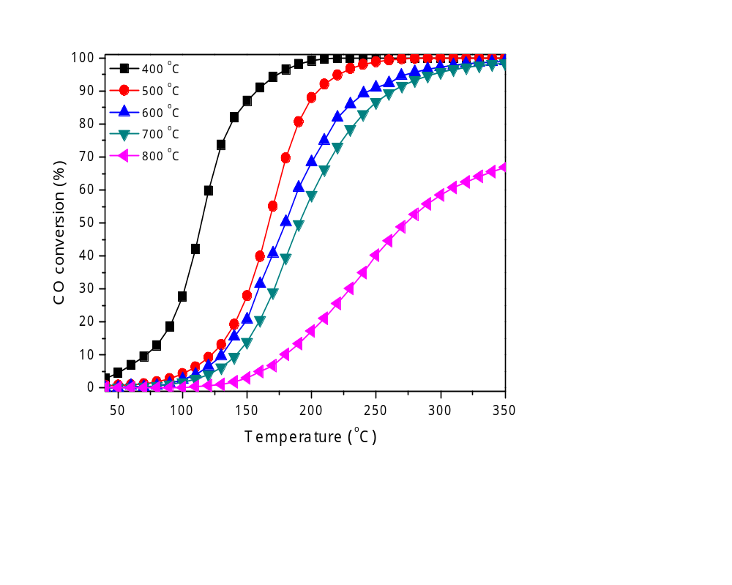

Fig. S1 Conversion profiles of CO oxidation over the Mn_{0.25}Ce_{0.75} sample calcined at different temperatures. Reaction conditions: CO/O₂/N₂ (vol.%) = 1/4/95, flow rate = 200 cm³/min, WHSV = 120,000 cm³/g h.

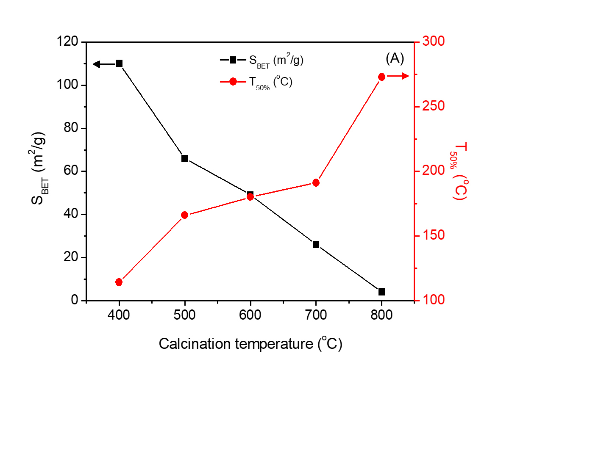
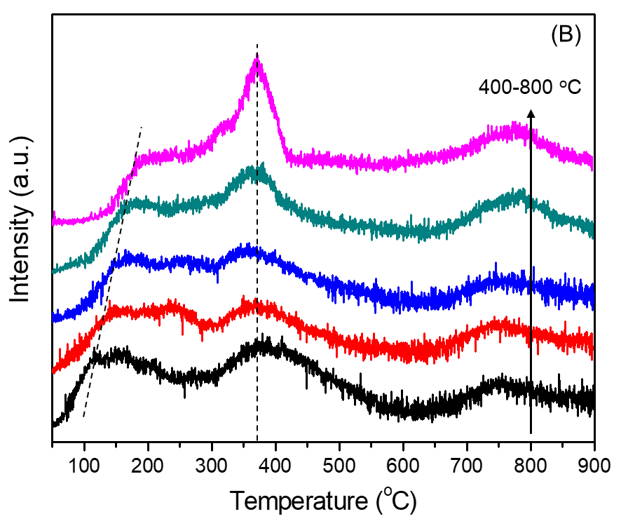

Fig. S2 (A) Change in surface area and T_{50%} values, and (B) CO-TPR profiles of Mn_{0.25}Ce_{0.75} sample calcined at different temperatures

Graphical Abstract

CO oxidation over Mn-Ce mixed oxides prepared by a simple redox method

Jung-Hyun Park*, Hyeryeung Noh, Joong Jin Han

Carbon Neutral Demo-Plant Center, Korea Research Institute of Chemical Technology, Yeosu-si, Jeollanam-do, Republic of Korea

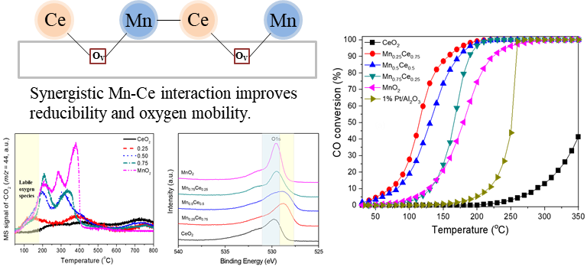

To whom should correspondence be addressed.
Phone: +82-10-9730-6820
Corresponding author: jhp1024@krict.re.kr

