Supplementary Information for
Sensitive and fast mid-wave infrared graphene/HgCdTe van der Waals heterojunction empowered by interface engineering
Wenxin Li^{1,2#}, Hanxue Jiao^{2,3#}, Ruotong Yin^{2#}, Yan Chen^{1*}, Haoran Yan², Dongyang Zhao¹, Yahui Wang³, Xiaochi Tai^{1,2}, Jinchao Tong¹, Xudong Wang², Junhao Chu^{1,2}, Jianlu Wang^{1,3}
¹Shanghai Frontier Base of Intelligent Optoelectronics and Perception, Institute of Optoelectronics, College of Future Information Technology, Fudan University, 200433 Shanghai, P. R. China
²State Key Laboratory of Infrared Physics, Shanghai Institute of Technical Physics, Chinese Academy of Sciences, No.500 Yutian Road, Shanghai 200083, P. R. China.
³Frontier Institute of Chip and System, College of Integrated Circuits & Micro-Nano Electronics, Fudan University, Shanghai 200433, P. R. China.
*Corresponding authors: Yan Chen (yanchen_@fudan.edu.cn)
#These authors contributed equally: Wenxin Li, Hanxue Jiao, Ruotong Yin.

Table of contents
Supplementary Note. Work function calculation of graphene
Figure S1| Electrical measurement of the HgCdTe and Graphene.
Figure S2| Transfer characteristic curve and AFM topography of HNO3-treated graphene.
Figure S3| Output characteristic of graphene/metal electrodes and HgCdTe/metal electrodes.
Figure S4| The temporal stability, reproducibility, and photoresponse characteristics under 520 nm laser illumination of the device.
Figure S5| Noise spectrum of doped graphene/HgCdTe photodetector at different bias.
Figure S6| 90–10% rise and fall times of doped graphene/HgCdTe photodetector at different bias.
Figure S7| The different responsivity regions of the device used for specific detectivity calculations.
Figure S8| Fourier transform infrared spectrometer test of the doped graphene/HgCdTe photodetector.
Figure S9| Schematic Illustration of Fourier-Transform Infrared (FTIR) Spectrometer Operation.

Supplementary Information is available for this paper

Supplementary Note
Work function calculation of graphene
The Fermi energy position in graphene with respect to the Dirac point can be derived as ¹⁻³：
$$\begin{aligned}\left|E_{F}\right|=ℏv_{F}\sqrt{π\left|n_{s}\right|}\#1\end{aligned}$$
where ℏ is the reduced Planck constant, $v_{F}$ is the Fermi velocity of graphene (*$v_{F}$≈10⁶ ms⁻¹), and $n_{s}$ is the carrier density in graphene. The carrier density $n_{s}$ can be calculated using Equation 2.
$$\begin{aligned}n=\frac{ϵ_{0}ϵ_{r}}{et}⋅V_{g}\#2\end{aligned}$$
where $ϵ_{0}$ is the vacuum permittivity, $ϵ_{r}$ is the relative permittivity of the gate dielectric, t is the thickness of the gate dielectric layer, and V_{g} denotes the gate voltage at the transition point in the graphene transfer characteristic curve.
We used 285 nm SiO₂ as the gate dielectric layer, The thickness of the graphene is 13 nm. The gate voltages (V_{g}) for pristine and doped graphene were extracted from their transfer characteristic curves as –2.7 V and 59.6 V, respectively. The corresponding carrier densities were calculated to be 6.81×10¹⁰ cm⁻² and 4.51×10¹² cm⁻² from Equation 2. The Fermi level positions relative to the Dirac point, derived from Equation 1, were +0.03 eV for pristine graphene and –0.248 eV for doped graphene. Based on these results, we conclude that treatment with 70% nitric acid increases the work function of graphene by 0.251 eV.

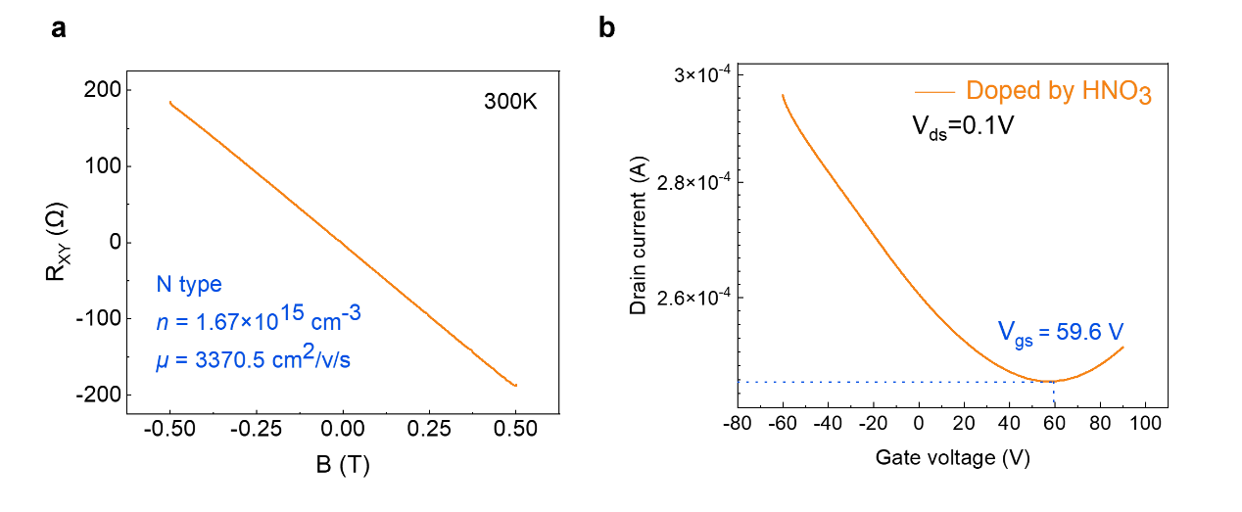
Figure S1| Electrical measurement of the HgCdTe and Graphene. a Hall measurement results of HgCdTe film. b The transfer characteristic curve of graphene on a larger scale.

Figure S2| Transfer characteristic curve and AFM topography of HNO3-treated graphene. a,d,g,j Transfer characteristic curve of HNO₃-treated graphene FETs with different thicknesses. b,e,h,k AFM mapping image of HNO₃-treated graphene with different thicknesses. c,f,I,l height extracted from white dash line in (b, e, h, k).

Figure S3| Output characteristic of graphene/metal electrodes and HgCdTe/metal electrodes. a I-V characteristic of graphene flake with Ti/Au electrodes. b I-V characteristic of HgTeCd film with Ti/Au electrodes. c,d Optical image of graphene flake with Ti/Au electrodes and HgTeCd film with Ti/Au electrodes.

Figure S4| The temporal stability, reproducibility, and photoresponse characteristics under 520 nm laser illumination of the device. a J–V curves of the device measured at different times. b J–V curves of multiple devices. c Photocurrent mapping image measured at zero bias with 520 nm laser illumination. d Measured photocurrent as a function of incident illumination(520nm) intensity.

Figure S5| Noise spectrum of doped graphene/HgCdTe photodetector at different bias. a-f current noise spectrum of the doped graphene/HgCdTe photodetector at -0.01V, -0.1V, -0.5V, 0.01V, 0.1V, 0.5V.

Figure S6| 90–10% rise and fall times of doped graphene/HgCdTe photodetector at different bias. a-f photoresponse and time dependence of the doped graphene/HgCdTe photodetector at -0.01 V, -0.1 V, -0.5 V, 0.01 V, 0.1 V,0.5 V.

Figure S7| The different responsivity regions of the device used for specific detectivity calculations. The area (white dashed boxes) used for calculating the specific detectivity. a doped graphene/HgCdTe heterojunction. b the entire device.

Figure S8| Fourier transform infrared spectrometer test of the doped graphene/HgCdTe photodetector. a Relative response spectrum of the background obtained by the internal (DTGS) detector. b Relative response spectrum of the doped graphene/HgCdTe photodetector.

Figure S9| Schematic Illustration of Fourier-Transform Infrared (FTIR) Spectrometer Operation. Infrared radiation is emitted from a globar source and directed into a Michelson interferometer, where it is modulated to form an interferogram. This modulated beam is then guided through an optical path and incident upon the sample. The resulting photocurrent generated by the sample is first amplified by a preamplifier into a voltage signal, which is subsequently acquired by a computer. The spectral response information is ultimately retrieved by applying an inverse Fourier transform to the acquired time-domain signal.

References
1 Castro Neto, A. H. et al. The electronic properties of graphene. Rev. Mod. Phys. 81, 109-162 (2009).
2 Zhang, Y. et al. Experimental observation of the quantum Hall effect and Berry's phase in graphene. Nature 438, 201-204 (2005).
3 Novoselov, K. S. et al. Two-dimensional gas of massless Dirac fermions in graphene. Nature 438, 197-200 (2005).

