Appendices
Appendix A – Structural Equation Model

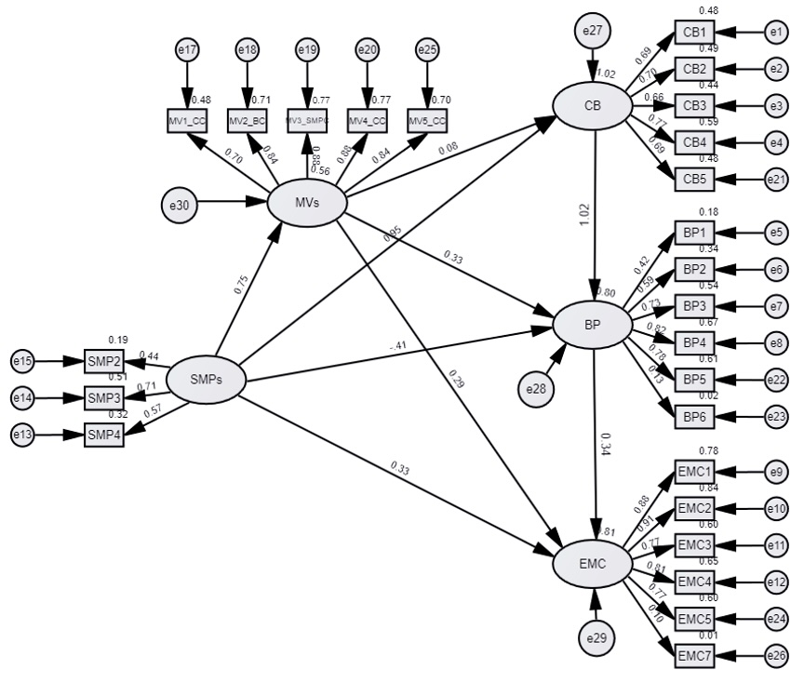

Appendix B: Table 7. Moderation Results
X → Y | Moderator (W) | Interaction (X×W) b | SE | t | p | ΔR² | Simple slope @ Low W (b, p) | @ Mean W (b, p) | @ High W (b, p) | Johnson–Neyman region
SMP → CB | Consumer Characteristics (MV_CC) | 0.0677 | 0.0446 | 1.52 | .130 | .0036 | — | — | — | n/a (interaction NS)
SMP → CB | Brand Characteristics (MV2_BC) | 0.0329 | 0.0379 | 0.87 | .386 | .0012 | — | — | — | n/a (interaction NS)
SMP → CB | SM Platform Characteristics (MV3_SMPC) | 0.0889 | 0.0398 | 2.23 | .026 | .0082 | 0.3212, p < .001 | 0.4101, p < .001 | 0.4991, p < .001 | No cutoff; significant throughout
Notes. All predictors and moderators were mean-centered. ΔR² = incremental variance explained by adding the interaction term. “Low,” “Mean,” and “High” refer to the 16th, 50th, and 84th percentiles of the moderator distribution.

