Supplementary Material

Multi-Objective Optimization of Coastal Aquifer Management Based on Temporal GALDIT and Explainable Deep Learning Models

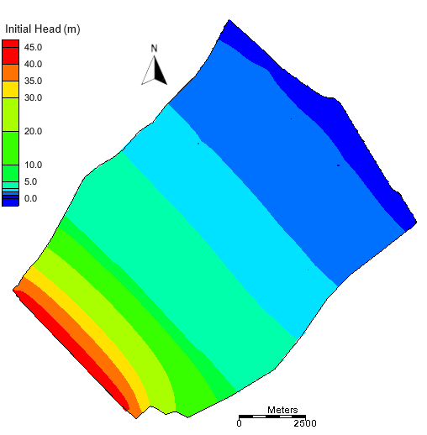

Figure S1. The initial water level (meters) map of the Wadi al-Jizi aquifer.

Figure S2. Time changes in vulnerable areas of the Wadi Al Jizi aquifer determined using the GALDIT method.

Figure S3. Average annual pumping rates of the Wadi Al Jizi aquifer wells (1 through 22) from 2000 to 2017.

Figure S4. The average annual recharge rate of the Wadi Al Jizi aquifer from 2000 to 2017.

Figure S5. The impact of recharge well configurations on observation wells’ average hydraulic head change.

Figure S6. The impact of pumping rate reduction scenarios on observation wells’ average hydraulic head change.

Figure S7. The effect of dam runoff rate on average hydraulic head changes for 50 recharge wells.

Figure S8. The effect of the percentage of wastewater injected into the aquifer on average hydraulic head changes for 50 recharge wells.

Figure S9. The effect of treated wastewater volume on average hydraulic head changes for 50 recharge wells.

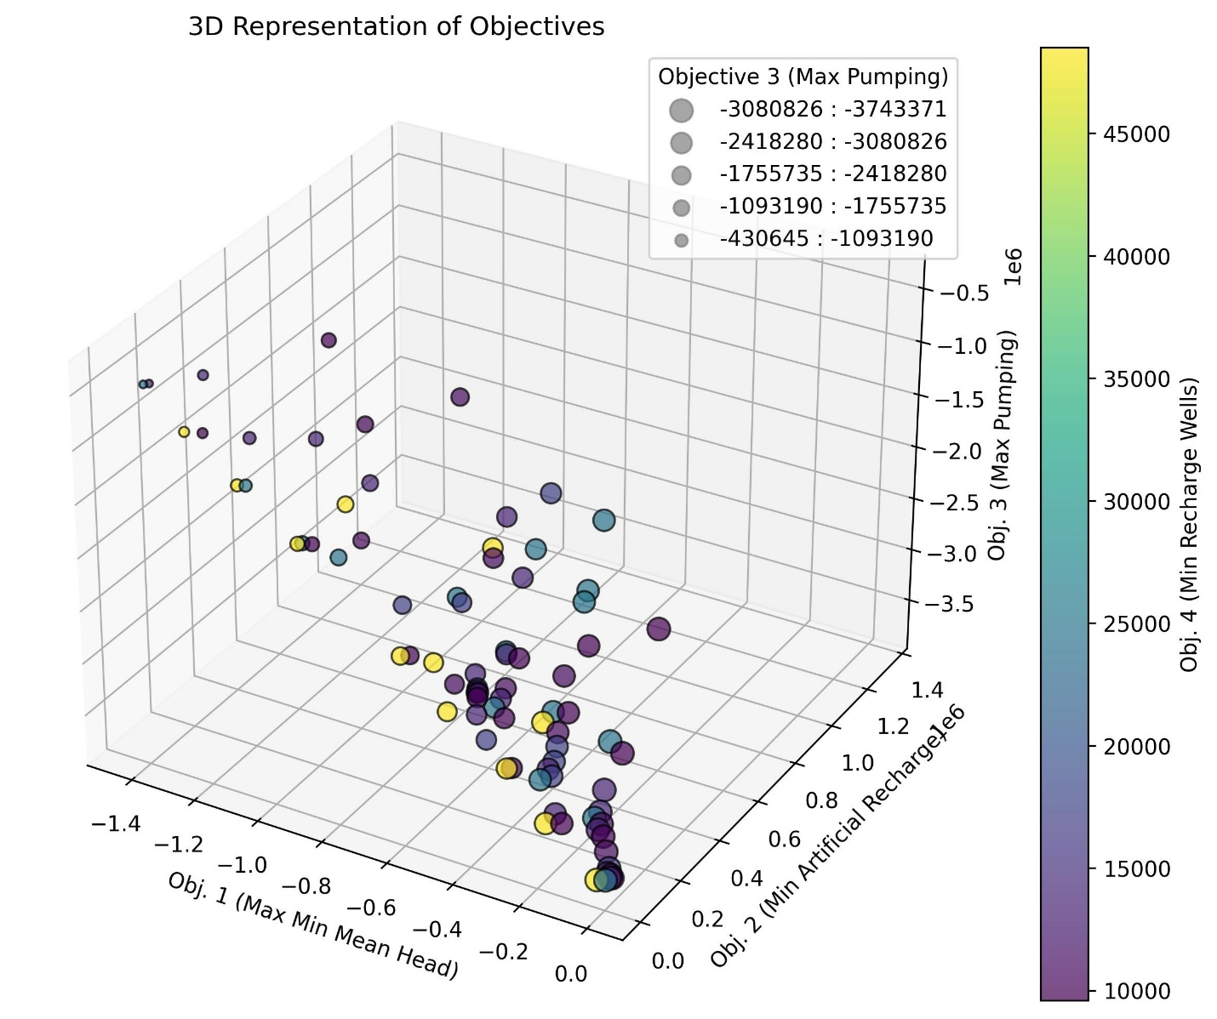

Figure S10. 3D Pareto front obtained for the groundwater management model.
In Fig. S10, the x-axis corresponds to Objective 1, the y-axis to Objective 2, and the z-axis to Objective 3. The color gradient of the points, as shown by the color bar, represents Objective 4. Each point in the graph represents a potential solution, highlighting the trade-offs between competing objectives. Solutions near the Pareto-optimal front demonstrate the best possible compromises among these objectives. Brighter colors (yellow) indicate higher costs (more recharge wells), while darker colors (purple) indicate lower costs.
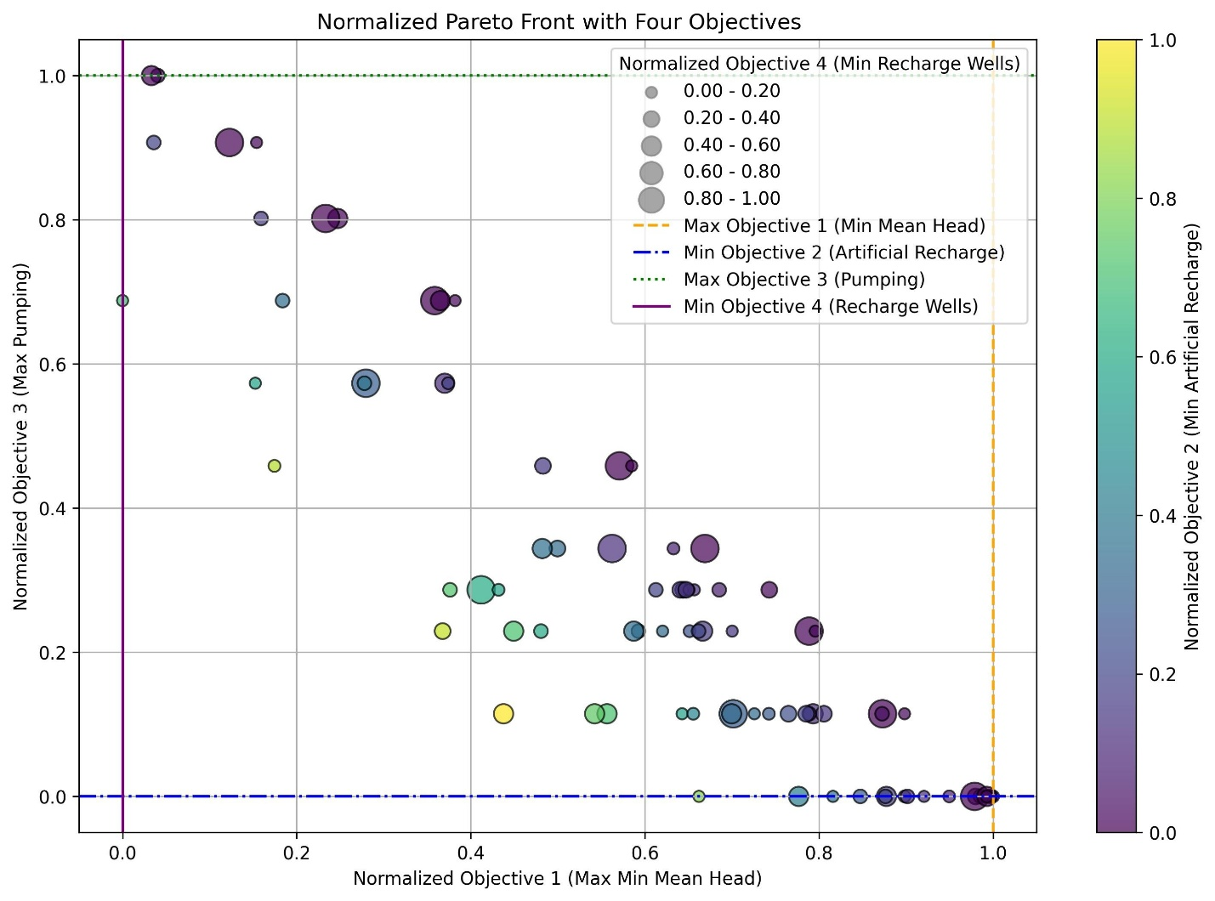

Figure S11. Normalized Pareto front showing the distribution of solutions with normalized objectives.
Fig. S11 visualizes the normalized Pareto front where all objectives are scaled between 0 and 1 using the Min-Max normalization technique. Additionally, vertical and horizontal dashed lines mark the extreme values of each normalized objective (e.g., maximum/minimum values for Objectives 1–4) to emphasize trade-offs.

