Supporting information

Developing α-lipoic acid-derived solvent-free bioadhesives via deep eutectic melting

Experiment section
1. Materials
DL-Lipoic acid (LA), ethanolamine (EA), aminopropanediol (AP), diethanolamine (DEA), tris(hydroxymethyl)aminomethane (Tris), N-Hydroxy succinimide (NHS), 1-(3-Dimethylaminopropyl)-3-ethylcarbodiimide hydrochloride (EDC·HCl), N,N’-dicyclohexylcarbodiimide (DCC), methanol, dichloromethane, DMF, ethyl acetate, ethanol, diethyl ether, deuterated solvents (DMSO-d6) are purchased from Shanghai Aladdin Biochemical Technology Co., Ltd (China). Silica gel is purchased from Sinopharm Chemical Reagent Co., Ltd (China).
2. Instrumentation
All ¹H NMR spectra are recorded on Bruker 500 MHz NMR spectrometers. Chemical shifts are given in ppm relative to the residual solvent peak (DMSO-d6: 2.50 for ¹H). Differential scanning calorimetry (DSC) analyses of LA, its derivatives, and their mixtures are performed on a TA instrument at a heating/cooling rate of 10 °C min⁻¹ under N₂ atmosphere. The infrared spectra are performed on a Nicolet IS10 Fourier Transform Infrared Spectrometer from Thermo Fisher Scientific with potassium bromide pellet method. UV-Vis absorption spectra of LA, its derivatives, and their mixtures are characterized on the quartz plates using a V-750 UV-Visible Spectrophotometers from JASCO. The prepared sample is placed on a glass slide and tested on a D8 Discover X-ray Diffractometer for analysis of its crystalline structure at a scanning angle of 5-90° and a scanning speed of 10°/min. Raman spectra are performed on a microconfocal Raman Spectrometer (INVIA QONTOR) with excitation wavelength 532 nm, scanning wavelength 200-1000 cm⁻¹. The sample is placed between a slide and a cover slip, and then tested on an BA 310Met polarizing microscope for analysis of its crystalline structure. All mechanical tests (shear and peel) are performed using an NSS CMT6103 machine, either with a 50 N, 500 N, 1 kN or 10 kN load cell. The lap shear tensile experiments are performed at a constant crosshead speed of 50 mm/min. The shear strength is calculated as the maximum load divided by the overlap area (2.5×1.0 cm, 2.0×1.0 cm). The peel tests are performed with slight modifications at a constant crosshead speed of 50 mm/min. Rheological measurements are performed on a DHR-3 Rheometer from TA instrument with a parallel plate geometry (25 mm diameter). The electronic spray ionization (ESI) mass spectra are obtained on XEVO G2 TOF. Matrix-assisted laser desorption ionization time-of-flight mass spectrometry (MALDI-TOF-MS) (Singapore ABS Corporation; 400-500000 Da/4800plus) are used to determine the polymer molecular weight distribution of the deep eutectic bioadhesives in DMSO and mixed solvent of DMSO and H₂O (the volume ratio of DMSO and H₂O is 2:1) respectively.
3. Synthesis of the ELA, APLA, DELA and TLA
3.1 Synthesis of ELA
LA (4.12 g, 20 mmol), ethanolamine (EA, 1.47 g, 24 mmol) and EDC·HCl (4.60 g, 24 mmol) are dissolved in methanol (30 ml). The mixture is stirred at 30 °C for 10 h. Then the solvent is removed under the reduced pressure and the residue is further purified by column chromatography over silica gel to give 3.30 g ELA (13.2 mmol, yield 66.2%). ¹H NMR (500 MHz, DMSO-d6) δ 7.77 (t, J = 5.7 Hz, 1H), 4.64 (t, J = 5.5 Hz, 1H), 3.60 (dq, J = 8.8, 6.3 Hz, 1H), 3.36 (m, 2H), 3.21-3.05 (m, 4H), 2.40 (dq, J = 12.5, 6.2 Hz, 1H), 2.06 (t, J = 7.4 Hz, 1H), 1.86 (dq, J = 12.7, 6.8 Hz, 1H), 1.65 (m, 1H), 1.59-1.43 (m, 3H), 1.39-1.26 (m, 2H) ppm. MS (ESI) (m/z): [M+H]⁺ calcd. for ELA, 250.09, found 249.92.
3.2 Synthesis of APLA
LA (4.12 g, 20 mmol), aminopropanediol (AP, 2.19 g, 24 mmol) and EDC·HCl (4.60 g, 24 mmol) are dissolved in methanol (30 ml). The mixture is stirred at 30 °C for 10 h. Then the solvent is removed under the reduced pressure and the residue is further purified by column chromatography over silica gel to give 2.99 g APLA (10.7 mmol, yield 53.6%).¹H NMR (500 MHz, DMSO-d6) δ 7.78 (t, J = 5.8 Hz, 1H), 4.60 (d, J = 85.4 Hz, 2H), 3.60 (dq, J = 8.6, 6.2 Hz, 1H), 3.46 (m, 1H), 3.31-2.91 (m, 6H), 2.41 (dq, J = 12.5, 6.2 Hz, 1H), 2.09 (t, J = 7.4 Hz, 2H), 1.86 (dq, J = 13.5, 6.8 Hz, 1H), 1.66 (m, 1H),1.60-1.44 (m, 3H), 1.41-1.26 (m, 2H) ppm. MS (ESI) (m/z): [M+H]⁺ calcd. for APLA, 280.10, found 279.99.
3.3 Synthesis of DELA
LA (4.12 g, 20 mmol), diethanolamine (DEA, 2.52 g, 24 mmol) and EDC·HCl (4.61 g, 24 mmol) are dissolved in methanol (30 ml). The mixture is stirred at 30 °C for 10 h. Then the solvent is removed under the reduced pressure and the residue is further purified by column chromatography over silica gel to give 2.34 g DELA (7.98 mmol, yield 41.2%).¹H NMR (500 MHz, DMSO-d6) δ 4.79 (s, 1H), 4.63 (s, 1H), 3.61 (dq, J = 8.7, 6.2 Hz, 1H), 3.50 (t, J = 6.0 Hz, 2H), 3.45 (t, J = 6.2 Hz, 2H), 3.37 (t, J = 6.0 Hz, 2H), 3.32 (t, J = 6.2 Hz, 2H), 3.15 (m, 2H), 2.42 (dq, J = 12.5, 6.2 Hz, 1H), 2.33 (t, J = 7.4 Hz, 2H), 1.86 (dq, J = 13.6, 6.9 Hz, 1H), 1.67 (m, 1H),1.62-1.43 (m, 3H), 1.43-1.29 (m, 2H) ppm. MS (ESI) (m/z): [M+H]⁺ calcd. for DELA, 294.11, found 293.97.
3.4 Synthesis of TLA
LA (5.98 g, 29 mmol), NHS (3.11 g, 27 mmol) is dissolved in dry dichloromethane (25 mL) and cooled to 0 °C, DCC (6.6 g, 29.7 mmol) is added portions-wise to the precooled solution. The reaction mixture is allowed to warm to room temperature and stirred overnight under N₂. After filtration, the obtained filtrate is concentrated under reduced pressure at 30 °C. The filtrate is precipitated with cold diethyl ether to obtain the intermediate NHS-LA (7.3 g, yield 89%). ¹H NMR (500 MHz, DMSO-d₆) δ 3.62 (dq, J = 8.6, 6.2 Hz, 1H), 3.15-3.24 (m, 1H), 3.07-3.15 (m, 1H), 2.81 (s, 4H), 2.68 (t, J = 7.2 Hz, 2H), 2.42 (dq, J = 12.4, 6.3 Hz, 1H), 1.88 (dq, J = 13.3, 6.8 Hz, 1H), 1.53-1.75 (m, 4 H), 1.40 -1.51 (m, 2H) ppm. Then, NHS-LA (6.52 g, 21.2 mmol), tris(hydroxymethyl)aminomethane (Tirs, 3.84 g, 31.7 mmol) are dissolved in DMF (25 ml). The mixture is stirred at 50 °C for 24 h. The reaction solution is transferred into the separating funnel, and about 70 mL of deionized water and 180 mL of ethyl acetate are added. After shaking and standing, the upper organic phase is taken. Then the organic phase is removed under the reduced pressure and the residue is further purified by column chromatography over silica gel to give 0.67 g TLA (6.5 mmol, yield 10.0%).¹H NMR (500 MHz, DMSO-d6) δ 7.11 (s, 1H), 4.75 (t, J = 5.8 Hz, 3H), 3.61 (dq, J = 8.6, 6.2 Hz, 1H), 3.51 (d, J = 5.6 Hz, 6H), 3.15 (m, 2H), 2.41 (dq, J = 12.4, 6.2 Hz, 1H), 2.14 (t, J = 7.4 Hz, 2H), 1.87 (dq, J = 13.5, 6.8 Hz, 1H), 1.67 (m, 1H),1.62-1.43 (m, 3H), 1.43-1.29 (m, 2H). MS (ESI) (m/z): [M+H]⁺ calcd. for TLA, 310.11, found 310.83.
4. Preparation of the ELA/LA, APLA/LA, DELA/LA, TLA/LA deep eutectic bioadhesives.
4.1Preparation of ELA/LA deep eutectic bioadhesives
ELA/LA deep eutectic system is prepared by mixing ELA with LA to a centrifuge tube at a certain molar ratio and using a glass rod to mechanically stir for 2 min, the molar ratios are shown in Table S1. After ultraviolet radiation (365 nm, 25 mW/cm²), the cured adhesive is named ELA/LA@UV.
Table S1. Preparation parameters of ELA/LA system with different ratios
Name | ELA (mmol) | LA (mmol)
ELA/LA_{6:1} | 6 | 1
ELA/LA_{4:1} | 4 | 1
ELA/LA_{2:1} | 2 | 1
ELA/LA_{1:1} | 1 | 1
ELA/LA_{1:2} | 1 | 2

4.2 Preparation of APLA/LA deep eutectic bioadhesivesy
APLA/LA deep eutectic system is prepared by mixing APLA with LA to a centrifuge tube at a certain molar ratio and using a glass rod to mechanically stir for 10 min, the molar ratios are shown in Table S2. After ultraviolet radiation (365 nm, 25 mW/cm²), the cured adhesive is named APLA/LA@UV.
Table S2. Preparation parameters of APLA/LA system with different ratios
Name | APLA (mmol) | LA (mmol)
APLA/LA_{4:1} | 4 | 1
APLA/LA_{2:1} | 2 | 1
APLA/LA_{1.5:1} | 1.5 | 1
APLA/LA_{1:1} | 1 | 1
APLA/LA_{1:2} | 1 | 2

4.3 Preparation of DELA/LA eutectic bioadhesives
DELA/LA deep eutectic system is prepared by mixing DELA with LA to a centrifuge tube at a certain molar ratio and using a glass rod to mechanically stir for 1 min, the molar ratios are shown in Table S3. After ultraviolet radiation (365 nm, 25 mW/cm²), the cured adhesive is named DELA/LA@UV.
Table S3. Preparation parameters of DELA/LA system with different ratios
Name | DELA (mmol) | LA (mmol)
DELA/LA_{2:1} | 2 | 1
DELA/LA_{1:1} | 1 | 1
DELA/LA_{1:2} | 1 | 2

4.4 Preparation of TLA/LA eutectic bioadhesives
TLA/LA deep eutectic system is prepared by mixing DELA with LA to a centrifuge tube at a certain molar ratio and using a glass rod to mechanically stir for 15 min, the molar ratios are shown in Table S4. After heating polymerization, the cured adhesive is named P(TLA/LA).
Table S4. Preparation parameters of TLA/LA system with different ratios
Name | TLA (mmol) | LA (mmol)
TLA/LA_{5:1} | 5 | 1
TLA/LA_{3:1} | 3 | 1
TLA/LA_{2:1} | 2 | 1
TLA/LA_{1:1} | 1 | 1
TLA/LA_{1:2} | 1 | 2
TLA/LA_{1:3} | 1 | 3
TLA/LA_{1:4} | 1 | 4

5. Lap shear testing
5.1 Lap shear testing of the ELA/LA, APLA/LA, DELA/LA deep eutectic bioadhesives before and after UV curing.
Before adhesion, the glass sheets are cleaned upon sonication for 30 min in ethanol and deionized water and then completely dried at room temperature. The deep eutectic bioadhesive with different molar ratios is uniformly painted on the surface of one glass sheet (overlap area 2.5 x 1 cm), and the lap joint is formed by hand pressing the adhesive-containing glass sheet with another adhesive-free glass sheet. After that, the lap joint is exposed to UV radiation with different times. The lap shear testing is performed at a rate of 50 mm/min until failure. At least 3 repetitions are performed. The adhesive strengths are calculated as F/S (where F is the maximum load and S is the joint area).
5.2 Lap shear testing of the TLA/LA deep eutectic bioadhesives
Before adhesion, the substrates, such as glass sheets, stainless steel, PTFE, are cleaned upon sonication for 30 min in ethanol and deionized water and then completely dried at room temperature. The TLA/LA powder with different molar ratios is applied on the surface of one substrate (overlap area 2 x 1 cm), and the lap joint is formed by hand pressing the adhesive-containing substrate with another adhesive-free substrate, followed by clamping with two mini binder clips (Office Deli brand). The lap joints are cured at melting temperature for 12 hours and cooled to room temperature before being subjected to the lap shear tensile test at a rate of 50mm/min until failure. At least 3 repetitions are performed. The adhesive strengths are calculated as F/S (where F is the maximum load and S is the joint area).
5.3 Lap shear testing of the water-resistance adhesion
The lap joints are cured after UV radiation or heating, and then immersed underwater for different days. The lap shear testing is performed at a rate of 50 mm/min until failure. At least 3 repetitions are performed. The adhesive strengths are calculated as F/S (where F is the maximum load and S is the joint area).
6. Adhesion display of the ELA/LA, APLA/LA, DELA/LA deep eutectic bioadhesives on different substrates
Taking ELA/LA_{2:1} as an example, ELA/LA_{2:1} deep eutectic bioadhesives is loaded into a syringe and injected onto the surface of substrate such as ceramic, wood, rubber, PTFE, and so on. And the adhesive is pressed with a glass sheet, and then irradiated by UV light for 5 min to demonstrate the adhesion effect of ELA/LA_{2:1} adhesive.
7. Adhesive display for underwater use of the ELA/LA deep eutectic bioadhesives
ELA/LA_{2:1} deep eutectic bioadhesives is loaded into a syringe and dropped onto the surface of substrate such as glass, metal and plastic cap underwater. Then, a glass sheet is pressed onto the adhesive to form a joint. After that, the joint is exposed to UV radiation for 5 min to demonstrate the use of ELA/LA_{2:1} adhesive underwater.
8. Rheological Measurements
Frequency sweeps are recorded with a parallel plate geometry (25 mm diameter and the gap between the plates is 0.28 mm±0.01) as the angular frequency is ramped logarithmically from 0.1 to 500 rad/s at a constant strain of 0.6 % and 37 °C. Amplitude sweeps are recorded with a parallel plate geometry (25 mm diameter and the gap between the plates is 0.28 mm±0.01) as the strain amplitude is ramped logarithmically from 0.01 to 500% at a constant frequency at 10 rad/s and temperature 37°C. The viscosity is recorded with a parallel plate geometry (25 mm diameter and the gap between the plates is 0.28 mm±0.01) as the shear rate is ramped logarithmically from 0.004 to 180 s⁻¹. Time sweeps are recorded with a parallel plate geometry (25 mm diameter and the gap between the plates is 0.28 mm±0.01) as the step time is ramped lineally from 0 to 300 s with or without UV radiation at a constant strain of 0.6 %, frequency at 10 rad/s and 37 °C. At least 3 repetitions are performed, and averages are reported.
9. Simulation calculations
Based on density functional theory, the structure and binding energies between LA and its derivatives, the cleavage and polymerization of ELA and LA are respectively studied. All calculations are performed using the ORCA 6.0 program¹⁻⁴. The configuration optimization and vibration analysis are calculated at the basis group level of B3LYP-D3 and def2-TZVP, while the energy calculation is performed at the def2-TZVPP level using the more accurate wB97M-V functional⁵⁻⁷. The Gibbs free energy of a compound is equal to the sum of the calculated electronic energy and the Thermal Free Energy Correction, and the Gibbs free energy change of the reaction is the Gibbs free energy difference between the product and the reactant.
The combination can be calculated in the following formula:
E_{bind} =E(AB)-E(A)-E(B)
Among them, E_{bind} is the total energy of the complex formed by A and B, and E(A) and E(B) are the individual energies of compounds A and B, respectively. The computational structure and plotting are carried out using the software VESTA⁸.
Molecular dynamics simulations are performed on several systems. The simulation system consists of the following components: ELA (130), LA (65), the molar ratio of ELA to LA is 2:1. Using the PACKMOL software package to build the initial configuration of the system (a 3 × 3 × 3 nm cube box). All molecular dynamics (MD) calculations are performed using GROMACS 2023. General Amber Force Field (GAFF) is used in electrolyte systems. The long-range electrostatic interaction is calculated by the particle grid Ewald (PME) method, and the real spatial cut-off value is 1.0 nm. The cut-off value for the van der Waals interaction is set at 1.0 nm and the energy is minimized before each simulation. The system is balanced for 0.5 ns using a V-rescale thermostat and a Berendsen regulator to obtain a stable temperature of 300 K and a constant pressure of 1 Pa. Then the system is re-equilibrated for 2 nanoseconds in an NPT unit at 300 K and 1 Pa. After annealing and equilibration, the system ran in MD simulations for 10 ns. The time step is 1 fs, at a temperature of 300 K and a constant pressure of 1 Pa, the trajectories are collected every 5000 ps using a V-thermostat, and the trajectories of the results are analyzed with VMD 1.9.3.
10. In-Vitro Tissue Adhesion Studies
10.1 Macroscopic display of the ELA/LA, APLA/LA, DELA/LA deep eutectic bioadhesives on different tissues.
Chicken liver, lung, heart, kidney and porcine fat
Freshly harvested and untreated chicken liver, lung, heart, kidney and porcine fat are purchased from the local butcher shop. Taking ELA/LA_{2:1} as an example, ELA/LA_{2:1} deep eutectic bioadhesives is loaded into a syringe and injected onto the surface of above tissues. And the adhesive is pressed with a glass sheet by hand, and then irradiated by UV light for 5 min to demonstrate the adhesion effect of ELA/LA_{2:1} adhesive.
Porcine cornea
Freshly harvested and untreated porcine eyeball are purchased from the local butcher shop. Pieces of cornea are obtained from the porcine eyeball with a scalpel. ELA/LA_{2:1} deep eutectic bioadhesives is loaded into a syringe and dropped onto the corneal surface of the porcine eyeball, another piece of cornea is used to gently press the adhesive, and then UV light is used to demonstrate the adhesion effect of ELA/LA_{2:1} adhesive on the cornea of the biological eye.
10.2 Lap shear testing of the ELA/LA deep eutectic bioadhesives on porcine skin and porcine lean meat.
Freshly harvested and untreated porcine skin and porcine lean meat are purchased from the local butcher shop. The ELA/LA deep eutectic bioadhesive with different molar ratios is uniformly painted on the surface of fresh porcine skin or porcine lean meat (overlap area 0.8 x 0.8 cm), and the lap joint is formed by hand pressing the adhesive-containing porcine skin or porcine lean meat with an adhesive-free glass sheet. After that, the lap joint is exposed to UV radiation for 5 min. The lap shear testing is performed at a rate of 50 mm/min until failure. At least 3 repetitions are performed. The adhesive strengths are calculated as F/S (where F is the maximum load and S is the joint area).
10.3 Peel testing of the ELA/LA deep eutectic bioadhesives on porcine skin.
The ELA/LA deep eutectic bioadhesive with different molar ratios is uniformly painted on the surface of fresh porcine skin (overlap area 7.5 x 0.8 cm), and the lap joint is formed by hand pressing the adhesive-containing porcine skin with an adhesive-free glass sheet. After that, the lap joint is exposed to UV radiation for 5 min. The peel testing is performed at a rate of 50 mm/min until failure. At least 3 repetitions are performed. The average peeling strength is calculated within the plateau region (14 mm to 33 mm displacement). The peel testing of the fibrin glue on porcine skin is set as a control group.
10.4 Organ sealing experiments of the DELA@TLA/LA deep eutectic bioadhesives.
The TLA/LA_{1:3} powders are placed in the PTFE mold, heated to melt and maintained for 12 hours, then cooled to room temperature. After demolding, the TLA/LA deep eutectic film (thickness 0.84±0.05 mm) is obtained. Subsequently, DELA that has self-polymerized for 3 days is applied to the surface of the TLA/LA deep eutectic film to prepare self-adhesive patch (named as DELA@TLA/LA).
Freshly harvested and untreated porcine intestine and stomach are purchased from the local butcher shop. The porcine intestine and stomach are filled with PBS containing food blue color for better visibility. Then, a 3 mm incision is made with a scalpel on the liquid-filled intestine. Afterward, the DELA@TLA/LA patch is placed on the incision and secured with hand pressing. Then investigating the leakage. Similarly, another 3 mm incision is made with a scalpel on the liquid-filled stomach. Afterward, the DELA@TLA/LA patch is placed on the incision and secured with hand pressing. Then investigating the leakage.
11. In-Vivo Studies
All the animal care, housing, and study procedures for rats complied with the ARRIVE guidelines and are performed in accordance with the National Research Council’s Guide for the Care and Use of Laboratory Animals.
11.1 In-Vivo the rat liver hemostasis performance of the ELA/LA_{2:1} deep eutectic bioadhesives
To evaluate the hemostatic ability of the ELA/LA_{2:1} deep eutectic bioadhesives, the SD rat liver hemorrhage model is set up. Blank control group and adhesive group are involved in the related experimental study. The rats are randomly divided into these two groups, with have 5 rats in each group. After fasting for 12 hours, the SD rats are anesthetized by intraperitoneal administration of pentobarbital sodium (10mg/kg of body weight), and their livers are exposed along the midline abdominal incision. The liver hemorrhage is induced using an 18 G needle. 0.1 mL of ELA/LA_{2:1} deep eutectic bioadhesives is immediately injected onto the bleeding site, and then UV exposed for 5 min. After that, a pre-weighed filter paper is placed under the liver on a cork board that is tilted about 30°. The weight of the blood-sucking filter paper is measured, recorded and compared with the control group (untreated after liver stab wound).
11.2 In-Vivo enhanced sealing and healing of rat gastric perforations of the ELA/LA_{2:1} deep eutectic bioadhesives
Animal models
After fasting for 12 hours, the SD rats are anesthetized by intraperitoneal administration of pentobarbital sodium (10mg/kg of body weight), and their stomachs are exposed along the midline abdominal incision. A 3.5-mm vertical perforation is then made at the body of the stomach using a scalpel. The wound is disinfected with iodophor. Then the ELA/LA_{2:1} deep eutectic bioadhesives (0.1 mL) are injected onto the wound. After being UV exposed for 5 min, the curing in situ is achieved. The wound is sutured as the positive control group. The wound is left untreated as the blank control group. All experiments are performed under sterile conditions. The rats returned to a normal diet after 36 hours and are given standard care and regular monitoring. Three rats (200 to 250 g) are used for the adhesives group, the suture and blank groups, respectively.
Macroscopic observation and tissue preparation
Rats are euthanized 7 days after surgery. Then, the stomachs are opened along the lesser curvature to observe wound healing. Macroscopic images revealing wound approximation are taken. The tissues are fixed in phosphate-buffered formalin for 24 hours, dehydrated, and embedded in paraffin.
Histological assessment and Immunohistochemistry
Paraffin-embedded samples are cut into 5-μm sections, which are dewaxed using xylene and dehydrated using gradient alcohol. Then, the slides are stained with H&E, Masson, IL-6, IL-10, CD31, α-SMA, TNFα and TGFβ staining according to established protocols. Histological analysis is conducted by a blinded pathologist to assess the healing of gastric perforations.
Statistical analysis
The experimental data from all the studies are presented as mean ± standard deviation (SD). Single factor analysis for variance (ANOVA) is used to assess the statistical significance of the results. Statistical significance is set to a p-value < 0.05.

Supplementary Figures

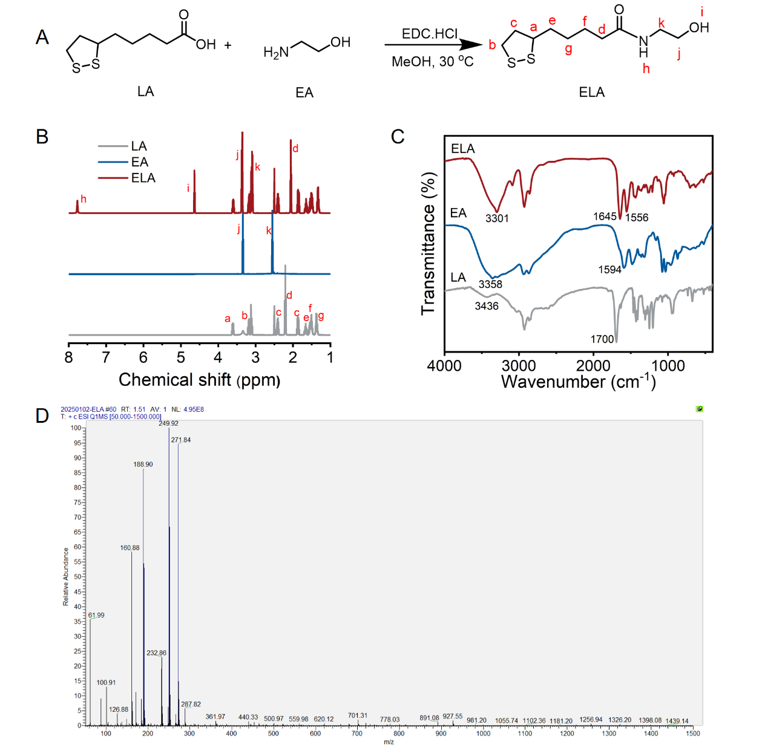
Fig. S1. Synthesis and characterization of the ELA. (A) Synthesis route of the ELA. (B) ¹H NMR spectra, (C) FT-IR spectra and (D) Mass spectrum of the ELA.
Fig. S1 showed the ¹H NMR spectra of LA, EA and ELA. The proton peak at 2.21 ppm is attributed to the methylene groups adjacent to the carboxyl groups in LA. The characteristic peaks of CH₂- groups in EA appeared at 2.55 and 3.34 ppm. In ELA, the proton peak at 2.21 ppm corresponding to the methylene groups is red shift to 2.06 ppm, the proton peak at 2.55 ppm corresponding to the methylene groups is blue shift to 3.10 ppm. The characteristic peaks of N-H and O-H groups in ELA appeared at 7.80 and 4.64 ppm. By calculating the area ratios of CH₂- groups of ELA, and methylene groups of LA, it is proved that the ELA is synthesized successfully. According to FT-IR spectra of LA, EA and ELA, the stretching vibration of O-H bond in LA could be characterized by the peak at 3436 cm⁻¹, the peak at 1700 cm⁻¹ is ascribed to the stretching vibration of carbonyl group in carboxyl group. For EA, the stretching vibration of the N-H and O-H bond could be characterized by the wide peak at 3358 cm⁻¹, the peak at 1594 cm⁻¹ is ascribed to the bending vibration of N-H. For ELA, the wide peak at 3301 cm⁻¹ according to the stretching vibration of the N-H and O-H groups appeared, and the characteristic absorption peaks at 1645 and 1556 cm⁻¹ are attributed to amide I and amide II groups, suggesting that the ELA is synthesized successfully by amidation reactions. The molecular weight of the ELA is 249 (M+H, m/z=249.9; M+Na, m/z=271.84). The ELA is cracked into small molecules (m/z = 188.90, 61.99) by cleaving the amide bonds. In the mass spectrum, no high-molecular-weight proton peaks are observed, indicating that ELA is a small molecule and has not undergone polymerization.
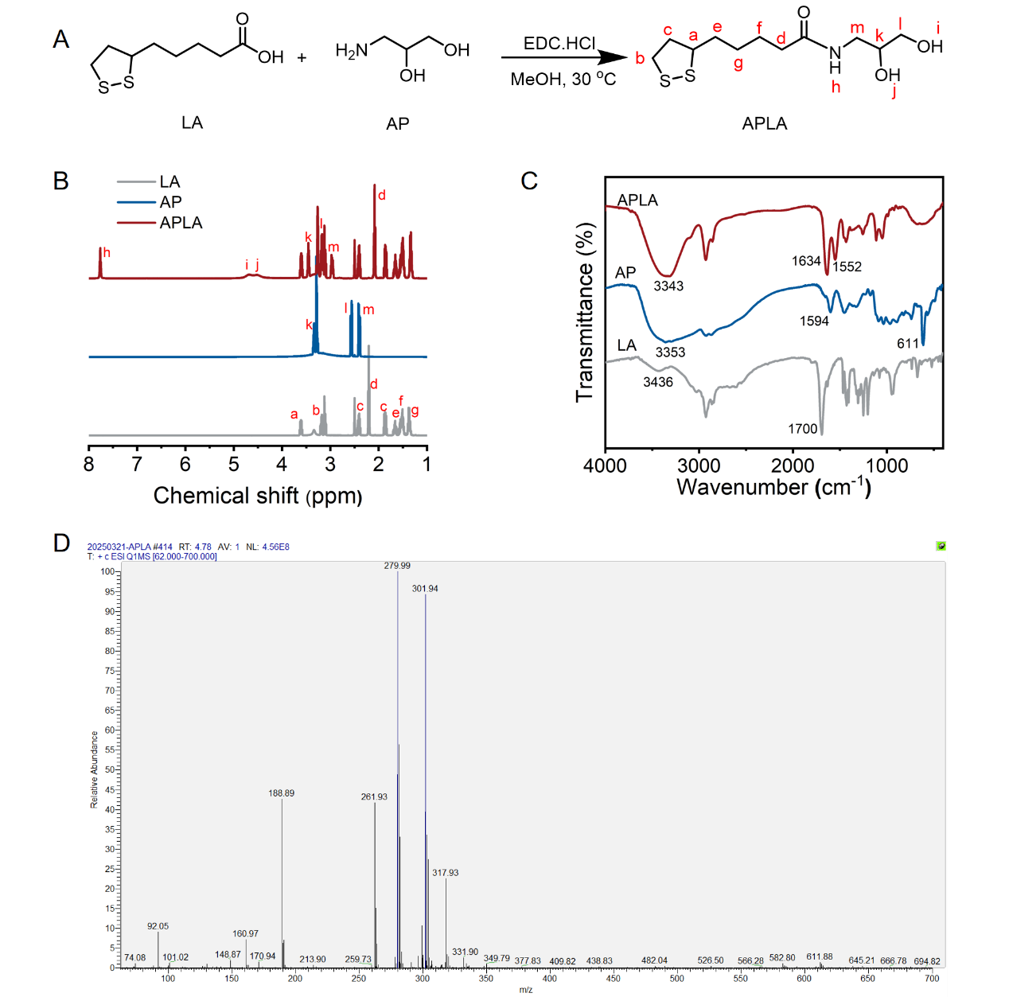
Fig. S2. Synthesis and characterization of the APLA. (A) Synthesis route of the APLA. (B) ¹H NMR spectra, (C) FT-IR spectra and (D) Mass spectrum of the APLA.
Fig. S2 showed the ¹H NMR spectra of LA, AP and APLA. The characteristic peaks of CH₂- groups in AP appeared at 2.42, 2.56 and 3.34 ppm. In APLA, the proton peak at 2.21 ppm corresponding to the methylene groups in LA is red shift to 2.09 ppm, the proton peak at 2.42 and 2.55 ppm corresponding to the methylene groups is blue shift to 3.04 and 3.26 ppm. The characteristic peaks of N-H and O-H groups in APLA appeared at 7.76 and 4.60 ppm. By calculating the area ratios of CH₂- groups of APLA, and methylene groups of LA, it is proved that the APLA is synthesized successfully. According to FT-IR spectra of LA, AP and APLA, the stretching vibration of O-H bond in LA could be characterized by the peak at 3436 cm⁻¹, the peak at 1700 cm⁻¹ is ascribed to the stretching vibration of carbonyl group in carboxyl group. For AP, the stretching vibration of the N-H and O-H bond could be characterized by the wide peak at 3353 cm⁻¹, the peak at 1594 cm⁻¹ is ascribed to the bending vibration of N-H. For APLA, the wide peak at 3343 cm⁻¹ according to the stretching vibration of the N-H and O-H groups appeared, and the characteristic absorption peaks at 1634 and 1552 cm⁻¹ are attributed to amide I and amide II groups, suggesting that the APLA is synthesized successfully by amidation reactions. The molecular weight of the APLA is 279 (M+H, m/z=279.99; M+Na, m/z=301.94, M+K, m/z=317.93). The APLA is cracked into small molecules (m/z=188.89, 92.05) by cleaving the amide bonds. In the mass spectrum, no high-molecular-weight proton peaks are observed, indicating that APLA is a small molecule and has not undergone polymerization.
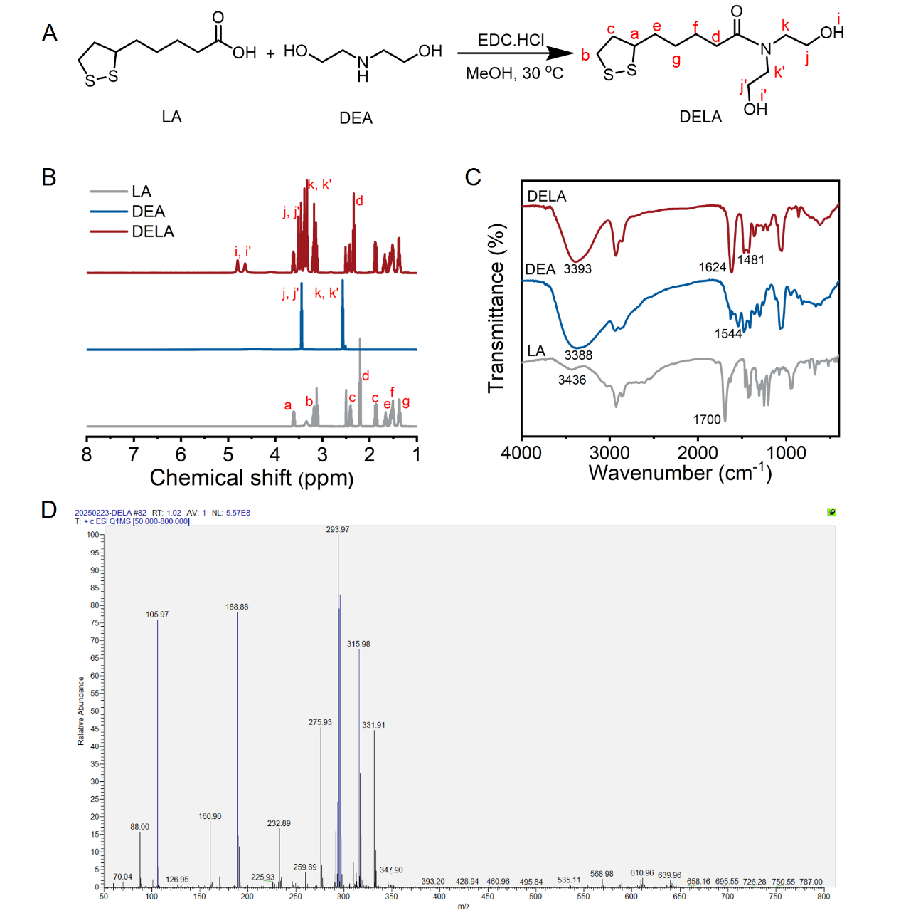
Fig. S3. Synthesis and characterization of the DELA. (A) Synthesis route of the DELA. (B) ¹H NMR spectra, (C) FT-IR spectra and (D) Mass spectrum of the DELA.
Fig. S3 showed the ¹H NMR spectra of LA, DEA and DELA. The characteristic peaks of CH₂- groups in DEA appeared at 2.57 and 3.44 ppm. In DELA, the proton peak at 2.21 ppm corresponding to the methylene groups in LA is blue shift to 2.33 ppm, the proton peak at 2.57 corresponding to the methylene groups in DEA is blue shift to 3.34 ppm. The characteristic peaks of the O-H groups in DELA appeared at 4.79 and 4.63 ppm. By calculating the area ratios of CH₂- groups of DELA, and methylene groups of LA, it is proved that the DELA is synthesized successfully. According to FT-IR spectra of LA, DE and DELA, the stretching vibration of O-H bond in LA could be characterized by the peak at 3436 cm⁻¹, the peak at 1700 cm⁻¹ is ascribed to the stretching vibration of carbonyl group in carboxyl group. For DE, the stretching vibration of the N-H and O-H bond could be characterized by the wide peak at 3388 cm⁻¹, the peak at 1544 cm⁻¹ is ascribed to the bending vibration of N-H. For DELA, the wide peak at 3393 cm⁻¹ according to the stretching vibration of the O-H groups appeared, and the characteristic absorption peaks at 1624 and 1481 cm⁻¹ are attributed to amide I and amide II groups, suggesting that the DELA is synthesized successfully by amidation reactions. The molecular weight of the DELA is 293 (M+H, m/z=293.97; M+Na, m/z=315.98, M+K, m/z=331.91). The APLA is cracked into small molecules (m/z=188.88, 105.97) by cleaving the amide bonds. In the mass spectrum, no high-molecular-weight proton peaks are observed, indicating that DELA is a small molecule and has not undergone polymerization.
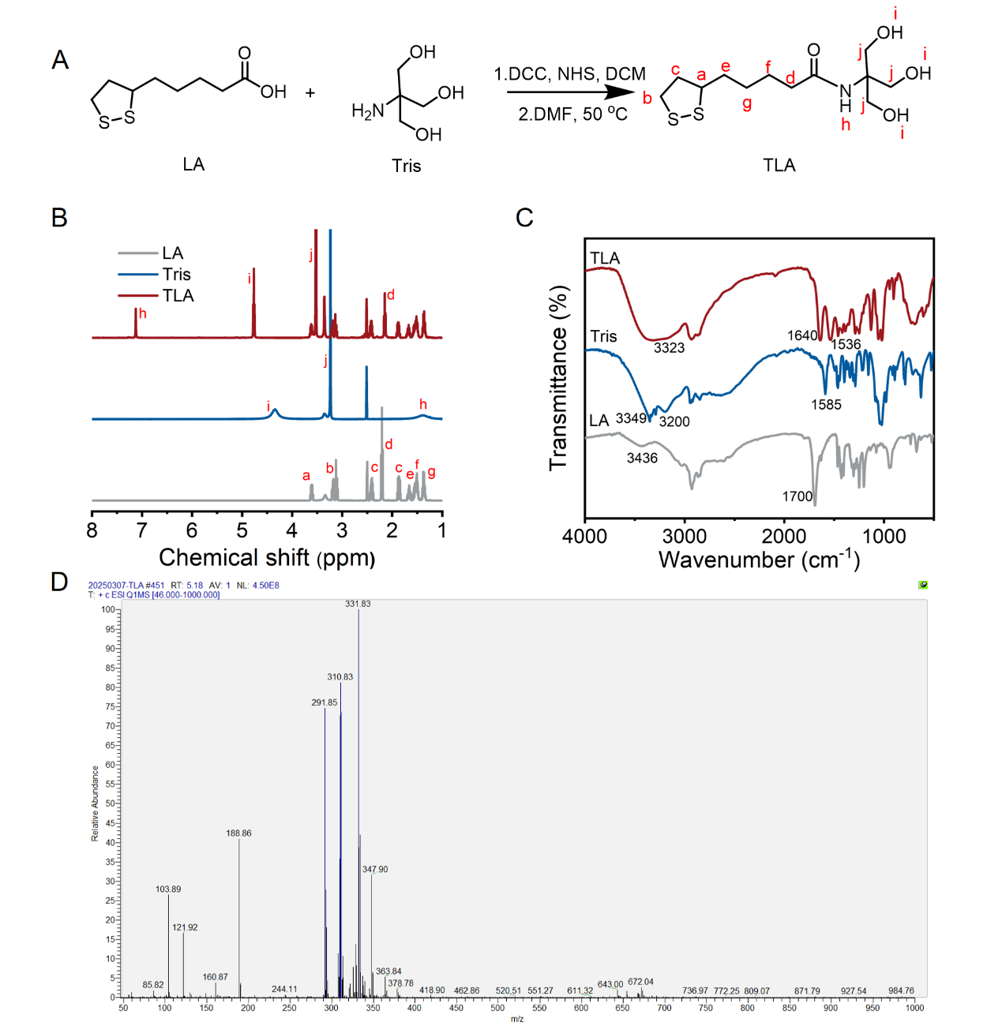
Fig. S4. Synthesis and characterization of the TLA. (A) Synthesis route of the TLA. (B) ¹H NMR spectra, (C) FT-IR spectra and (D) Mass spectrum of the TLA.
Fig. S4 shows the ¹H NMR spectra of LA, Tris and TLA. The characteristic peaks of N-H, CH₂- and O-H groups in Tris appeared at 1.40, 3.24 and 4.35 ppm. In TLA, the proton peak at 2.21 ppm corresponding to the methylene groups in LA is red shift to 2.15 ppm, the proton peak at 3.24 corresponding to the methylene groups in Tris is blue shift to 3.52 ppm. The characteristic peaks of the N-H and O-H groups in TLA appeared at 7.11 and 4.75 ppm. By calculating the area ratios of CH₂- groups of TLA, and methylene groups of LA, it is proved that the TLA is synthesized successfully. According to FT-IR spectra of LA, Tris and TLA, For Tris, the stretching vibration of the N-H and O-H bond could be characterized by the peaks at 3388 and 3200 cm⁻¹, the peak at 1585 cm⁻¹ is ascribed to the bending vibration of N-H. For TLA, the wide peak at 3323 cm⁻¹ according to the stretching vibration of the N-H and O-H groups appeared, and the characteristic absorption peaks at 1640 and 1536 cm⁻¹ are attributed to amide I and amide II groups, suggesting that the TLA is synthesized successfully by amidation reactions. The molecular weight of the TLA is 309 (M+H, m/z=310.83; M+Na, m/z=331.83, M+K, m/z=347.9). The TLA is cracked into small molecules (m/z=291.85, 188.86, 121.92) by removing H₂O or cleaving the amide bonds. In the mass spectrum, no high-molecular-weight proton peaks are observed, indicating that DELA is a small molecule and has not undergone polymerization.
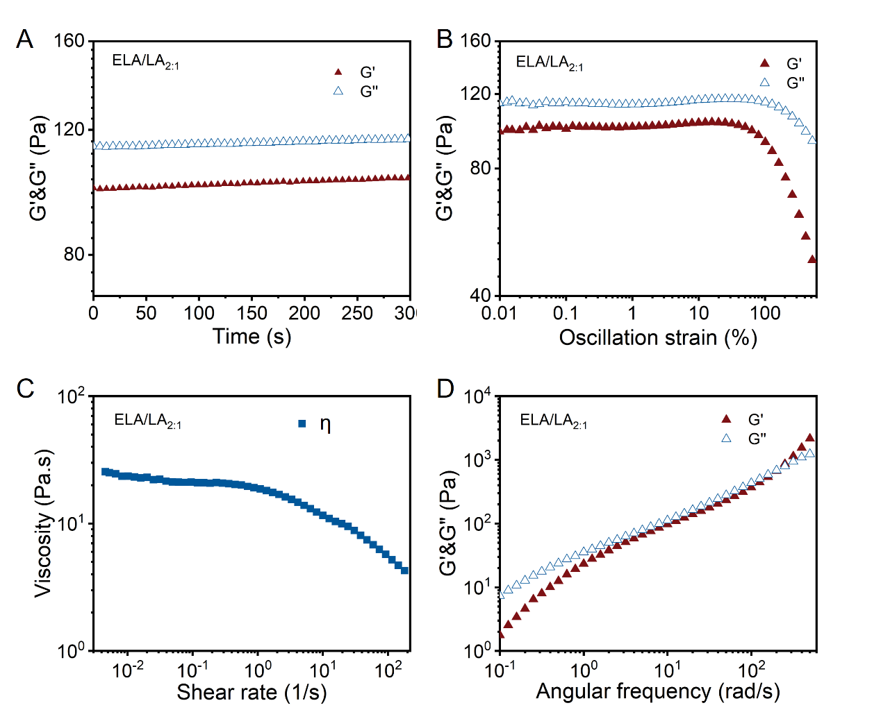
Fig. S5. Rheological characterization of the ELA/LA_{2:1}. The G’ and G’’ of ELA/LA_{2:1} in time sweep mode (A), oscillation strain sweep mode (B) and angular frequency sweep mode (D). (C) The viscosity of ELA/LA_{2:1}as a function of shear rate.
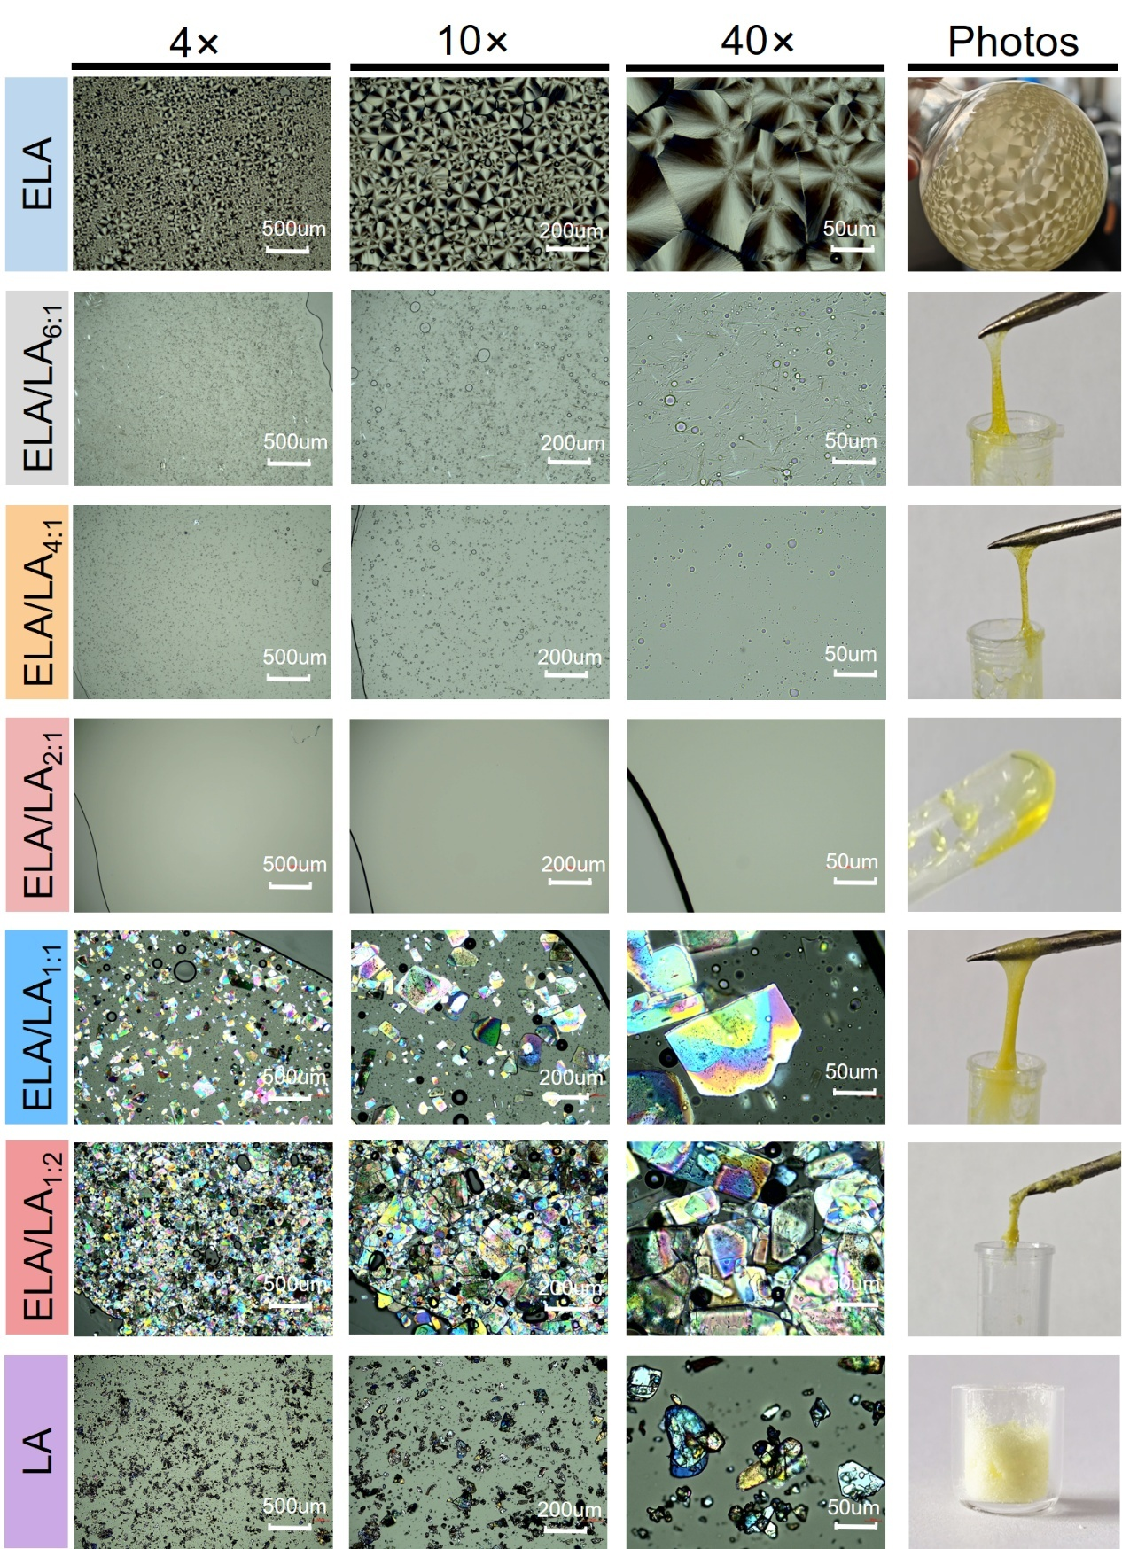
Fig. S6. The polarizing microscopes and macroscopic photos of the ELA/LA deep eutectic system.
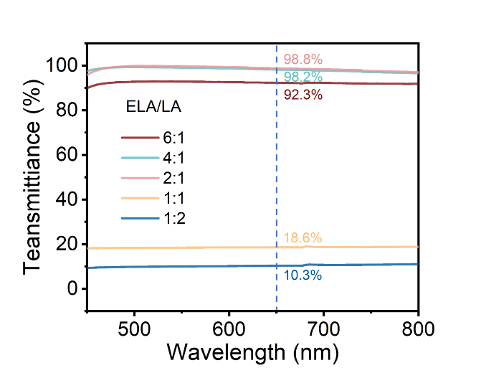
Fig. S7. The transmittance of the ELA/LA deep eutectic systems.
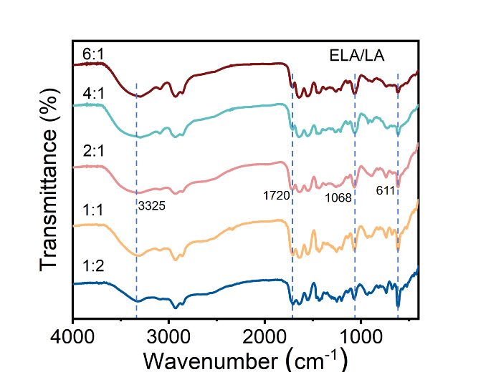
Fig. S8. The FT-IR of the ELA/LA deep eutectic systems.
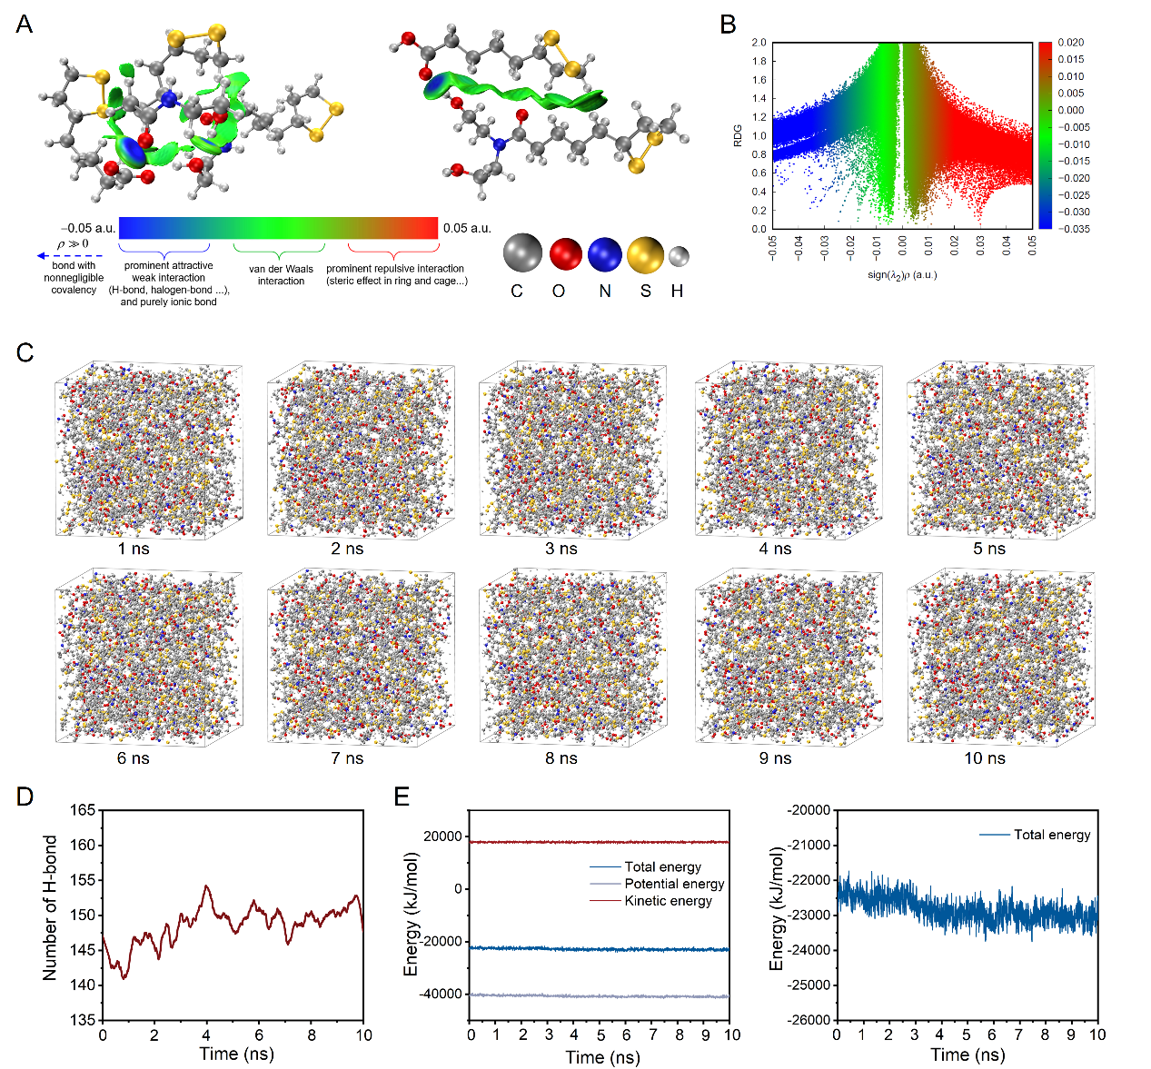
Fig. S9. Molecular dynamics simulation of the formation of the ELA/LA_{2:1} deep eutectic system. (A) IGMH calculation of interaction force between LA and ELA. (B) IRI scatter plot. (C) Nanosecond MD simulation observation of the ELA/LA_{2:1}(deep eutectic system or bio-adhesive) formation. (D) The number of hydrogen bonds during the 10 ns simulation process. (E) The variation curves of the total energy, potential energy, and kinetic energy of the entire model system over time during the 10 ns simulation process.
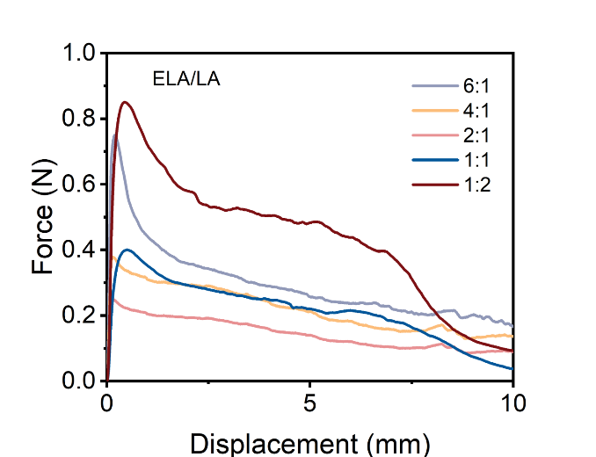
Fig. S10. Lap-shear curves of the ELA/LA deep eutectic systems with different molar ratios adhered on glasses.
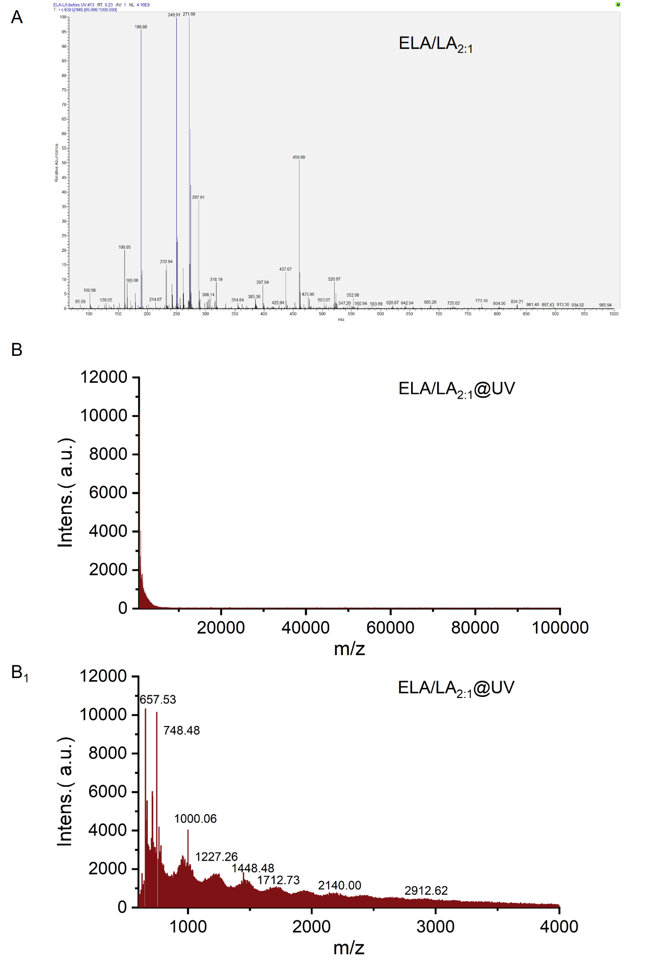
Fig. S11. The Mass spectra before and after UV irradiation. (A) ELA/LA_{2:1}. (B-B₁) ELA/LA_{2:1}@UV.
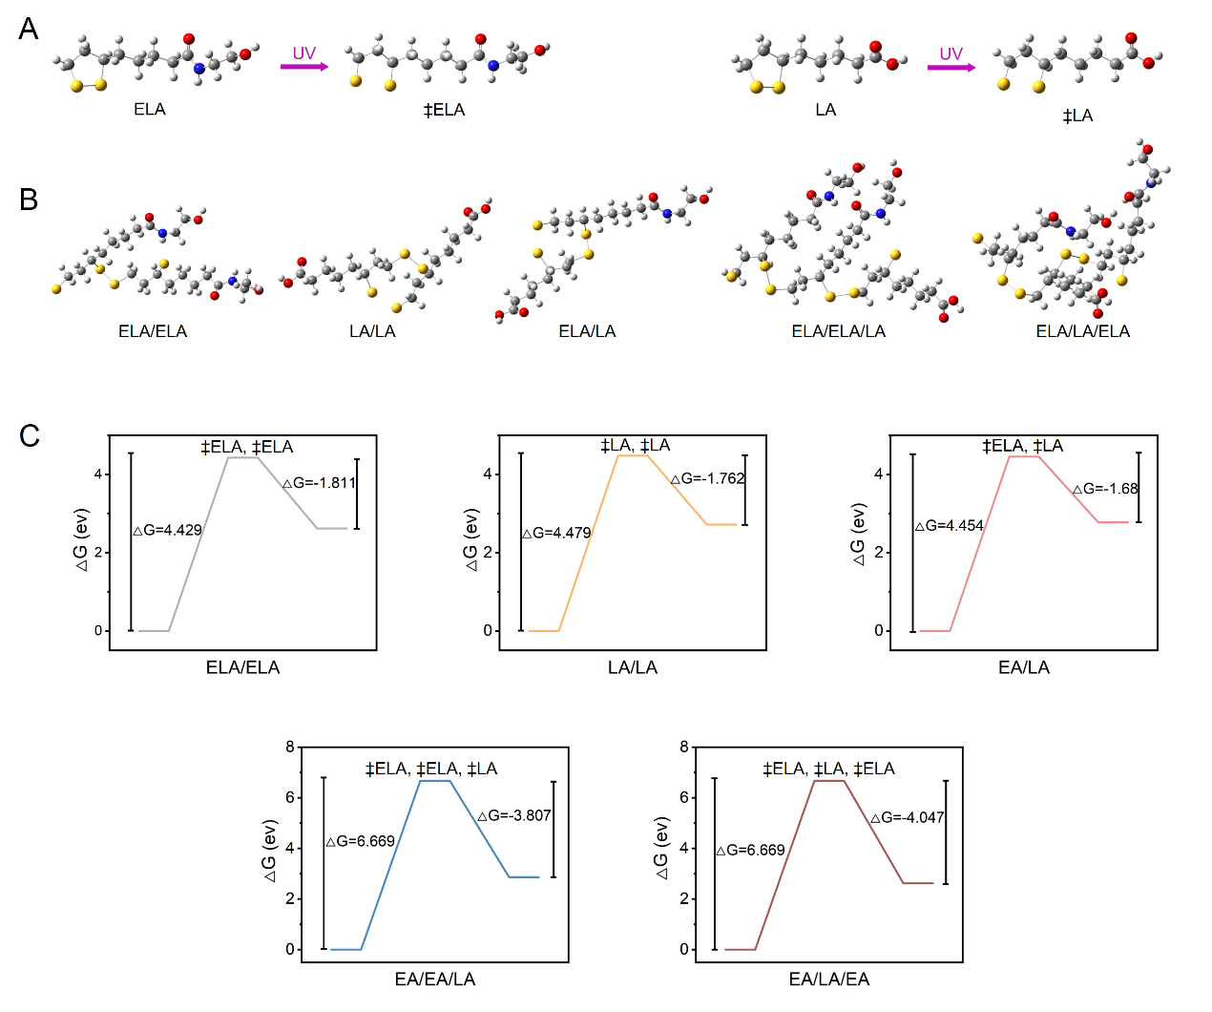
Fig. S12. The five types of the polymerization segments, namely ELA/ELA, LA/LA, ELA/LA, ELA/ELA/LA and ELA/LA/ELA, with corresponding Gibbs free energies.
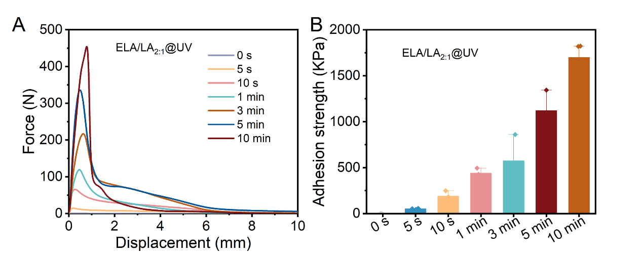
Fig. S13. (A) Lap-shear curves and (B) adhesion strength of the ELA/LA_{2:1} deep eutectic system under different UV irradiation time adhered on glasses.
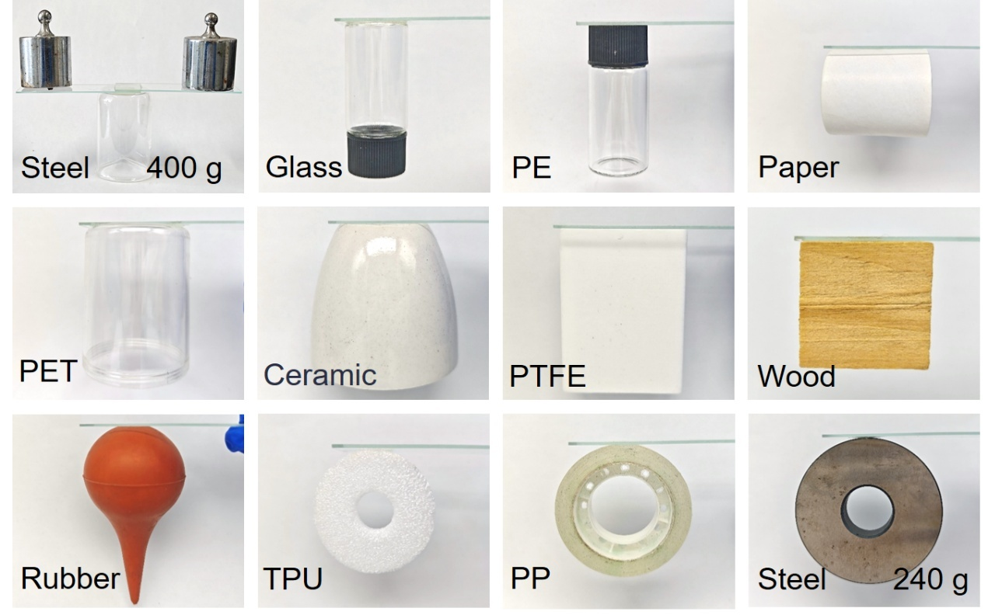
Fig. S14. The adhesion demonstration of the ELA/LA_{2:1}@UV on different substrates, as well as a load-bearing demonstration.
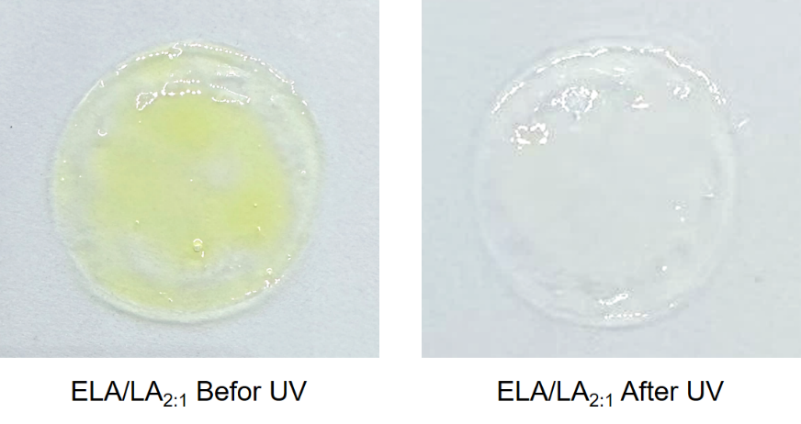
Fig. S15. The color change of the ELA/LA_{2:1} before and after UV exposure.
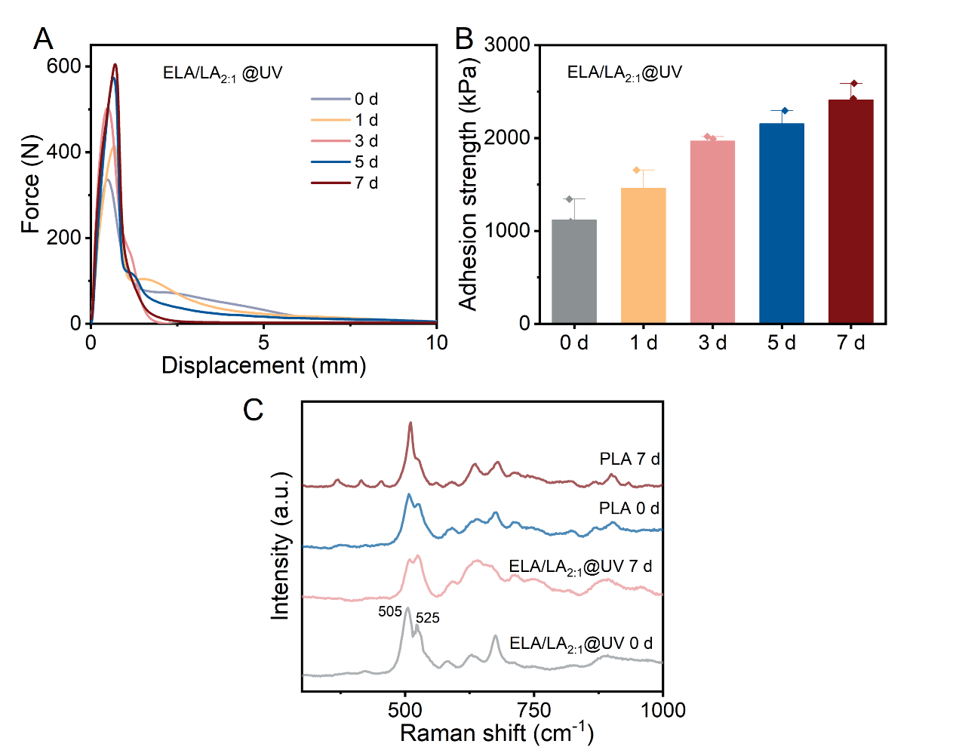
Fig. S16. The self-enhancement of the ELA/LA_{2:1}@UV under natural light for different days (A, B). (C) Raman spectra of the PLA and ELA/LA_{2:1}@UV under natural light with 0 day and 7days to track the depolymerization.
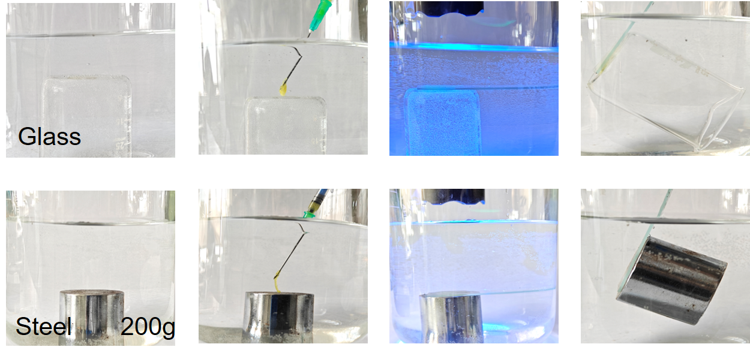
Fig. S17. The adhesion demonstration of the ELA/LA_{2:1} on different substrates underwater.
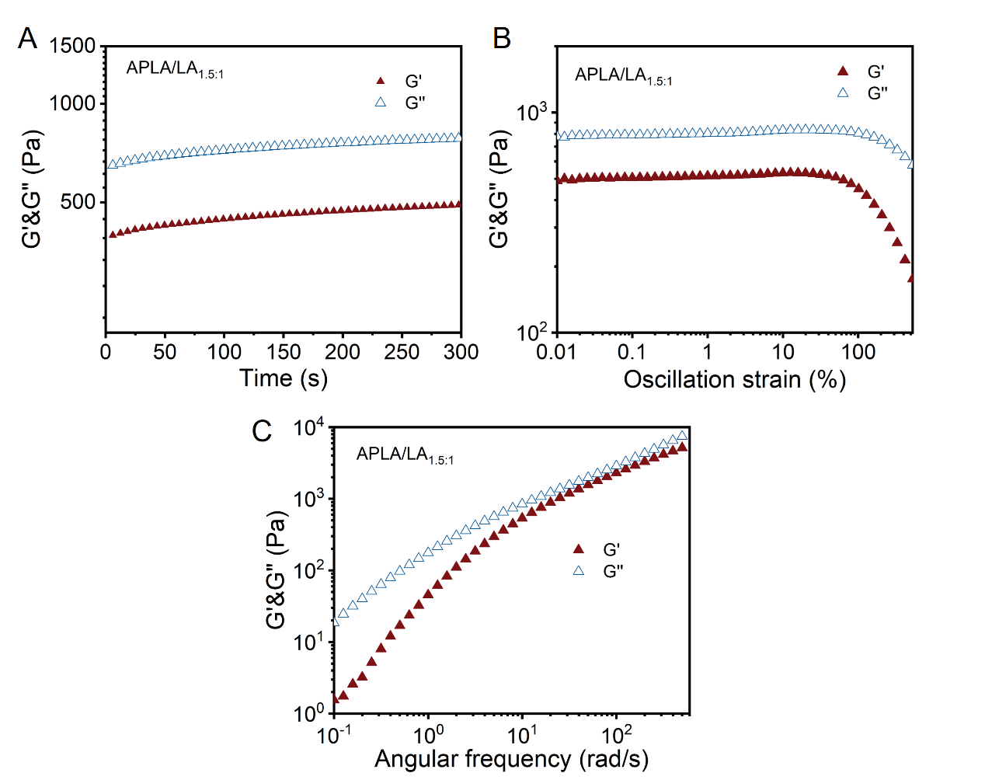
Fig. S18. Rheological characterization of the APLA/LA_{1.5:1}. The G’ and G’’ ofAPLA/LA_{1.5:1} in time sweep mode (A), oscillation strain sweep mode (B) and angular frequency sweep mode (C).
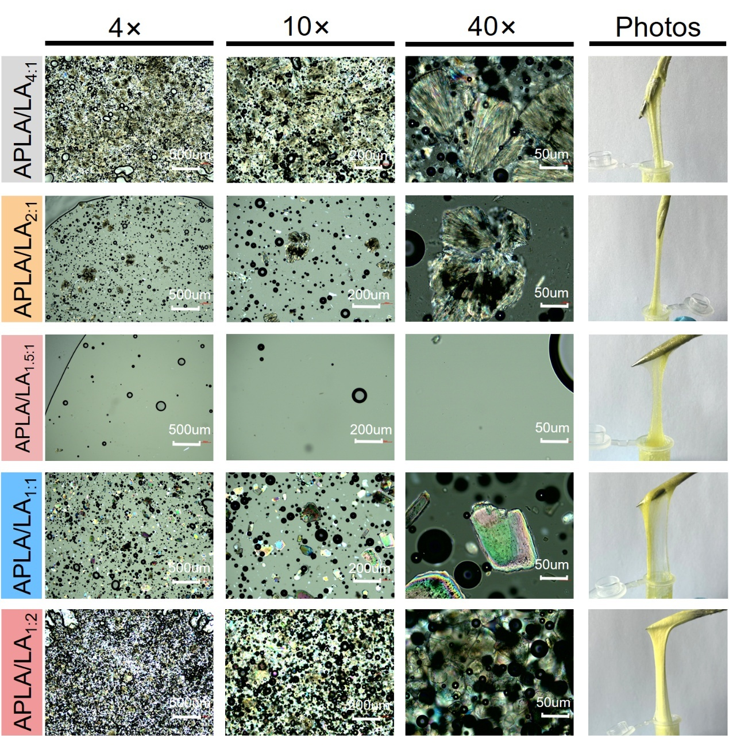
Fig. S19. The polarizing microscopes and macroscopic photos of the APLA/LA deep eutectic system.
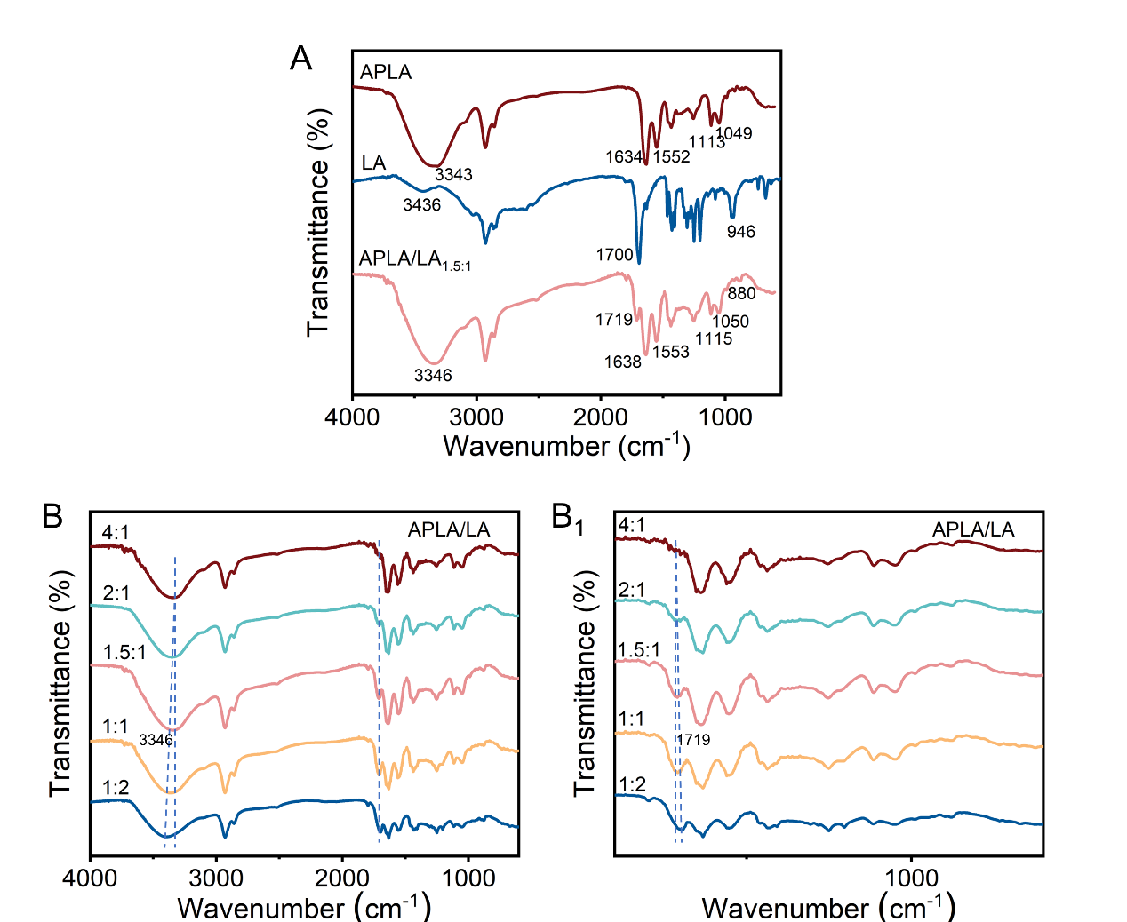
Fig. S20. FT-IR spectra to illustrate the intermolecular interactions in APLA/LA deep eutectic system.
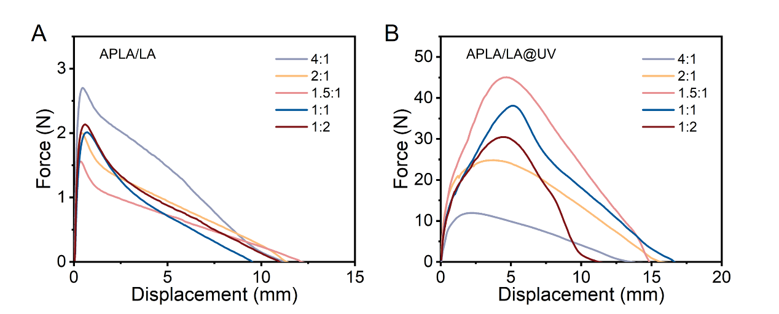
Fig. S21. Lap-shear curves of the APLA/LA deep eutectic system before and after UV irradiation adhered on glasses.
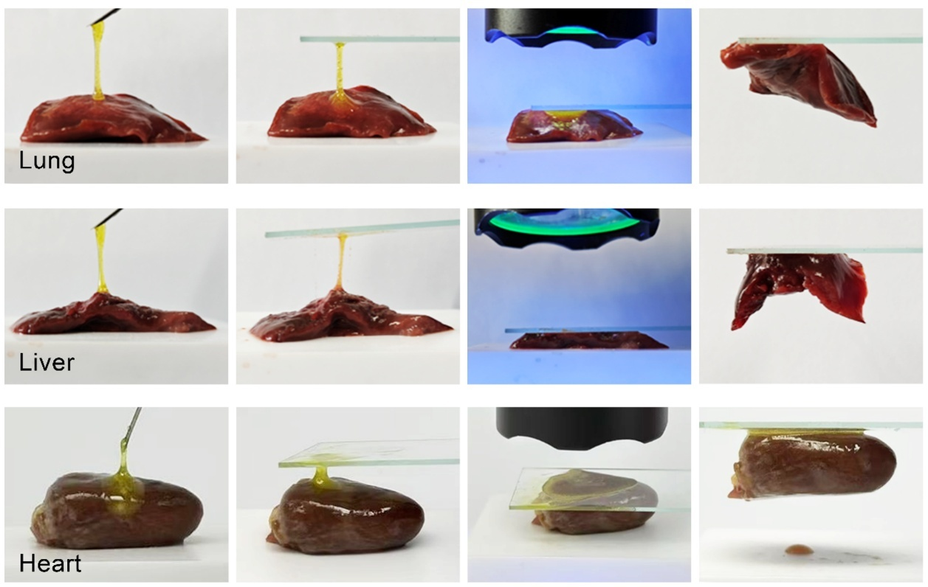
Fig. S22. The adhesive performance of the ELA/LA_{2:1} on chicken lung, liver and heart.
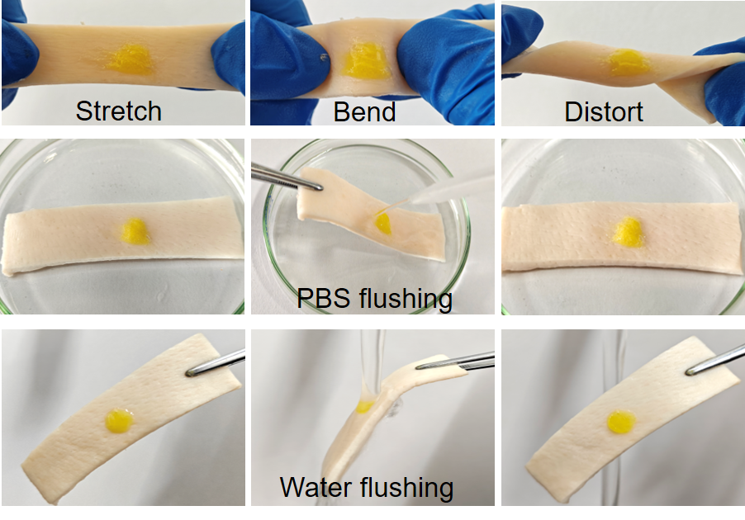
Fig. S23. The adhesive performance of the ELA/LA_{2:1}@UV on porcine skin.
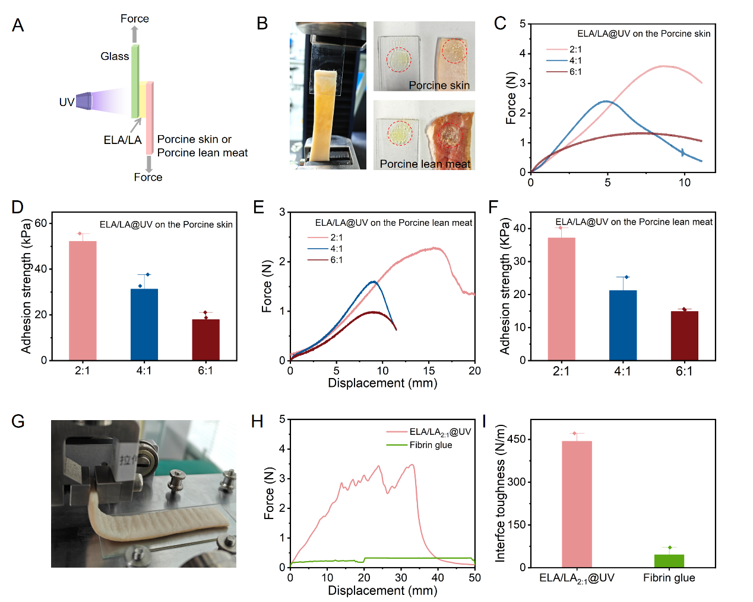
Fig. S24. The adhesion and peel testing of the ELA/LA_{2:1}@UV on porcine tissue. (A) Schematic diagram of the lap-shear test. (B) Fracture surfaces of porcine skin and porcine lean meat after lap-shear test. Lap-shear curves (C, E) and adhesion strength (D, F) of the ELA/LA_{2:1}@UV on the porcine skin and porcine lean meat. (G) Image of the peel test. The peel force (H) and interface toughness (I) of the ELA/LA_{2:1}@UV and fibrin glue on porcine skin.
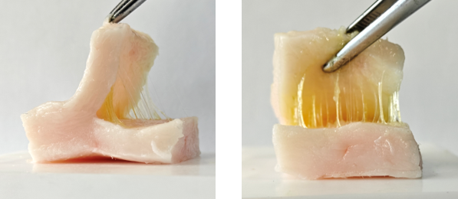
Fig. S25. The adhesive performance of the ELA/LA_{2:1} between fresh cut sections of porcine fat.

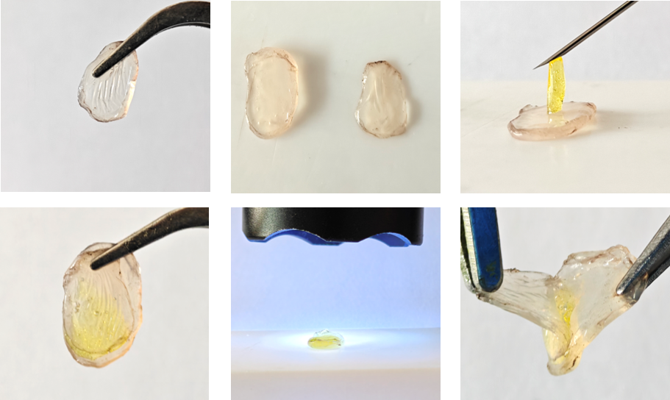
Fig. S26. The adhesive performance of the ELA/LA_{2:1} on the corneas.
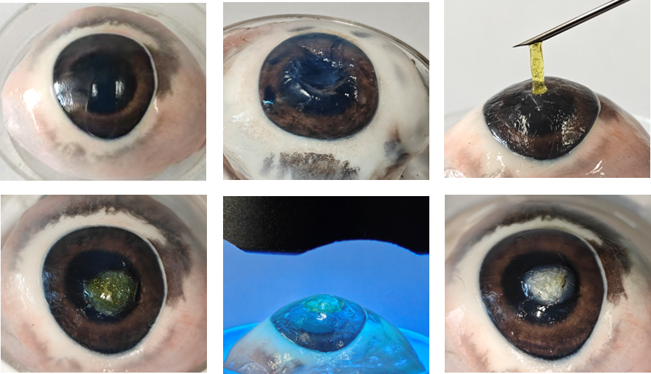
Fig. S27. The adhesive performance of the ELA/LA_{2:1} on the cornea of porcine eyeballs
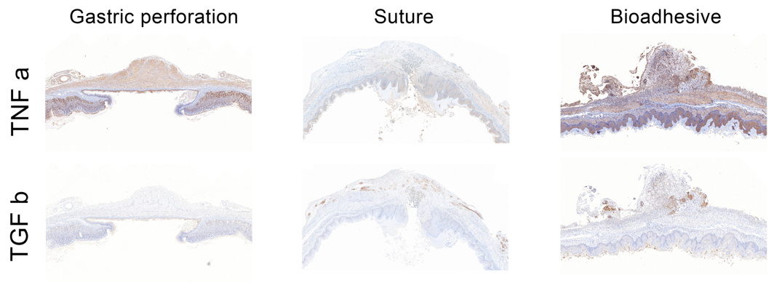
Fig. S28. TNFα and TGFβ staining of the gastric perforation repair on day 7 post-surgery.
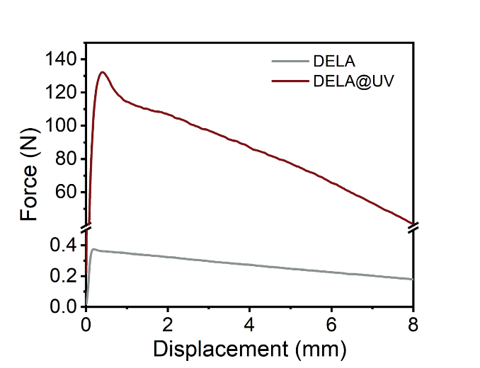
Fig. S29. Lap-shear curves of the DELA before and after UV irradiation adhered on glasses.

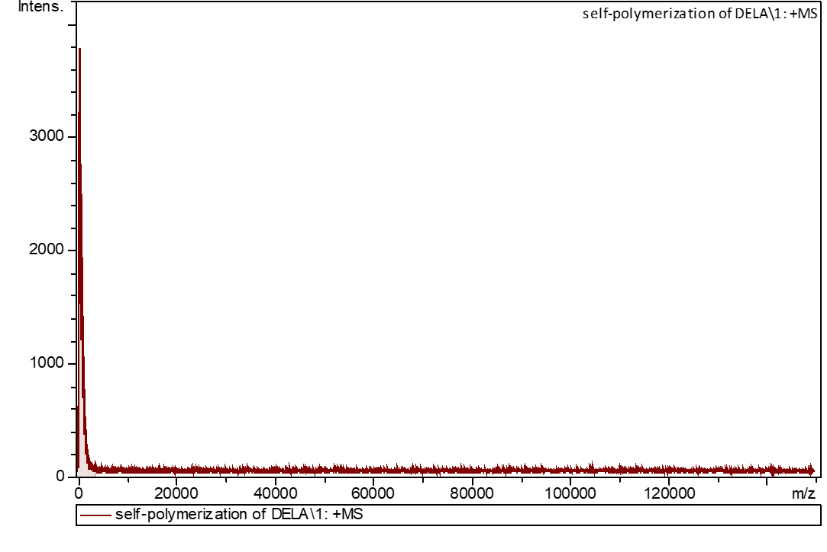
Fig. S30. The MALDI-TOF-MS spectra of the self-polymerization of DELA.
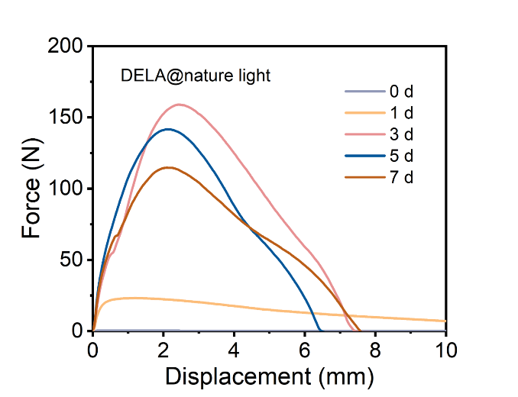
Fig. S31. Lap-shear curves of the DELA after nature light for different days adhered on glasses.
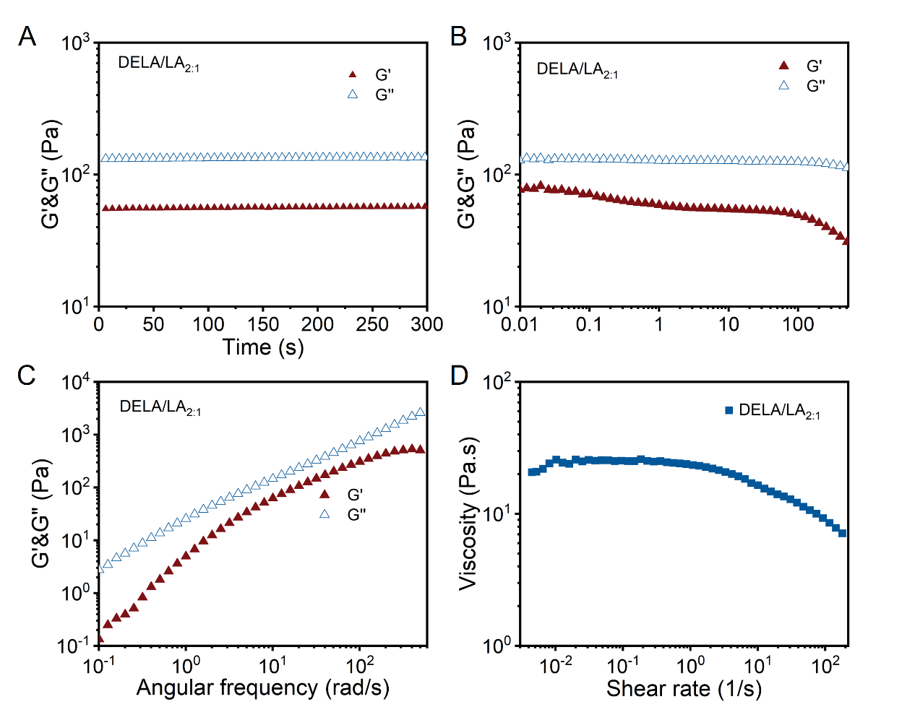
Fig. S32. Rheological characterization of the DELA/LA_{2:1}. The G’ and G’’ ofDELA/LA_{2:1} in time sweep mode (A), oscillation strain sweep mode (B) and angular frequency sweep mode (C). (D) The viscosities of the DELA/LA_{2:1} as a function of shear rate.
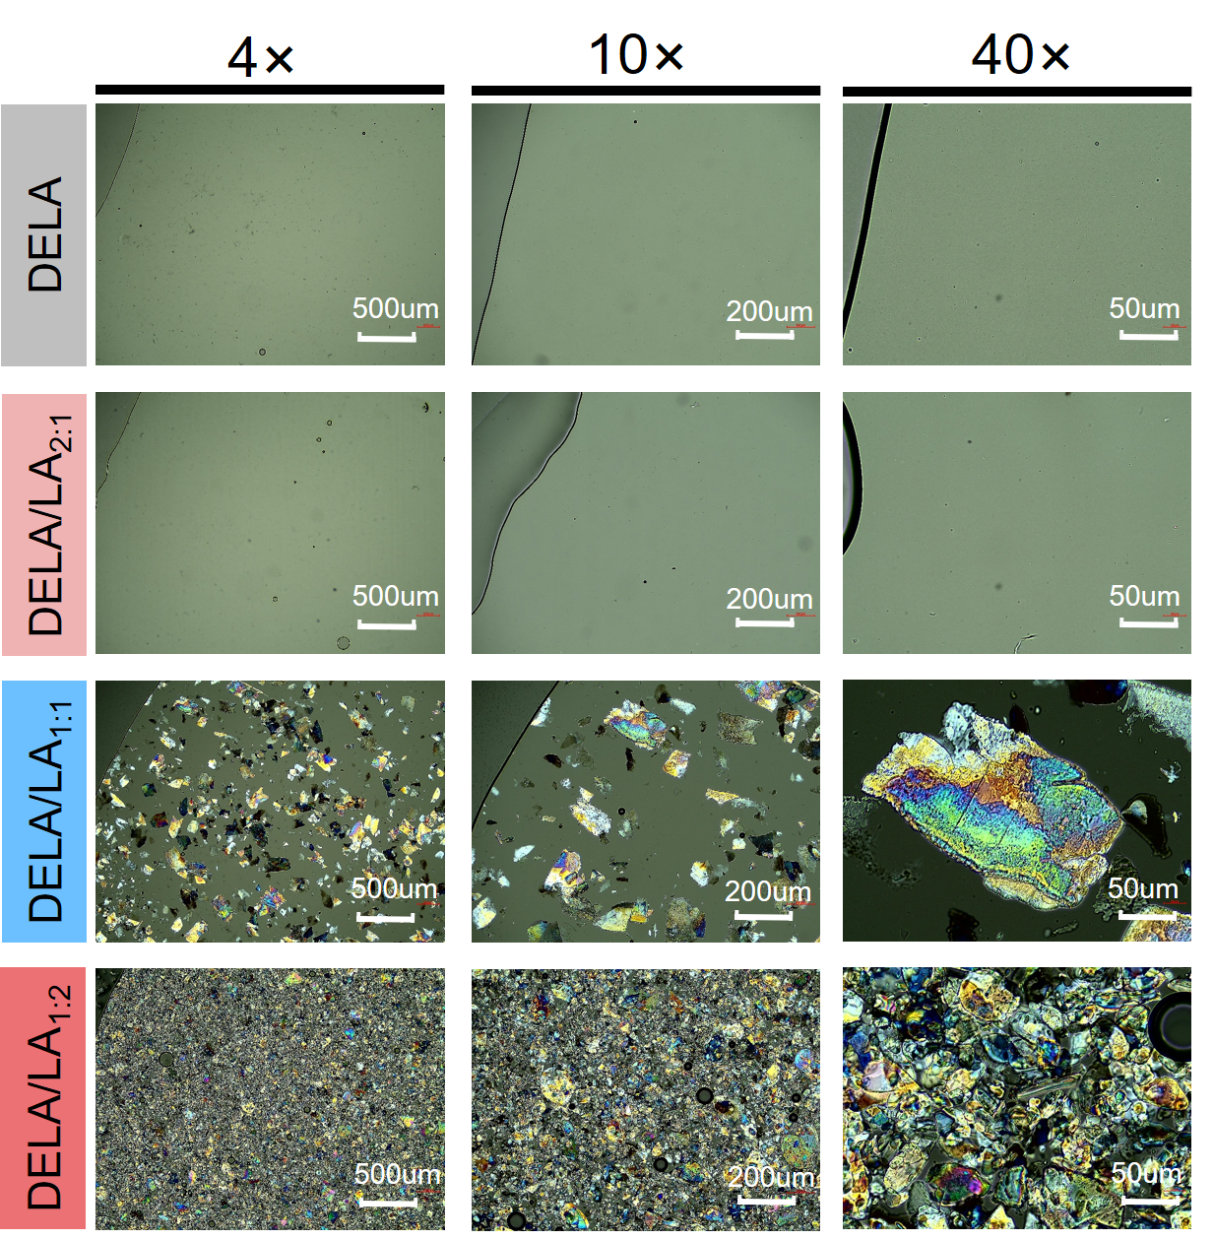
Fig. S33. The polarizing microscopes of the DELA/LA deep eutectic system.
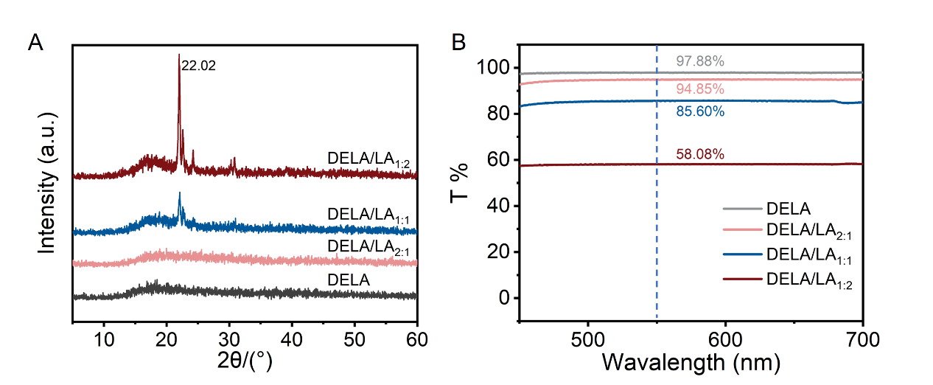
Fig. S34. The XRD spectra and transmittance of the DELA/LA deep eutectic system.
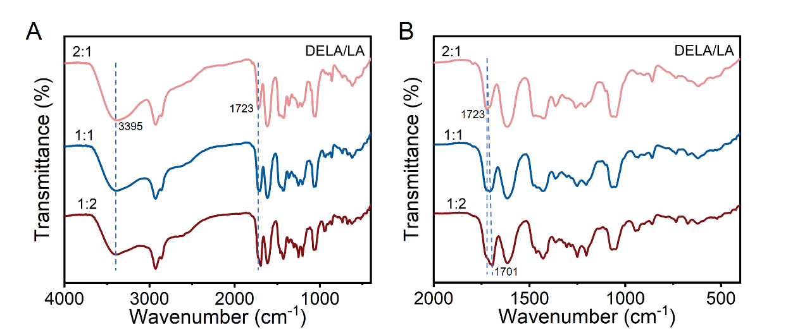
Fig. S35. The FT-IR of the DELA/LA deep eutectic systems.
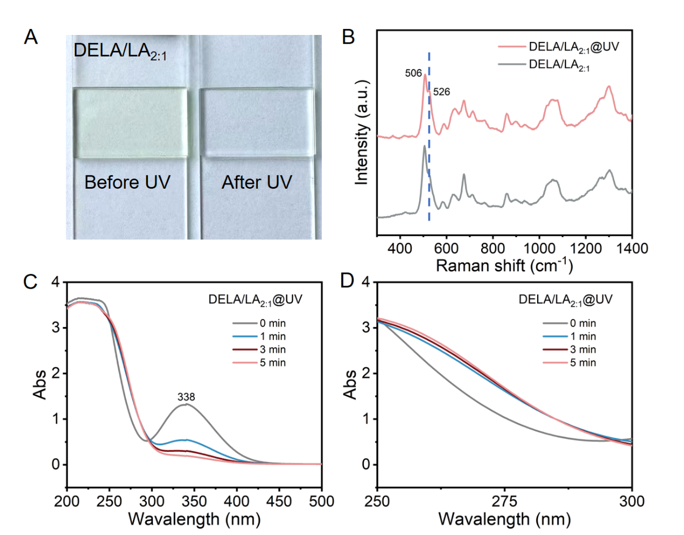
Fig. S36. (A) Images to show the UV-responsiveness of the DELA/LA_{2:1}. Raman spectra (B) and UV-Vis spectra (C, D) to track the UV-responsiveness.
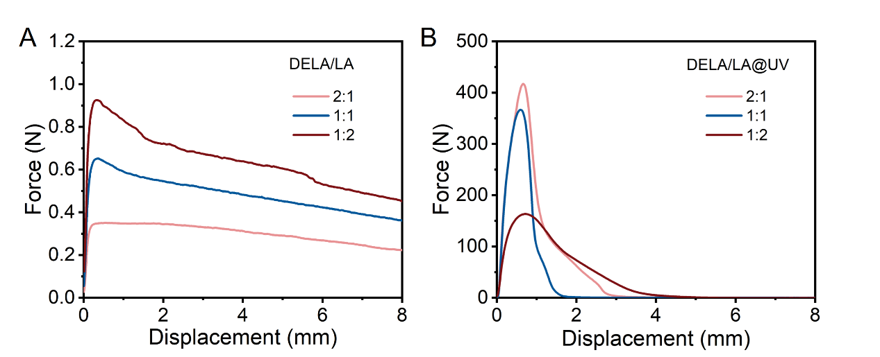
Fig. S37. Lap-shear curves of the DELA/LA deep eutectic system before and after UV irradiation adhered on glasses.
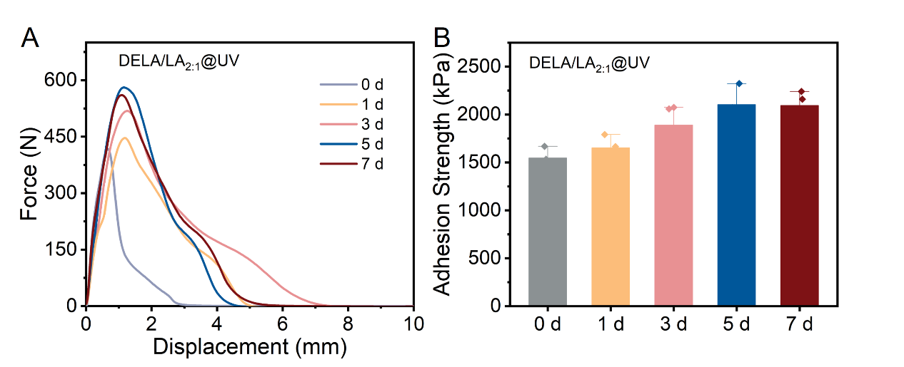
Fig. S38. Lap-shear curves of the DELA/LA_{2:1}@UV under nature light for different days adhered on glasses.
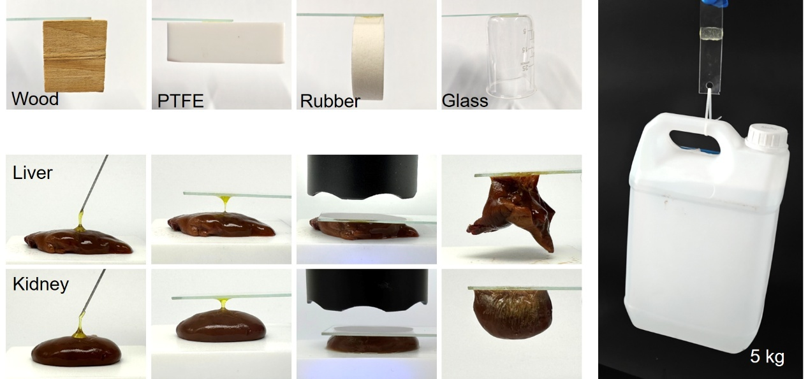
Fig. S39. The adhesive performance of the DELA/LA_{2:1} deep eutectic system.
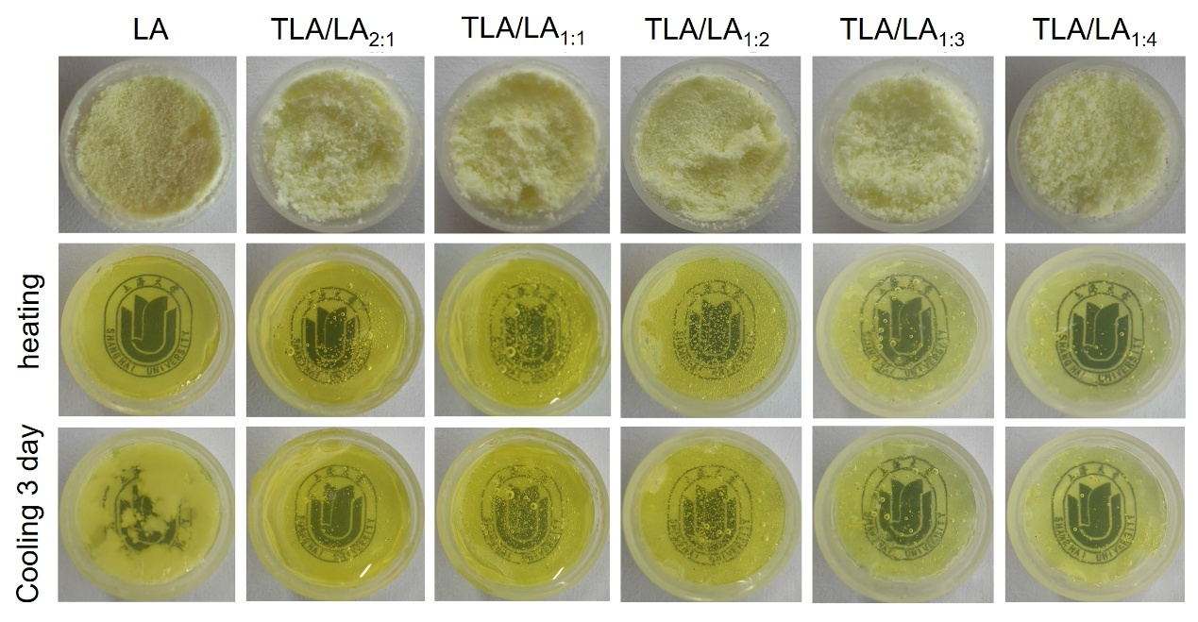
Fig. S40. Pictures showing the state of the LA and TLA/LA mixture with different molar ratios before heating, after heating and after cooling to room temperature left them for 3 days.
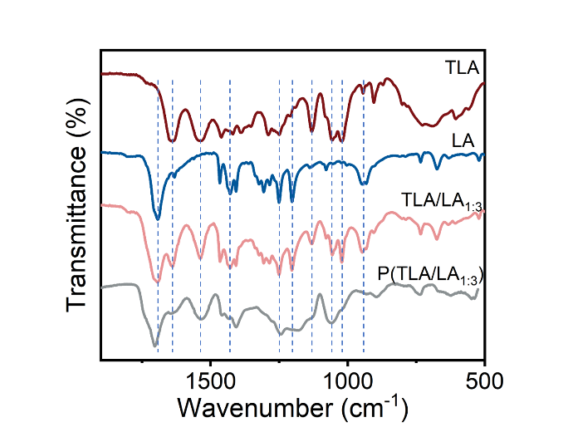
Fig. S41. Local magnification of the FT-IR spectra of the TLA/LA deep eutectic system.
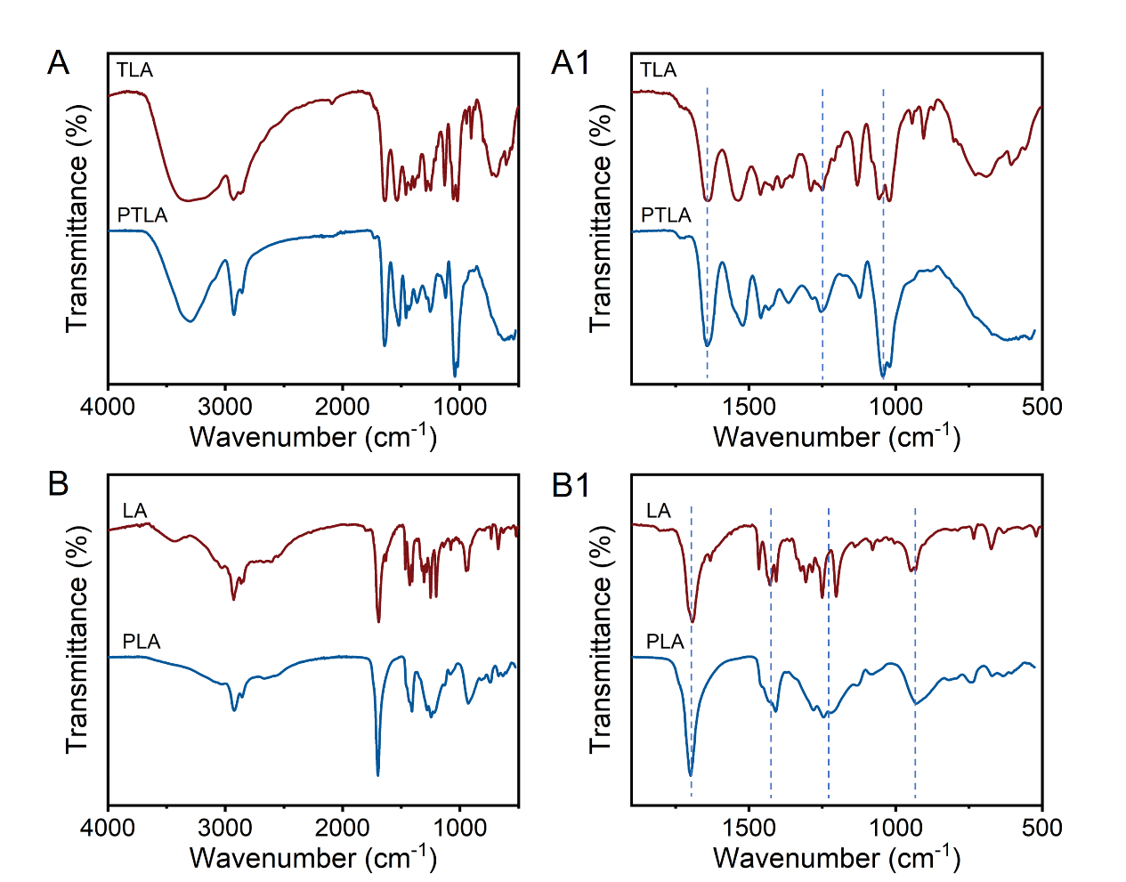
Fig. S42. FT-IR spectra of the PTLA and PLA, local magnification of the FT-IR spectra of the PTLA and PLA.
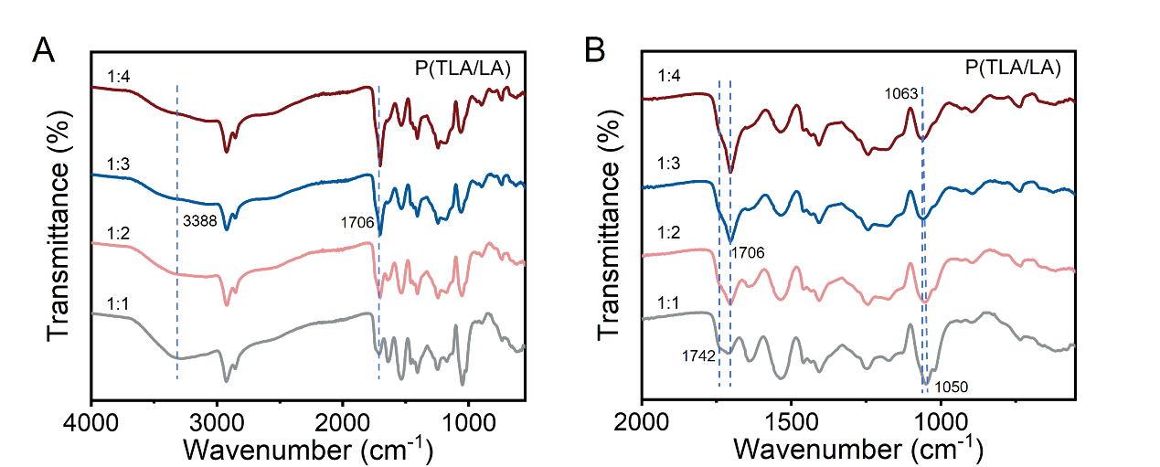
Fig. S43. FT-IR spectra of the TLA/LA mixtures with different molar ratios.
Fig. S44. Adhesion strength of the P(TLA/LA_{1:3}) adhered on stainless steel and glass for 3 days (* means that the use of P(TLA/LA_{1:3}) caused the failure of the glass substrates before breaking of the adhesive bond).
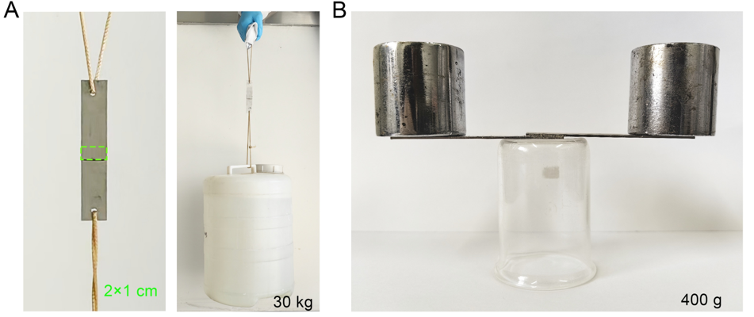
Fig. S45. Digital images depicting the adhesive ability of the P(TLA/LA_{1:3})-adhered stainless steels after soaking in water.
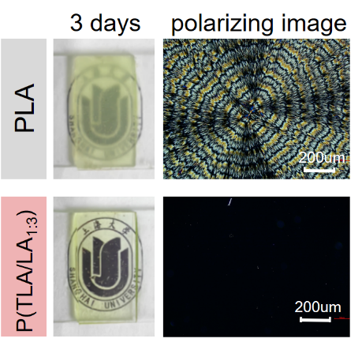
Fig. S46. Macroscopic and polarizing images of the anti-depolymerization of P(TLA/LA_{1:3}) after 3 days.
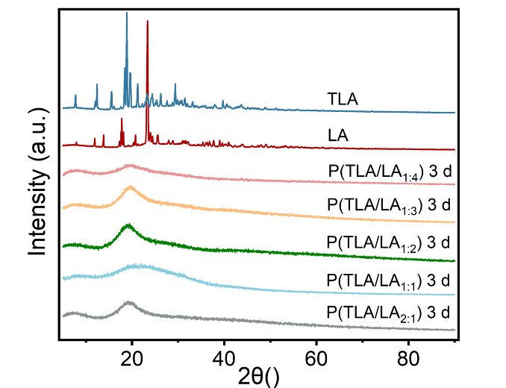
Fig. S47. XRD of the anti-depolymerization of the P(TLA/LA_{1:3}) after 3 days.

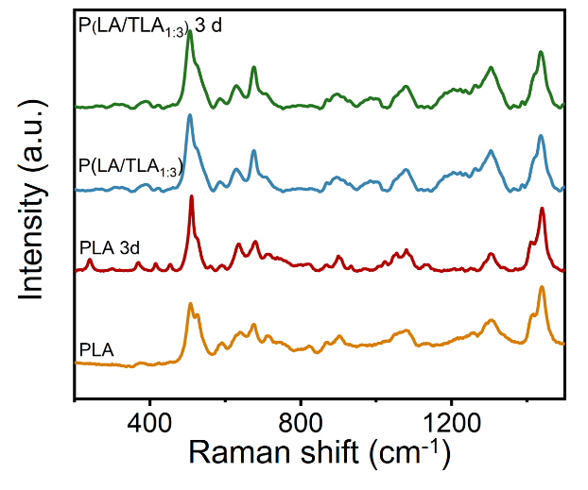
Fig. S48. Raman of the anti-depolymerization of the P(TLA/LA_{1:3}) after 3 days.
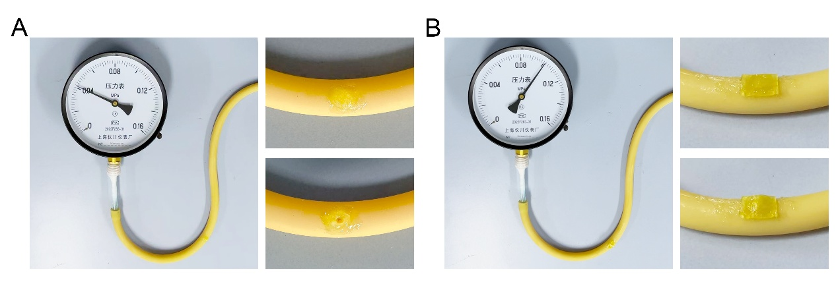
Fig. S49. Bursting pressure of the DELA under nature light for 3 days (A) and P(TLA/LA)@DELA band-aid (B).

References：
- Neese, F. Software update: The ORCA program system-Version 5.0. WIREs Comput. Mol. Sci. 12, e1606 (2022).
- Neese, F. An improvement of the resolution of the identity approximation for the formation of the Coulomb matrix. J. Comp. Chem. 24, 1740-1747 (2003).
- Neese, F. et al. Efficient, approximate and parallel Hartree-Fock and hybrid DFT calculations. A 'chain-of-spheres' algorithm for the Hartree-Fock exchange. Chem. Phys. 356, 98-109 (2009).
- Neese, F. The SHARK Integral Generation and Digestion System. J. Comp. Chem. 44, 381-396 (2023).
- Grimme,S. et al. A consistent and accurate ab initio parametrization of density functional dispersion correction (DFT-D) for the 94 elements H-Pu. J. Chem. Phys. 132, 154104 (2010).
- Grimme,S. et al. Effect of the damping function in dispersion corrected density functional theory. J. Comput. Chem. 32, 1456-1465 (2011).
- Weigend, F. and Ahlrichs, R. Balanced basis sets of split valence, triple zeta valence and quadruple zeta valence quality for H to Rn: Design and assessment of accuracy. Phys. Chem. Chem. Phys. 7, 3297-3305 (2005).
- Momma, K. and Izumi, F. VESTA 3 for three-dimensional visualization of crystal, volumetric and morphology data. J. Appl. Cryst. 44, 1272-1276 (2011).

