SUPPLEMENTARY MATERIALS LEGENDS
S 1 UV-Visible spectrum of the Pt(II) complex in CHCl₃ at room temperature
S 2.FTIR spectrum of the Pt(II) complex in the range of 4000-400 cm⁻¹ at room temperature
S 3.¹H NMR spectrum of the BBHMP in CDCl₃
S 4.¹H NMR spectrum of the Pt(II) complex in CDCl₃
S 5.¹H NMR chemical shifts (δ,ppm) of the BBHMP, NA and Pt(II) complex
S 6.TG-DTA graph of the Pt(II) complex at the temperature range of 25-1000 °C.

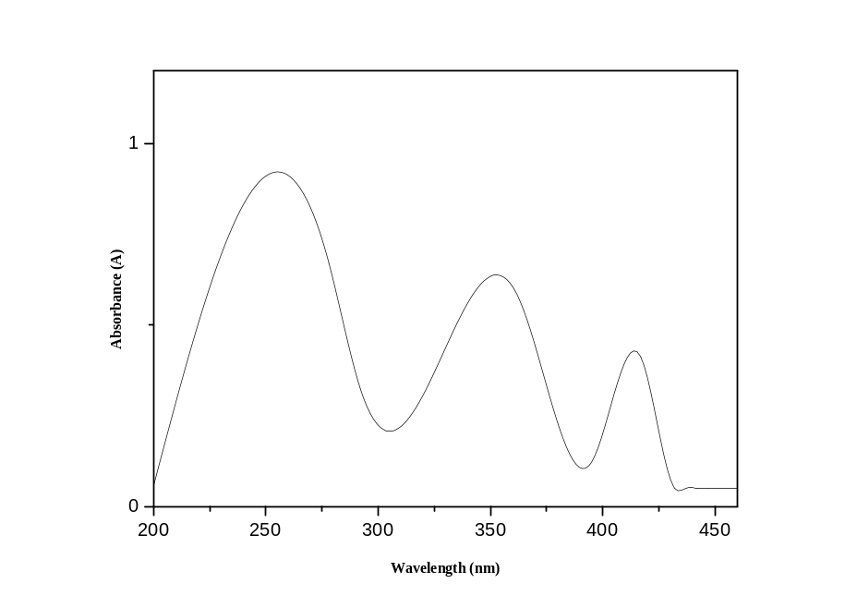
S 1 V-Visible spectrum of the Pt(II) complex in CHCl₃ at room temperature
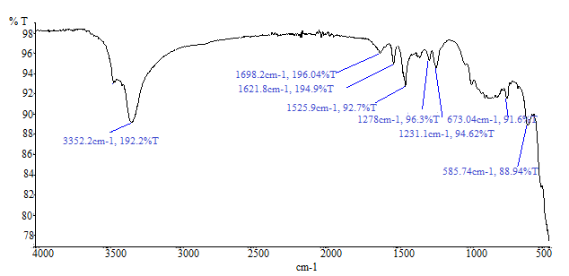
S 2 FTIR spectrum of the Pt(II) complex in the range of 4000-400 cm⁻¹ at room temperature

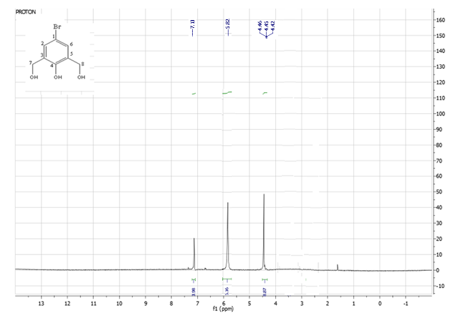
S 3 ¹H NMR spectrum of the BBHMP in CDCl₃
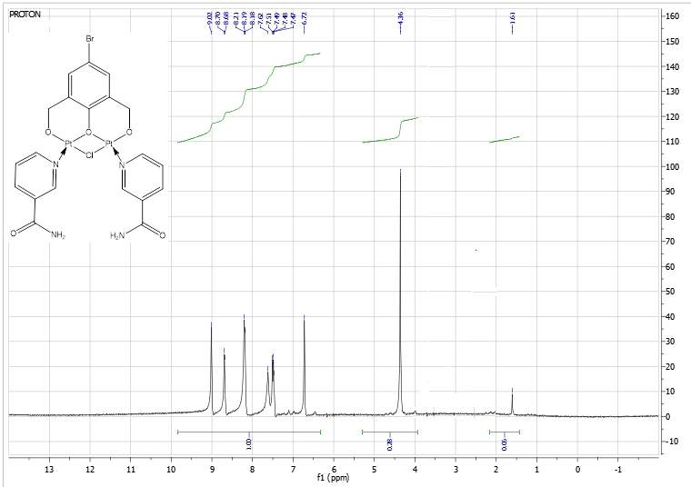
S 4 ¹H NMR spectrum of the Pt(II) complex in CDCl₃
S 5 ¹H NMR chemical shifts (δ,ppm) of the BBHMP, NA and Pt(II) complex
Compound | C₂-H | C₃H | C₄-H | C₅-H | C₆-H | C₇-H | C₈-H | NH₂ | H₂O | OH
BBHMP | 7.41,s | - | - | - | 7.41,s | 4.62,s | 4.62,s | - | - | 5.8,s
NA | 7.46,s | - | 8.48,d | 7.55,t | 8.36,d | - | - | 5.14,s | - | -
Complex | 6.72,s  9.12,s | - | -  8.36,m | -  8.36,m | 6.72,s  8.68,d | 4.37,s | 4.37,s | 7.49-7.55,m | - | -

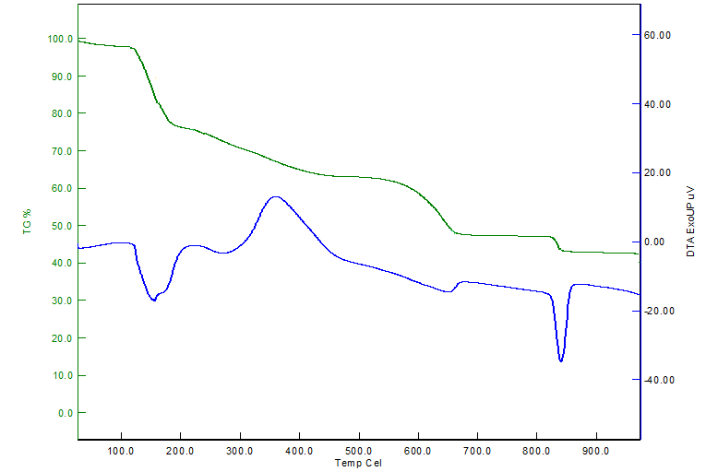
S 6 TG-DTA graph of the Pt(II) complex at the temperature range of 25-1000°C.

