Supporting Information

Programmably switching the NIR upconversion for orthogonal activation of photoacoustic imaging and on-demand phototherapy
Yang Yang,¹ Jinshu Huang,² Wei Wei,¹ Qin Zeng,¹ Xipeng Li,¹ Da Xing,¹ Bo Zhou,²* Tao Zhang¹*
¹MOE Key Laboratory of Laser Life Science & Institute of Laser Life Science, College of Biophotonics and Guangdong Provincial Key Laboratory of Laser Life Science, South China Normal University, Guangzhou 510631, China
²State Key Laboratory of Luminescent Materials and Devices, South China University of Technology, Guangzhou 510641, China
Email: zhoubo@scut.edu.cn (B. Zhou); zt@scnu.edu.cn (T. Zhang)

Supplementary Methods
Synthesis of UCNPs
UCNP was prepared by an improved solvothermal menthod according to a previously reported. Generally, Er(CH₃COO)₃•xH₂O (0.015 mmol), Tm(CH₃COO)₃•xH₂O (0.003 mmol), Y(CH₃COO)₃•4H₂O (0.77 mmol), Yb(CH₃COO)₃•4H₂O (0.20 mmol), OA (6 mL) and ODE (15 mL) were mixed into a 100 ml flask, respectively. The solution temperature was increased to 120 degrees centigrade, at which the solution temperature was decreased to 37 degrees centigrade. The NH₄F (4 mmol) and NaOH (2.5 mmol) was dissolved in 10 ml of methanol was tardily added to the flask and continue an agitated 30 min. Thereafter, the solution was elevated at 120 degrees centigrade for 30 min to remove methanol and degassed, and then heated under argon to 300 degrees centigrade (90 min). After the solution was allowed to cool, precipitated with ethanol from the solution of nanocrystal, collected by centrifugation (6000 r, 3 min), then with cyclohexan/ethanol and washed 3 times. The precipitate can be redispersed in cyclohexane.
Synthesis of DPP
The DPP polymers by Stille cross-coupling of donor - acceptor moiety synthetic compositions, such as supplementary material shown in Figure 1a. 5,5'-dibromo-2,2'-dithiophene (monomer 2, 85 mg, 0.25 mmol), 3,6-bis(5-trimethylstannylthien-2-thienyl)-2,5-bis(2-decyltetradecyl)-2,5-dihydropyrrolo[3,4-c]pyrrole-1 ,4-dione (monomer 1,325 mg, 0.25 mmol), and palladium catalyst Pd(PPh3)4 (5 mg, 0.004 mmol) were stirred together and dissolved in 10 mL toluene. Then, in order to remove the air of the reaction flask, it was degassed and filled with three freeze-pump-thaw cycles. Under the protection of sealed nitrogen, the reaction was stirred at 100 °C for 4 hours. Then gradually add 20 mg (4,4,5,5-tetramethyl-1,3,2-dioxaborane-2-yl)benzene and 0.2 mL bromobenzene to remove the ends of the reactant basal end. After the solution was cooled to room temperature slowly in 150 mL methanol, the precipitate was gathered by filter paper. The polymer is purified by Soxhlet extraction using a mixture of methanol and acetone. The DPP product dissolved in chloroform was purified using a 0.22-μm membrane filter, and precipitated with 100 mL methanol. Finally, the resulting black solid was vacuum dried at 40 °C for 24 hours.

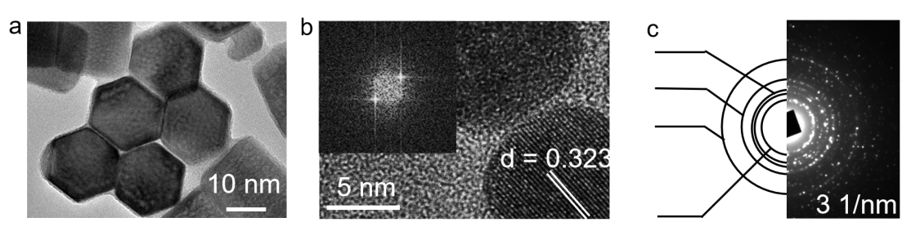
Figure S1 TEM images of UCNPs (a) HRTEM micrograph of the UCNPs. (Inset: FFT image). (b) The selected area electron diﬀraction (SAED) pattern of UCNPs.
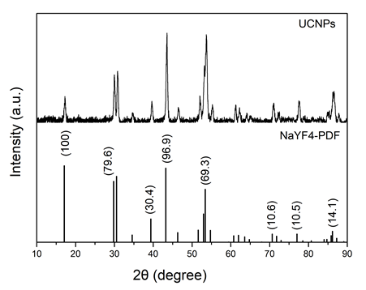
Figure S2 XRD spectrum of the UCNPs produced. As a reference, the pattern corresponding to the NaYF₄ (PDF#83-0074) is also shown.
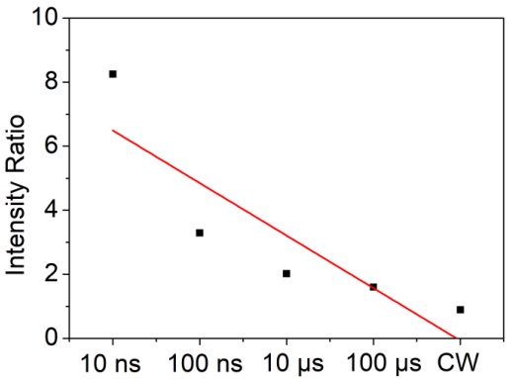
Figure S3 Ratio between UCL_{650 nm/}UCL_{800 nm} of UCNPs decreased linearly after responding to different pulsed width.
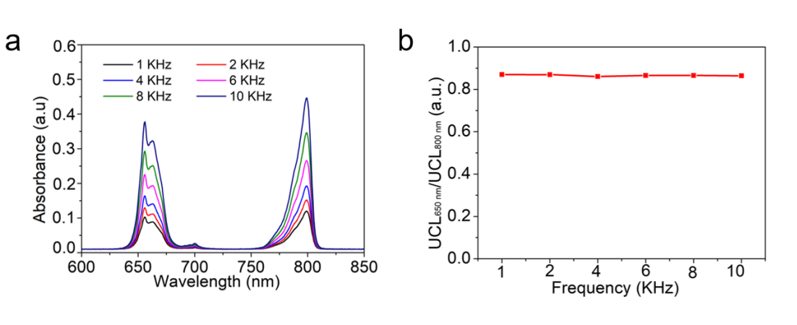
Figure S4 (a) Upconversion luminescence spectra of UCNPs-DI in 980 nm PW different frequency. (b) Frequency dependence of the UCL_{650 nm}/UCL_{800 nm} obtained upon excitation of the UCNPs at 980 nm pulsed laser (0.5 W/cm²).
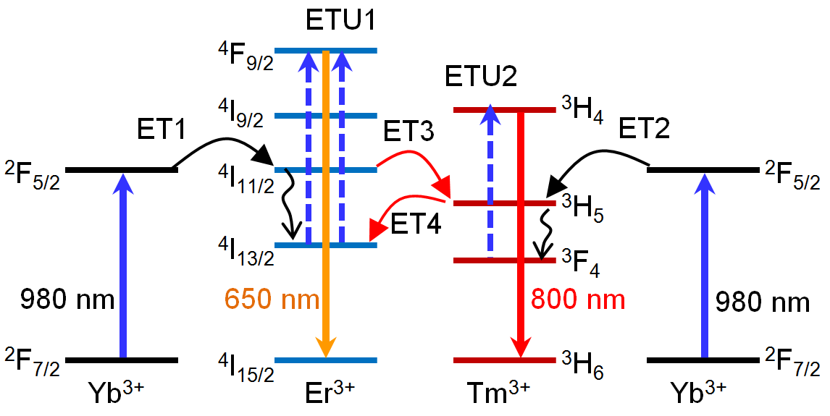
Figure S5 Schematic of promoting the red upconversin of Er through the energy circling of Er³⁺ (⁴I_{11/2}) → Tm³⁺ (³H₅) → Er³⁺ (⁴I_{11/2}). TE3: Er³⁺ (⁴I_{11/2}) → Tm³⁺ (³H₅); ET4: Tm³⁺ (³H₅) → Er³⁺ (⁴I_{11/2}). The meaning of other marks can refer to Figure 2d in maintext.
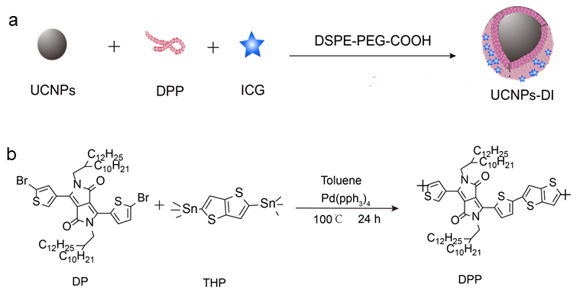
Figure S6 Synthesis route of (a) UCNPs-DI and (b) DPP.
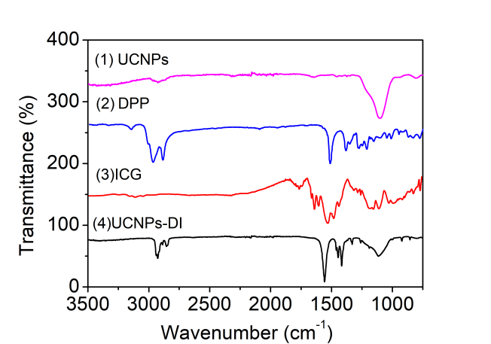
Figure S7 FTIR transmission spectrum of free UCNPs, DPP, ICG, UCNPs-DI.

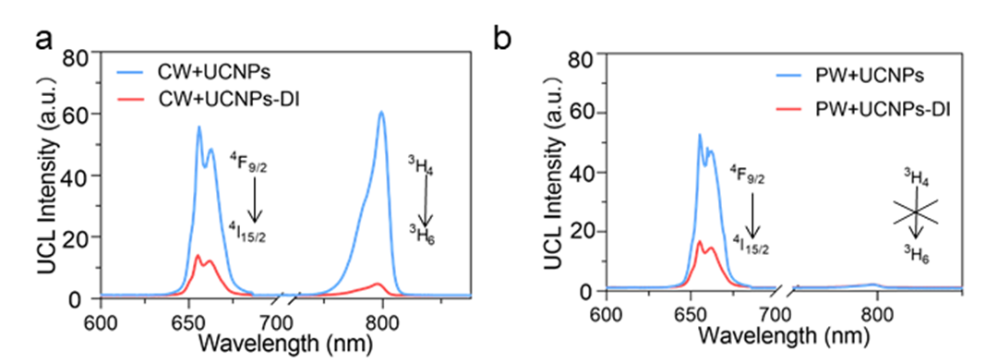
Figure S8 Upconversion luminescence spectra of UCNPs and UCNPs-DI in (a) 980 nm continuous laser and (b) 980 nm pulsed laser.
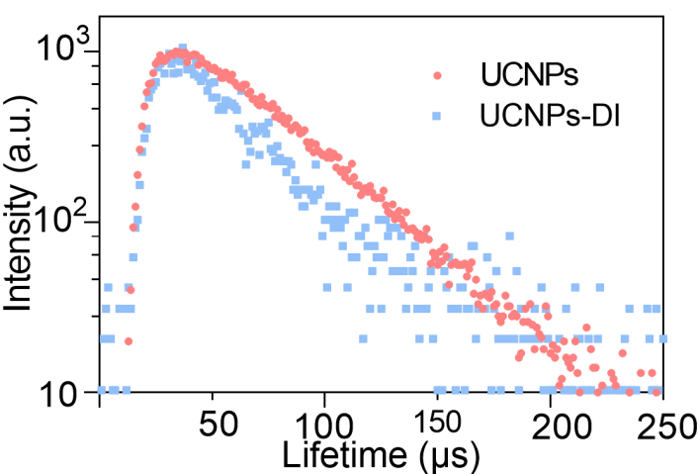
Figure S9 Luminescence decay curves of the emission at 800 nm of UCNPs and UCNPs-DI excited by 980 nm laser (0.5 W/cm²).
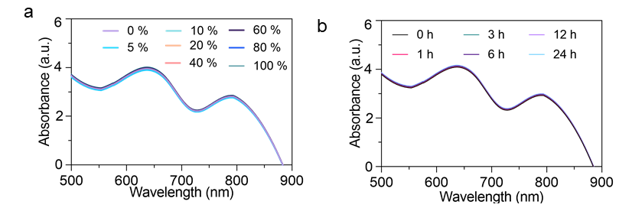
Figure S10 Changes in absorption of UCNPs-DI in PBS (pH = 7.4) with (a) different serum concentration (from 0 to 100%) and (b) 100% serum keeping for various time (from 0.5 to 24 h).
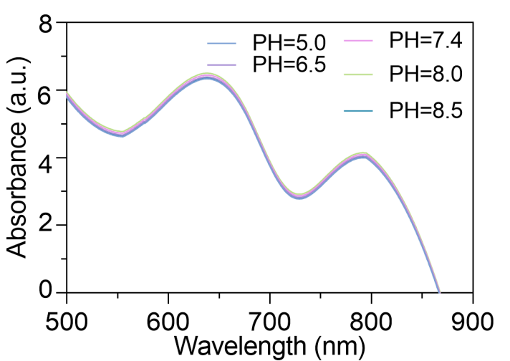
Figure S11The pH-dependent changes in absorbance of UCNPs-DI.
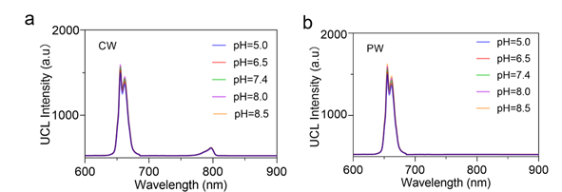
Figure S12 The pH-dependent changes in upconversion luminescence spectra of UCNPs-DI (a) 980 nm continuous laser and (b) 980 nm pulsed laser.
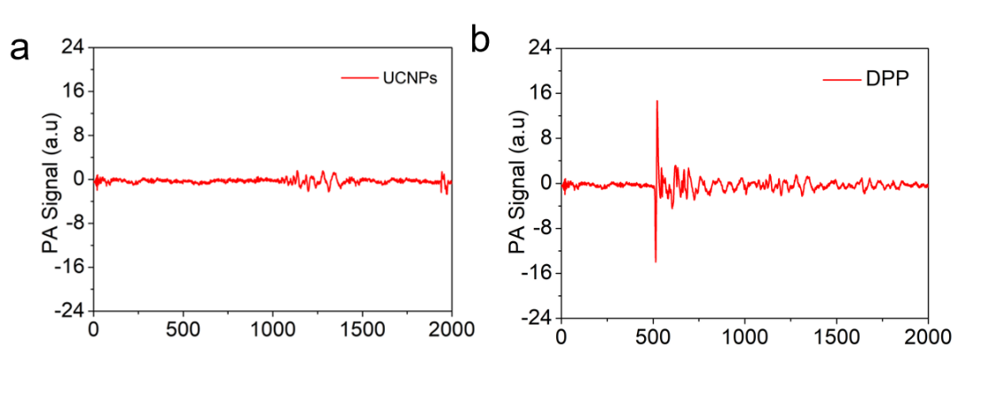
Figure S13 PA signals of (a) UCNPs and (b) DPP at 980 nm at the same concentration (0.2 mg/mL).
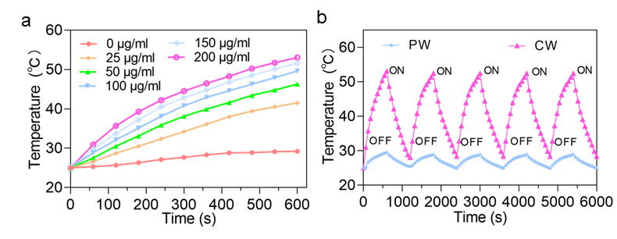
Figure S14 (a) The photothermal heating curves of pure water and UCNPs-DI solutions with different concentrations (0, 25, 50, 100, 150 and 200 μg/mL) under 980 nm continuous laser irradiation at the power density of 0.5 W/cm². (b) Temperature variations of the UCNPs and UCNPs-DI under irradiation at a power density of 0.5W/cm² for four light on/off cycles.
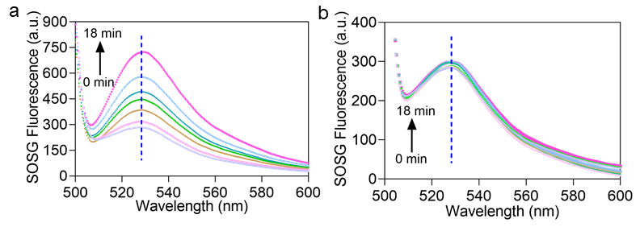
Figure S15 Singlet oxygen generation of UCNPs-DI during (a) 980 nm pulsed laser irradiation and (b) 980 nm continuous laser.
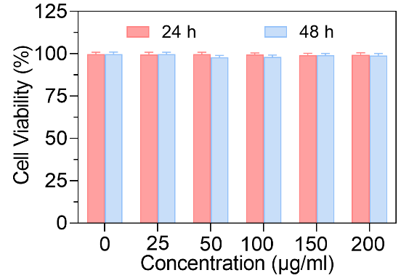
Figure S16 In vitro cell viability of LO₂ cells incubated with (a) UCNPs-DI and (b) UCNPs-DI in 980 nm pulsed laser irradiation.
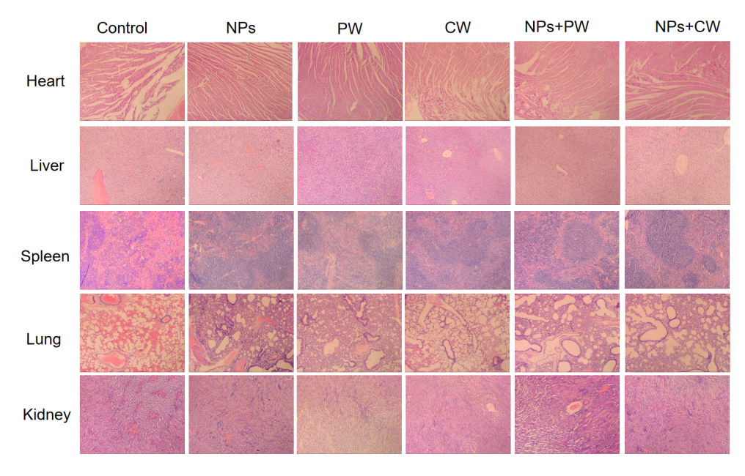
Figure S17 H&E-stained images of major organs from different treated mice.

