Supplementary Information
Ligating atom modulated metal-oxygen bonds for electrocatalytic water oxidation
Pengqi Yang^{1,2,9}, Hongjian Ge^{2,4,9}, Siyang Li^{1,9}, Caoyu Yang¹, Fulin Jia¹, Mingxuan Zhang⁵, Guikai Zhang⁸, Lei Shi¹, Jinghao Wang¹, Sihan Chen¹, Sheng Chen¹, Lei Shi³, Jiawei Zhu⁶, Jia Zhang^{2,4}, Huajie Yin^{2,4}, Wensheng Yan⁴, Zhangquan Peng⁷, Junliang Sun⁵, Shenlong Zhao^{1,*}, Zhengyan Wu^{2,4,*}, Zhiyong Tang^{1,*}

¹CAS Key Laboratory of Nanosystem and Hierarchical Fabrication, National Center for Nanoscience and Technology, Beijing 100190, China
²Key Laboratory of High Magnetic Field and Ion Beam Physical Biology, Hefei Institutes of Physical Science, Chinese Academy of Sciences, Hefei 230031, China
³College of Materials Science and Engineering, Nanjing Forestry University, Nanjing 210037, China
⁴University of Science and Technology of China, Hefei 230026, China
⁵College of Chemistry and Molecular Engineering, Beijing National Laboratory of Molecular Sciences, Peking University, Beijing 100871, China
⁶Qingdao Institute of Bioenergy and Bioprocess Technology, Chinese Academy of Sciences, Qingdao, 266101 China
⁷Laboratory of Advanced Spectro-electrochemistry and Li-ion Batteries Dalian Institute of Chemical Physics Chinese Academy of Sciences, Dalian 116023, China
⁸Beijing Synchrotron Radiation Facility, Institute of High Energy Physics, Chinese Academy of Sciences, Beijing 100049, China
⁹These authors contributed equally to this work.
*Corresponding authors: zhaosl@nanoctr.cn; zywu@ipp.ac.cn; zytang@nanoctr.cn

Table of Contents
Supplementary Methods 5
Chemicals and Reagents 5
Synthesis of MOFs 5
Electrochemical measurements in an AEMWE 6
In situ ATR-SEIRAS measurement 6
XAFS measurements and analysis 6
Supplementary Figures 8
Supplementary Fig. 1 8
Supplementary Fig. 2 9
Supplementary Fig. 3 11
Supplementary Fig. 4 12
Supplementary Fig. 5 13
Supplementary Fig. 6 14
Supplementary Fig. 7 15
Supplementary Fig. 8 16
Supplementary Fig. 9 17
Supplementary Fig. 10 19
Supplementary Fig. 11 20
Supplementary Fig. 12 21
Supplementary Fig. 13 22
Supplementary Fig. 14 23
Supplementary Fig. 15 24
Supplementary Fig. 16 25
Supplementary Fig. 17 26
Supplementary Fig. 18 27
Supplementary Fig. 19 28
Supplementary Fig. 20 29
Supplementary Fig. 21 30
Supplementary Fig. 22 31
Supplementary Fig. 23 32
Supplementary Fig. 24 32
Supplementary Fig. 25 33
Supplementary Fig. 26 34
Supplementary Fig. 27 35
Supplementary Fig. 28 36
Supplementary Fig. 29 37
Supplementary Fig. 30 38
Supplementary Fig. 31 39
Supplementary Fig. 32 40
Supplementary Fig. 33 41
Supplementary Fig. 34 42
Supplementary Fig. 35 43
Supplementary Fig. 36 44
Supplementary Fig. 37 45
Supplementary Fig. 38 46
Supplementary Fig. 39 47
Supplementary Fig. 40 48
Supplementary Fig. 41 49
Supplementary Fig. 42 50
Supplementary Fig. 43 51
Supplementary Fig. 44 52
Supplementary Fig. 45 53
Supplementary Fig. 46 54
Supplementary Fig. 47 55
Supplementary Fig. 48 56
Supplementary Fig. 49 57
Supplementary Fig. 50 58
Supplementary Fig. 51 59
Supplementary Fig. 52 60
Supplementary Fig. 53 61
Supplementary Fig. 54 62
Supplementary Fig. 55 63
Supplementary Fig. 56 64
Supplementary Fig. 57 65
Supplementary Fig. 58 66
Supplementary Fig. 59 67
Supplementary Fig. 60 68
Supplementary Fig. 61 69
Supplementary Fig. 62 70
Supplementary Fig. 63 71
Supplementary Fig. 64. 72
Supplementary Fig. 65. 73
Supplementary Fig. 66. 74
Supplementary Fig. 67 75
Supplementary Tables 76
Supplementary Table 1. 76
Supplementary Table 2. 78
Supplementary Table 3. 80
Supplementary Table 4 81
Supplementary Table 5 82
Supplementary Table 6 83
Supplementary Table 7 84
Supplementary Table 8 85
Supplementary Table 9 87
Supplementary Table 10 88
Supplementary Table 11 89
Supplementary Table 12 90
Supplementary Table 13 92
Supplementary Table 14 94
Supplementary References 98

Supplementary Methods

Chemicals and Reagents
Cobalt(II) acetate tetrahydrate (99.9%, metals basis), cobalt(II) nitrate hexahydrate (99.99%, metals basis), cobalt(II) dichloride (99.99%, metals basis), KOH (electronic grade, 99.999% metals basis), methanol (99.5%), ethanol (95%), isopropanol (99.7%), H₂¹⁸O (99.9%), dimethylsulfoxide (DMSO), and dimethylformamide (DMF) were purchased from Shanghai Sinopharm Chemical Reagent Co., Ltd.. Terephthalic acid (BDC, 99%), 2,5-diaminoterephthalic acid (BDC(NH₂)₂, ≥95%), and 2,5-dimercaptoterephthalic acid (BDC(SH)₂, ≥95%) were bought from Shanghai Bide Pharmatech Technology Co., Ltd.. Nafion 117 solution (5%), 20%Pt/C, and RuO₂ (99.9%) were purchased from Sigma-Aldrich. Carbon paper (TGP-H-060), Raney nickel, and fumasep anion exchange membrane (FAA-3-PK-130) were obtained from Sinero Technology Co., Ltd.. All chemical reagents were used as received without further purification. All aqueous solutions were prepared using deionized water (DI water) with a resistivity of 18.2 MΩ cm⁻¹.

Synthesis of MOFs
Synthesis of thio-Co-MOF
In synthesis of thio-Co-MOF, 3 mmol of cobalt(II) acetate tetrahydrate was first dissolved in 50 mL of methanol under vigorous stirring. 50 mL of methanol and 10 mL of DMF solution containing 1 mmol of BDC(SH)₂ were added dropwise under continued stirring, and the mixed solution was continuously stirred for about 3 h to form the black mixture at room temperature. The mixture was washed several times with water and methanol, respectively, and then ultrasonically dispersed in 50 mL of water. The mixture was then transferred into a Teflon-lined autoclave, tightly capped, and placed in an oven at 180℃ for 15 h. After cooling to room temperature, the black precipitate was collected and washed several times with water and methanol. The final product was dried at 50℃ in a vacuum oven for further use.
Synthesis of hydroxy-Co-MOF
In synthesis of hydroxy-Co-MOF, 8 mmol of cobalt(II) acetate tetrahydrate was first dissolved in 80 mL of methanol solution under vigorous stirring. 50 mL of DMF containing 4 mmol of BDC was added dropwise under continued stirring, and the mixed solution was further stirred for about 3 h at room temperature. The mixture was washed with methanol and water for three times, respectively, and then ultrasonically dispersed in 50 mL of water. The mixture was then transferred into a Teflon-lined autoclave, tightly capped, and placed in an oven at 180℃ for 15 h. After cooling to room temperature, the yellow precipitate was collected and washed with water and methanol for several times. The final product was dried at 50℃ in a vacuum oven for further use.

Electrochemical measurements in an AEMWE
The anion exchange membrane water electrolyzer (AEMWE) was assembled with nickel foam as electrode substrates, FAA-3-PK-130 as a separated membrane, sealing washers, bipolar plates, and pipelines. Co-MOFs and 20% Pt/C inks were loaded onto the nickel foam by spray as the cathode and anode for the OER, respectively. Line sweep voltammetry (LSV) curves were recorded in alkaline solutions (1.0 M KOH, pH = 13.93) with a rate of 5 mV s⁻¹. Chronopotentiometry (CP) tests were carried out to evaluate the stability of Co-MOFs under a constant current density. The metal content in the electrolyte was determined by inductively coupled plasma optical emission spectroscopy (ICP-OES) during the OER. Unless otherwise stated, all experiments were performed at ambient temperature (25 ± 2℃).

In situ ATR-SEIRAS measurement
In situ attenuated total reflectance surface enhanced infrared absorption spectroscopy (ATR-SEIRAS) was carried out with a Nicolet iS50 spectrometer with an HgCdTe (MCT) detector cooled with liquid N₂ and a VeeMax III (PIKE Technologies) accessory. Electrochemical tests were conducted in a customized electrochemical microcell with a three-electrode system. A Pt wire and a saturated Ag/AgCl were used as counter and reference electrodes. The Au film deposition Si prism was used as the working electrode to load catalysts. An Au thin-layer with a thickness of 40 nm was deposited by solvent reaction. The reflecting plane of the Si prism was polished with Al₂O₃ powder (0.03 µm), and sonicated in ethanol and water before deposition. For ATR-SEIRAS measurement, 32 scans were collected with a spectral resolution of 4 cm⁻¹ for each spectrum. The background spectrum of the working electrode was recorded in an open-circuit condition. The recorded spectra were processed via OMNIC software.

XAFS measurements and analysis
XAFS spectra of Co K-edges were collected at the 1W1B beamline station of BSRF. The storage ring of the BSRF was operated at 2.5 GeV with a maximum current of 250 mA and a Si (111) double-crystal monochromator. Ex situ XAS spectra were collected in transmission mode using standard Ar/N₂-filled ion chambers to monitor the intensity of the incident and transmitted X-rays. Operando XAS spectra were collected in fluorescence mode with ionization chambers filled with Ar at room temperature using a homemade in situ cell and an electrochemical workstation. In this operando cell, a Pt wire, Hg/HgO electrode, and 1 M KOH were used as the counter electrode, reference electrode, and electrolyte, respectively. Thin carbon paper loaded with Co-MOFs with a circular window covered with Kapton film was employed as the working electrode. The Co K-edge k³-weighted χ(k) data in k-space were Fourier-transformed to R-space using Hanning windows to separate EXAFS contributions from different coordination shells. The structural parameters of the Co atoms in the prepared samples were determined by quantitative curve fitting of the Fourier-transformed k³χ(k) in R-space using the ARTEMIS module of IFEFFIT. The effective backscattering amplitudes F(k) and phase shifts Φ(k) of the fitting paths were calculated using the ab initio code FEFF 8.0.

Supplementary Figures
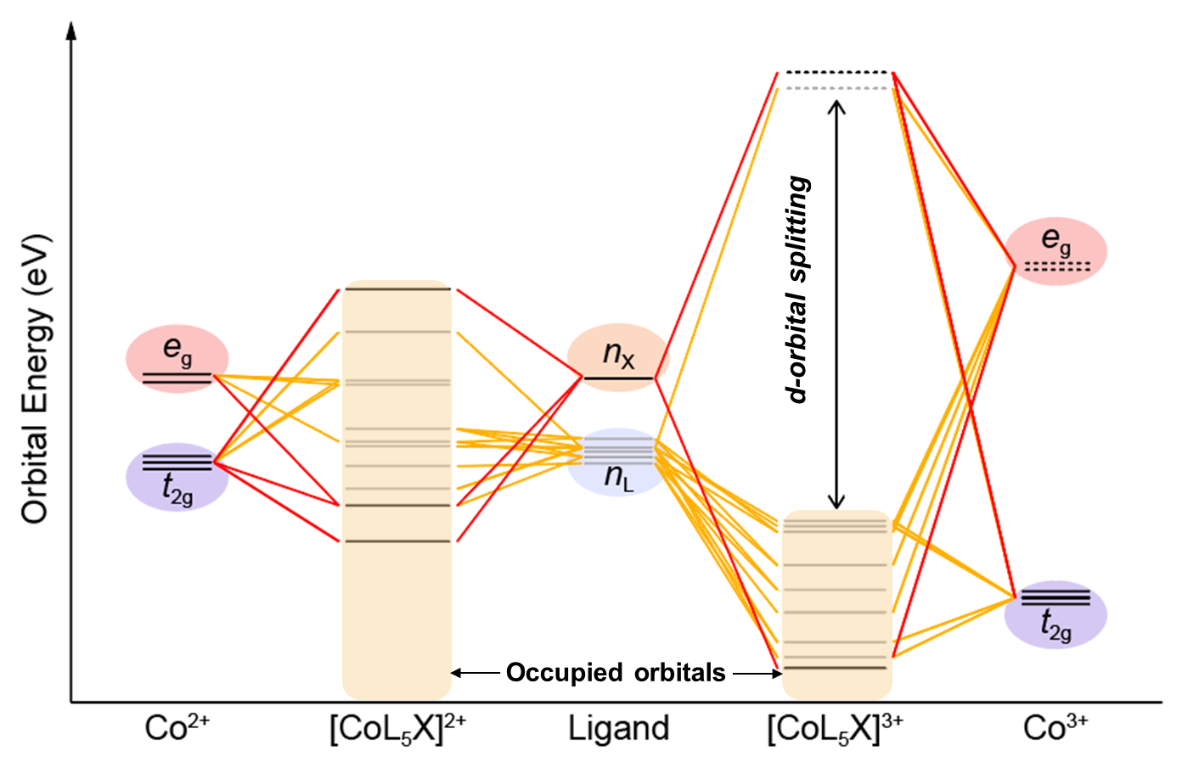
Supplementary Fig. 1
. Schematic diagram for the molecular orbitals of [CoL₅X]^{n+}.
To explore how ligand field tunes the redox properties of metal centers, cobalt complexes are chosen as the model. Choosing cobalt as the object of study provides convenience for the characterization of the ligand field: if the ligand field is strong enough, the special d⁶ configuration of cobalt would offer a clear picture, where t_{2g} orbitals contribute to the HOMO while e_{g} orbitals contribute to the LUMO of the complex, so that the distance between them indicates the d-orbital splitting.

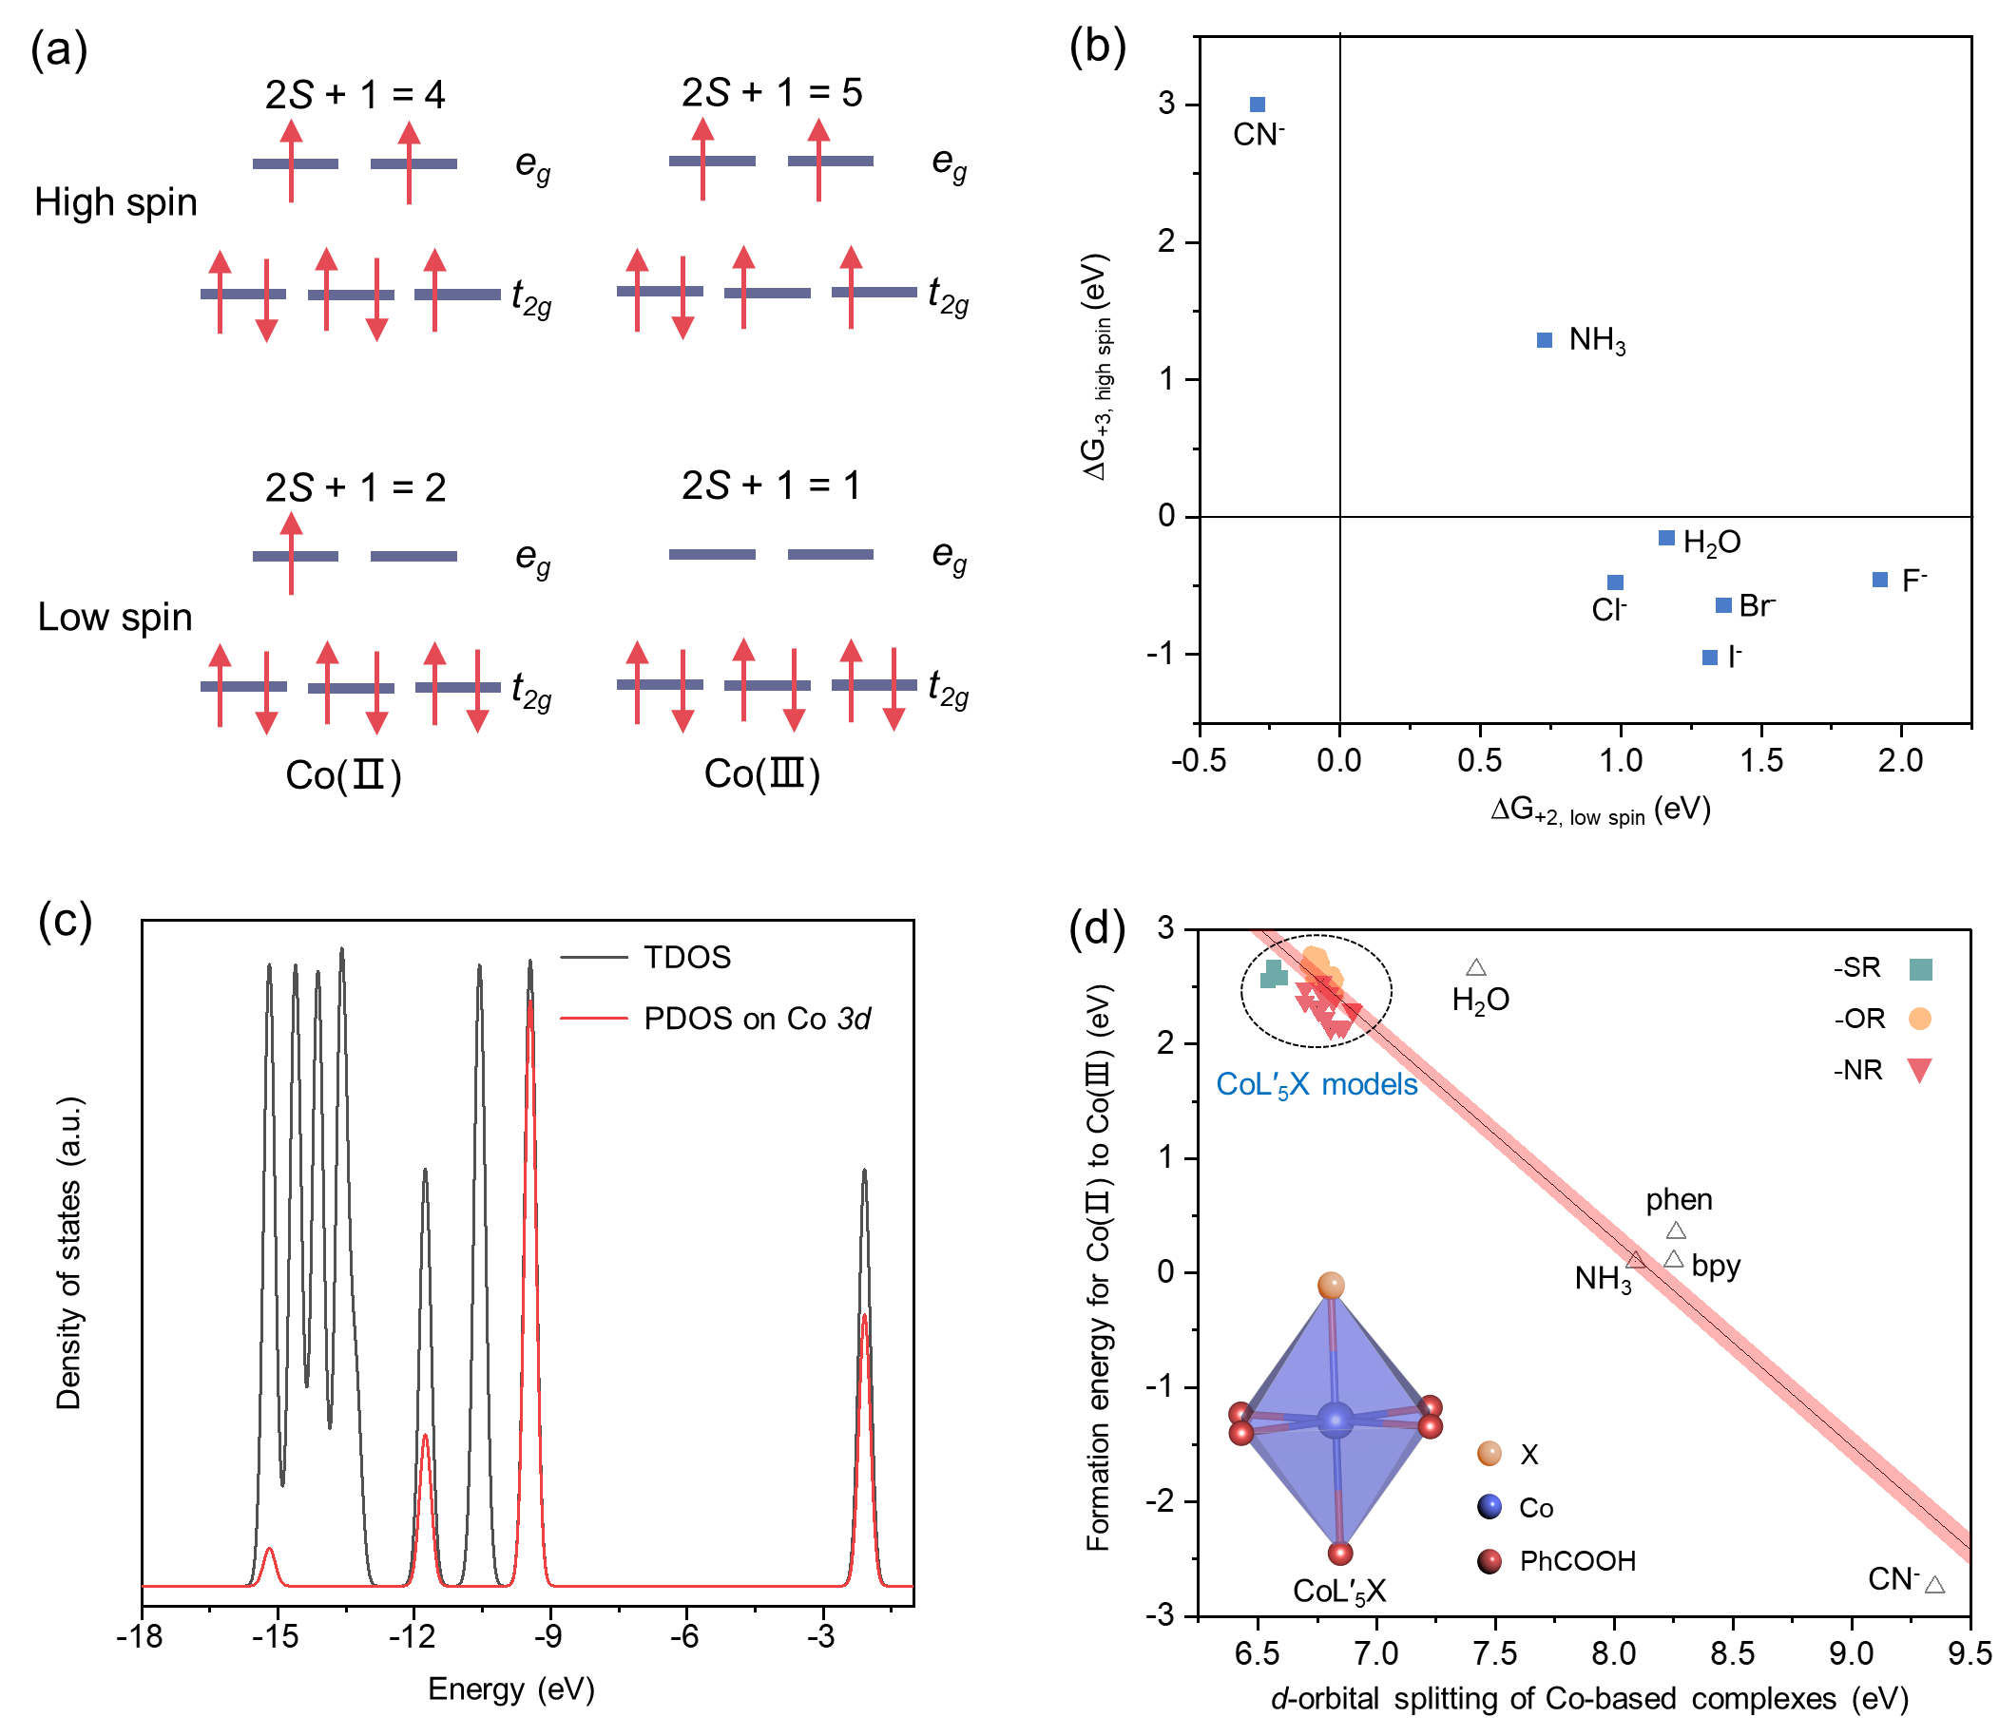
Supplementary Fig. 2
. (a) Schematic diagram for possible spin states of Co(II) and Co(III) species. (b) Relative Gibbs free energy of low-spin reduced state and high-spin oxidized state for [CoX₆]^{n+}. (c) The partial density of states (PDOS) diagram of [CoL₆]³⁺. (d) Energy-dependent relationship (Pearson’s r = -0.90) between the formation energy of Co(III) and the d-orbital splitting of cobalt complexes with CoL′₅X (solid, Supplementary Table 2) and CoR₆ (hollow, Supplementary Table 3); Red area is the fitted confidence band. Pearson’s r represents the Pearson correlation coefficient: |r| ≥ 0.70 indicates a strong correlation, 0.69 ˃ |r| ≥ 0.40 indicates a moderate correlation, and 0.39 ˃ |r| ≥ 0.10 indicates a weak correlation^{1,2}.
Complexes with classical ligands from the spectrochemical series ([CoX₆]^{n+}, X = CN⁻, NH₃, H₂O, F⁻, Cl⁻, Br⁻, and I⁻) are first built to determine the ground spin configurations at both valence states (Supplementary Fig. 2a). It turns out that NH₃ is a good choice for it offers enough ligand field strength (Supplementary Fig. 2b). Afterwards, [CoL₅X]^{n+} is adopted as the platform to broaden the scope of ligand, where L represents NH₃ that serves as the background ligand for maintaining the low spin state in high valent complexes. The formation energy of Co(III) complex $∆G_{f}\left(L,X\right)$ is defined by
$$∆G_{f}\left(L,X\right)=G\left({\left[{CoL}_{5}X\right]}^{3+}\right)-G\left({\left[{CoL}_{5}X\right]}^{2+}\right)+C$$
where $G$ is the Gibbs free energy obtained from Gaussian 09 D.01 package.³ The correction term $C$ is given by
$$C=-G\left({\left[{CoL}_{6}\right]}^{3+}\right)+G\left({\left[{CoL}_{6}\right]}^{2+}\right)+0.1 eV$$
where 0.1 eV is the standard reduction potential of [CoL₆]³⁺/[CoL₆]²⁺.⁴ The total density of states of a Co(III) complex is projected on the 3d orbitals of cobalt with the help of Multiwfn 3.8(dev).⁵ Supplementary Fig. 2c shows the partial density of states (PDOS) diagram of [CoL₆]³⁺, as an example. The splitting energy Co(III) complex $Δ_{o}(L,X)$ is given by
$$Δ_{o}(L,X)=\left.\begin{aligned}\overset{̲}{\int_{m}^{+∞}{ρ_{L,X}\left(E\right)E}dE-\int_{-∞}^{m}{ρ_{L,X}\left(E\right)E}dE} \\ \int_{-∞}^{+∞}{ρ_{L,X}\left(E\right)}dE\end{aligned}\right.$$
where $ρ_{L,X}(E)$ is PDOS of Co 3d orbitals, and $m$ is the middle point of the gap between HOMO and LUMO. Total 46 ligands are used as X and their results are summarized in Supplementary Table 1.
To mimic the situation in MOFs, the formation energy and the splitting energy of [CoL′₅X]³⁺ are estimated, where L′ represents the benzoic acid. We assume that the contribution of each ligand in the coordination octahedron is independent, so that the properties of [CoL₅L′]³⁺ can be written as the linear combination of [CoL′₆]³⁺ and [CoL₆]³⁺:
$$Y\left(L, L^{'}\right)=\frac{1}{6}\left[5Y\left(L,L\right)+Y\left(L^{'},L^{'}\right)\right]$$
Therefore, we have
$$Y\left(L^{'}, L^{'}\right)=6Y\left(L,L^{'}\right)-5Y\left(L,L\right)$$
when we know the properties of [CoL₅X]³⁺, the properties of [CoL′₅X]³⁺ can be deduced from
$$Y\left(L^{'},X\right)=\frac{1}{6}\left[5Y\left(L^{'},L^{'}\right)+Y\left(X,X\right)\right]=Y\left(L,X\right)+5\left[Y\left(L,L^{'}\right)-Y\left(L,L\right)\right]$$
In the reasoning above, the properties $Y$ can be either the formation energy or the splitting energy. The estimated results are summarized in Supplementary Table 2. Together with the results of [CoR₆]^{n+} (Supplementary Table 3), a strongly negative correlation between the formation energy of Co(III) and the d-orbital splitting of cobalt complexes can be found (Pearson’s r = -0.90, Supplementary Fig. 2d).
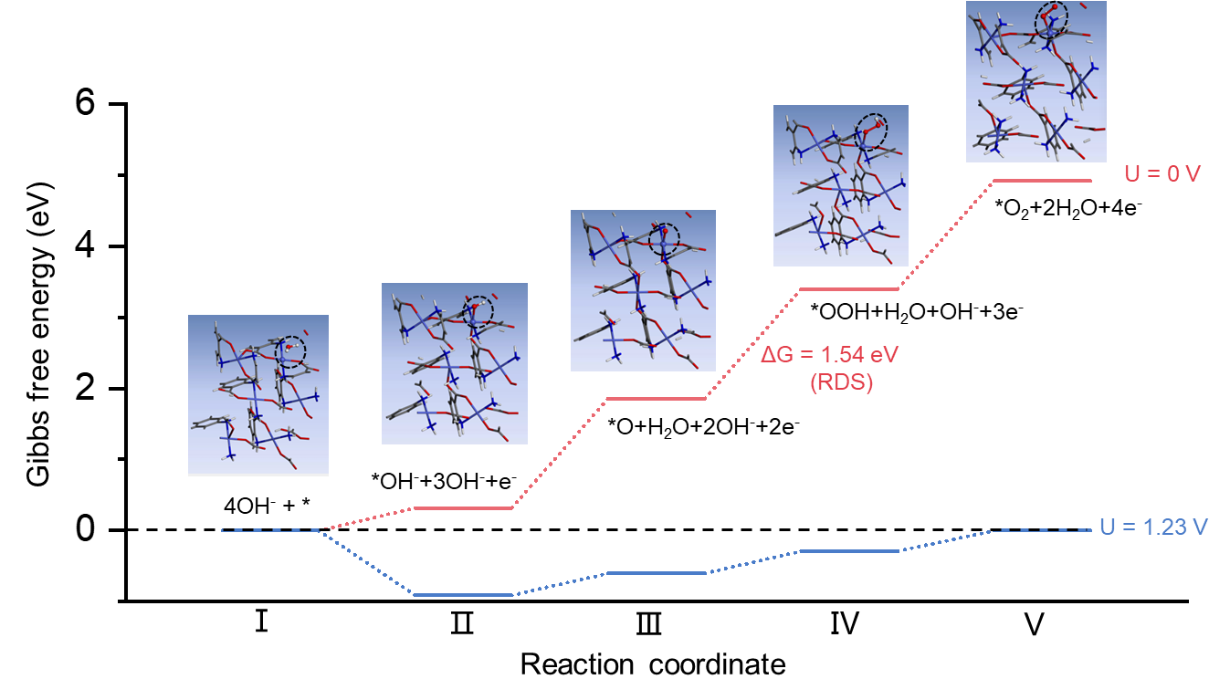
Supplementary Fig. 3
. Gibbs free energy profiles of OER process on amino-Co-MOFs. Insets are the structures of each intermediate.
The OER involves four proton-coupled electron transfer steps:
1. * + H₂O → *OH + H⁺ + e⁻ (ΔG₁)
2. *OH → *O + H⁺ + e⁻ (ΔG₂)
3. *O + H₂O → *OOH + H⁺ + e⁻ (ΔG₃)
4. *OOH → * + O₂ + H⁺ + e⁻ (ΔG₄)
The overpotential (η) required for OER is related to the Gibbs free energy changes of these steps:
η = max(ΔG_{i})/e − E_{θ}
where e is the elementary charge (1.602×10⁻¹⁹ C), and E_{θ} is the standard potential for OER (1.23 V).
For amino-Co-MOF, adsorbed water molecules on active Co sites initiate OER, converting Co-H₂O into Co-OH by a deprotonation process accompanied by the transformation of Co²⁺ into Co³⁺ (for example, Co²⁺-H₂O + OH⁻ → Co³⁺-OH + H₂O + e⁻). Based on the proton-coupled electron transfer process above, ΔG₃ from *O to *OOH shows the highest energy barrier of 1.54 eV, representing the rate-determining step (RDS, Supplementary Table 4).
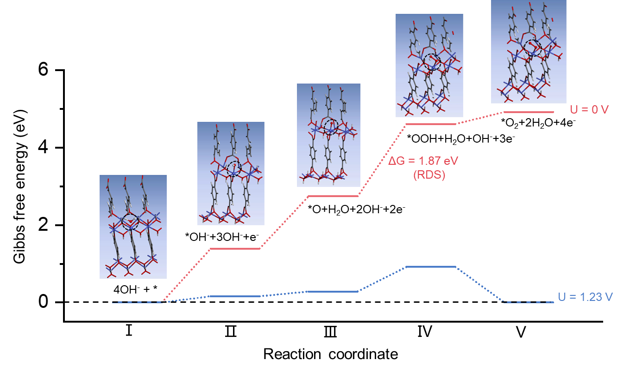
Supplementary Fig. 4
. Gibbs free energy profiles of OER process on hydroxy-Co-MOFs. Insets are the structures of each intermediate.
For hydroxy-Co-MOF, ΔG₃ from *O to *OOH also shows the highest energy barrier of 1.87 eV, representing the rate-determining step (RDS, Supplementary Table 4).

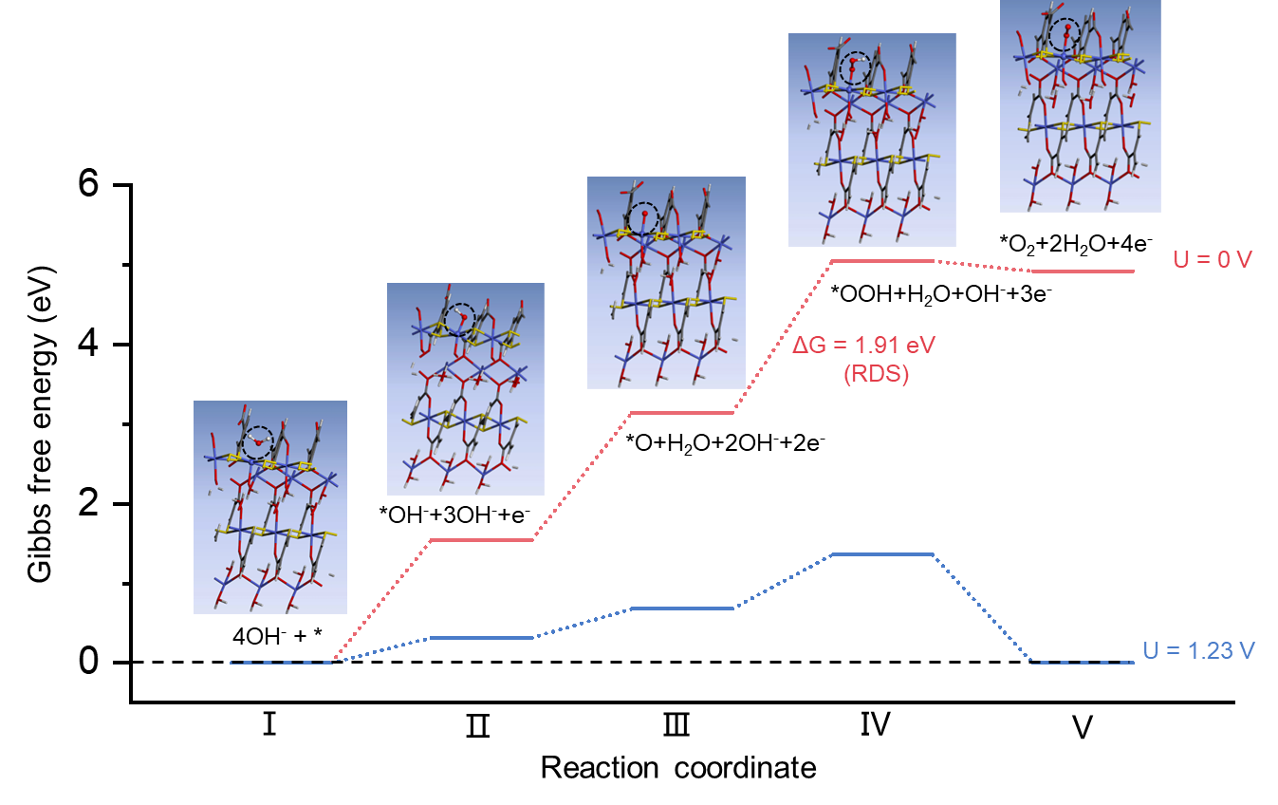
Supplementary Fig. 5
. Gibbs free energy profiles of OER process on thio-Co-MOFs. Insets are the structures of each intermediate.
For thio-Co-MOF, ΔG₃ from *O to *OOH also shows the highest energy barrier of 1.91 eV, representing the rate-determining step (RDS, Supplementary Table 4).

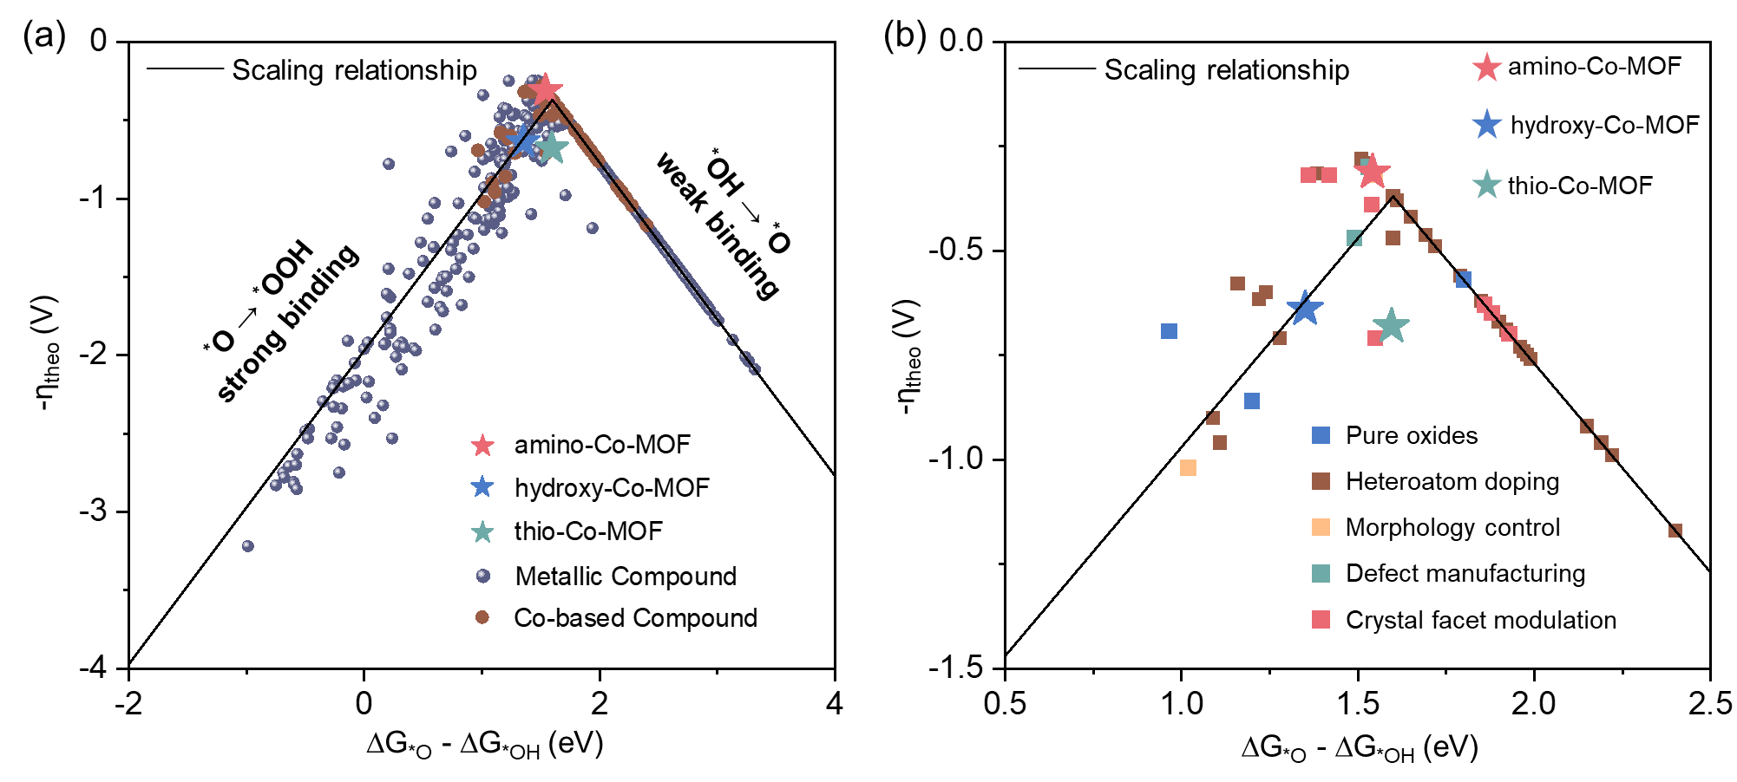
Supplementary Fig. 6
. Volcano plot of OER activity trends for (a) Co-MOFs (vide Supplementary Table 4), Co-based compounds, and metallic compounds; (b) Co-MOFs and Co-based compounds with different strategies from (a).
The volcano plot of theoretical overpotential (η_{theo}) is established by using the expression of η_{theo} = max {∆G_{O*} - ∆G_{OH*}, 3.2 eV - (∆G_{O*} - ∆G_{OH*})}/e - 1.23 V, which is based on the scaling relationship ∆G_{OOH*} = ∆G_{OH*} + 3.2 eV. Except for Co-MOFs, data are obtained from a reported dataset⁶. From plotting the volcano plot of OER activity for Co-MOFs, Co-based compounds, and metal oxides, it can be found that the theoretical overpotential of amino-Co-MOF is the minimum and located at the top of the volcano plot, suggesting its great potential to serve as an outstanding OER catalyst.

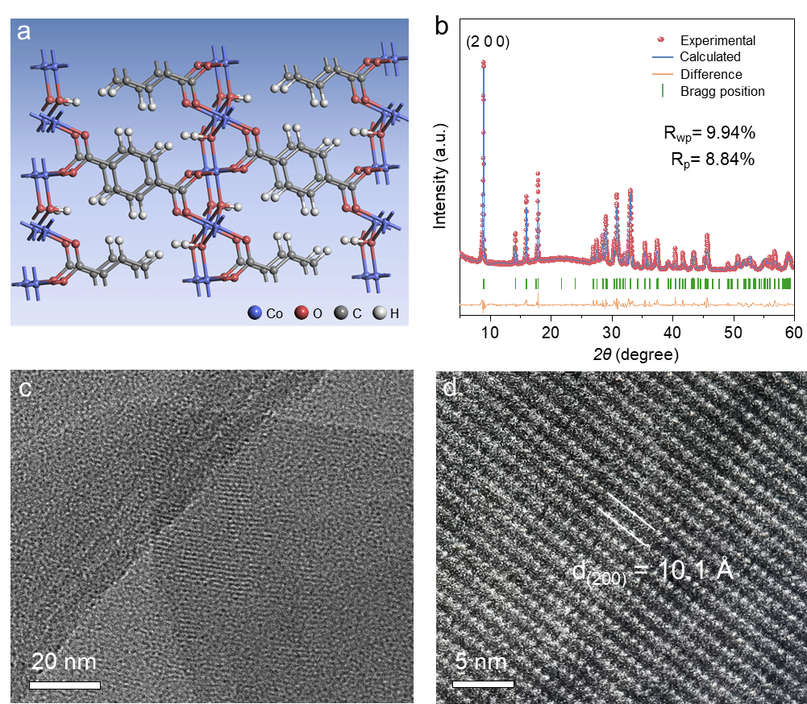
Supplementary Fig. 7
. (a) Crystal structure of hydroxy-Co-MOF; (b) Rietveld refinement of experimental PXRD data; (c) HR-TEM image of hydroxy-Co-MOF and (d) enlarged image.
The refinement results of PXRD (R_{wp} = 9.94% and R_{p} = 8.84%) and the matched lattice fringe with the (200) plane demonstrate that the hydroxy-Co-MOF is successfully synthesized.

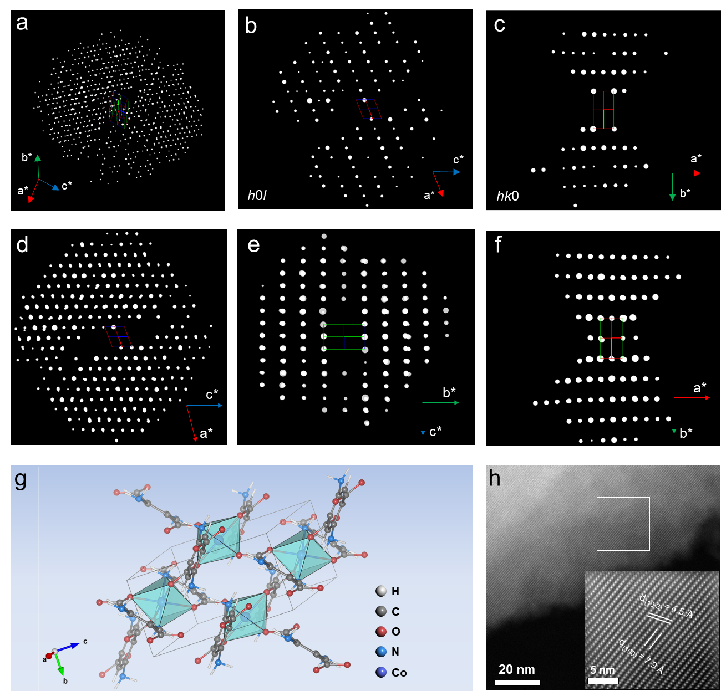
Supplementary Fig. 8
. (a) Reconstructed 3D reciprocal lattice of amino-Co-MOF. The obtained lattice parameters are a = 8.20 Å, b = 5.09 Å, c = 9.13 Å, α = γ = 90°, β = 109.85° (monoclinic crystal system) based on continuous rotation electron diffraction data. 2D slices cut from the reconstructed 3D reciprocal lattice showing (b) (h0l) plane and the extinction rule with l = 2n, and (c) (hk0) plane and the extinction rule with k = 2n. Reconstructed 3D reciprocal lattice viewed along the (d) [010], (e) [100], (f) [001]. (g) Crystal structure of amino-Co-MOF. (h) Low-dose spherical aberration-corrected HAADF-STEM image of amino-Co-MOF and enlarged image of the white box.

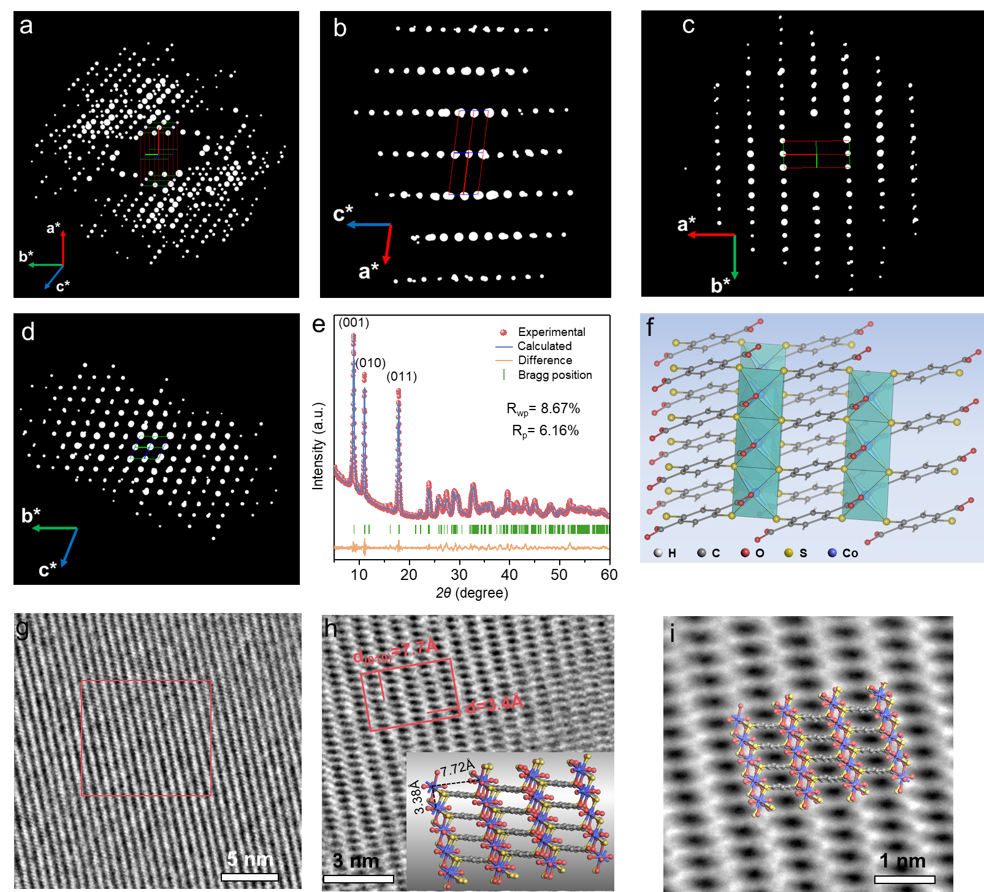
Supplementary Fig. 9
. (a) Reconstructed 3D reciprocal lattice of thio-Co-MOF. The obtained lattice parameters are a = 3.39 Å, b = 8.299 Å, c = 10.07 Å, α = 113.21°, β = 97.67°, γ = 90.58° (triclinic crystal system) based on continuous rotation electron diffraction data. Reconstructed 3D reciprocal lattice viewed along the (b) [010], (c) [001], and (d) [100]. (e) Rietveld refinement of experimental PXRD data. (f) Crystal structure of thio-Co-MOF. (g) Low-dose spherical aberration-corrected HAADF-STEM image along the [001] axis of thio-Co-MOF and (h) enlarged image from the orange box in (f). (i) Symmetry-imposed and lattice-averaged HR-STEM image along with the crystal structure overlaid on the image.
With the help of continuous-rotation electron diffraction (cRED) technology and Rietveld refinement of PXRD, the crystal structure of thio-Co-MOF is resolved and belongs to the triclinic crystal system (Supplementary Fig. 9a-f and Supplementary Table 5). Low-dose spherical aberration-corrected high-angle annular dark field-STEM (HAADF-STEM) images along the [001] axis of thio-Co-MOF match the projected atomic arrangements (Supplementary Fig. 9i). The lattice fringe spacings of 7.7 Å and 3.4 Å correspond to the interplanar spacing of the crystal structure (Supplementary Fig. 9g, h).
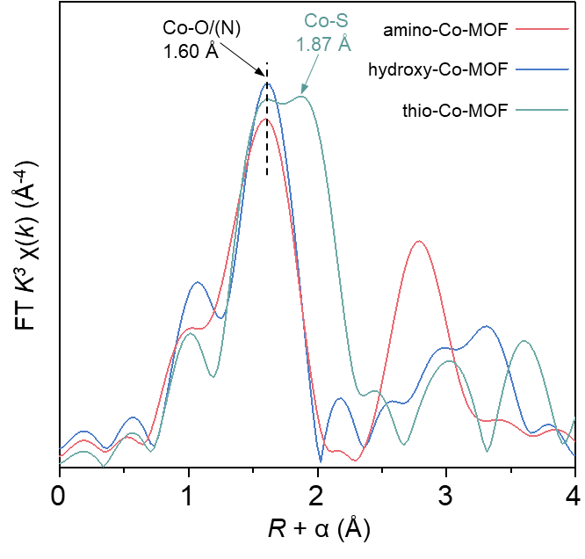
Supplementary Fig. 10
. Co K-edge Fourier-transformed extended X-ray absorption fine structure of Co-MOFs.
As shown in Supplementary Fig. 10, a characteristic peak corresponding to Co-N or Co-O scattering is observed at ~1.60 Å (without phase correction) in the Fourier-transformed extended X-ray absorption fine structure (FT-EXAFS) of Co-MOFs at Co K-edge. A new peak at 1.87 Å emerges in the FT-EXAFS of thio-Co-MOF, attributed to Co-S scattering with a larger bond length.

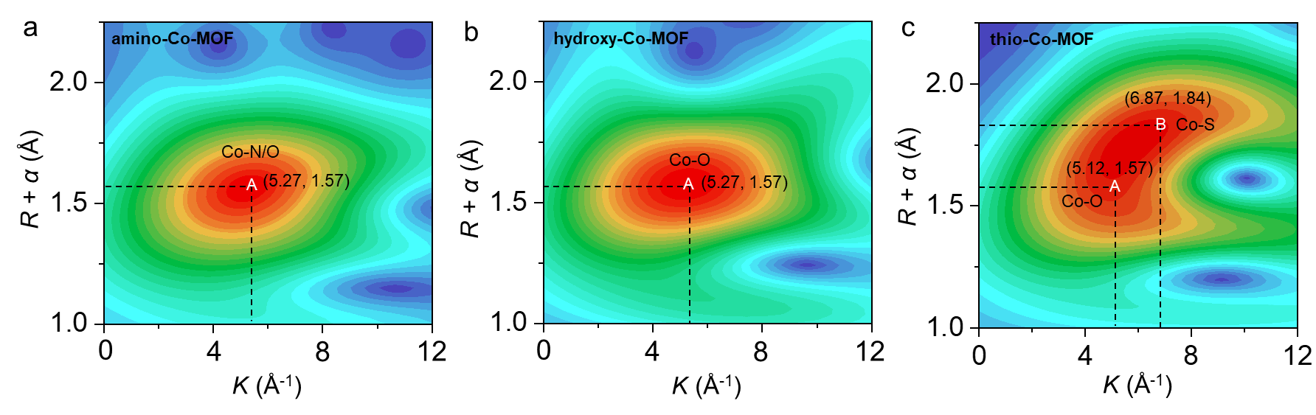
Supplementary Fig. 11
. Wavelet-transformed extended X-ray absorption fine structure (WT-EXAFS) of (a) amino-Co-MOF, (b) hydroxy-Co-MOF, and (c) thio-Co-MOF.
Compared with similar wavelet-transformed EXAFS (WT-EXAFS) plots of hydroxy-Co-MOF and amino-Co-MOF, that of thio-Co-MOF exhibits a non-elliptical shape, as shown in Supplementary Fig. 11. The new feature B is attributed to a Co-S scattering pair. These observations further confirm that Co-MOFs with heterogeneous ligands are successfully constructed.

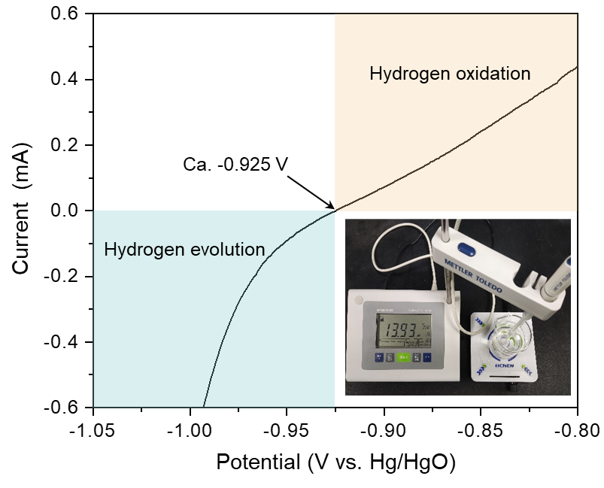
Supplementary Fig. 12
. Calibration curves of the reference electrode (Hg/HgO filled with saturated KOH solution) in H₂-saturated 1 M KOH solution (pH = 13.93).
The difference between the theoretical value of 0.920 V and the experimental value of 0.925 V is 0.005 V in KOH with pH = 13.93 from the calibration experiment based on the Nernst equation. The interference of this result on the OER test result can be neglected.

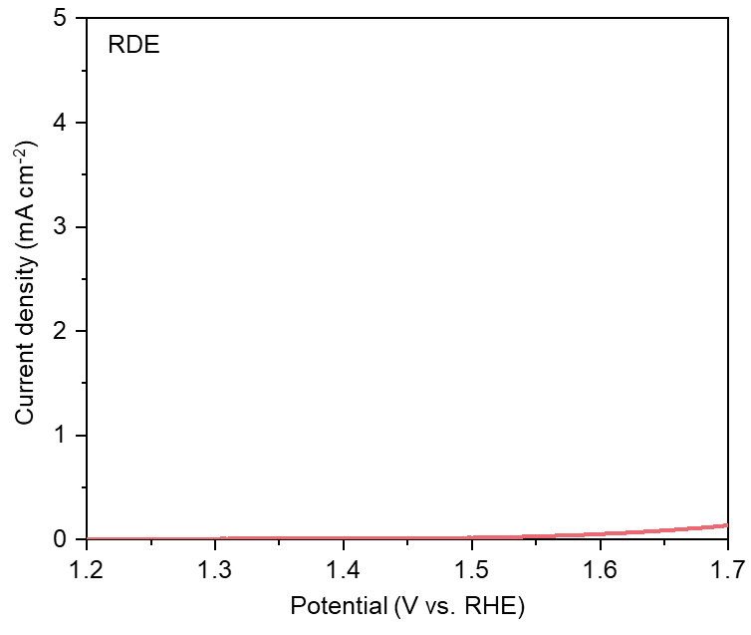
Supplementary Fig. 13
. Polarization curve of the bare rotating disk electrodes with 90% iR-correction normalized by the geometric area.
It is found in Supplementary 13 that the bare rotating disk electrode is inactive for the OER, ensuring that the obtained performance of Co-MOFs is intrinsic OER activity.

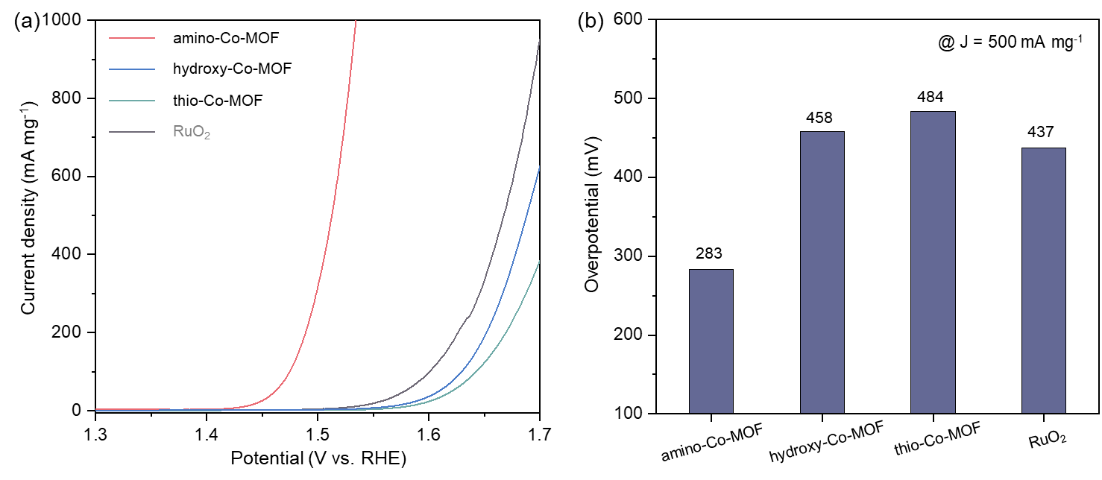
Supplementary Fig. 14
. (a) Polarization curves of Co-MOFs and reference RuO₂ with 90% iR-correction by the rotating disk electrodes and the current normalized by the mass of the catalyst, and (b) the corresponding overpotential at 500 mA mg⁻¹.
Among these catalysts, amino-Co-MOF shows the highest mass activity with an overpotential of merely 283 mV at 500 mA mg⁻¹.

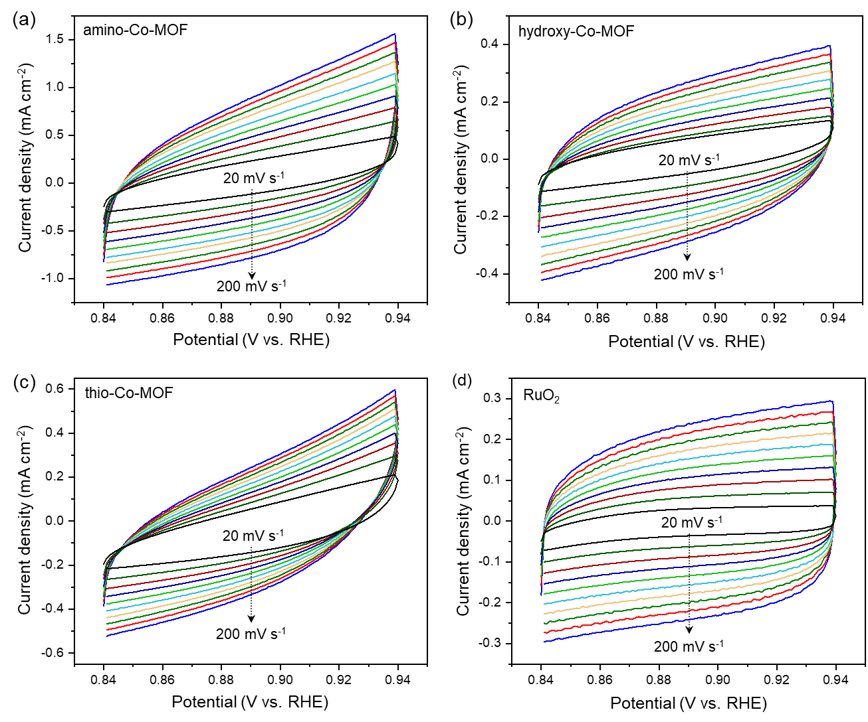
Supplementary Fig. 15
. Cyclic voltammetry curves of (a) amino-Co-MOF, (b) hydroxy-Co-MOF, (c) thio-Co-MOF, and (d) RuO₂ recorded in a potential window between 0.84 and 0.94 V (vs. RHE) at the scan rates from 20 to 200 mV s⁻¹.

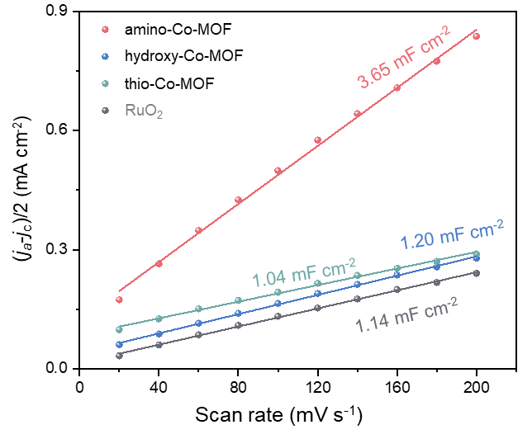
Supplementary Fig. 16
. Capacitive current density as a function of scan rates of different catalysts. The slopes are equal to the double-layer capacitance. ECSA is calculated and shown in Supplementary Table 6.

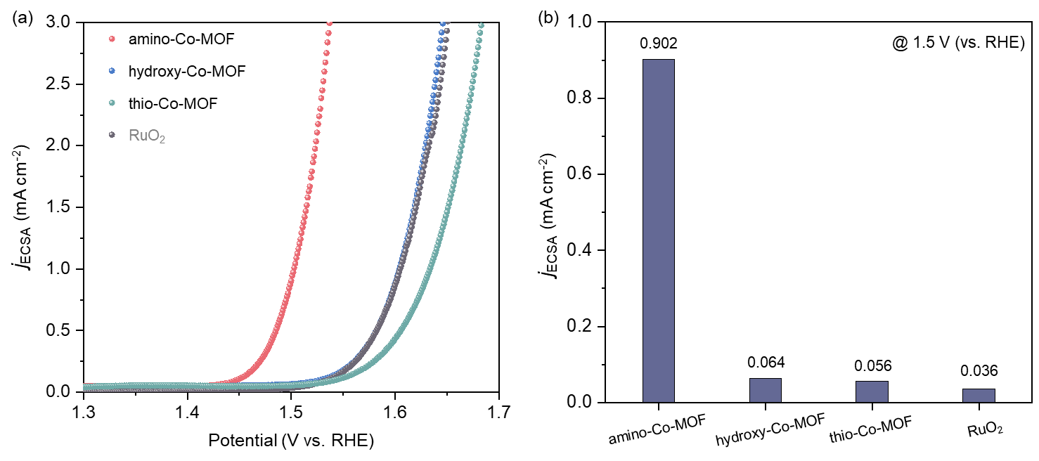
Supplementary Fig. 17
. (a) Polarization curves of Co-MOFs and commercial RuO₂ with 90% iR-correction by the rotating disk electrodes and the current normalized by the electrochemically active area, and (b) the corresponding current density at 1.5 V.
The intrinsic activities of Co-MOFs are further assessed based on ECSA, among which amino-Co-MOF shows the highest j_{ECSA} of 0.902 mA cm⁻² at 1.5 V (vs. RHE, Supplementary Fig. 17b).

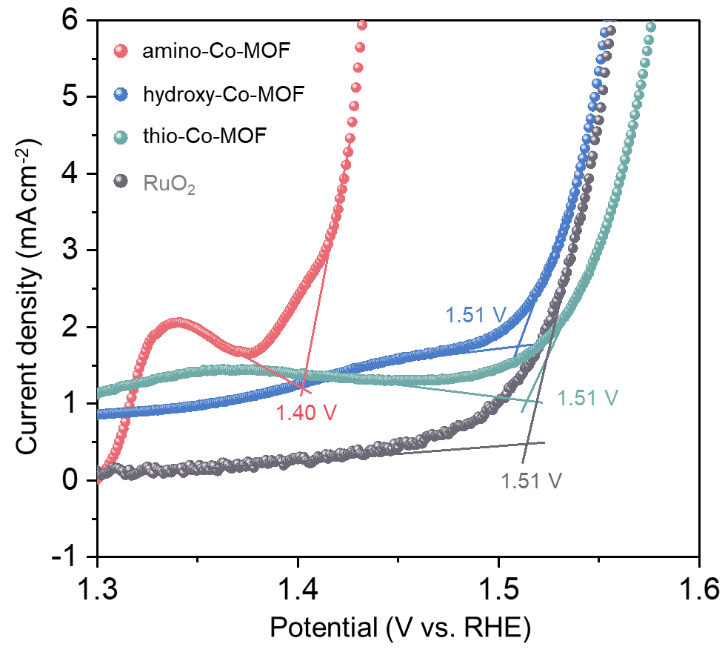
Supplementary Fig. 18
. Onset potential of Co-MOFs and reference RuO₂.
We obtain the onset potentials of Co-MOFs and reference RuO₂ (the critical potential for OER) using the tangent method. As shown in Supplementary Fig. 18, the onset potential of amino-Co-MOF, hydroxy-Co-MOF, thio-Co-MOF, and RuO₂ is 1.40 V, 1.51 V, 151 V, and 1.51 V, respectively.

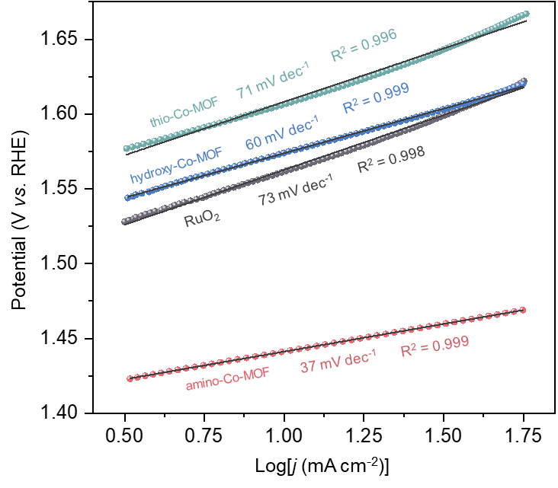
Supplementary Fig. 19
. Tafel slope of Co-MOFs and reference RuO₂.
As shown in Supplementary Fig. 19, the Tafel slope of amino-Co-MOF, hydroxy-Co-MOF, thio-Co-MOF, and RuO₂ is 37 mV dec⁻¹, 60 mV dec⁻¹, 71 mV dec⁻¹, and 73 mV dec⁻¹, respectively.

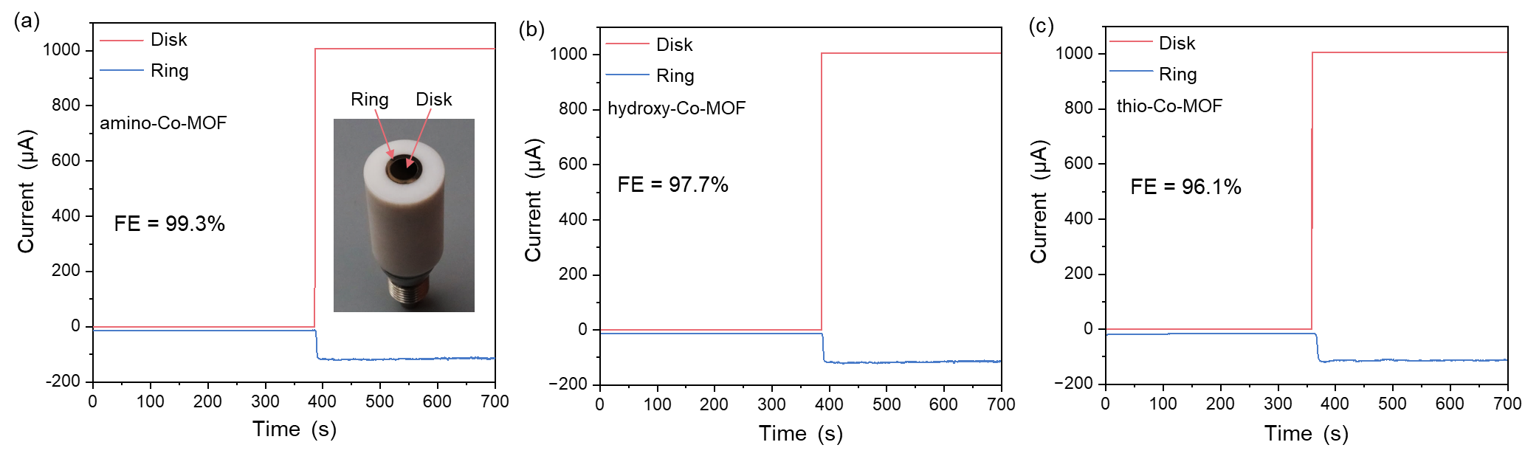
Supplementary Fig. 20. Faraday efficiencies (FE) of the OER for (a) amino-Co-MOF, (b) hydroxy-Co-MOF, and (c) thio-Co-MOF tested by the rotating ring-disk electrode.
Faraday efficiency (FE) of the OER is measured up to 99.3% using the rotating disk electrodes (RRDE) test (Supplementary Fig. 20a), further confirming the real catalytic activity of amino-Co-MOF. Meanwhile, those of the other two Co-MOFs are also tested to be 97.7% and 96.1%, respectively (Supplementary Fig. 20b, c).

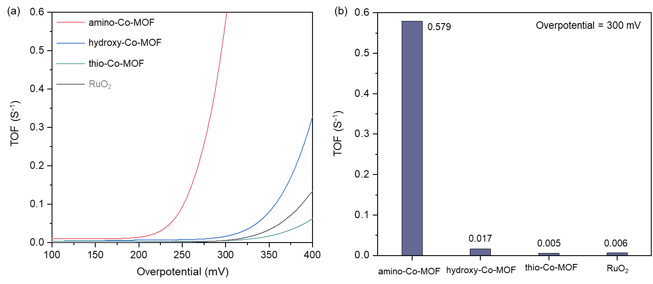
Supplementary Fig. 21
. (a) Turnover frequencies (TOFs) of Co-MOFs by rotating disk electrodes and (b) the corresponding TOFs at overpotentials of 300 mV.
The intrinsic activities of Co-MOFs are also assessed based on turnover frequencies (TOFs), among which amino-Co-MOF shows the highest TOF of 0.579 O₂ s⁻¹ per electrochemically accessible metal site at the overpotentials of 300 mV (Supplementary Fig. 21b).

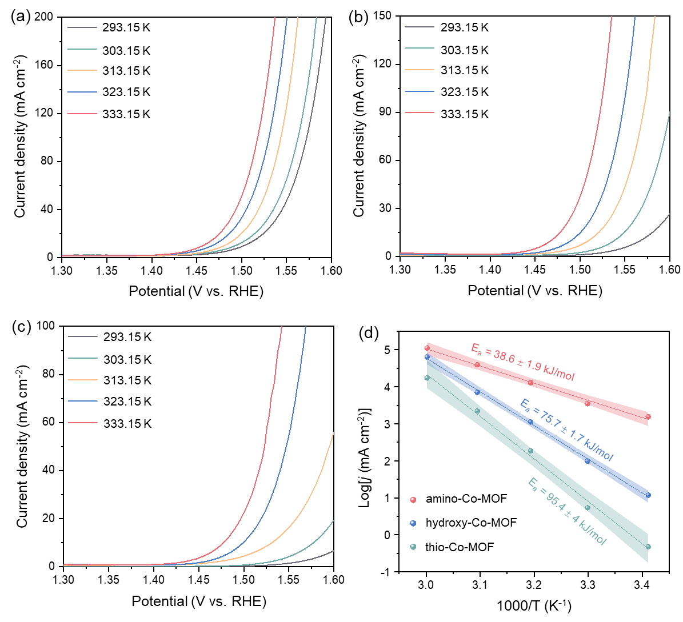
Supplementary Fig. 22
. Active energy measurements by temperature-dependent polarization curves of (a) amino-Co-MOF, (b) hydroxy-Co-MOF, and (c) thio-Co-MOF without iR compensation. (d) The apparent activation energy of Co-MOFs at 1.5 V (vs. RHE).
Compared with hydroxy-Co-MOF and thio-Co-MOF, amino-Co-MOF exhibits the highest intrinsic OER activity, attributed to the lowest apparent activation energy (E_{a}) of 38.6 kJ mol⁻¹ (Supplementary Fig. 22).

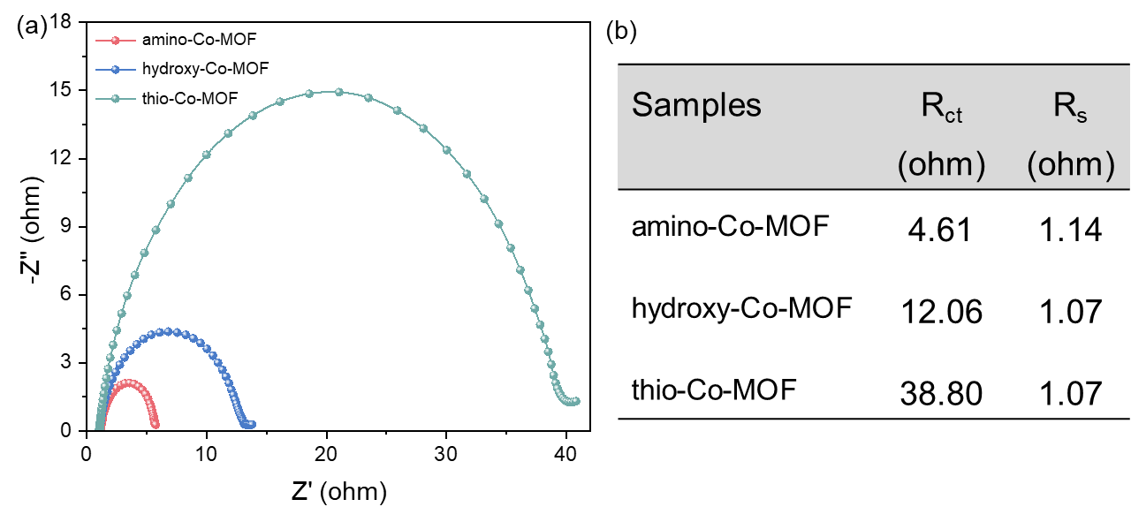
Supplementary Fig. 23
. (a) Nyquist plots of Co-MOFs and (b) a table of the corresponding resistance electrochemical impedance values.
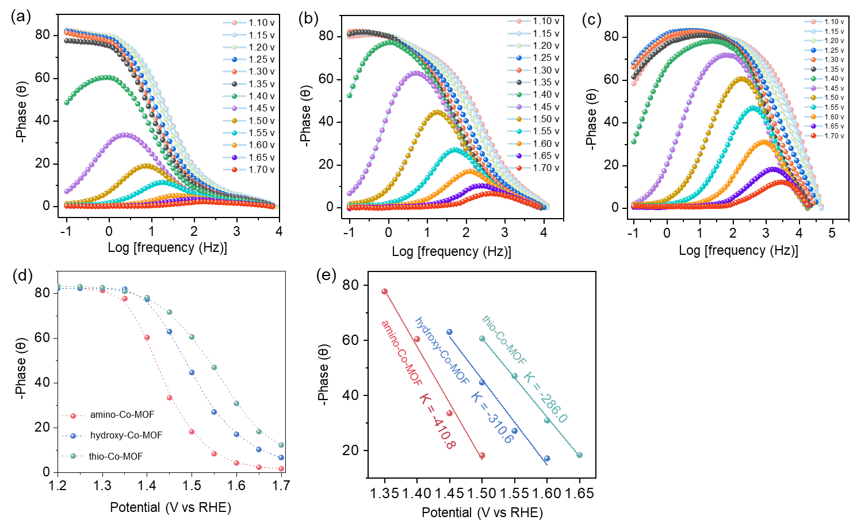
Supplementary Fig. 24
. In-situ Bode phase plots of (a) amino-Co-MOF, (b) hydroxy-Co-MOF, and (c) thio-Co-MOF; (d) Response of the phase angle to the applied potential, and (e) response rate of the phase angle. A large slope means that the electrons are more easily transferred as the applied potential changes.
Compared with hydroxy-Co-MOF and thio-Co-MOF, amino-Co-MOF exhibits the highest kinetic activity, attributed to the lowest electron transfer resistance of 4.61 ohm (Supplementary Fig. 23) and the highest charge transfer kinetics of 410.8 (Supplementary Fig. 24).
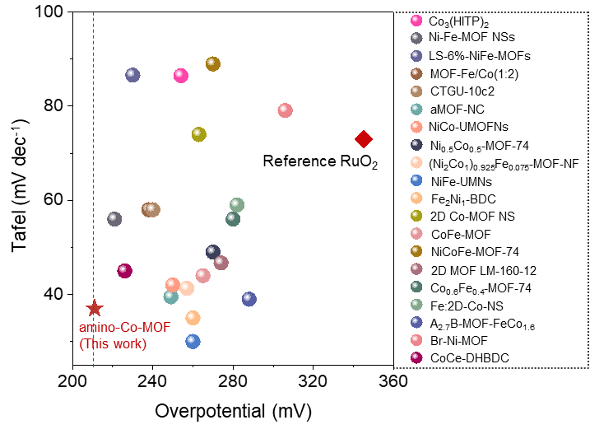
Supplementary Fig. 25
. Comparison of the intrinsic OER performance (Tafel and overpotential at 10 mA cm⁻²) of amino-Co-MOF and reported MOFs (vide Supplementary Table 8).
The amino-Co-MOF shows the lowest overpotential of 211 mV among the reported pristine MOF catalysts at 10 mA cm⁻².

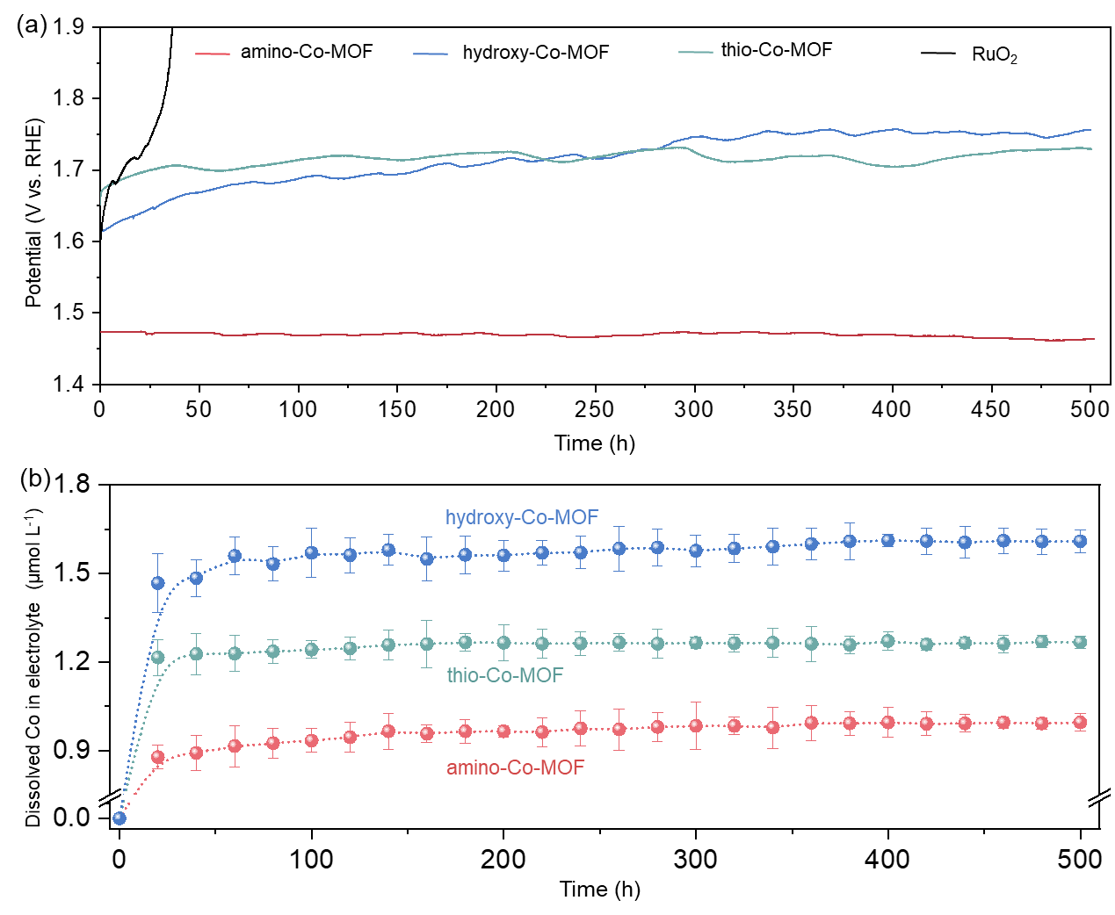
Supplementary Fig. 26
. (a) Galvanostatic measurement of Co-MOFs and reference RuO₂ at a current density of 10 mA cm⁻² for 500 hours at room temperature, (b) and the corresponding metal leaching content calculated from ICP-AES results.
Compared with reference RuO₂, Co-MOFs exhibits a more stable electrocatalytic performance at 10 mA cm⁻² for more than 500 h, with a trace of cobalt detected in the electrolyte during electrolysis. Especially, amino-Co-MOF maintains nearly 100% stability after 500 hours of electrolysis.

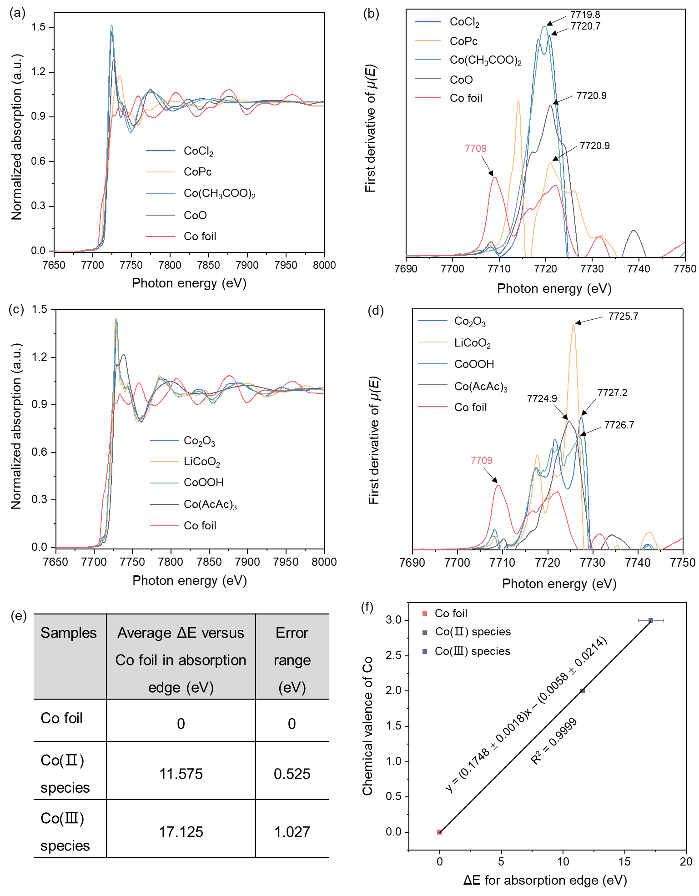
Supplementary Fig. 27
. (a) Co K-edge XANES spectra of standard Co(II) complexes and (b) the first derivative of absorption edge; (c) Co K-edge XANES spectra of standard Co(III) complexes and (d) the first derivative of absorption edge. (e) Average energy variation (ΔE) of absorption edge of Co(II) and Co(III) complexes versus Co foil (E₀ = 7709 eV), and (f) a linear function for energy shifts of Co absorption edge as a function together with the Co valence in standard species. The error bars of standard samples represent an average value of different Co(II) and Co(III) compounds with standard deviation.

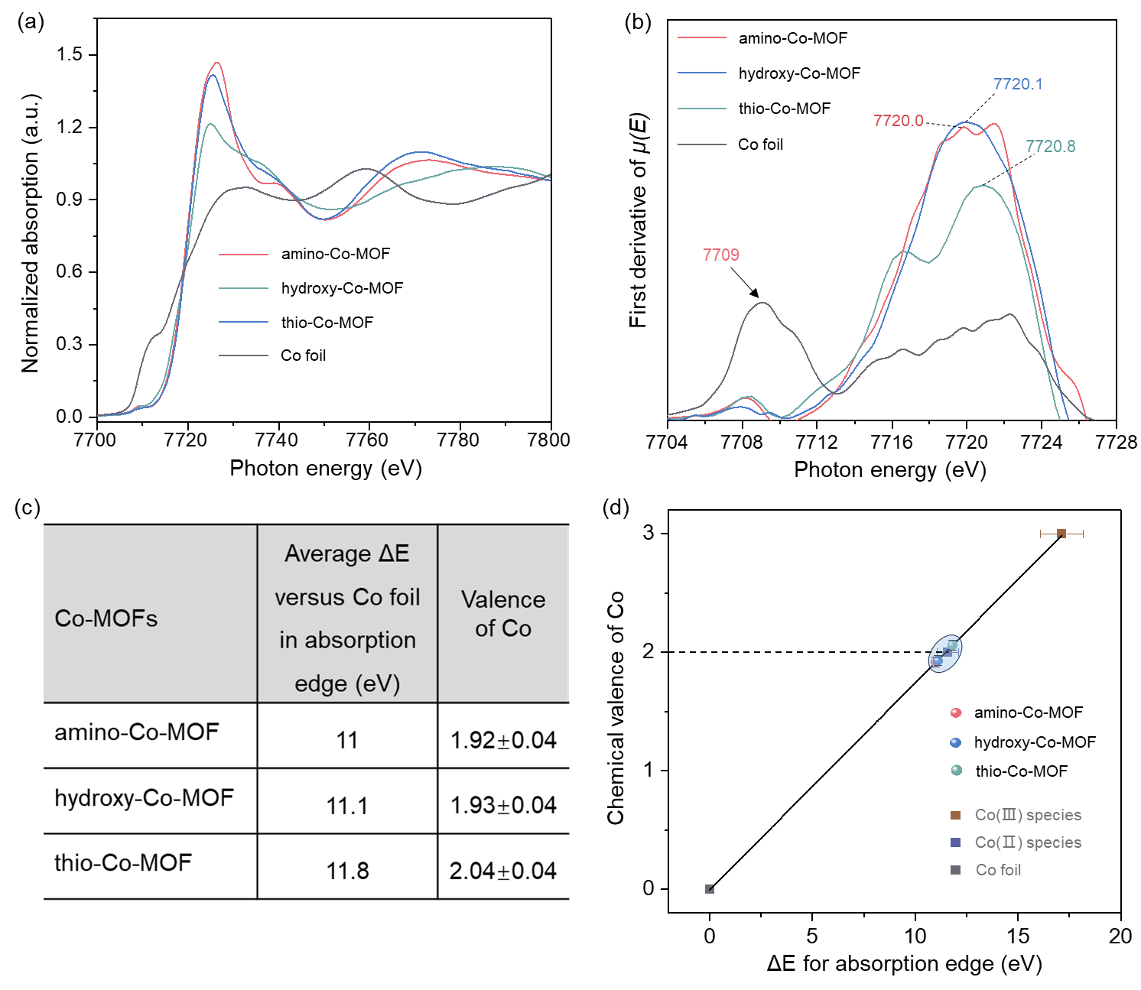
Supplementary Fig. 28
. (a) Co K-edge XANES spectra of Co-MOFs and (b) the first derivative of absorption edge; (c) Average energy variation (ΔE) of absorption edge of Co-MOFs versus Co foil (E₀ = 7709 eV), and (d) linear fitting for determining the Co valence in Co-MOFs via a model linear function. The error bars of Co-MOFs are determined by the linear function.
We collect the different types of standard Co(Ⅱ) and Co(Ⅲ) compounds to obtain an accurate linear relation with valence and energy variation of the absorption edge for subsequent valence calibration of samples. Evidently, Co valence in Co-MOFs is determined to be approximately +2 through linear fitting of X-ray absorption near edge structure (Supplementary Fig. 28d).

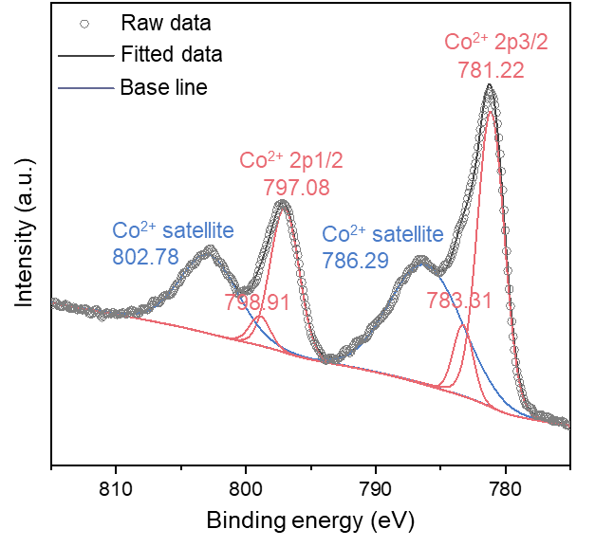
Supplementary Fig. 29
. Co 2p high-resolution XPS spectrum of amino-Co-MOF.
The XPS of amino-Co-MOF shows that only Co²⁺ exists, which is consistent with the XANES result.

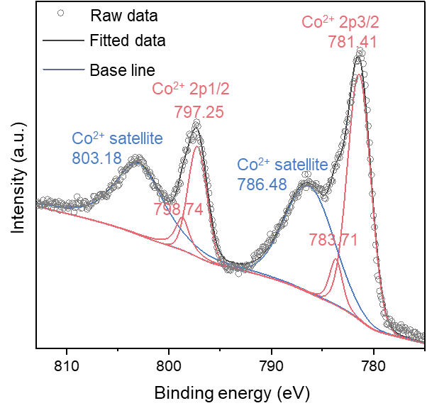
Supplementary Fig. 30
. Co 2p high-resolution XPS spectrum of hydroxy-Co-MOF.
The XPS of hydroxy-Co-MOF shows that only Co²⁺ exists, which is consistent with the XANES result.

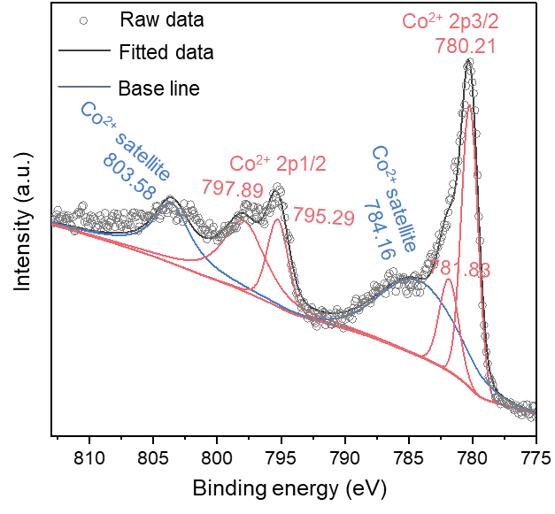
Supplementary Fig. 31
. Co 2p high-resolution XPS spectrum of thio-Co-MOF.
The XPS of thio-Co-MOF shows that only Co²⁺ exists, which is consistent with the XANES result.

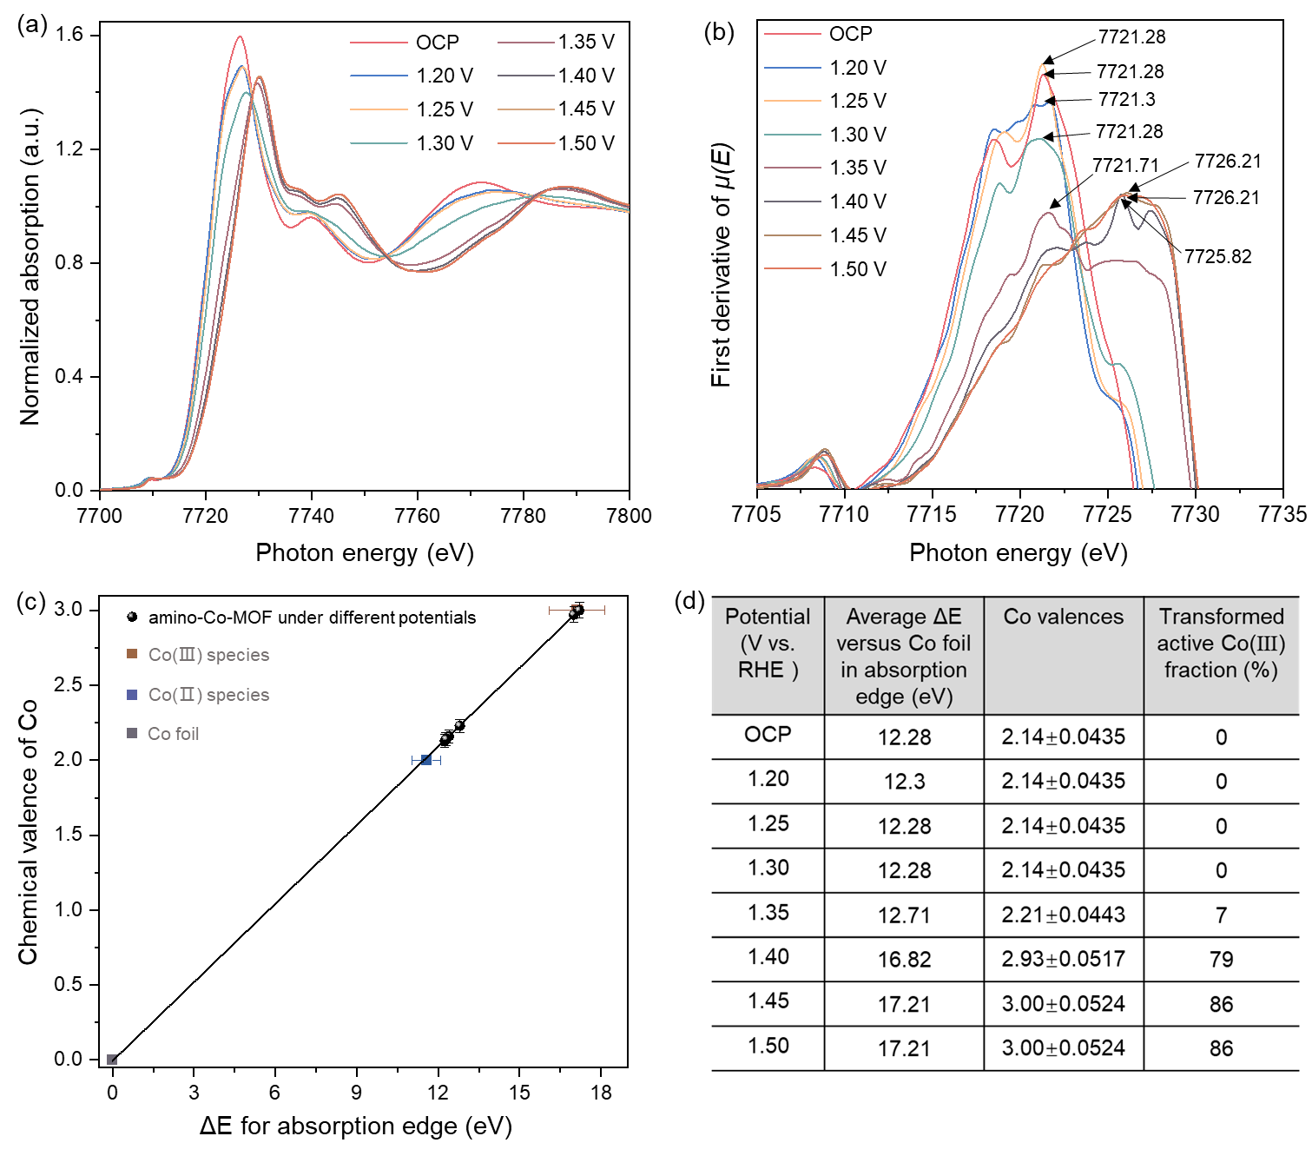
Supplementary Fig. 32
. (a) Operando Co K-edge XANES spectra of amino-Co-MOF and (b) the first derivative of absorption edge. (c) Linear fitting for determining the Co valence during the OER via a model linear function; The error bars of amino-Co-MOF are determined by the linear function. (d) A table of average energy variation (ΔE) of absorption edge versus Co foil (E₀ = 7709 eV) and Co valences.
The transformed Co(III) fraction is calculated by the following equation:
Co(III) fraction (%) = (Co valence at the applied potential - Co valence at OCP)*100%.

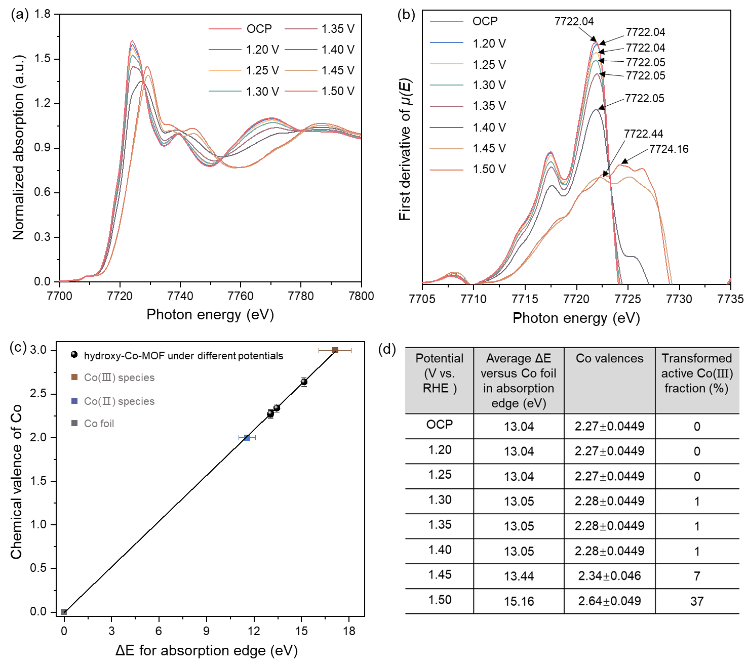
Supplementary Fig. 33
. (a) Operando Co K-edge XANES spectra of hydroxy-Co-MOF and (b) the first derivative of absorption edge. (c) Linear fitting for determining the Co valence during the OER via a model linear function; The error bars of hydroxy-Co-MOF are determined by the linear function. (d) A table of average energy variation (ΔE) of absorption edge versus Co foil (E₀ = 7709 eV) and Co valences.
The transformed Co(III) fraction is calculated by the following equation:
Co(III) fraction (%) = (Co valence at applied potential - Co valence at OCP)*100%.

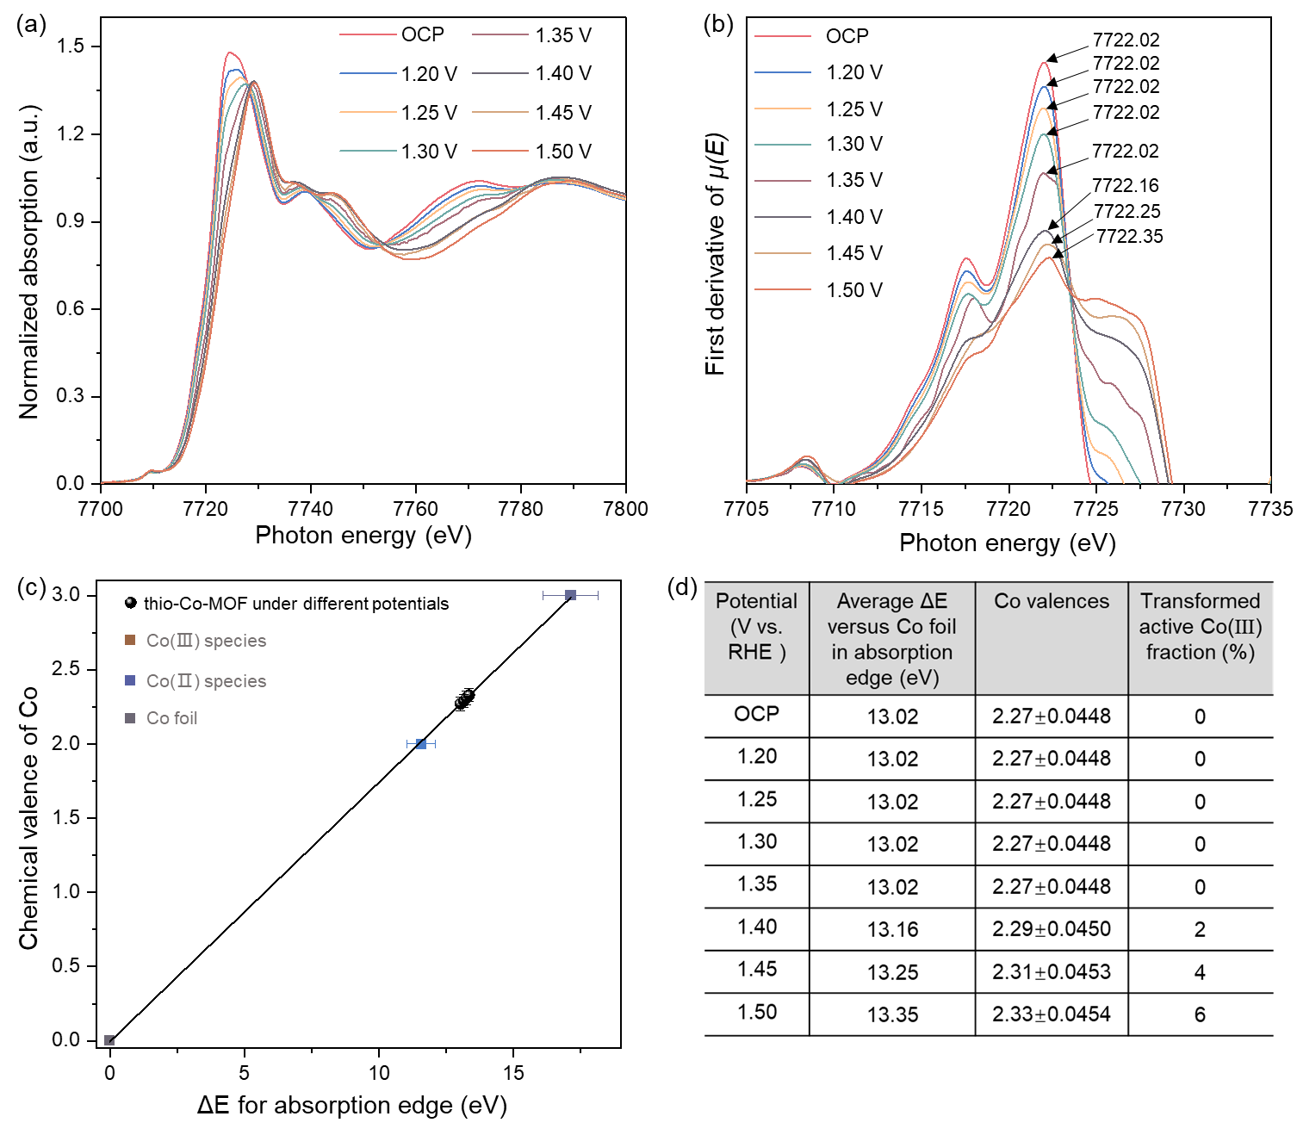
Supplementary Fig. 34
. (a) Operando Co K-edge XANES spectra of thio-Co-MOF and (b) the first derivative of absorption edge. (c) Linear fitting for determining the Co valence during the OER via a model linear function; The error bars of thio-Co-MOF are determined by a linear function. (d) A table of average energy variation (ΔE) of absorption edge versus Co foil (E₀ = 7709 eV) and Co valences.
The transformed Co(III) fraction is calculated by the following equation:
Co(III) fraction (%) = (Co valence at applied potential - Co valence at OCP)*100%.

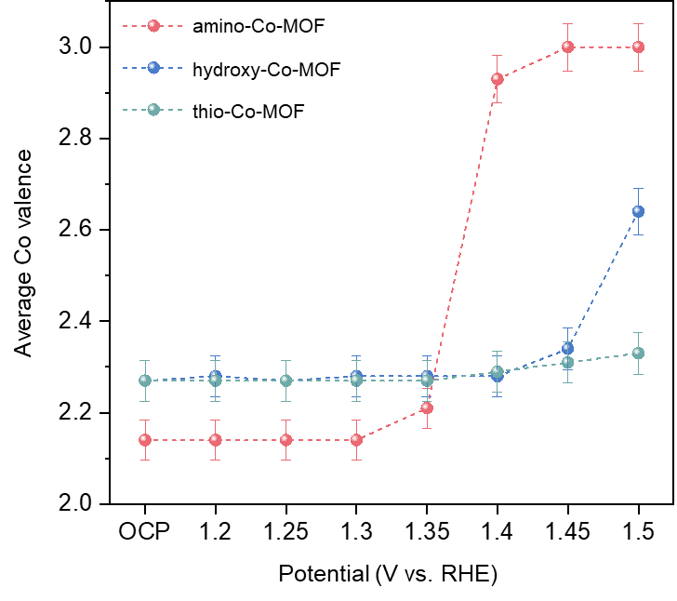
Supplementary Fig. 35
. Co valence variations in Co-MOFs at different potentials compiled by operando XAS spectra recorded during potentiostatic OER experiments in 1 M KOH from Supplementary Figs. 32-34.
From Supplementary Fig. 35, we find that the initial Co valence of amino-Co-MOF, hydroxy-Co-MOF, and thio-Co-MOF at the OCP is +2.14, +2.27, and +2.27, respectively. Co valence under this condition is regarded as a benchmark to evaluate the transformed Co(III) fraction at different potentials.

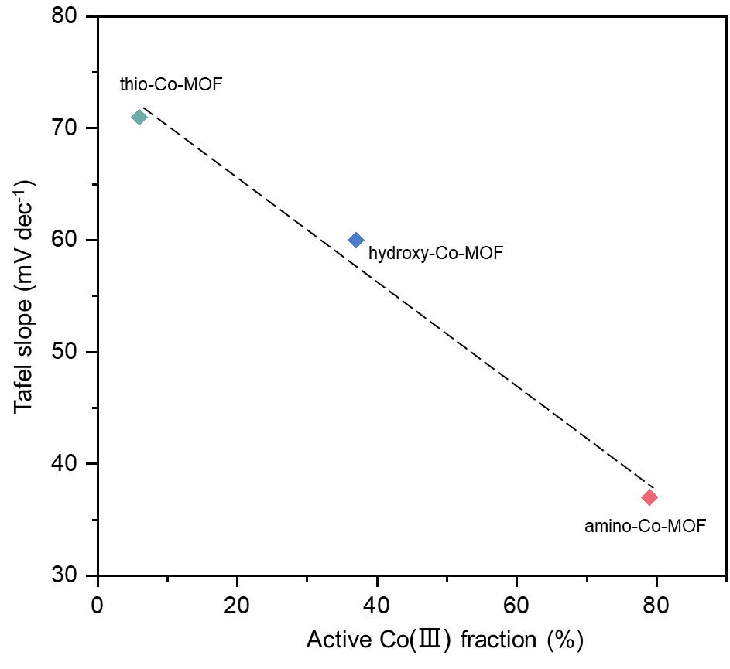
Supplementary Fig. 36
. OER kinetic relationship between the Co(III) fraction (taken from onset potential) and Tafel slope in Co-MOFs.
Tafel slopes decrease with increasing Co(III) fractions in Co-MOFs, indicating that OER kinetic activity highly depends on conversion capability to active Co(III).

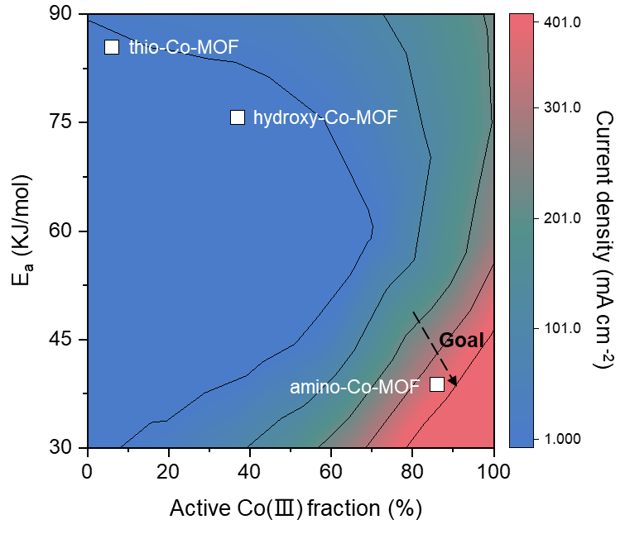
Supplementary Fig. 37
. Relationship between OER activity, E_{a}, and the Co(III) fraction of Co-MOFs (The current density and E_{a} at 1.5 V (vs. RHE) are obtained from Fig. 2a and Supplementary Fig. 30, respectively).
From Supplementary Fig. 37, we find that Co-MOFs present a positive correlation between the availability of Co(III) species, E_{a}, and OER activity. The amino-Co-MOF with a greater splitting energy exhibits higher OER performance.

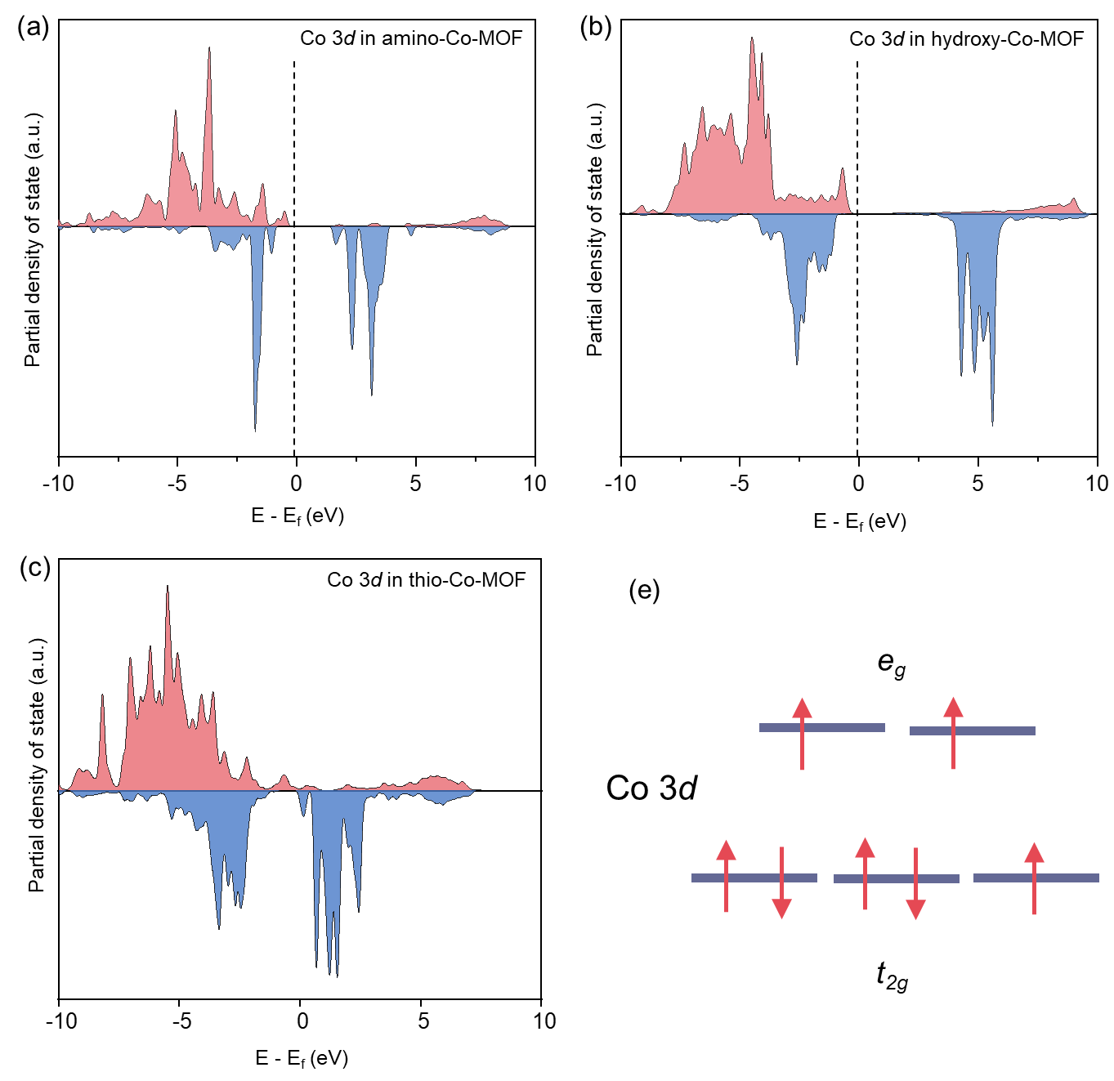
Supplementary Fig. 38
. (a-c) Spin-resolved partial density of states (PDOS) of Co 3d orbitals in Co-MOFs; (e) Spin-resolved integral electron numbers and schematic illustration of Co 3d orbital configuration in Co-MOFs.

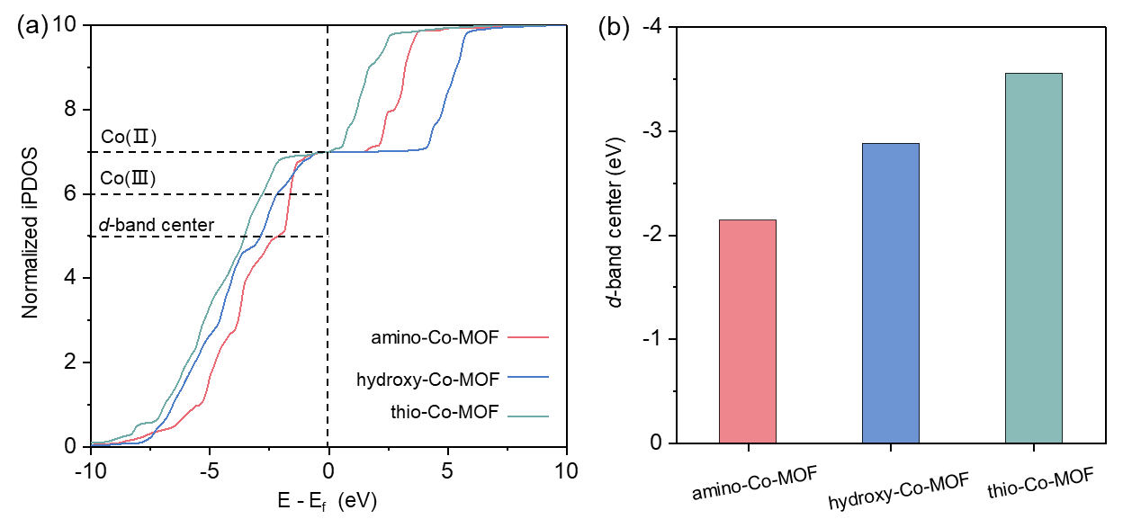
Supplementary Fig. 39
. (a) Normalized integral PDOS of Co 3d orbitals in Co-MOFs, (b) d-band center in Co-MOFs.
From Supplementary Fig. 39, it can be found that the theoretical energy required for Co(II) of 3d⁷ to lose one electron to convert to Co(III) of 3d⁶ in Co-MOFs is 1.62, 2.17, and 2.8 eV for amino-Co-MOF, hydroxy-Co-MOF, and thio-Co-MOF, respectively. This result indicates that the formation energy of Co(III) in amino-Co-MOF is lowest in Co-MOFs. The location of d-band centers of Co(II) in Co-MOFs relative to the Fermi energy is -2.14, -2.87, and -3.55 eV for amino-Co-MOF, hydroxy-Co-MOF, and thio-Co-MOF, respectively, illustrating that amino-Co-MOF adsorbs reactants more readily.

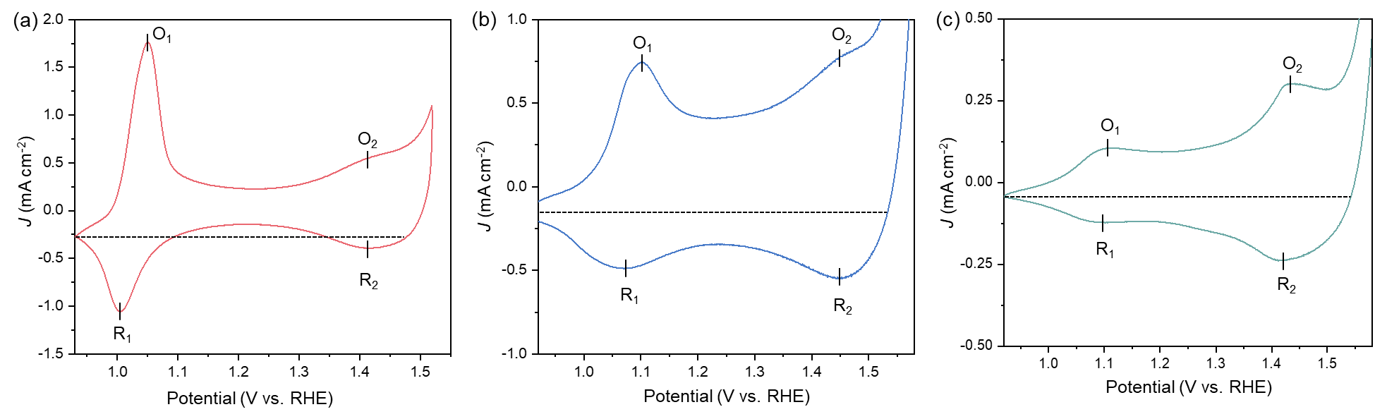
Supplementary Fig. 40
. Electrochemical redox capacity of Co centers in Co-MOFs. Cyclic voltammograms of (a) amino-Co-MOF, (b) hydroxy-Co-MOF, and (c) thio-Co-MOF recorded in anhydrous acetonitrile containing 0.1 M tetrabutylammonium hexafluorophosphate using a glassy carbon electrode. The baselines used for capacitance correction are denoted in the cyclic voltammograms as horizontal lines.
As shown in Supplementary Fig. 40, it can be found that Co centers in Co-MOFs undergo two redox couples to the OER catalytic wave at ~1.1 V (O₁ and R₁) and at ~1.45 V (O₂ and R₂) that are attributed to the Co²⁺/Co³⁺ and Co³⁺/Co^{3+δ} redox couples, respectively. The redox electrochemistry of Co centers in Co-MOFs strongly depends on their pristine electronic configuration due to the variation of the intensity ratio between the two redox pairs in Co-MOFs⁷. Because transformed Co³⁺ species in Co-MOFs are recognized as the catalytically active state for the OER reactions, therefore, we interpret the capacitance-corrected current ratio of O₁/O₂ as the mean oxidizability of the Co centers in Co-MOFs⁷. Moreover, the oxidizability of Co centers represents the transformation ability from pristine Co²⁺ to active Co³⁺.

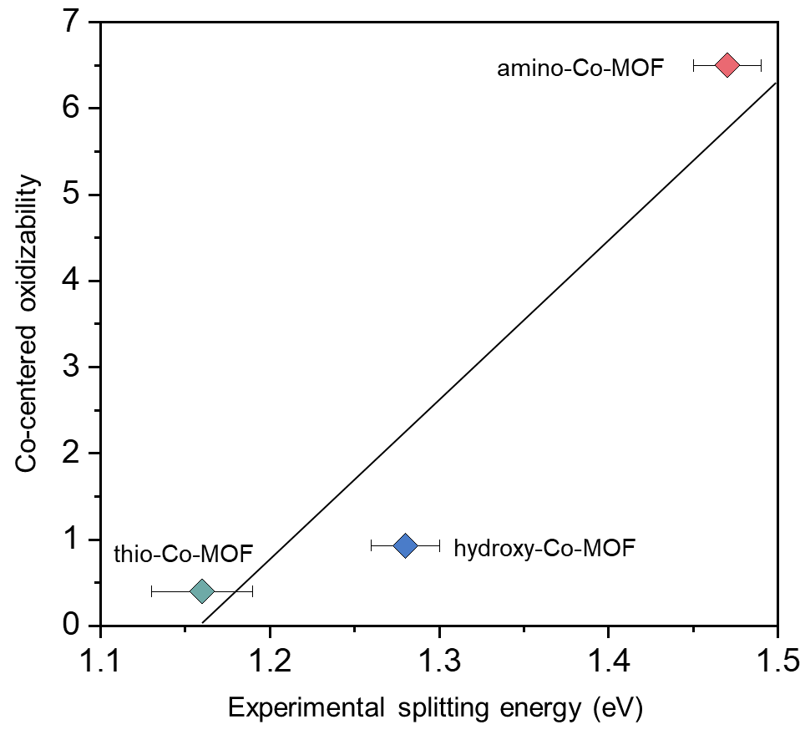
Supplementary Fig. 41
. Dependence relationship between the oxidizability of Co in Co-MOFs and their splitting energies. The Co-MOFs with larger splitting energy are more easily oxidized.
As shown in Supplementary Fig. 41, establishing a dependency relationship indicates that the oxidizability of Co centers is positively correlated with the splitting energy of Co centers. Therefore, Co(Ⅱ) centers in amino-Co-MOF with a large splitting energy are more easily oxidized to Co(Ⅲ) during OER, in agreement with the fitting results of operando Co K-edge XANES (Supplementary Fig. 35).

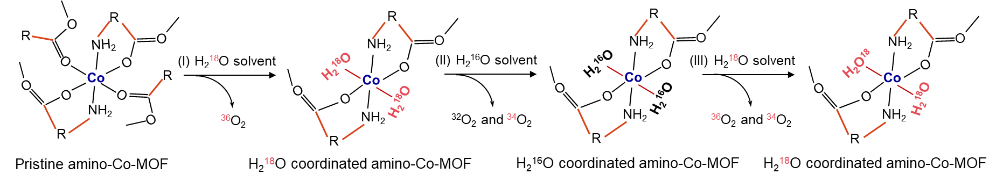
Supplementary Fig. 42
. Flowchart for the isotope labeling experiment and evolution of coordinated water oxidation route (CWOR) in amino-Co-MOF.

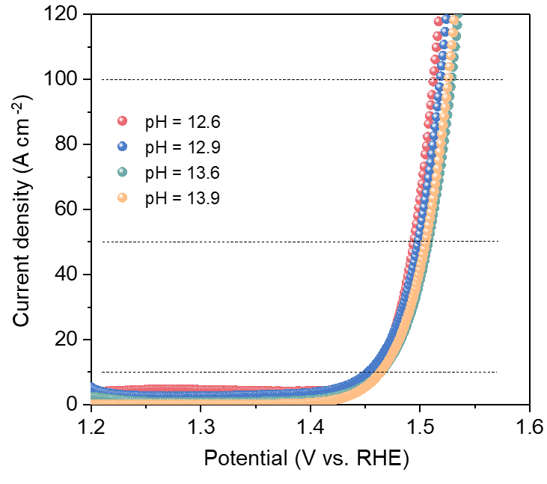
Supplementary Fig. 43
. pH-dependent tests of the OER activities of amino-Co-MOF.
As shown in Supplementary Fig. 43, because catalysts involving lattice oxygen oxidation mechanism (LOM) have a strong pH-dependence, the almost constant OER activity of amino-Co-MOF in electrolyte solutions with different pH also confirms the proposed coordinated water oxidation route, distinguishing from the classic LOM.

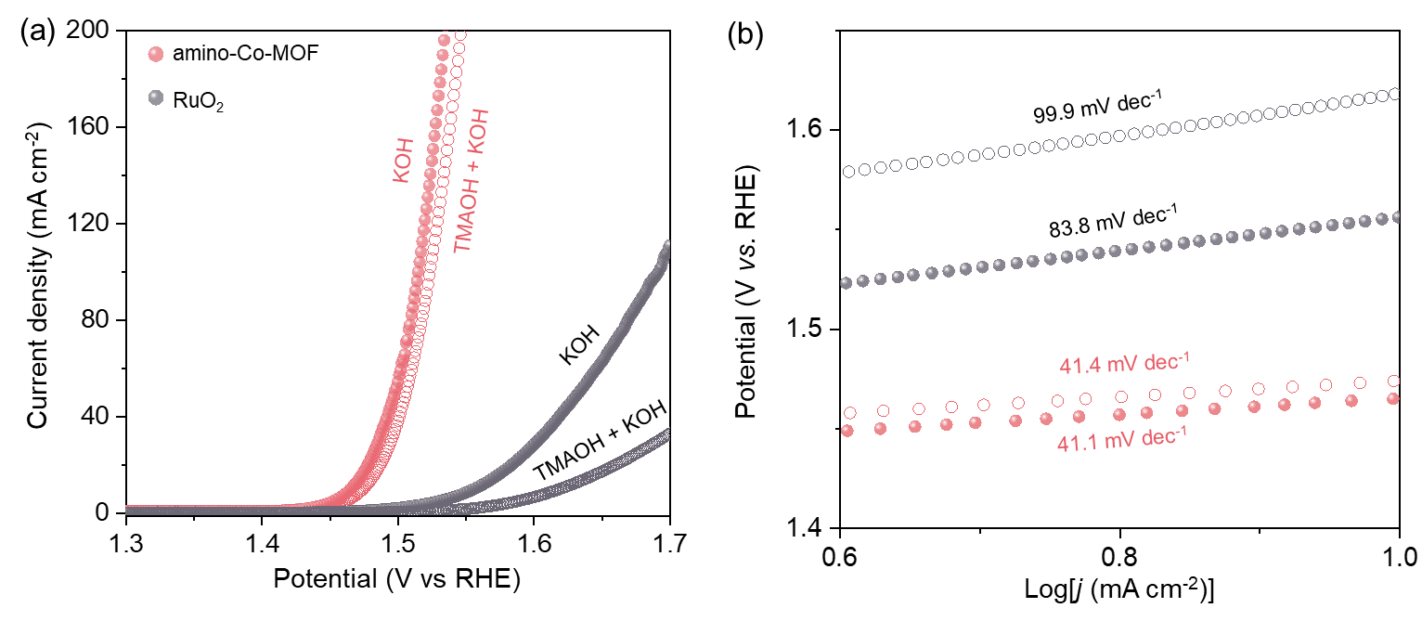
Supplementary Fig. 44
. (a) Polarization curves and (b) Tafel slopes of amino-Co-MOF and RuO₂ in 1 M KOH solution with and without TMAOH, respectively.
As shown in Supplementary Fig. 44, after adding tetramethylammonium hydroxide (TMAOH), the OER activity of RuO₂ is significantly reduced, and its Tafel slope is increased from 83.8 to 99.9 mV dec⁻¹ owing to the inhibition of the lattice oxygen by the strong binding with TMA⁺. On the contrary, amino-Co-MOF shows very minimal change, indicating the OER mechanism of amino-Co-MOF does not belong to classic LOM.

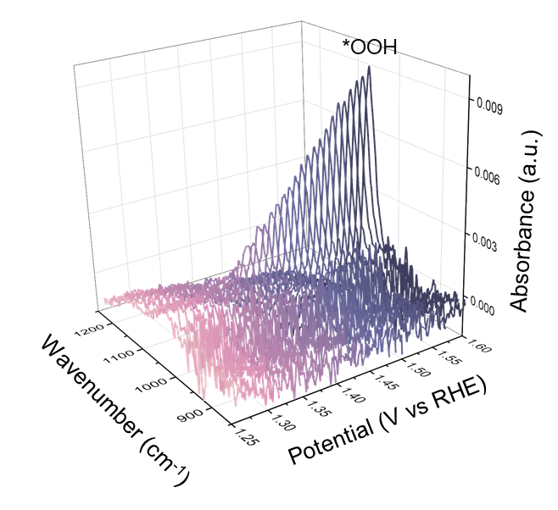
Supplementary Fig. 45
. In-situ DRIFTS of amino-Co-MOF at different potentials in 1 M KOH.
In-situ diffuse reflection Fourier transform infrared spectroscopy (DRIFTS) is adopted to probe the signals of intermediate species on the surface of catalysts during the OER. With voltage increases, the *OOH intermediate signals at 1042 cm⁻¹ gradually intensify, which well corresponds to the generated O-O superoxide intermediate signal during the coordinated water oxidation route.

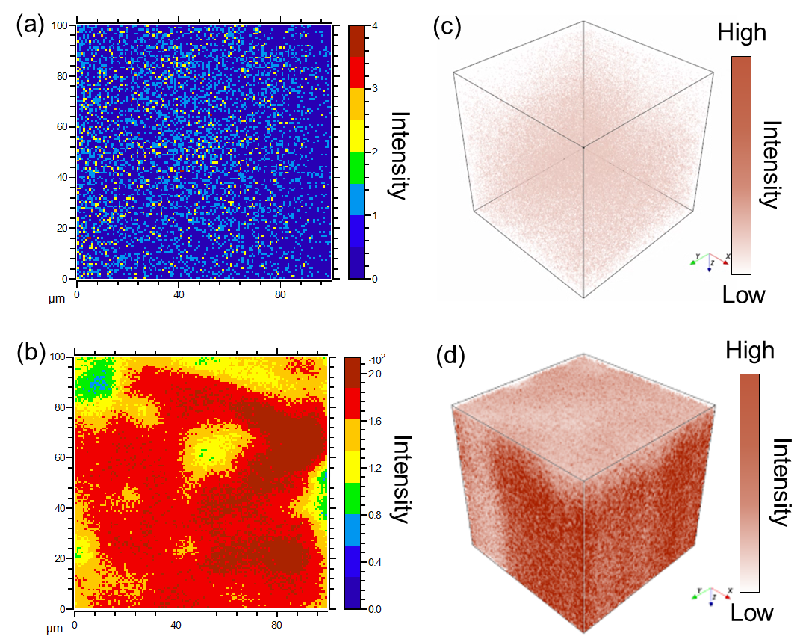
Supplementary Fig. 46
. (a, b) Two-dimensional and (c, d) three-dimensional distributions of ¹⁸O⁻ produced by TOF-SIMS surface and depth profiling for pristine amino-Co-MOF (upper) and amino-Co-MOF after the OER in H₂¹⁸O solution (lower).
Compared with the ¹⁸O⁻ signals intensity of pristine amino-Co-MOF (upper), the sample after OER in H₂¹⁸O solution shows a much stronger ¹⁸O⁻ signals distribution (lower). This result confirms the proposed coordinated water oxidation route (CWOR) (Supplementary Fig.42).

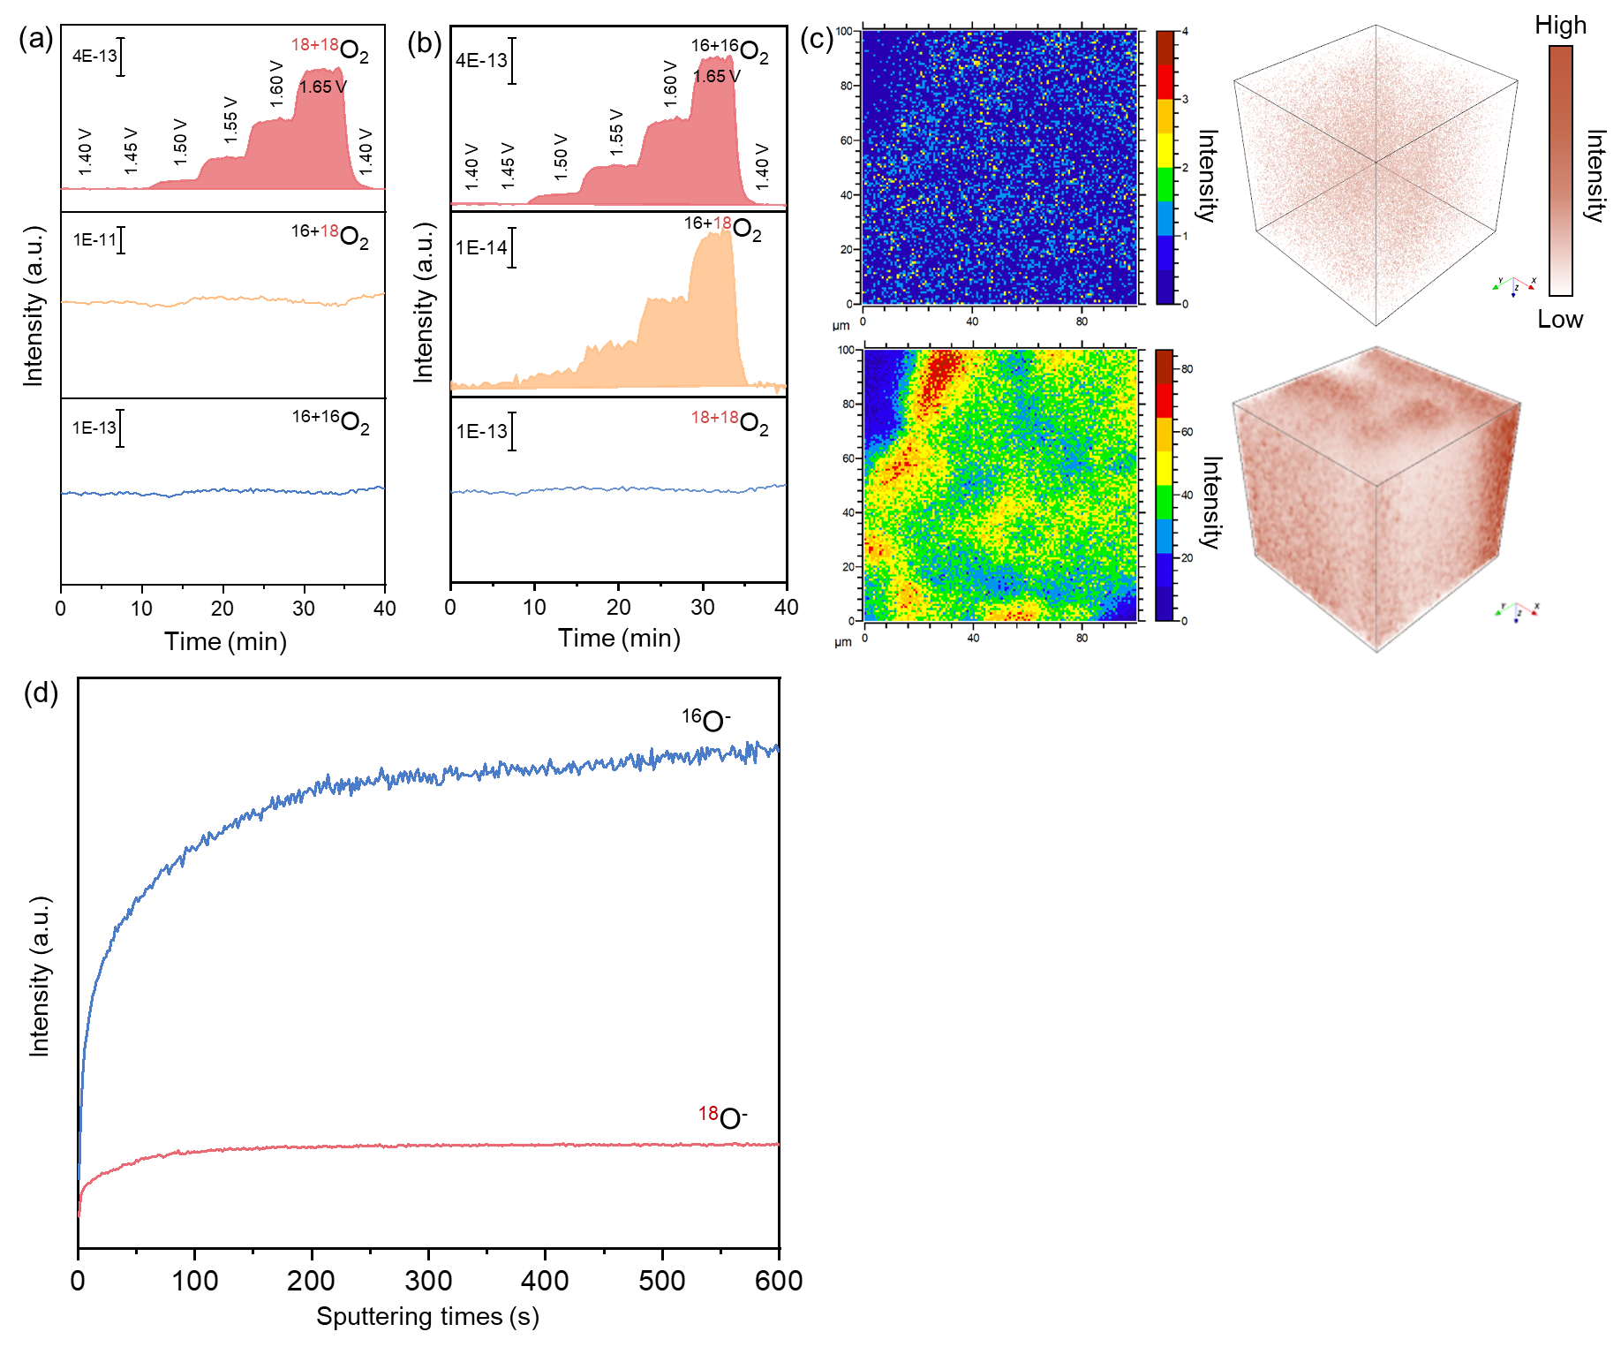
Supplementary Fig. 47
. Operando DEMS tests of hydroxy-Co-MOF alternately in (a) H₂¹⁸O and (b) H₂¹⁶O solvent. (c) 2D and 3D distributions of ¹⁸O⁻ based on TOF-SIMS surface and depth scan. The upper part represents pristine hydro-Co-MOF, and the lower part stands for hydroxy-Co-MOF after the OER in H₂¹⁸O solution. (d) TOF-SIMS depth profiles of hydroxy-Co-MOF after the OER in H₂¹⁸O solution.

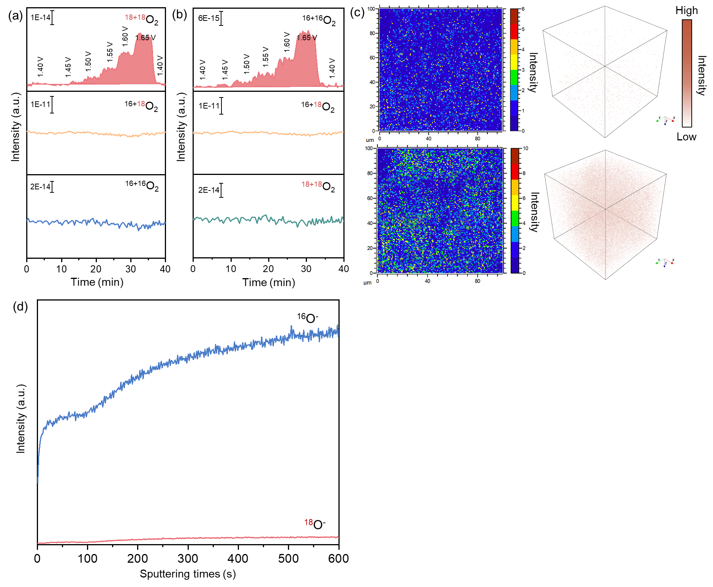
Supplementary Fig. 48
. Operando DEMS tests of thio-Co-MOF alternately in (a) H₂¹⁸O and (b) H₂¹⁶O solution. (c) 2D and 3D distributions of ¹⁸O⁻ based on TOF-SIMS surface and depth scan. The upper part represents pristine hydro-Co-MOF, and the lower part stands for thio-Co-MOF after the OER in H₂¹⁸O solution. (d) TOF-SIMS depth profiles of thio-Co-MOF after the OER in H₂¹⁸O solution.

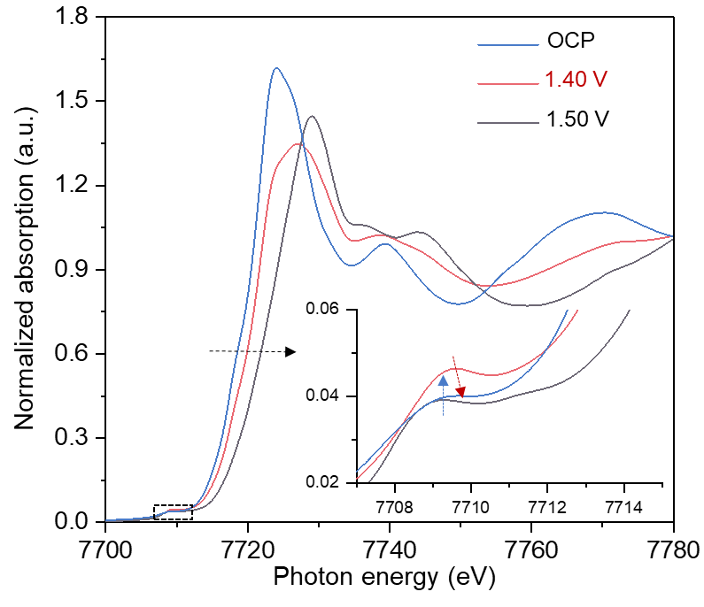
Supplementary Fig. 49
Operando Co K-edge XANES spectra of hydroxy-Co-MOF at different OER potentials in 1 M KOH. Inset represents the enlarged pre-edge peaks. Blue arrow represents the uptrend of pre-edge peaks from OCP to 1.4 V, and red arrow represents the downtrend of the pre-edge peaks from 1.4 V to 1.5 V. In addition, the black arrow represents the right shift of the absorption edges from OCP to 1.5 V.
Operando Co K-edge XANES also confirms the structural conversion of active centers from the perspective of symmetry. As shown in Supplementary Fig. 49, with the potential increase from OCP to 1.5 V, the intensity of the pre-edge peaks first rises and then declines. This finding indicates that the geometric symmetry first decreases and then increases, closely aligning with the transition process between a high-symmetry octahedron with O_{h} and a low-symmetry square planar with D_{4h}⁸. Moreover, the positive shift of the absorption edges indicates that the Co oxidation occurs simultaneously.

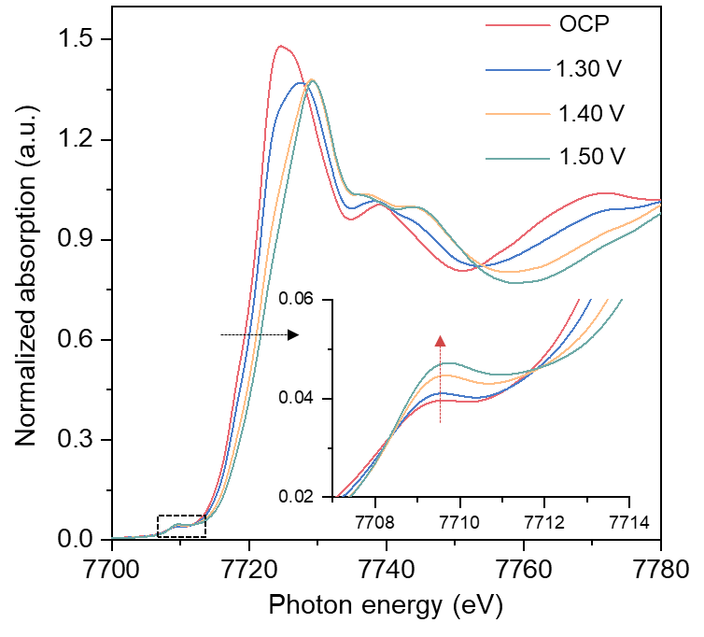
Supplementary Fig. 50
Operando Co K-edge XANES spectra of thio-Co-MOF at different OER potentials in 1 M KOH. Inset represents the enlarged pre-edge peaks. Red arrow represents the changed trend of pre-edge peaks from OCP to 1.5 V. Black arrow represents the shift of absorption edges from OCP to 1.5 V.
The pre-edge peaks of thio-Co-MOF only exhibit a continuous, monotonic increase, suggesting that Co centers in thio-Co-MOF do not experience the evolution in local symmetry.

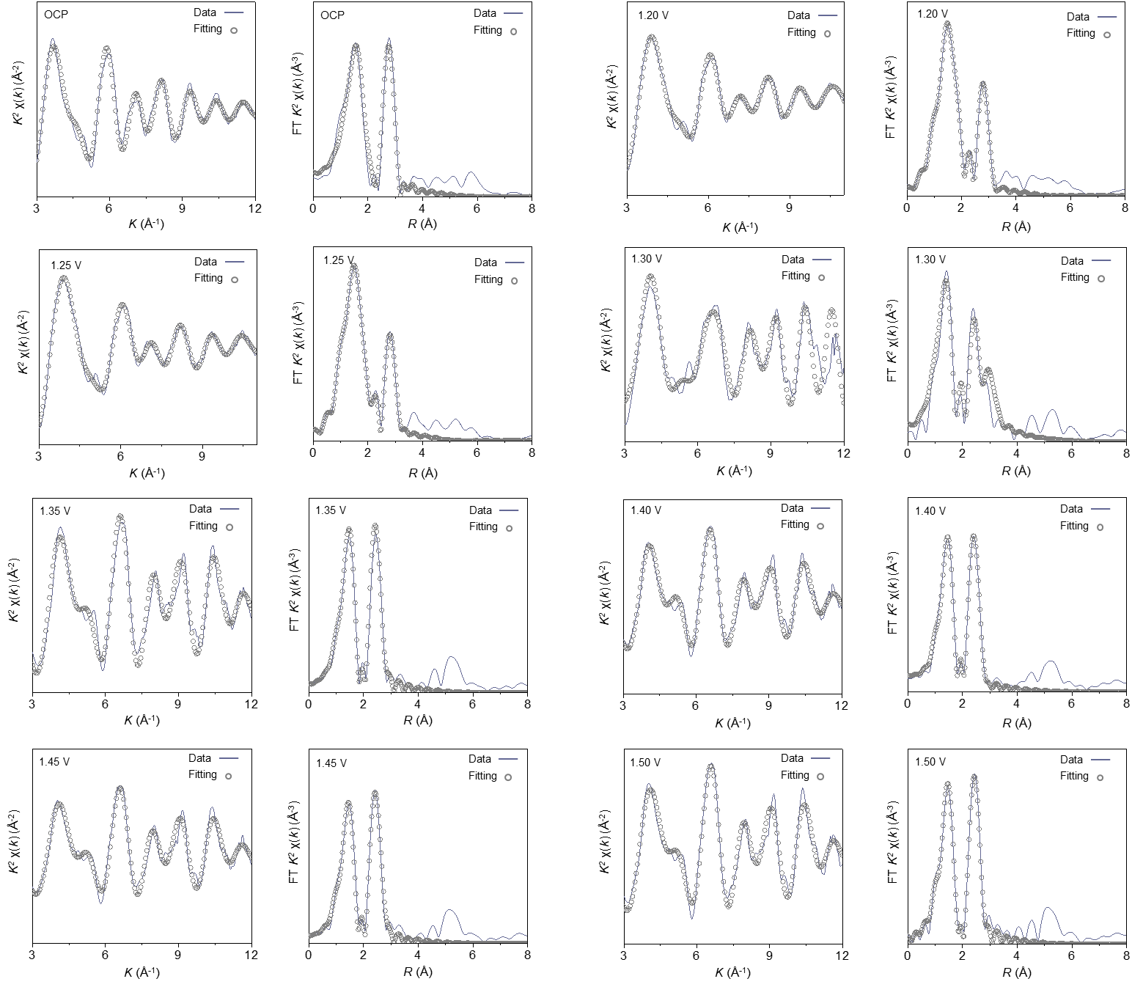
Supplementary Fig. 51
. Operando Co K-edge EXAFS spectra and the Fourier-transformed magnitudes for amino-Co-MOF at different applied potentials. The best-fit parameters and detailed results are summarized in Supplementary Table 10.

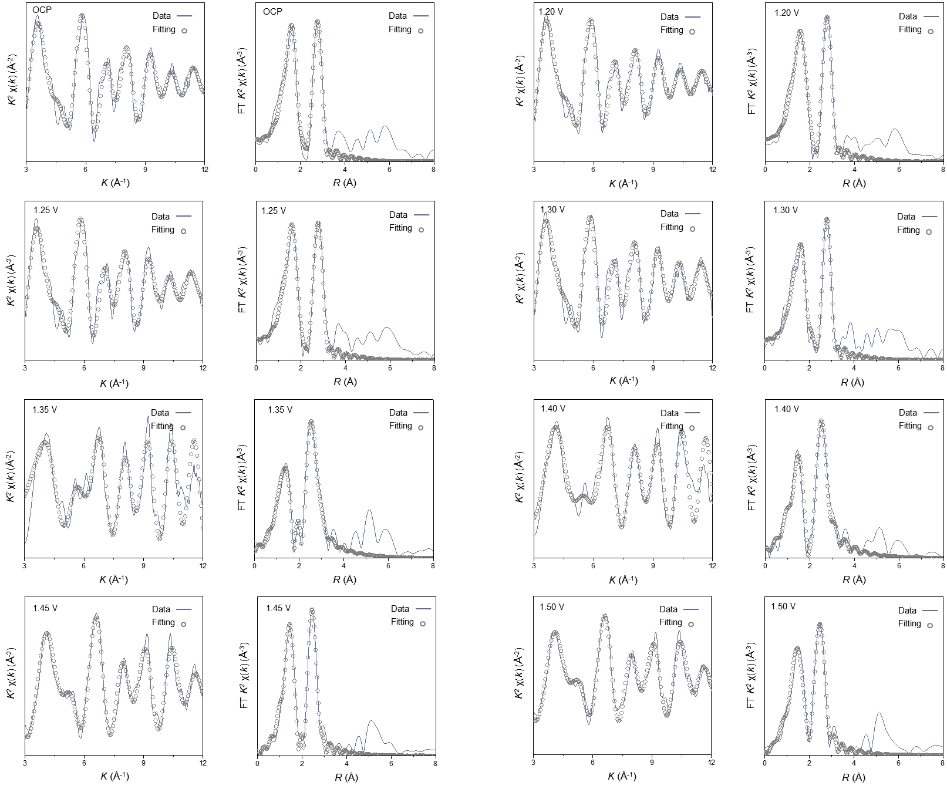
Supplementary Fig. 52
. Operando Co K-edge EXAFS spectra and the Fourier-transformed magnitudes for hydroxy-Co-MOF at different applied potentials. The best-fit parameters and detailed results are summarized in Supplementary Table 11.

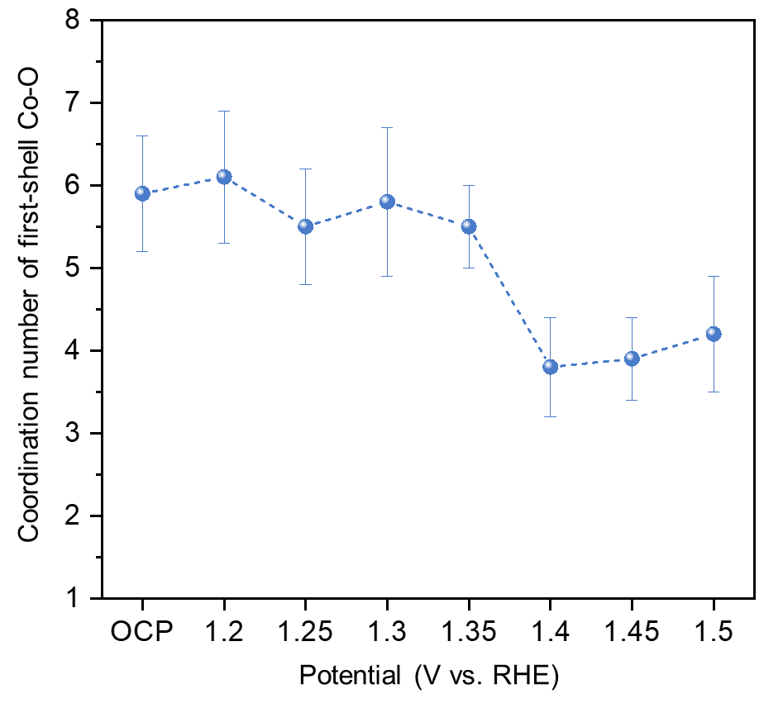
Supplementary Fig. 53
. Change of coordination number of the first-shell Co-O in hydroxy-Co-MOF at different potentials obtained by the operando FT-EXAFS fitting results from Supplementary Fig. 56 and Table 11.

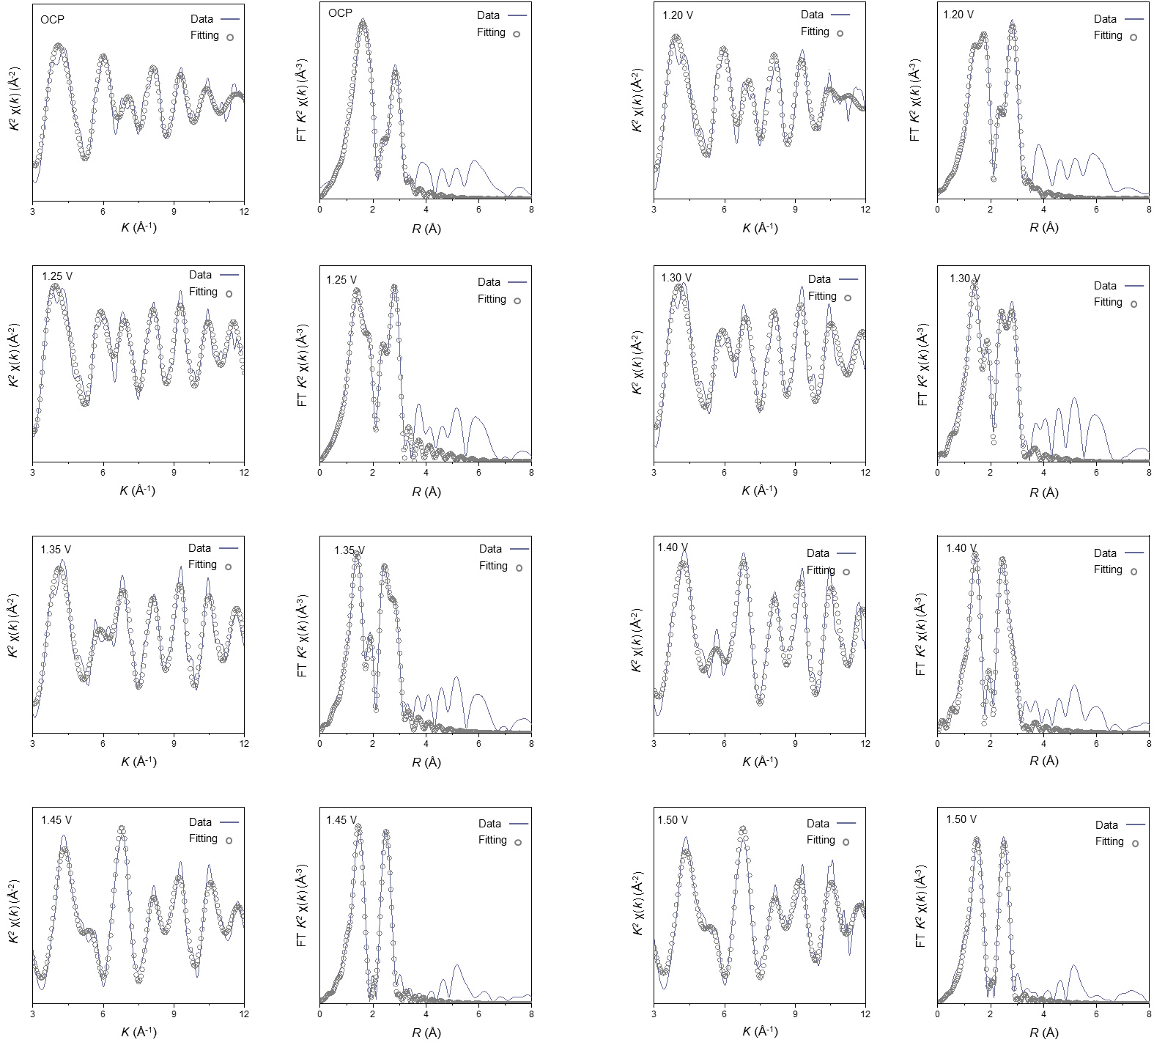
Supplementary Fig. 54
. Operando Co K-edge EXAFS spectra and the Fourier-transformed magnitudes for thio-Co-MOF at different applied potentials. The best-fit parameters and detailed results are summarized in Supplementary Table 12.

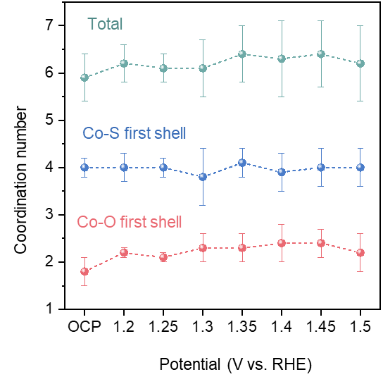
Supplementary Fig. 55
. Changes of coordination number of the first shell Co-O and Co-S in thio-Co-MOF at different potentials obtained by the operando FT-EXAFS fitting results from Supplementary Fig. 58 and Table 12.
For S-ligating atoms with the weakest field strength, the coordination number of Co-O and Co-S in thio-Co-MOF (Supplementary Fig. 55) shows only slight fluctuations, indicating the octahedral configuration remains almost constant during OER.

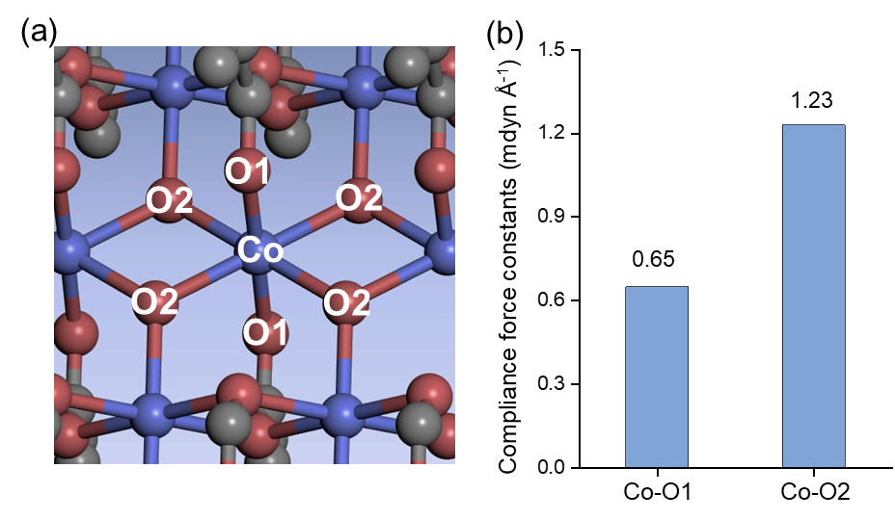
Supplementary Fig. 56
. (a) Illustration for different types of coordination bonds on Co nodes in hydroxy-Co-MOF and (b) corresponding compliance force constants for different types of coordination bonds. The compliance force constants indicate different coordinated bond strengths.

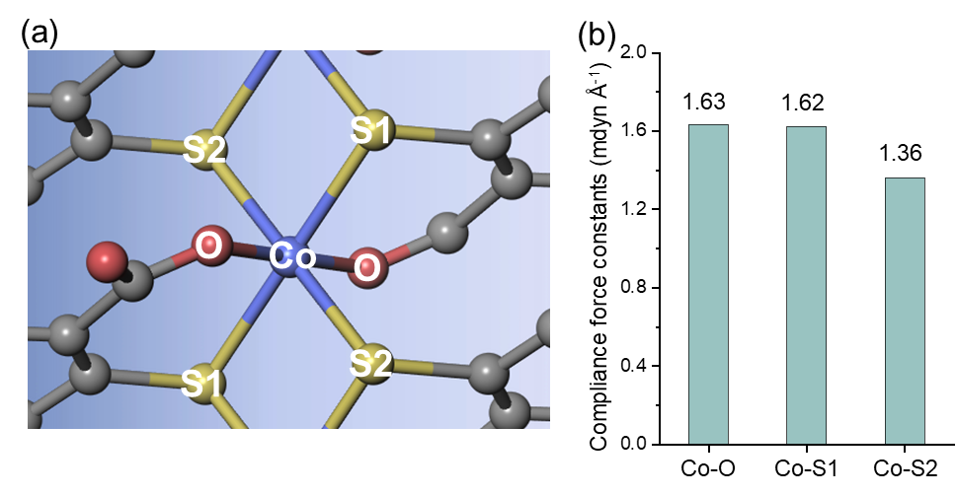
Supplementary Fig. 57
. (a) Illustration for different types of coordination bonds on Co nodes in thio-Co-MOF and (b) corresponding compliance force constants for different types of coordination bonds. The compliance force constants indicate different coordinated bond strengths.

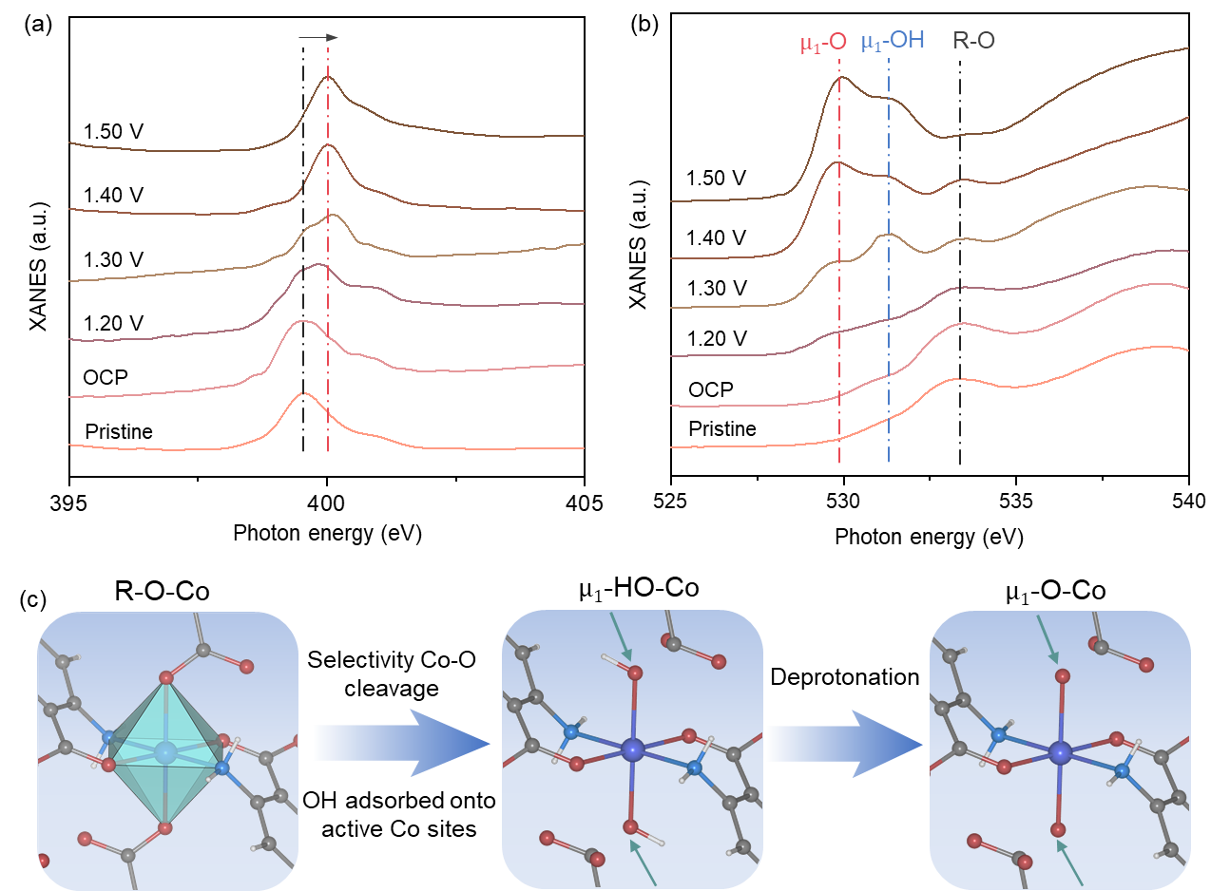
Supplementary Fig. 58
. Quasi in-situ N K-edge (a) and O K-edge (b) sXAS TEY spectra of amino-Co-MOF from OCP to 1.5 V (μ₁-O, 529.9 eV; μ₁-OH, 531.4 eV; R-O, 533.5 eV). (c) Structural evolution of different oxygenated motifs on the active Co site (μ₁-OH and μ₁-O, terminal oxyl from solution phase water; R-O, intrinsic oxyl).
As shown in Supplementary Fig. 58a, pre-edge peaks in the N K-edge soft X-ray absorption spectroscopy (sXAS) in total electron yield (TEY) mode begin to shift slightly when the voltage increases above 1.30 V, which may be attributed to the effect of the raised oxidation state of Co in the amino-Co-MOF. In contrast, the pre-edge features in O K-edge XANES exhibit significant changes with increasing potential (Supplementary Fig. 58b), indicating that the oxygenated species attached to the active sites undergo clear evolution during the OER, especially terminal oxyl (μ₁-OH and μ₁-O)^{7,9}. The feature at 533.5 eV occurs at the pristine state or low potential, representing R-O belonging to intrinsic oxygenated groups in MOFs (such as Ar-COO-). As the OER reaction gradually occurs, the features at 531.4 and 529.9 eV gradually emerge (Supplementary Fig. 58b), suggesting that terminal oxyl (μ₁-OH and μ₁-O) stems from the evolution process of reactants at the active sites. These results solidly validate the formation of active sites and evolution of oxygenated species on them (Supplementary Fig. 58c).
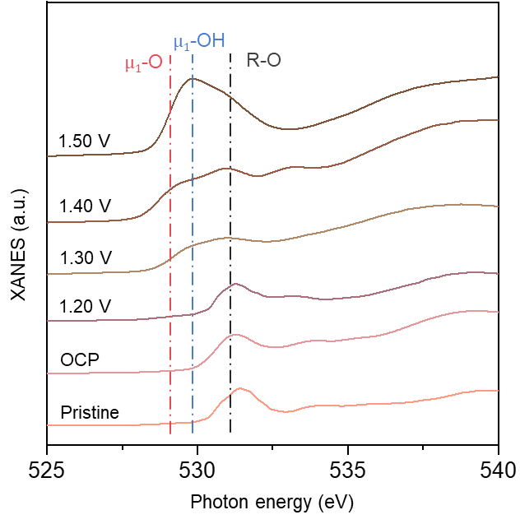
Supplementary Fig. 59
Quasi in-situ O K-edge sXAS TEY spectra of hydroxy-Co-MOF from OCP to 1.5 V.

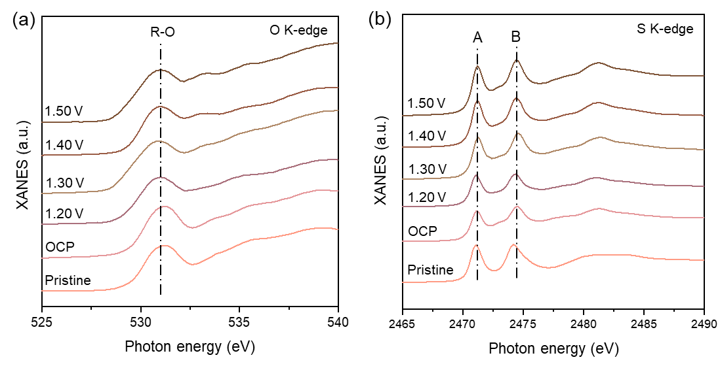
Supplementary Fig. 60
(a) Quasi in-situ O K-edge sXAS TEY spectra and (b) Quasi in-situ S K-edge XANES spectra of thio-Co-MOF from OCP to 1.5 V.
The almost unchanged O K-edge and S K-edge XANES spectra illustrate that pristine hexa-coordinated Co sites in thio-Co-MOF are hardly transformed into tetra-coordinated Co(III) active sites, which is attributed to the S-ligating atoms with weak field strength reinforcing Co-O bonds.

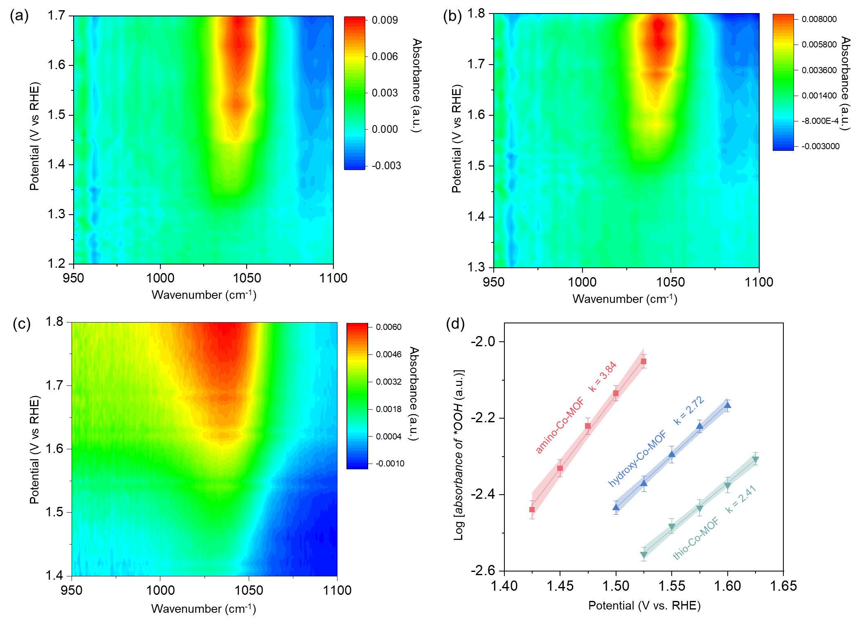
Supplementary Fig. 61
. In situ diffuse reflection Fourier transform infrared spectroscopy (DRIFTS) of (a) amino-Co-MOF, (b) hydroxy-Co-MOF, and (c) thio-Co-MOF at different OER potentials in 1 M KOH. *OOH signals at ~1044 cm⁻¹ gradually generate and increase with increasing potential. (d) Kinetic correlation between the logarithm of *OOH signal intensity and potentials.
With increasing potential, the generated *OOH signals indicate that water molecules interact with active Co sites. *OOH signals in amino-Co-MOF show a lower applied potential compared with the other two Co-MOFs, indicating that N-ligating atom with high field strength more easily promotes the formation of active sites by selectively weakening Co-O interaction. In contrast, thio-Co-MOF requires a higher voltage to initiate the formation of *OOH species, indicating that S-ligating atom with the weakest field strength makes it difficult to form active sites due to reinforced Co-O interaction. The slope represents the evolution rate of *OOH species on active Co sites, where the larger slope suggests the easier formation of *OOH species. *OOH signals in amino-Co-MOF show the fastest kinetic process (k = 3.84) with increasing potential than the other two types of Co-MOFs, indicating a faster evolution process of oxygenated species during the OER process.

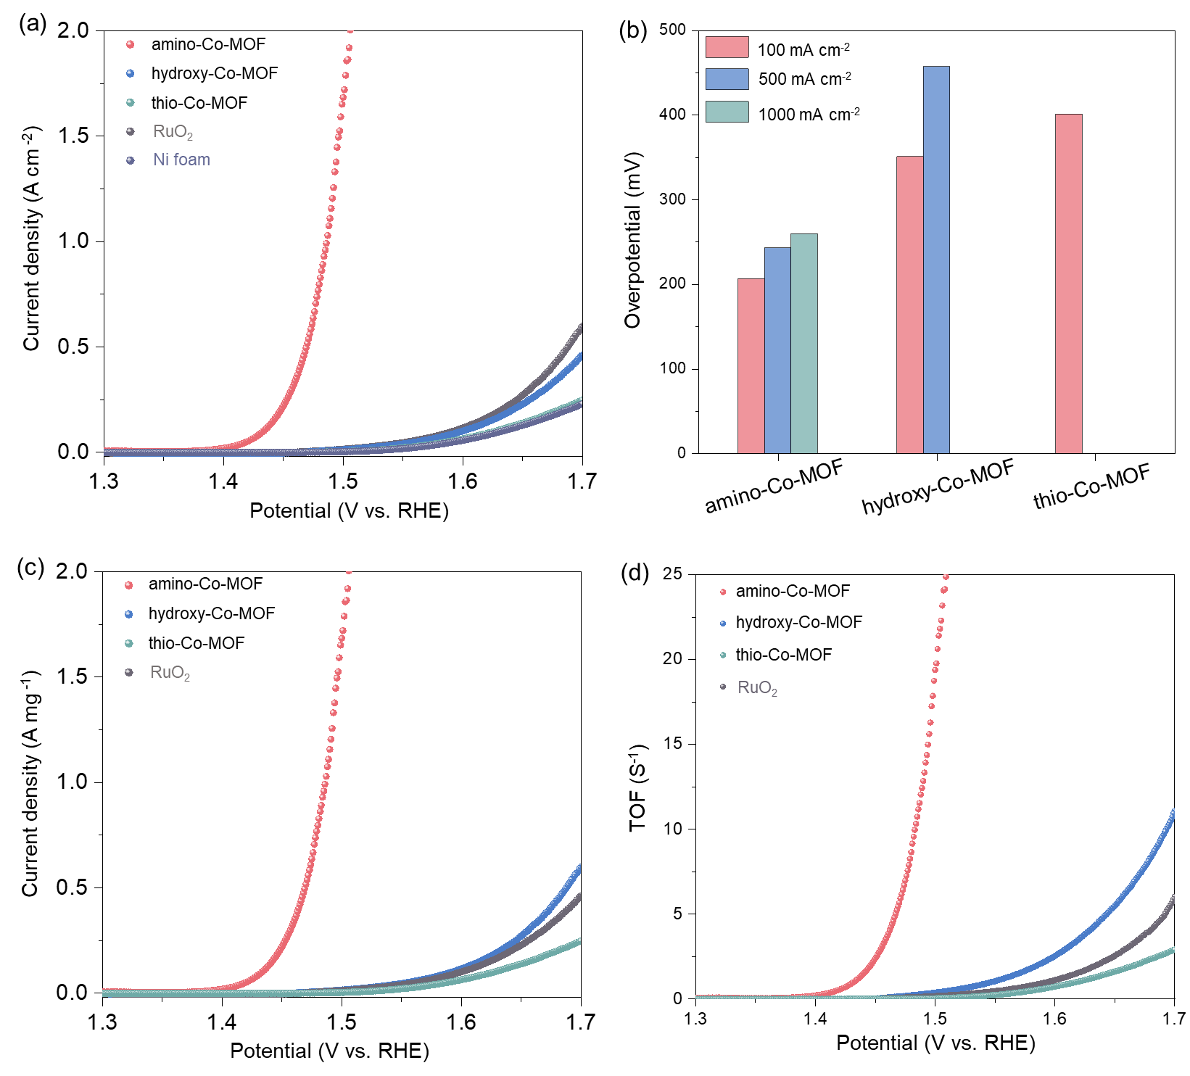
Supplementary Fig. 62
. Polarization curves of Co-MOFs, commercial RuO₂, and Ni foam substrate with 90% iR-correction in O₂-saturated 1 M KOH and the current normalized by (a) geometric area and (b) catalyst mass. (c) Overpotential at different current densities of Co-MOFs. (d)Turnover frequencies of Co-MOFs and commercial RuO₂ on Ni foam substrate.
As shown in Supplementary Fig. 62a and c, amino-Co-MOF requires only an overpotential of 203, 239, and 256 mV to achieve 100, 500, and 1000 mA cm⁻², respectively, and these results surpass the OER performance of the state-of-the-art transition metal-based catalysts (Supplementary Table 13). Moreover, excellent TOFs further confirm the intrinsic catalytic activity of amino-Co-MOF (Supplementary Fig. 62d).

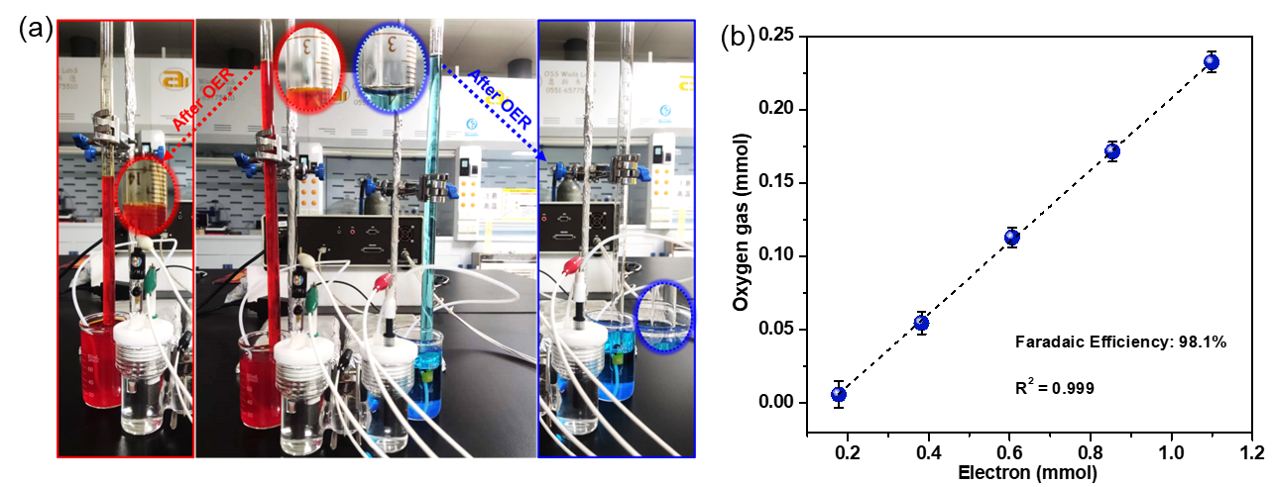
Supplementary Fig. 63
. (a) H-type cell set-up for determining the Faraday efficiency of OER using the volumetric method, and (b) calculating the Faradaic efficiency of amino-Co-MOF.
The Faraday efficiency of OER is measured up to 98.1% by a volumetric method deploying a graduated tube, further confirming the excellent catalytic activity of amino-Co-MOF.

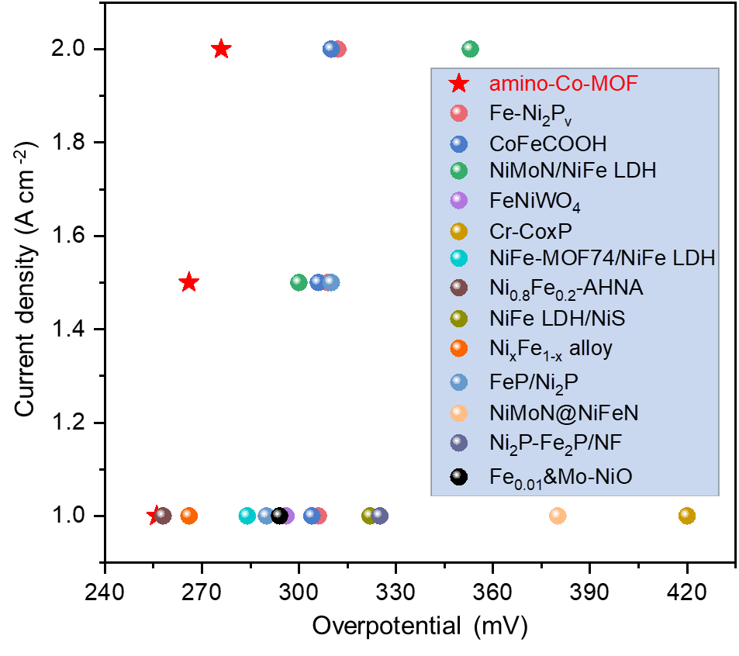
Supplementary Fig. 64.
Overpotential comparison under the high current density of amino-Co-MOF and reported non-noble metal-based catalysts in 1 M KOH (vide Supplementary Table 13).
The amino-Co-MOF shows a higher OER performance by comparison with previously reported transition metal-based OER catalysts under high current density.

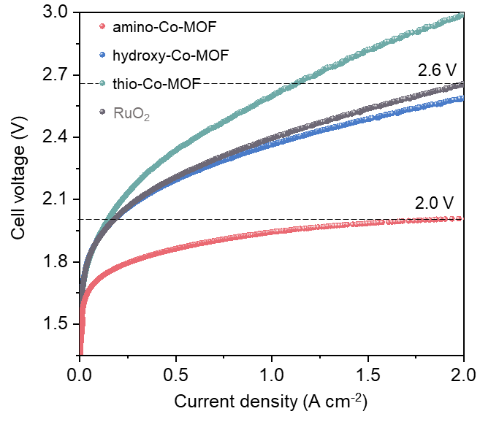
Supplementary Fig. 65.
Polarization curves of Co-MOFs and reference RuO₂ at a Nickel substrate with 90% iR-correction in an AEMWE system.
Across the entire current density range, amino-Co-MOF exhibits the lowest cell voltage compared with hydroxy-Co-MOF, thio-Co-MOF, and RuO₂, highlighting its superior catalytic efficiency under practical electrolysis conditions. These results demonstrate the practical viability of amino-Co-MOF as a high-performance anode for alkaline water electrolysis.

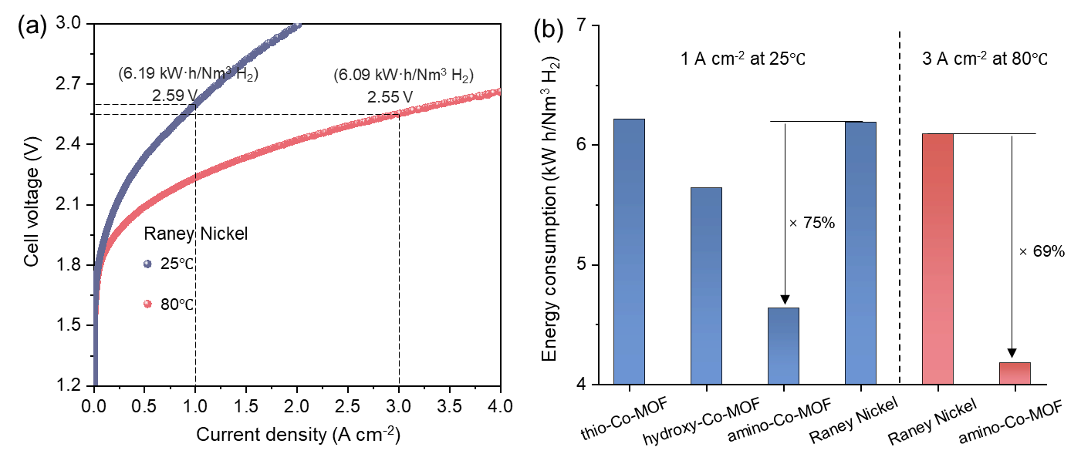
Supplementary Fig. 66.
(a) Polarization curves of commercial Raney Nickel at operating conditions of 25℃ and 80℃ with 90% iR-correction in an AEMWE system. (b) Comparison of energy consumption for different samples at different operating conditions.
The direct current energy consumption for water electrolysis can be calculated using the following formula:
Energy Consumption (kW h/Nm³ H₂) = 2390(A h/Nm³)*E/1000
where 2390 A h/Nm³ is the theoretical amount of electricity required to produce 1 m³ of hydrogen under standard conditions, and 1000 is the conversion factor.
Therefore, under the current density of 1 A cm⁻² at 25℃, compared to the energy consumption of commercial Raney Nickel (6.19 kW·h/Nm³ H₂), that of amino-Co-MOF is reduced by 75% (Supplementary Figs. 65, 67). Notably, under the current density of 3 A cm⁻² at 80℃, the energy consumption of commercial Raney Nickel is calculated to be 6.09 kW h/Nm³ H₂ (Supplementary Fig. 66a), while that of amino-Co-MOF is 4.18 kW·h/Nm³ H₂ (Fig. 5a), exhibiting a 31% improvement for hydrogen production (Supplementary Fig. 66b).

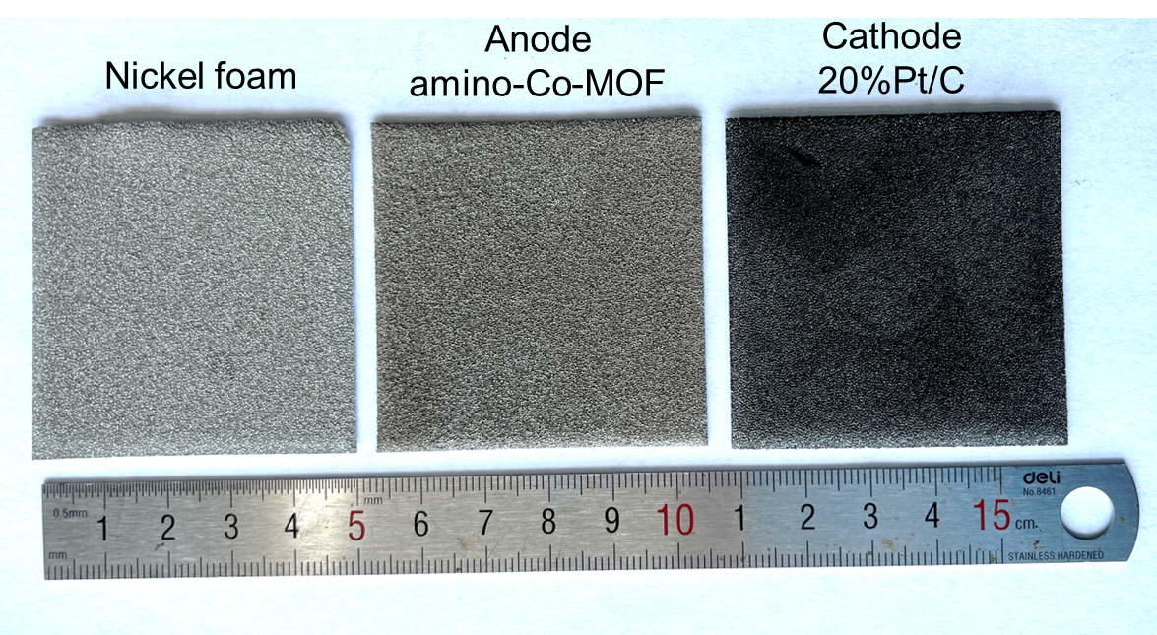
Supplementary Fig. 67
. Photograph of the nickel foam substrate and electrode used in a 25 cm² electrolyzer.

Supplementary Tables
Supplementary Table 1.
Data for splitting energies of Co-based complex models (CoL₅X, L represents a fixed amino group and X represents variable coordinating groups) and corresponding formation energies of Co(III) species. Note: ª Elements in parentheses represent the atoms coordinated to cobalt.
Coordinating groupsª | Splitting energy (eV) | Formation energy of Co(III) (eV)
H₂S | 7.84 | 0.52
PhSH(S) | 7.82 | 0.62
PhSMe(S) | 7.79 | 0.50
HCOOH(O) | 8.06 | 0.56
PhCONH₂(O) | 8.05 | 0.54
PhCOMe(O) | 8.05 | 0.51
H₂O(O) | 8.06 | 0.38
PhBO₂H₂(O) | 8.02 | 0.54
PhCHO(O) | 8.07 | 0.48
PhCOOH(OH) | 8.08 | 0.51
PhCOOMe(O) | 8.06 | 0.43
PhNHOH(O) | 8.01 | 0.72
PhNO₂(O) | 8.02 | 0.65
PhCOOH(O) | 7.99 | 0.72
PhOH(O) | 7.98 | 0.51
PhPO₃H₂(O) | 8.05 | 0.53
PhPO₄H₂(O) | 8.04 | 0.47
PhSO₃H(O) | 8.00 | 0.72
PhSO₄H(O) | 7.97 | 0.62
HCHO(O) | 8.04 | 0.50
HCOOMe(O) | 8.06 | 0.53
HNHOH(O) | 8.03 | 0.52
HOPO₃H₂(O) | 8.06 | 0.41
HPO₃H₂(O) | 8.03 | 0.47
PhOMe | 7.96 | 0.63
PhNO(O) | 8.08 | 0.38
HCONH₂(O) | 8.05 | 0.45
HCOMe(O) | 8.06 | 0.47
PhCOOH(O) | 8.01 | 0.68
HCOOH(OH) | 7.97 | 0.74
H₃N(N) | 8.09 | 0.10
PhNH₂(N) | 8.00 | 0.27
PhNHMe(N) | 7.95 | 0.44
PhNHNH₂(NH) | 7.95 | 0.32
PhNHNH₂(NH₂) | 8.03 | 0.18
PhNHOH(N) | 8.01 | 0.24
PhNO(N) | 8.02 | 0.41
HNHNH₂(N) | 8.06 | 0.08
HNHOH(N) | 8.11 | 0.09
HCHNOH(N) | 8.15 | 0.23
PhCNOH(N) | 8.14 | 0.25
PhOCN(N) | 8.03 | 0.38
PhOCN(N) | 8.04 | 0.37
HCN(N) | 8.02 | 0.50
HSCN(N) | 8.05 | 0.39
PhCN(N) | 8.07 | 0.32

Supplementary Table 2.
Data for splitting energies of Co-based complex models (CoL′₅X, L′ represents a fixed carboxyl group from the benzene ring and X represents variable coordinating groups) and corresponding formation energies of Co(III) species. Note: ª Elements in parentheses represent the atoms coordinated to cobalt.
Coordinating groupsª | Splitting energy (eV) | Formation energy of Co(III) (eV)
H₂S | 6.59 | 2.57
PhSH(S) | 6.57 | 2.67
PhSMe(S) | 6.54 | 2.55
HCOOH(O) | 6.81 | 2.61
PhCONH₂(O) | 6.80 | 2.59
PhCOMe(O) | 6.80 | 2.56
H₂O(O) | 6.81 | 2.43
PhBO₂H₂(O) | 6.77 | 2.59
PhCHO(O) | 6.82 | 2.53
PhCOOH(OH) | 6.83 | 2.56
PhCOOMe(O) | 6.81 | 2.48
PhNHOH(O) | 6.76 | 2.77
PhNO₂(O) | 6.77 | 2.70
PhCOOH(O) | 6.74 | 2.77
PhOH(O) | 6.73 | 2.56
PhPO₃H₂(O) | 6.80 | 2.58
PhPO₄H₂(O) | 6.79 | 2.52
PhSO₃H(O) | 6.75 | 2.77
PhSO₄H(O) | 6.72 | 2.67
HCHO(O) | 6.79 | 2.55
HCOOMe(O) | 6.81 | 2.58
HNHOH(O) | 6.78 | 2.57
HOPO₃H₂(O) | 6.81 | 2.46
HPO₃H₂(O) | 6.78 | 2.52
PhOMe | 6.71 | 2.68
PhNO(O) | 6.83 | 2.43
HCONH₂(O) | 6.80 | 2.50
HCOMe(O) | 6.81 | 2.52
PhCOOH(O) | 6.76 | 2.73
HCOOH(OH) | 6.72 | 2.79
H₃N(N) | 6.84 | 2.15
PhNH₂(N) | 6.75 | 2.32
PhNHMe(N) | 6.70 | 2.49
PhNHNH₂(NH) | 6.70 | 2.37
PhNHNH₂(NH₂) | 6.78 | 2.23
PhNHOH(N) | 6.76 | 2.29
PhNO(N) | 6.77 | 2.46
HNHNH₂(N) | 6.81 | 2.13
HNHOH(N) | 6.86 | 2.14
HCHNOH(N) | 6.90 | 2.28
PhCNOH(N) | 6.89 | 2.30
PhOCN(N)phocn | 6.78 | 2.43
PhOCN(N) | 6.79 | 2.42
HCN(N) | 6.77 | 2.55
HSCN(N) | 6.80 | 2.44
PhCN(N) | 6.82 | 2.37

Supplementary Table 3.
Data for splitting energies of CoR₆ complex models and corresponding formation energies of Co(III) species.
Coordinating groupsª | Splitting energy (eV) | Formation energy of Co(III) (eV)
CN⁻ | 9.35 | -2.74
phen | 8.26 | 0.35
bpy | 8.25 | 0.11
NH₃ | 8.09 | 0.10
H₂O | 7.42 | 2.65

Supplementary Table 4
. Gibbs free energies of reaction coordinate calculated by DFT calculation in the OER process. Note: ª G_{*OH} represents the formation energies of Co(II) to Co(III) because the deprotonation process of water molecules on Co sites from Co-*H₂O into Co-*OH is accompanied by the oxidation state transition of Co(II) into Co(III) (Co²⁺-H₂O + OH⁻ → Co³⁺-OH + H₂O + e⁻).
Catalysts | G_{*OH} (eV)ª | G_{*O} (eV) | G_{*OOH} (eV) | G_{*OO} (eV) | d(G_{*O}-G_{*OH}) (eV) | d(G_{*OOH}-G_{*O}) (eV) | η_{theo} (V)
amino-Co-MOF | 0.32 | 1.86 | 3.40 | 4.92 | 1.54 | 1.54 | 0.31
hydroxy-Co-MOF | 1.39 | 2.74 | 4.61 | 4.92 | 1.53 | 1.87 | 0.64
thio-Co-MOF | 1.55 | 3.14 | 5.05 | 4.92 | 1.59 | 1.91 | 0.68

Supplementary Table 5
. Crystallographic data from 3D cRED and Rietveld refinement results of Co-MOFs. Note: ª The unreported crystal structure is resolved and identified by cRED technology.

Supplementary Table 6
. The double-layer capacitance C_{dl} and the electrochemically active area of Co-MOFs.
C_{s} = 0.04 (mF cm⁻²)
Catalyst | amino-Co-MOF | hydroxy-Co-MOF | thio-Co-MOF | RuO₂
C_{dl} (mF cm⁻²) | 3.65 | 1.20 | 1.04 | 1.14
ECSA = C_{dl}/C_{s} | 91.25 | 30 | 26 | 28.5

Supplementary Table 7
. OER performance of Co-MOFs using RDE in 1 M KOH.
Samples | η₁₀ (mV) | Tafel (mV/dec) | j_{ECSA} (mA/cm²) at 1.5 V | Onset potential (V) | TOF (S⁻¹) at 1.5 V | E_{a} (kJ/mol)
amino-Co-MOF | 211 | 36 | 0.902 | 1.377 | 0.579 | 38.6±1.9
hydroxy-Co-MOF | 340 | 60 | 0.064 | 1.521 | 0.017 | 75.7±1.7
thio-Co-MOF | 366 | 71 | 0.056 | 1.532 | 0.005 | 95.4±4

Supplementary Table 8
. Comparison of the intrinsic OER activity of MOFs onto an inert substrate. Our work breaks the current record of overpotential at 10 mA cm⁻².
Catalysts | Electrolyte | ƞ₁₀ (mV) | Tafel slope (mV dec⁻¹) | Stability | Ref.
amino-Co-MOF | 1 M KOH | 211 | 36 | 500 h at 10 mA cm⁻² | This work
CoCe-DHBDC | 1 M KOH | 226 | 45 | 100 h at 10 mA cm⁻² | 10
Co₃(HITP)₂ | 1 M KOH | 254 | 86.5 | 12 h at 16 mA cm⁻² | 11
Ni-Fe-MOF NSs | 1 M KOH | 221 | 56 | 20 h at 10 mA cm⁻² | 12
LS-6%-NiFe-MOFs | 1 M KOH | 230 | 86.6 | 20000 s at 1.51 V | 13
MOF-Fe/Co(1:2) | 1 M KOH | 238 | 58 | 50000 s at 1.489 V | 14
HHTP@ZIF-67 | 1 M KOH | 238 | 104 | 12000 s at 1.494 V | 15
CTGU-10c2 | 0.1 M KOH | 240 | 58 | 50 h at 10 mA cm⁻² | 16
aMOF-NC | 0.1 M KOH | 249 | 39.5 | 24 h at 10 mA cm⁻² | 17
NiCo-UMOFNs | 1 M KOH | 250 | 42 | 200 h at 1.48 V | 18
(Ni₂Co₁)_{0.925}Fe_{0.075}-MOF-NF | 1 M KOH | 257 | 41.3 | 35 h at 1.488 V | 19
NiFe-UMNs | 1 M KOH | 260 | 30 | 10000 s at 1.51 V | 20
Fe₂Ni₁-BDC | 1 M KOH | 260 | 35 | 10 h at 10 mA cm⁻² | 21
2D Co-MOF NS | 1 M KOH | 263 | 74 | 12000 s at 1.492 V | 22
CoFe-MOF | 1 M KOH | 265 | 44 | 40 h at 10 mA cm⁻² | 23
Ni_{0.5}Co_{0.5}-MOF-74 | 1 M KOH | 270 | 49 | - | 24
NiCoFe-MOF-74 | 1 M KOH | 270 | 89 | 8 h at 1.47 V | 25
2D MOF LM-160-12 | 1 M KOH | 274 | 46.7 | 10 h at 10 mA cm⁻² | 26
Co_{0.6}Fe_{0.4}-MOF-74 | 1 M KOH | 280 | 56 | 12 h at 1.51 V | 27
Fe:2D-Co-NS | 1M KOH | 282 | 59 | 96 h at 10 mA cm⁻² | 28
A_{2.7}B-MOF-FeCo_{1.6} | 1 M KOH | 288 | 39 | 38000 s at 10 mA cm⁻² |  | 29
Br-Ni-MOF | 1 M KOH | 306 | 79.1 | 100 h at 10 mA cm⁻² | 30

Supplementary Table 9
. ICP-AES analysis of Co content in Co-MOFs.
Samples | Co (wt%)
amino-Co-MOF | 29.52
hydroxy-Co-MOF | 13.50
thio-Co-MOF | 25.04

Supplementary Table 10
. Fitting results of Co K-edge EXAFS spectra for amino-Co-MOF at selected potentials (FT-EXAFS fitting from OCP to 1.5 V is shown in Supplementary Fig. 46).
Condition | Path | CN | R | σ² | R-factor
Pristine | Co-O  Co-N | 4.0(2)  2.0(2) | 2.03  1.99 | 0.005  0.005 | 0.5%
OCP | Co-O  Co-N | 4.1(4)  2.1(2) | 2.09  1.99 | 0.004  0.005 | 1.0%
1.20 V | Co-O  Co-N | 4.0(5)  2.0(2) | 2.02  1.99 | 0.005  0.004 | 0.2%
1.25 V | Co-O  Co-N | 4.1(2)  2.0(2) | 1.93  1.99 | 0.005  0.004 | 0.7%
1.30 V | Co-O  Co-N | 2.0(2)  2.0(2) | 1.90  1.99 | 0.005  0.004 | 1.5%
1.35 V | Co-O  Co-N | 2.1(3)  2.0(2) | 1.91  1.98 | 0.006  0.004 | 2.0%
1.40 V | Co-O  Co-N | 3.5(5)  2.0(4) | 1.92  1.95 | 0.005  0.005 | 1.7%
1.45 V | Co-O  Co-N | 3.4(4)  1.9(4) | 1.91  1.93 | 0.006  0.004 | 1.9%
1.50 V | Co-O  Co-N | 3.5(4)  1.9(3) | 1.90  1.99 | 0.006  0.005 | 2.0%
Note: CN represents coordination numbers; R represents bond distance; σ² represents Debye-Waller factors; R-factor represents goodness of fit. Ѕ₀² was set to 0.80 according to the experimental EXAFS fitting of Co₃O₄ reference by fixing CN as the known crystallographic value. The structural parameters obtained by EXAFS spectroscopy were estimated as CN ± 20%; R ± 1%; σ² ± 20%; ∆E₀ ± 20%. Fitting range: 3.0 ≤ K (/Å) ≤ 11.0.

Supplementary Table 11
. Fitting results of Co K-edge EXAFS spectra for hydroxy-Co-MOF at selected potentials (FT-EXAFS fitting from OCP to 1.5 V is shown in Supplementary Fig. 53).
Condition | Path | CN | R | σ² | R-factor
Pristine | Co-O | 6.0(2) | 2.01 | 0.005 | 0.5%
OCP | Co-O | 5.9(7) | 2.09 | 0.006 | 0.9%
1.20 V | Co-O | 6.1(8) | 2.09 | 0.007 | 1.2%
1.25 V | Co-O | 5.5(5) | 2.09 | 0.008 | 2.0%
1.30 V | Co-O | 5.8(7) | 2.08 | 0.008 | 1.9%
1.35 V | Co-O | 5.5(5) | 1.88 | 0.007 | 2.0%
1.40 V | Co-O | 3.8(6) | 1.90 | 0.007 | 1.3%
1.45 V | Co-O | 3.9(5) | 1.90 | 0.007 | 1.2%
1.50 V | Co-O | 4.2(7) | 1.90 | 0.006 | 1.2%
Note: CN represents coordination numbers; R represents bond distance; σ² represents Debye-Waller factors; R-factor represents goodness of fit. Ѕ₀² was set to 0.81 according to the experimental EXAFS fitting of Co₃O₄ reference by fixing CN as the known crystallographic value. The structural parameters obtained by EXAFS spectroscopy were estimated as CN ± 20%; R ± 1%; σ² ± 20%; ∆E₀ ± 20%. Fitting range: 3.0 ≤ K (/Å) ≤ 11.0.

Supplementary Table 12
. Fitting results of Co K-edge EXAFS spectra for thio-Co-MOF at selected potentials (FT-EXAFS fitting from OCP to 1.5 V are shown in Supplementary Fig. 55).
Condition | Path | CN | R | σ² | R-factor
Pristine | Co-O  Co-S | 1.9(2)  4.0(2) | 1.91  2.26 | 0.004  0.005 | 0.3%
OCP | Co-O  Co-S₁  Co-S₂ | 1.8(3)  2.0(2)  2.0(2) | 1.88  2.18  2.33 | 0.006  0.004  0.004 | 0.4%
1.20 V | Co-O  Co-S₁  Co-S₂ | 2.2(1)  2.2(1)  1.8(2) | 1.89  2.22  2.37 | 0.005  0.004  0.004 | 0.7%
1.25 V | Co-O  Co-S₁  Co-S₂ | 2.1(1)  2.0(1)  2.0(1) | 1.87  2.21  2.36 | 0.005  0.004  0.005 | 1.7%
1.30 V | Co-O  Co-S₁  Co-S₂ | 2.3(3)  1.8(3)  2.0(3) | 1.85  2.18  2.34 | 0.004  0.004  0.005 | 1.5%
1.35 V | Co-O  Co-S₁  Co-S₂ | 2.3(3)  1.9(2)  2.2(1) | 1.84  2.15  2.33 | 0.005  0.004  0.004 | 1.2%
1.40 V | Co-O  Co-S₁  Co-S₂ | 2.4(5)  1.9(4)  2.0(1) | 1.83  2.10  2.29 | 0.004  0.005  0.004 | 1.2%
1.45 V | Co-O  Co-S | 2.4(3)  4.0(4) | 1.83  2.03 | 0.006  0.006 | 1.5%
1.50 V | Co-O  Co-S | 2.2(4)  4.0(4) | 1.81  2.03 | 0.005  0.004 | 1.9%
Note: CN represents coordination numbers; R represents bond distance; σ² represents Debye-Waller factors; R-factor represents goodness of fit. Ѕ₀² was set to 0.67 according to the experimental EXAFS fitting of Co₃O₄ reference by fixing CN as the known crystallographic value. The structural parameters obtained by EXAFS spectroscopy were estimated as CN ± 20%; R ± 1%; σ² ± 20%; ∆E₀ ± 20%. Fitting range: 3.0 ≤ K (/Å) ≤ 11.0. Co-S₁ and Co-S₂ represent the formation of two ligand bonds with different lengths during the applied potential due to the distortion effect.

Supplementary Table 13
. Overpotential comparison under the high current density of amino-Co-MOF and reported non-noble metal-based catalysts in a three-electrode system.
Catalysts | Electrolyte | J (mA cm⁻²) | Overpotential (mV) | Ref.
amino-Co-MOF | 1 M KOH | 500  1000  1500  2000 | 239  256  266  276 | This work
FeNiHOF | 1 M KOH | 500  1000  1500  2000 | 273  280  282  284 | 31
Fe-Ni₂P_{v} | 1 M KOH | 500  1000  1500  2000 | 275  306  309  312 | 32
FeOOH/Co(OH)₂ | 1 M KOH | 500  1000  1500  2000 | 290  304  306  310 | 33
NiMoN/NiFe LDH | 1 M KOH | 500  1000  1500  2000 | 236  266  300  353 | 34
FeNi(OH)_{x} | 1 M KOH | 500  1000 | 278  296 | 35
Cr-Co_{x}P | 1 M KOH | 500  1000 | 380  420 | 36
NiFe-MOF74/NiFe LDH | 1 M KOH | 500  1000 | 270  284 | 37
Ni_{0.8}Fe_{0.2}-AHNA | 1 M KOH | 500  1000 | 248  258 | 38
NiFe LDH/NiS | 1 M KOH | 500  1000 | 310  322 | 39
Ni_{x}Fe_{1-x} alloy nanocones arrays | 1 M KOH | 500  1000 | 255  266 | 40
FeP/Ni₂P | 1 M KOH | 500  1000  1500 | 270  290  310 | 41
NiMoN@NiFeN | 1 M KOH | 500  1000 | 337  380 | 42
Ni₂P-Fe₂P/NF | 1 M KOH | 500  1000 | 308  328 | 43
Fe_{0.01}&Mo-NiO | 1 M KOH | 500  1000 | 272  294 | 44

Supplementary Table 14
. Activity and stability comparison of amino-Co-MOF and reported electrocatalysts in an AEMWE system.
Anode |  | Cathode | Membrane | J @ 1.8 V in 1 M KOH | Stability in 1 M KOH at room temperature | Ref.
amino-Co-MOF |  | 20%Pt/C | FAA-3-PK-130 | 4.0 A cm⁻² at 80℃ | 1 A cm⁻² for 2020 h | This work
CoCe-DHBDC |  | 40%Pt/C | FAA-3-50 | 1.14 A cm⁻² at 80℃ | 1 A cm⁻² for 1000 h | 10
Cs⁺-CoFeOOH |  | PtRu/C | NA | 4.7 A cm⁻² at 80℃ | 1 A cm⁻² for 450 h | 45
MOF@POM |  | 20%Pt/C | Sustainion X37-50 Grade T | 3.2 A cm⁻² at 80℃ | 1 A cm⁻² for 2000 h | 46
Ni_{0.67}Fe_{0.33}S₂ |  | 60%Pt/C | AF1-HNN8-50 | 1.6 A cm⁻² at 80℃ | 1 A cm⁻² for 550 h | 47
NiFe LDH |  | 50%Pt/C | AP2-HNN8-X-50 | 2.1 A cm⁻² at 80℃ | 1 A cm⁻² for 110 h | 48
Ru SS/FeNiPi |  | Ru SS/FeNiPi | X37-50 grade T | 2.0 A cm⁻² at 80℃ (@1.78 V) | 1 A cm⁻² for 100 h | 49
Ni₂Fe₁ |  | 50%Pt-25%Ru/C | HTMA-DAPP | 5.3 A cm⁻² at 85℃ | 0.2 A cm⁻² for 160 h | 50
CAPist-L1 |  | Ni₄Mo/MoO₂ | PAP-TP-85 | 4.0 A cm⁻² at 80℃ | 1 A cm⁻² for 1750 h | 51
NP-(FeCoNi)₂Nb |  | NP-(FeCoNi)₂Nb | NA | 1.1 A cm⁻² at 85℃ | 1 A cm⁻² for 110 h | 52
(Ni,Fe)S₂@Ti₃C |  | Raney Ni mesh | FAA-3-PK-130 | 0.75 A cm⁻² at 75℃ | 0.5 A cm⁻² for 500 h | 53
MoZnFeCoNi |  | 20%Pt/C | NA | 1.1 A cm⁻² at 85℃ | 0.53 A cm⁻² for 350 h | 54
NiAlMo |  | NiAlMo | HMT-PMBI | 0.88 A cm⁻² at 60℃ | 1 A cm⁻² for 154 h | 55
Ni₂Fe₈–Ni₃S₂/NF |  | Ni₄Mo/MoO₂/NF | FAA-3-50 | 1.3 A cm⁻² at 80℃ | 1 A cm⁻² for 100 h | 56
M-NiFe-LDH |  | Pt/C | Sustainion X37-50 | 1.1 A cm⁻² at 50℃ | 1 A cm⁻² for 50 h | 57
VCoP |  | VCoP | PBI | 3.7 A cm⁻² at 60℃ | 1 A cm⁻² for 200 h | 58
CoNiS |  | CoNiS | Sustainion X37-50 | 2.5 A cm⁻² at 60℃ | 1 A cm⁻² for 600 h | 59
NiFe |  | Pt/C | FAA-3-50 | 1.8 A cm⁻² at 70℃ | 1 A cm⁻² for 3 h | 60
Ni–Fe–O_{x} |  | Ni–Fe–Co | PBI | 0.85 A cm⁻² at 60℃ | 1 A cm⁻² for 100 h | 61
(NiCo)₃Se₄ |  | Pt/C | Sustainion X37-50 | 1.75 A cm⁻² at 80℃ | 1 A cm⁻² for 95 h | 62
NiMo |  | Fe-NiMo | Sustainion X37-50 | 1.15 A cm⁻² at 80℃ | 0.5 A cm⁻² for 25 h | 63
NiCoP@rGO |  | NiCoP@rGO | AIEM | 0.38 A cm⁻² at 50℃ | 0.4 A cm⁻² for 70 h | 64
IrO₂ |  | Pt/C | Orion TM1 | 2.0 A cm⁻² at 70℃ | 0.5 A cm⁻² for 50 h | 65
NiFeV LDH |  | Pt/C | Sustainion X37-50 | 2.11 A cm⁻² at 50℃ | 0.5 A cm⁻² for 100 h | 66
CE-CCO |  | Pt/C | Sustainion X37-50 | 1.37 A cm⁻² at 45℃ | 0.5 A cm⁻² for 64 h | 67
CCO-11 |  | Pt/C | Sustainion X37-50 | 1.32 A cm⁻² at 45℃ | 0.4 A cm⁻² for 100 h | 68
Ni_{0.75}Fe_{2.25}O₄ |  | Pt/C | Sustainion X37-50 | 1.35 A cm⁻² at 25℃ | 0.5 A cm⁻² for 21 h | 69
Ir-Ni/Mo₅N₆ |  | Ir-Ni/Mo₅N₆ | Sustainion X37-50 | 1.09 A cm⁻² at 25℃ | 0.4 A cm⁻² for 30 h | 70
Ni-Fe |  | Ni-Fe | PFTP-13 | 3.9 A cm⁻² at 80℃ | 0.5 A cm⁻² for 1100 h | 71
IrO₂ |  | Pt/C | QMter-co-Mpi | 0.2 A cm⁻² at 80℃ | 0.2 A cm⁻² for 500 h | 72
Ir black |  | Pt/C | AF1-HNN8-50 | 1.83 A cm⁻² at 60℃ | 0.5 A cm⁻² for 1000 h | 73
IrO₂ |  | Pt/C | PFOTFPh-TMA-C6 | 1.06 A cm⁻² at 80℃ | 0.2 A cm⁻² for 135 h | 74
IrO₂ |  | Pt/C | PTP-85 | 0.61 A cm⁻² at 75℃ | 0.4 A cm⁻² for 120 h | 75
Ni_{0.6}Co_{0.2}Fe_{0.2} |  | Ni–MoO₂ | Fumapem-3-PE-30 | 1.12 A cm⁻² at 50℃ | 0.5 A cm⁻² for 65 h | 76
CuCoO |  | NiCoO-NiCo/C | Sustainion X37-50 | 0.43 A cm⁻² at 50℃ | 0.44 A cm⁻² for 10 h | 77
Co(OH)_{x}/Ag/Co(OH)₂ |  | Pt/C/CP | Sustainion X37-50 | 0.57 A cm⁻² at 50℃ | 0.6 A cm⁻² for 24 h | 78
IrO₂/CP |  | Ni-Co-S/CP | Nafion 212 | 0.12 A cm⁻² at 50℃ | 0.4 A cm⁻² for 78 h | 79
IrO₂/C/CP |  | Ru₂P/CP | Sustainion X37-50 | 1.11 A cm⁻² at 70℃ | 0.5 A cm⁻² for 100 h | 80
Cu_{0.81}Co_{2.19}O₄ |  | 3-Co₃S₄ NS/NF | Sustainion X37-50 | 0.13 A cm⁻² at 45℃ | 0.5 A cm⁻² for 11 h | 81
Ni₂P@FePO_{x}H_{y} |  | MoNi₄/MoO₂ | Sustainion X37-50 | 0.76 A cm⁻² at 60℃ | 0.5 A cm⁻² for 72 h | 82
NiFeOOH |  | Pt/C | FAA-3-50 | 2.5 A cm⁻² at 70℃ | 0.5 A cm⁻² for 100 h | 83
IrO₂ |  | Pt black | PiperION | 0.75 A cm⁻² at 70℃ | 0.5 A cm⁻² for 180 h | 84
Ir black |  | Pt/C | PBI-PVBCNMPD/Cl | 0.42 A cm⁻² at 60℃ | 0.5 A cm⁻² for 3.3 h | 85
NiFe-LDH |  | NiMo | PVBCMPy/35%PEK-cardo | 0.25 A cm⁻² at 60℃ | 0.5 A cm⁻² for 42 h | 33
FeOOH/Co(OH)₂ | MoNi₄/MoO₂ |  | N.A. | 1.38 A cm⁻² at 25℃  (@1.7 V) | 0.5 A cm⁻² for 40 h | 86

Supplementary References
- Schober, P., et al. Correlation coefficients: appropriate use and interpretation. Anesth. analg. 126, 1763–1768 (2018).
- Mukaka, M.M. A guide to appropriate use of correlation coefficient in medical research. Malawi med. j. 24, 69–71 (2012).
- Frisch, M. J. G. et al. Gaussian 09, Revision D.01, Gaussian, Inc., Wallingford CT, (2013).
- Haynes, W. M. et al. CRC Handbook of Chemistry and Physics, 95th Edition, CRC Press: Taylor & Francis Group, ISBN: 9781482208689, (2014).
- Lu, T. and Chen, F. Multiwfn: a multifunctional wavefunction analyzer. J. Comput. Chem. 33, 580–592 (2012).
- Divanis, S. et al. Oxygen evolution reaction: a perspective on a decade of atomic scale simulations. Chem. Sci. 11, 2943–2950 (2020).
- Bergmann, A. et al. Unified structural motifs of the catalytically active state of Co(oxyhydr)oxides during the electrochemical oxygen evolution reaction. Nat. Catal. 1, 711–719 (2018).
- Wang, X. et al. Pivotal role of reversible NiO₆ geometric conversion in oxygen evolution. Nature 611, 702–708 (2022).
- Mom, R.V. et al. Operando structure-activity-stability relationship of iridium oxides during the oxygen evolution reaction. ACS Catal. 12, 5174–5184 (2022).
- Guo, Y. et al. Scalable metal-organic framework-based electrodes for efficient alkaline water electrolysis. Nat. Chem. Eng. (2025). https://doi.org/10.1038/s44286-025-00262-2
- Xing, D. et al. Co₃(hexaiminotriphenylene)₂: A conductive two-dimensional π-d conjugated metal-organic framework for highly efficient oxygen evolution reaction. Appl. Catal. B 278, 119295 (2020).
- Li, F.L. et al. Large-scale, bottom-up synthesis of binary metal-organic framework nanosheets for efficient water oxidation. Angew. Chem. Int. Ed. 58, 7051 (2019).
- Ji, Q. et al. Lattice strain induced by linker scission in metal-organic framework nanosheets for oxygen evolution reaction. ACS Catal. 10, 5691 (2020).
- Ge, K. et al. Facile synthesis of two-dimensional iron/cobalt metal-organic framework for efficient oxygen evolution electrocatalysis. Angew. Chem. Int. Ed. 60, 12097 (2021).
- Zhu, R. et al. π-Conjugated molecule boosts metal–organic frameworks as efficient oxygen evolution reaction catalysts. Small 14, 1803576 (2018).
- Zhou, W. et al. Stable hierarchical bimetal–organic nanostructures as high performance electrocatalysts for the oxygen evolution reaction. Angew. Chem. Int. Ed. 58, 4227 (2019).
- Liu, C. et al. Amorphous metal-organic framework-dominated nanocomposites with both compositional and structural heterogeneity for oxygen evolution. Angew. Chem. Int. Ed. 59, 3630–3637 (2020).
- Zhao, S. et al. Ultrathin metal-organic framework nanosheets for electrocatalytic oxygen evolution. Nat. Energy 1, 16184 (2016).
- Qian, Q. et al. Ambient fast synthesis and active sites deciphering of hierarchical foam-like trimetal-organic framework nanostructures as a platform for highly efficient oxygen evolution electrocatalysis. Adv. Mater. 31, 1901139 (2019).
- Hai, G. et al. High-performance oxygen evolution catalyst using two-dimensional ultrathin metal-organic frameworks nanosheets. Nano Energy 44, 345 (2018).
- Li, J. et al. Low-crystalline bimetallic metal-organic framework electrocatalysts with rich active sites for oxygen evolution. ACS Energy Lett. 4, 285 (2018).
- Xu, Y. et al. Ultrathin two-dimensional cobalt-organic framework nanosheets for high-performance electrocatalytic oxygen evolution. J. Mater. Chem. A 6 22070 (2018).
- Zou, Z. et al. Expediting in-situ electrochemical activation of two-dimensional metal-organic frameworks for enhanced OER intrinsic activity by iron incorporation. ACS Catal. 9, 7356 (2019).
- Zhao, S. et al. Structural transformation of highly active metal-organic framework electrocatalysts during the oxygen evolution reaction. Nat. Energy 5, 881 (2020).
- Wang, X. et al. Constructing NiCo/Fe₃O₄ heteroparticles within MOF-74 for efficient oxygen evolution reactions. J. Am. Chem. Soc. 140, 15336 (2018).
- Cai, M. et al. Constructing 2D MOFs from 2D LDHs: A highly efficient and durable electrocatalyst for water oxidation. J. Mater. Chem. A 8, 190 (2020).
- Zaheer, W. et al. Reversible room-temperature fluoride-ion insertion in a tunnel-structured transition metal oxide host. ACS Energy Lett. 5, 2520 (2020).
- Huang, J. et al. Electrochemical exfoliation of pillared-layer metal-organic framework to boost the oxygen evolution reaction. Angew. Chem. Int. Ed. 130, 4722 (2018).
- Xue, Z. et al. Modulating electronic structure of metal-organic framework for efficient electrocatalytic oxygen evolution. Adv. Energy Mater. 8, 1801564 (2018).
- Cheng, W. et al. In situ activation of Br-confined Ni-based metal-organic framework hollow prisms toward efficient electrochemical oxygen evolution. Sci. Adv. 7, eabk0919 (2021).
- Chen, Y. et al. Boosting oxygen evolution reaction by FeNi hydroxide-organic framework electrocatalyst toward alkaline water electrolyzer. Nat. Commun. 15, 7278 (2024).
- Liu, X. et al. Manipulating electron redistribution in Ni₂P for enhanced alkaline seawater electrolysis. Adv. Mater. 36, 2307395 (2024).
- Li, D. et al. In situ regulating Cobalt/Iron oxide-oxyhydroxide exchange by dynamic Iron incorporation for robust oxygen evolution at large current density. Adv. Mater. 36, 2305685 (2024).
- Zhai, P. et al. Regulating electronic states of nitride/hydroxide to accelerate kinetics for oxygen evolution at large current density. Nat. Commun. 14, 1873 (2023).
- Du, J. et al. Grain boundary effects of hierarchical Ni-Fe (oxy)hydroxide nanosheets in water oxidation. Small, 19, 2304245 (2023).
- Song, Y. et al. Alleviating the work function of vein-like CoXP by Cr doping for enhanced seawater electrolysis. Adv. Funct. Mater. 33, 2214081 (2023).
- Mu, G. et al. A kinetic control strategy for one-pot synthesis of efficient bimetallic metal-organic framework/layered double hydroxide heterojunction oxygen evolution electrocatalysts. Adv. Funct. Mater. 33, 2211260 (2023).
- Liang, C. et al. Exceptional performance of hierarchical Ni–Fe oxyhydroxide@ NiFe alloy nanowire array electrocatalysts for large current density water splitting. Energy Environ. Sci., 13, 86 (2020).
- Wen, Q. et al. Schottky heterojunction nanosheet array achieving high-current-density oxygen evolution for industrial water splitting electrolyzers. Adv. Energy Mater. 11, 2102353 (2021).
- Liu, P. et al. Tip-enhanced electric field: a new mechanism promoting mass transfer in oxygen evolution reactions. Adv. Mater. 33, 2007377 (2021)
- Yu, F. et al. High-performance bifunctional porous non-noble metal phosphide catalyst for overall water splitting. Nat. Commun. 9, 2551 (2018).
- Yu, L. et al. Non-noble metal-nitride based electrocatalysts for high-performance alkaline seawater electrolysis. Nat. Commun. 10, 5106 (2019).
- Wu, L. et al. Heterogeneous bimetallic phosphide Ni₂P-Fe₂P as an efficient bifunctional catalyst for water/seawater splitting. Adv. Funct. Mater. 31, 2006484 (2021).
- Ning, M. et al. Boosting efficient alkaline fresh water and seawater electrolysis via electrochemical reconstruction. Energy Environ. Sci. 15, 3945 (2022).
- Wang, S. et al. Topochemical exfoliation of metal oxyhydroxides for the electrolytic oxygen evolution reaction. Nat. Synth. (2025). https://doi.org/10.1038/s44160-025-00837-0
- Yue K et al. Polyoxometalated metal-organic framework superstructure for stable water oxidation. Science 388, 430–436 (2025).
- Xia, L. et al. Operando-informed precatalyst programming towards reliable high-current-density electrolysis. Nat. Mater. 24, 753–761 (2025).
- Klingenhof, M. et al. High-performance anion-exchange membrane water electrolysers using NiX (X = Fe,Co,Mn) catalyst-coated membranes with redox-active Ni-O ligands. Nat. Catal. 7, 1213–1222 (2024).
- Lu, S.Y. et al. Synthetic tuning stabilizes a high-valence Ru single site for efficient electrolysis. Nat. Synth. 3, 576–585 (2024).
- Li, D. et al. Highly quaternized polystyrene ionomers for high performance anion exchange membrane water electrolysers. Nat Energy 5, 378–385 (2020).
- Li, Z. et al. Seed-assisted formation of NiFe anode catalysts for anion exchange membrane water electrolysis at industrial-scale current density. Nat. Catal. 7, 944–952 (2024)
- Li, Z. et al. Empowering multicomponent alloys with unique nanostructure for exceptional oxygen evolution performance through self-replenishment. Joule 8, 2920–2937, (2024)
- Wang, J. et al. MXene-assisted NiFe sulfides for high-performance anion exchange membrane seawater electrolysis. Nat Commun. 16, 1319 (2025)
- Mei, Y, et al. MoZn-based high entropy alloy catalysts enabled dual activation and stabilization in alkaline oxygen evolution. Sci. Adv. 10, eadq6758 (2024)
- Wang, L. et al. High performance anion exchange membrane electrolysis using plasma-sprayed, non-precious-metal electrodes. ACS Appl. Energy Mater. 2, 7903–7912 (2019).
- Ding, G. et al. Highly Efficient and durable anion exchange membrane water electrolyzer enabled by a Fe-Ni₃S₂ anode catalyst. Adv. Energy Sustainability Res. 4, 2200130 (2023).
- Jeon, S.S. et al. Design principles of NiFe-layered double hydroxide anode catalysts for anion exchange membrane water electrolyzers. ACS Appl. Mater. Interfaces 13, 37179–37186 (2021).
- Wan, L. et al. Overall design of novel 3D-ordered MEA with drastically enhanced mass transport for alkaline electrolyzers. Energy Environ. Sci. 15, 1882–1892 (2022).
- Wan, L. et al. Oriented intergrowth of the catalyst layer in membrane electrode assembly for alkaline water electrolysis. Nat. Commun. 13, 7956 (2022).
- Park, J.E. et al. Effect of catalyst layer designs for high-performance and durable anion-exchange membrane water electrolysis. J. Ind. Eng. Chem. 109, 453–460 (2022).
- Vincent, I. et al. Highly cost-effective platinum-free anion exchange membrane electrolysis for large scale energy storage and hydrogen production. RSC Advances 10, 37429–37438 (2020).
- Abed, J. et al. In Situ Formation of Nano Ni-Co Oxyhydroxide Enables Water Oxidation Electrocatalysts Durable at High Current Densities. Adv. Mater. 33, 2103812 (2021).
- Chen, P. and Hu, X. High-Efficiency Anion Exchange Membrane Water Electrolysis Employing Non-Noble Metal Catalysts. Adv. Energy Mater. 10, 2002285 (2020).
- Mandal, J. R. Singh, K. and Shahi, V. K. Amphoteric membrane loaded with a noble metal-free hollow spherical NiCoP@rGO bifunctional electrocatalyst for alkaline water electrolyzers. ACS Appl. Energy Mater. 5, 8611–8620 (2022).
- Kang, S. Y. et al. High-performance and durable water electrolysis using a highly conductive and stable anion-exchange membrane. Int. J. Hydrogen Energy 47, 9115–9126 (2022).
- Lee, J. et al. High-efficiency anion-exchange membrane water electrolyzer enabled by ternary layered double hydroxide anode. Small 17, 2100639 (2021).
- Park, Y. S. et al. Superior performance of anion exchange membrane water electrolyzer: Ensemble of producing oxygen vacancies and controlling mass transfer resistance. Appl. Catal. B-Environ. 278, 119276 (2020)
- Jang, M. J. et al. Superior performance and stability of anion exchange membrane water electrolysis: pH-controlled copper cobalt oxide nanoparticles for the oxygen evolution reaction. J. Mater. Chem. A 8, 4290–4299 (2020).
- Lee, J. et al. Corrosion-engineered bimetallic oxide electrode as anode for high-efficiency anion exchange membrane water electrolyzer. Chem. Eng. J. 420, 127670 (2021).
- Wang, H., Tong, Y., Li, K. and Chen, P. Heterostructure engineering of iridium species on nickel/molybdenum nitride for highly-efficient anion exchange membrane water electrolyzer. J. Colloid Interface Sci. 628, 306–314 (2022).
- Chen, N. et al. High-performance anion exchange membrane water electrolyzers with a current density of 7.68 A cm⁻² and a durability of 1000 hours. Energy Environ. Sci. 14, 6338–6348 (2021).
- Yan, X. et al. Twisted ether-free polymer based alkaline membrane for high-performance water electrolysis. J. Power Sources 480, 228805 (2020).
- Fortin, P. et al. High-performance alkaline water electrolysis using Aemion™ anion exchange membranes. J. Power Sources 451, 227814 (2020).
- Soni, R. et al. Pure Water Solid Alkaline Water electrolyzer using fully aromatic and high-molecular-weight poly(fluorene-alt-tetrafluorophenylene)-trimethyl ammonium anion exchange membranes and Ionomers. ACS Appl. Energy Mater. 4, 1053–1058 (2021)
- Hu, X. et al. Piperidinium functionalized aryl ether-free polyaromatics as anion exchange membrane for water electrolysers: Performance and durability. J. Membr. Sci. 621, 118964 (2021).
- Faid, A. Y. et al. Tuning Ni-MoO₂ catalyst–ionomer and electrolyte interaction for water electrolyzers with anion exchange membranes. ACS Appl. Energy Mater. 4, 3327–3340 (2021).
- Park, Y. S. et al. Commercial anion exchange membrane water electrolyzer stack through nonprecious metal electrocatalysts. Appl. Catal. B-Environ. 292, 120170, (2021).
- Guo, W. et al. Sandwich-like Co(OH)x/Ag/Co(OH)₂ nanosheet composites for oxygen evolution reaction in anion exchange membrane water electrolyzer. J. Alloys Compd. 889, 161674 (2021).
- Guo, W. et al. Direct electrodeposition of Ni-Co-S on carbon paper as an efficient cathode for anion exchange membrane water electrolysers. Int. J. of Energy Res. 45, 1918–1931 (2021).
- Kim, J.C. et al. Ru₂P nanofibers for high-performance anion exchange membrane water electrolyzer. Chem. Eng. J. 420, 130491 (2021).
- Park, Y. S. et al. Co₃S₄ nanosheets on Ni foam via electrodeposition with sulfurization as highly active electrocatalysts for anion exchange membrane electrolyzer. Int. J. Hydrogen Energy 45, 36–45 (2020).
- Meena, A. et al. Crystalline-amorphous interface of mesoporous Ni₂P@FePOxHy for oxygen evolution at high current density in alkaline-anion-exchange-membrane water-electrolyzer. Appl. Catal. B-Environ. 306, 121127 (2022).
- Park, J. E. et al. Three-dimensional unified electrode design using a NiFeOOH catalyst for superior performance and durable anion-exchange membrane water electrolyzers. ACS Catal. 12, 135–145 (2022).
- Lindquist, G. A. et al. Performance and durability of pure-water-fed anion exchange membrane electrolyzers using baseline materials and operation. ACS Appl. Mater. Interfaces 13, 51917–51924 (2021).
- Lu, W. et al. Piperidinium-functionalized poly(Vinyl benzyl Chloride) cross-linked by polybenzimidazole as an anion exchange membrane with a continuous ionic transport pathway. Ind. Eng. Chem. Res. 59, 21077–21087 (2020).
- Li, H. et al. Poly(vinyl benzyl methyl pyrrolidinium) hydroxide derived anion exchange membranes for water electrolysis. J. Mater. Chem. A 7, 17914–17922 (2019).

