METHODS
Participants and Clinical Characteristics
This study was approved by the Ruijin Hospital Ethics Committee, and all participants provided written informed consent prior to sample collection and data acquisition. The recruitment for this study began on August 1, 2023, and ended on September 1, 2024. Elderly, non-obese males (BMI < 30) aged 65-75 years were enrolled.¹⁵ Exclusion criteria included smoking, cancer, chronic inflammatory conditions, blood-borne infections, recent cold or flu symptoms, and secondary hypertension causes like aldosteronism, renal artery stenosis, and diabetes. Subjects with coronary artery atherosclerosis, left-heart disease, lung disease, or renal insufficiency were also excluded. Peripheral blood (~10 ml) was collected in the morning after an overnight fast, and clinical blood panel tests were performed. Four patients with systolic blood pressure ≥ 140 mmHg and confirmed persistent atrial fibrillation (AF) were included, along with two hypertensive controls. We conducted scRNA-seq analysis to compare these groups, ensuring uniform donor characteristics with typical biochemical features of hypertension and AF.

Isolation of PBMCs and preparation of single-cell suspensions
The PBMCs were isolated from anticoagulated blood according to the Ficoll Plus 1.077 solution (Solarbio, Beijing, China). Briefly, 3 mL of whole blood was carefully layered onto 3 mL of Ficoll Plus 1.077 in a 15-ml conical centrifuge tube and then centrifuged for 30min at 400 × g at room temperature without braking. After centrifugation, the upper layer above the opaque interface containing mononuclear cells was removed with a Pasteur pipette. The opaque interface was carefully transferred into a clean conical centrifuge tube, washed by adding 10 mL of 1x phosphate-buffered saline (PBS) supplemented with 0.04% bovine serum albumin (BSA), and mixed, followed by centrifugation at 300 × g for 5 min at 4 °C. The supernatant was aspirated and discarded, and the cell pellet was washed twice. After that, the cell pellet was resuspended in 0.5mL of 1× PBS containing 0.04% BSA. For each sample, the cell numbers were counted, and the cell viability was evaluated by CountStar.

Single-cell Preparation
Single-cell RNA sequencing was carried out by personnel in the laboratory of NovelBio Co., Ltd. Cells were washed with PBS containing 0.04% BSA, re-suspended, and filtered through a 40μm cell strainer. Viability was assessed using an AO/PI stain and the Countstar Fluorenscence Cell Analyzer. The original sequencing data were stored in NCBI database with GEO accession number GSE285199.

Single-cell Sequencing
Single-cell RNA-Seq libraries were generated using the 10X Genomics Chromium Controller Instrument and Chromium Single Cell 3’ V3.1 Reagent Kits (10X Genomics, Pleasanton, CA). Approximately 1000 cells/μL were concentrated and loaded into each channel to form single-cell Gel Bead-In-Emulsions (GEMs). After reverse transcription (RT), GEMs were disrupted, and barcoded cDNA was purified and amplified. The amplified cDNA was then fragmented, A-tailed, ligated with adaptors, and further amplified via index PCR. The final libraries were quantified using the Qubit High Sensitivity DNA assay (Thermo Fisher Scientific), and the size distribution was determined with a High Sensitivity DNA chip on a Bioanalyzer 2200 (Agilent). Sequencing was performed on a 150 bp paired-end run using an Illumina sequencer (Illumina, San Diego, CA).

Single-cell RNA-seq (scRNA-seq) Data Processing
The data that support the findings of this study are available from the corresponding author upon reasonable request. The adaptor sequences were filtered using fastp with default parameters, and low-quality reads were removed to obtain clean data. Feature-barcode matrices were generated by aligning the reads to the human genome (GRCh38, Ensembl 104) using Cell Ranger v7.1.0. Sequencing data from six samples, including four patients with hypertension and atrial fibrillation (AF_HTN_01, AF_HTN_02, AF_HTN_03, AF_HTN_04) and two control patients with hypertension only (HTN_CON_01, HTN_CON_02), were processed using the Seurat R package (version 4.3.0). The raw gene expression matrices were first read using the `Read10X` function, and Seurat objects were created for each sample with a minimum requirement of 200 features and 3 cells per feature. The individual Seurat objects were merged into a single object for further analysis using the `merge` function. To assess data quality, we calculated the percentage of mitochondrial and hemoglobin gene expression using the `PercentageFeatureSet` function, and the quality of the data was visualized via violin plots (`VlnPlot`). Low-quality cells were filtered out based on the following criteria: cells with more than 1000 and less than 6000 genes, mitochondrial gene expression under 15%, and hemoglobin gene expression below 0.1%. Normalization of the gene expression data was performed using SCTransform with regression of mitochondrial and hemoglobin gene expression (`SCTransform` function). Principal component analysis (PCA) was then conducted to reduce dimensionality, followed by the construction of a nearest neighbor graph (`FindNeighbors` function) and clustering of cells (`FindClusters` function) based on the first 30 principal components. To correct for batch effects across the different samples, the Harmony algorithm was employed (`RunHarmony` function), which was followed by neighbor graph construction and dimensionality reduction using UMAP (`RunUMAP`) and tSNE (`RunTSNE`). Clustering was fine-tuned with a resolution ranging from 0 to 1, with the final clusters determined at a resolution of 0.4. Visualization of the clustering was performed with `DimPlot`, and cluster stability was assessed using the `clustree` package.

Cell-cell communication analysis
To investigate cell-cell communication via ligand-receptor interactions, we utilized two complementary approaches: CellPhoneDB (version 5.0.1, https://www.cellphonedb.org/) and CellChat (version 2.1.2, https://github.com/sqjin/CellChat) to cross-validate our findings. For the CellPhoneDB analysis, we used the Python-based toolkit to identify significant ligand-receptor interactions. The analysis was performed by calculating interaction scores between cell types based on the mean expression levels of ligand-receptor pairs. A permutation test was conducted with 1000 iterations to assess the significance of each interaction (p-value < 0.01). Interactions that passed the significance threshold were visualized using network plots. In parallel, we employed the R package CellChat to further explore and validate cell-cell communication networks. The CellChat pipeline was used to infer and analyze the communication probabilities between different cell types, integrating prior knowledge from the included database. Key signaling pathways were identified and visualized through network diagrams and heatmaps, providing a comprehensive overview of intercellular communication patterns. The results from CellPhoneDB and CellChat were compared to ensure consistency and reliability in our conclusions.

Enrichment Analysis Using Gene Set Module Scores
To assess the enrichment of specific gene sets, we utilized the AddModuleScore function within the Seurat package. Gene sets related to cholesterol metabolism and atrial fibrillation were obtained from the Molecular Signatures Database (MSigDB, https://www.gsea-msigdb.org/gsea/msigdb/index.jsp). These gene sets were curated based on established biological pathways associated with cholesterol regulation and atrial fibrillation development. The AddModuleScore function was employed to calculate module scores for individual cells, measuring the relative expression of each gene set within single cells. These module scores represent the average expression of the gene set after subtracting the aggregated expression of control genes matched for expression levels. Module scores were computed for each cell cluster, allowing for the identification of clusters enriched in cholesterol-related and atrial fibrillation-related gene sets. Enrichment was visualized through violin plots, highlighting the differential expression across cell clusters.

Trajectory Analysis Using RNA Velocity and Pseudotime
To explore the dynamic transcriptional changes and infer cell lineage trajectories, we performed RNA velocity analysis using velocyto (version 0.17.17, https://velocyto.org/) and pseudotime analysis with monocle (version 2.18.0, https://cole-trapnell-lab.github.io/monocle-release/). For RNA velocity, spliced and unspliced mRNA counts were calculated using the velocyto Python package from the aligned single-cell RNA-seq data. RNA velocity vectors were then computed for each cell, estimating the future transcriptional states and providing insights into the direction of cellular transitions. The resulting velocity fields were visualized on the UMAP projection to identify the progression of cell states across clusters. Pseudotime analysis was conducted with monocle to further validate the inferred trajectories. Cells were ordered along a pseudotemporal axis based on their transcriptional profiles, allowing the reconstruction of cell differentiation pathways. The DDRTree method was employed to reduce dimensionality, and the trajectory was visualized to delineate the sequential states of cell populations. This dual approach enabled a comprehensive understanding of the cellular dynamics within the dataset, providing both velocity-based predictions and a temporal ordering of cells.

Flow cytometry
Peripheral blood mononuclear cells (PBMCs) were isolated using Ficoll Plus 1.077 solution (Solarbio, Beijing, China). The cells were stained with the following antibodies: Brilliant Violet 421™ anti-human CD14 (BioLegend, #367143, 5:100), APC anti-human CD16 (BioLegend, #302011, 1:200), PE anti-human CD41 (BioLegend, #303705, 1:200), and Ghost Dye™ Violet 510 Viability Dye (TONBO Bioscience, #13-0870-T100, 1:200). The samples were incubated at room temperature (20°C) for 20 minutes. Flow cytometry was performed using Beckman Coulter Gallios (Beckman Coulter, America) and analyzed by FlowJo (FlowJo V10).

Inflammation Biomarker Quantification
Peripheral blood was collected from 39 patients with primary hypertension and 41 patients with hypertension and atrial fibrillation (AF). To quantify inflammatory biomarkers (including G-CSF, IL-10, IL-13, IFNγ, IL-2, TNFα, IL-17A, IL-12p70, IL-4, IL-1β, MCP-1, IL-23p19, and IL-6), a custom RayPlex Human Multiplex Bead Array kit (FAH-INF-1-96) was used on serum samples. The samples were processed according to the manufacturer's instructions. Twenty-five microliters of the diluted supernatant were added to the beads, shaken at 1000 rpm for 2 hours at room temperature, followed by rinsing and preparation for flow cytometric analysis. The PE MFI values were obtained and used to calculate the concentration of each biomarker using standard curves. Data with zero values were excluded from the analysis. Normality was checked before statistical testing: if the data followed a normal distribution, an unpaired t-test was applied; otherwise, the Mann-Whitney test was used.

Statistical Analysis
The statistical analysis of the experimental data was conducted using GraphPad Prism version 9 (La Jolla, CA, USA). The normality of the data was assessed using the Shapiro-Wilk test to determine if it followed a normal distribution. The results are presented as means ± SD. A significance level of P < 0.05 was used for all statistical tests.

Availability of data and materials
The dataset(s) supporting the conclusions of this article are available in the NCBI Gene Expression Omnibus (GEO) repository, accession numbers GSE285199 (raw and processed human PBMC scRNA-seq data, https://www.ncbi.nlm.nih.gov/geo/query/acc.cgi?acc=GSE285199) and GSE224959 (processed human cardiac scRNA-seq data used for comparison, https://www.ncbi.nlm.nih.gov/geo/query/acc.cgi?acc=GSE224959).

Ethics Statement
This study was approved by the Ethics Committee of Ruijin Hospital Ethics Committee, Shanghai JiaoTong University School of Medicine. All participants provided written informed consent prior to the collection of peripheral blood samples. The study was conducted in accordance with the ethical standards of the Ethics Committee of Ruijin Hospital Ethics Committee and the 1964 Helsinki Declaration and its later amendments.
Supplementary Table
Clinical Demographic Characteristics of Hypertensive Patients with AF
Name | HTN1 | HTN2 | AFHTN  1 | AFHTN  2 | AFHTN  3 | AFHTN  4
Sex | Male | Male | Male | Male | Male | Male
Age | 72 | 71 | 66 | 71 | 73 | 76
BH (cm) | 169 | 169 | 180 | 164 | 172 | 176
BW (Kg) | 74.7 | 67.7 | 80 | 73.2 | 83.7 | 68
BMI | 26.31 | 23.7 | 24.69 | 27.38 | 28.29 | 21.95
AF | - | - | persistent | persistent | persistent | persistent
AF time | - | - | 2023/3/1 | 2019/6/1 | 2020/5/1 | 2018/1/1
AF drug | - | - | Metoprolol | Metoprolol, propafenone | Metoprolol | Metoprolol, amiodarone
Ablation | - | - | Yes | No | No | Yes
HT time | 2000/1/1 | 2001/1/1 | 2023/3/1 | 2017/6/1 | 2014/1/1 | 2018/1/1
HT drug | amlodipine | amlodipine | valsartan | amlodipine, allisartan | amlodipine | sacubitril valsartan
LDL (mmol/L) | 4.06 | 2.46 | 4.22 | 2.7 | 1.8 | 3.54

Supplementary Figure 1
A.
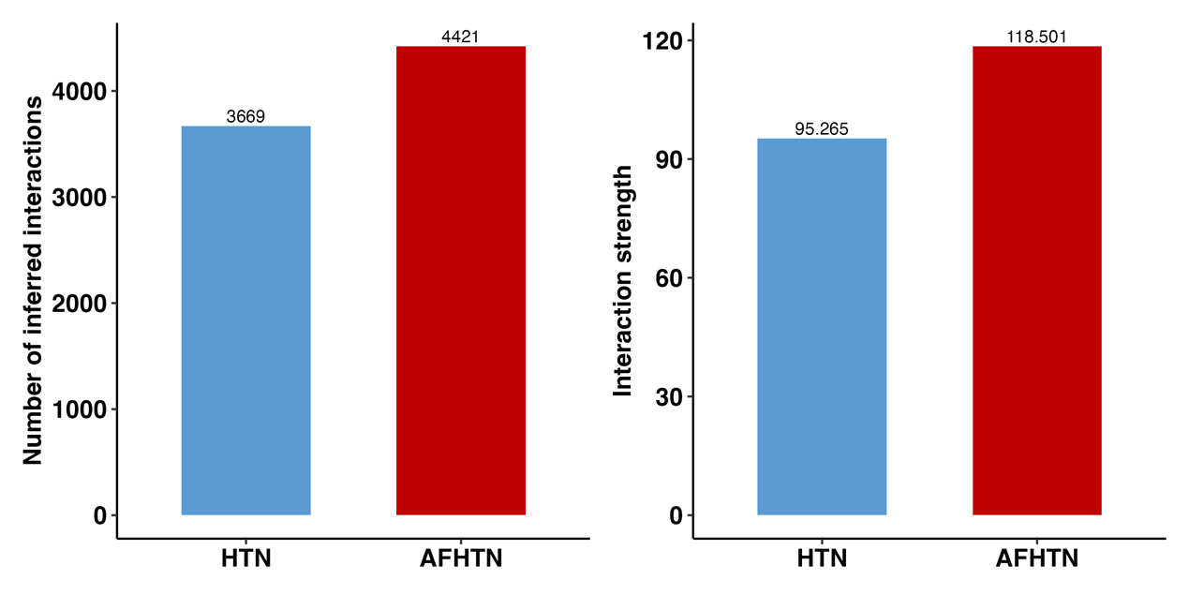

B.
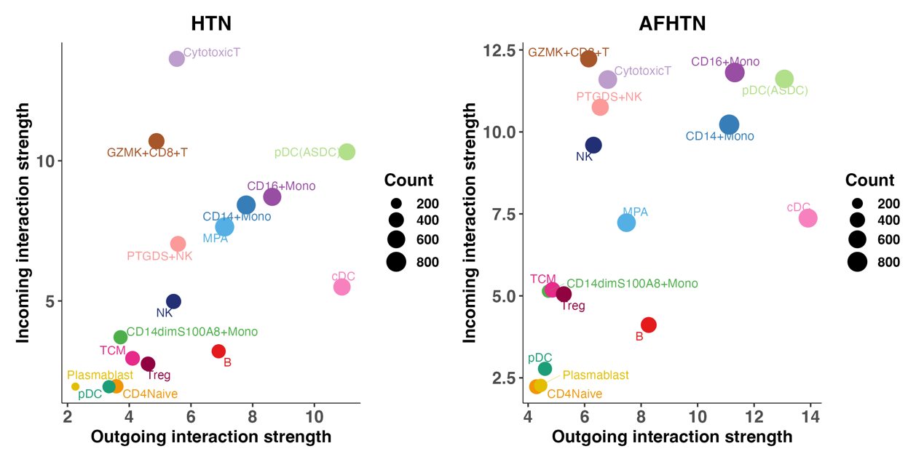

Supplementary Figure 2
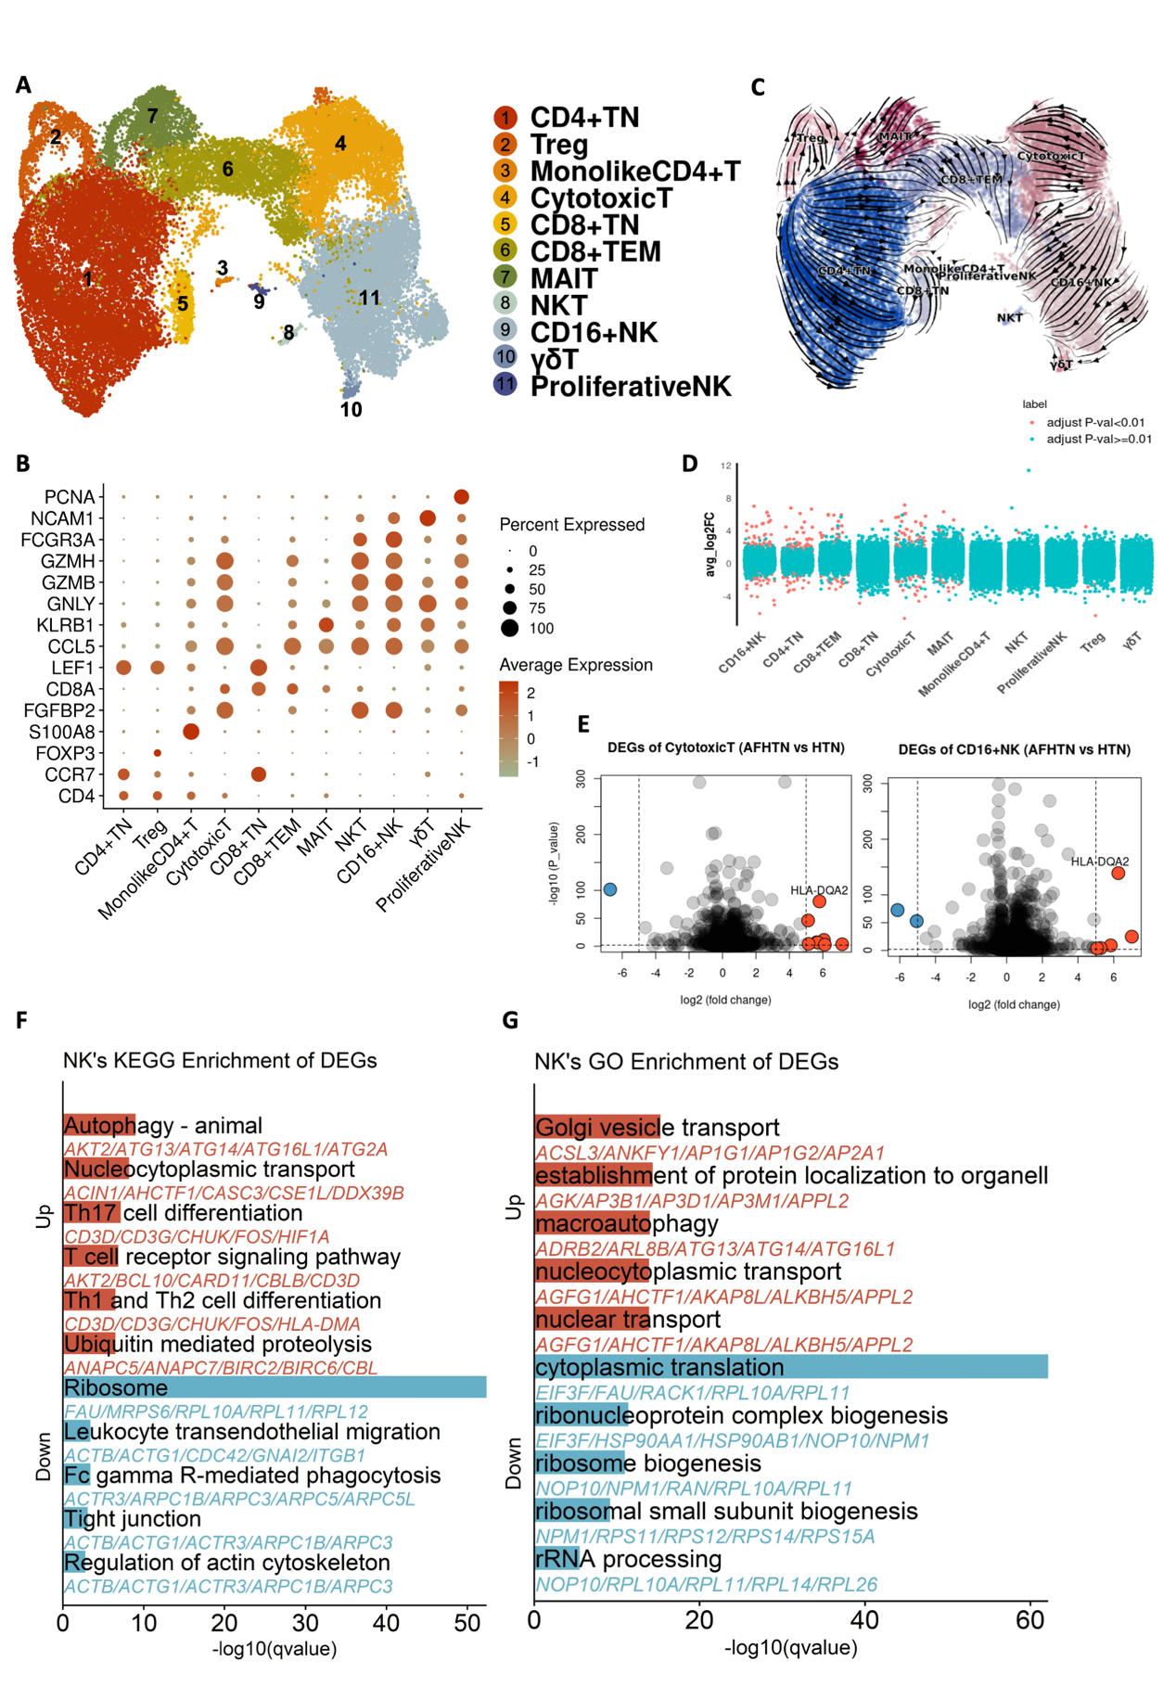

Supplementary Figure 3
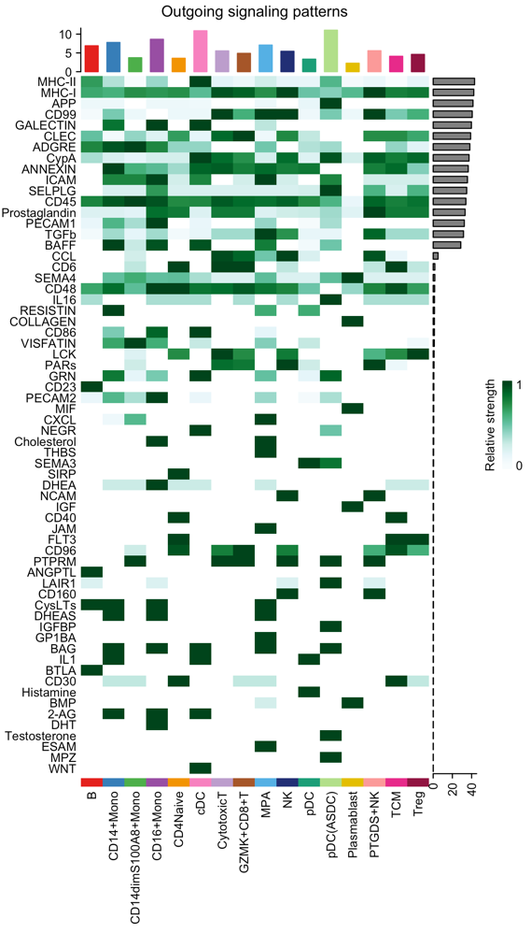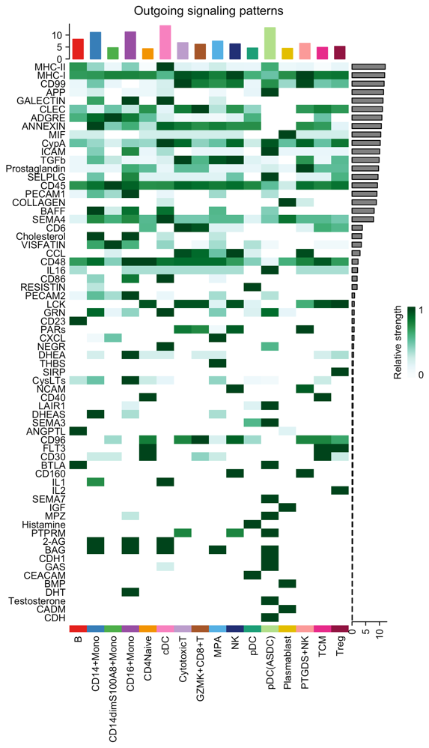

Supplementary Figure 4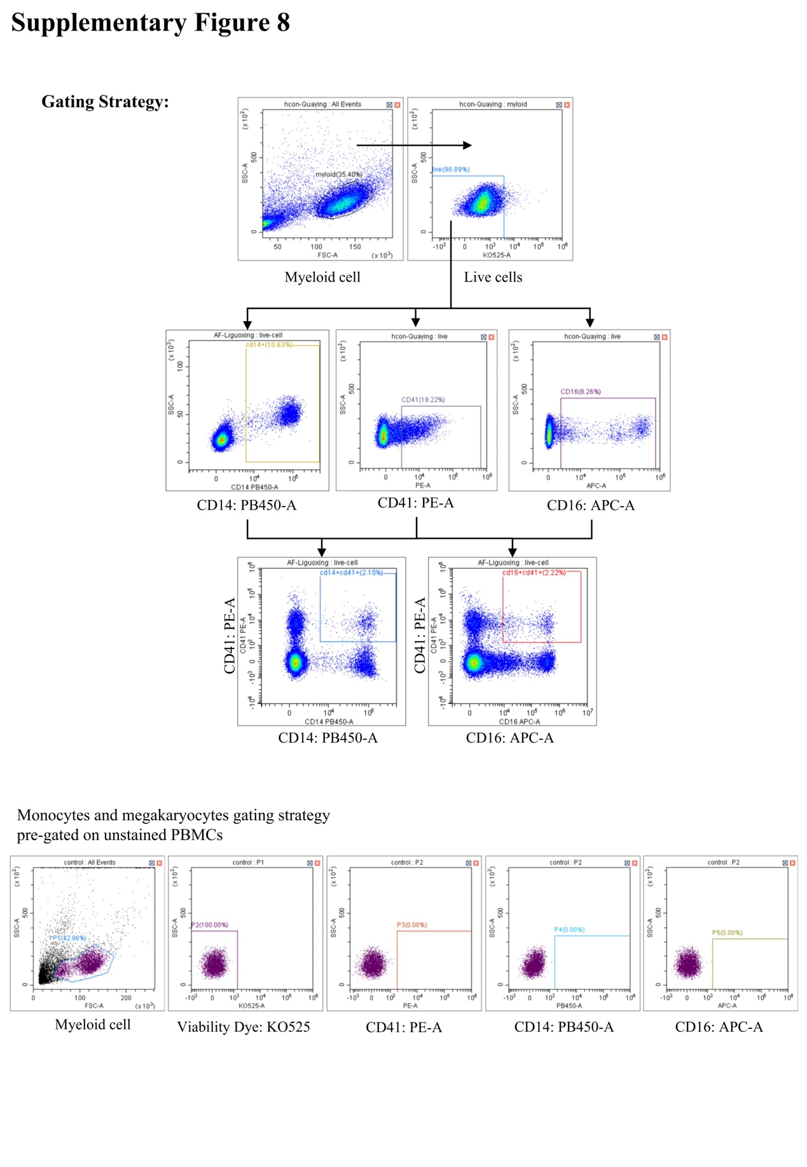

Legend of Supplementary Figure

Supplementary Figure 1 Interaction Analysis Among Cell Clusters
(A) Bar plot comparing the number and strength of interactions between AF and hypertension (HTN).
(B) Scatter plot comparing interaction strength (x-axis) and number (y-axis) between HTN (left) and AF (right).

Supplementary Figure 2 Alterations in T/NK Cell Composition in Hypertensive Patients with Atrial Fibrillation
(A) UMAP plot displaying the subclusters of T cells and NK cells.
(B) Dot plot illustrating the expression of signature genes across the major T and NK cell subtypes.
(C) RNA velocity stream plot depicting the dynamic transitions among the major T and NK cell subtypes.
(D) Differential gene expression analysis highlighting up- and down-regulated genes across all subclusters. Genes with an adjusted p-value < 0.01 are shown in red, while those with an adjusted p-value ≥ 0.01 are shown in blue.
(E) Volcano plot illustrating differentially expressed genes (Bonferroni adjusted p-value < 0.01 and avg_log2FC > 0.5, shown in red) between hypertensive patients with and without AF in cytotoxic T cells and NK cells (i.e., CD16+ NK cells shown in the figure). Co-expressed genes are labeled.
(F) (G) Bar plots representing the KEGG and GO enrichment analysis results for the DEGs in NK cells.

Supplementary Figure 3 Outgoing signaling patterns of HTN (left) and AFHTN (right).

Supplementary Figure 4 Gating strategy
Illustration of positive gating, including gating for live cells in peripheral blood and then for CD14+, CD16+, CD41+, and double-positive cells.

