Supplementary Figure 1. Distribution Characteristics of cell types in cervical cancer tissues. A. The UMAP map shows the distribution of major cell types, including pDC, macrophages, B cells, mast cells, epithelial cells, T cells, CAFs and plasma cells. B. The UMAP distribution of cell types in non-metastatic (normal) and metastatic (tumor) tissues is consistent with the color in Figure A. C. The heat map shows the average expression levels of marker genes in different cell types. D. The dot plot shows the expression ratio and average expression level of marker genes in each cell type. 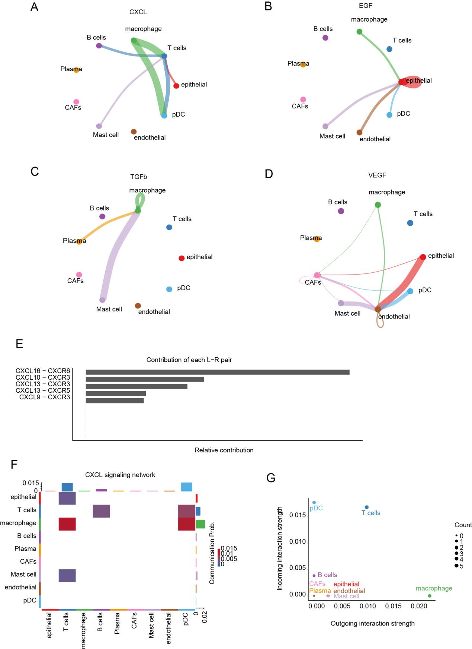Supplementary Figure 2. Analysis of intercellular communication in cervical cancer tissues with metastasis. A-D. Intercellular communication network based on ligand -receptor pairs of CXCL, EGF, TGFB, and VEGF. Nodes represent different cell types, lines represent cell-to-cell communication, and line thickness represents interaction strength. E. Ranking of contribution of ligand-receptor pairs in the CXCL signaling pathway. The ligand-receptor pair names are shown on the left and the corresponding contribution bars are shown on the right. F. Heat map of the relative contributions of different cell types in the CXCL signaling pathway. Rows represent source cell types, columns represent target cell types, and colors ranging from light blue to dark red indicate contribution levels from low to high. G. Bubble charts of input and output interactions among different cell types. The size of the bubbles indicates the number of interactions (Count), and the color represents different cell types.

Supplementary Figure 3. Analysis of intercellular communication between EGF and TGFB signaling pathways in cervical cancer tissues with metastasis. A. The contribution ranking of ligand-receptor pairs in the EGF signaling pathway. On the left is the name of the ligand-receptor pair, and on the right is the corresponding contribution bar chart. B. Heat map of the relative contributions of different cell types in the EGF signaling pathway. Rows represent source cell types, columns represent target cell types, and colors ranging from light blue to dark red indicate contribution levels from low to high. C. Bubble charts of input and output interactions among different cell types. The size of the bubbles indicates the number of interactions (Count), and the color represents different cell types. D. The contribution ranking of ligand-receptor pairs in the TGFB signaling pathway. On the left is the name of the ligand-receptor pair, and on the right is the corresponding contribution bar chart. E. Heat map of the relative contributions of different cell types in the TGFB signaling pathway. Rows represent source cell types, columns represent target cell types, and colors ranging from light blue to dark red indicate contribution levels from low to high. F. Bubble chart of input and output interactions among different cell types. The size of the bubbles indicates the number of interactions (Count), and the color represents different cell types. Supplementary Figure 4. Analysis of intercellular communication between VEGF and THBS signaling pathways in cervical cancer tissues with metastasis. A. Contribution ranking of ligand-receptor pairs in the VEGF signaling pathway. On the left is the name of the ligand-receptor pair, and on the right is the corresponding contribution bar chart. B. Heat map of the relative contributions of different cell types in the VEGF signaling pathway. Rows represent source cell types, columns represent target cell types, and colors ranging from light blue to dark red indicate contribution levels from low to high. C. Bubble chart of input and output interactions among different cell types. The size of the bubbles indicates the number of interactions (Count), and the color represents different cell types. D. Contribution ranking of ligand-receptor pairs in the THBS signaling pathway. On the left is the name of the ligand-receptor pair, and on the right is the corresponding contribution bar chart. E. Heat map of the relative contributions of different cell types in the THBS signaling pathway. Rows represent source cell types, columns represent target cell types, and colors ranging from light blue to dark red indicate contribution levels from low to high. F. Bubble chart of input and output interactions among different cell types. The size of the bubbles indicates the number of interactions (Count), and the color represents different cell types. Supplementary Figure 5. The distribution and gene expression characteristics of cancer-associated fibroblasts (CAFs) subsets. A. UMAP map shows the distribution of CAFs subsets in tumor tissues of 6 patients with and without metastasis. Each plot represents a sample (normal1-3, turned1-3), and different colors indicate different cell lineages. B. The heat map shows the average expression levels of marker genes in different cell types. Rows represent different cell types, columns represent different marker genes, and colors ranging from light yellow to dark blue indicate expression levels from low to high. C. Dot plots show the expression distribution of marker genes in different cell types. The size of the dots indicates the proportion of cells expressing the gene in the corresponding cell type, and the color indicates the mean expression level. In the legend, the size of the dots corresponds to the proportion of cells (25, 50), and the color ranges from light yellow to dark blue to indicate the expression level from low to high.

Supplementary Figure 6. Functional enrichment and expression analysis of differentially expressed CAFs genes in cervical cancer with metastasis. A-B. The bubble chart of functional enrichment of differentially expressed genes, with the horizontal axis representing gene ratios and the vertical axis representing functional terms. The size of the bubbles indicates the number of genes, and the color represents the adjusted P-value. C. The box plot shows the expression levels of differentially expressed genes in cervical cancer cells with and without metastasis.
Supplementary Figure 7. Characteristic Analysis of tumor-associated macrophages in cervical Cancer with metastasis. A. The UMAP graph shows the distribution of macrophage subsets in tumor tissues of 6 patients with and without metastasis. B. The heat map shows the average expression levels of marker genes in different cell types. C. Dot plots show the expression ratios and average levels of marker genes in each cell type.

