Supporting Information
Designing 3D Oxygen–Diffusion Scaffolds for High-performance Metal Fuels
Shan Feng^{1,2#}, Hexige Wuliji^{1,3#*}, Ruifeng Liu¹, Xinba Yaer¹, Xiaoping Niu², Jun Wang⁴, Kunpeng Zhao^{5*} and Hexi Baoyin^{6,7*}
¹ Inner Mongolia Engineering Research Center of Multi-functional Copper Alloys, School of Materials Science and Engineering, Inner Mongolia University of Technology, Hohhot, 010051, China.
² China North Nuclear Fuel Co., Ltd., Baotou, 014035, China.
³ Key Laboratory of Advanced Optoelectronic Quantum Architecture and Measurement, Ministry of Education, School of Physics, Beijing Institute of Technology, Beijing 100081, China.
⁴ Inner Mongolia Key Laboratory of Biophysics and Bioinformatics, School of Physical Science and Technology, Inner Mongolia University, Hohhot, 010021, China.
⁵ State Key Laboratory of Metal Matrix Composites, School of Materials Science and Engineering, Shanghai Jiao Tong University, Shanghai, 200240, China.
⁶ Inner Mongolia Key Laboratory of New Energy and Energy Storage Technology, Inner Mongolia University of Technology, Hohhot, 010051, China.
⁷ School of Aerospace Engineering, Tsinghua University, Beijing, 100084, China.
* Corresponding authors: wljhxg@imut.edu.cn; zkp.1989@sjtu.edu.cn and baoyin@tsinghua.edu.cn.
# These authors contributed equally: Shan Feng and Hexige Wuliji.

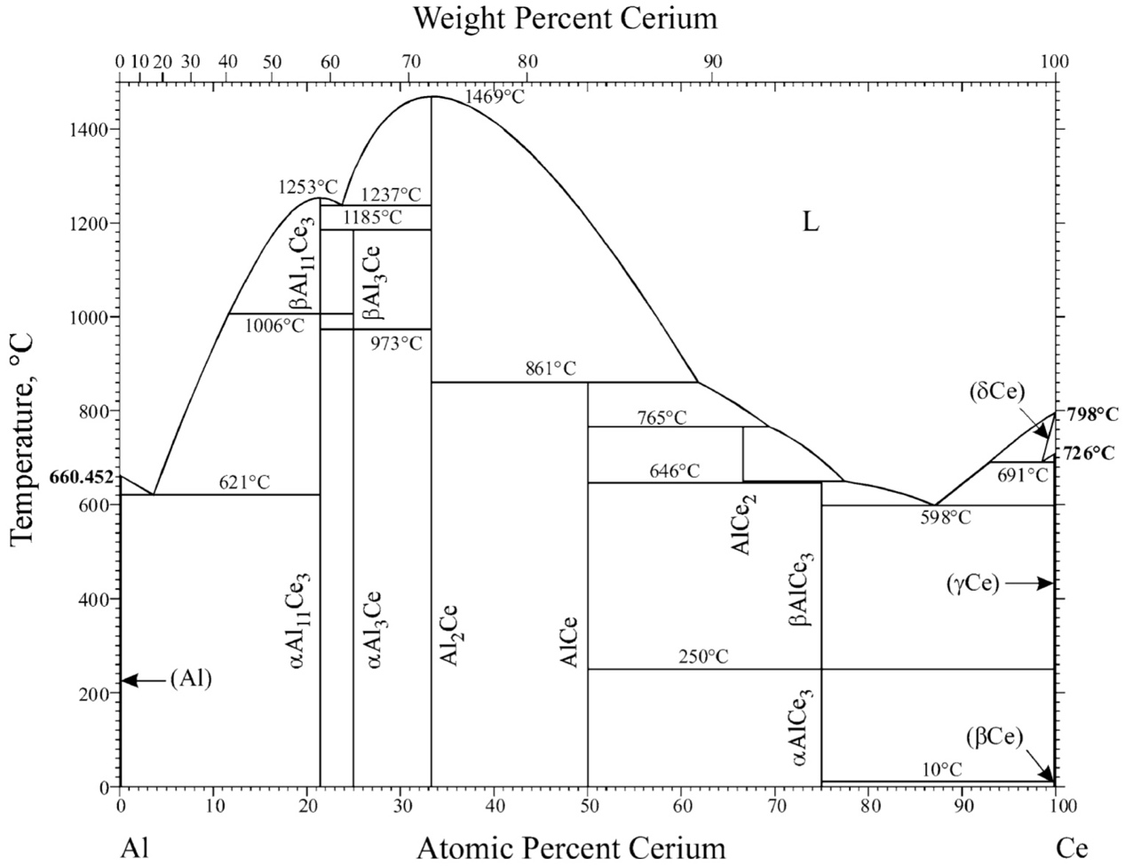
Fig. S1. Al-Ce binary phase diagram¹.

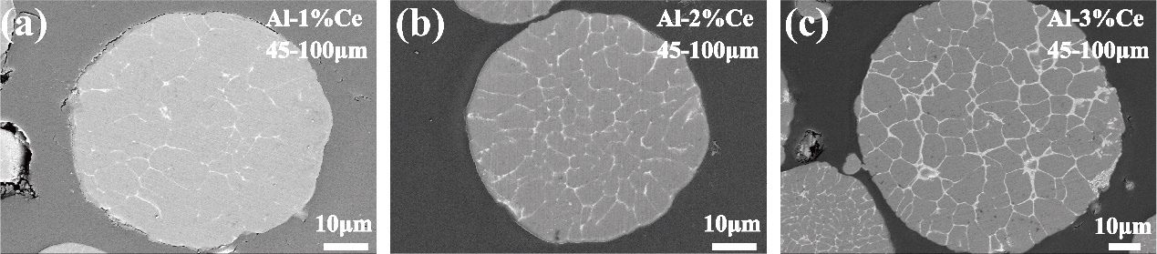
Fig. S2. SEM images of Al–xCe (x = 1, 2, 3 wt.%) alloy powders with 45-100μm particle size. (a) Al-1%Ce, (b) Al-2%Ce , (c) Al-3%Ce.

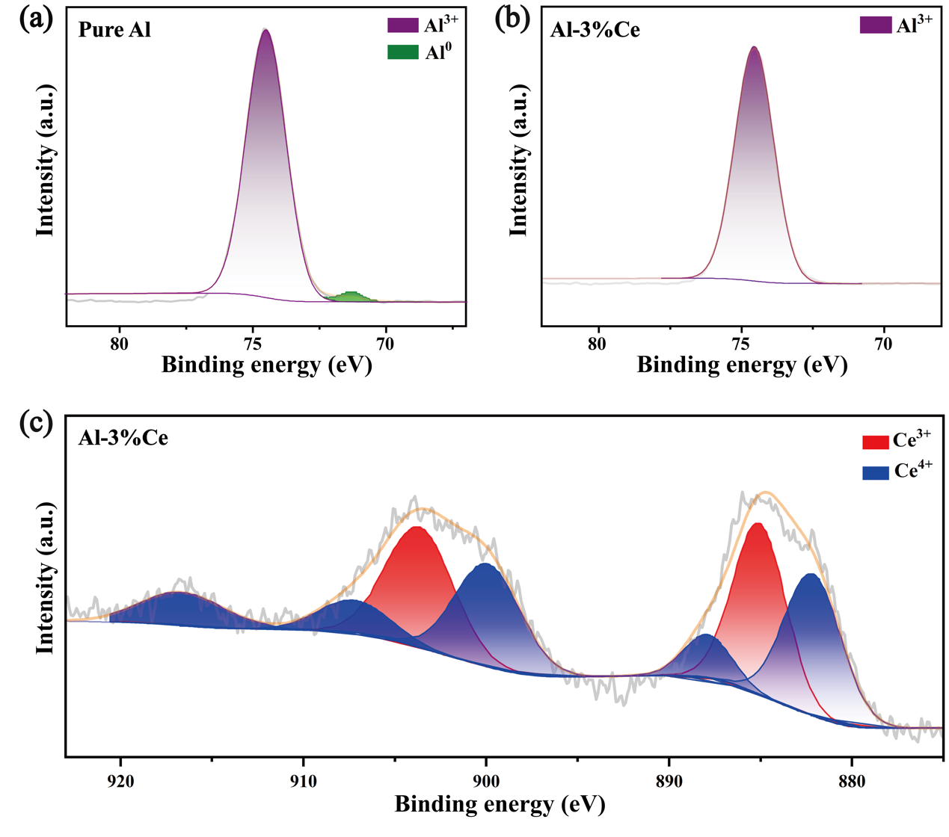
Fig. S3. XPS spectrum of (a) Al³⁺ and Al in the combustion products of pure Al powder, (b) Al–3%Ce alloy powders, and (c) Ce³⁺/Ce⁴⁺ of Al–3%Ce alloy powders.

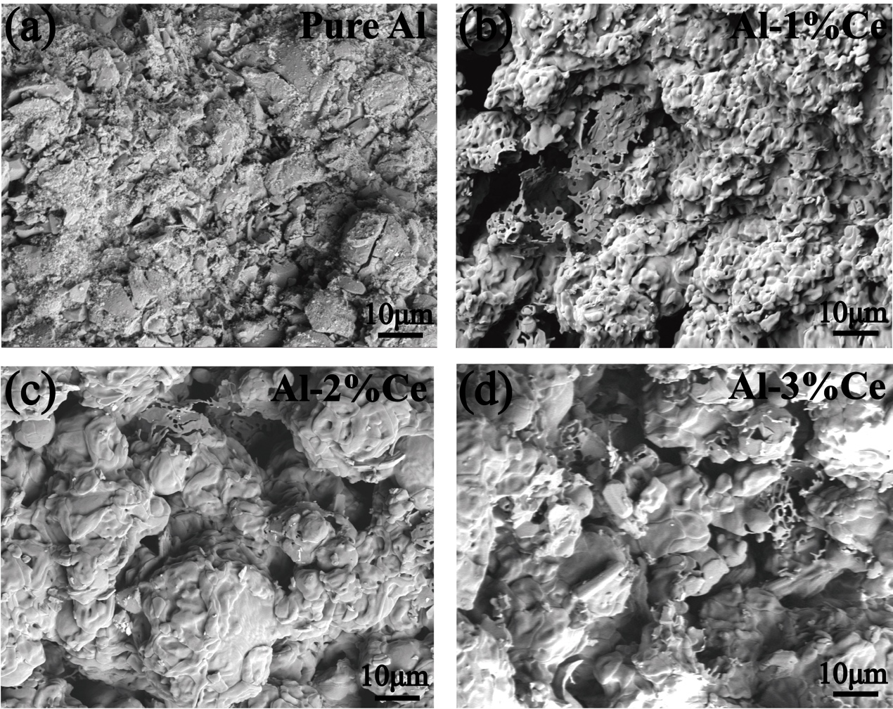
Fig. S4. SEM images of combustion products for (a) Pure Al, (b) Al-1%Ce, (c) Al-2%Ce, and (d) Al-3%Ce Powder.

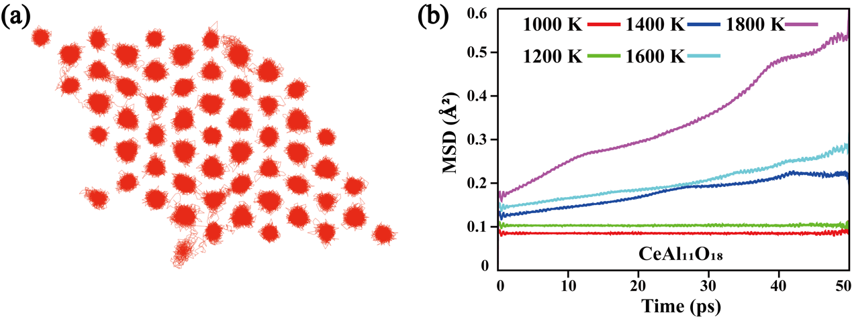
Fig. S5. (a) Oxygen atom trajectories and (b) mean square displacement (MSD) of O atom in CeAl₁₁O₁₈.

References
1. Okamoto, H. Al-Ce (Aluminum-Cerium). J. Phase Equilibria Diffus. 32, 392–393 (2011).

