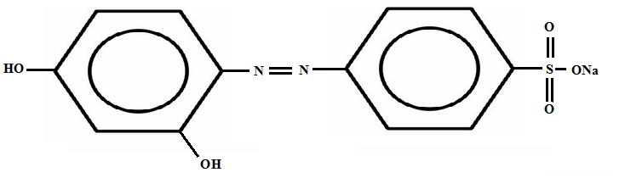
Scheme-I: Chemical structure of Tropaeline-O dye.
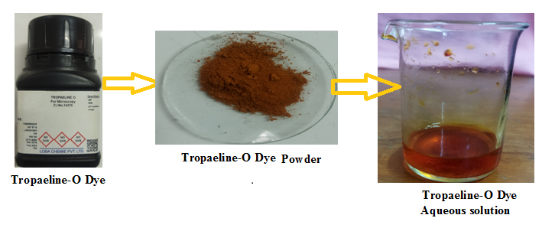 (Scheme II): Tropaeline-O powder and its aqueous solution

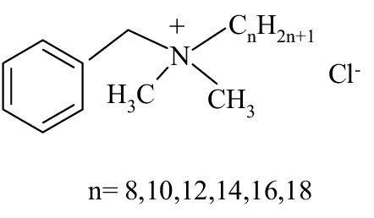
Scheme-III: Chemical structure of Benzalkonium chloride surfactant.
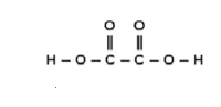
Scheme-IV: Chemical structure of Oxalic acid reductant.

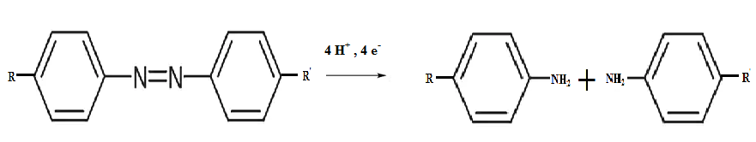
Scheme-V: Reduction of azo dye
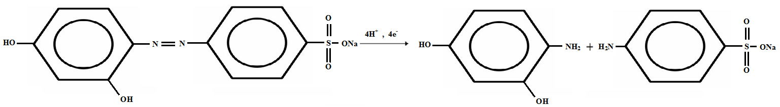
Scheme-VI: Reduction of Tropaeline-O dye

