Evaluating the effect of sorafenib on Gd-EOB-DTPA-mediated contrast enhancement: An experimental study using DCE-MRI
Yeon Ji Chae^{1,2}, Do-Wan Lee³, Chul-Woong Woo², Yu Sub Sung^{1,2}, Jung-Hyun Choi⁴, Eunyoung Tak¹, Chang Hoon Ha¹, Jin Kyung Roh¹, In-Jeoung Baek^{1,2}, Chan-Gi Pack^{1,2}, Hwon Heo², Kyung Won Kim³, Jeong Kon Kim³, Yoonseok Choi^{5*}, Dong-Cheol Woo^{1,2*}

¹Department of Convergence Medicine, Asan Medical Center, University of Ulsan College of Medicine, Seoul, Republic of Korea
²Convergence Medicine Research Center, Asan Institute for Life Sciences, Asan Medical Center, Seoul, Republic of Korea
³Department of Radiology, Asan Medical Center, University of Ulsan College of Medicine, Seoul, Republic of Korea
⁴Department of Biochemistry, Chungbuk National University, Cheongju, Korea
⁵Medical Research Institute, Gangneung Asan Hospital, Gangneung-si, Gangwon-do, Republic of Korea

Corresponding Author:
Yoonseok Choi, Medical Research Institute, Gangneung Asan Hospital, University of Ulsan College of Medicine 38, Bangdong-gil, Sacheon-myeon, Gangneung-si, Gangwon-do 25440, Korea. Tel: +82-33-610-4799, Fax: +82-33-610-3089, E-mail: yschoi21rad@gnah.co.kr
Dong Cheol Woo, Convergence Medicine Research Center, Asan Institute for Life Sciences, Asan Medical Center 88, Olympic-ro 43-gil, Songpa-gu, Seoul 05505, Korea. Tel: +82-2-3010-4155, Fax: +82-10-5559-7102, E-mail: dcwoo@amc.seoul.kr
Supplemental Figure
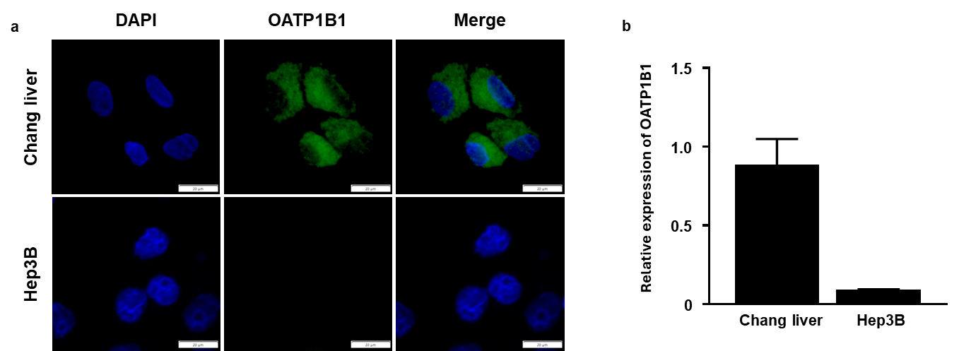
Supplementary Figure 1. Expression of OATP1B1. (a) OATP1B1 immunofluorescence stain in Chang liver and Hep3B cells. (b) qRT-PCR expression of OATP1B1 in Chang liver and Hep3B cells.

