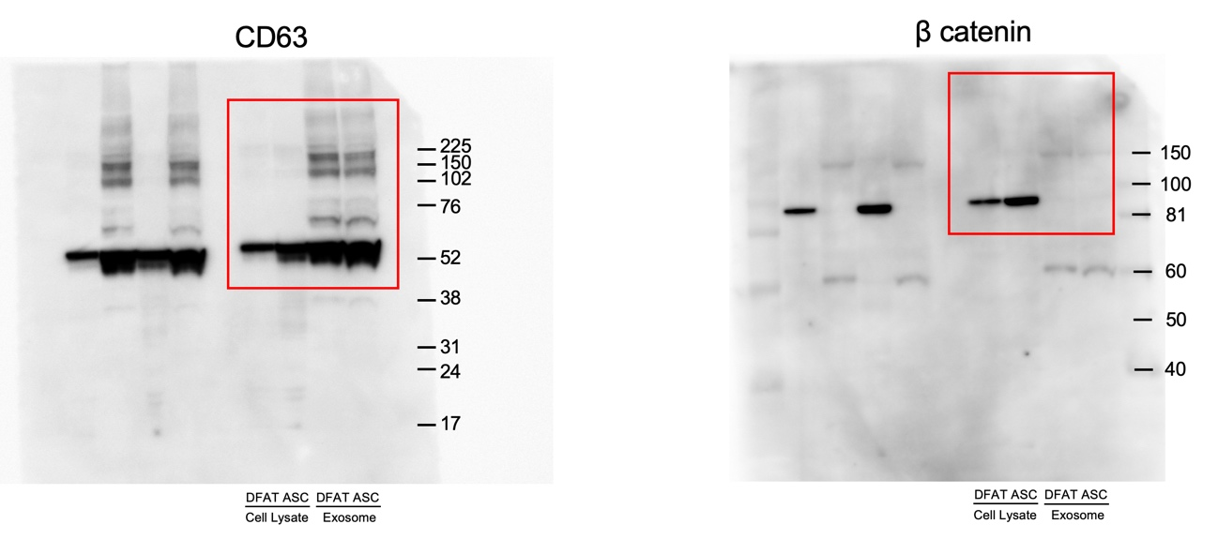

Supplementary Fig. S1. Uncropped and unedited Western blot images corresponding to Fig. 1b. Red boxes indicate the regions shown in the main figures.

