Cord blood co-methylation network mediates the association between prenatal diet and cognition at age 2 years: A birth cohort study

Supplementary material
Table of Contents
Figure S1. Summary table and volcano plot from the epigenome-wide association study (EWAS) of cognition. 2
Figure S2. Construction of co-methylation networks using Weighted Gene Co-expression Network Analysis (WGCNA). 3
Table S1. Associations between prenatal dietary factors and child outcomes (cognition and language) at 2 years old 4
Table S2. Sensitivity analysis of the mediating role of Co-MN^{cog1} in the relationship between prenatal diet and children’s Bayley III scores. 5
Table S3. Interventional Effects of prenatal wholefood dietary pattern on children’s cognition (Bayley-III) through maternal GlycA (M1) at 28 weeks of gestation and Co-MN^{cog1} (M2) at cord blood. 6
Table S4. APrON Neurotox sub-sample characteristics . 6
Table S5. Association between the Co-MN^{cog1} network and Bayley-III and parent reported outcomes at age 2 years in the APrON cohort 7

CpG | Chromosome/position | Gene | logFC
cg00125947 | chr12, 133324413 | ANKLE2 (body) | 0.0265
cg24094073 | chr6, 168376325 |  | -0.0132
cg11131384 | chr18, 48188506 | MAPK4 (5'UTR; | -0.022
cg27068297 | chr15, 43813642 | MAP1A;RNU6-28P5'UTR;Body | 0.011
cg03187614 | chr11, 1965140 |  | 0.127
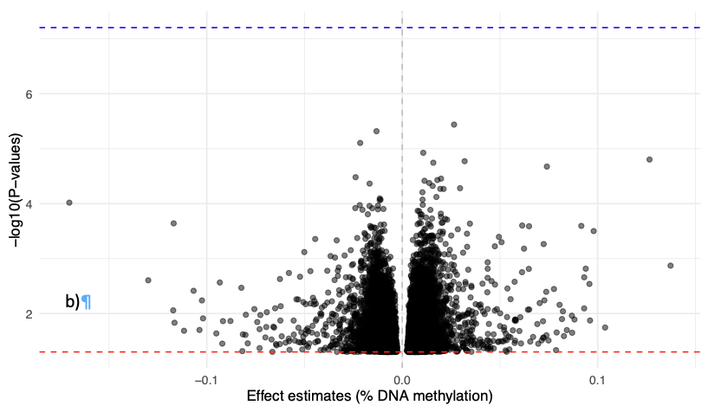
B
A

Figure S1. Summary table and volcano plot from the epigenome-wide association study (EWAS) of cognition.
a) The top five CpGs including chromosome number, position, gene annotation, and log fold change. b) Volcano plot showing 20,043 unadjusted CpG p-values, with direction of association between DNA methylation variation and the continuous cognitive outcome (Bayley-III at age 2 years). No CpGs passed the FDR threshold, with the lowest adjusted p-value being 0.99. The blue line indicates the Bonferroni threshold, and the red line indicates the conventional unadjusted significance threshold (p < 0.05). The x-axis represents the percentage difference in methylation per one-unit increase in the cognitive subscale score, and the y-axis represents –log10 (p-value).

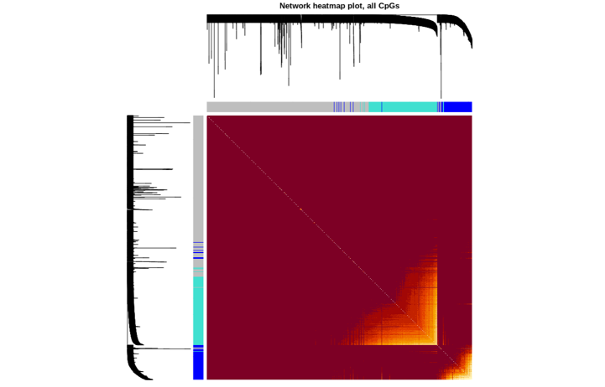
A

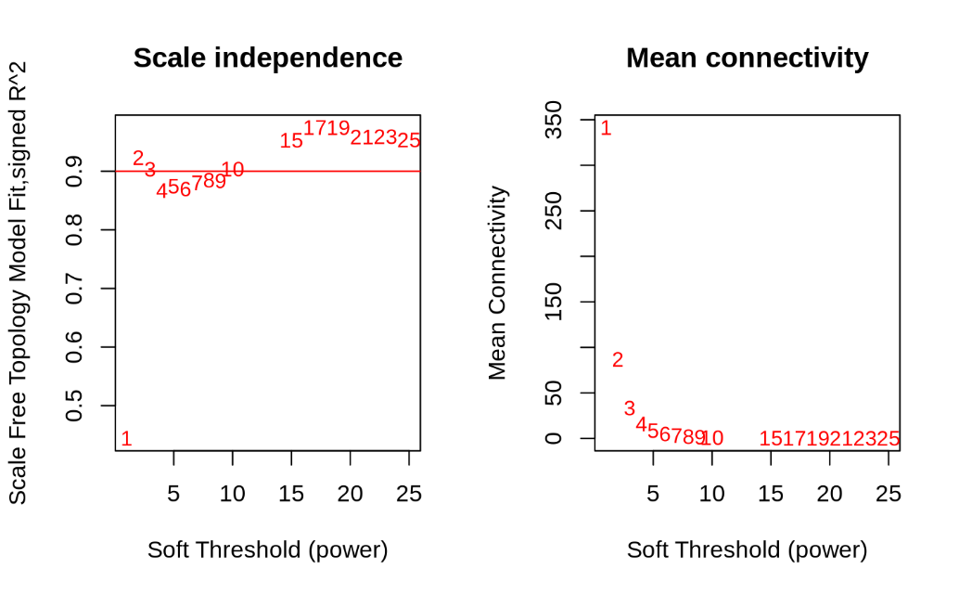
B

C

Figure S2. Construction of co-methylation networks using Weighted Gene Co-expression Network Analysis (WGCNA).
a) Sample clustering to detect outliers (none observed). b) Scale-free topology fit index and mean connectivity used to select the optimal power parameter. c) Cluster dendrogram built by hierarchical clustering of the dissimilarity (1–Topological Overlap Matrix) matrix, where height represents dissimilarity. Each colour corresponds to one co-methylation module; grey denotes unclustered CpGs. d) Heatmap representation of module topological overlap. Pale shades indicate minimal topological overlap, while deeper red shades indicate stronger overlap.

Table S1. Associations between prenatal dietary factors and child outcomes (cognition and language) at 2 years old
Prenatal maternal factors | Child Cognition scores |  |  |  | Child Receptive Communication score |  |  |  | Child Expressive Communication score
Prenatal maternal factors | β | 95% CI | p-value |  | β | 95% CI | p-value |  | β | 95% CI LL | p-value
Wholefoods dietary pattern | 0.71 | 0.40, 1.02 | <0.001 |  | 1.02 | 0.68, 1.36 | <0.001 |  | 1.00 | 0.56, 1.43 | <0.001
Dietary inflammatory index | -0.39 | -0.59, -0.19 | <0.001 |  | -0.46 | -0.68, -0.24 | <0.001 |  | -0.31 | -0.60, -0.02 | 0.039
Processed dietary pattern | -0.83 | -1.41,-0.25 | 0.005 |  | -1.24 | -1.89, -0.59 | <0.001 |  | -1.10 | -1.94, -0.26 | 0.010

Adjusted for dietary energy intake, child’s post-conceptional age at the time of Bayley-III testing, Bayley-III tester experience, child’s sex at birth. Such association was previously published by (13, 53)

Table S2. Sensitivity analysis of the mediating role of Co-MN^{cog1} in the relationship between prenatal diet and children’s Bayley III scores.
 |  | Child’s Bayley-III raw score
 |  | Cognition |  | Receptive communication |  | Expressive communication
Prenatal dietary factors | Effects | β (95%CI) | p-value | β (95%CI) | p-value | β (95%CI) | p-value
Co-MN^{cog1} as mediator
Wholefood diet | Indirect | 0.05 (0,0.12) | 0.046 | 0.05 (0, 0.13) | 0.068 | 0.05 (-0.02,0.14) | 0.2
 | Direct | 0.32 (0,0.65) | 0.050 | 0.50 (0.14, 0.88) | 0.008 | 0.62 (0.17,1.11) | 0.008
 | Total | 0.36 (0.04,0.70) | 0.036 | 0.55 (0.18, 0.94) | 0.004 | 0.67 (0.20, 1.15) | 0.004
 | Proportion mediated = 12% |  |  | Proportion mediated=8% |  | Proportion mediated = 6%
Dietary inflammatory index | Indirect | -0.03 (-0.07,0) | 0.032 | -0.03 (-0.07, 0) | 0.054 | -0.02 (-0.07, 0.01) | 0.18
 | Direct | -0.10 (-0.28,0.08) | 0.27 | -0.12 (-0.32, 0.08) | 0.24 | 0 (-0.25,0.26) | 0.98
 | Total | -0.13 (-0.30, 0.05) | 0.15 | -0.15 (-0.35, 0.05) | 0.14 | -0.02 (-0.27, 0.24) | 0.85
 | Proportion mediated = 17% |  |  | Proportion mediated 15% |  | Proportion mediated = 4%
Processed dietary pattern | Indirect | -0.05 (-0.15, 0.03) | 0.21 | -0.07 (-0.19, 0.03) | 0.17 | -0.046 (-0.17,0.04) | 0.35
 | Direct | -0.36 (-0.7, -0.01) | 0.048 | -0.45 (-0.85, -0.05) | 0.026 | -0.71 (-1.2, -0.20) | 0.006
 | Total | -0.42 (-0.77, -0.05) | 0.022 | -0.52 (-0.93, -0.09) | 0.014 | -0.76 (-1.26, -0.24) | 0.004
Note: Models were adjusted for socioeconomic adversity (lower maternal education and/or lower household income vs otherwise) PC 1 of genetic ancestry, dietary energy, mother’s age (less than 25 vs not), child’s gender assigned at birth, child’s post-conceptional age at time of Bayley-III testing, Bayley-III tester experience and passive tobacco smoking during pregnancy and total day of activity per week.
Note: Adjusting for pre-pregnancy BMI (kg/m²) did NOT significantly change these results.

Table S3. Interventional Effects of prenatal wholefood dietary pattern on children’s cognition (Bayley-III) through maternal GlycA (M1) at 28 weeks of gestation and Co-MN^{cog1} (M2) at cord blood.
Effect | Β (95%CI) | P-value | Proportion mediated
Indirect effect through mediator 1  (M1: maternal GlycA) | 0.03 (-0.02, 0.09) | 0.210 | 5%
Indirect effect through mediator 2  (M2: Co-MN^{cog1}) | 0.05 (-0.00,0.12) | 0.054 | 9%
Direct effect | 0.44 (0.08, 0.81) | 0.018 | -
Total effect | 0.52 (0.16, 0.88) | 0.004 | -
Note: Models were adjusted for socioeconomic adversity (based on maternal education and household income), PC1 of ancestry, dietary energy, mother’s age (less than 25 years vs not), child’s assigned sex at birth, child’s post-conceptional age at time of Bayley-III testing, Bayley-III tester experience. Bold values show p<0.05, italics show p<0.1.

Table S4. APrON Neurotox sub-sample characteristics .
 | Buffy coat blood subset  (n = 145) | BEC subset  (n = 240)
Characteristic | N (%); M (SD, range) | N (%); M (SD, range)
Maternal Characteristic
Maternal self-reported race
White | 131 (90.34%) | 207 (86.25%)
Non-White | 14 (9.66%) | 33 (13.75%)
Maternal parity
Primiparous | 80 (55.17%) | 143 (59.58%)
Multiparous | 65 (44.83%) | 97 (40.42%)
Maternal age (years) | 32.24 (4.08) | 31.94 (4.35)
Child Characteristic
Sex at birth
Female | 73 (50.34%) | 109 (45.42%)
Male | 72 (49.66%) | 131 (54.58%)
Gestational age at birth (weeks) | 39.41 (1.38) | 38.99 (1.83)
Birthweight (grams) | 3464 (499) | 3343 (551)
Infant age at biological sample collection (weeks) | 12.38 (1.31) | 13.07 (3.00)
Child age at Bayley-III (years) | 2.55 (0.13) | 2.53 (0.11)

Table S5. Association between the Co-MN^{cog1} network and Bayley-III and parent reported outcomes at age 2 years in the APrON cohort.
Bayley-III outcome | Buffy coat blood subset  β (95%CI) p value | BEC subset  β (95%CI) p value
Cognitive compositeª | 0.08 (-0.16, 0.32) 0.511 | 0.08 (-0.1, 0.25) 0.395
Language compositeª | -0.03 (-0.26, 0.21) 0.826 | -0.05 (-0.24, 0.14) 0.611
Motor compositeª | -0.19 (-0.43, 0.05) 0.116 | -0.07 (-0.27, 0.12) 0.454
Cognitive scaledª | 0.02 (-0.03, 0.06) 0.497 | 0.02 (-0.02, 0.05) 0.399
Receptive Communication scaledª | 0 (-0.04, 0.04) 0.874 | -0.01 (-0.04, 0.02) 0.622
Expressive Communication scaledª | -0.02 (-0.06, 0.03) 0.525 | -0.01 (-0.05, 0.03) 0.77
Fine Motor scaledª | -0.02 (-0.07, 0.02) 0.268 | -0.02 (-0.06, 0.01) 0.138
Gross Motor scaledª | -0.03 (-0.09, 0.02) 0.263 | 0 (-0.05, 0.04) 0.937
Social-Emotional composite^{b} | -0.06 (-0.3, 0.17) 0.587 | -0.21 (-0.38, -0.04) 0.015
General Adaptive composite^{b} | -0.09 (-0.32, 0.14) 0.438 | -0.02 (-0.19, 0.15) 0.83
Social-Emotional scaled^{b} | -0.01 (-0.06, 0.03) 0.608 | -0.04 (-0.08, -0.01) 0.013
Communication scaled^{b} | 0 (-0.04, 0.04) 0.96 | -0.02 (-0.05, 0.01) 0.206
Community Use scaled^{b} | -0.01 (-0.06, 0.03) 0.482 | -0.01 (-0.04, 0.02) 0.61
Functional Pre-academics scaled^{b} | -0.01 (-0.06, 0.03) 0.586 | 0.01 (-0.03, 0.04) 0.731
Home Living scaled^{b} | -0.01 (-0.05, 0.04) 0.714 | 0.01 (-0.02, 0.04) 0.549
Health and Safety scaled^{b} | -0.03 (-0.08, 0.02) 0.195 | -0.02 (-0.06, 0.01) 0.222
Leisure scaled^{b} | 0 (-0.05, 0.05) 0.941 | -0.03 (-0.06, 0.01) 0.121
Self-Care scaled^{b} | -0.01 (-0.05, 0.02) 0.424 | 0.01 (-0.02, 0.04) 0.557
Self-Direction scaled^{b} | -0.02 (-0.07, 0.03) 0.459 | -0.01 (-0.05, 0.02) 0.505
Social scaled^{b} | -0.01 (-0.05, 0.04) 0.726 | 0.01 (-0.03, 0.04) 0.767
Motor scaled^{b} | -0.04 (-0.09, 0.01) 0.099 | 0.03 (-0.01, 0.07) 0.13
Linear regression adjusted for child’s age at assessment and assigned sex at birth.
ªThe performance-based metrics of the Bayley-III were available for the entire subsets (i.e., n = 145 and n= 240 for the buffy coat blood and BEC subsets, respectively)
^{b}The parent-report metrics from the Bayley-III Social-Emotional and Adaptive Behavior Questionnaire were available for n = 130 from the buffy coat blood subset and n= 215 from the BEC subset

