SUPPLEMENTARY FILES
TITLE PAGE
Association of glycated hemoglobin A_{1c} levels with cardiovascular outcomes in the general population: Results from the BiomarCaRE (Biomarker for Cardiovascular Risk Assessment in Europe) consortium
Christoph Sinning^{a,b}*■, Nataliya Makarova^{a,b}*, Henry Völzke^{c,d}, Renate Schnabel^{a,b}, Francisco Ojedaª, Marcus Dörr^{d,e}, Stephan B. Felix^{d,e}, Wolfgang Koenig^{f,g}, Annette Peters^{h,t}, Wolfgang Rathmann^{i}, Ben Schöttker^{j,k}, Hermann Brenner^{j,k,}, Giovanni Veronesi^{l}, Giancarlo Cesana^{m}, Paolo Brambilla^{m}, Tarja Palosaari^{n}, Kari Kuulasmaa^{n}, Inger Njølstadº, Ellisiv Bøgeberg Mathiesen^{p,q}, Tom Wilsgaard^{o,r}, Stefan Blankenberg^{a,b}, Stefan Söderberg^{s+}, Marco M. Ferrario^{l+}, Barbara Thorand^{h,t+}

ª University Heart & Vascular Center Hamburg, Department of Cardiology, Hamburg, Germany
^{b} German Center for Cardiovascular Research (DZHK), Partner Site Hamburg/Kiel/Lübeck, Hamburg, Germany
^{c} University Medicine Greifswald, Institute for Community Medicine, Department of Study of Health in Pomerania/Clinical-Epidemiological Research, Greifswald, Germany
^{d} German Center for Cardiovascular Research (DZHK), Partner site Greifswald, Greifswald, Germany
^{e} University of Medicine Greifswald, Department of Internal Medicine B, Greifswald, Germany;
^{f} German Heart Center Munich, Technical University, Munich, Germany; German Center for Cardiovascular Research (DZHK), Partner Site Munich Heart Alliance, Munich, Germany
^{g} Institute of Epidemiology and Medical Biometry, University of Ulm, Ulm, Germany
^{h} Helmholtz Zentrum München, German Research Center for Environmental Health, Institute of Epidemiology, Neuherberg, Germany
^{i} German Diabetes Center Düsseldorf, Institute of Biometrics and Epidemiology, Düsseldorf, Germany
^{j} German Cancer Research Center, Division of Clinical Epidemiology and Ageing Research, Heidelberg, Germany
^{k} University of Heidelberg, Network Aging Research, Heidelberg, Germany
^{l} EPIMED Research Center, Department of Medicine and Surgery, University of Insubria at Varese, Varese, Italy
^{m} Department of Medicine and Surgery, University of Milano-Bicocca, Milan, Italy
^{n} National Institute for Health and Welfare, Helsinki, Finland
º UiT The Arctic University of Norway, Department of Community Medicine, Tromsø, Norway
^{p} UiT The Arctic University of Norway, Brain and Circulation Research Group, Tromsø, Norway
^{q} University Hospital of North Norway, Neurological Department, Tromsø, Norway
^{r} UiT The Arctic University of Norway, Epidemiology of Chronic Diseases Research Group, Tromsø, Norway
^{s} Umeå University, Department of Public Health and Clinical Medicine, Umeå, Sweden
^{t} German Center for Diabetes Research (DZD), München-Neuherberg, Germany

* Co-shared first
+ Co-shared last

Corresponding author
Christoph Sinning, MD
University Heart & Vascular Center Hamburg
Department of Cardiology
Martinistr. 52
20246 Hamburg
Germany
Tel: +4915222817675
E-Mail: c.sinning@uke.de

Table S1
Overview and description of contributing studies
BiomarCaRE cohorts
Study/cohort (Reference) | Country | Study/cohort full name and short description
MONICA Brianza Study[1] | Italy | The MONICA-Brianza Cohort Study is a prospective observational study of three cohorts of 25-64 years old residents in Brianza, a highly-industrialised area located between Milan and the Swiss border, Northern Italy. Gender- and ten-year age stratified samples were randomly drawn in 1986, 1990, and 1993, and cardiovascular risk factors were investigated at baseline following the procedures of the WHO MONICA Project. The overall participation rate was 69%. For all individuals whole blood and serum samples were stored in a biobank. Persons with ICD-9 code 250 were considered having history of diabetes. An affirmative answer to any one of the options "diabetes mellitus, treated by diet only", "diabetes mellitus, treated by oral hypoglycemic agents", "diabetes mellitus, treated by insulin" or "diabetes mellitus, no therapy" under the question "previous medical history" was considered as history of diabetes.  The protocol was approved by the Monza Hospital Ethical Committee. Study participants were followed up for first coronary or stroke events, fatal and non-fatal, up to the end of 2008, for a median of 15 years. Further details on the study procedures can be found at http://epimed.uninsubria.eu and https://thl.fi/publications/morgam/cohorts/full/italy/ita-bria.htm.
MONICA/Kooperative Gesundheits-forschung in der Region Augsburg (KORA)[2] | Germany | The WHO Multinational Monitoring of Trends and Determinants in Cardiovascular Disease (MONICA)/ Cooperative Health Research in the Region of Augsburg (KORA) cohorts comprise all respondents from representative sample surveys from the city of Augsburg and the less urban Landkreis Augsburg and Landkreis Aichach-Friedberg regions in Bavaria, Southern Germany. List of municipalities and population registers were used as sampling frames for the first and the second stage of two-stage sampling, respectively. The second stage of sampling was stratified by sex and ten-year age group. The Survey 3 (S3) baseline examination (1994-1995) was carried out as part of the WHO MONICA project and consists of 4856 men and women aged 25-74 years with a response rate of 75%. The Survey 4 (S4) baseline examination was carried out in 1999-2001 and includes 4261 participants (response rate: 66%). The S4 study and morbidity and mortality follow-ups were conducted within the frame of KORA. The BiomarCaRE project includes n=4692 and n=4221 participants from S3 and S4, respectively.  Within the framework of the KORA Studies, follow-up questionnaires were sent to each former participant in 1997-1998, in 2002-2003, and in 2008-2009 to obtain information on the occurrence of chronic diseases and risk factors. Mortality follow-up was performed as follows: If a person did not return the follow-up questionnaire, the person's vital status was ascertained through the population registries inside and outside the study area.  Coronary events were identified through the MONICA/KORA Augsburg coronary event registry [3]. Coronary deaths were validated by autopsy reports, death certificates, and chart review from the last treating physician. Self-reported cases of incident stroke were validated by medical records [4]. The diagnostic classification of history of diabetes was done using the general practitioner’s notes or hospital discharge letters. When information on the type of diabetes was not available, it was considered to be type 2 if the age of the person was above 35 years. An affirmative answer to the question "Have you ever been told by a doctor that you have diabetes mellitus?" or if the answer was negative but the person was currently taking medication for diabetes.  Further details on the study procedures can be found under https://thl.fi/publications/morgam/cohorts/full/germany/ger-auga.htm and https://www.helmholtz-muenchen.de/en/kora/.
Study of Health in Pomerania (SHIP)[5] | Germany | The SHIP study is an established population-based project conducted in Northeast Germany. The study aims to assess prevalence and incidence of common risk factors, subclinical disorders and clinical diseases and to investigate associations and interactions among them using comprehensive medical assessments. The first SHIP cohort was recruited between 1997 and 2001 and included 4308 individuals at baseline (SHIP-0, 20-70 years, response 68.8%), 3300 after five years (SHIP-1) and 2333 after 11 years (SHIP-2). In parallel to SHIP-2, baseline examinations of a second, independent cohort (SHIP-TREND) were conducted in 4420 participants (20-79 years, response 50.3%). For the current analysis only SHIP-0 was used. SHIP is one of the population-based projects with very comprehensive examinations including interviews, cardio-metabolic ultrasound exams, cardiopulmonary exercise tests and whole-body magnetic resonance imaging in a general population setting. History of diabetes was self-reported or based on relevant information for diabetes derived from the SHIP-database with level of HbA_{1c} > 6.5%, serum glucose > 11.1 mmol/L, or treatment of the subject with antidiabetic medication). In addition to the examination follow-ups, information on fatal and non-fatal disease is collected on a regular basis. Mortality follow-ups are conducted semi-annually by record linkage with data bases of the regional population registry. Causes of death are defined from the official death documents provided by regional health authorities. Active follow-ups for non-fatal diseases are performed biannually and by interviews during follow-up examinations every five years. Self-reported information is validated by GP’s and using databases of the regional Association of SHI Physicians.  Data from the SHIP study were directly transferred to the University Heart Center Hamburg in accordance with a project specific data transfer agreement.  https://thl.fi/publications/morgam/cohorts/full/germany/ger-grea.htm and http://www.medizin.uni-greifswald.de/cm/fv/ship.html.
ESTHER Study[6, 7] | Germany | ESTHER is a large-scale population-based cohort study, which was initiated to study potential new approaches for the prevention and early detection of chronic diseases. From June 2000 to December 2002, more than 400 general practitioners recruited 9953 participants, born between 1925 and 1952, during a routine health check-up in Saarland, a state located in the south west of Germany. More than 98% of the participants were of German nationality. All members of compulsory health insurances in Germany (90% of the German population) aged 35 years or older are entitled to have these health-screening examinations focusing on early detection of cardiovascular and renal diseases and diabetes mellitus every 2 years. All participants gave written informed consent. The ESTHER study was approved by the Ethics Committees of the Medical Faculty, University of Heidelberg and of the Medical Association of Saarland and is conducted in accordance with the Declaration of Helsinki. All participants completed a standardized questionnaire regarding sociodemographic and lifestyle factors, and their medical history. Special emphasis was made to record lifetime history of lifestyle factors like smoking, alcohol consumption, physical activity or body weight. History of diabetes was defined as known and newly diagnosed diabetes, which has been documented in the health check-up report by primary physicians. In addition, anti-diabetic drug use was reported by the general practitioners. An affirmative answer to the question “Did a physician ever diagnose diabetes?” is also considered as history of diabetes.  https://thl.fi/morgam/a/publications/cohorts/full/germany/ger-esra.htm and http://esther.dkfz.org/esther/.
The Northern Sweden MONICA Study[8] | Sweden | The Northern Sweden MONICA Study: The Northern Sweden MONICA study covered the two northernmost counties of Sweden, i.e. Norrbotten and Västerbotten with altogether 510,000 inhabitants. Population surveys were performed in 1986, 1990, 1994, 1999, 2004 and 2009, with altogether 10,517 unique participants [9]. In the first two surveys, 2,000 persons aged 25 to 64 years were randomly selected, and in the last three surveys, the upper age limit was extended to 74 years and 2,500 individuals were invited. A stratified randomized selection procedure by age and sex (250 persons in each sex/10-year age stratum) was used. The participation rate was 69-81%. Detailed analyses of non-participants have been performed. All participants donated blood to the Northern Sweden Biobank in Umeå, and in 2012 samples from the surveys in 1994 and 2009 were thawed and HbA_{1c} was measured. An affirmative answer to the question "Do you have diabetes?" was considered as history of type 1 or type 2 diabetes. If diabetes had been diagnosed before baseline, this was considered indicative of history of diabetes  Incident cardiovascular events (myocardial infarction and stroke) occurring in the region between 1985 and 2010 and below the age of 75 were collected and validated according to MONICA criteria by two event registers whose accuracy and validity have been tested against national registers. Follow-up is available for all cohorts until December 2011 for mortality and non- fatal coronary, stroke, chronic heart failure, atrial fibrillation, cancer and diabetes events. Coronary and stroke events below the age of 75 validated applying the MONICA diagnostic criteria, and diabetes according to careful case review.[10] http://www.thl.fi/publications/morgam/cohorts/full/sweden/swe-nswa.htm
The Tromsø Study[11] | Norway | The Tromsø Study was initiated in 1974 in an attempt to help combat the high mortality of cardiovascular diseases in Norway that was particularly pronounced among middle-aged men. In the mid-1970s, Norwegian men had a 20% risk of dying of myocardial infarction (MI) before the age of 75 years. The Tromsø Study consists of seven surveys (referred to as Tromsø 1–7) that have been conducted in the municipality of Tromsø from 1974 to 2016. The BiomarCaRE project includes participants from Tromsø 3 and 4. HbA_{1c} was measured only among those of Tromsø 4 who attended the second visit with more extensive examinations. Therefore, only this subcohort was included in the current analysis. In this group, everyone in age group 55-74 was invited, as well as 5-10% from age groups 25-54 and 75-85.  An affirmative answer to the question "Do you have, or have you had diabetes:" was considered as self-reported history of diabetes. Possible cases of diabetes were identified through linkage of the Tromsø Study participant list to diabetes related discharge diagnoses in the digital patient records at the only local hospital (ICD- 9 codes 250, 357.2, 362.0, 583.8, 648.0, 648.8, 790.2). Manual and electronic searches for notes on diabetes were also done as a part of our adjudication process for cardiovascular diseases. Cases were classified as having diabetes if they had non-fasting glucose ≥ 11.1 mmol/L, fasting glucose > 7.0 mmol/L, 2 h glucose load ≥ 11.1 mmol/L or HbA1c ≥ 7.0% and/or recorded regular use of insulin or oral anti-diabetic drugs. The diagnosis of diabetes was based on information from the medical records.  All participants are being followed-up with regard to mortality and disease incidence. Further details on the study procedures can be found at https://thl.fi/morgam/a/publications/cohorts/full/norway/nor-tro.htm and https://en.uit.no/prosjekter/prosjekt?p_document_id=80172.

Table S2. Baseline characteristics shown for each study cohort separately
 | All (N=36180) | Brianza (N=3155) | ESTHER (N=9767) | MONICA/KORA (N=8641) | Northern Sweden (N=3045) | SHIP (N=4402) | Tromso (N=7170)
Baseline characteristics
Survey year | 1987-2012 | 1987-1994 | 2000-2003 | 1994-2001 | 1994-2009 | 2008-2012 | 1994-1995
Examination age (years) | 57.4  (47.0, 65.1) | 46.7  (36.9, 56.1) | 62.6  (57.1, 67.2) | 50.2  (37.6, 61.7) | 50.6  (38.3, 61.9) | 53.0  (40.0, 64.0) | 60.4  (54.3, 67.4)
Male (%) | 17069  (47.2) | 1564  (49.6) | 4404  (45.1) | 4334  (50.2) | 1541  (50.6) | 2133  (48.5) | 3093  (43.1)
BMI (kg/m²) | 26.4  (23.8, 29.4) | 25.0  (22.6, 28.0) | 27.3  (24.8, 30.1) | 26.5  (23.9, 29.6) | 25.8  (23.3, 28.7) | 27.5  (24.5, 31.0) | 25.5  (23.2, 28.2)
Daily smoker (%) | 8243  (27.7) | 910  (28.9) | 1438  (43.0) | 1957  (22.7) | 500  (16.5) | 1179  (26.9) | 2259  (31.5)
High blood pressure (%) | 17084  (47.5) | 1046  (33.4) | 5226  (54.5) | 3429  (39.8) | 1098  (36.1) | 2100  (47.8) | 4185  (58.4)
Systolic BP (mmHg) | 133.5  (120.0, 149.0) | 126.0  (114.0, 140.0) | 140.0  (130.0, 150.0) | 129.5  (118.0, 144.0) | 126.0  (115.0, 140.0) | 127.0  (114.5, 139.5) | 142.5  (129.5, 159.5)
Diastolic BP (mmHg) | 80.0  (74.0, 90.0) | 81.0  (74.0, 89.0) | 80.0  (80.0, 90.0) | 80.0  (73.0, 88.0) | 79.0  (72.0, 87.0) | 76.5  (70.0, 83.5) | 83.0  (75.0, 92.5)
Antihypertensive (%) | 7827  (21.7) | 358  (11.4) | 3371  (34.7) | 1242  (14.4) | 442  (14.8) | 1527  (34.7) | 887  (12.4)
Diabetes (%) | 3684  (10.2) | 235  (7.4) | 1842  (18.9) | 530  (6.1) | 243  (8.0) | 550  (12.5) | 284  (4.0)
Family history of CHD (%) | 4716  (18.6) | 553  (17.6) | 1216  (12.6) | 848  (19.1) | 317  (13.1) | - | 1782  (31.3)
Prev. MI or stroke (%) | 2132  (6.0) | 58  (1.8) | 798  (8.5) | 283  (3.3) | 179  (5.9) | 215  (4.9) | 599  (8.4)
History of MI (%) | 1417  (4.0) | 36  (1.1) | 522  (5.5) | 174  (2.0) | 111  (3.6) | 132  (3.0) | 442  (6.2)
Prev. Stroke (%) | 862  (2.4) | 23  (0.7) | 329  (3.5) | 132  (1.5) | 78  (2.6) | 100  (2.3) | 200  (2.8)
History of heart failure (%) | 1454  (5.7) | - | 980  (10.1) | 331  (4.0) | 21  (0.7) | 122  (2.8) | -
Endpoints
Cardiovascular mortality (%) | 1392  (3.9) | 58  (1.8) | 315  (3.2) | 260  (3.0) | 95  (3.1) | 24  (0.6) | 640  (8.9)
Cardiovascular disease (%) | 2339  (8.2) | 202  (6.5) | 182  (2.2) | 409  (5.3) | 216  (7.5) | - | 1330  (20.2)
Overall mortality (%) | 4601  (12.7) | 309  (9.8) | 1137  (11.6) | 852  (9.9) | 278  (9.1) | 135  (3.1) | 1890  (26.4)
Biomarkers
HbA_{1c} (mmol/mol) | 36.6  (32.2, 39.9) | 35.5  (30.1, 41.0) | 37.7  (34.4, 42.1) | 34.4  (31.1, 38.8) | 38.0  (35.0, 42.0) | 34.4  (30.1, 38.8) | 35.5  (32.2, 37.7)
HbA_{1c} (%) | 5.5  (5.1, 5.8) | 5.4  (4.9, 5.9) | 5.6  (5.3, 6.0) | 5.3  (5.0, 5.7) | 5.6  (5.4, 6.0) | 5.3  (4.9, 5.7) | 5.4  (5.1, 5.6)
Total cholesterol (mmol/L) | 5.9  (5.0, 6.7) | 5.5  (4.8, 6.3) | 5.7  (4.8, 6.5) | 5.8  (5.1, 6.6) | 5.8  (5.0, 6.6) | 5.4  (4.6, 6.1) | 6.6  (5.8, 7.5)
HDL cholesterol (mmol/L) | 1.4  (1.2, 1.7) | 1.4  (1.2, 1.7) | 1.3  (1.1, 1.6) | 1.4  (1.1, 1.7) | 1.4  (1.2, 1.7) | 1.4  (1.2, 1.7) | 1.5  (1.2, 1.8)

Baseline characteristics are presented as absolute and relative frequencies for categorical variables, and quartiles (medians with 25th and 75th percentiles) for continuous variables as well as range in years for years of baseline examinations. BMI, body mass index; BP, blood pressure; CHD, coronary heart disease; HDL, high density lipoprotein; LDL, low density lipoprotein; MI, myocardial infarction.

Table S3 Follow-up time of the different study in years
Cohort study | Cardiovascular mortality | Cardiovascular disease | Overall mortality
Brianza | 15.1 (14.6, 19.2) | 15.0 (14.5, 19.2) | 18.5 (14.6, 19.2)
ESTHER | 9.5 (9.0, 9.9) | 7.9 (5.5, 8.2) | 9.6 (9.1, 10.0)
MONICA/KORA | 9.7 (8.8, 14.0) | 9.4 (8.6, 14.1) | 13.0 (8.9, 14.1)
Northern Sweden | 3.0 (2.8, 17.9) | 5.9 (2.8, 17.9) | 7.1 (2.8, 17.9)
SHIP | 2.3 (1.4, 3.2) |  | 2.3 (1.4, 3.2)
Tromso | 15.8 (15.6, 16.1) | 15.8 (15.6, 16.0) | 15.9 (15.7, 16.1)
Quartiles of follow-up time (in years) were estimated by the Kaplan-Meier potential follow-up estimator.

Table S4 Cox proportional hazards models for HbA_{1c} as continuous variable
A) Cardiovascular mortality
 | Beta (95% CI) | HR (95% CI) | p-value
log(HbA1c [mmol/mol])/IQR | 0.11 (0.04, 0.19) | 1.12 (1.04, 1.20) | 0.0019
BMI, kg/m² | -0.16 (-0.24, -0.09) |  | <0.001
BMI², (kg/m²)² | 0.003 (0.002, 0.004) |  | <0.001
Systolic BP, mmHg | 0.01 (0.01, 0.01) | 1.01 (1.01, 1.01) | <0.001
Total cholesterol/HDL cholesterol | 0.09 (0.06, 0.13) | 1.10 (1.06, 1.14) | <0.001
Diabetes | 0.63 (0.42, 0.85) | 1.88 (1.52, 2.33) | <0.001
Daily smoker | 0.64 (0.51, 0.77) | 1.89 (1.66, 2.16) | <0.001
N | 27971
N events | 1144

B) Cardiovascular disease
 | Beta (95% CI) | HR (95% CI) | p-value
log(HbA1c [mmol/mol])/IQR | 0.10 (0.04, 0.15) | 1.10 (1.04, 1.16) | <0.001
BMI, kg/m² | -0.03 (-0.11, 0.04) |  | 0.36
BMI², (kg/m²)² | 0.001 (0.000, 0.002) |  | 0.18
Systolic BP, mmHg | 0.01 (0.01, 0.01) | 1.01 (1.01, 1.01) | <0.001
Total cholesterol/HDL cholesterol | 0.13 (0.11, 0.16) | 1.14 (1.11, 1.17) | <0.001
Diabetes | 0.47 (0.29, 0.65) | 1.60 (1.34, 1.92) | <0.001
Daily smoker | 0.54 (0.45, 0.64) | 1.72 (1.57, 1.90) | <0.001
N | 21635
N events | 2187

C) Overall mortality
 | Beta (95% CI) | HR (95% CI) | p-value
log(HbA1c [mmol/mol])/IQR | 0.09 (0.05, 0.13) | 1.09 (1.05, 1.14) | <0.001
BMI, kg/m² | -0.21 (-0.25, -0.17) |  | <0.001
BMI², (kg/m²)² | 0.004 (0.003, 0.004) |  | <0.001
Systolic BP, mmHg | 0.01 (0.00, 0.01) | 1.01 (1.00, 1.01) | <0.001
Total cholesterol/HDL cholesterol | 0.02 (-0.01, 0.04) | 1.02 (0.99, 1.04) | 0.16
Diabetes | 0.44 (0.31, 0.56) | 1.55 (1.37, 1.75) | <0.001
Daily smoker | 0.70 (0.63, 0.78) | 2.02 (1.88, 2.17) | <0.001
N | 28051
N events | 3717

HbA_{1c} in mmol/mol was log-transformed and divided by the interquartile range (IQR) of the log-transformed values in the entire sample (IQR = 0.213).. HR stands for hazard ratio. 95% CI stands for 95% confidence interval.

Figure S1 Distribution of HbA_{1c}. Density histogram of log-transformed HbA1c divided by its IQR in the entire study population. The units of log-transformed HbA1c are one IQR in the entire cohort (IQR = 0.213).

- With log-transformation
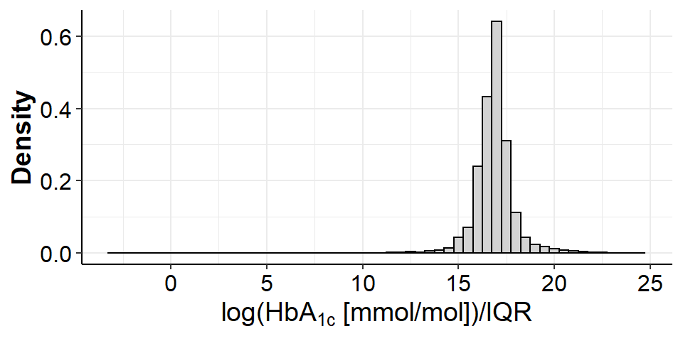
- Without log-transformation

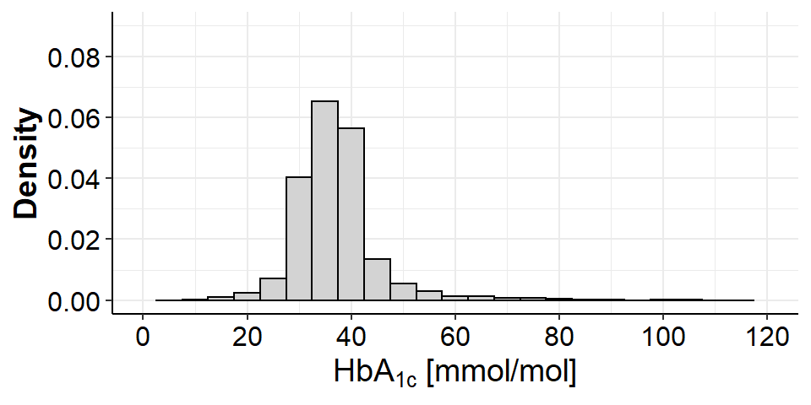

- in each cohort

- With log-transformation
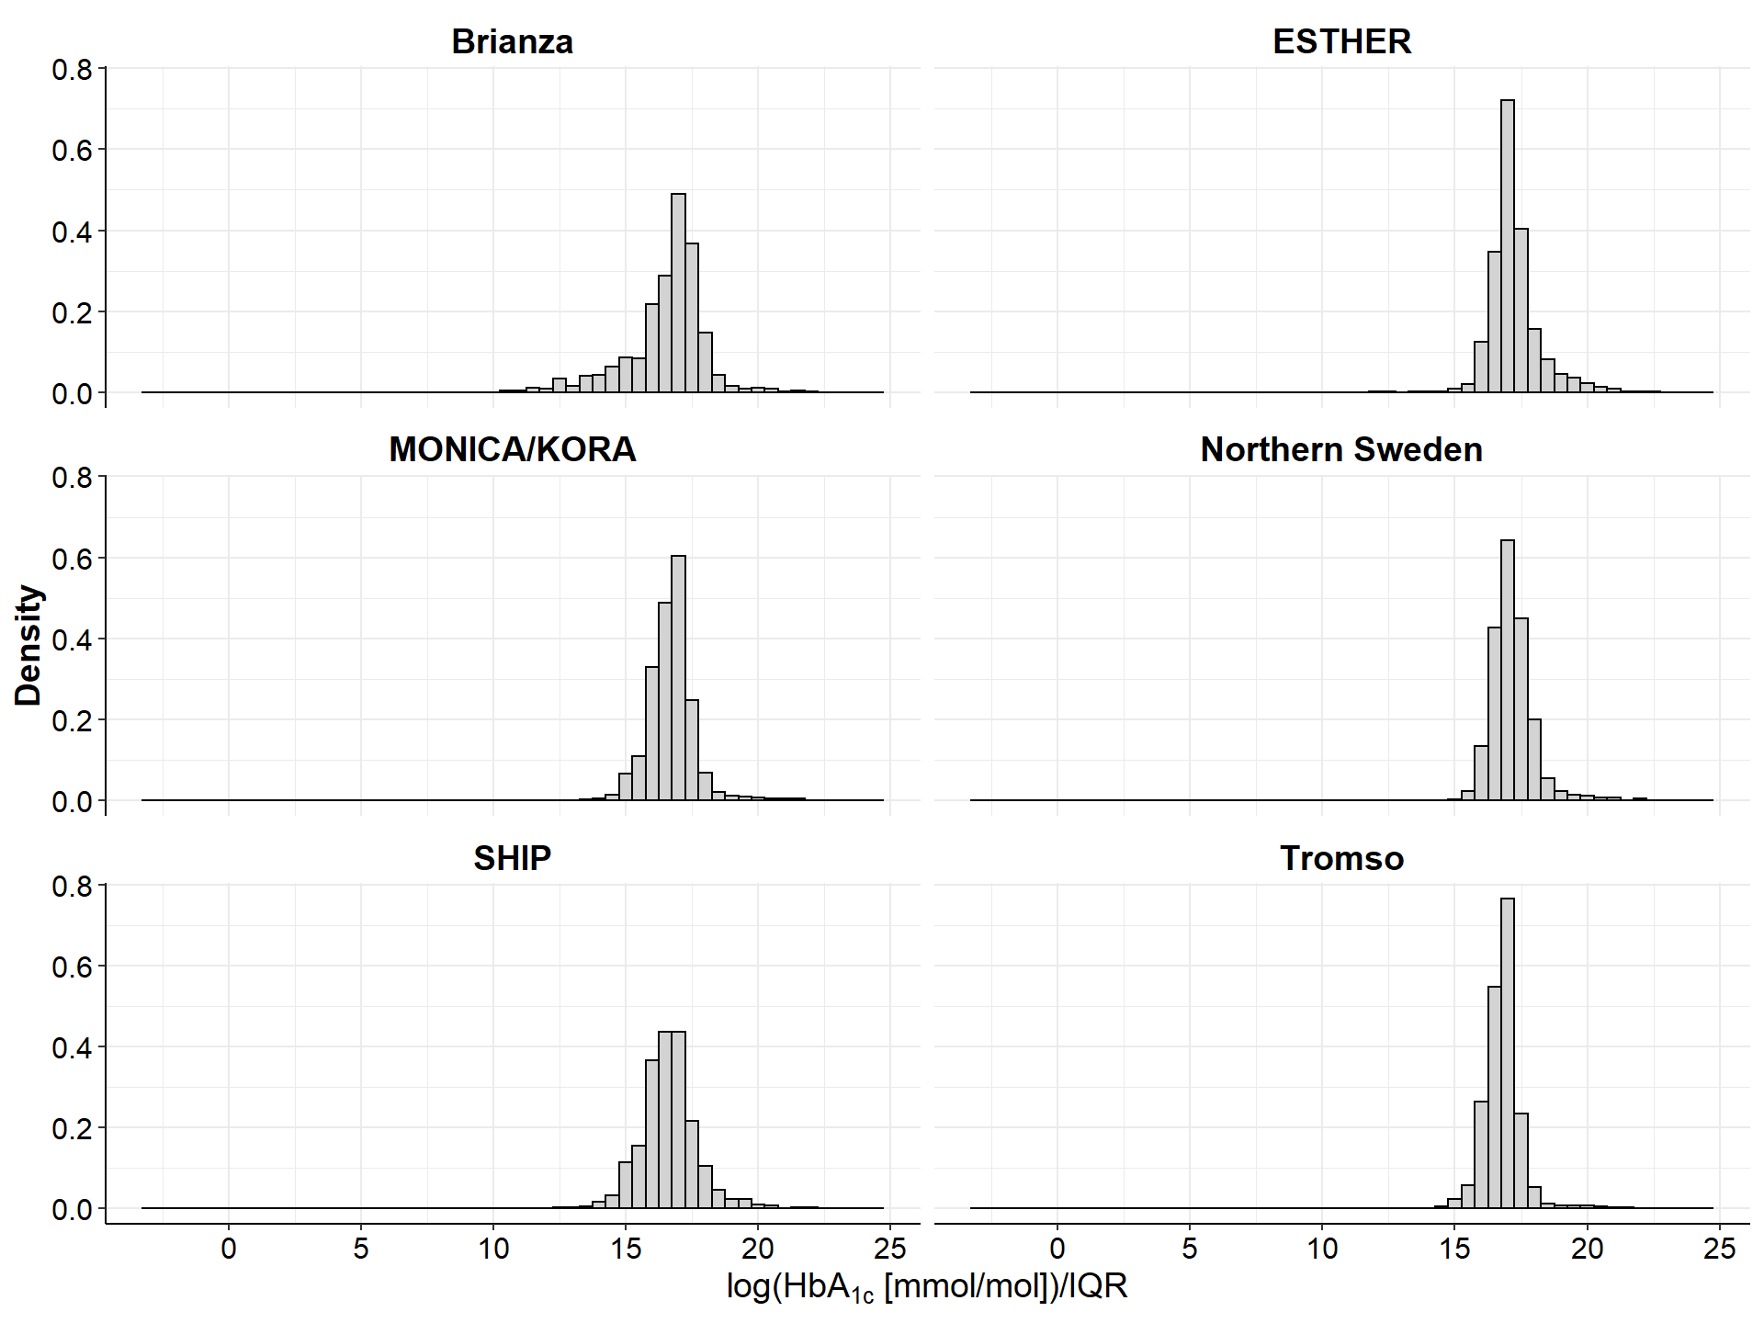
- Without log-transformation

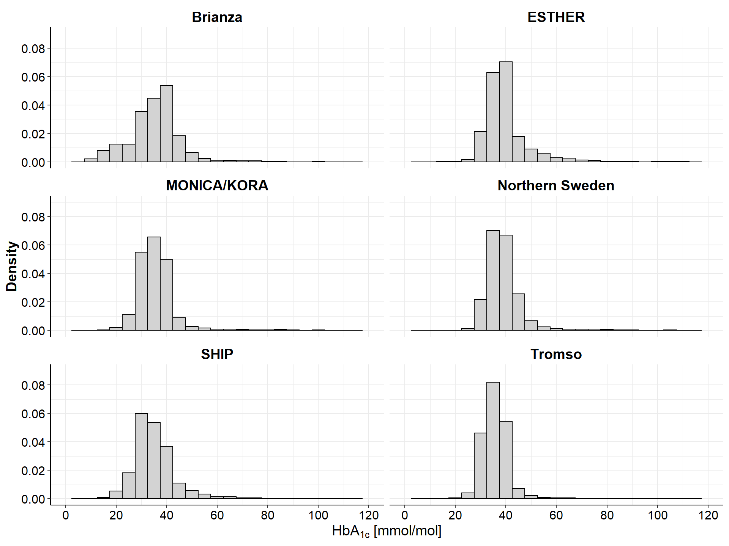
Figure S2 Unadjusted Kaplan–Meier curves of cardiovascular mortality (A), cardiovascular disease (B), and overall mortality (C) according to thirds of HbA_{1c}.
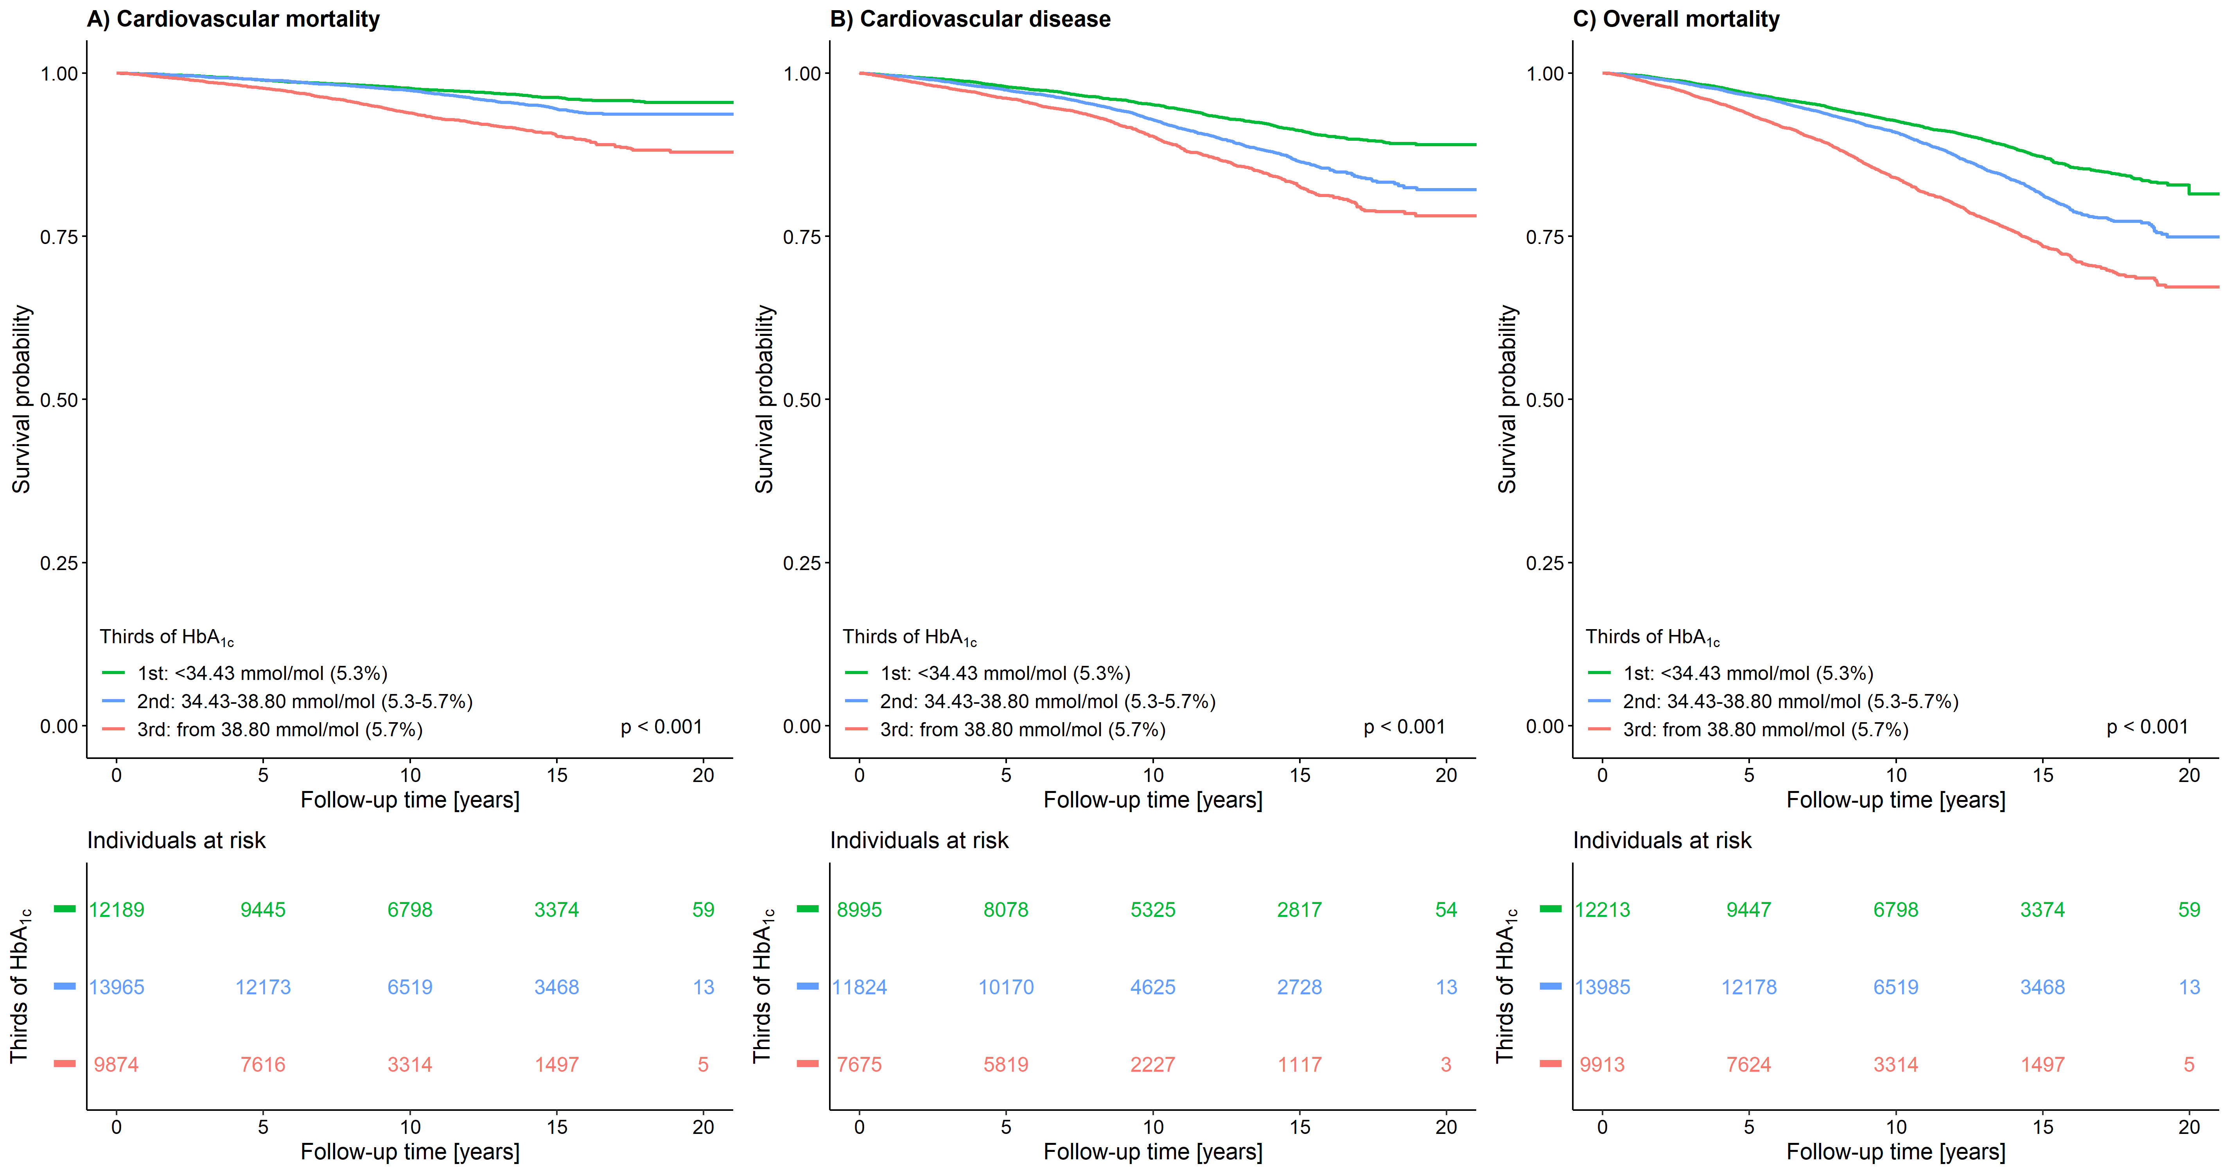

Figure S3 Unadjusted Kaplan–Meier curves
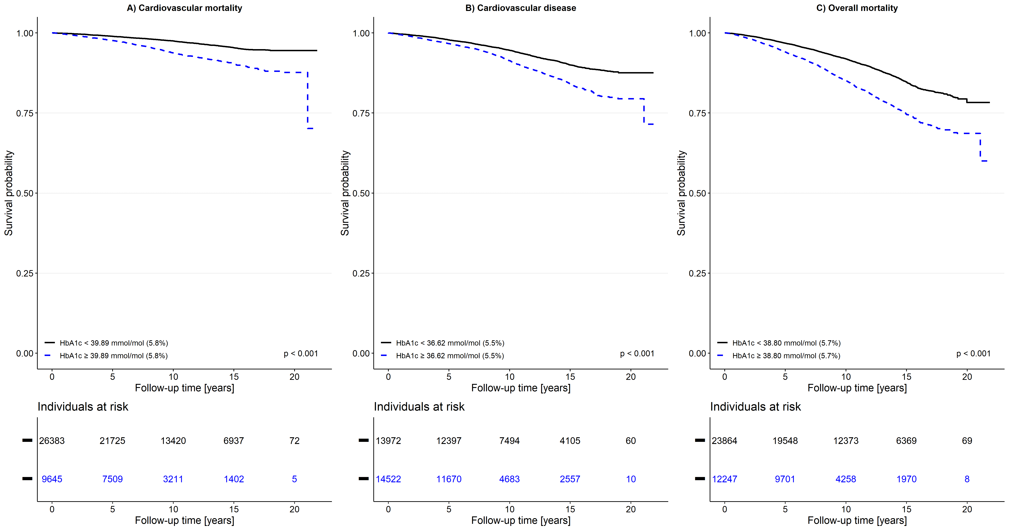

4. References
1. Gianfagna F, Veronesi G, Guasti L, Chambless LE, Brambilla P, Corrao G, Mancia G, Cesana G, Ferrario MM: Do apolipoproteins improve coronary risk prediction in subjects with metabolic syndrome? Insights from the North Italian Brianza cohort study. Atherosclerosis 2014, 236(1):175-181.
2. Löwel H, Döring A, Schneider A, Heier M, Thorand B, Meisinger C, Group nftMKS: The MONICA Augsburg surveys-basis for prospective cohort studies. Das Gesundheitswesen 2005, 67(S 01):13-18.
3. Holle R, Happich M, Löwel H, Wichmann H-E, Group nftMKS: KORA-a research platform for population based health research. Das Gesundheitswesen 2005, 67(S 01):19-25.
4. Löwel H, Lewis M, Hörmann A, Keil U: Case finding, data quality aspects and comparability of myocardial infarction registers: results of a south German register study. Journal of clinical epidemiology 1991, 44(3):249-260.
5. Völzke H, Alte D, Schmidt CO, Radke D, Lorbeer R, Friedrich N, Aumann N, Lau K, Piontek M, Born G: Cohort profile: the study of health in Pomerania. International journal of epidemiology 2010, 40(2):294-307.
6. Schottker B, Herder C, Rothenbacher D, Roden M, Kolb H, Muller H, Brenner H: Proinflammatory cytokines, adiponectin, and increased risk of primary cardiovascular events in diabetic patients with or without renal dysfunction: results from the ESTHER study. Diabetes Care 2013, 36(6):1703-1711.
7. Schottker B, Herder C, Muller H, Brenner H, Rothenbacher D: Clinical utility of creatinine- and cystatin C-based definition of renal function for risk prediction of primary cardiovascular events in patients with diabetes. Diabetes Care 2012, 35(4):879-886.
8. Eriksson M, Holmgren L, Janlert U, Jansson JH, Lundblad D, Stegmayr B, Söderberg S, Eliasson M: Large improvements in major cardiovascular risk factors in the population of northern Sweden: the MONICA study 1986–2009. Journal of internal medicine 2011, 269(2):219-231.
9. Eriksson M, Holmgren L, Janlert U, Jansson JH, Lundblad D, Stegmayr B, Soderberg S, Eliasson M: Large improvements in major cardiovascular risk factors in the population of northern Sweden: the MONICA study 1986-2009. J Intern Med 2011, 269(2):219-231.
10. Rolandsson O, Norberg M, Nystrom L, Soderberg S, Svensson M, Lindahl B, Weinehall L: How to diagnose and classify diabetes in primary health care: lessons learned from the Diabetes Register in Northern Sweden (DiabNorth). Scand J Prim Health Care 2012, 30(2):81-87.
11. Jacobsen BK, Eggen AE, Mathiesen EB, Wilsgaard T, Njølstad I: Cohort profile: the Tromsø study. International journal of epidemiology 2011, 41(4):961-967.

