Supplementary material
Supplementary Figure 1. Clinical flowcharts for the empirical management of urinary tract infections at Hospital Universitario San Ignacio.
Figure S1A: Flowchart for the management of complicated cystitis.
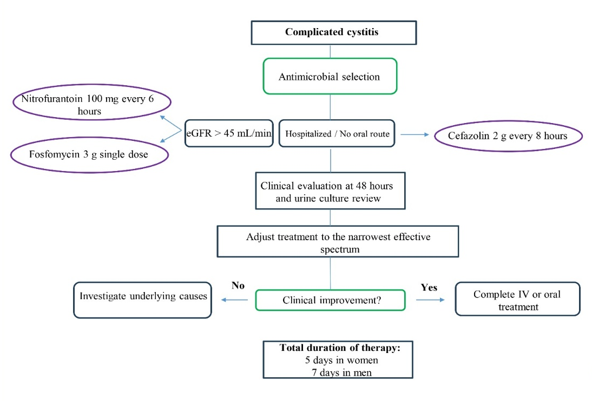
Figure S1 B: Flowchart for the management of uncomplicated cystitis.

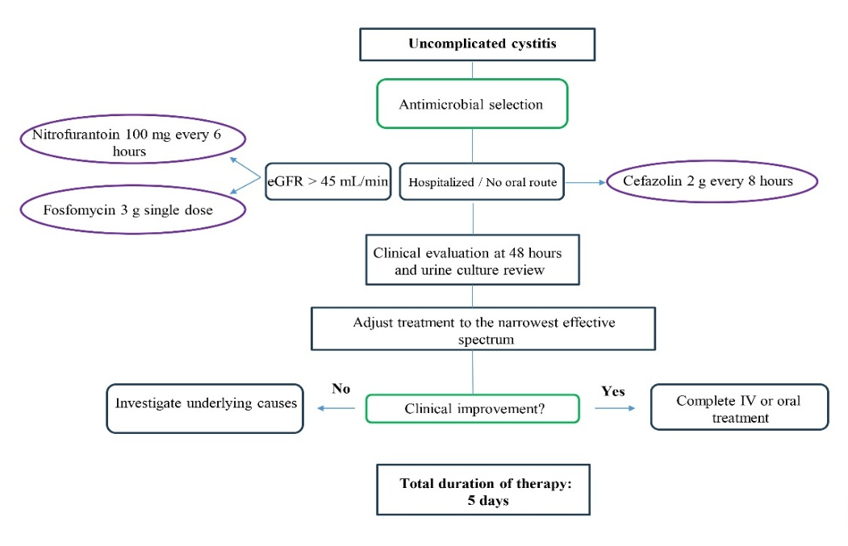
Figure S1 C: Flowchart for the management of complicated pyelonephritis.
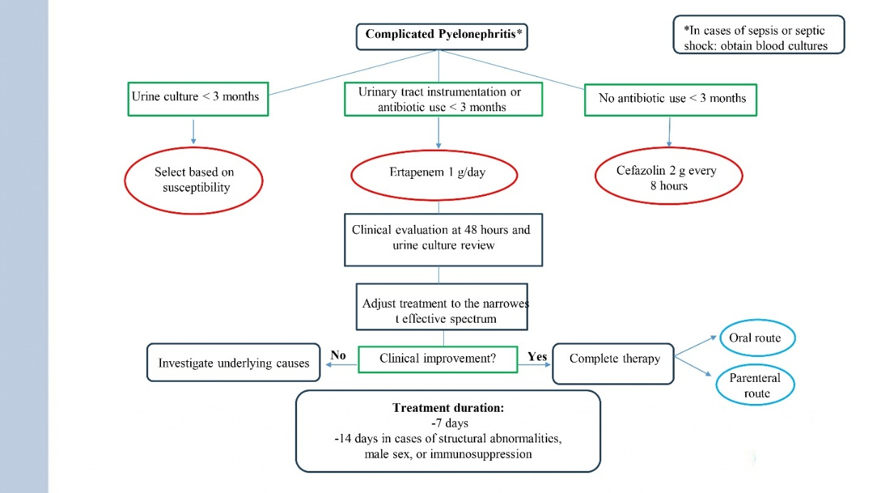
Figure S1B: Flowchart for the management of uncomplicated pyelonephritis.
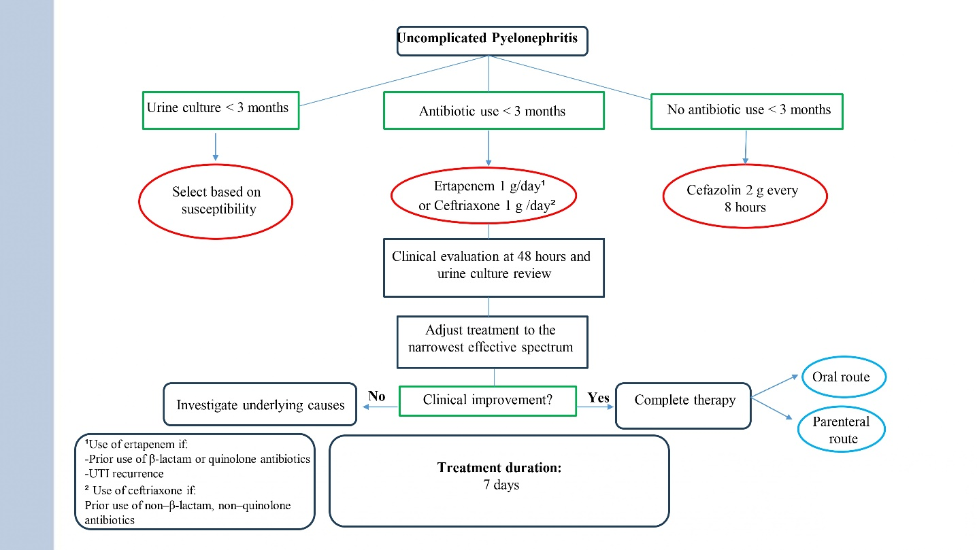
Supplementary Figure 2. Covariate balance before and after inverse probability of treatment weighting (IPTW).

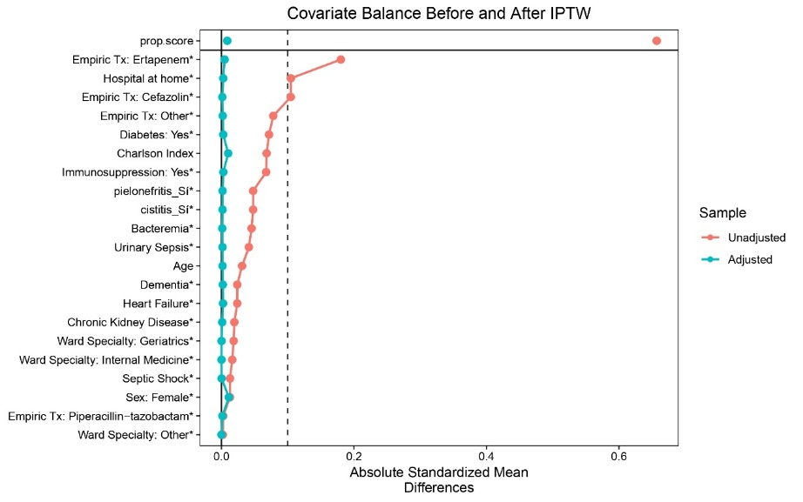
Absolute standardized mean differences for each covariate before (red) and after (blue) IPTW adjustment. Dashed lines indicate commonly used thresholds for acceptable balance (|SMD| < 0.1 and < 0.2).
Microbiological Characteristics of Urine Culture Isolates from UTI Patients Before and After Flowchart Implementation (N = 601).
Microorganism Type, n (%) | Total, n (%) | Pre-intervention Period, n (%) | Post-intervention Period, n (%)
Escherichia coli | 366 (74.69) | 190 (73.29) | 171 (73.90)
Klebsiella pneumoniae | 45 (9.18) | 24 (9.26) | 21 (9.09)
Proteus mirabilis | 37 (7.55) | 14 (5.40) | 23 (9.95)
Enterococcus faecalis | 30 (6.12) | 9 (3.47) | 21 (9.09)
Klebsiella oxytoca | 11 (2.24) | 3 (1.15) | 8 (3.46)
Citrobacter freundii | 10 (2.04) | 6 (2.31) | 4 (1.73)
Pseudomonas aeruginosa | 9 (1.83) | 4 (1.54) | 5 (2.17)
Morganella morganii | 8 (1.63) | 3 (1.15) | 5 (2.17)
Enterobacter cloacae | 7 (1.42) | 5 (1.93) | 2 (0.87)
Serratia marcescens | 6 (1.22) | 3 (1.15) | 3 (1.29)
Proteus vulgaris | 5 (1.02) | 2 (0.77) | 3 (1.29)
Others* | 38 (7.75) | – | –
Others*: Citrobacter koseri (4), Enterococcus faecium (4), Klebsiella aerogenes (3) Staphylococcus aureus (3) Streptococcus agalactiae (3) Cándida albicans (3) Staphylococcus saprophyticus (2), Klebsiella variicola (2), Enterobacter hormaechei (2), Enterococcus hirae(2), Streptococcus constellatuns (2), Citrobacter braakii (2), Citrobacter werkmanii (1), Providencia rettgeri (1), T. asahii (1), Bacteroides fragilis (1), Pasteurella multocida (1), Pantoea spp. (1).
Note: The denominator used for each microorganism type was the total number of positive urine cultures per study period: Pre-intervention (259), Post-intervention (231); combined total across both periods (490).
Supplementary Figure 3: Types of Microorganisms and Resistance Patterns in Blood Cultures by Study Period.
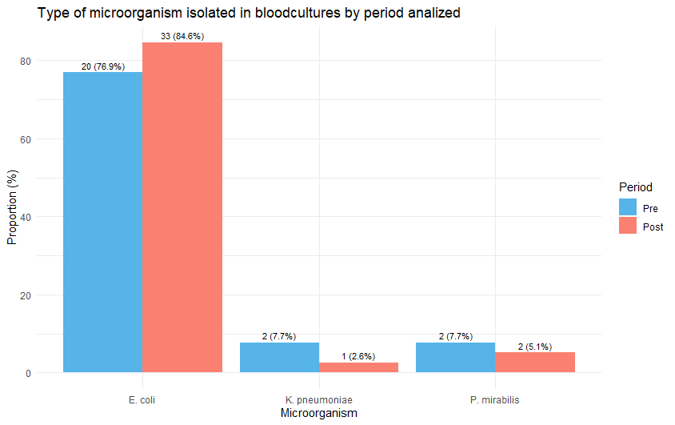
A.
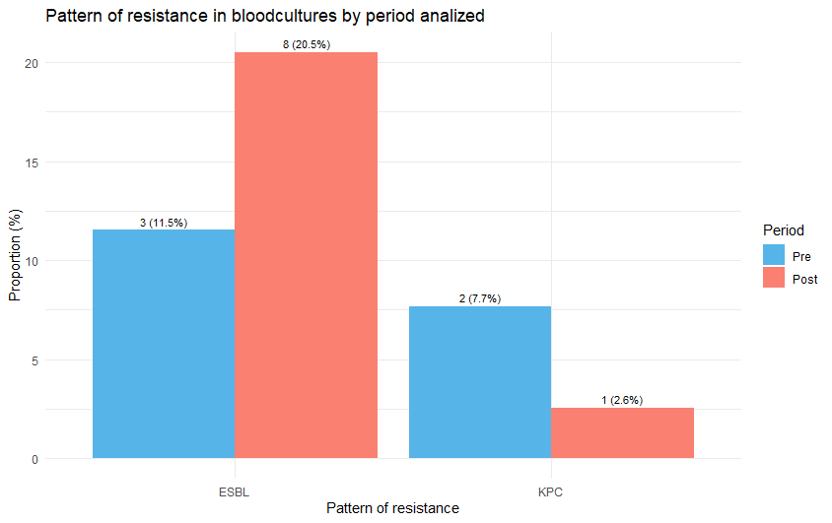
B.
Supplementary Table 2. Microbiological Characteristics and Resistance Patterns of Enterobacterales in Urine Cultures Before and After Flowcharts (N = 601).
Variable | Total, n (%) | ESBL | AmpC | KPC | NDM
Pre-intervention period, n (%)
Escherichia coli | 190 (73.35) | 34 (17.89) | 3 (1.57) | 2(1.05) | –
Klebsiella pneumoniae | 24 (9.26) | 2 (8.33) | – | 6 (25.00) | –
Proteus mirabilis | 14 (5.40) | 1 (7.14) | – | – | –
Post-intervention period, n (%)
Escherichia coli | 176 (76.02) | 54 (30.68) | 3 (1.71) | – | –
Klebsiella pneumoniae | 21 (9.09) | 5 (23.81) | – | 5 (23.81) | 1(4.76)
Proteus mirabilis | 23 (9.95) | – | – | – | –
Abbreviations:
ESBL: Extended-spectrum beta-lactamase. AmpC: AmpC-type beta-lactamase.
KPC: Klebsiella pneumoniae carbapenemase. NDM: New Delhi metallo-beta-lactamase.
Note: The denominator used for the proportion of each microorganism was the total number of positive urine cultures per analyzed period: Pre-intervention (259), Post-intervention (231). The denominator used for resistance pattern proportions was the number of isolates with susceptibility results for each microorganism per study period. Only the three most frequently isolated microorganisms in each period are shown.
Supplementary Table 3. Microbiological Characteristics and Resistance Patterns of Blood Culture Isolates from UTI Patients (N = 601)
Microorganism | Total, n (%) | ESBL | AmpC | KPC
Pre-intervention period, n (%)
Escherichia coli | 20 (76.92) | 2 (10) | – | 1 (5.0)
Klebsiella pneumoniae | 2 (7.69) | – | – | 1 (50)
Proteus mirabilis | 2 (7.69) | 1 (50) | – | –
Post-intervention period, n (%)
Escherichia coli | 33 (84.62) | 8 (24.24) | – | –
Klebsiella pneumoniae | 1 (2.56) | – | – | 1 (100)
Proteus mirabilis | 2 (5.12) | – | – | –
Abbreviations:
ESBL: Extended-spectrum beta-lactamase. AmpC: AmpC-type beta-lactamase.
KPC: Klebsiella pneumoniae carbapenemase.
Note: Note: The denominator used for the proportion of each microorganism was the total number of positive blood cultures for each study period: Pre-intervention (26), Post-intervention (39). The denominator used for resistance pattern proportions was the number of positive results for each microorganism category according to the corresponding period. The three most frequently isolated microorganisms in each period are reported.
Supplementary Figure 4. Kaplan-Meier analysis of time to switch from intravenous to oral antibiotic therapy.
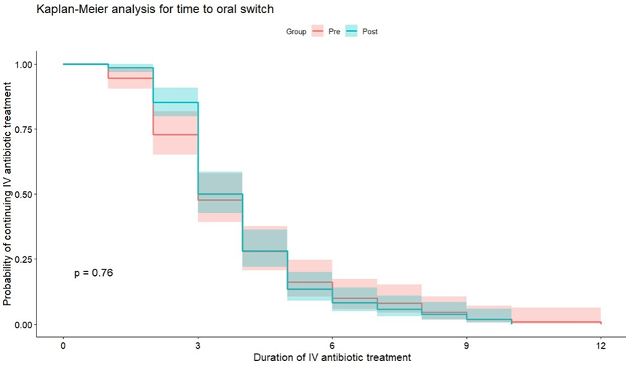
Survival curves comparing time to switch from intravenous to oral antibiotic therapy in hospitalized patients with urinary tract infection, according to the intervention period (pre-intervention in pink; post-intervention in blue). No statistically significant differences were found between groups (p = 0.76). The analysis was performed using the log-rank test. Shaded areas represent the 95% confidence interval for each curve.
Supplementary Figure 5. Kaplan-Meier analysis of hospital length of stay by study period.
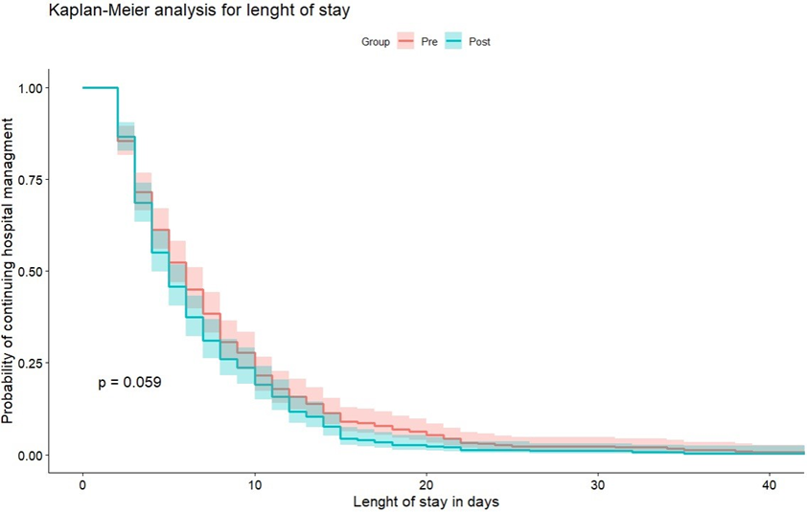
Survival curves showing the cumulative probability of remaining hospitalized among patients with urinary tract infection, comparing the pre-intervention period (January–November 2023, in pink) and the post-intervention period (March 2024–January 2025, in blue). A non-significant trend toward shorter hospital stays was observed in the post-intervention period (p = 0.059, log-rank test). Shaded areas represent 95% confidence intervals for each group.

