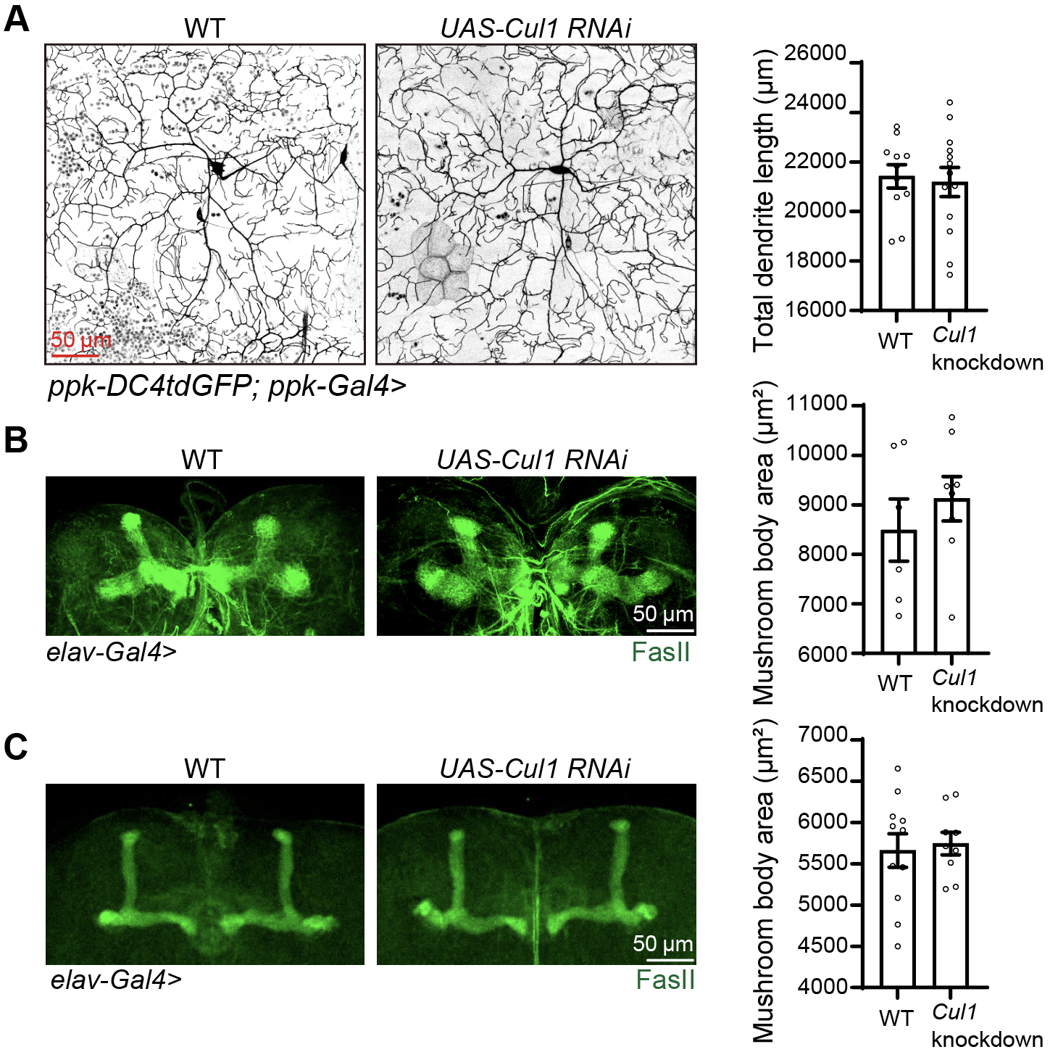Supplemental Figure 1. Cul1 knockdown did not lead to obvious neuron or MB morphological defects. (A) C4da neuron total dendrite length is comparable between WT and Cul1 knockdown. Analyzed by unpaired t-test. n = 11, 13 neurons. (B and C) MB morphology in Cul1 knockdown is similar to WT at larval (B) and adult (C) stage. Larval stage: n = 6, 8, adult stage: n = 11, 9 brains. Analyzed by unpaired t-test. Scale bar, 50 μm.

