Supporting Information
High-throughput screening of spin Hall conductivity in 2D materials
Fu Li¹, Xiaoxiong Liu³, Vikrant Chaudhary^{1,2}, Ruiwen Xie¹, Chen Shen^{1*}, Hao Wang^{1*} and Hongbin Zhang¹
¹Institute of Materials Science, Technology University of Darmstadt, 64287, Darmstadt, Germany
²Department of Physics and CSMB, Humboldt University of Berlin, 12489, Berlin, Germany
³Department of Physics, Southern University of Science and Technology, 518055, Shenzhen, China

Corresponding author(s). E-mail(s): chenshen@tmm.tu-darmstadt.de;
haowang@tmm.tu-darmstadt.de

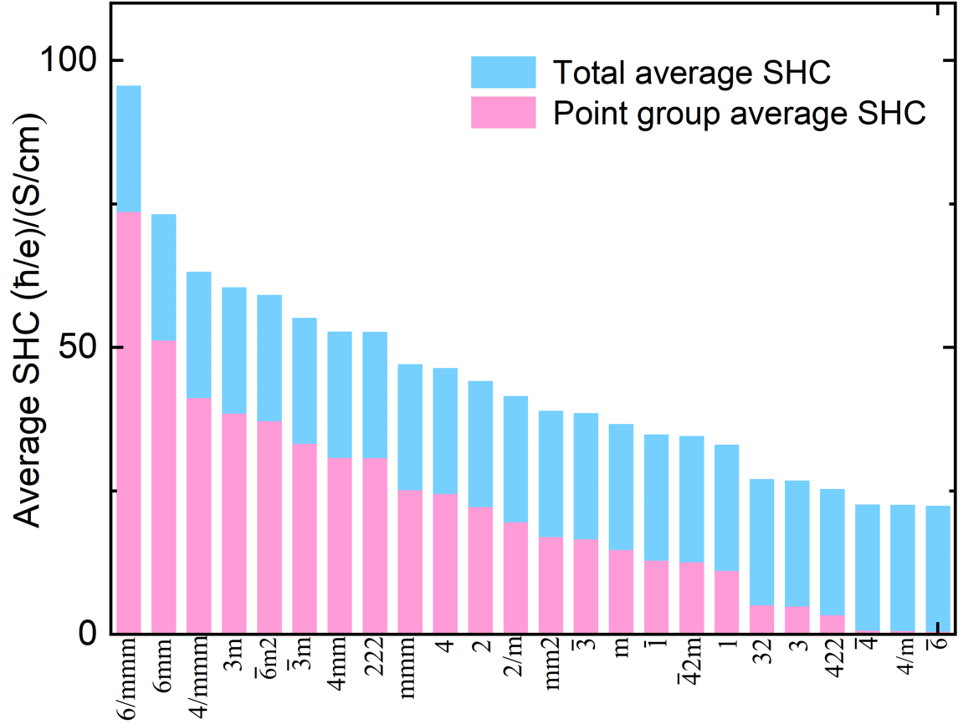
Figure S1: Comparison of the average spin Hall conductivity (SHC) for different point groups and the overall average SHC across all materials. The red bars represent the average SHC of individual point groups, while the blue bar indicates the overall average.

Table S1: Summary of the number of mirror operator
Number of mirror operator | Point group example
0 | 1, -1, 2, 222, 4, -4, 3, -3, 6, -6, 432, etc.
1 | m, 2/m, 4/m, 6/m
2 | mm2
3 | mmm, 3m, m-3
4 | 4mm, -42m
5 | 4/mmm
6 | -3m, 6mm, -6m2, -43m
7 | 6/mmm
9 | m-3m

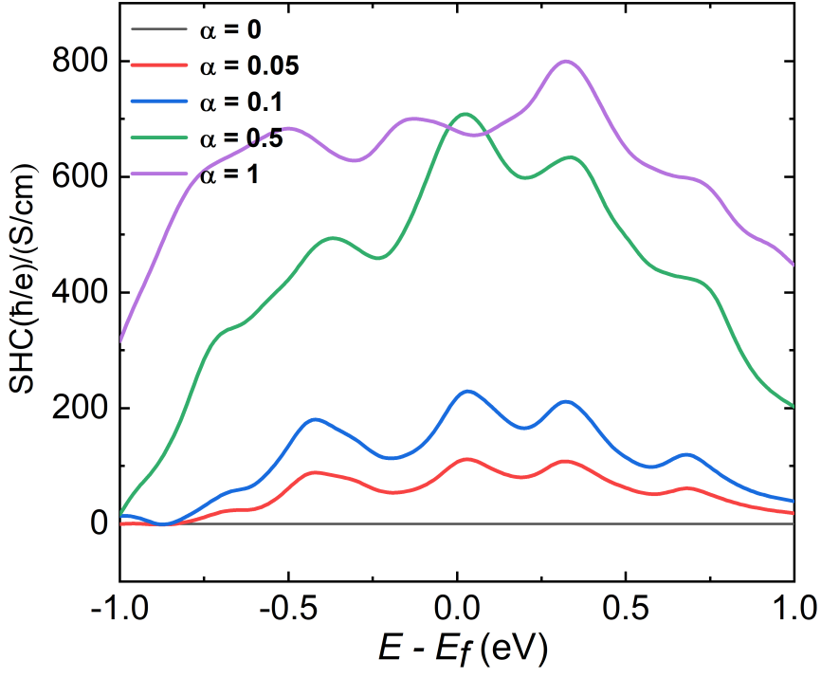
Figure S2: SHC of Bi₄Pb₃​ computed for different spin–orbit coupling (SOC) strengths: 0.0, 0.05, 0.1, 0.5 and 1.0.

Figure S3: Band structure without and with SOC of Ta₂S.

Figure S4: Band structure without and with SOC of CaPb₂.

Figure S5: (a) Crystal structure of Ta₂S. (b) Band structure of Ta₂S with SOC. (c) The red solid line stand for the SHC of Ta₂S, and two green dashed vertical lines represent E = E_{F} and E = E_{F} + 0.13 eV, respectively. (d) k-resolved SBC in the 2D BZ of Ta₂S.

Figure S6: Band structure without and with SOC of Te₃Os₄.

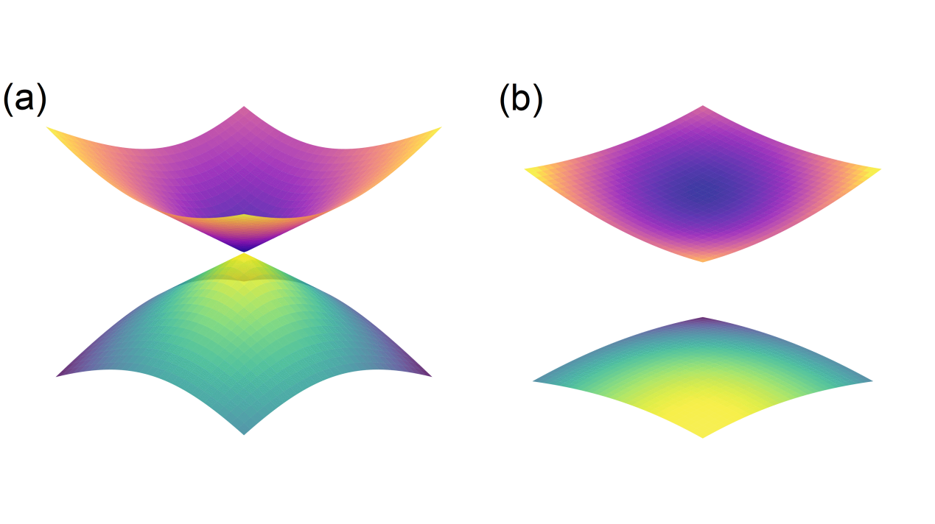
Figure S7: Dirac-like crossings in the three-dimensional bands (a) without and (b) with SOC of PW at the (0.131, 0.131, 0.000) k-point.

Full List of Screened Topological Insulators:
Lattice vectors and band structure of GaBi₃
 | x (Å) | y (Å) | z (Å)
a₁ | 8.7953320799999997 | 0.0000000000000000 | 0.0000000000000000
a₂ | -4.397667040000000 | 7.6169803500000004 | 0.0000000000000000
a₃ | 0.0000000000000000 | 0.0000000000000000 | 21.1982530000000011
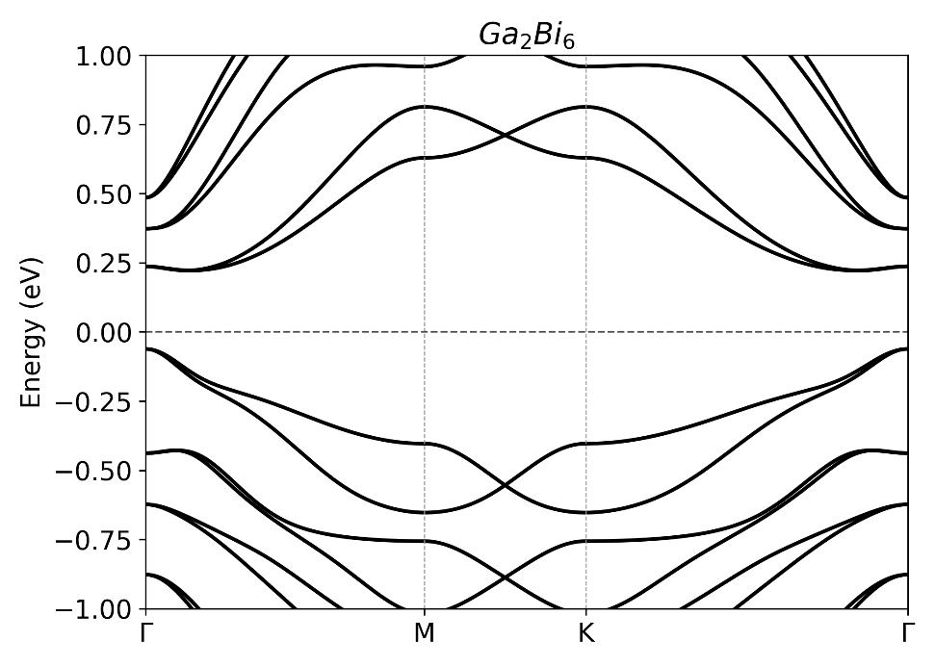
Lattice vectors and band structure of HfSe₅
 | x (Å) | y (Å) | z (Å)
a₁ | 3.7143579999999998 | 0.0000000000000000 | 0.0000000000000000
a₂ | 0.0000000000000000 | 12.4595230000000008 | 0.0000000000000000
a₃ | 0.0000000000000000 | 0.0000000000000000 | 25.3784990000000015
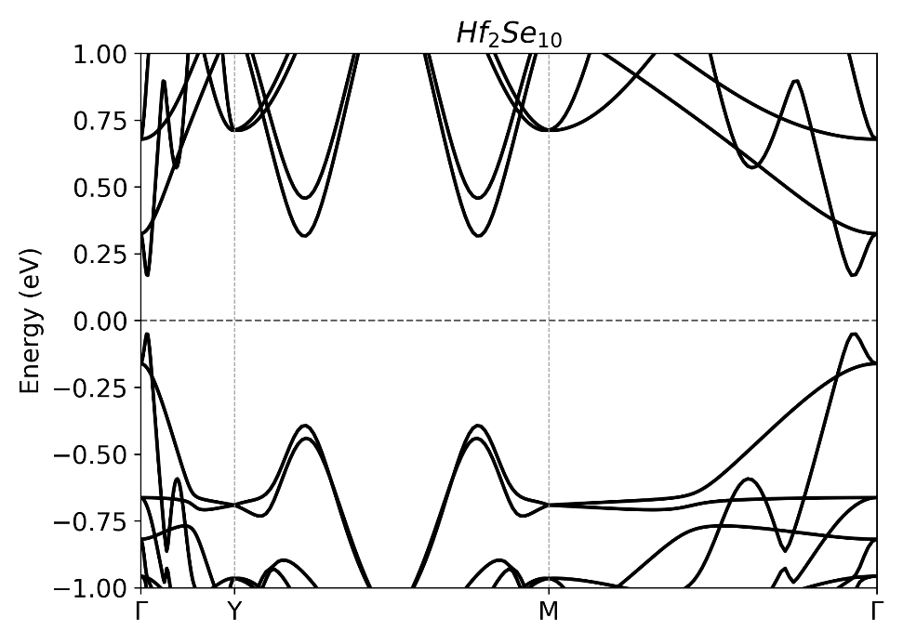
Lattice vectors and band structure of GePb
 | x (Å) | y (Å) | z (Å)
a₁ | 4.5214868299999997 | 0.0000000000000000 | 0.0000000000000000
a₂ | -2.260742880000000 | 3.9157217400000000 | 0.0000000000000000
a₃ | 0.0000000000000000 | 0.0000000000000000 | 20.7697469999999988
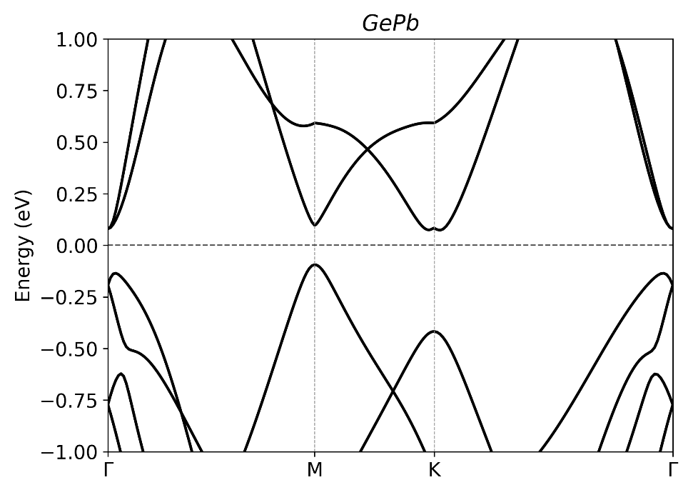
Lattice vectors and band structure of CrP
 | x (Å) | y (Å) | z (Å)
a₁ | 3.0012010000000000 | -0.001111000000000 | 0.0941970000000000
a₂ | 0.0315830000000000 | 3.0009260000000002 | 0.0935900000000000
a₃ | -0.780015000000000 | -0.777543000000000 | 23.6499449999999989
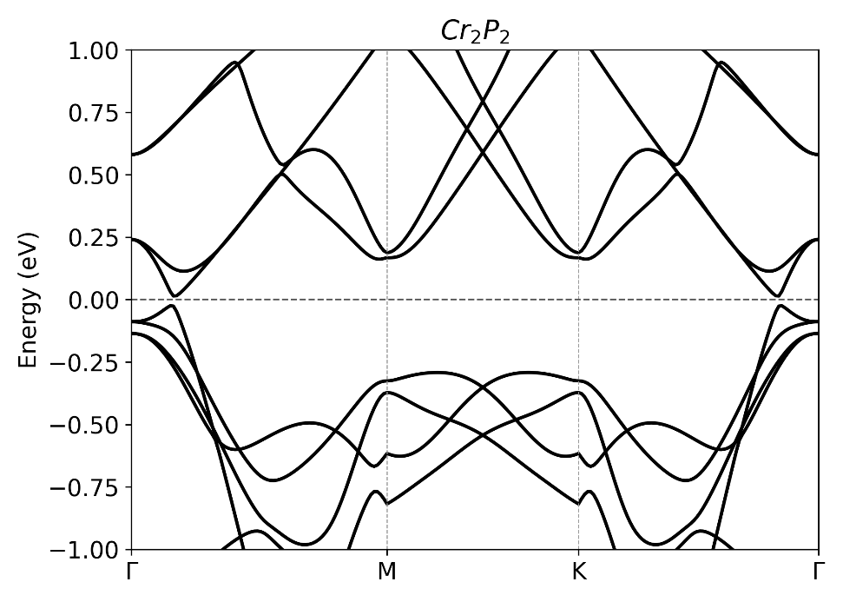

Lattice vectors and band structure of ZrS₅
 | x (Å) | y (Å) | z (Å)
a₁ | 3.5334767399999998 | 0.0000000000000000 | 0.0000000000000000
a₂ | 0.0000000000000000 | 11.7935498499999998 | 0.0000000000000000
a₃ | 0.0000000000000000 | 0.0000000000000000 | 23.7093699999999998
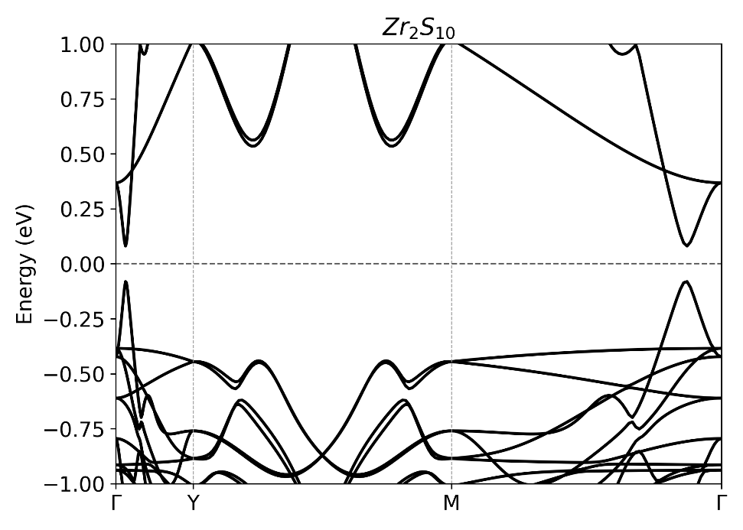

Lattice vectors and band structure of ZrSe₅
 | x (Å) | y (Å) | z (Å)
a₁ | 3.7395309999999999 | 0.0000000000000000 | 0.0000000000000000
a₂ | 0.0000000000000000 | 12.5056390000000004 | 0.0000000000000000
a₃ | 0.0000000000000000 | 0.0000000000000000 | 25.2975530000000006
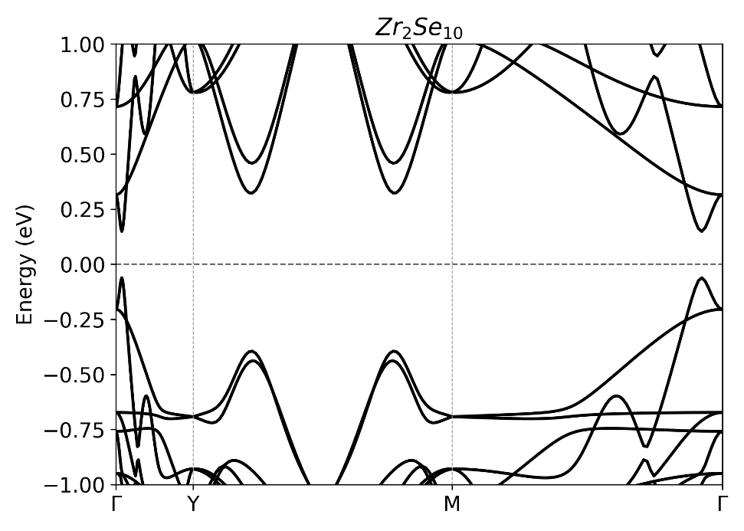
Lattice vectors and band structure of BSb₃
 | x (Å) | y (Å) | z (Å)
a₁ | 7.8220660000000004 | -0.000181000000000 | -0.000055000000000
a₂ | -3.911189999999999 | 6.7727139999999997 | 0.0005840000000000
a₃ | -0.000151000000000 | 0.0017430000000000 | 21.1982530000000011
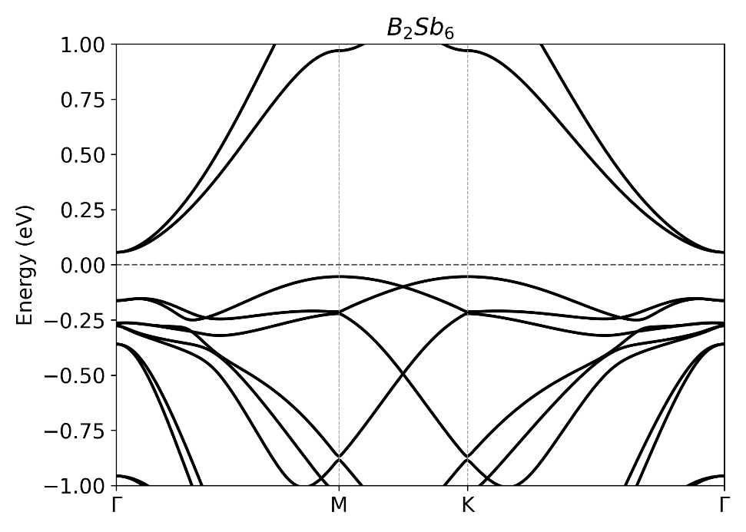

Lattice vectors and band structure of BiSe
 | x (Å) | y (Å) | z (Å)
a₁ | 7.7420530999999997 | 0.0000000000000000 | 0.0000000000000000
a₂ | 0.0000000000000000 | 7.3424410299999998 | 0.0000000000000000
a₃ | 0.0000000000000000 | 0.0000000000000000 | 22.0755000000000017
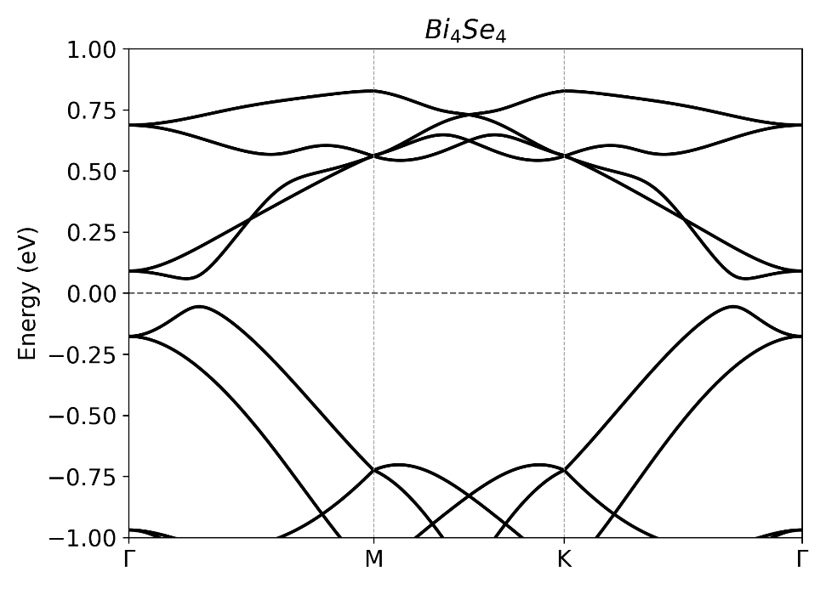
Lattice vectors and band structure of NaMgSb
 | x (Å) | y (Å) | z (Å)
a₁ | 4.8554656100000004 | 0.0000000000000000 | 0.0000000000000000
a₂ | 0.0000000000000000 | 4.8554656100000004 | 0.0000000000000000
a₃ | 0.0000000000000000 | 0.0000000000000000 | 26.8963816899999983
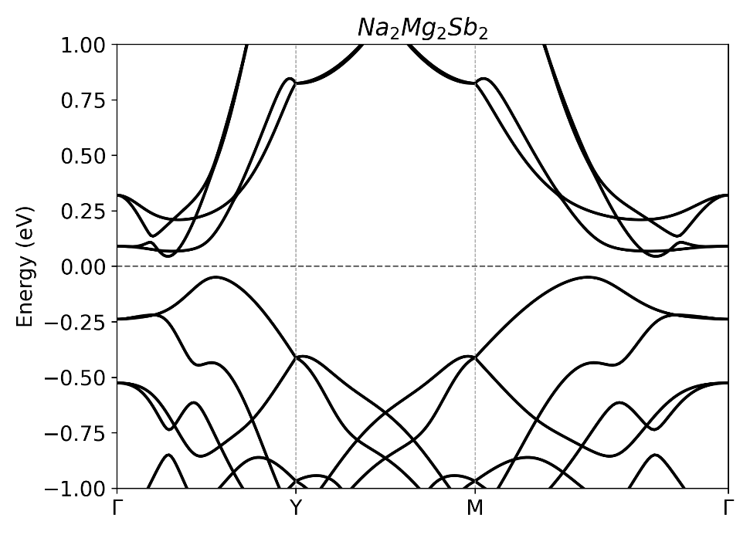

Lattice vectors and band structure of InBi₃
 | x (Å) | y (Å) | z (Å)
a₁ | 9.0892054600000005 | -0.000000120000000 | 0.0000000000000000
a₂ | -4.544603430000000 | 7.8714828099999998 | 0.0000000000000000
a₃ | 0.0000000000000000 | 0.0000000000000000 | 21.1982530000000011
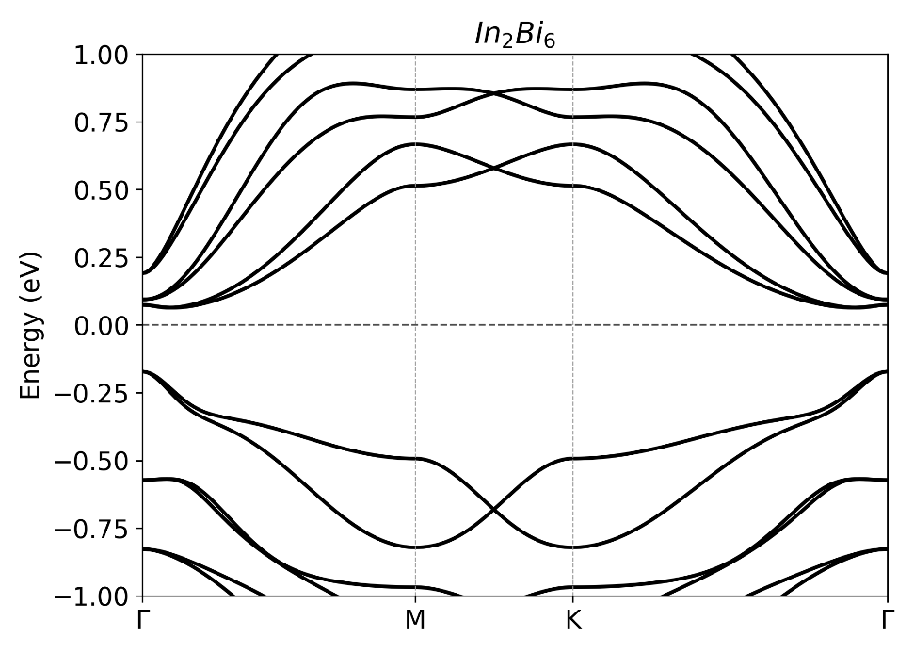
Lattice vectors and band structure of AlBi₃
 | x (Å) | y (Å) | z (Å)
a₁ | 8.8458998300000005 | 0.0000000000000000 | 0.0000000000000000
a₂ | -4.422950410000000 | 7.6607736099999997 | 0.0000000000000000
a₃ | 0. 000000000000000 | 0. 000000000000000 | 21.1982530000000011
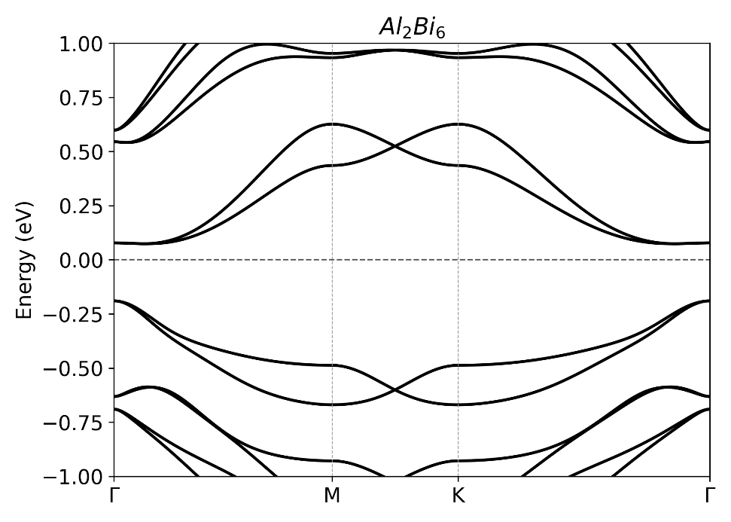

Lattice vectors and band structure of SrSbSe₂F
 | x (Å) | y (Å) | z (Å)
a₁ | 4.0993773200000003 | 0.0000000000000000 | 0.0000000000000000
a₂ | 0.0000000000000000 | 4.0993773200000003 | 0.0000000000000000
a₃ | 0.0000000000000000 | 0.0000000000000000 | 31.4330810000000014
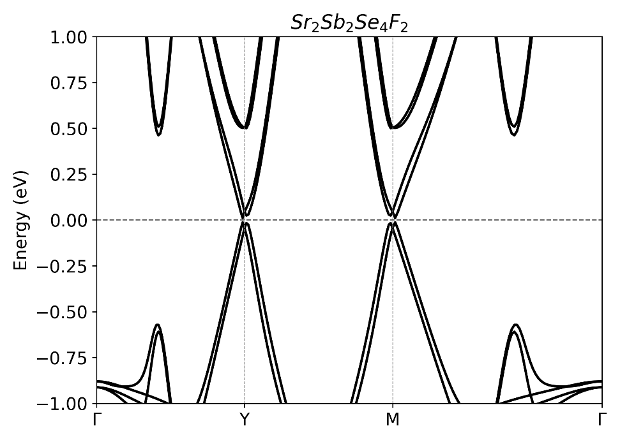
Lattice vectors and band structure of YbBi₂
 | x (Å) | y (Å) | z (Å)
a₁ | 4.1754122100000002 | 0.0000000000000000 | 0.0000000000000000
a₂ | 0.0000000000000000 | 5.1621684800000001 | 0.0000000000000000
a₃ | 0.0000000000000000 | 0.0000000000000000 | 23.0479948199999995
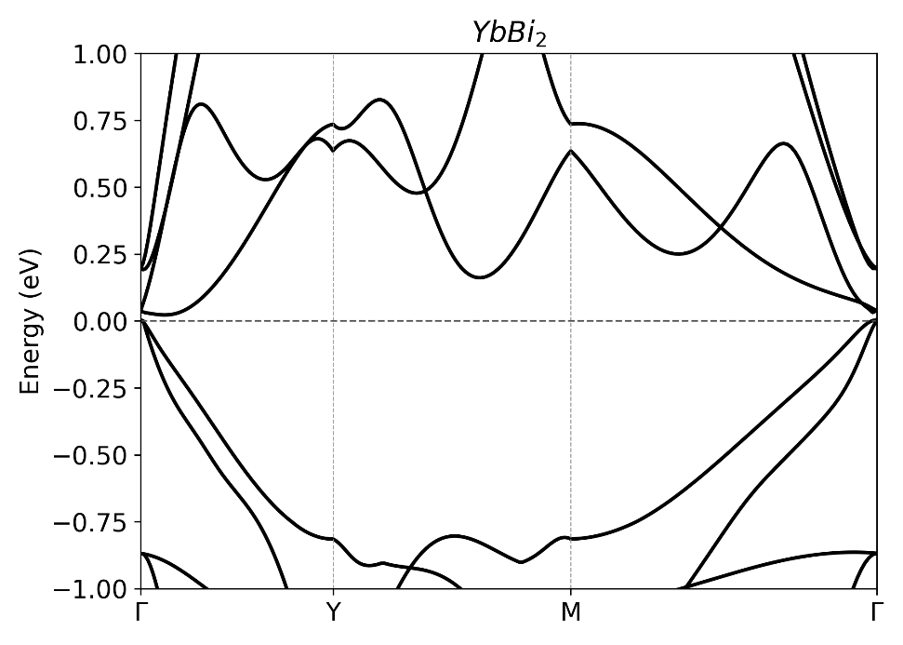
Lattice vectors and band structure of TaI₅
 | x (Å) | y (Å) | z (Å)
a₁ | 3.7530090000000000 | 0.0289320000000000 | -0.0059960000000000
a₂ | 0.0173710000000000 | 10.8266559999999998 | 0.1640670000000000
a₃ | 0.0266790000000000 | 0.2687750000000000 | 23.7404919999999997
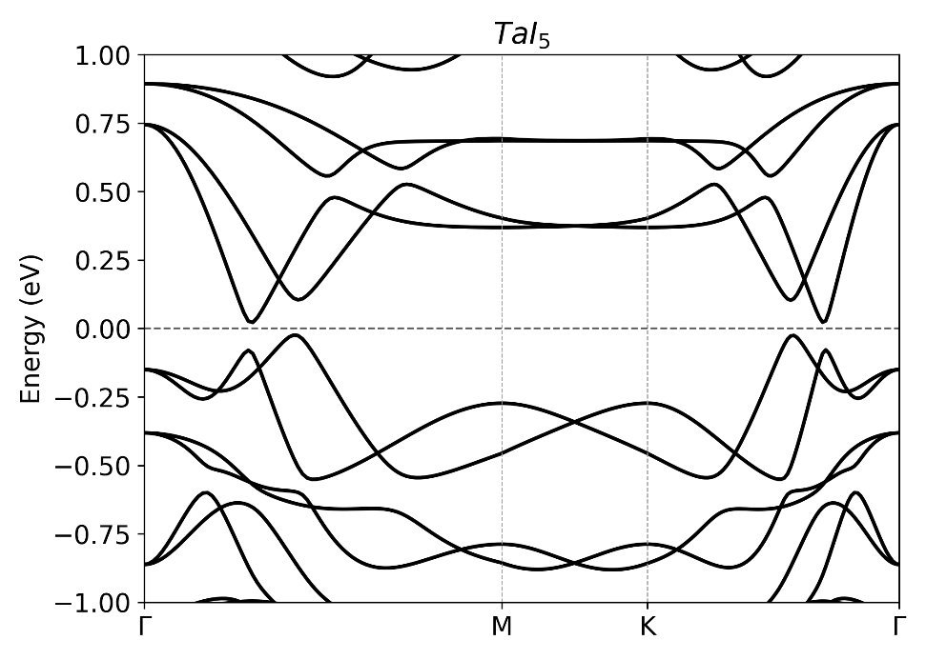

Lattice vectors and band structure of AuBr
 | x (Å) | y (Å) | z (Å)
a₁ | 4.4788670000000002 | 0.0000000000000000 | 0.0000000000000000
a₂ | -2.239434000000000 | 3.8788130000000001 | 0.0000000000000000
a₃ | 0.0000000000000000 | 0.0000000000000000 | 20.1955199999999984
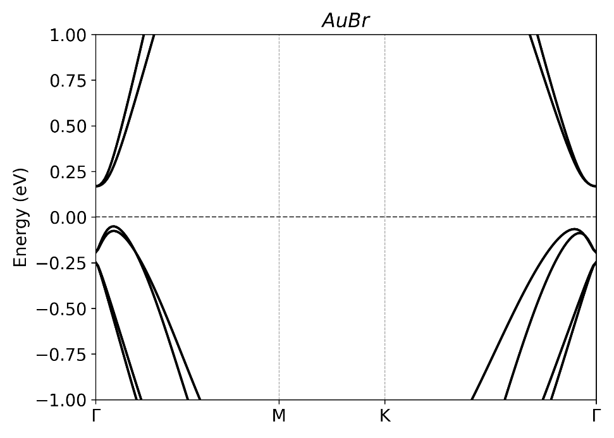
Lattice vectors and band structure of NbTe₄Ir
 | x (Å) | y (Å) | z (Å)
a₁ | 3.7946973700000002 | 0.0000000000000000 | 0.0000000000000000
a₂ | 0.0000000000000000 | 12.5864946300000007 | 0.0000000000000000
a₃ | 0.0000000000000000 | 0.0000000000000000 | 24.0001439999999988
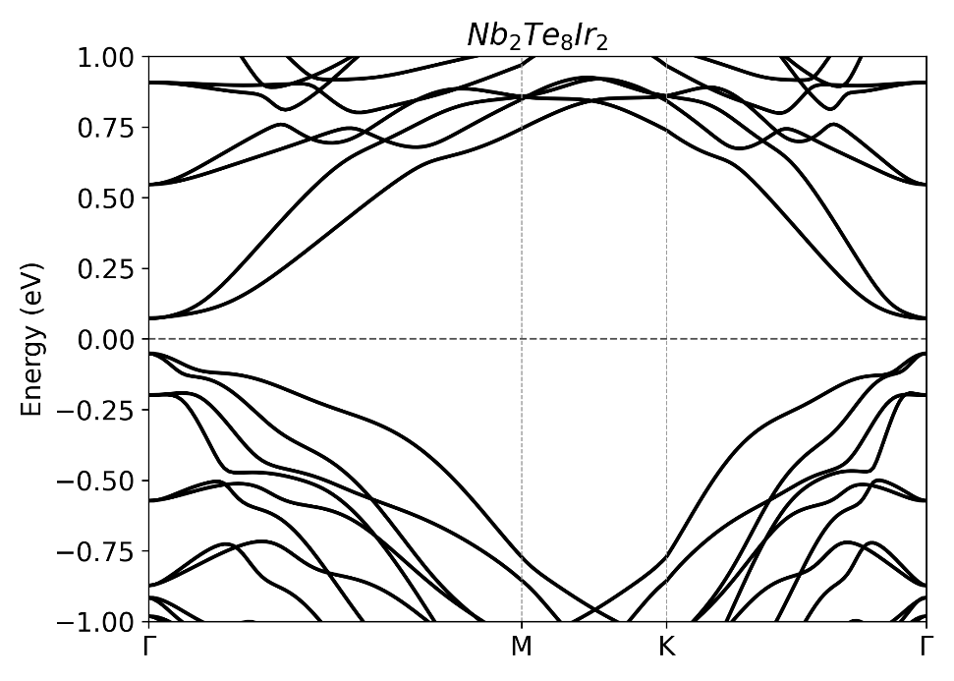

Lattice vectors and band structure of Cu₂Te
 | x (Å) | y (Å) | z (Å)
a₁ | 4.9124049999999997 | 0.0000000000000000 | 0.0000000000000000
a₂ | 0.0000000000000000 | 4.7459300000000004 | -1.3565929999999999
a₃ | -0.000151000000000 | 0.0017430000000000 | 21.1982530000000011
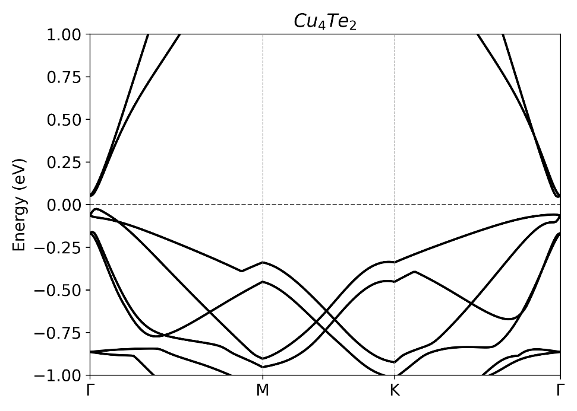
Lattice vectors and band structure of Ta₂Se₃
 | x (Å) | y (Å) | z (Å)
a₁ | 3.3669683400000001 | -0.000009530000000 | -0.0003212600000000
a₂ | 0.0002191100000000 | 9.6937915799999992 | 1.9395309400000000
a₃ | -0.00025142000000 | -0.071930110000000 | 24.1657083700000008
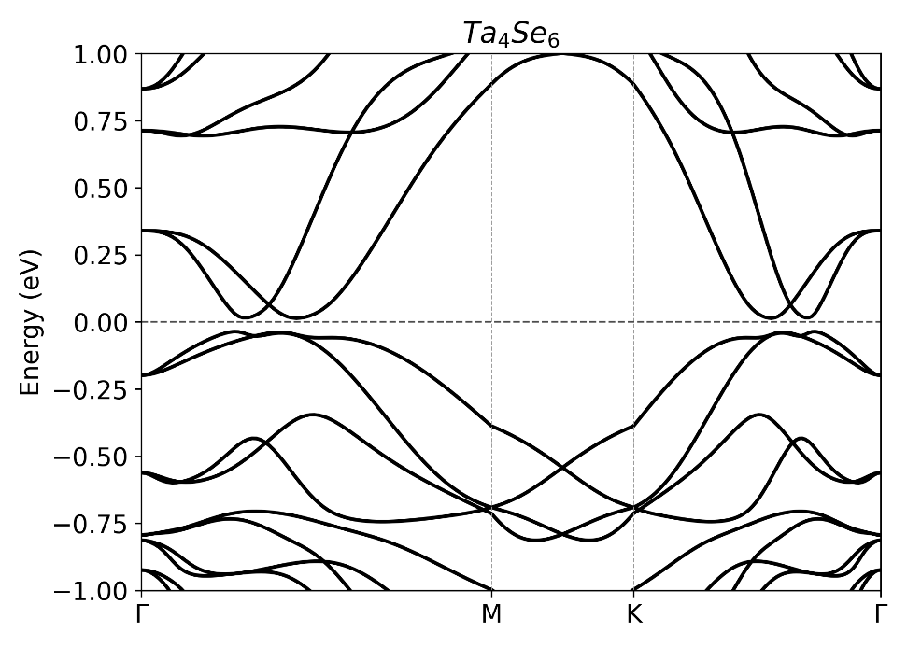

Lattice vectors and band structure of AuI
 | x (Å) | y (Å) | z (Å)
a₁ | 4.7010169599999996 | 0.0000000000000000 | 0.0000000000000000
a₂ | -2.350509479999999 | 4.0711991899999997 | 0.0000000000000000
a₃ | 0.0000000000000000 | 0.0000000000000000 | 20.0000000000000000
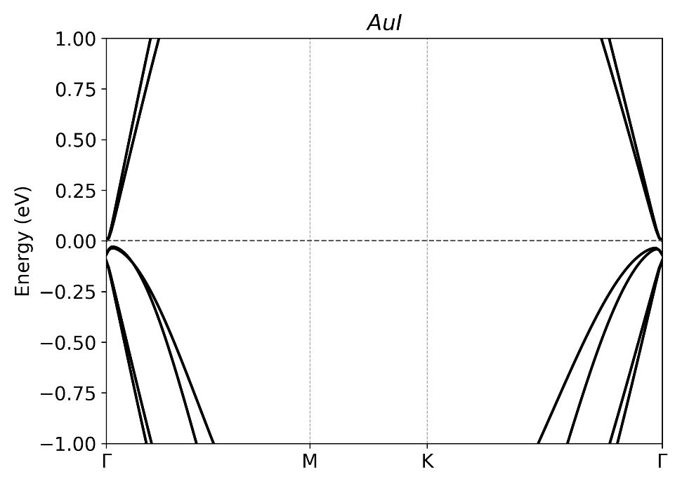
Lattice vectors and band structure of Pb
 | x (Å) | y (Å) | z (Å)
a₁ | 4.8907097000000004 | 0.0000000000000000 | 0.0000000000000000
a₂ | -2.445354850000000 | 4.2720334500000003 | 0.0000000000000000
a₃ | 0.0000000000000000 | 0.0000000000000000 | 20.6882279999999987
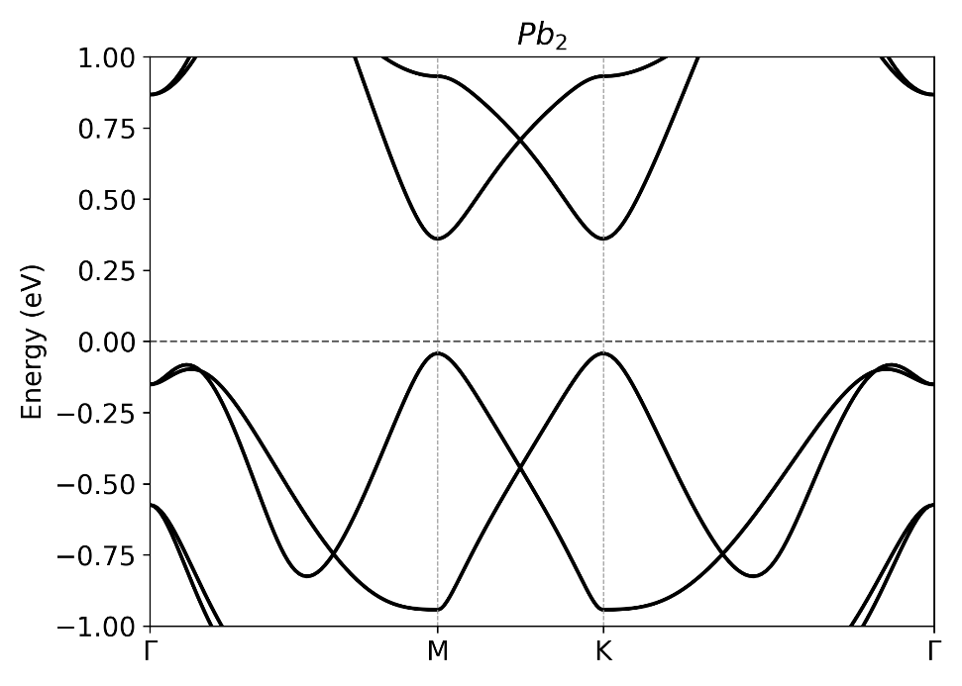

Lattice vectors and band structure of HgO
 | x (Å) | y (Å) | z (Å)
a₁ | 3.7690667800000002 | 0.0000000000000000 | 0.0000000000000000
a₂ | -1.884533390000000 | 3.2641072499999999 | 0.0000000000000000
a₃ | 0.0000000000000000 | 0.0000000000000000 | 20.6349209999999985
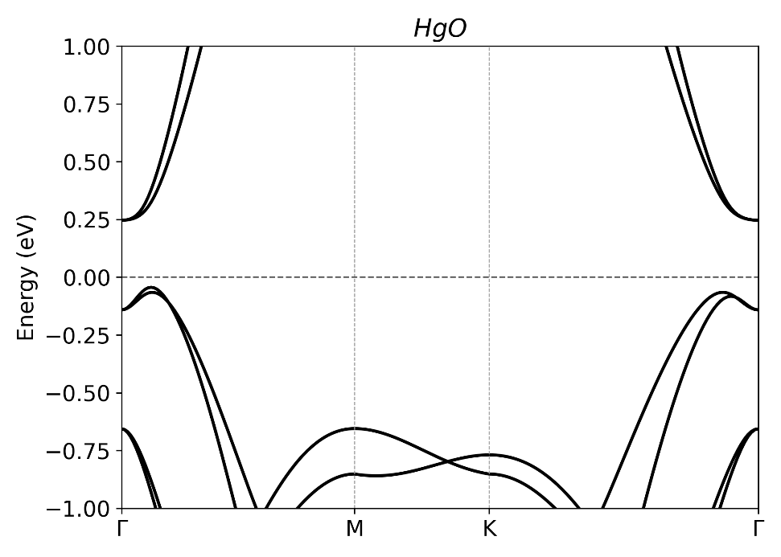
Lattice vectors and band structure of Tl₂Te₃
 | x (Å) | y (Å) | z (Å)
a₁ | 7.6898567399999997 | -0.037079290000000 | 0.0005671700000000
a₂ | -3.877039110000000 | 6.6414011000000004 | -0.000031080000000
a₃ | 0.0014782700000000 | 0.000754530000000 | 20.0118290499999993
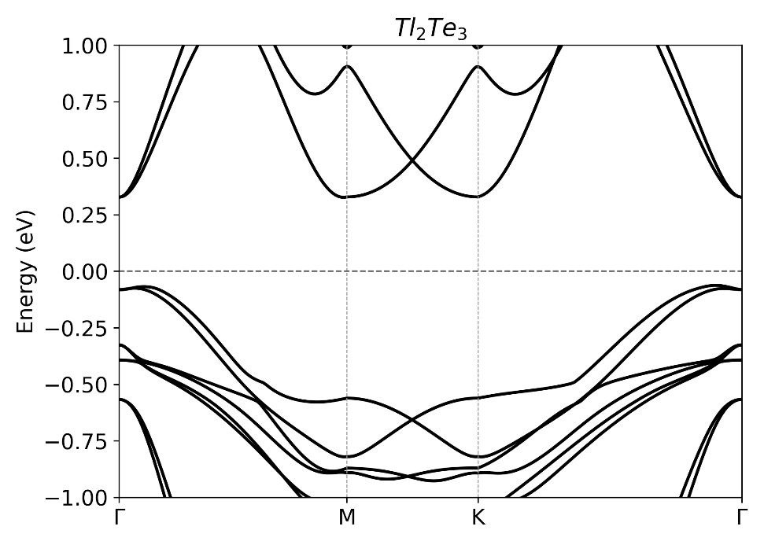

Lattice vectors and band structure of EuBi₂
 | x (Å) | y (Å) | z (Å)
a₁ | 4.2655062199999998 | 0.0000000000000000 | 0.0000000000000000
a₂ | 0.0000000000000000 | 5.3038907000000002 | -0.2373712900000000
a₃ | 0.0000000000000000 | 0.0394084300000000 | 23.1733267800000000
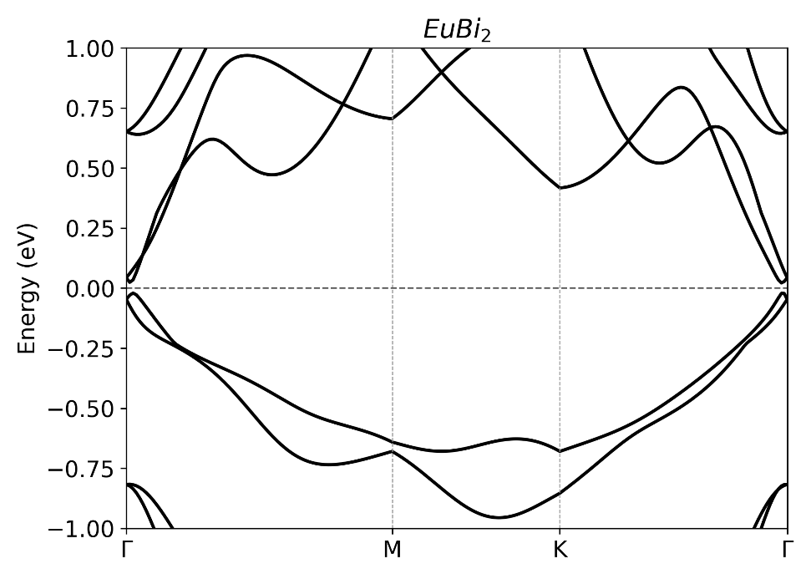
Lattice vectors and band structure of TiSe₅
 | x (Å) | y (Å) | z (Å)
a₁ | 3.5908099099999999 | 0.0000000000000000 | 0.0000000000000000
a₂ | 0.0000000000000000 | 12.3180775100000002 | 0.0000000000000000
a₃ | 0.0000000000000000 | 0.0000000000000000 | 25.2975530000000006
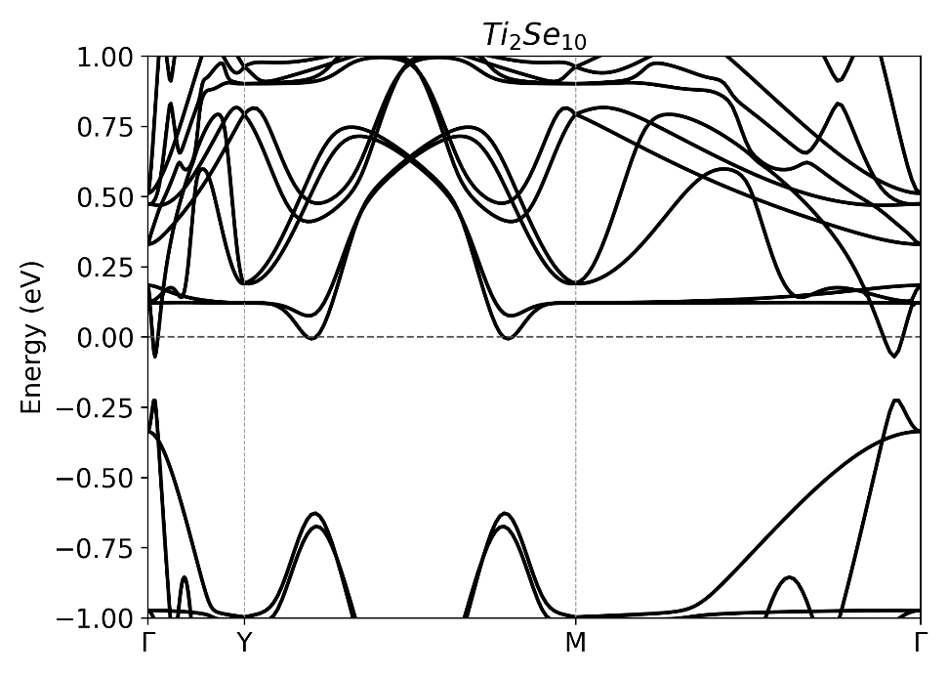

Lattice vectors and band structure of SnPb
 | x (Å) | y (Å) | z (Å)
a₁ | 4.7995473799999999 | 0.0000000000000000 | 0.0000000000000000
a₂ | -2.399773090000000 | 4.1565291000000002 | 0.0000000000000000
a₃ | 0.0000000000000000 | 0.0000000000000000 | 20.7697469999999988
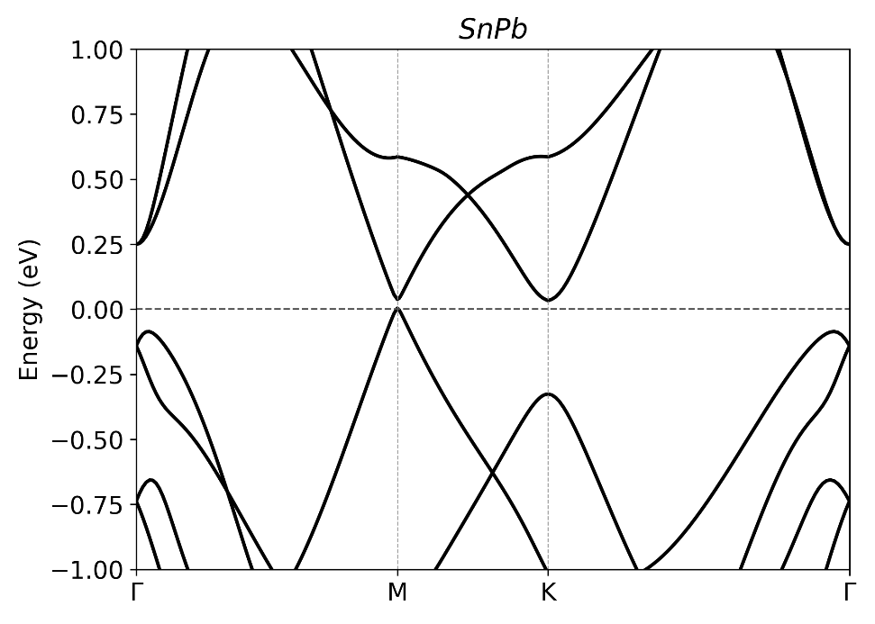
Lattice vectors and band structure of ZrTe₅
 | x (Å) | y (Å) | z (Å)
a₁ | 4.0530077400000000 | 0.0000000000000000 | 0.0000000000000000
a₂ | 0.0000000000000000 | 13.8694415299999996 | 0.0000000000000000
a₃ | 0.0000000000000000 | 0.0000000000000000 | 25.4220332300000003
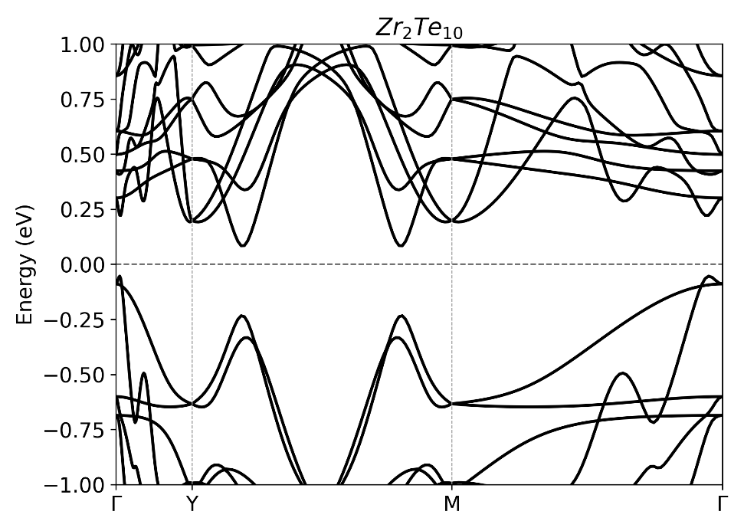

Lattice vectors and band structure of HfTe₅
 | x (Å) | y (Å) | z (Å)
a₁ | 4.0282380699999996 | 0.0000000000000000 | 0.0000000000000000
a₂ | 0.0000000000000000 | 13.8604544000000001 | 0.0000000000000000
a₃ | 0.0000000000000000 | 0.0000000000000000 | 25.2975840000000005
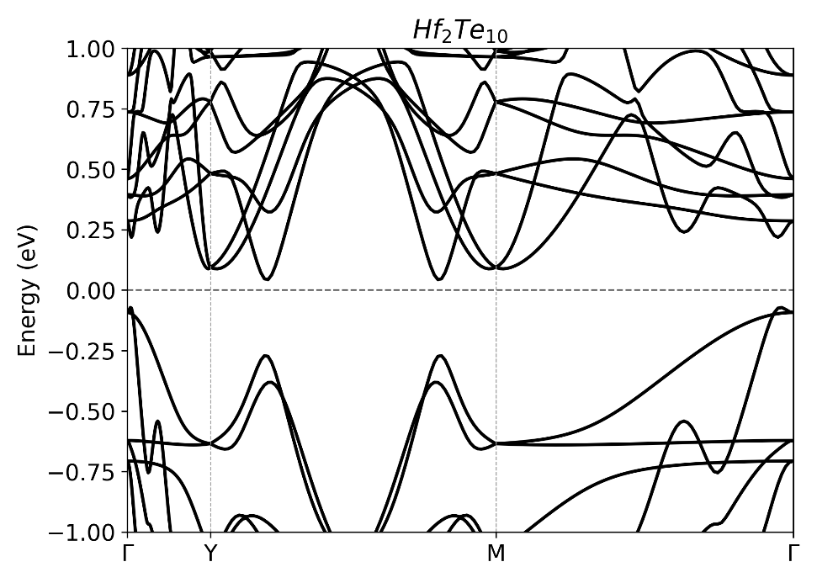
Lattice vectors and band structure of EuAs₂
 | x (Å) | y (Å) | z (Å)
a₁ | 3.7673929899999998 | 0.0000000000000000 | 0.0000000000000000
a₂ | 0.0000000000000000 | 4.9166714899999997 | 0.0000000000000000
a₃ | 0.0000000000000000 | -0.010691840000000 | 23.1722685599999991
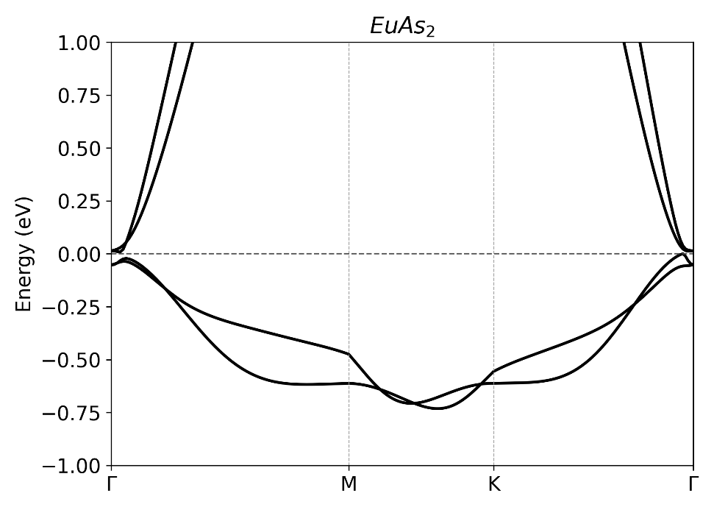

Lattice vectors and band structure of V₂Se₃
 | x (Å) | y (Å) | z (Å)
a₁ | 3.2175180000000001 | 0.0022180600000000 | -0.0039827000000000
a₂ | 1.6067597300000001 | 9.4233658600000005 | 0.3345847100000000
a₃ | 0.0098896400000000 | -0.035210370000000 | 24.9735266299999985
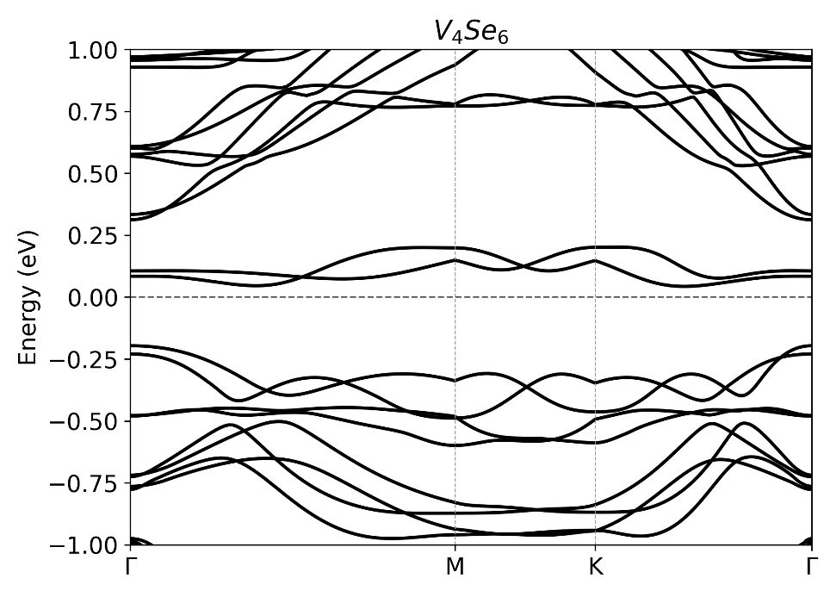

Lattice vectors and band structure of AuF
 | x (Å) | y (Å) | z (Å)
a₁ | 3.9157996300000000 | 0.0000000000000000 | 0.0000000000000000
a₂ | -1.957899300000000 | 3.3911813300000002 | 0.0000000000000000
a₃ | 0.0000000000000000 | 0.0000000000000000 | 20.1955199999999984
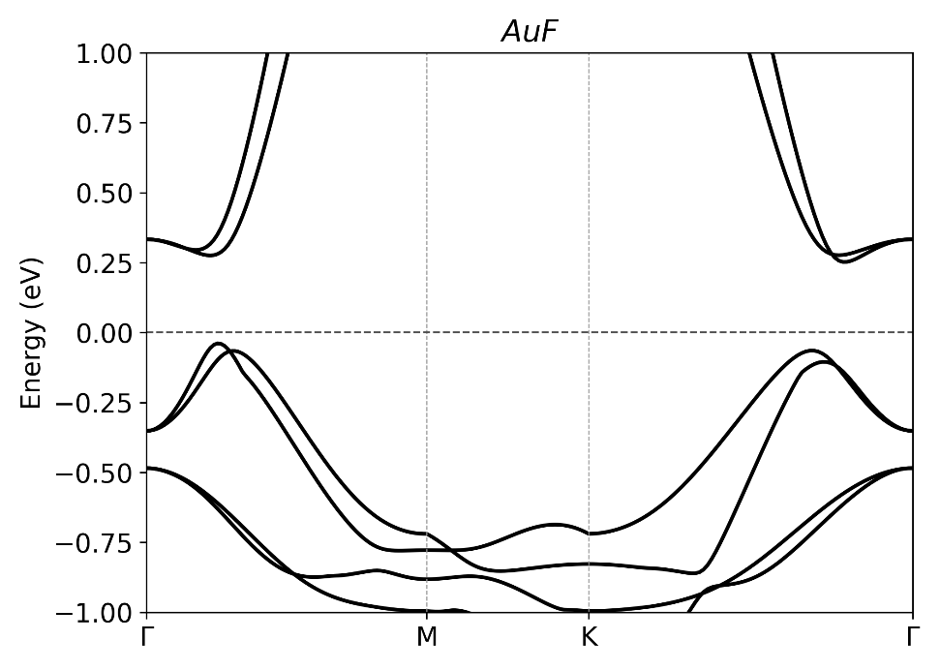
Lattice vectors and band structure of LiTl
 | x (Å) | y (Å) | z (Å)
a₁ | 5.0975631200000002 | 0.0000000000000000 | 0.0000000000000000
a₂ | -2.548781560000000 | 4.4139679599999999 | 0.0000000000000000
a₃ | 0.0000000000000000 | 0.0000000000000000 | 25.7673079999999999
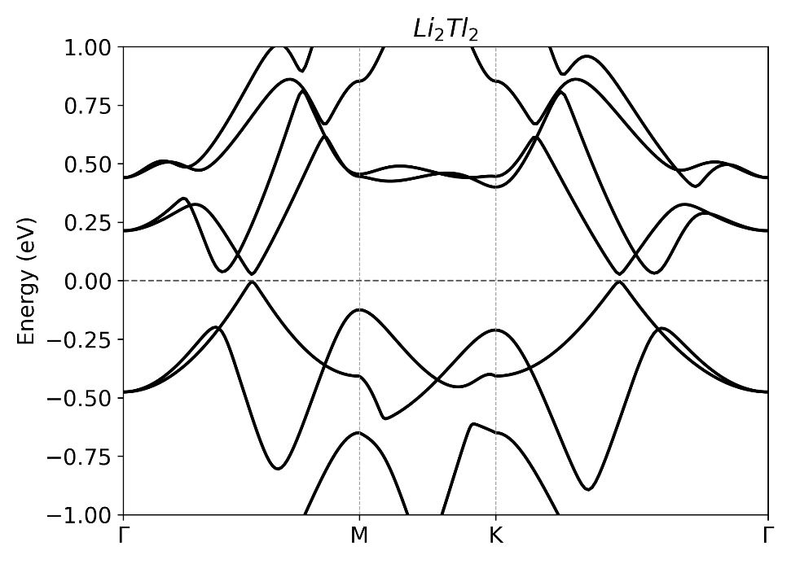

Lattice vectors and band structure of Sn₃H
 | x (Å) | y (Å) | z (Å)
a₁ | 4.6930519999999998 | 0.0000000000000000 | 0.0000000000000000
a₂ | -2.346527000000000 | 4.0643019999999996 | 0.0000000000000000
a₃ | 0.0000000000000000 | 0.0000000000000000 | 30.1104500000000002
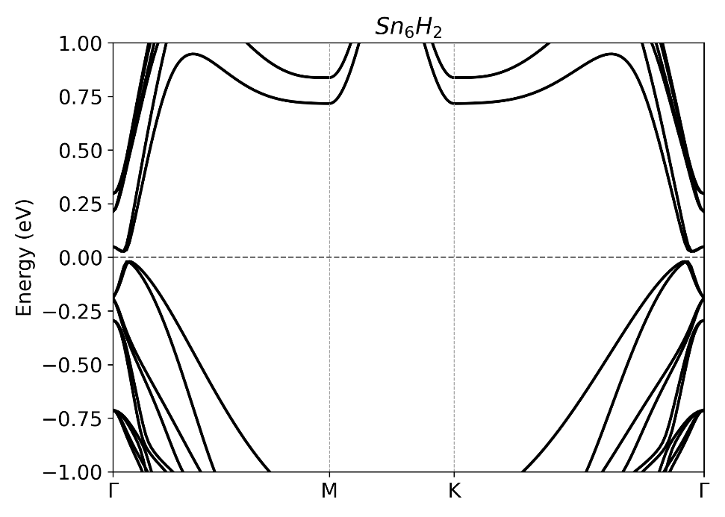
Lattice vectors and band structure of TiTe₅
 | x (Å) | y (Å) | z (Å)
a₁ | 3.9315979500000000 | 0.0000000000000000 | 0.0000000000000000
a₂ | 0.0000000000000000 | 13.769169850000000 | 0.0000000000000000
a₃ | 0.0000000000000000 | 0.0000000000000000 | 25.2975530000000006
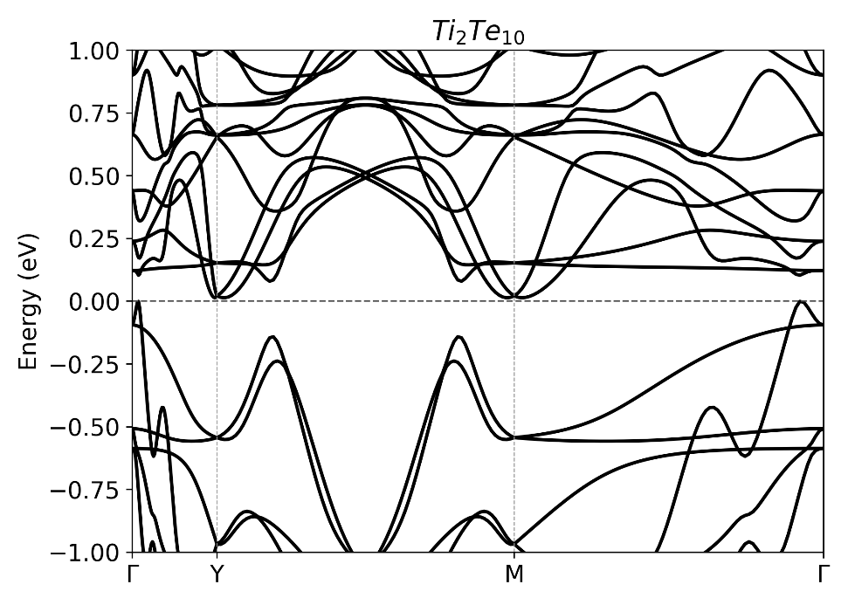

Lattice vectors and band structure of EuP₂
 | x (Å) | y (Å) | z (Å)
a₁ | 3.5430477300000001 | 0.0000000000000000 | 0.0000000000000000
a₂ | 0.0000000000000000 | 4.8166235100000003 | -0.2578819800000000
a₃ | 0.0000000000000000 | -0.012583350000000 | 23.1727655100000014
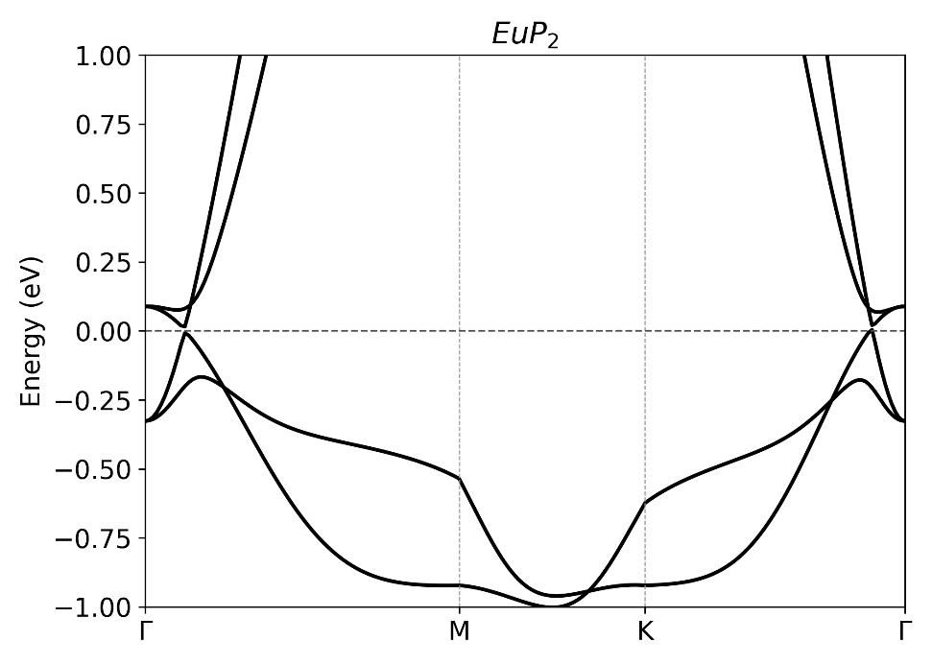

Lattice vectors and band structure of HfS₅
 | x (Å) | y (Å) | z (Å)
a₁ | 3.5079405399999999 | 0.0000000000000000 | 0.0000000000000000
a₂ | 0.0000000000000000 | 11.6604945999999998 | 0.0000000000000000
a₃ | 0.0000000000000000 | 0.0000000000000000 | 25.3784990000000015
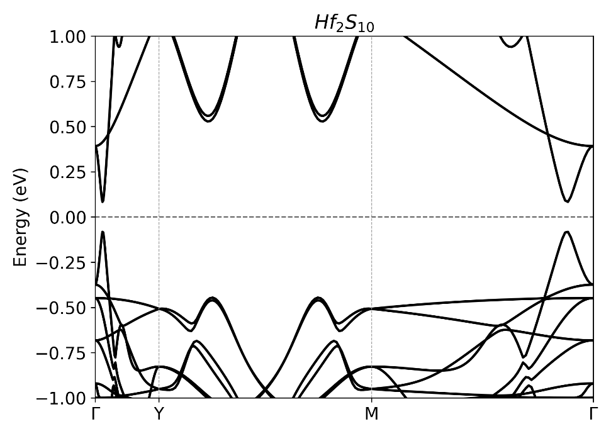
Lattice vectors and band structure of HgS
 | x (Å) | y (Å) | z (Å)
a₁ | 4.2852671999999998 | 0.0000000000000000 | 0.0000000000000000
a₂ | -2.142633599999999 | 3.7111499600000002 | 0.0000000000000000
a₃ | 0.0000000000000000 | 0.0000000000000000 | 20.1669300000000007
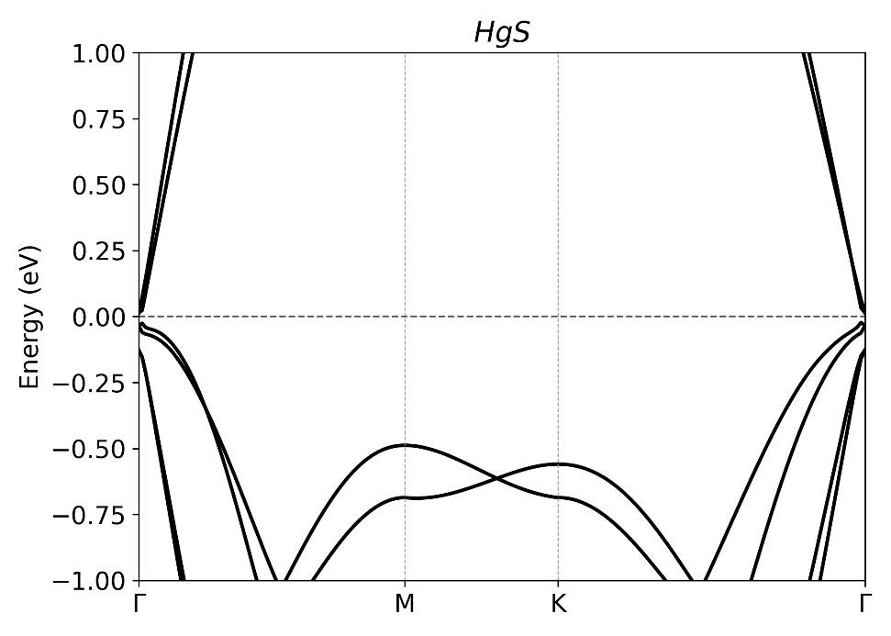

Lattice vectors and band structure of TlSe
 | x (Å) | y (Å) | z (Å)
a₁ | 4.2016570000000000 | 0.0000000000000000 | 0.0000000000000000
a₂ | -2.100827000000000 | 3.6387420000000001 | 0.0000000000000000
a₃ | 0.0000000000000000 | 0.0000000000000000 | 24.6231550000000006
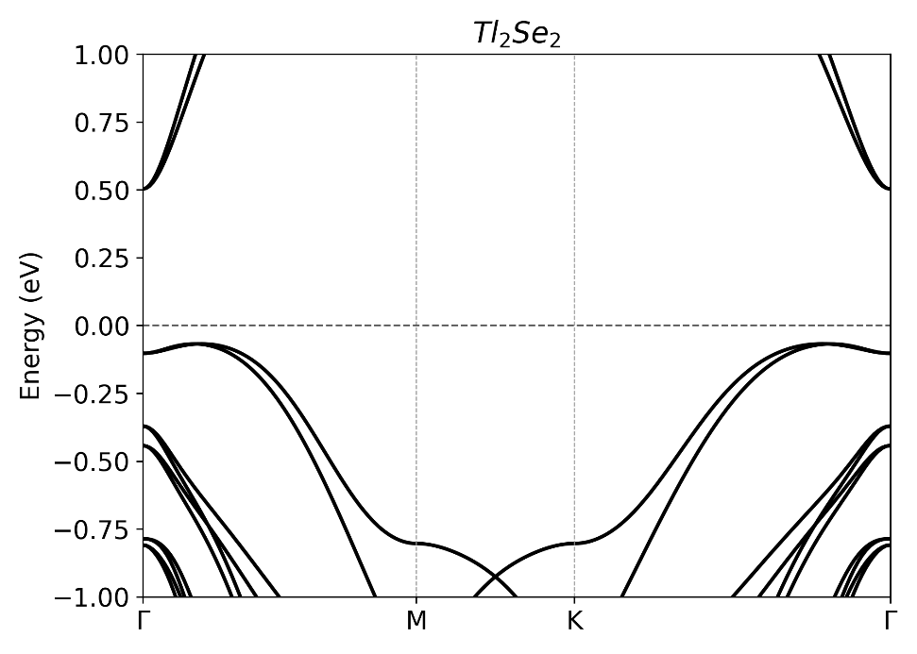
Lattice vectors and band structure of Ta₂S₃
 | x (Å) | y (Å) | z (Å)
a₁ | 3.2360530000000001 | 0.0005720000000000 | -0.0036150000000000
a₂ | 1.6205369999999999 | 9.7229320000000001 | 0.4153560000000000
a₃ | -0.002782000000000 | -0.225844000000000 | 24.9717060000000011
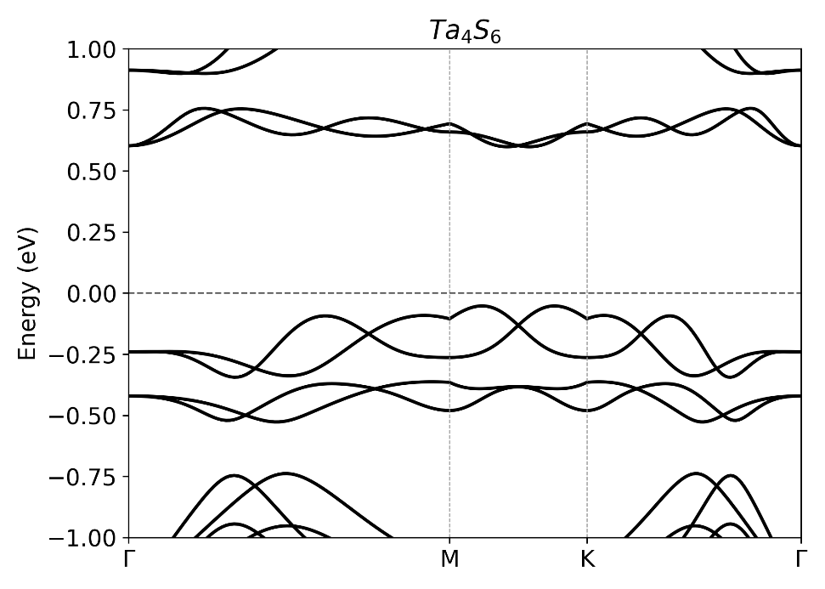
Lattice vectors and band structure of MoAs
 | x (Å) | y (Å) | z (Å)
a₁ | 3.2829700000000002 | -0.010893000000000 | 0.1298240000000000
a₂ | 0.0249610000000000 | 3.2830530000000002 | 0.1285130000000000
a₃ | -0.433307000000000 | -0.438465000000000 | 23.6335930000000012
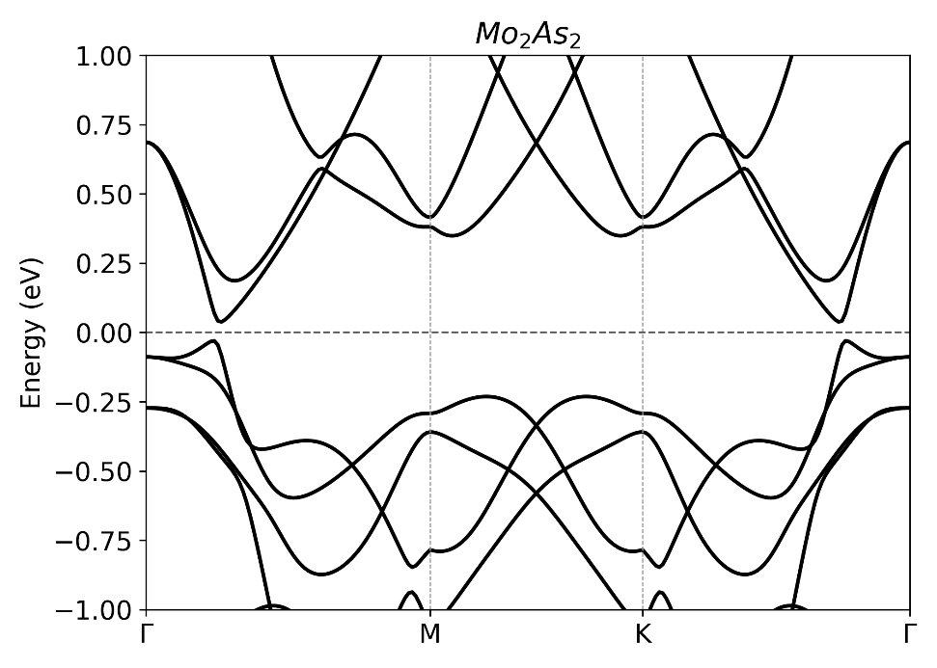
Lattice vectors and band structure of HPb₃
 | x (Å) | y (Å) | z (Å)
a₁ | 4.9659964800000003 | 0.0000000000000000 | 0.0000000000000000
a₂ | -2.482998740000000 | 4.3006788699999996 | 0.0000000000000000
a₃ | 0.0000000000000000 | 0.0000000000000000 | 30.1104500000000002
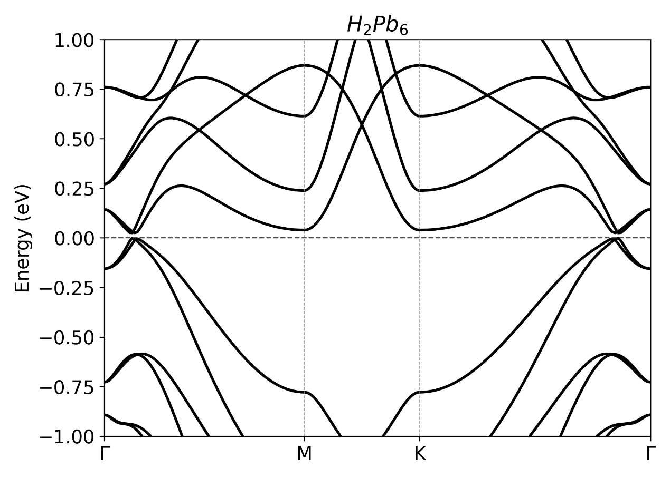

Lattice vectors and band structure of Ag₂Te
 | x (Å) | y (Å) | z (Å)
a₁ | 4.8222829999999997 | 0.0000000000000000 | 0.0000000000000000
a₂ | -2.411141000000000 | 4.1762189999999997 | 0.0000000000000000
a₃ | 0.0000000000000000 | 0.0000000000000000 | 24.5376949999999994
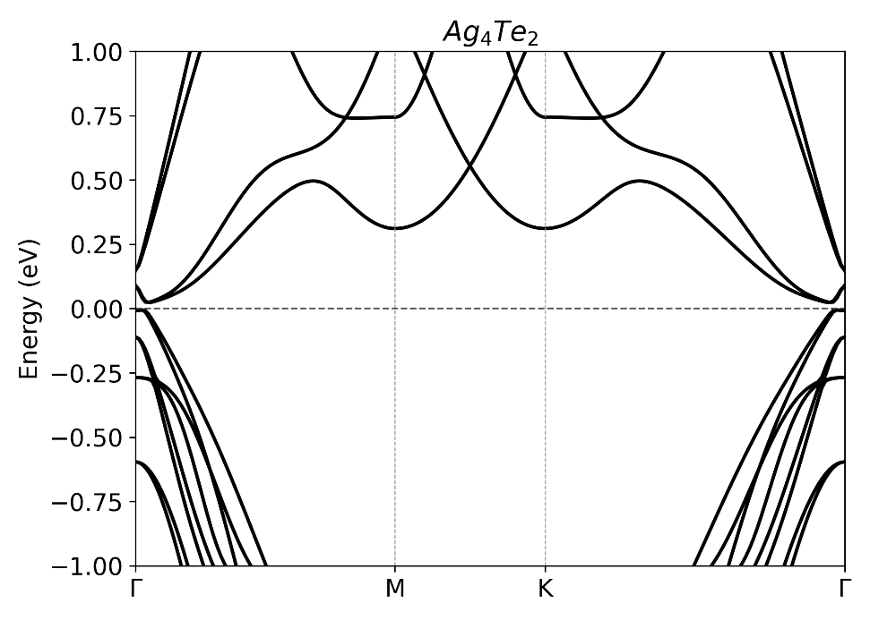
Lattice vectors and band structure of AuCl
 | x (Å) | y (Å) | z (Å)
a₁ | 4.2790628799999997 | 0.0000000000000000 | 0.0000000000000000
a₂ | -2.139531949999999 | 3.7057768100000001 | 0.0000000000000000
a₃ | 0.0000000000000000 | 0.0000000000000000 | 20.1955199999999984
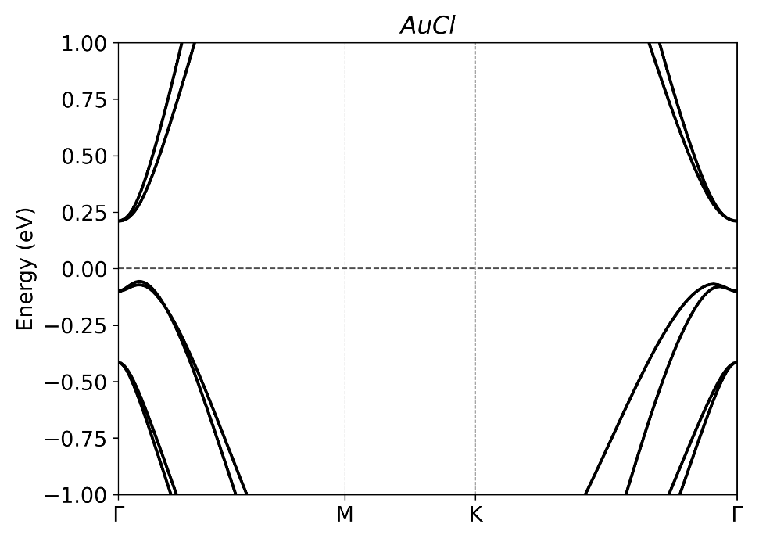

Lattice vectors and band structure of NaMgAs
 | x (Å) | y (Å) | z (Å)
a₁ | 4.6329061300000003 | 0.0000000000000000 | 0.0000000000000000
a₂ | 0.0000000000000000 | 4.6329061300000003 | 0.0000000000000000
a₃ | 0.0000000000000000 | 0.0000000000000000 | 29.1230909999999987
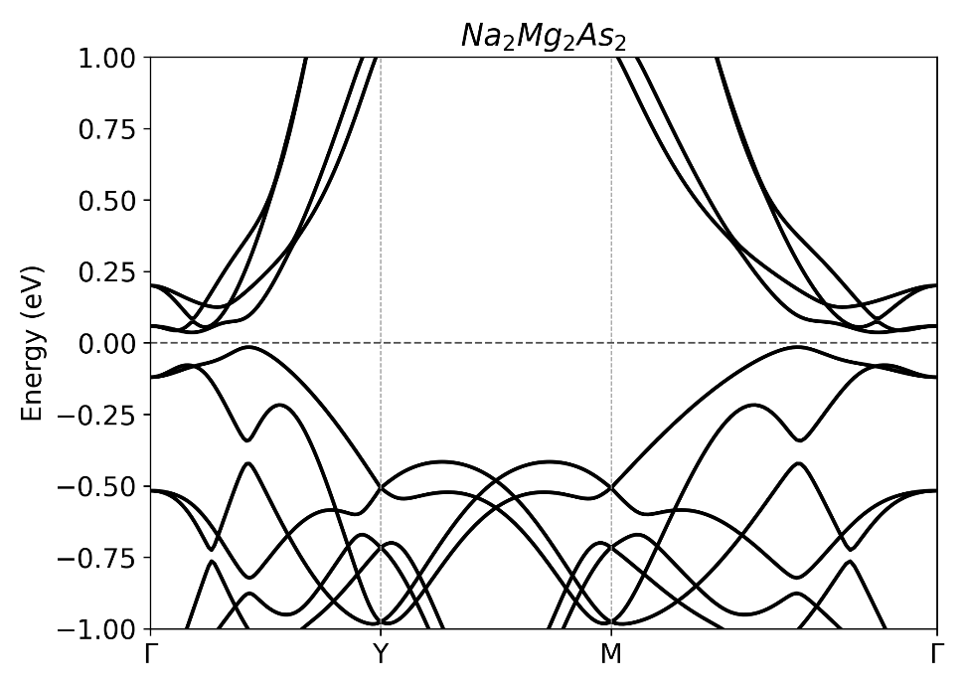
Lattice vectors and band structure of BiTe
 | x (Å) | y (Å) | z (Å)
a₁ | 8.2904905099999997 | 0.0000000000000000 | 0.0000000000000000
a₂ | 0.0000000000000000 | 7.5181791899999997 | 0.0000000000000000
a₃ | 0.0000000000000000 | 0.0000000000000000 | 22.0755000000000017
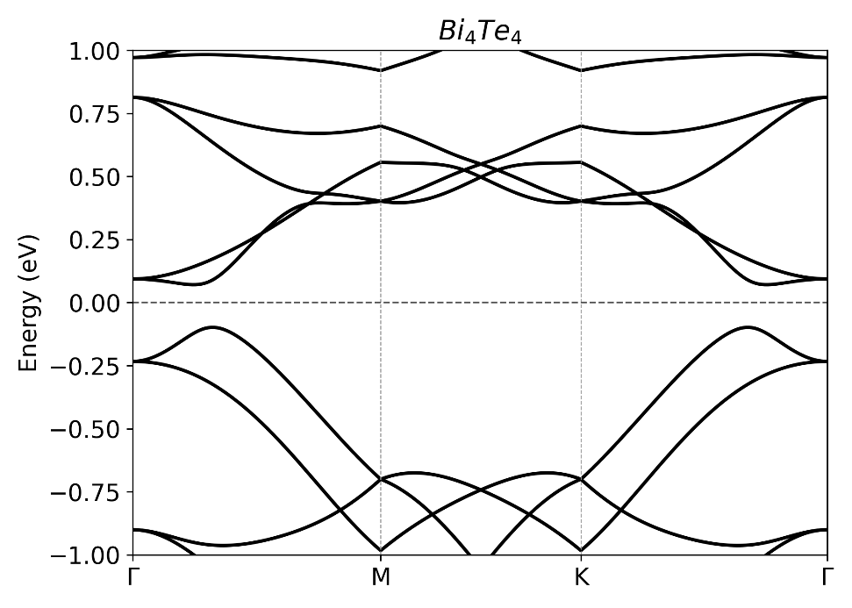

Lattice vectors and band structure of Sb₃C
 | x (Å) | y (Å) | z (Å)
a₁ | 7.5647808300000001 | 0.0000000000000000 | 0.0000000000000000
a₂ | -3.782390420000000 | 6.5512934300000003 | 0.0000000000000000
a₃ | 0.0000000000000000 | 0.0000000000000000 | 21.4054339999999996
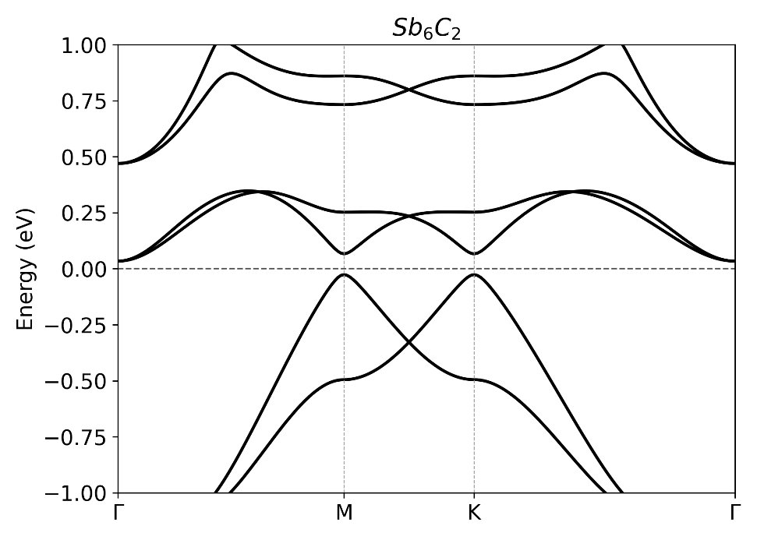

Lattice vectors and band structure of CuF
 | x (Å) | y (Å) | z (Å)
a₁ | 3.4678137800000002 | 0.0000000000000000 | 0.0000000000000000
a₂ | -1.733906549999999 | 3.0032146700000002 | 0.0000000000000000
a₃ | 0.0000000000000000 | 0.0000000000000000 | 20.1955199999999984
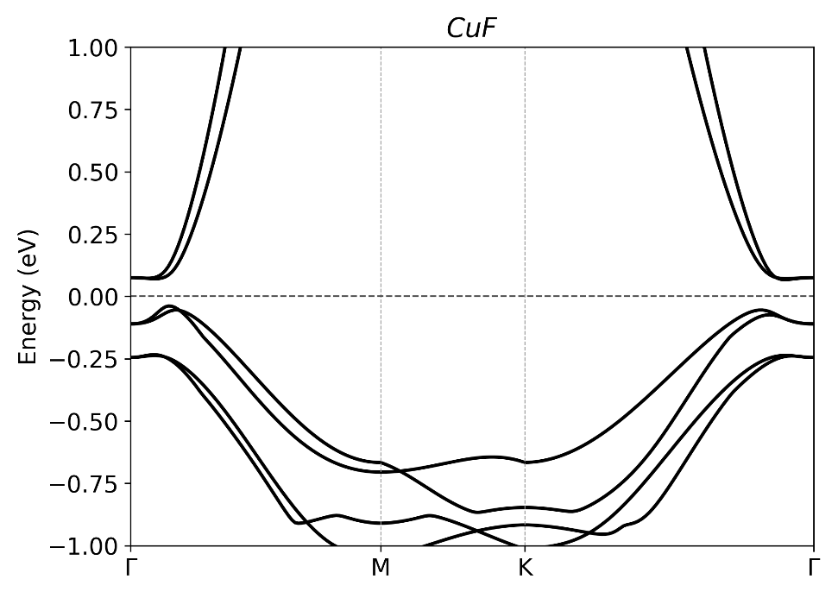
Lattice vectors and band structure of BiBr₅
 | x (Å) | y (Å) | z (Å)
a₁ | 6.7578703500000001 | 0.0000000000000000 | 0.0000000000000000
a₂ | 0.0000000000000000 | 5.4951828799999998 | 0.0000000000000000
a₃ | 0.0000000000000000 | 0.0000000000000000 | 23.7586060000000003
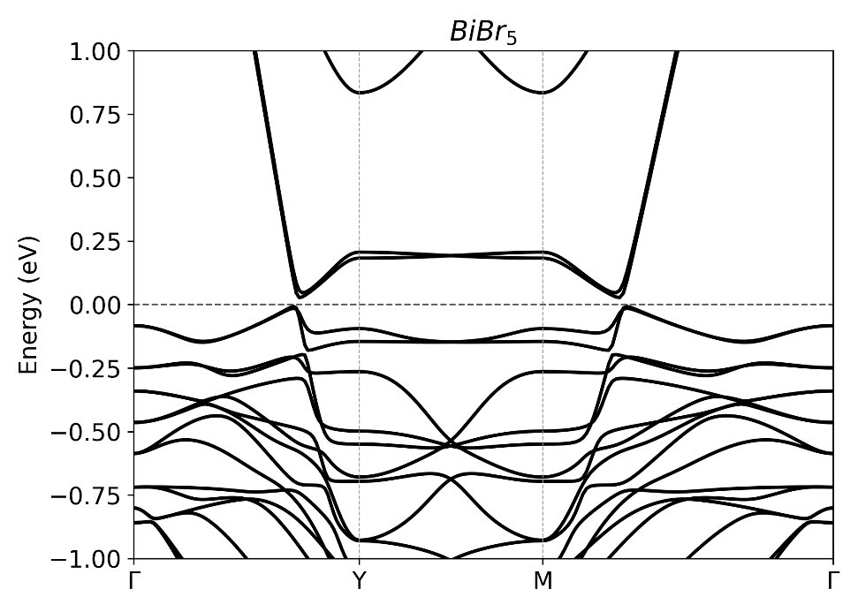

Lattice vectors and band structure of BiSb
 | x (Å) | y (Å) | z (Å)
a₁ | 4.4714468900000002 | 0.0091504600000000 | -0.1301007700000000
a₂ | -0.012158070000000 | 4.7960650500000002 | -0.1178978800000000
a₃ | -0.233315400000000 | -0.171815520000000 | 22.4734668299999996
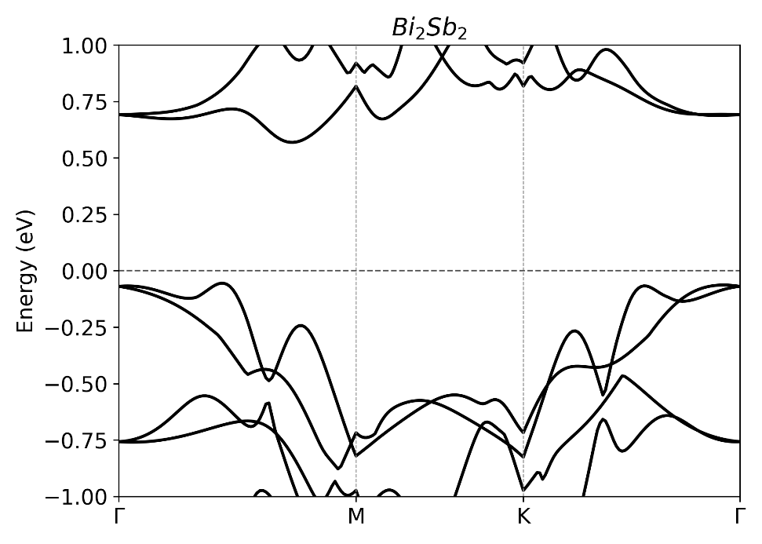
Lattice vectors and band structure of HfBr
 | x (Å) | y (Å) | z (Å)
a₁ | 3.4513527700000002 | 0.0054486900000000 | 0.2870285400000000
a₂ | 1.6932485399999999 | 3.0189667899999999 | 0.2815849000000000
a₃ | 0.0331153000000000 | 0.0224347900000000 | 25.9018439700000016
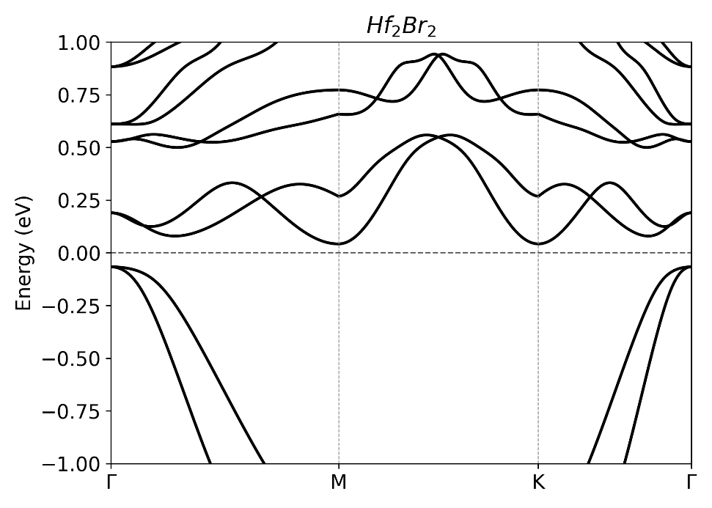

Lattice vectors and band structure of HgTe
 | x (Å) | y (Å) | z (Å)
a₁ | 4.7340843699999997 | 0.0000000000000000 | 0.0000000000000000
a₂ | -2.367042179999999 | 4.0998369400000003 | 0.0000000000000000
a₃ | 0.0000000000000000 | 0.0000000000000000 | 20.1669300000000007
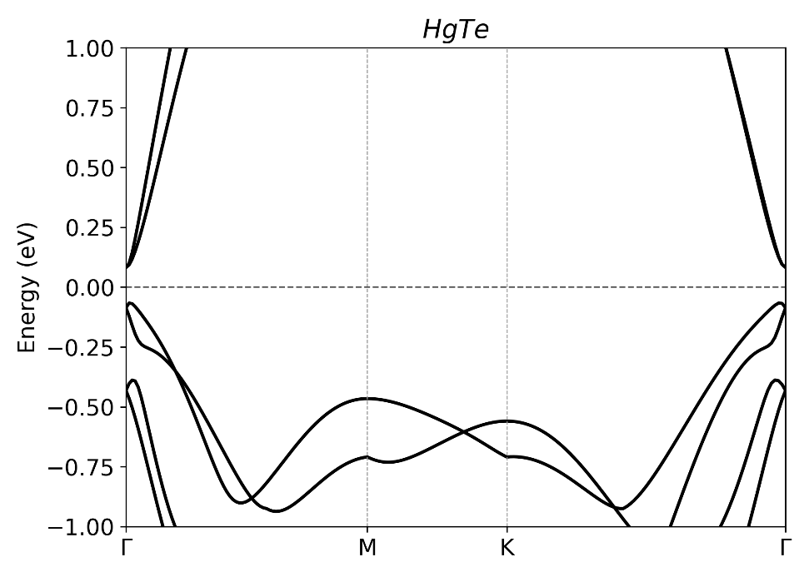
Lattice vectors and band structure of PdI₂
 | x (Å) | y (Å) | z (Å)
a₁ | 4.9317732899999998 | -0.477987660000000 | 0.3142239800000000
a₂ | 0.5679990600000000 | 4.4664598399999997 | 0.0000000000000000
a₃ | -1.909285820000000 | -1.100534190000000 | 24.8868942400000002
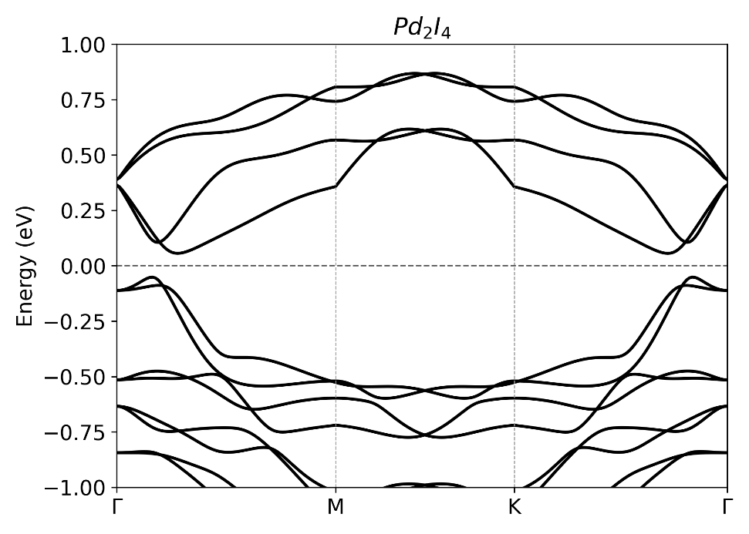

Lattice vectors and band structure of Ca₂Ge
 | x (Å) | y (Å) | z (Å)
a₁ | 8.1322863099999996 | 0.0310781000000000 | 0.0000000000000000
a₂ | -0.018807730000000 | 8.1141384999999993 | 0.0000000000000000
a₃ | 0.0000000000000000 | 0.0000000000000000 | 24.8868942400000002
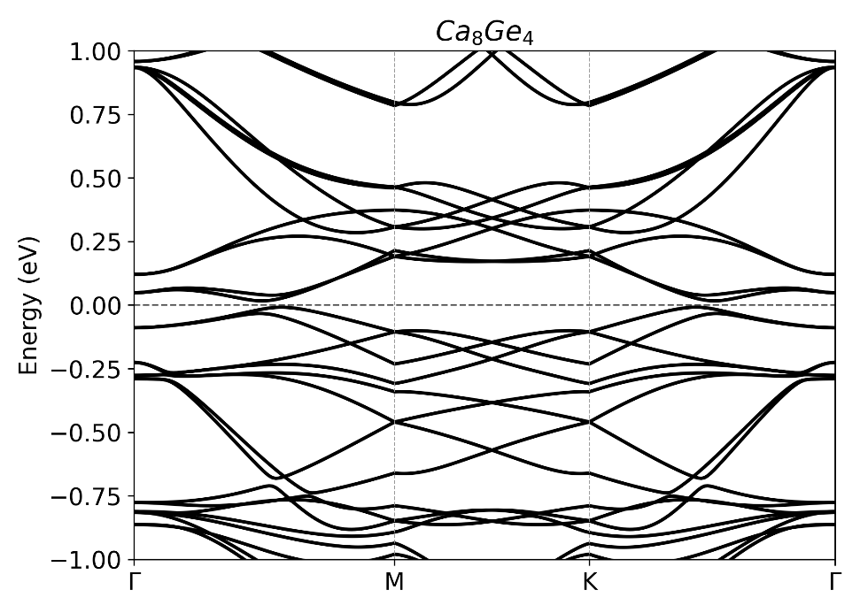
Lattice vectors and band structure of Ta₂Se₃
 | x (Å) | y (Å) | z (Å)
a₁ | 3.3497182099999998 | 0.0005764400000000 | -0.0044203200000000
a₂ | 1.6772771799999999 | 9.9863667599999992 | 0.4387815600000000
a₃ | -0.008642540000000 | -0.168152930000000 | 24.9723825200000000
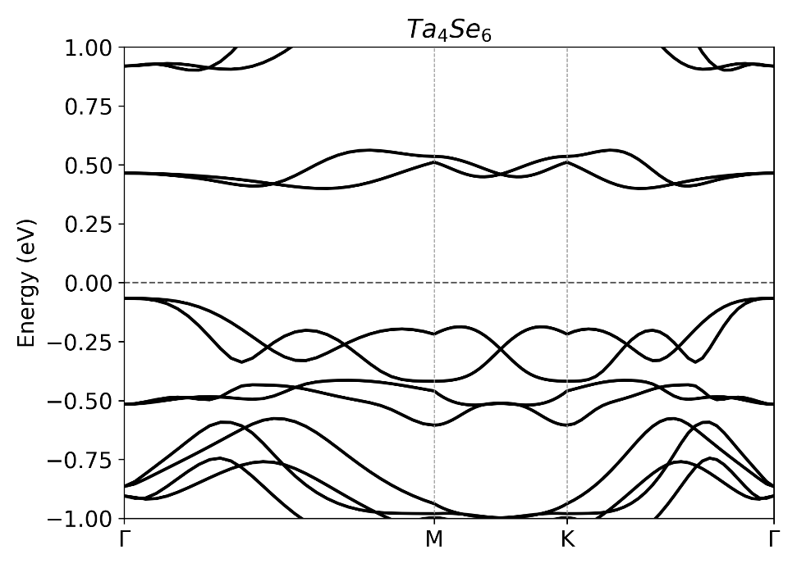
Lattice vectors and band structure of PtI₂
 | x (Å) | y (Å) | z (Å)
a₁ | 4.9384229700000004 | -0.353924180000000 | 0.3944571100000000
a₂ | 0.7003246800000000 | 4.5552051300000000 | 0.4566458900000000
a₃ | -1.514552050000000 | -0.708540460000000 | 24.8506994600000013
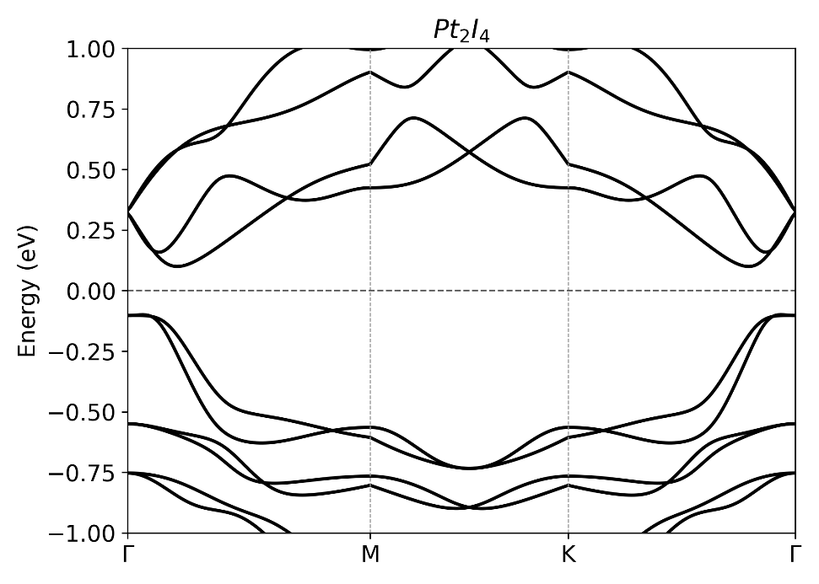

Lattice vectors and band structure of NbI₃
 | x (Å) | y (Å) | z (Å)
a₁ | 6.9986791899999998 | 0.0000000000000000 | 0.0000000000000000
a₂ | -3.499340100000000 | 6.0610329900000002 | 0.0000000000000000
a₃ | 0.0000000000000000 | 0.0000000000000000 | 24.8506994600000013
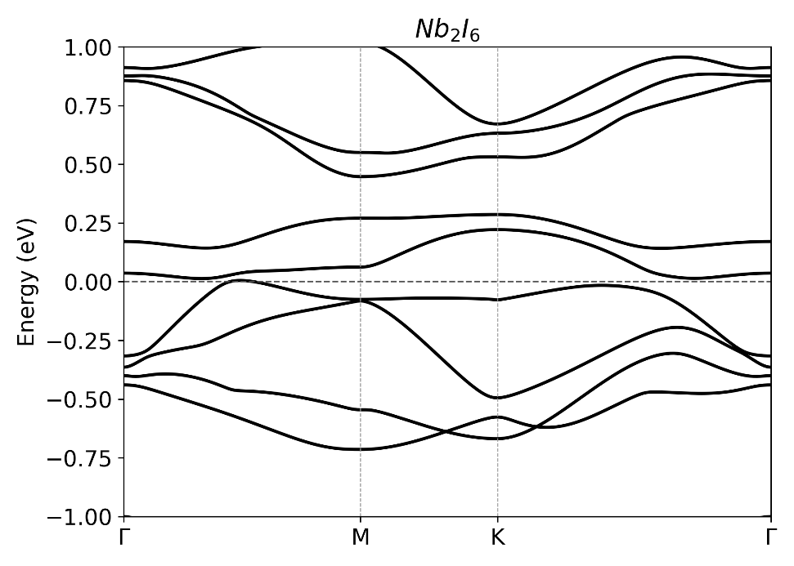
Lattice vectors and band structure of Ta₂S₃
 | x (Å) | y (Å) | z (Å)
a₁ | 3.2360530000000001 | 0.0005720000000000 | -0.003615000000000
a₂ | 1.6205369999999999 | 9.7229320000000001 | 0.4153560000000000
a₃ | -0.002782000000000 | -0.225844000000000 | 24.9717060000000011
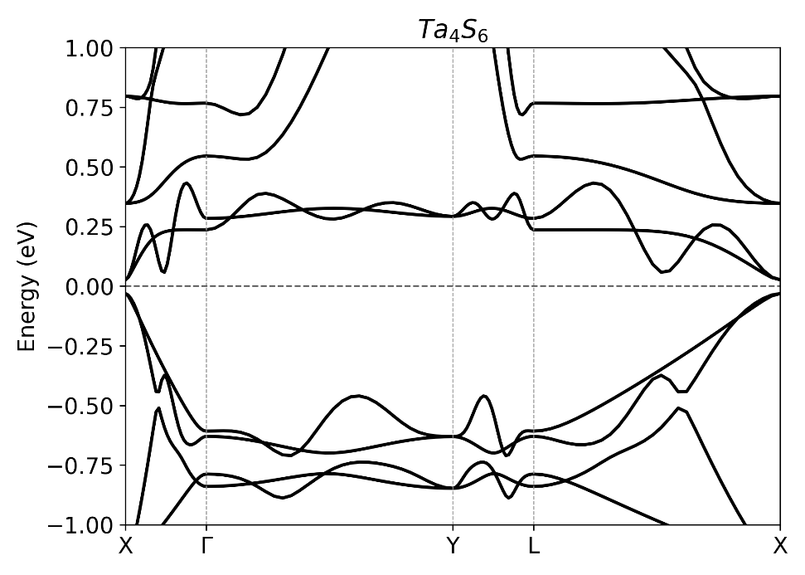

Lattice vectors and band structure of SbBr₅
 | x (Å) | y (Å) | z (Å)
a₁ | 7.1637636100000002 | -0.040986840000000 | 0.6846067100000000
a₂ | -0.048077300000000 | 5.5449332699999996 | -0.0160568300000000
a₃ | 2.0902358300000001 | 0.0128197600000000 | 23.8037616800000009
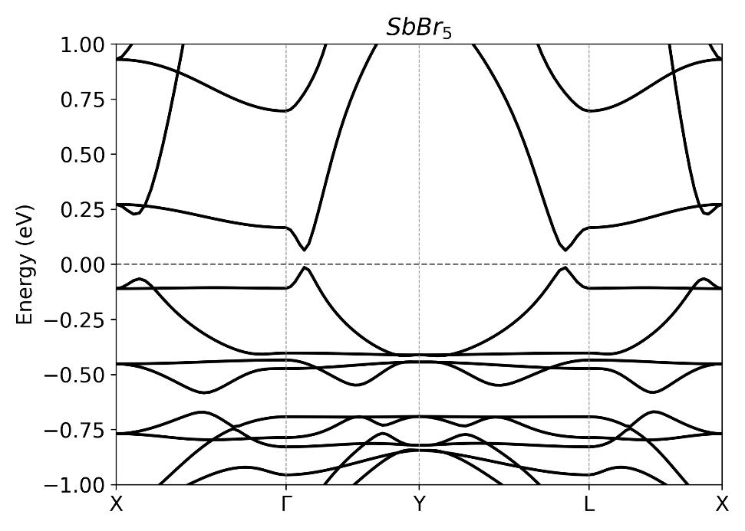
Lattice vectors and band structure of Ta₂Se₃
 | x (Å) | y (Å) | z (Å)
a₁ | 3.3917088500000001 | 0.0000000000000000 | 0.0000000000000000
a₂ | 0.0000000000000000 | 9.8513192200000006 | 0.0000000000000000
a₃ | 0.0000000000000000 | 0.0000000000000000 | 23.7671069999999993
