Supplementary Information
Table S1. Metallic ions concentration in residuals solutions resulting from silver post-leaching.

Chemical Species | Ag | Cu | Fe | Pb | Zn | CN─
Concentración [ppm] | 2.67 | 12.21 | 1.83 | 2.05 | 16.41 | 100

Table S2. Concentrations of metallic species in synthetic solutions designed to represent effluents from the silver post-leaching process.

Metal | Chemical sources | Molar mass | Concentration
Metal | Chemical sources | [g/mol] | [µM] | [ppm]
Ag | AgNO₃ | 169.870 | 15.67 | 2.66
Cu | CuSO₄∙5H₂O | 249.70 | 48.06 | 12.00
Fe | FeSO₄∙7H₂O | 278.02 | 7.19 | 1.99
Pb | Pb(NO₃)₂ | 331.2 | 6.20 | 2.05
Zn | ZnSO₄∙7H₂O | 287.54 | 55.64 | 15.99
CN | NaCN | 49.01 | 2041 | 100.03

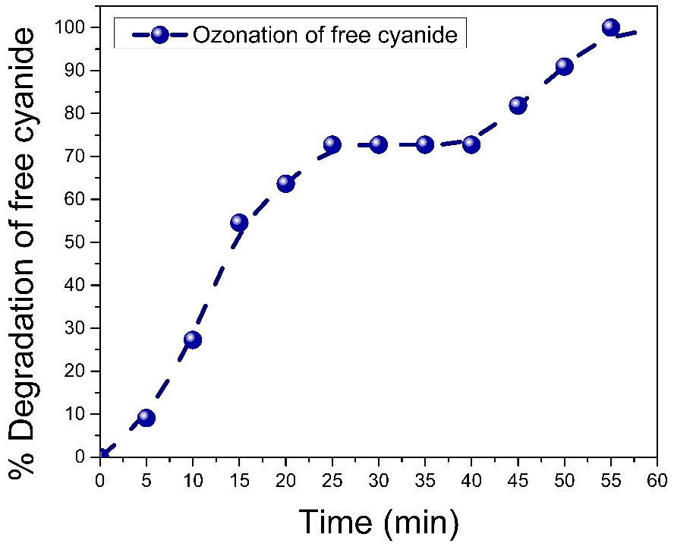

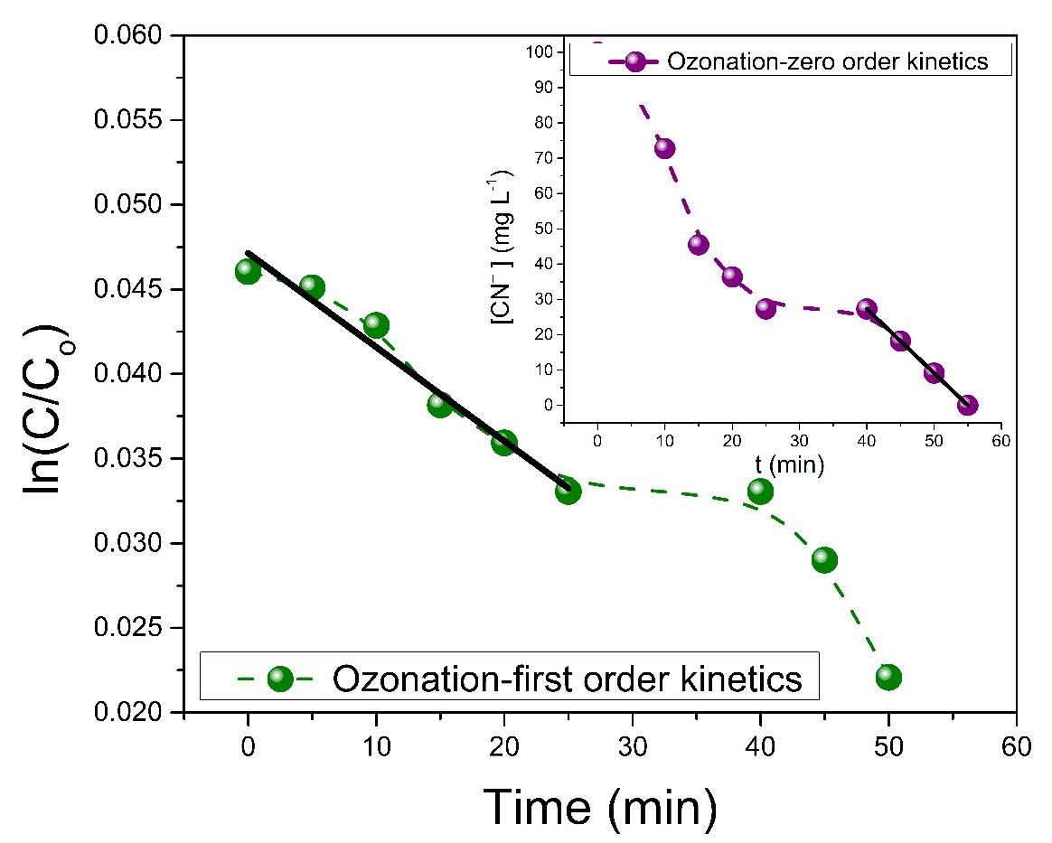

Figure S1: a. Ozonation process: % degradation of free cyanide and reactions kinetics.
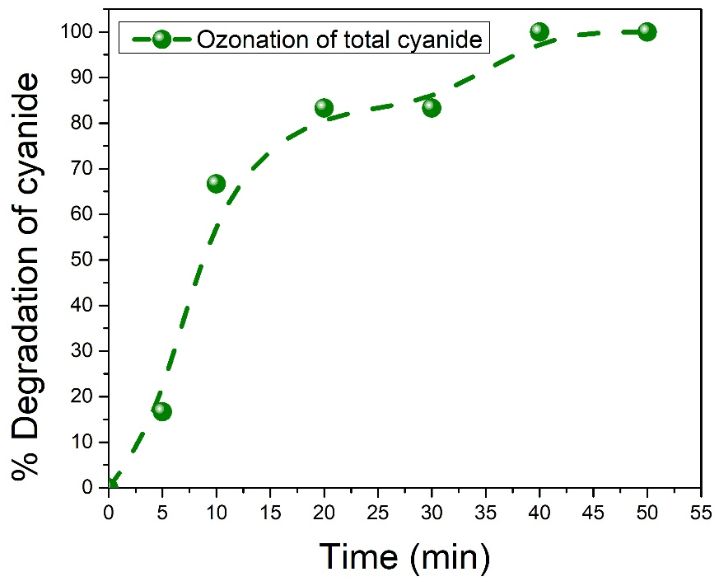

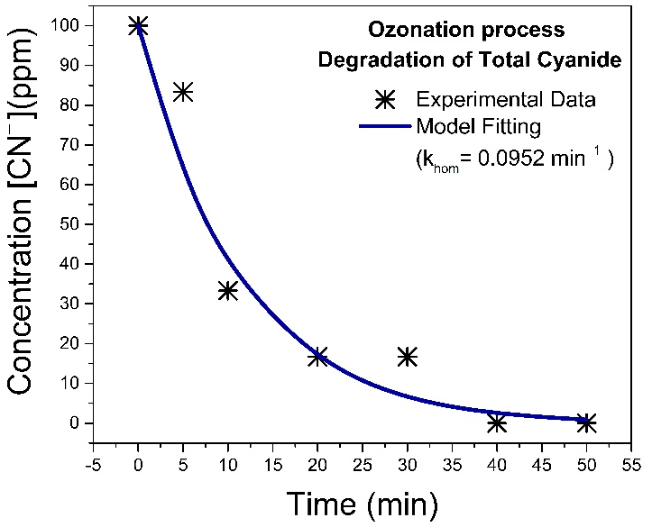

Figure S1b. Ozonation process: degradation of total cyanide and reaction kinetics. In the intervals of 10–20 min, 20–30 min, and 30–40 min, the quantification technique for free cyanide exhibits lower sensitivity in recording the conversion data.

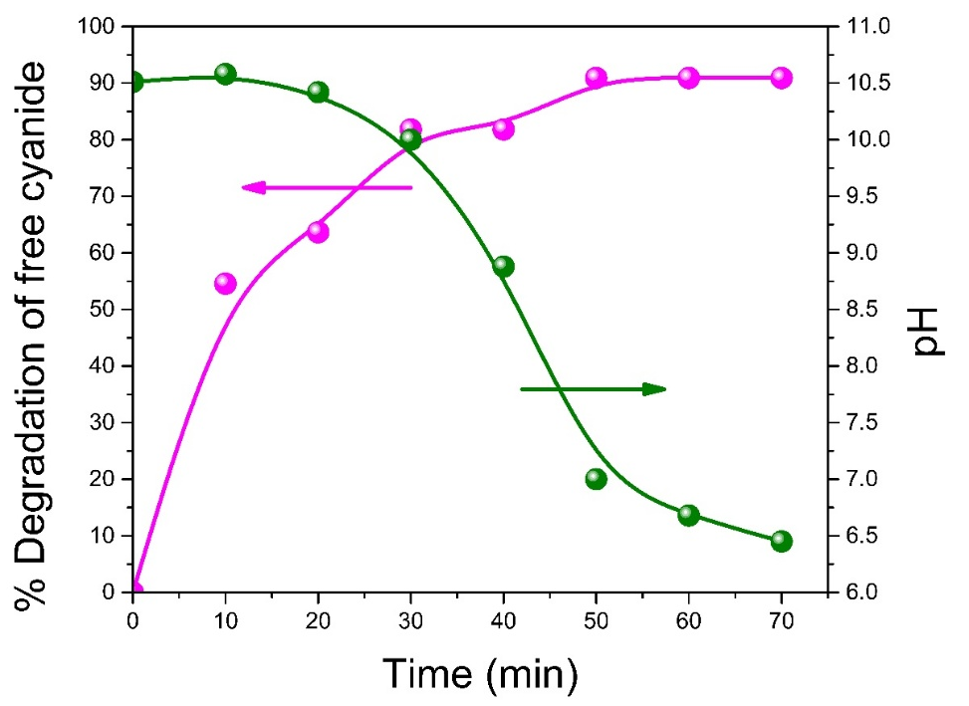

Figure S2. Reaction evolution of the ozonation process for free cyanide degradation without pH adjustment.

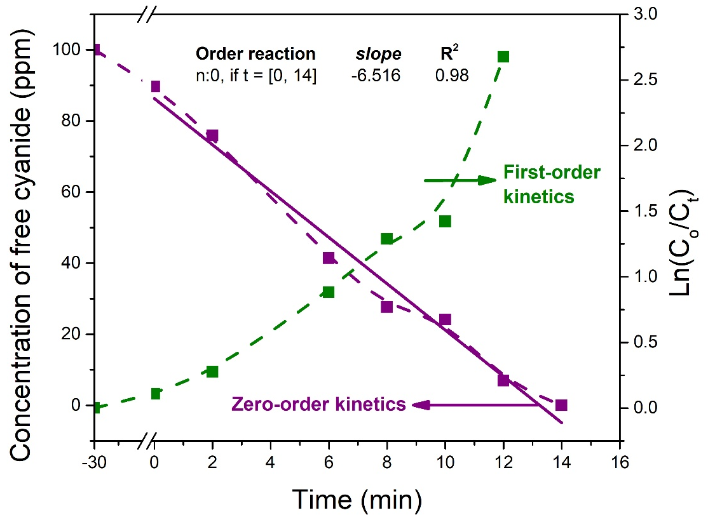
(a)

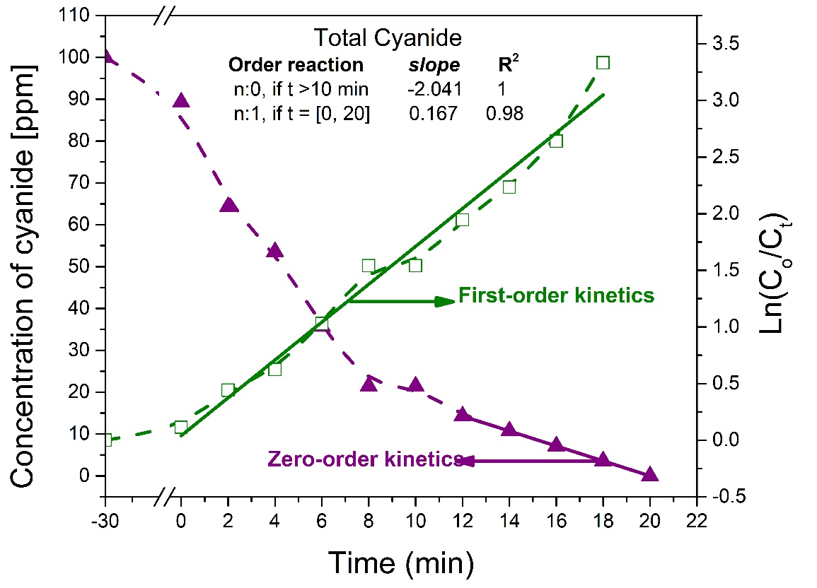
(b)

Figure S3. Reaction kinetics of the degradation process by photocatalytic ozonation: (a) free cyanide and (b) total cyanide.

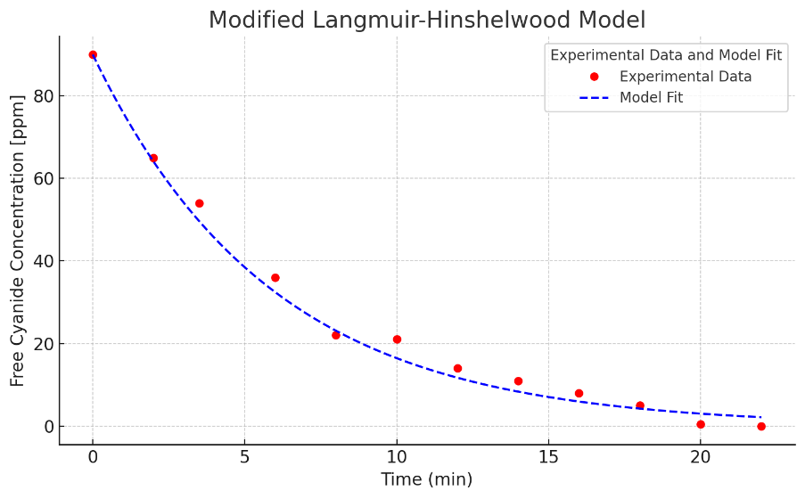

Figure S4. Fitting of experimental data to the modified Langmuir–Hinshelwood kinetic model, considering an effective kinetic constant that includes the interaction of ozone in solution. The model describes the photocatalytic ozonation system applied to the degradation of total cyanide in synthetic solutions representative of silver post-leaching effluents.

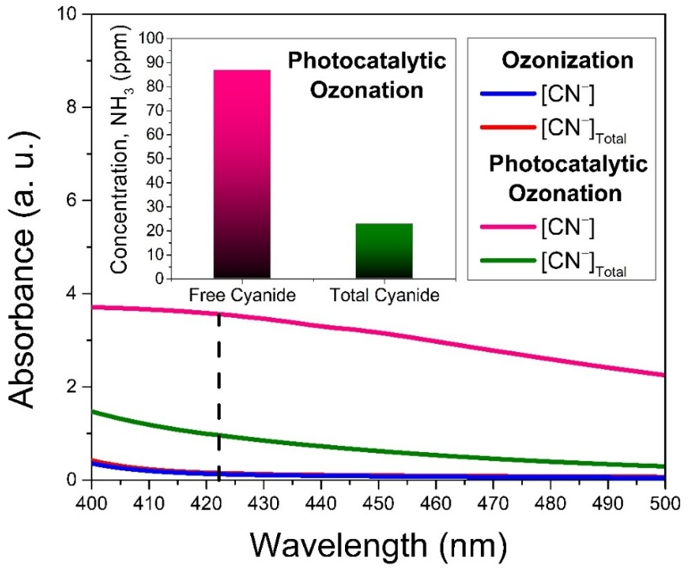

Figure S5. Ammonia concentration determined for both free cyanide and total cyanide after the photocatalytic ozonation reaction.

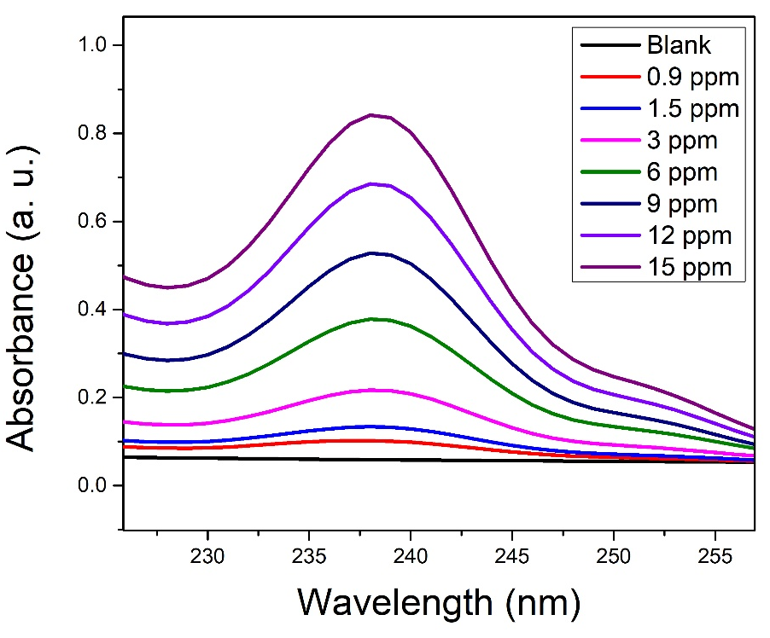

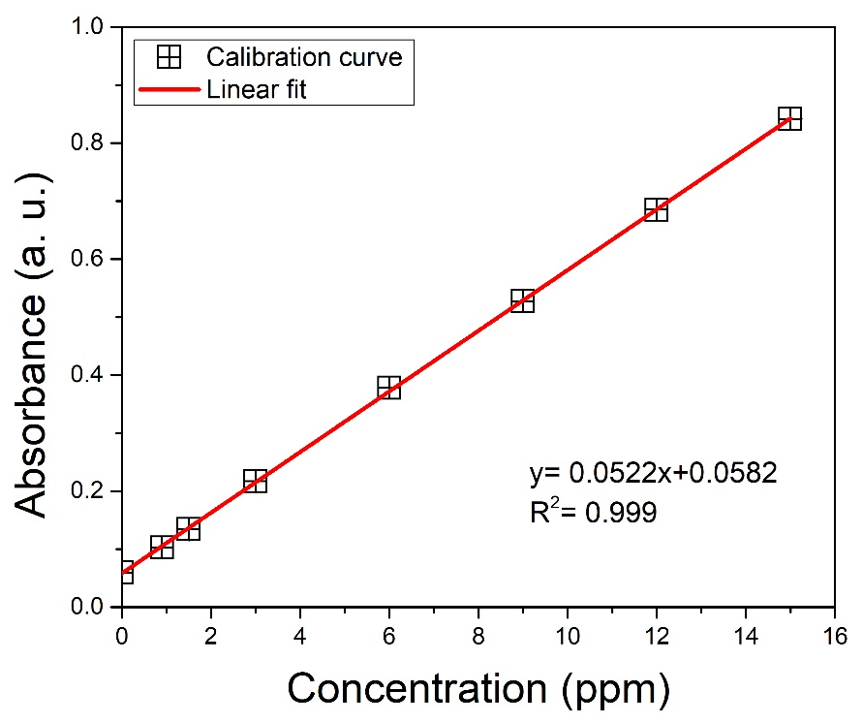

Figure S6. Calibration curve for the detection of cyanide–copper complexes prepared with a cyanide concentration of 100 ppm (2041 μM) and an initial copper concentration of 15 ppm (60.08 μM). Sodium cyanide (NaCN) and copper(II) sulfate pentahydrate (CuSO₄·5H₂O) were used as precursor sources.
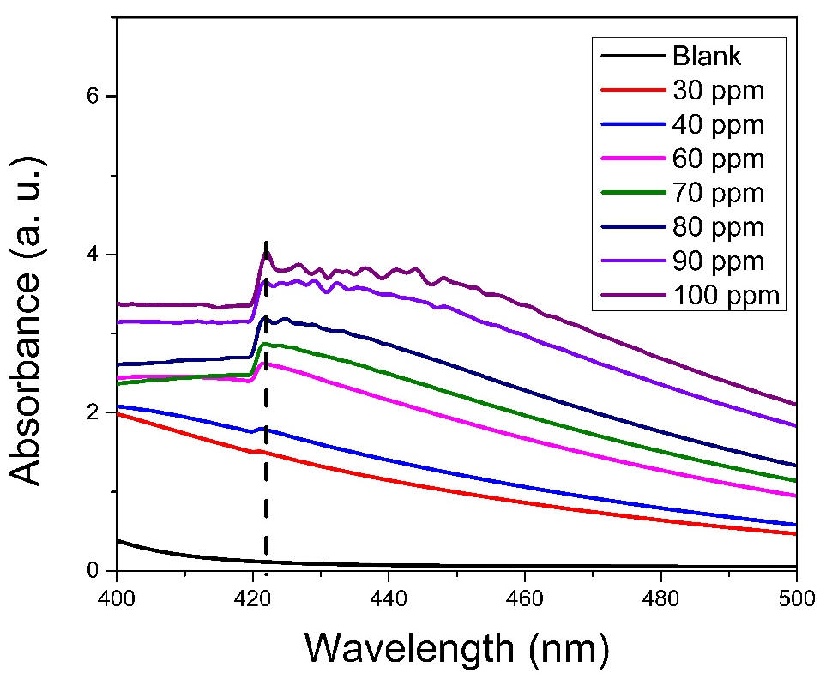

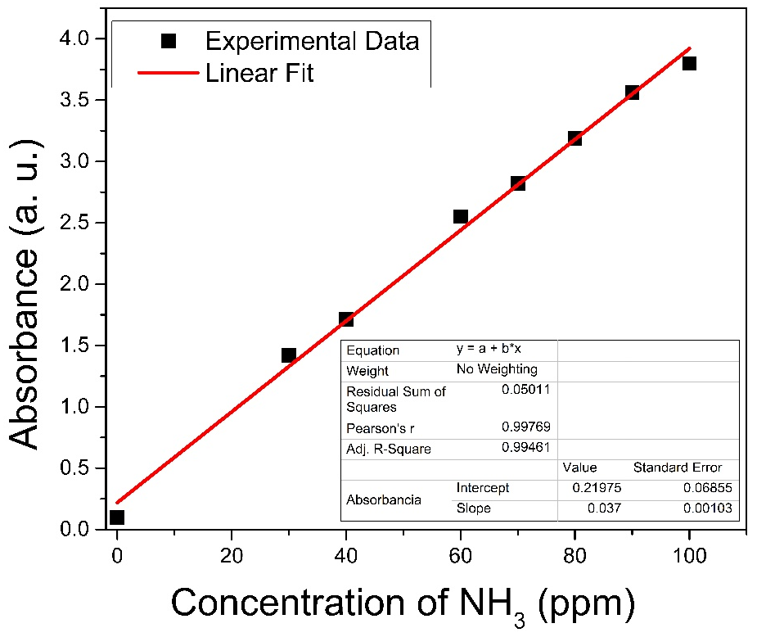

Figure S7. Calibration curve for ammonium determination using the Nessler method, prepared with ammonium chloride as the NH₃ source at pH 10.5.

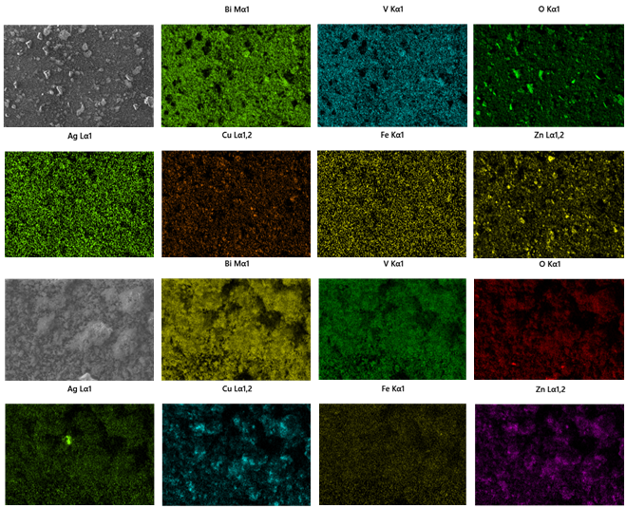
(b)
(a)

Figure S8. Elemental mapping by EDX of the BiVO₄ photocatalyst in the presence of both free cyanide and metal-cyanide complexes after the (a) first cycle and (b) the fourth recycling.

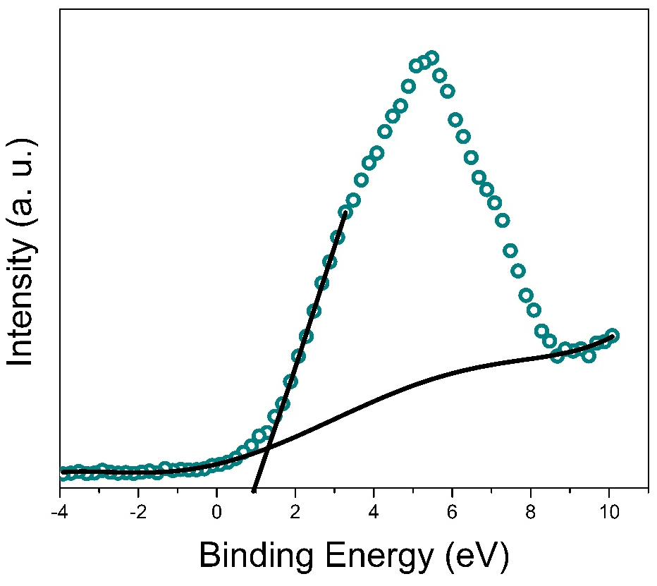

Figure S9. XPS valence band spectrum of bismuth vanadate obtained by the sol–gel method.

NOTE S1
The reaction between iron (II) and ozone is described as follows [40]:
$${Fe}^{2+}+O_{3}→{FeO}^{2+}+O_{2} [1]$$
$${FeO}^{2+}+{Fe}^{2+}+2H^{+}→2{Fe}^{3+}+H_{2}O [2]$$
The iron (III) ions (${Fe}^{3+}$) can be further oxidized in the presence of excess ozone, forming Fe₂O₃(cr) (as shown Equation 50), which predominates after the degradation process.
$$2{Fe}^{3+}+3O_{3}+6H_{2}O→ {Fe}_{2}O_{3}+3O_{2}+6H^{+} [3]$$
For copper (aq), the reaction between ozone and Cu²⁺ are given in Equations 51 and 52.
$${Cu}^{+}+O_{3}→{CuO}^{+}+O_{2} [4]$$
$${CuO}^{+}+H_{2}O→{Cu}^{2+}+{OH}^{•}+{OH}^{-} [5]$$
So, the overall reaction is as follows:
$${Cu}^{+}+O_{3}+H_{2}O→{Cu}^{2+}+O_{2}+{OH}^{•}+{OH}^{-} [6]$$
For silver (aq), based on reference [37], the reaction between the ozone and silver are described in Equations 54-56.
$${Ag}^{+}+O_{3}→{AgO}^{+}+O_{2} [7]$$
$${AgO}^{+}+H_{2}O→2{AgO}_{(s)}+2H^{+} [8]$$
$${AgO}^{+}+O_{3}→2{AgO}_{(s)}+O_{2} [9]$$
According to thermodynamic analysis, a similar mechanism can be proposed for lead (aq) and zinc (aq), as follows.
$${Pb}^{2+}+{4O}_{3}+{2H}_{2}O→{{Pb(OH)}_{4}}^{2-}+{4O}_{2} [10]$$
$${Pb}^{2+}+O_{3}+{2H}_{2}O→{{Pb(OH)}_{2}}_{(s)}+O_{2}+2H^{+} [11]$$
$${Zn}^{2+}+3O_{3}+{2H}_{2}O→{{Zn(OH)}_{3}}^{-}+{3O}_{2} [12]$$
$${Zn}^{2+}+O_{3}+H_{2}O→ZnO+O_{2}+2H^{+} [13]$$

