SUPPLEMENTAL FIGURES
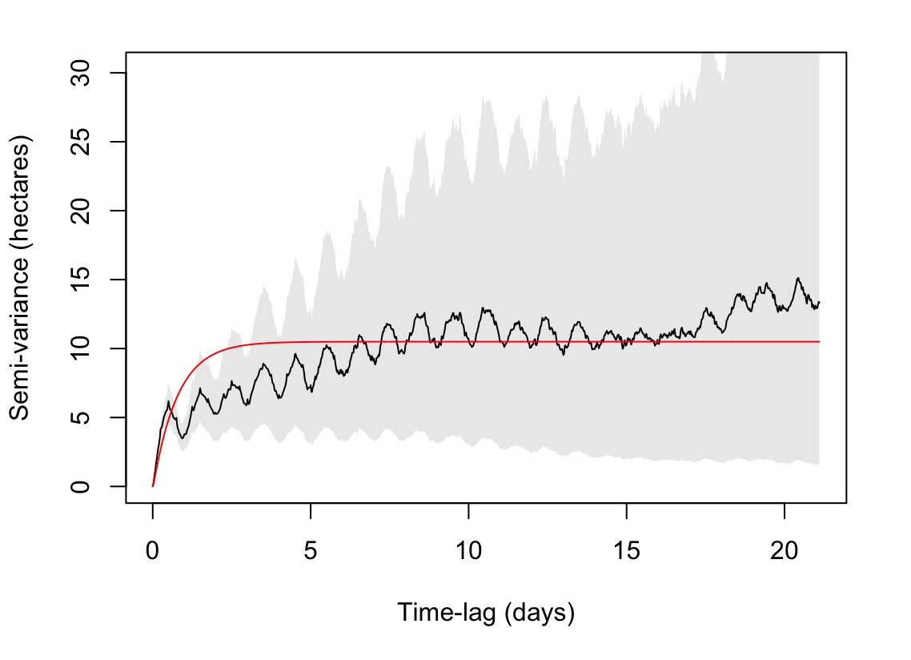
Supplemental Figure 1: An example variogram from a range resident invidual (ID = ‘236517’). The assymptote in red indicates the fitted model to the semi-variance in movement. The black line indicates the variance in movement of an individual between fixes. A better fit assymptote results in smaller confidence intervals in home range estimate.

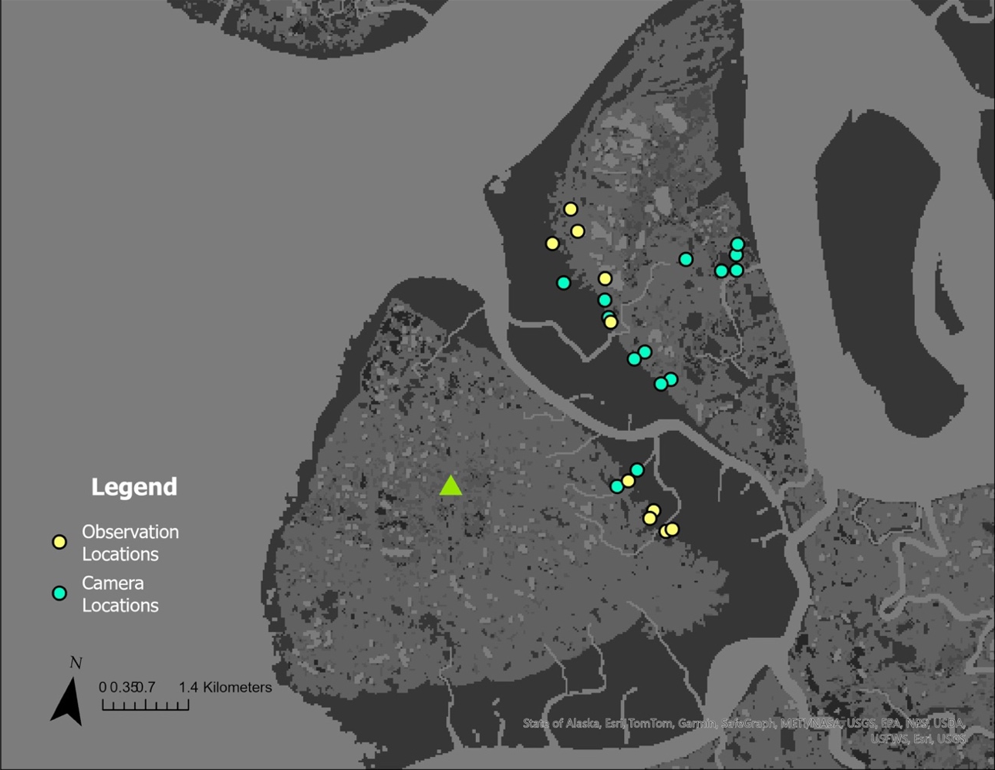
Supplemental Figure 2: Map of camera locations and human observer locations for behavioral observations of emperor geese on mudflats and grazing lawns on Yukon-Kuskokwim Delta, Alaska 2023. Location of field camp is designated by green triangle. Green dots indicate locations where game cameras were deployed. Yellow dots indicate where human observations occurred.

SUPPLEMENTAL TABLES
Supplemental Table I: AICc values for competing models for our home range estimate
 | ΔAICc
Inverse-Guassian | 0
Dirac - δ | 159.8286
 | Area | 95% CI
Mean (km²) | 9.7595740 | 5.5379850 - 15.884614
CoV² (rvar) | 0.8436018 | 0.2225721 - 1.870719

Supplemental Table II: Ethogram used to delineate behaviors exhibited by emperor goose broods and adults. Other information recorded during the observational period included tidal information, conspecifics present, weather metrics (wind, precipitation, temperature), family group size, coordinates, and time at start/end.
Behavior | Code | Definition | Behavior Type
Alert | A | Head up, scanning horizon for predators, active | Alert
Head Up | Hu | At rest, just normal head up vs alert | Resting
Resting | Re | Still or sitting, eyes closed/sleeping, not alert, head tucked | Resting
Brooding | Br | Goslings gathered beneath goose | Resting
Preening | P | Reaching around and reorganizing feathers using bill | Resting
Head down (mud) | Dm | Eating/drinking/gritting, foraging in mud | Foraging
Head down (grass) | Dg | Eating/drinking/gritting, foraging in grass | Foraging
Head down (water) | Dw | Eating/drinking/gritting, foraging in water | Foraging
Interacting | In | Interspecific or intraspecific communication between individuals, positive or negative | Interacting
Fleeing | Fl | Running away from predators/people | Traveling
Flying | Fly | Flying/traveling | Traveling
Swimming | Sw | Floating and moving through water | Traveling
Walking | Wa | Walking across substrate | Traveling
Running | Ru | Running across substrate | Traveling
Calling | C | Open mouthed vocalizations, head up, peeping/honking to communicate to others | Not Observed
Bathing | Ba | Fluffing feathers in water | Not Observed
Tip Up | Tu | Head down butt up | Not Observed
Other | O | Any behavior not described | Not Observed

Supplemental Table III: Odds-Ratio and associated confidence intervals for our global model resource selection function for 13 brood-rearing emperor geese on the Yukon Kuskokwim Delta, Alaska 2022-2023.
 | Estimate | 2.5% | 97.5%
Distance to Water | 0.87 | 0.83 | 0.92
Mudflat | 0. 08 | 0. 07 | 0.09
Tidal Sedge | 1.56 | 1. 43 | 1. 72
Tundra | 0. 76 | 0. 57 | 1.01

