Supplementary material
Supplementary Tables
Supplementary Table 1: Full donor demographic variables and missing data information. Abbreviations: BMI = body mass index, CMV = cytomegalovirus, DCD = donation after circulatory death, IV = intravenous, HLA = human leukocyte antigen, ALT = alanine aminotransferase.
Donor characteristics | Pancreas not transplanted  (N=119374) | Pancreas transplanted  (N=14612) | Overall  (N=133986)
Age, median [IQR], y | 43.0 [30.0, 55.0] | 23.0 [18.0, 29.0] | 40.0 [27.0, 53.0]
BMI, median [IQR], kg/m2 | 27.2 [23.4, 32.0] | 23.4 [20.9, 26.1] | 26.7 [22.9, 31.3]
Missing | 315 (0.3%) | 12 (0.1%) | 327 (0.2%)
Ethnicity
White | 81880 (68.6%) | 8932 (61.1%) | 90812 (67.8%)
Asian | 2778 (2.3%) | 296 (2.0%) | 3074 (2.3%)
Black | 16881 (14.1%) | 2868 (19.6%) | 19749 (14.7%)
Hispanic/Latino | 16265 (13.6%) | 2344 (16.0%) | 18609 (13.9%)
Other | 1491 (1.2%) | 164 (1.1%) | 1655 (1.2%)
Missing | 79 (0.1%) | 8 (0.1%) | 87 (0.1%)
Sex
Male | 71935 (60.3%) | 10104 (69.1%) | 82039 (61.2%)
Female | 47439 (39.7%) | 4508 (30.9%) | 51947 (38.8%)
CMV status
Negative | 45248 (37.9%) | 6034 (41.3%) | 51282 (38.3%)
Positive | 73329 (61.4%) | 8485 (58.1%) | 81814 (61.1%)
Missing | 797 (0.7%) | 93 (0.6%) | 890 (0.7%)
Blood group
A | 44486 (37.3%) | 5166 (35.4%) | 49652 (37.1%)
AB | 4471 (3.7%) | 219 (1.5%) | 4690 (3.5%)
B | 13891 (11.6%) | 1700 (11.6%) | 15591 (11.6%)
O | 56517 (47.3%) | 7527 (51.5%) | 64044 (47.8%)
Missing | 9 (0.0%) | 0 (0%) | 9 (0.0%)
Cause of death
Anoxia | 34286 (28.7%) | 3042 (20.8%) | 37328 (27.9%)
Cerebrovascular/stroke | 33776 (28.3%) | 1550 (10.6%) | 35326 (26.4%)
Drug overdose | 16354 (13.7%) | 1516 (10.4%) | 17870 (13.3%)
Head trauma | 30935 (25.9%) | 8165 (55.9%) | 39100 (29.2%)
Other | 4023 (3.4%) | 339 (2.3%) | 4362 (3.3%)
DCD donor
No | 88286 (74.0%) | 14210 (97.2%) | 102496 (76.5%)
Yes | 31087 (26.0%) | 402 (2.8%) | 31489 (23.5%)
Missing | 1 (0.0%) | 0 (0%) | 1 (0.0%)
Given insulin 24 hours before clamp
No insulin given | 63888 (53.5%) | 7178 (49.1%) | 71066 (53.0%)
Insulin given | 54606 (45.7%) | 7367 (50.4%) | 61973 (46.3%)
Missing | 880 (0.7%) | 67 (0.5%) | 947 (0.7%)
Heavy alcohol use
No heavy alcohol use | 90315 (75.7%) | 13175 (90.2%) | 103490 (77.2%)
Heavy alcohol use | 26696 (22.4%) | 1180 (8.1%) | 27876 (20.8%)
Missing | 2363 (2.0%) | 257 (1.8%) | 2620 (2.0%)
Coronary artery disease
No coronary artery disease | 112210 (94.0%) | 14568 (99.7%) | 126778 (94.6%)
Coronary artery disease | 6442 (5.4%) | 18 (0.1%) | 6460 (4.8%)
Missing | 722 (0.6%) | 26 (0.2%) | 748 (0.6%)
Smoking
No smoking | 89391 (74.9%) | 13880 (95.0%) | 103271 (77.1%)
Smoking | 27977 (23.4%) | 615 (4.2%) | 28592 (21.3%)
Missing | 2006 (1.7%) | 117 (0.8%) | 2123 (1.6%)
Hypertension
No hypertension | 79165 (66.3%) | 13996 (95.8%) | 93161 (69.5%)
Hypertension | 39841 (33.4%) | 603 (4.1%) | 40444 (30.2%)
Missing | 368 (0.3%) | 13 (0.1%) | 381 (0.3%)
IV drug use
No IV drug use | 103929 (87.1%) | 13498 (92.4%) | 117427 (87.6%)
IV drug use | 14236 (11.9%) | 1027 (7.0%) | 15263 (11.4%)
Missing | 1209 (1.0%) | 87 (0.6%) | 1296 (1.0%)
Latest blood pH, median [IQR] | 7.41 [7.36, 7.45] | 7.43 [7.39, 7.46] | 7.41 [7.36, 7.45]
Missing | 997 (0.8%) | 64 (0.4%) | 1061 (0.8%)
Hepatitis C antibody status
Negative | 108632 (91.0%) | 14405 (98.6%) | 123037 (91.8%)
Positive | 10715 (9.0%) | 206 (1.4%) | 10921 (8.2%)
Missing | 27 (0.0%) | 1 (0.0%) | 28 (0.0%)
Number of rare HLA variants
0 | 91844 (76.9%) | 11159 (76.4%) | 103003 (76.9%)
1 | 22477 (18.8%) | 2879 (19.7%) | 25356 (18.9%)
2 | 3223 (2.7%) | 418 (2.9%) | 3641 (2.7%)
3 | 529 (0.4%) | 56 (0.4%) | 585 (0.4%)
4 | 357 (0.3%) | 24 (0.2%) | 381 (0.3%)
5 | 535 (0.4%) | 40 (0.3%) | 575 (0.4%)
6 | 409 (0.3%) | 36 (0.2%) | 445 (0.3%)
Peak lipase, median [IQR], U/L | 46.0 [21.0, 119] | 38.0 [18.0, 92.0] | 45.0 [20.0, 115]
Missing | 18306 (15.3%) | 68 (0.5%) | 18374 (13.7%)
Peak ALT, median [IQR], U/L | 83.0 [37.0, 229] | 63.0 [31.0, 166] | 81.0 [36.0, 221]
Missing | 319 (0.3%) | 1 (0.0%) | 320 (0.2%)
Peak creatinine, median [IQR], U/L | 1.41 [1.05, 2.13] | 1.25 [1.00, 1.59] | 1.40 [1.03, 2.04]
Missing | 120 (0.1%) | 5 (0.0%) | 125 (0.1%)
Hospital stay, median [IQR], days | 4.00 [3.00, 6.00] | 4.00 [3.00, 6.00] | 4.00 [3.00, 6.00]
Missing | 583 (0.5%) | 49 (0.3%) | 632 (0.5%)
Inotropic support
No inotropic support used | 74831 (62.7%) | 8317 (56.9%) | 83148 (62.1%)
Inotropic support used | 43513 (36.5%) | 6210 (42.5%) | 49723 (37.1%)
Missing | 1030 (0.9%) | 85 (0.6%) | 1115 (0.8%)

Supplementary Table 2: Multivariable logistic regression sensitivity analysis for pancreas utilisation for the full cohort (n=133986). An event was defined as successful pancreas transplant (n=14612). This sensitivity analysis includes amylase and AST, which were excluded in the main analysis due to collinearity with lipase and ALT respectively. HbA1c is also included in this sensitivity analysis due to being excluded in the main analysis for having substantial missing data. For restricted cubic spline terms, a p-value is given for the overall impact of the variable on outcome with plots for these restricted cubic splines shown in Supplementary Figure 2. Abbreviations: CMV = cytomegalovirus, DCD = donation after circulatory death, IV = intravenous, HLA = human leukocyte antigen, BMI = body mass index, AST = aspartate aminotransferase.
Donor variable | Adjusted Odds Ratio (95% CI) | P-value
Ethnicity
White | Ref
Asian, Non-Hispanic | 1.111 (0.955 to 1.293) | 0.172
Black, Non-Hispanic | 1.213 (1.140 to 1.290) | <0.001
Hispanic/Latino | 0.850 (0.799 to 0.904) | <0.001
Other | 0.733 (0.607 to 0.886) | 0.001
Sex: male | 1.002 (0.954 to 1.052) | 0.940
CMV positive | 0.914 (0.873 to 0.956) | <0.001
Blood group
A | Ref
AB | 0.284 (0.244 to 0.331) | <0.001
B | 0.923 (0.859 to 0.991) | 0.028
O | 1.153 (1.101 to 1.208) | <0.001
Cause of death
Anoxia | Ref
Cerebrovascular/stroke | 0.973 (0.892 to 1.060) | 0.528
Drug overdose | 1.083 (0.997 to 1.177) | 0.057
Head trauma | 1.059 (0.996 to 1.125) | 0.065
Other | 0.730 (0.633 to 0.842) | <0.001
DCD donor | 0.078 (0.070 to 0.087) | <0.001
Given insulin 24 hours before cross-clamp | 0.963 (0.921 to 1.007) | 0.095
Heavy alcohol use | 0.565 (0.525 to 0.609) | <0.001
Coronary artery disease | 0.392 (0.238 to 0.646) | <0.001
Smoking | 0.850 (0.768 to 0.940) | 0.002
Hypertension | 0.583 (0.528 to 0.643) | <0.001
IV drug use | 0.583 (0.534 to 0.637) | <0.001
Hepatitis C antibody positive | 0.163 (0.140 to 0.191) | <0.001
Number of rare HLA variants
0 | Ref
1 | 0.963 (0.912 to 1.017) | 0.176
2 | 0.919 (0.808 to 1.047) | 0.204
3 | 0.835 (0.597 to 1.168) | 0.293
4 | 0.620 (0.387 to 0.993) | 0.047
5 | 0.648 (0.444 to 0.945) | 0.024
6 | 0.749 (0.503 to 1.115) | 0.154
Inotropic support used | 0.982 (0.940 to 1.027) | 0.437
RCS: BMI | RCS terms | <0.001
RCS: Age, years | RCS terms | <0.001
RCS: Donation date | RCS terms | <0.001
RCS: Latest blood pH | RCS terms | <0.001
RCS: Peak amylase | RCS terms | <0.001
RCS: Peak AST | RCS terms | <0.001
RCS: Peak creatinine | RCS terms | <0.001
RCS: Hospital stay, days | RCS terms | <0.001
RCS: HbA1c | RCS terms | <0.001
Supplementary Table 3: Multivariable logistic regression model for pancreas utilisation for the full cohort (n=133986), pooled from 20 imputed datasets, as part of interaction analysis. Overall P values are shown for interaction terms between key variables (marked with *) and donation date. Plots for key variables are shown in Figure 3 with additional plots in Supplementary Figure 4. Abbreviations: DCD = donation after circulatory death, CMV = cytomegalovirus, HLA = human leukocyte antigen, BMI = body mass index, ALT = alanine aminotransferase, IV = intravenous.
Donor variable | Adjusted Odds Ratio (95% CI) | P-value
DCD donor | 0.126 (0.095 to 0.168) | <0.001
Hepatitis C antibody positive | 0.000 (0.000 to 0.000) | <0.001
Blood group
A | Ref
AB | 0.272 (0.186 to 0.398) | <0.001
B | 0.973 (0.809 to 1.170) | 0.769
O | 1.155 (1.023 to 1.303) | 0.020
Heavy alcohol use | 0.446 (0.364 to 0.546) | <0.001
IV drug use | 0.248 (0.187 to 0.330) | <0.001
Ethnicity
White | Ref
Asian, Non-Hispanic | 1.012 (0.872 to 1.175) | 0.876
Black, Non-Hispanic | 1.102 (1.037 to 1.170) | 0.002
Hispanic/Latino | 0.821 (0.774 to 0.872) | <0.001
Other | 0.683 (0.567 to 0.822) | <0.001
Sex: male | 0.994 (0.947 to 1.043) | 0.796
CMV positive | 0.906 (0.867 to 0.947) | <0.001
Cause of death
Anoxia | Ref
Cerebrovascular/stroke | 0.974 (0.895 to 1.060) | 0.545
Drug overdose | 1.069 (0.984 to 1.160) | 0.113
Head trauma | 1.167 (1.099 to 1.239) | <0.001
Other | 0.759 (0.660 to 0.872) | <0.001
Given insulin 24 hours before clamp | 0.954 (0.913 to 0.996) | 0.034
Coronary artery disease | 0.418 (0.254 to 0.690) | <0.001
Smoking | 0.735 (0.666 to 0.812) | <0.001
Hypertension | 0.535 (0.485 to 0.590) | <0.001
Number of rare HLA variants
0 | Ref
1 | 0.963 (0.912 to 1.016) | 0.164
2 | 0.902 (0.795 to 1.024) | 0.112
3 | 0.821 (0.591 to 1.139) | 0.238
4 | 0.627 (0.394 to 0.999) | 0.050
5 | 0.673 (0.464 to 0.977) | 0.037
6 | 0.769 (0.520 to 1.139) | 0.191
Inotropic support used | 0.961 (0.920 to 1.004) | 0.074
RCS: Age, years | RCS terms
RCS: Donation date | RCS terms | <0.001
RCS: BMI | RCS terms | <0.001
RCS: Peak creatinine | RCS terms | <0.001
RCS: Peak lipase | RCS terms | <0.001
RCS: Peak ALT | RCS terms | <0.001
RCS: Latest blood pH | RCS terms | <0.001
RCS: Hospital stay, days | RCS terms | <0.001
RCS: Age, years * | RCS terms | <0.001
RCS: BMI * | RCS terms | 0.005
RCS: DCD donor * | RCS terms | 0.003
RCS: Peak creatinine * | RCS terms | 0.004
RCS: Hepatitis C positive * | RCS terms | <0.001
RCS: Blood group * | RCS terms | 0.897
RCS: Peak lipase * | RCS terms | 0.825
RCS: Peak ALT * | RCS terms | <0.001
RCS: Heavy alcohol use * | RCS terms | 0.069
RCS: IV drug use * | RCS terms | <0.001

Supplementary Figures

Supplementary Figure 1: Absolute number of pancreas transplants per year from 2010 to 2023.
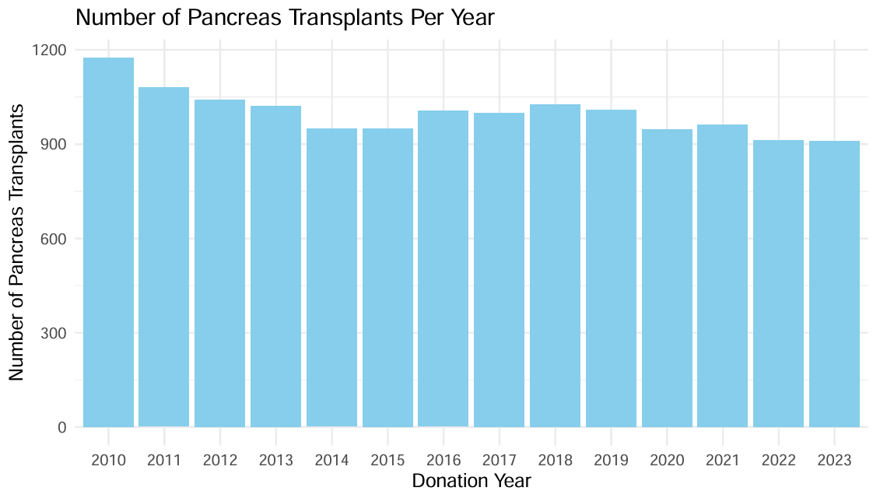

Supplementary Figure 2: Restricted cubic spline models showing association between donor variables from sensitivity analysis and pancreas utilisation. Sensitivity analysis includes amylase and AST, which were excluded due to collinearity with lipase and ALT respectively. HbA1c is also included in the sensitivity analysis and not the main analysis due to substantial missing data. Restricted cubic splines were plotted using 4 knots and were adjusted for all variables in Supplementary Table 2. A log-scaled y-axis is used for all variables for better visualisation of relationships. A log-scaled x-axis is also used for peak amylase, peak AST and peak creatinine.
A) BMI. B) Age. C) Donation date. D) Latest blood pH. E) Peak amylase. F) Peak AST. G) Peak creatinine H) Hospital stay length. I) Peak HbA1c.
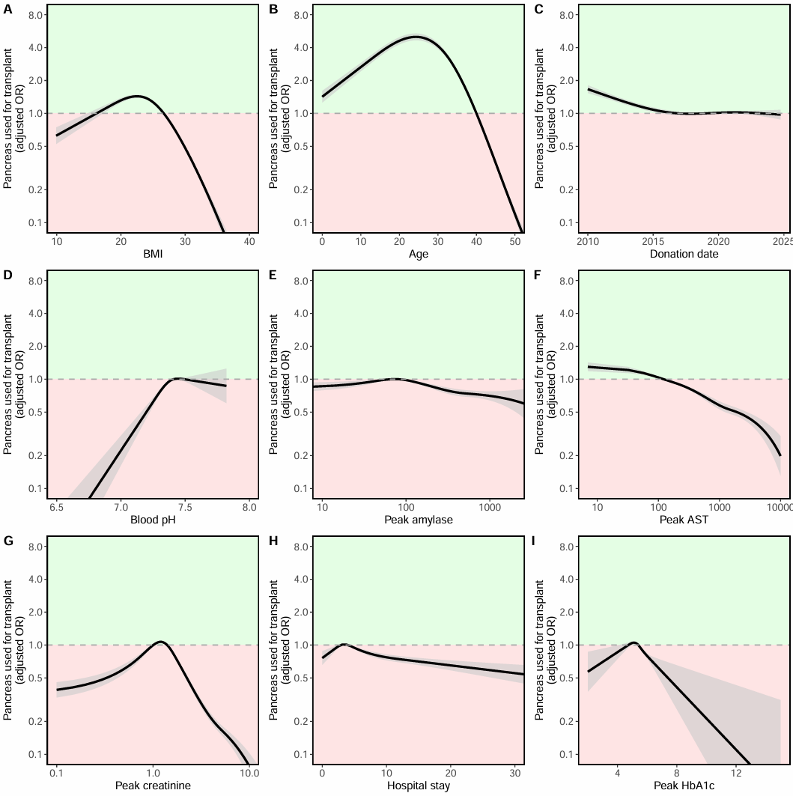

Supplementary Figure 3: Plot showing Wald statistics for variables from main analysis using ANOVA function from rms package. Values further right represent greater importance of the variable in determining utilisation decisions, with age being the most important, and sex being the least important factor.

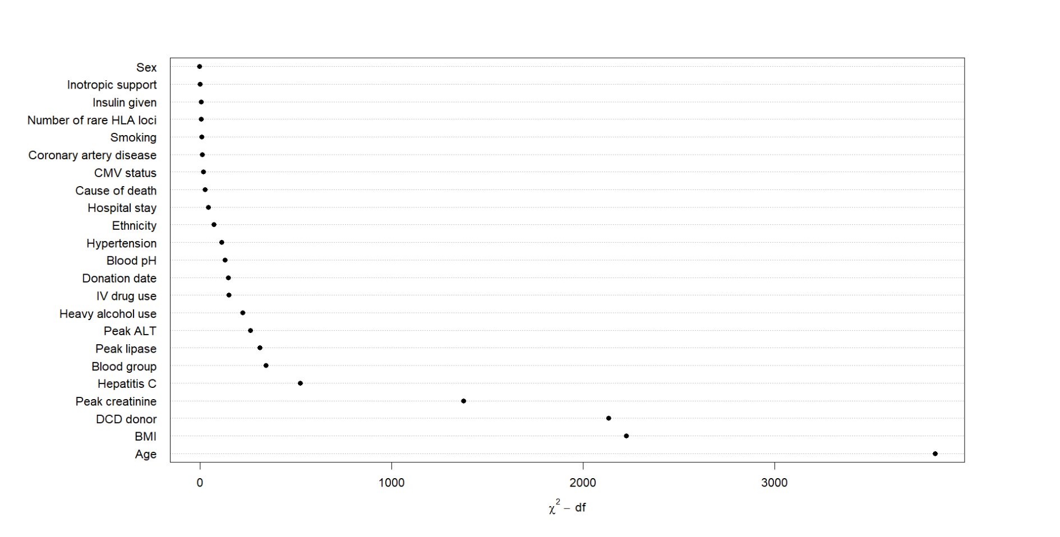

Supplementary Figure 4: Restricted cubic spline models showing interaction effects between variables and donation date on pancreas utilisation. Restricted cubic splines were plotted using 3 knots with a log scaled y-axis. Interaction models for key variables are shown in Figure 3. A) Donor blood group. B) Donor heavy alcohol use. C) Donor BMI. D) Donor peak creatinine. E) Donor peak lipase. F) Donor peak ALT
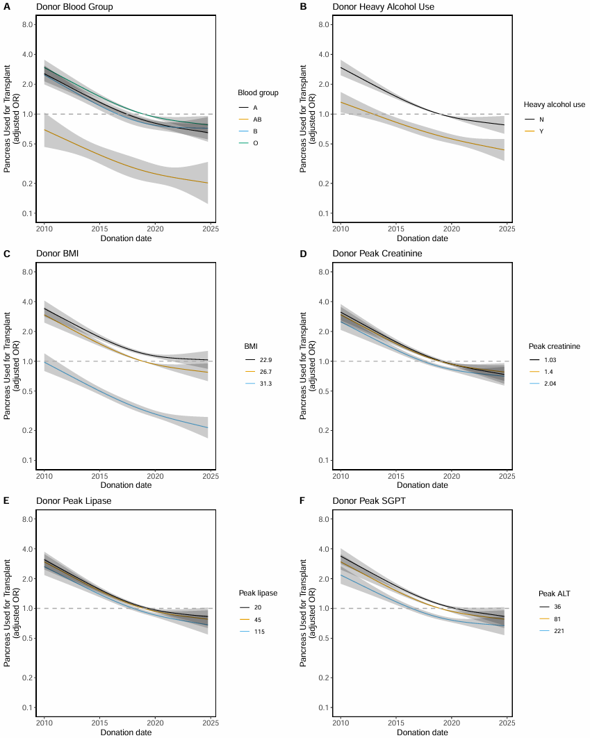

Supplementary Figure 5: Plot of centre-level DCD transplant percentage by total transplant volume over the study period. Blue line represents a LOESS smoothed trend with 95% confidence interval (grey band). Centres performing less than 5 pancreas transplants per year were excluded as DCD utilisation percentage would be too unstable for comparison.
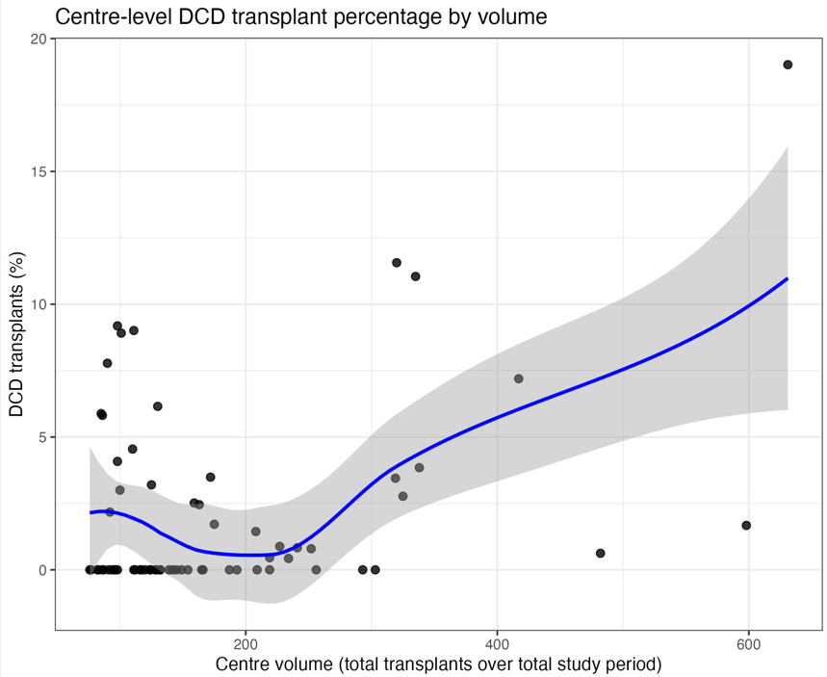

Supplementary Figure 6: Counts of annual DCD donors by retrieval type over the study period. A) DCD donors stratified by retrieval type in the full cohort. B) DCD donors stratified by retrieval type in those utilised for transplantation. Abbreviations: SRR = super rapid recovery, NRP = normothermic regional perfusion.
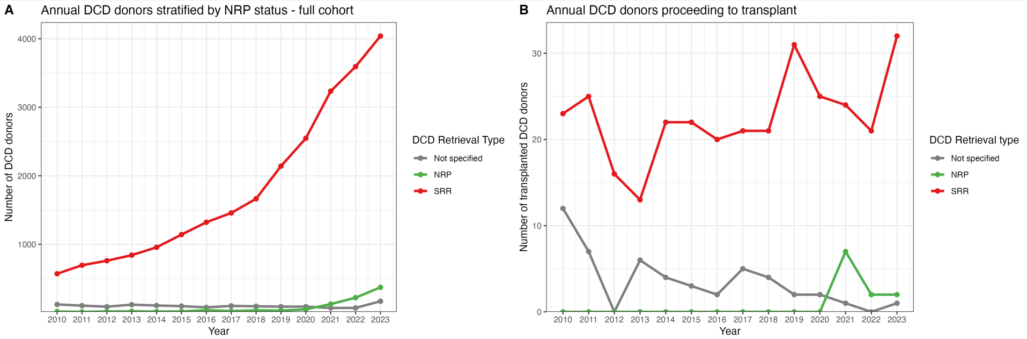

Supplementary Figure 7: Breakdown of HCV antibody positive donors by HCV NAT status. A&B) HCV antibody positive donors in the full cohort (including those donors where the pancreas was not transplanted). C&D) HCV antibody positive donors where the pancreas was transplanted. Counts (panel A&C) and proportions (B&D) are displayed. Proportions are only displayed from 2017 onwards, as prior to this too few HCV antibody positive donor pancreas transplants took place.
