Can a factual approach using contextualized complex information provide clinical insights for appropriate transfusion at emergency departments?

Frédéric Garban,^{1,2,} Christophe Cancé,¹ Dimitri Sourd, MSc,³ Guillaume Dupouy,³ Eve Laborde,² Damien Viglino, MD,⁴ Paul Antoine Beaudoin,¹ Antoine Vilotitch,³ Sandra David Tchouda,³ Alexandre Moreau Gaudry,^{1,3*} Jean Luc Bosson,^{1,3*}
* These authors contributed equally

Supplemental data

1. Flow chart of the TRANSFUSIA database elaboration
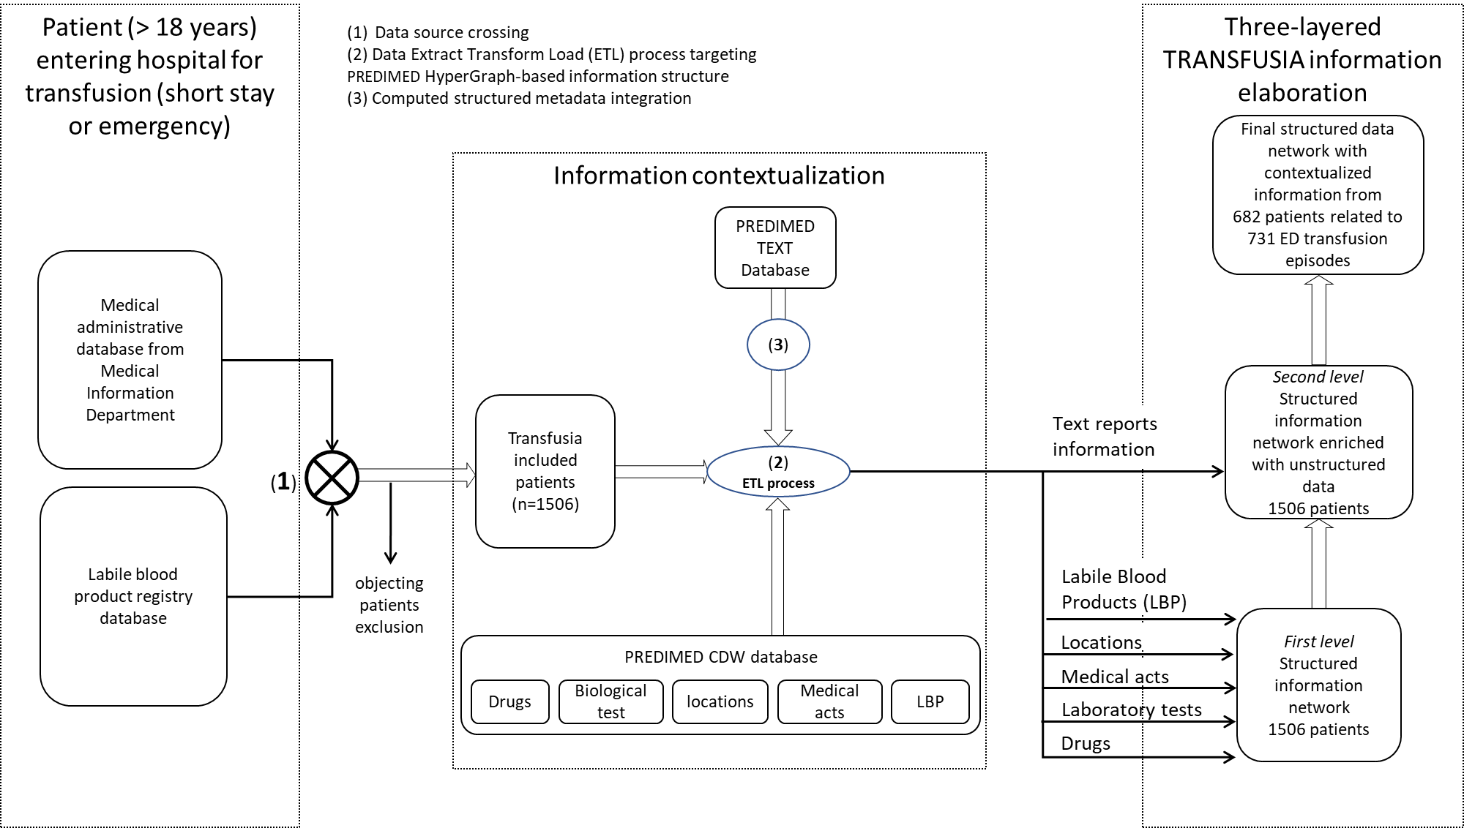

After extraction of 731 transfusion episodes at ED , we restricted on transfusion episodes with RBC unit >0 ( so at least 1) and corresponding patients as shown below with hypergraph navigation :
Finally, we obtained 705 transfusion episodes representing 657 patients with at least 1 RBC unit as treatment of anaemia.

2. Knowledge Hypergraph constitution
Multimodal data were implemented in a HyperGraph database where medical information was reshaped in the form of events of interest from the specific point of view of medical expertise. Events are thus contextualized in relation to each other according to their effective semantic and temporal relationships of interest.
The main idea was to build information contained in the health data warehouse (HDW) as a highly connected Knowledge Hypergraph network of structured data with the methodology described below.
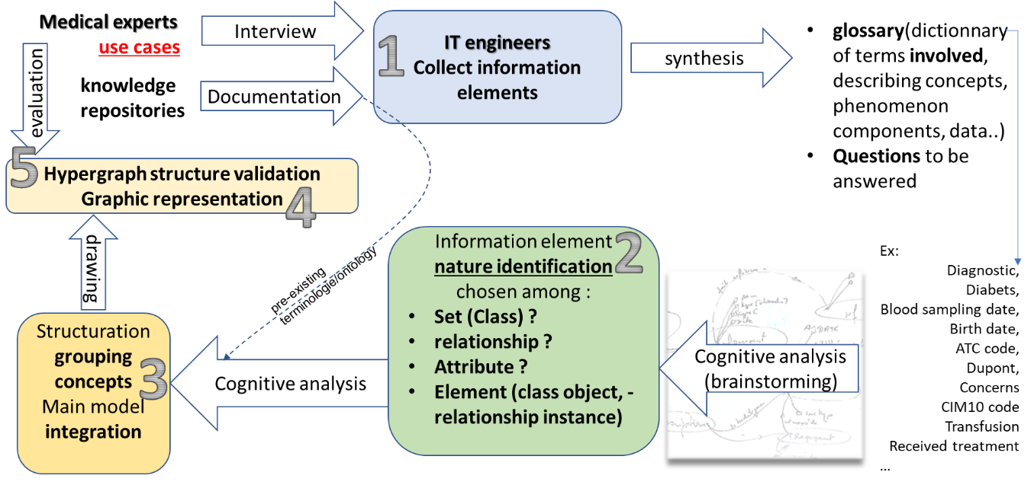

The first step of the design process consists in gathering and structuring information about the use-case or phenomenon described by medical experts, as well as documentation such as existing knowledge repositories.
To do this, interviewing medical experts is necessary to understand the use-case, collect questions they are expecting to be answered, and establish a dictionary of the vocabulary involved to describe the information to be collected and then structured before being processed.
Then, if a terminology or ontology already exists, or if part of it corresponds to the use-case, the process can move straight to the phase of integrating it in the main model. Otherwise, for each new term of the glossary, its nature must be identified as an object class, a class attribute or a relationship attribute.
Afterwards, the concept hierarchy must be organized, factoring semantic relationships and attributes into a main model that capitalizes the structure of health information knowledge. The model is then represented graphically to enable communication between medical and information technology (IT) experts.
The last step consists in validation by both medical and IT experts that the model can be used to answer questions identified in step1, and that the structure can be generalized to other use-cases involving the same concepts.

Once the model has been defined, the implementation process consists in several key stages, which must be monitored to guarantee data quality.
The first stage is an extraction-transformation-loading phase using Talend, which extracts data from the hospital's information system and builds JSON files that will make up the collections of objects and links in the HyperGraph database. Each object in the JSON files is identified by a unique key. A link is made-up of the unique keys of two objects, and may also carry attributes. Objects are also composed of attributes, common to the class to which they belong. Within a hyperclass, attributes are shared by all objects, regardless of their class. Within a hyperclass, classes are identified by a _type_ attribute.

3. Construction of clinically relevant information through the HyperGraph network
The graph data organization allows the user to simply select from a set of source objects in one class, filtered according to the interest values of their chosen attributes, such as digestive hemorrhage diagnosis International Classification of Diseases (ICD10) codes for example, to target objects actually connected to them in another class, such as patients fitting the chosen semantic relationship “concerns” that links the source class to the target one.
In this way, successive filters and jumps(hops) can be used to navigate step by step through the information, and provide simple answers to potentially complex queries. 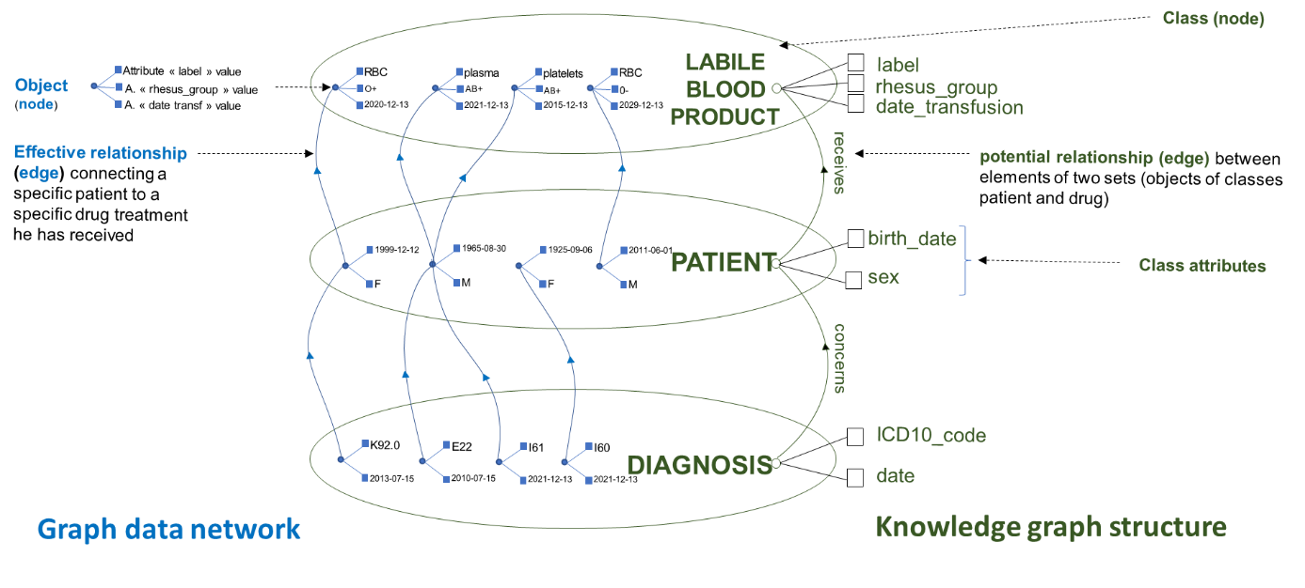
For example, to build the list of cancer treatments administered before a transfusion, a simple 3-hop graph query is needed:
(t:Treatment { _type_: 'trsf' })
--[:IS_RECEIVED_BY]--> (p : Patient)
--[:RECEIVES]--> (tfer:Treatment { atc_code: 'B03AC%' AND DATE_DIFF(t.date_start,tfer.date_start) <= 0 })
WITH t._key as trsf, COLLECT(tfer) as list_ferinject
Update t with list_ferinject

This Knowledge Hypergraph model constitutes a central target structure, expressed in a dual form, both graphical and formal, which gathers the concepts and their semantic relations into a graph the implementation of which can be easily manipulated by medical experts. The implementation is based on a property graphic database linked to an interactive graphical interface allowing to navigate through the data and interact in real time with a search engine as well as visualization and analysis tools
This graphical navigation interface has been implemented to a specifically developed editor allowing to generate graph transversal queries.
Thus, each graphical selection defining a path in the graph, from a source class or hyperclass node, to target one following an edge, generates a textual query in which the filter constraints on the node attributes or the link involved can be easily specified
To do this, the PREDIMED Application Interface (API) and the datalake Navigation and Exploration application were used. From software engineering point of view, an in-memory indexed property graph database was used, that enables fast transversal queries, hosting the graph data network, the structure of which is driven by the knowledge graph model. The PREDIMED central API enables communications between the database kernel and PREDIMED applications.
As massive relationships between graphic data network nodes have previously been computed, the hardware infrastructure needed to host and explore this network, which is in read-only mode and does not require any heavy hardware infrastructure. It is also energy-efficient compared to standard SQL-based solutions that would have to constantly recalculate the joints of interest for each use.
Trajectories have been defined as the temporal chaining of events of interest from the point of view of medical expertise, according to Allen's topological relationships of precedence^{S1,S2} and concomitance, which materialise arcs between these events, the path of which may eventually lead to a transfusion in ED as part of the temporal tracking patient history.
4. Dataset navigation
Besides advantages in data elaboration that served the statistical part of the study, this Knowledge Hypergraph networked data graph also lent itself to interactive exploration of information using applications developed in the PREDIMED CDW, for interactive navigation through the dataset, to raise new hypotheses about constructed features. For example, the question “how many patients took an anticancer drug before transfusion and died within 4 months of transfusion?” could be answered by navigating through 3 hops in the Knowledge Hypergraph.

Supplemental references
S1. Noël, D Villanova-Olive M, Gensel J, Le Quéau P. Design patterns for modelling life trajectories in the semantic web. 15th International Symposium on Web and Wireless Geographical Information Systems (W2GIS 2017), 2017, Shanghai, China. hal-01481127
S2. Dubois M , Schwer S. Classification topologique des ensembles convexes de Allen. R.F.I.A. 2000, Reconnaissance des Formes et Intelligence Artificielle, 2000, Paris, France. ffhal-00575250f

