Supplementary Figure 1. Kaplan-Meier Estimate of Median Overall Survival Across the Main Molecular Alterations.
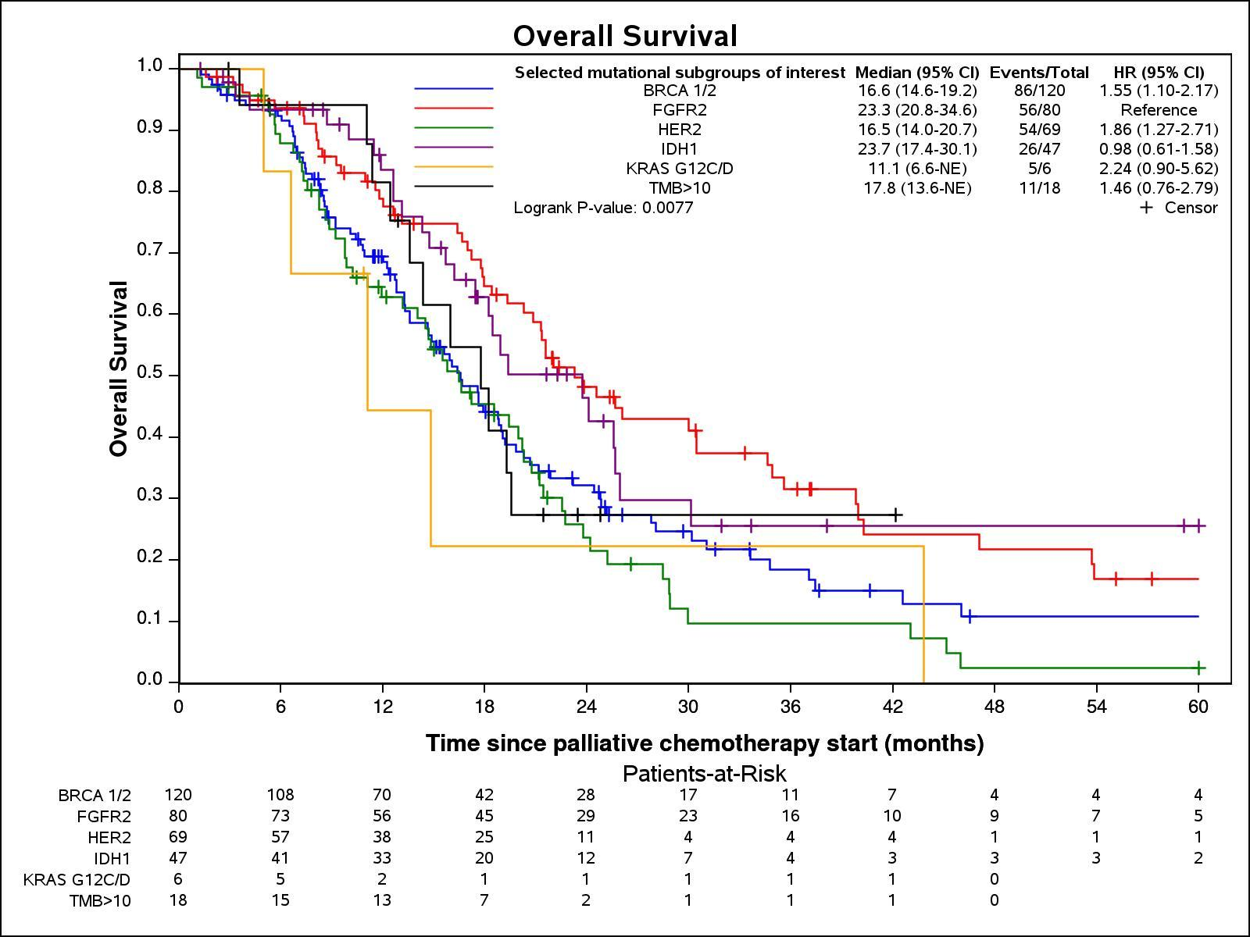

Supplemental Table 1. Patient Baseline Characteristics Stratified by the Presence of Tumor Actionable Alterations and the Use of Targeted Therapy in those receiving two or more total lines of treatment
 | Non-actionable group  (N=432) | Unmatched group  (N=123) | Matched group  (N=149) | P-value
Data Source |  |  |  | <0.001
Duke University | 40 (9.3%) | 4 (3.3%) | 27 (18.1%)
Japanese combined dataset | 294 (68.1%) | 94 (76.4%) | 46 (30.9%)
Mayo Clinic | 98 (22.7%) | 25 (20.3%) | 76 (51.0%)
Age at diagnosis, years | 66.0 (21.9-88.8) | 66.0 (36.0-81.2) | 61.0 (21.6-84.0) | <0.001
Female | 198 (45.8%) | 51 (41.5%) | 85 (57.0%) | <0.001
Race |  |  |  | <0.001
American Indian or Alaska Native | 0 (0.0%) | 0 (0.0%) | 2 (1.3%)
Asian | 304 (70.4%) | 94 (76.4%) | 49 (32.9%)
African American | 17 (3.9%) | 2 (1.6%) | 7 (4.7%)
Caucasian | 104 (24.1%) | 25 (20.3%) | 88 (59.1%)
Primary tumor location |  |  |  | <0.001
Intrahepatic | 191 (46.8%) | 58 (48.7%) | 111 (75.5%)
Extrahepatic | 113 (27.7%) | 22 (18.5%) | 20 (13.6%)
Gallbladder | 104 (25.5%) | 39 (32.8%) | 16 (10.9%)
Lines of Therapy | 2.0 (2.0 – 8.0) | 2.0 (2.0-6.0) | 3.0 (2.0-10.0) | <0.001
Selected mutational subgroup
KRAS G12C mut |  | 1 (0.8%) | 2 (1.4%)
BRCA 1/2 mut |  | 64 (53.3%) | 23 (16.5%)
IDH1 mut |  | 9 (7.5%) | 27 (19.4%)
ERBB2 amp |  | 36 (30.0%) | 18 (12.9%)
FGFR2 fusion |  | 7 (5.8%) | 58 (41.7%)
TMB high |  | 3 (2.5%) | 11 (7.9%)
RET fusion |  | 3 (2.5%) | 2 (1.4%)
MSI-H |  | 0 | 6 (4%)
BRAF-V600E |  | 0 | 2 (1.4%)
n (%) or median (range) values presented
Abbreviations: Amp, amplification; Mut, mutation; MSI-H, microsatellite instability high; TMB, tumor mutational burden.

