Supplementary Material:

Unraveling Malaria Transmission Dynamics in Saudi Arabia using Climate Sensitive VECTRI model
Vaibhav Kumar^{1,2} *, Abhishek Anand^{2,3}, Aman Rai⁴

- Research Institute for Geo-hydrological Protection, National Research Council, Via Madonna Alta 126, 06128, Perugia, Italy.
- Center for Atmospheric Sciences, Indian Institute of Technology, Hauz Khas, New Delhi 110016, India
- Regional Meteorological Centre, India Meteorological Department, Kolkata, 700052, India
- Department of Geography, Delhi School of Economics, University of Delhi, New Delhi 110007, India.

Key Highlights:
- Malaria transmission patterns in Saudi Arabia are mapped using the VECTRI model.
- Optimal temperature and rainfall conditions for malaria spread are determined.
- Three high-risk provinces of malaria are identified for focused control efforts.

*Corresponding author: Dr. Vaibhav Kumar,
Postdoctoral Research Fellow
Research Institute for Geo-hydrological Protection (IRPI),
National Research Council of Italy,
Via Madonna Alta 126, 06128, Perugia Italy.
E-mail: vaibhavkumar@cnr.it
Supplementary Figures:

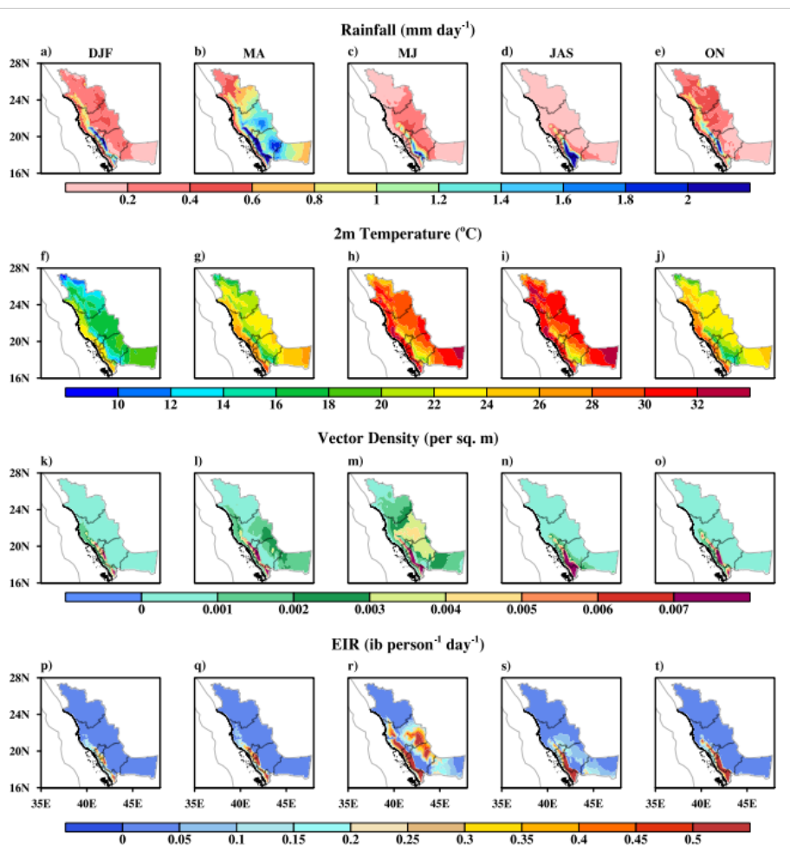
Figure S1: Provinces having higher malaria prevalence during the different seasons (winter-DJF, spring-MA, early summer-MJ, summer-JAS, autumn-ON) across Saudi Arabia, averaged from 1981 to 2017; (a-e) rainfall, (f-j) 2m air temperature, (k-o) simulated vector density, and (p-t) simulated EIR, respectively. The figure is plotted using NCAR/NCL software version 6.6.2 (https://www.ncl.ncar.edu).

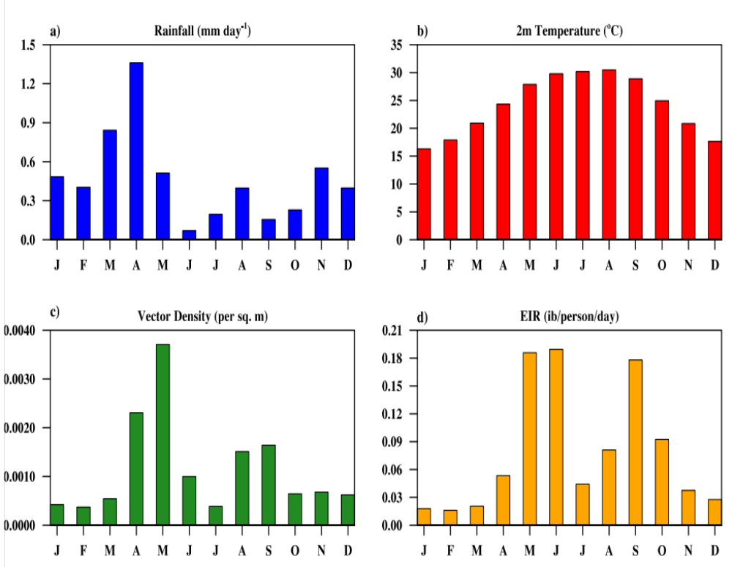
Figure S2: Monthly variation in (a) mean rainfall, (b) 2m air temperature, (c) simulated vector density, and (d) simulated EIR, averaged from 1981 to 2017 over selected provinces having higher malaria prevalence. The figure is plotted using NCAR/NCL software version 6.6.2 (https://www.ncl.ncar.edu).

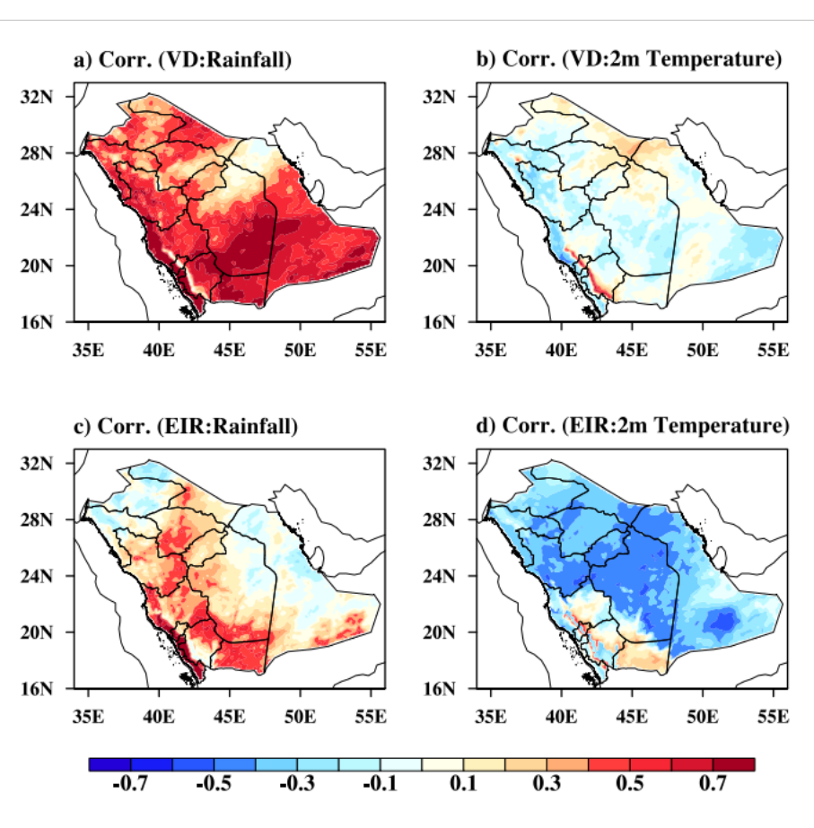
Figure S3: Yearly spatial correlation analysis for KSA region from 1981 to 2017; between (a) Vector density (VD) and Rainfall; (b) VD and 2m Temperature; (c) EIR and Rainfall; (d) EIR and 2m Temperature.

