Supplemental Materials for: Why Reform Stalls: Justification and Outrage as Competing Public Responses to Police Violence
Jonathan E. Doriscar^{1, 2}, William J. Brady³, Ava Q. Ma de Sousa⁴, Lauryn Hoard⁵, Wendi L. Gardner¹, Sylvia P. Perry^{1,2}

¹Northwestern University Department of Psychology
²Northwestern University, Institute for Policy Research
³Northwestern University, Kellogg School of Management,
⁴University of California, Santa Barbara, Department of Psychology
⁵George Washington University, Department of Psychology

Supplemental Materials Table of Contents

1. Data Collection and Preprocessing
1.1 Full description of data collection and cleaning processes
1.1b Detailed explanation of dataset creation (API workflow, Python/R)
1.2 Specific inclusion and exclusion criteria for Study 1 and Study 2

2. Classifier Construction and Validation
2.1 GPT-3.5-based classification: prompts, labeling protocol, and reliability metrics
2.2 Google Jigsaw moral outrage classifier: implementation procedures and validation
2.3 Representative examples of comment classifications (justification, police blame, outrage)

3. Coding Manual and Descriptive Information
3.1 Coding manual/codebook for video-level features; inter-rater reliability and adjudication
3.2 Summary of video-level data (views, likes, comments, subscribers; Table 7, Figures 1–5)
3.3 Summary of participant demographics for Study 2 (Table 8)

4. Study 2 Measures and Materials
4.1 Social Dominance Orientation scale (Table 9)
4.2 Defund Police scale (Table 10)
4.3 Discrimination Concern scale (Table 11)
4.4 Color-Blind Ideology scale (Table 12)
4.5 Dehumanization scale (Table 13)
4.6 Justification of Force items (Table 14)
4.7 Superhumanization items (Table 15)
4.8 Consent and Debriefing materials (full text)

5. Statistical Model Details
5.1 Sensitivity analyses and robustness checks

Data cleaning and collection

1.1 Full description of data collection and cleaning processes (e.g., handling duplicates, missing data)

Study 1. To examine public discourse around police use of force, we compiled a dataset of 57 widely viewed YouTube videos depicting incidents of police violence. Videos were identified using the YouTube Data API based on the search term “police brutality,”. Our goal was to focus specifically on high-engagement videos that not only depict police violence but also elicit significant public response.

To operationalize this, we conducted a pilot analysis of a larger set of videos that included both preliminary examples and additional cases scraped from the API. From this broader pool, we computed the 75th percentile of comment volume as a cutoff for engagement (threshold = 931 comments). All videos meeting or exceeding this threshold were retained, excluding duplicates and previously collected videos. This ensured that the final dataset comprised cases with both visibility and discursive traction, consistent with our theoretical aim of analyzing justification and outrage in widely shared public conversations.

The YouTube Data API provides access to public video metadata and associated comment threads based on search criteria and platform indexing. Because API results are dynamically ranked according to YouTube’s internal algorithms, which update frequently and vary across sessions, it does not support reproducible random sampling via seed. Instead, we used engagement-based selection as a transparent and replicable filtering criterion. This approach ensured that our sample reflected the types of high-profile cases that dominate public discourse, while also allowing us to define clear inclusion parameters for replication.

The final dataset included 257,401 unique comments across 57 videos. These cases represent some of the most-discussed police violence incidents on the platform, providing an ideal context for examining rhetorical patterns surrounding justification, outrage, and reform.

Study 2. Study 2 data did not require filtering or transformations beyond ensuring all responses were complete. However, all numeric variables used in the analyses were z-scored to ensure comparability across participants.

1.1b Detailed explanation of dataset creation (e.g., how YouTube videos and comments were collected via API)

Study 1. Three of the authors applied for an Application Programming Interface (API) key from the Google Developers Console and received permission to collect data via the YouTube platform. After receiving access, the lead researcher used Python version 3.12.4 to randomly sample a set of videos related to police brutality using the search term "police brutality." Importantly, YouTube’s API is not influenced by the IP address or account of the researcher. Instead, the API draws directly from the broader YouTube database, ensuring an unbiased and representative sample of videos. After collecting the video IDs of interest, a team of research assistants coded the videos for specific variables relevant to the study. Once the coding was complete, the lead researcher used the video IDs to iteratively retrieve metadata (including likes, views, subscriber counts, and comments) from each video through additional API calls. This metadata was compiled into a CSV file using Python. Following data collection, the lead researcher performed all subsequent data cleaning and analyses in R version 4.4.2.

Study 2. We designed the study using Qualtrics, a survey creation platform. Participants were exposed to 10 videos in total, with the goal of simulating a typical YouTube viewing experience as closely as possible (See Table 1 for a full list of videos used in Study 2). To maintain consistency, all videos were limited to 30 seconds. After watching each video, participants were asked to report the emotions they were experiencing at that moment and to leave a comment as though they were commenting on YouTube. In addition, participants were asked to describe what they thought a typical YouTube user would comment on the video they just watched.

The video set included a combination of content to evoke a range of emotional responses. Participants watched five heartwarming or funny videos, two outrage-inducing videos unrelated to police brutality, one video of police-on-police violence, and two police brutality incidents in which the victim was paralyzed following a non-violent traffic stop. All videos were posted as unlisted on a YouTube account where commenting was disabled. We used identical titles for the police brutality videos to ensure consistency: Victim Paralyzed as a Result of Police Brutality. Participants watched the videos in randomized order to prevent order effects from influencing their responses. By exposing participants to a variety of content types, the study aimed to capture a range of emotional reactions, allowing us to assess how different forms of outrage, humor, and empathy influence responses to police brutality incidents.
Table 1
Video Type | Title | Source Link | Timestamp Used
Pet Fail 1 | The FUNNIEST Pet Videos of 2023! 🤣 | Funny Pet Compilation 1 | 0:00 - 0:30
Pet Fail 2 | Funniest Cats And Dogs Videos 😁 - Best Funny Animal Videos 2024 🥰#10 | Funny Pet Compilation 2 | 0:00 - 0:30
Funny Baby Video | Try Not To Laugh with These Funny Baby Moments - Funny Baby Videos | Funny Kid Compilation | 0:00 - 0:30
Kitchen Fail | Funny Kitchen Fails Compilation | Funny Kitchen Fails | 0:00 - 0:30
Heartwarming 1 | 100 Random Acts of Kindness That Will Make You Cry | Heartwarming Video 1 | 12:36 - 13:06
Heartwarming 2 | 35 Most Emotional Moments Ever Caught on Camera | Kindness Compilation | 15:35 - 15:50
Outrage-Inducing 1 | Customer Meltdown at Tim Hortons | Outrage Video 1 | Full Video (1:28)
Outrage-Inducing 2 | Stupid Road Rage Compilation - 4 (USA & Canada Only) | Outrage Video 2 | 2:55 - 3:29
Police Brutality (Black Victim) | Man Paralyzed After Police Bodyslam Him to the Ground in Traffic Stop | Police Brutality Video (Black Victim) | 0:02 - 0:29
Police Brutality (White Victim) | Yuba City Army Veteran Paralyzed by Police, Awarded $20 Million Settlement | Police Brutality Video (White Victim) | 0:27 - 1:24
Police-on-Police Incident | Bodycam Shows Florida Police Sergeant Grabbing Female Officer by the Throat | Police Brutality Video (Officer Victim) | 2:00 - 2:21

1.2 Specific inclusion and exclusion criteria for both studies (e.g., participants excluded for non-compliance)

Study 1. Our analysis for Study 1 focused solely on publicly available comments on YouTube videos. We excluded non-English comments. There were no additional exclusion criteria for Study 1, as all available comments from the selected videos were included in the final dataset.

Study 2. In Study 2, participants were recruited from Prolific and were required to complete the full study to be included in the analyses. We did not exclude any participants based on demographic criteria.

2. Classifier Construction and Validation

2.1 GPT-3.5-based classification: justification and police accountability prompts, labeling protocol, and reliability metrics
To classify public discourse surrounding police violence, we used a structured prompting protocol with OpenAI’s GPT-3.5-turbo-instruct model to label each YouTube comment along two dimensions: (1) justification of force and (2) blame attributed to the police. This approach allowed us to efficiently analyze over 250,000 comments while maintaining conceptual alignment with our research questions. Each comment was submitted to the model with a fixed zero-shot prompt requesting binary classification for two labels:

Justification of Force (1 = defends police or blames the victim; 0 = all other responses)

Police Blame (1 = explicitly criticizes police; 0 = all other responses)

The model was primed using four labeled examples to constrain format and ensure semantic clarity. The prompt was intentionally brief to minimize token cost and maximize consistency across the dataset.

Sample prompt (excerpted for illustration):

Classify police use-of-force comment:

justification_of_force (1/0): Defends police/blames victim

police_blame (1/0): Criticizes police

Examples:
"He should’ve complied" → {"justification_of_force":1,"police_blame":0}
"These cops are criminals" → {"justification_of_force":0,"police_blame":1}
"Both sides wrong" → {"justification_of_force":1,"police_blame":1}

Comment: [Insert comment]
JSON response only.

We processed all comments using Python and the OpenAI API. The classification system included automatic error handling, retry logic, and real-time tracking of token usage and cost. Comments that failed to return valid JSON or contained out-of-spec values were excluded.

GPT-3.5-turbo-instruct was selected for its demonstrated reliability on classification tasks involving informal, short-form social media language. Although zero-shot classification does not rely on supervised fine-tuning, prior work supports its validity when paired with robust prompting and validation protocols (e.g., Rathje et al., 2023). To evaluate classifier reliability, a stratified random subsample of comments was independently annotated by trained human coders (blinded to model output). Interrater agreement between human coders and GPT classifications was satisfactory across all three constructs: justification of force (κ = 0.477, percent agreement = 85.4%), police blame (κ = 0.494, percent agreement = 74.4%). All agreement metrics are reported in Supplementary Table 2. The final labeled dataset contained 257,401 comments across 57 videos. For each comment, we retained the original text and binary labels for justification of force, police blame, and moral outrage. Representative examples are provided in Tables 3, 4, and 5, respectively. The full classification pipeline, including prompt structure and code, is available upon request.

2.2 Google Jigsaw classifier: implementation procedures, threshold selection, and validation against human coders
The Perspective API, developed by Google’s Jigsaw and Counter Abuse Technology teams, is a free and open-source tool designed to assist platforms, publishers, and community managers in moderating online conversations. Launched in 2017, the API employs machine learning models to evaluate the perceived impact of user-generated content, scoring comments based on attributes such as toxicity, insult, profanity, threat, and identity attack. These scores, ranging from 0 to 1, indicate the likelihood that a comment will be perceived as harmful or disruptive to a conversation. While the Perspective API's core attributes are publicly accessible, Jigsaw has also developed experimental classifiers targeting more nuanced aspects of online discourse. Among these is a moral outrage classifier, which—though not available to the general public—is designed to detect expressions of moral indignation in text. This classifier aims to identify language that conveys a sense of moral violation or righteous anger, capturing the emotional intensity often present in discussions surrounding social and political issues.
In our study, we utilized this experimental moral outrage classifier to analyze user comments on videos depicting police brutality. To assess its reliability, we compared its outputs to human-coded annotations of outrage in a stratified subset of comments. Agreement between the classifier and human coders was high (Cohen’s κ = 0.501; percent agreement = 80.0%), indicating that the model reliably identifies expressions of moral outrage in online discourse. This validation supports the classifier’s utility in research contexts, particularly in studies examining the emotional dynamics of public reactions to social justice issues.

Table 2
Validation Metrics (Cohens Kappa and Percent Agreement) Across all Classifiers

Construct | Cohen’s Kappa | Percent Agreement
Justification of Force | 0.477 | 85.4%
Police Blame | 0.494 | 74.4%
Moral Outrage | 0.501 | 80%

Note: Cohen’s kappa values reflect the level of agreement between GPT-based classifications and independent human annotations on a stratified subsample of comments. Percent agreement refers to the proportion of classifications in which the human and model labels matched. Kappa values between 0.41 and 0.60 are typically interpreted as indicating moderate agreement. While these constructs involve complex and often subjective interpretations of online language, the observed agreement levels suggest that the classifiers perform reliably in capturing the intended social-psychological constructs. All annotations were conducted blind to model output.

2.3 Representative examples of comment classifications for justification, accountability, and outrage
Table 3
Representative YouTube Comments Classified for Moral Outrage
Moral Outrage = 1 | Moral Outrage = 0
The cop needs to be fired and prosecuted. | Ill miss the cop, I love cops.
Why is the former police officer not in prison? | Maybe there should be a force that polices the police?
All police should be trained better—this is outrageous. | The shooting was justified. Still, why ask him to exit?
This is a clear abuse of power. | Socioeconomic status can inspire positive change.
This makes me sick. They should be jailed. | The officer might have just made a mistake.
The officer is a coward, plain and simple. | Judges need better training.
They murdered him on camera and walked free. | The suspect was acting odd, that's all.
Every time I see this I cry. How is this justice? | Next time I see a cop getting beaten I’ll laugh.
They violated his rights and no one cares. | At least they’re enforcing the law somehow.
This video proves systemic brutality. | He looked suspicious. Cops can’t take risks.
Note. These comments illustrate typical examples of high vs. low levels of moral outrage as classified by the Google Jigsaw model. All comments are paraphrased and scrambled to preserve anonymity.
Table S4
Representative YouTube Comments Classified for Justification of Force
Justification = 1 | Justification = 0
She should have complied, plain and simple. | They cuffed those kids for nothing. Disgusting.
The officer had no way to know if he had a weapon. | Child abuse by law enforcement. Period.
They should have shot him earlier to avoid risk. | This was clearly police brutality.
He got what was coming to him. | There was no reason to treat him like that.
Cops are my heroes in this situation. | If he was white, this wouldn’t happen.
Classic example of resisting arrest. | Wrongful detention—this is unconstitutional.
He was lucky he wasn’t shot. | How are those children suspects?
You don’t fight police and expect leniency. | Profiling again. I'm so tired of this.
It’s not excessive if they’re not following orders. | You don’t slam a man for sitting down.
She deserved it for reaching like that. | This is beyond excessive force.
Note. These comments reflect varying levels of justification for police use of force as detected by our GPT-3.5 classifier. All comments are de-identified and reworded for confidentiality.
Table 5
Representative YouTube Comments Classified for Police Blame
Police Blame = 1 | Police Blame = 0
These cops are cowards with badges. | The guy filming was asking for trouble.
They need to be fired—no excuse. | Hero officers stayed calm under pressure.
This is why nobody trusts the police. | Don’t blame all cops for a few mistakes.
They assaulted him for no reason. | He should’ve complied, then nothing would happen.
Officers like these are why we need reform. | The system works, just not perfectly.
They escalated everything unnecessarily. | They had to act—he was being aggressive.
They need to be prosecuted to the full extent. | One bad cop doesn’t mean the system is broken.
No training just aggression and ego. | That suspect was provoking them.
The badge gives them unchecked power. | Respect authority and this won’t happen.
They didn’t even assess the situation properly. | They followed protocol—it’s unfortunate, but fair.
Note. Examples represent blame directed toward police (or lack thereof) in public YouTube discourse. Anonymity preserved via paraphrasing and scrambling.

3. Coding Manual and Descriptive Information

Study 1. In Study 1, research assistants (RAs) coded video-level characteristics to capture visible features that might shape audience responses. The coding scheme, developed by three of the authors, included variables such as victim race, officer race, setting, and other contextual features (see Table 6). Importantly, RAs were instructed to code only what was visible in the videos themselves, without referencing external information, as viewer comments were presumed to be direct responses to the video content. Each of the 57 videos was assigned to one of six RAs, who worked in overlapping pairs to code video subsets. This pairing allowed us to calculate inter-rater reliability and ensure the consistency of coding. All RAs received comprehensive training prior to coding: they practiced on a separate set of 10 videos, and their responses were compared to the lead researcher’s benchmark codes. Discrepancies were reviewed and resolved through group discussion to establish clear coding norms.

Although multiple variables were coded, only victim race was used in the primary analyses presented in Study 1. For this variable, agreement across RA pairs was exceptionally high (Cohen’s κ indicating near-perfect agreement), so we retained the code from a single randomly selected RA per video subset for our final dataset. This approach maintained data integrity while streamlining the analytic workflow. Throughout the process, the RAs were blind to the study’s hypotheses and to the codes assigned by other RAs. This ensured that their coding was unbiased and independent. To reduce the mental exhaustion associated with reviewing distressing content related to police brutality, each RA was tasked with coding only five videos per week. All RAs coded approximately 30% of the total videos, ensuring an equal distribution of effort across the team.This coding strategy allowed us to produce reliable video-level data, ensuring consistency in how the variables of interest were coded across the sample.

Table 6
Full list of contextual variables coded by RAs for Study 1
Variable | Definition | Scale
victim_escalation | The extent to which the victim is escalating the situation | 0 = no escalation, 1 = escalation, 2 = extreme escalation
officer_escalation | The extent to which the officer is escalating the situation | 0 = no escalation, 1 = escalation, 2 = extreme escalation
crime_type | for now lets just try coding for whether the crime in the video was said to be violent, if the crime is not mentioned than leave it blank | 0 = non-violent crime, 1 = violent crime
commentary | code for whether there is a commentary over the video like if it was from the news | 0 = non-news/personal vid, 1 = video with commentary
interaction_intensity | how intense this interaction was, it might help to think about how difficult it was to observe the interaction | 0 = not intense, 1 = intense, 2 = very intense
bystanders | are they there or not | 0 = no bystanders, 1 = bystanders
bystander_intervention | If a bystander intervened? This includes yelling/communicating with the officer and also includes physical intervention like trying to seperate them | 0 = no, 1 = yes
bystander_intervention_physical | Did they intervene, by physically stepping in? | 0 = no, 1 = yes
officer_gun_used | did the officer use their gun at any point? | 0 = no, 1 = yes
victim_gun_used | did the victim use a gun at any point? | 0 = no, 1 = yes
victim_gun | did the victim have a gun at any point? | 0 = no, 1 = yes
officer_taser_used | did the officer use their taser at any point? | 0 = no, 1 = yes
officer_weapon_used | did the officer use a weapon? | 0= no, 1 = yes
victim_weapon_used | did the victim use a weapon? | 0 = no, 1 = yes
victim_weapon | did the victim have a weapon? Weapons are things designed or used for inflicting bodily harm or physical damage. | 0 = no, 1=yes
officer_mention_race | did the officer mention race at all ( this could be his race, or the victims race, just mentioning it at all counts) | 0 = no, 1 = yes
victim_mention_race | did the victim mention race at all (this could be his race, or the officers race, just mentioning it at all counts) | 0 = no, 1 = yes
commentary_mention_race | if there is a commentary, did they mention race at all (this could be his race, or the victims race, just mentioning it at all counts) | 0 = no, 1 = yes
bystander_mention_race | if there is a bystander, did they mention race at all (this could be his race, or the victims race, just mentioning it at all counts) | 0 = no, 1 = yes
officer_mention_gender | did the officer mention gender in the video at all | 0 = no, 1 = yes
victim_mention_gender | did the victim mention gender in the video at all | 0 = no, 1 = yes
commentary_mention_gender | if there is a commentary, did they mention gender at all | 0 = no, 1 = yes
bystander_mention_gender | if there is a bystander, did they mention gender | 0 = no, 1 = yes
officer_amount | how many officers are in the video | 1 = 1, 2+ = 2
victim_amount | how many victims are there in the video | 1 = 1, 2+ = 2
commentator_amount | how many commentators are in the video | 1 = 1, 2+ = 2
bystander_amount | how many bystanders are in the video | 1 = 1, 2+ = 2
officer_majority_race | What is the race of the majority of officers in the video? | Black = 0, White = 1
victim_majority_race | What is the race of the majority of victims in the video? | Black = 0, White = 1
commentator_majority_race | What is the race of the majority of commentators in the video? | Black = 0, White = 1
bystander_majority_race | What is the race of the majority of bystanders in the video? | Black = 0, White = 1
officer_race | What is the race of the officers who first harms the victim in the video? | Black = 0, White = 1
victim_race | What is the race of the victim who is first harmed in the video? | Black = 0, White = 1
commentator_race | What is the race of the commentator who speaks the most in the video? | Black = 0, White = 1, Non-Black POC = 2
bystander_race | What is the race of the bystander who is the most active in the video? | Black = 0, White = 1
officer_gender | What is the gender of the officer who first harm the victim in the video? | Women = 0, Man = 1
victim_gender | What is the gender of the victim who is first harmed in the video? | Women = 0, Man = 1
commentator_gender | What is the gender of the commentator who speaks the most in the video? | Women = 0, Man = 1
bystander_gender | What is the gender of the bystander who is the most active in the video? | Women = 0, Man = 1
officer_majority_gender | What is the gender of the majority of officers who first harm the victim in the video? | Women = 0, Man = 1
victim_majority_gender | What is the gender of the majority of victims in the video? | Women = 0, Man = 1
commentator_majority_gender | What is the gender of the majority of commentators in the video? | Women = 0, Man = 1
bystander_majority_gender | What is the gender of the majority of bystanders in the video? | Women = 0, Man = 1
interaction_physical | Did the interaction get physical (i.e., fighting or pushing)? | 0 = no, 1 = yes
physical_initiation | Who intiated the physical contact? | Officer = 0, 1 = Victim
commentator_background | Is the commentator in the video giving context or background on what happened (beyond what you can see in the video)? If they are just stating their opinion and not providing novel information than this would be a 0 | 0 = no, 1 = yes
commentator_framing | If the commentator has a specific framing for the situation, is it pro-cop or pro-victim? If not leave blank | 0 = pro-cop, 1 = pro-victim
victim_plea | Did the victim plea for the officer to stop the brutality? | 0 = no, 1 = yes
victim_life_danger | Did the victim communicate to the officer that they think their life is in danger (i.e., cant breathe)? | 0 = no, 1 = yes
officer_life_danger | Did the officer communicate to the victim or other officers that they think their life is in danger? | 0 = no, 1 = yes
victim_anger | Did the victim communicate to the officer that they were angry with them? | 0 = no, 1 = yes
officer_anger | Did the officer communicate to the victim that they were angry with them? | 0 = no, 1 = yes
officer_remorse | Did the officer show remorse for their actions (i..e, crying, apologizing)? | 0 = no, 1 = yes
about_video | We just want you to leave a little text/qualitative response about what the video was about, and if there was a commentator what was their framing/what did you think about them? | This should be brief 2-4 setences.

3.2 Summary of video-level data (e.g., views, likes, comments)

Study 1. The descriptive statistics for the videos analyzed in Study 1 provide important insights into the patterns of public engagement.

On average, videos received 2.6 million views (SD = 3.86 million), 32,072 likes (SD = 57,167), and 6,844 comments (SD = 9,043). The 75th percentile for views was just under 3 million (2,961,791), whereas the maximum was 15.9 million—suggesting a long-tailed distribution where a few high-profile videos disproportionately drew public attention. Median values were much lower: 858,303 for views, 8,332 for likes, and 3,365 for comments, underscoring the skewness in the dataset.

Channel-level subscriber data, available for 40 of the 57 videos, showed a mean of 2.4 million subscribers (SD = 3.2 million), again reflecting considerable variation across sources. Correlations among the metrics revealed strong positive relationships between likes and comments (r = .87) and between likes and views (r = .63), suggesting that videos that were more liked were also more discussed and viewed. In contrast, subscriber count was weakly and negatively correlated with engagement metrics, indicating that highly subscribed channels did not necessarily garner more attention for individual police brutality videos. The videos spanned a wide timeframe, with publication dates ranging from September 5, 2010, to January 7, 2025. This range illustrates both the persistent relevance of police brutality over time and the archival nature of YouTube content. A spike in uploads occurred around the mid-2010s, reflecting a possible period of heightened public discourse following high-profile cases. In sum, although a small number of videos in our sample attracted millions of views and tens of thousands of comments, most videos exhibited relatively modest engagement levels, highlighting substantial variability in public attention to incidents of police brutality.
Table 7

Statistic | Views | Total Likes | Total Comments | Subscribers
Mean | 2,606,871.16 | 32,071.68 | 6,844.22 | 2,403,578.50
SD | 3,862,570.70 | 57,167.23 | 9,043.37 | 3,239,115.43
Median | 858,303.10 | 8,332.00 | 3,365.00 | 1,115,000.00
Min | 5,620 | 907 | 868 | 2,410
Max | 15,900,000 | 315,726 | 48,708 | 13,500,000
Range | 15,894,380 | 314,819 | 47,840 | 13,497,590
Skew | 2.20 | 3.12 | 2.56 | 2.02
Kurtosis | 4.48 | 10.75 | 7.42 | 4.16
SE | 511,609.99 | 7,571.98 | 1,197.82 | 512,149.12

Figure 1
Distribution of Video Views
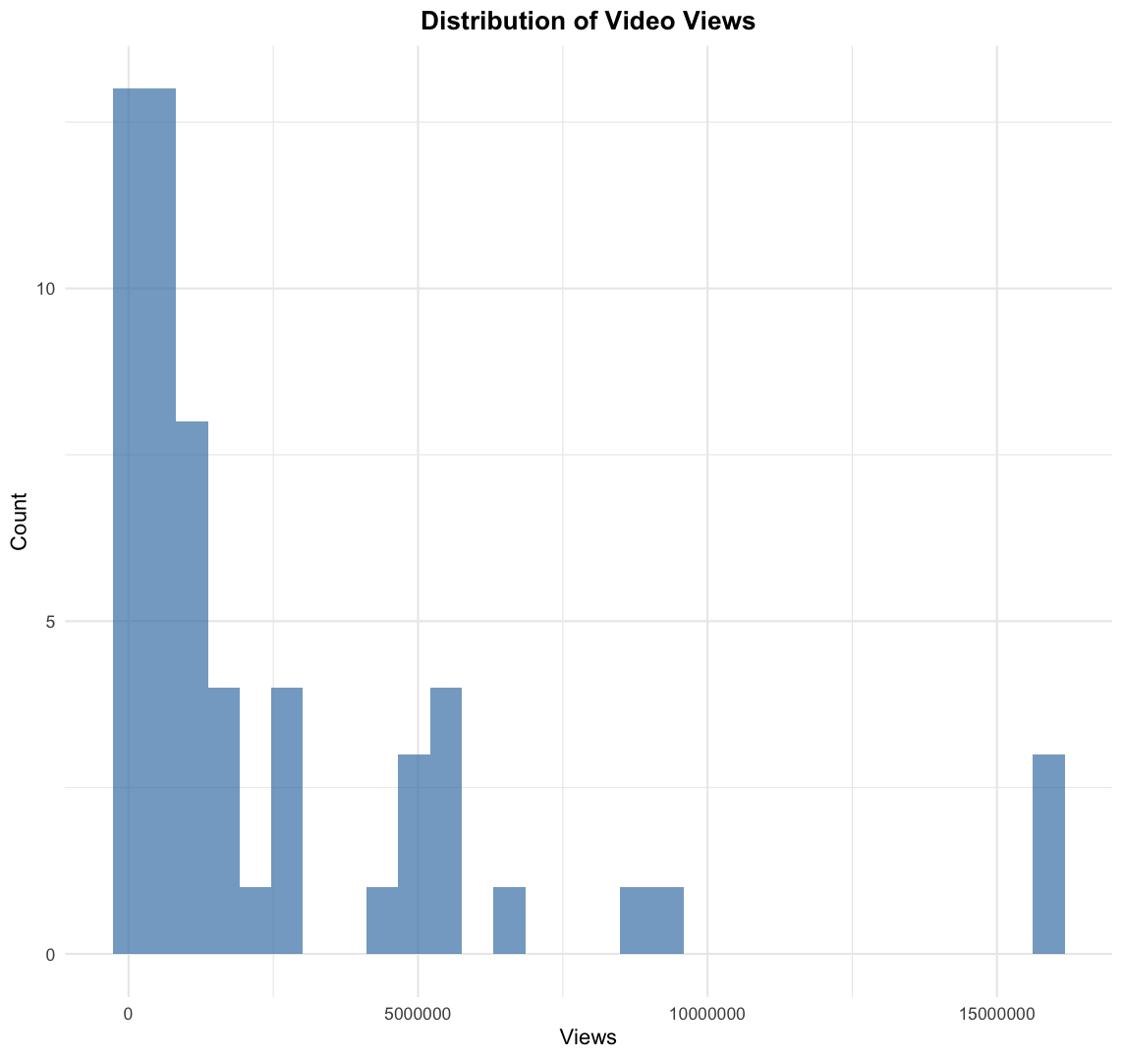

Figure 2
Distribution of Video Likes
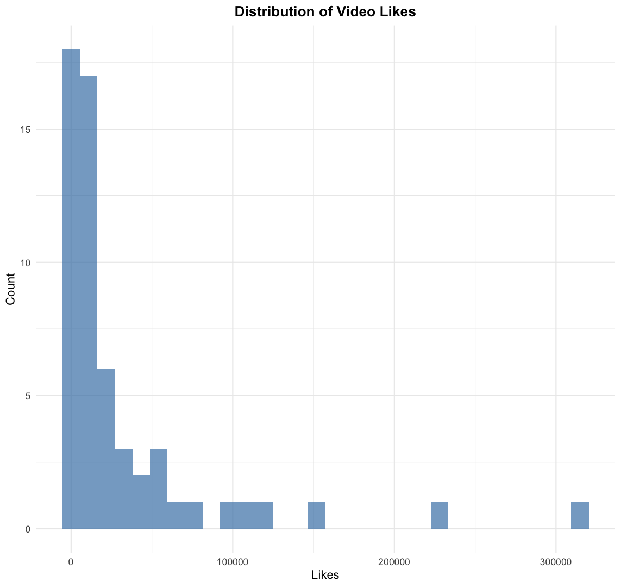

Figure 3
Distribution of Video Comments
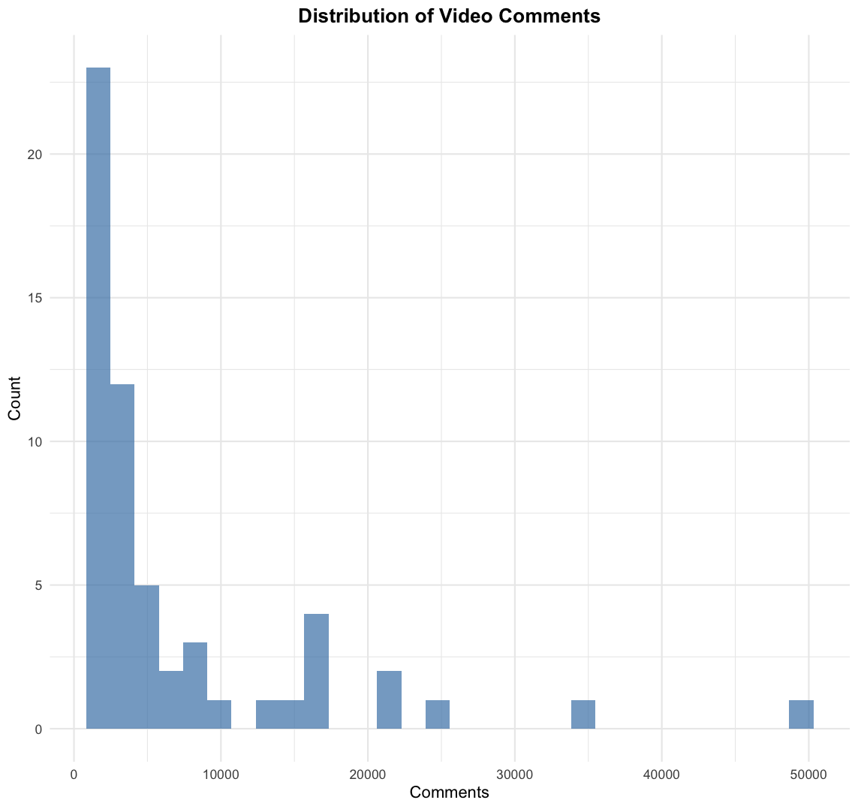

Figure 4
Distribution of Video Channel Subscribers
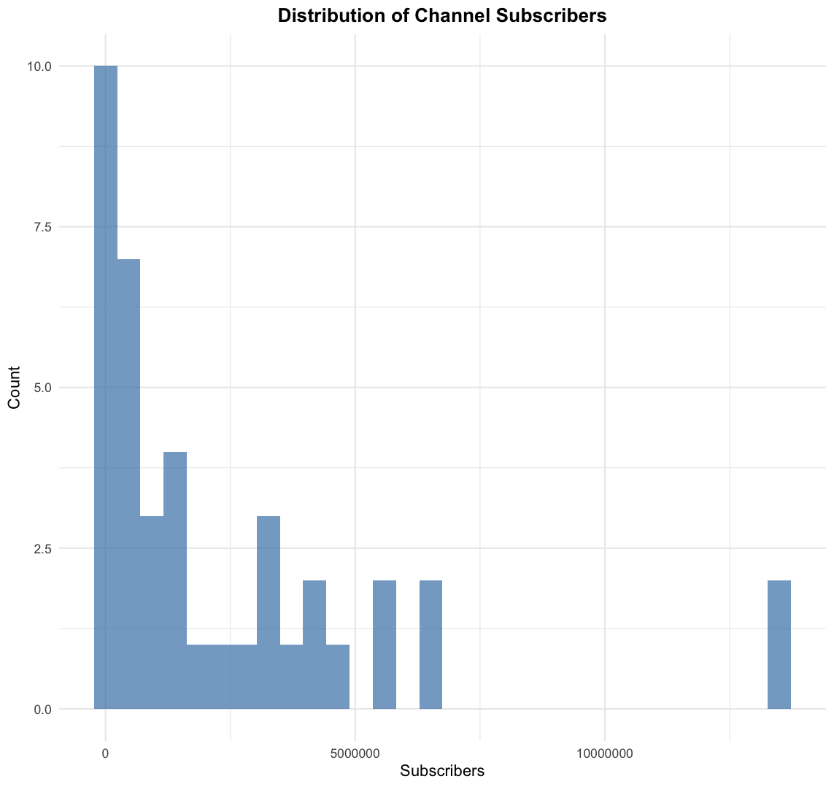

Figure 5
Distribution of Video Publication Dates
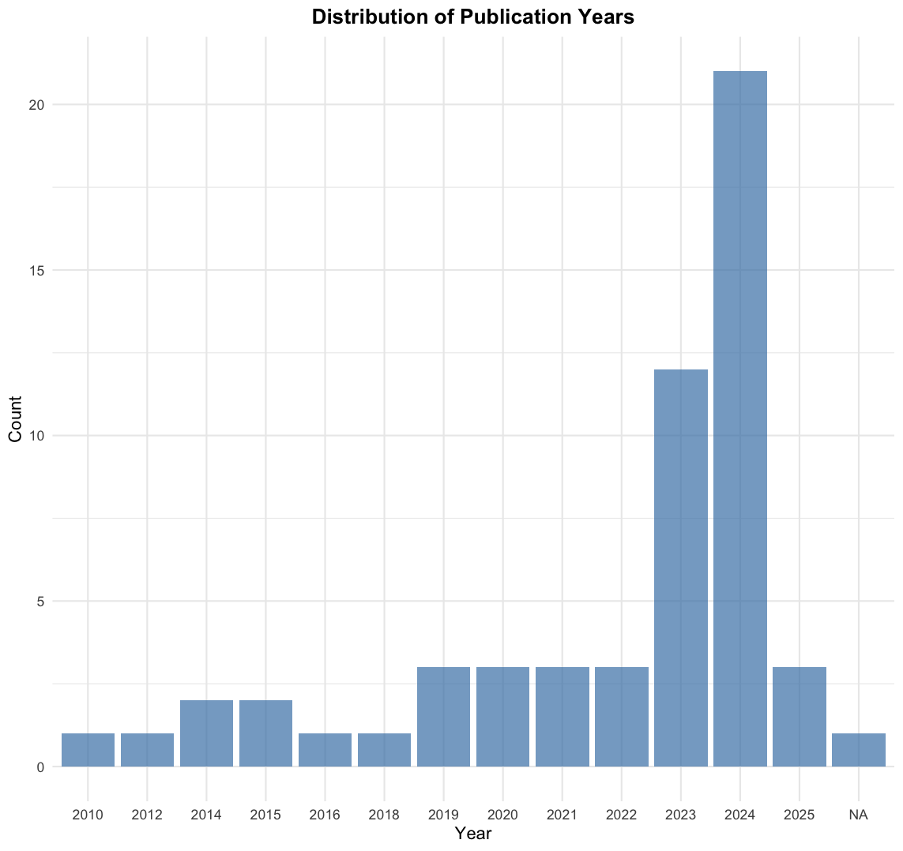

3.3 Summary of participant demographics for Study 2 (e.g., age, race, gender)
Study 2.
Table 8

Summary of participant demographics for Study 2

Demographic Category | Level | Percentage
Race | White or Caucasian | 53.09%
 | Black or African American | 13.58%
 | American Indian / Native American / Alaska Native | 4.94%
 | Asian | 1.65%
 | Native Hawaiian / Pacific Islander | 0.82%
 | Multiracial | 25.92%
 | Prefer not to say | 0.41%
Gender | Male | 27.16%
 | Female | 51.03%
 | Non-binary / Third Gender | 1.65%
 | Prefer to self-describe | 0.41%
 | Prefer not to say | 0.41%
Political Affiliation | Republican | 13.58%
 | Democrat | 37.86%
 | Independent | 24.69%
 | Other | 2.47%
 | No preference | 2.06%
Education Level | Some high school or less | 10.29%
 | High school diploma or GED | 18.11%
 | Some college, no degree | 9.05%
 | Associate's or technical degree | 26.75%
 | Bachelor’s degree | 16.46%
 | Graduate or professional degree | 19.34%

4. Study 2 Measures and Materials

4.1 Full text of any survey items or measures used (e.g., superhumanization scale, police reform scale)

Study 2:

Table 9

Social Dominance Orientation Scale (SDO)
Adapted from Pratto et al., 1994
Item | Scale (1–7)
Some groups of people must be kept in their place. | Strongly Disagree (1) to Strongly Agree (7)
It’s probably a good thing that certain groups are at the top and others are at the bottom.
An ideal society requires some groups to be on top and others to be on the bottom.
Some groups of people are simply inferior to other groups.
Groups at the bottom are just as deserving as groups at the top. (Reverse scored)
No one group should dominate in society. (Reverse scored)
Groups at the bottom should not have to stay in their place. (Reverse scored)
Group dominance is a poor principle. (Reverse scored)
We should not push for group equality.
We shouldn’t try to guarantee that every group has the same quality of life.
It is unjust to try to make groups equal.
Group equality should not be our primary goal.
We should work to give all groups an equal chance to succeed. (Reverse scored)
We should do what we can to equalize conditions for different groups. (Reverse scored)
No matter how much effort it takes, we ought to ensure all groups have the same chance in life. (Reverse scored)
Group equality should be our ideal. (Reverse scored)

Table 10

Defund Police Scale
Custom scale developed for this study (Alpha = .83, M = 4, SD = .71)
Item | Scale (1–6)
I would actively participate in community discussions advocating for police reform. | Strongly Disagree (1) to Strongly Agree (6)
I am inclined to support movements calling for the defunding of the police.
I am likely to engage in conversations with friends and family to raise awareness about the need for police accountability.
Supporting organizations that work towards changing police policies aligns with my values.
I am open to joining local initiatives that aim to improve relationships between the community and law enforcement.
I would consider contributing my time or resources to support community-based policing efforts.
I see myself participating in campaigns that promote transparency and accountability within law enforcement.

Table 11

Discrimination Concern Scale
Custom scale developed for this study (Alpha = .91, M = 4.1, SD = 1.2)
Item | Scale (1–6)
I’m not personally concerned about discrimination against Black people. (Reverse scored) | Strongly Disagree (1) to Strongly Agree (6)
People need to stop focusing so much time and energy worrying about racial discrimination. (Reverse scored)
White Americans around me actively engage in initiatives to combat racism.
I consider racial discrimination to be a serious social problem.

Table 12

Color-Blind Racial Ideology Scale
Adapted from Neville et al., 2000 (Alpha = .92, M = 2.3, SD = .93)
Item | Scale (1–5)
White people in the U.S. have certain advantages because of the color of their skin. | Not at all appropriate or clear (1) to Very appropriate or clear (5)
Race is very important in determining who is successful and who is not.
White people are more to blame for racial discrimination than racial and ethnic minorities.
Due to racial discrimination, programs such as affirmative action are necessary to help create equality.
Racial and ethnic minorities do not have the same opportunities as white people in the U.S.
Everyone who works hard, no matter what race they are, has an equal chance to become rich. (Reverse scored)
Race plays a major role in the type of social services people receive in the U.S.
Talking about racial issues causes unnecessary tension. (Reverse scored)
It is important for public schools to teach about the history and contributions of racial and ethnic minorities.
Racism is a major problem in the U.S.
Racism may have been a problem in the past, but it is not an important problem today. (Reverse scored)

Table 13

Dehumanization Scale (Excluding Superhuman Items)
Custom scale developed for this study
Item | Scale (1–5)
The victim in the video was experiencing significant pain. | Strongly Disagree (1) to Strongly Agree (5)
The emotional state of the victim during the incident was clearly distressed.
The victim in the video felt helpless during the event.
I feel empathetic towards the victim. (Reverse scored)
The treatment of the victim by the police in the video was unfair.
The treatment of the victim was justified.
The situation was handled appropriately by the authorities involved.

Table 14
Justification of Force Items
Custom scale for both Black and White victims (Alpha = .81, M = 2.20, SD = 0.60)
Item | Scale (1–5)
The victim in the video was experiencing significant pain. (reverse-coded) | Strongly Disagree (1) to Strongly Agree (5)
The victim in the video could endure the situation well.
The emotional state of the victim in the video during the incident was clearly distressed. (reverse-coded)
The victim in the video felt helpless during the event. (reverse-coded)
The victim had control over the situation.
The victim could have influenced the outcome of the event.
The victim possesses qualities or abilities beyond that of a typical person.
The victim could handle more than an average person in similar circumstances.
I feel empathetic towards the victim. (reverse-coded)
The treatment of the victim by the police in the video was unfair. (reverse-coded)
The treatment of the victim was justified.
The situation was handled appropriately by the authorities involved.

Table 15

Superhumanization Items
Custom scale for both Black and White victims (Alpha = .73 for Black victim, Alpha = .75 for White victim)
Item | Scale (1–5)
The victim had control over the situation. | Strongly Disagree (1) to Strongly Agree (5)
The victim could have influenced the outcome of the event.
The victim possesses qualities or abilities beyond that of a typical person.
The victim could handle more than an average person in similar circumstances.

Consent Form:
Title of Research Study: YouTube Video Attitudes

Principal Investigator: Wendi Gardner

Student Investigator: Jonathan Doriscar

Supported By: This research is supported by the Northwestern Department of Psychology.

Key Information about this research study:
The following is a short summary of this study to help you decide whether to be a part of this study. Information that is more detailed is explained later on in this form.

The purpose of this study is to understand how people's attitudes towards YouTube videos.

You will be asked to watch several YouTube videos, answer questions regarding your opinions of the videos, answer questions about your identity, and report your feelings.

We expect that you will be in this research study for up to 20 minutes.

Your data will be collected anonymously.

There is no direct benefit to you. However, this research may benefit society by enhancing knowledge of the factors contributing to positive relationships that support individual well-being.

For scientific reasons, this consent form does not include complete information about the research questions or topics being tested. You will be fully debriefed following your participation in the research.

The primary potential risk of participation is that you might experience psychological discomfort as you are asked to read these experiences.

Why am I being asked to take part in this research study?
We are asking you to take part in this research study because you are over the age of 18.

How many people will be in this study?
We expect up to 1000 people will be in this research study.

What should I know about participating in a research study?
Whether or not you take part is up to you.

You can choose not to take part.

You can agree to take part and later change your mind.

Your decision will not be held against you.

You can ask all the questions you want before you decide.

You do not have to answer any question you do not want to answer.

What happens if I say, “Yes, I want to be in this research”?
You will answer a series of survey questions online. You will watch several YouTube videos. These survey questions will ask you to report information about your personal identity, your opinions about the videos, and your personal feelings. This study will take up to 20 minutes.

Will being in this study help me in any way?
We cannot promise any benefits to you or others from your taking part in this research. Although, you will be making a direct contribution to scientific research.

Is there any way being in this study could be bad for me?
Upon interacting with your conversation partner you might experience some psychological discomfort.

What happens if I do not want to be in this research, or I change my mind later?
Participation in research is voluntary. You can decide to participate or not to participate. If you do not want to be in this study or withdraw from the study at any point, your decision will not affect your relationship with Northwestern University. You can leave the research at any time and it will not be held against you. If you decide to withdraw from this study, the researchers will ask you if the information already collected from you can be used.

How will the researchers protect my information?
Data collected from this study will be stored on password-protected computers accessible only to members of the research team. Any personal information will be deleted before data analysis. Data will be stored in OneDrive which is an NU-approved storage site for data.

Who will have access to the information collected during this research study?
Efforts will be made to limit the use and disclosure of your personal information, including research study records, to people who have a need to review this information. We cannot promise complete secrecy.

There are reasons why information about you may be used or seen by other people beyond the research team during or after this study. Examples include:

University officials, government officials, study funders, auditors, and the Institutional Review Board may need access to the study information to make sure the study is done in a safe and appropriate manner.

How might the information collected in this study be shared in the future?
We will keep the information we collect about you during this research study for study recordkeeping and for potential use in future research projects. Any information that can directly identify you will be stored securely and separately from the rest of the research information we collect from you.

De-identified data from this study may be shared with the research community, with journals in which study results are published, and with databases and data repositories used for research. We will remove or code any personal information that could directly identify you before the study data are shared. Despite these measures, we cannot guarantee the anonymity of your personal data.

Will I be paid or given anything for taking part in this study?
For your participation, you will receive $2.50 for the estimated 20-minute duration, equating to $9.00 per hour.

Who can I talk to?
If you have questions, concerns, or complaints, you can contact the Principal Investigator Wendi Gardner (wgardner@northwestern.edu) or Jonathan Doricar (jedoriscar@u.northwestern.edu).

This research has been reviewed and approved by an Institutional Review Board (“IRB”) – an IRB is a committee that protects the rights of people who participate in research studies. You may contact the IRB by phone at (312) 503-9338 or by email at irb@northwestern.edu if:

Your questions, concerns, or complaints are not being answered by the research team.

You cannot reach the research team.

You want to talk to someone besides the research team.

You have questions about your rights as a research participant.

You want to get information or provide input about this research.

If you want a copy of this consent for your records, you can print it from the screen.

If you cannot print the consent and would like a copy for your records, contact the Principal Investigator with the contact information above.

If you wish to participate, please click the “Yes” button and you will be taken to the survey.

If you do not wish to participate in this study, please select “No” or select X in the corner of your browser.

Debriefing Form:

Debriefing Information Template

Title of Research Study: YouTube Video Attitudes

Principal Investigator: Wendi Gardner

Study Number: STU00221383

Thank you for your participation in our study. Your participation is greatly appreciated. This form provides further information about the study purpose and procedures that was not fully disclosed during the consent process.
Study Purpose and Procedures:
Earlier in this study, during the consent process, we informed you that the study was designed to assess how individuals respond to different types of visual media. In truth, our study focuses more specifically on understanding the psychological impact of exposure to real-life videos depicting police brutality, aiming to explore viewers' cognitive and emotional reactions to such content. This aspect of the study’s purpose was not fully disclosed to you beforehand to ensure that your reactions remained uninfluenced by any preconceived knowledge about the specific nature of the videos or the study's true objectives.

The videos shown are actual footage and not fabricated; however, we took careful measures to select videos where the identities of the individuals involved were less discernible to respect privacy and reduce the directness of the brutality depicted. This was done with the dual aim of minimizing potential distress to you as a participant while still preserving the integrity of the study.

The necessity to partially withhold the study's full intent before your participation was to ensure that your reactions and responses to the videos would be as spontaneous and natural as possible. Such an approach allows us to gather authentic data on the immediate psychological effects of viewing real incidents of police brutality, which is crucial for developing a deeper understanding of public reactions to these incidents. We appreciate your participation and understanding of the sensitive nature of this research. Our goal is to utilize the insights gained from this study to contribute to meaningful discussions and interventions related to media exposure and public perception of law enforcement practices.

If you're feeling emotional distress, several resources are here to help. The National Suicide Prevention Lifeline offers 24/7 confidential support at 1-800-273-TALK or online at (https://suicidepreventionlifeline.org/). Text HOME to 741741 for Crisis Text Line's 24/7 support. Explore Mental Health America (https://www.mhanational.org/) and the Anxiety and Depression Association of America (https://adaa.org/) for resources. SAMHSA’s Helpline is available at 1-800-662-HELP. Online therapy is accessible through BetterHelp (https://www.betterhelp.com/) and Talkspace (https://www.talkspace.com/). Local health centers and Employee Assistance Programs (EAPs) also provide free counseling. Please do also feel free to contact the research team with any concerns you might have regarding emotional distress experienced from your participation in this research.

Confidentiality:

Please note that although the description of the study’s purpose has changed from the originally stated description, everything else on the consent form is correct. This includes the ways in which we will keep your data confidential. Data collected from this study will be stored on password-protected computers accessible only to members of the research team. Any personal information (i.e., your participant ID number, which we collected in order to provide you credit for completing the study) will be deleted before data analysis.

Now that you are fully informed about the study purpose and procedures, you may decide that you do not want your data used in this research. If you would like your data removed from the study and permanently deleted please email the principal investigator or message through the interface through which you took the survey (e.g., prolific, SONA). If you would like your data removed from the study and permanently deleted, you will still receive full compensation for your participation.

Contact Information:

If you have any questions or concerns regarding this study, its purpose or procedures, or if you have a research-related problem, please feel free to contact the Principal Investigator, Wendi Gardner, wgardner@northwestern.edu.

If you have any questions concerning your rights as a research participant, you may contact the Northwestern University Institutional Review Board office by calling (312) 503-9338 or emailing irb@northwestern.edu

***Please keep a copy of this form or print this from your screen, for your future reference. Once again, thank you for your participation in this study.***

5. Statistical Model Details

5.1 Sensitivity analyses and robustness checks
One potential concern in interpreting the effects reported in Study 1 is whether they might be confounded by video-level engagement. Videos that receive more views, likes, or comments may systematically differ in tone, content, or audience, potentially influencing the likelihood of encountering justification, outrage, or reform-oriented discourse. To test whether our key relationships persist after adjusting for such engagement characteristics, we estimated a series of mixed-effects logistic regression models that included standardized measures of total views, total likes, total comments, and likes on individual comments as covariates. Each model included a random intercept for video ID.
We first tested whether the effect of victim race on the justification of force remained significant when controlling for video engagement. In this model, the effect of victim race approached statistical significance, suggesting that commenters were marginally less likely to justify the use of force when the victim was White compared to Black, even when controlling for engagement metrics (β = -0.22, SE = 0.12, z = -1.83, p = .067). None of the engagement covariates accounted for this racial disparity, indicating that racialized patterns of justification are not reducible to differences in video virality or popularity. Notably, some engagement variables did have independent associations with justification. Specifically, total likes (β = 0.65, SE = 0.09, z = 6.90, p < .001) and comment likes (β = 0.01, SE = 0.004, z = 2.26, p = .024) were both associated with greater justification, while total comments predicted less justification (β = -0.58, SE = 0.11, z = -5.20, p < .001). Views did not significantly predict justification (β = -0.01, SE = 0.08, z = -0.16, p = .874).
We next tested whether justification predicted expressions of outrage when controlling for engagement. Consistent with our main text results, justification remained a strong negative predictor of outrage (β = -0.38, SE = 0.01, z = -34.41, p < .001). Engagement metrics again showed mixed effects. Total likes were associated with less outrage (β = -0.30, SE = 0.09, z = -3.20, p = .001), while total comments were associated with more outrage (β = 0.42, SE = 0.09, z = 4.74, p < .001). Views and comment likes were not significant predictors in this model.
In the model predicting police blame from justification, the effects remained extremely robust after adjusting for engagement. Justification was associated with significantly reduced police blame (β = -4.10, SE = 0.02, z = -183.53, p < .001). Of the covariates, total likes were again negatively associated with police blame (β = -0.81, SE = 0.11, z = -7.60, p < .001), while total comments were positively associated (β = 0.67, SE = 0.10, z = 6.56, p < .001). Views and comment likes were not significant.
Outrage remained a strong and highly significant predictor of police blame in models that included all covariates. Participants were more likely to blame the police when their comments were classified as expressing outrage (β = 2.01, SE = 0.01, z = 187.16, p < .001). Once again, total likes predicted less blame (β = -0.97, SE = 0.13, z = -7.29, p < .001), while total comments predicted more blame (β = 0.76, SE = 0.12, z = 6.32, p < .001). Views and comment likes remained non-significant.
Finally, we estimated a full model with both justification and outrage predicting police blame while controlling for all engagement metrics. In this model, both predictors remained significant and in the expected directions: justification predicted less blame (β = -4.48, SE = 0.02, z = -194.75, p < .001), and outrage predicted more blame (β = 2.44, SE = 0.01, z = 197.18, p < .001). Engagement covariates showed similar patterns to previous models. Likes were negatively associated with police blame (β = -0.87, SE = 0.13, z = -6.81, p < .001), and total comments were positively associated (β = 0.64, SE = 0.12, z = 5.15, p < .001). Views and comment likes remained non-significant.
Together, these results confirm that the core relationships between victim race, justification, outrage, and police blame are not artifacts of video popularity. Rather, they reflect robust psychological patterns in how people engage with police brutality across social media, above and beyond video-level visibility. Interestingly, the consistent negative relationship between video likes and both outrage and blame suggests that highly liked videos may be those in which audiences align more closely with police narratives, while videos that generate more comments—potentially reflecting controversy or disagreement—may foster greater outrage and demand for accountability. Future research might examine these dynamics further, especially the ways that public approval signals (such as likes) and engagement volume shape or reflect collective responses to racialized violence.

