Supplementary Information

Decoupling heat and ion transport with supercapacitor-mediation in cold-source-free thermogalvanic cells

Jun Zhang*, Jili Zheng, Xiaotian Li, Xiqiao Cheng, Shiwei Zhang, Xinyu Zhou, Miao Du*

College of New Energy, Collaborative Innovation Center for New Energy Vehicle of Henan Province, Zhengzhou University of Light Industry, Zhengzhou 450002, China

*Corresponding author. Tel.: +86-0371-6362-4381; fax: +86-0371-6362-4381; E-mail address: zhangjun@zzuli.edu.cn (J. Zhang), dumiao@zzuli.edu.cn (M. Du).

Table of Contents
Supplementary Method 3
Supplementary Figures S1-S25 7
Supplementary Tables S1-S4 32
Supplementary References 36

Supplementary Method
- Preparation of Capacitor Electrodes
The capacitor powder was mixed with PTFE at a mass ratio of 9:1 in an appropriate amount of ethanol solution to form a homogeneous slurry. The slurry was thoroughly stirred, pressed onto a titanium mesh (3 × 3 cm) at a pressure of 10 MPa for 30 minutes, and then dried to obtain the capacitor electrode (AC).
2. Preparation of Ti₃C₂
Ti₃C₂ MXene was prepared from Ti₃AlC₂ by selectively etching the Al layer. Specifically, 5 g of Ti₃AlC₂ powder was immersed in 50 mL of an etchant solution containing 50% HF with magnetic stirring for 24 hours. The resulting Ti₃C₂ MXene powder was then filtered and washed with distilled water until the pH exceeded 6. Finally, the obtained Ti₃C₂ powder was dried overnight in a vacuum oven at 60 °C.
3. Inductively Coupled Plasma Optical Emission Spectrometer (ICP-OES)
The concentration of K⁺ ions in the capacitor chamber was determined using an Agilent 720ES Inductively Coupled Plasma Optical Emission Spectrometer. The specific testing parameters are listed in Table S1.
4. Ion Chromatography (IC)
The concentration of Cl⁻ ions in the capacitor chamber was determined using a DIONEX AQUION RFIC Ion Chromatograph. The specific testing parameters are listed in Table S2.
5. Microstructural Morphology Analysis (SEM)
To observe the microstructure and morphology of the capacitor powder, field emission scanning electron microscopy (FESEM) characterization was performed using a JSM-7001F instrument at an accelerating voltage of 10 kV and different magnifications.
6. Elemental Composition Analysis (XPS)
To investigate the potential adsorption of K⁺ and Cl⁻ on the surface of the capacitor powder before and after the reaction, X-ray photoelectron spectroscopy (XPS) analysis was conducted to determine the elemental composition, content, and chemical states. The analysis of C, K, and Cl elements on the capacitor powder before and after the reaction was performed using a Thermo Scientific ESCALAB Xi X-ray photoelectron spectrometer.
7. Energy Dispersive Spectrometer (EDS)
To further investigate the adsorption of K⁺ and Cl⁻ on the surface of the capacitor powder before and after the reaction, Energy Dispersive X-ray Spectroscopy (EDS) analysis was performed using an EDAX Element spectrometer to analyze the composition and content of elements such as C, K, and Cl on the capacitor powder after adsorption.
8. Cyclic Voltammetry (CV) Tests
Cyclic voltammetry (CV) tests were performed to investigate the redox characteristics and reversibility of the potassium ferricyanide/ferrocyanide (Fe(CN)₆^{3-/4-}) couple. The measurements were carried out using a three-electrode system in a mixed solution containing 0.005 M / 0.005 M Fe(CN)₆^{3-/4-}. A carbon cloth served as the working electrode, a Pt mesh as the counter electrode, and an Ag/AgCl electrode as the reference electrode. The potential was scanned between -0.4 V and 0.8 V at a scan rate of 50 mV s⁻¹. To assess the redox stability, the Fe(CN)₆^{3-/4-} couple was subjected to 2000 CV cycles under identical conditions, with tests conducted before and after this cycling procedure.
In a two-electrode system, cyclic voltammetry measurements were conducted using a mixed solution of 0.2 M / 0.2 M Fe(CN)₆^{3-/4-}. A carbon cloth acted as the working electrode, while a Pt mesh served as both the counter and reference electrode. The potential was scanned from -0.6 V to 0.6 V at a scan rate of 50 mV s⁻¹.
To evaluate the adsorption capability of the capacitor powder, cyclic voltammetry (CV) tests were conducted in a three-electrode system. The electrolyte was 1 M KCl, using the capacitor electrode as the working electrode and a Pt mesh as the counter electrode. The potential was scanned from 0.1 V to 0.5 V at a scan rate of 50 mV s⁻¹. Furthermore, to investigate the change in capacitance before and after ion adsorption, the CV curves of the capacitor powder were recorded under identical conditions both before and after the reaction.
9. Galvanostatic charge-discharge (GCD)
Galvanostatic charge-discharge (GCD) tests were conducted to evaluate the specific capacitance of the capacitor powder. A three-electrode system was used, with 1 M KCl as the electrolyte, the capacitor electrode as the working electrode, a Pt mesh as the counter electrode, and an Ag/AgCl reference electrode. The voltage window was set to 0.8 V. GCD curves at different current densities were obtained by applying different constant currents.
The specific capacitance of the capacitor powder was calculated from the GCD curves using Equation (1).
$C_{sp}=\frac{IΔt}{mΔV}$ (S1)
Where $ΔV$ is potential window (V), $m$ is the mass of the active material (mg), $I$ is the discharge current density (A) and $Δt$ (s) is the discharge time.
10. The open-circuit voltage and short-circuit current during the device operation were recorded using an Agilent data acquisition unit (Model 34972A). The sampling interval was set to every 5 seconds.
11. The temperatures of the hot end and cold end were monitored using an Agilent data acquisition unit (Model 34972A) with a sampling interval of every 5 seconds. The temperature probes were placed in close contact with the hot-end and cold-end electrodes, respectively.
12. The thermopower (Se) of the device was calculated using the following formula^{1–3}:
$S_{e}=-\frac{E_{hot}-E_{cold}}{T_{hot}-T_{cold}}$ (S2)
where Se is in mV K⁻¹, E_{hot} and E_{cold} are the potentials (in mV) at the hot end and cold end, respectively, and T_{hot} and T_{cold} are the temperatures (in K) at the hot end and cold end, respectively.
13. Ion Migration Rate
The relationship between the ion migration rate ($v_{i}$), the current density (j), the ion transference number ($t_{i}$), and the Faraday constant (F) is given by:
$v_{i}=\frac{j×t_{i}}{z_{i}F}$ (S3)
Where $z_{i}$ is the charge number of the ion. For K⁺, $z_{K^{+}}=+$1; For Cl⁻ , $z_{{Cl}^{-}}=-1$. The current density is defined as the average value over a 10-minute period, calculated by the following formula:
$j=\frac{I}{S}$ (S4)
where I is the current in Amperes (A), and S is the electrode area in square meters (m²).

Potassium Ion (K⁺) Migration Rate:
$\begin{aligned}v_{K^{+}}&=\frac{j×t_{K^{+}}}{z_{K^{+}}F} \\ &\end{aligned}$ (S5)
Chloride Ion (Cl⁻) Migration Rate:
$\begin{aligned}v_{Cl}-&=\frac{j×t_{Cl^{-}}}{z_{Cl^{-}}F}\end{aligned}$ (S6)
14. Ion Diffusion Rate
According to the Nernst-Einstein equation, the relationship between the ion diffusion coefficient ($D_{i}$) and the ionic mobility ($u_{i}$) is given by:
$D_{i}=\frac{u_{i}RT}{z_{i}F}$ (S7)
where R is the ideal gas constant (R = 8.314 J/(mol·K)), and T is the absolute temperature (T = 298 K). Furthermore, the relationship between the ionic mobility ($u_{i}$) and the ion migration rate ($v_{i}$) is given by::
$u_{i}=\frac{v_{i}}{E}$ (S8)

Furthermore, the electric field strength (E) is calculated using Equation (S8):
$E=\frac{V}{L}$ (S9)
Under the assumption that only the electric field generated by the current is considered and the voltage across the solution obeys Ohm's law (V = IR), the relationship between the ion diffusion rate ($v_{d,i}$) and the ion migration rate ($u_{i}$) can be derived as:
$v_{d,i} =\frac{D_{i}}{L}= \frac{u_{i}RT}{z_{i}FL}$ (S10)
Potassium Ion (K⁺) Diffusion Rate:
$\begin{aligned}v_{d,K^{+}}&=\frac{v_{K^{+}}RT}{z_{K^{+}}F}×\frac{1}{L} \\ & \\ &\end{aligned}$ (S11)
Chloride Ion (Cl⁻) Diffusion Rate:
$\begin{aligned}v_{d,Cl}&=\frac{v_{Cl^{-}}RT}{z_{Cl^{-}}F}×\frac{1}{L}\end{aligned}$ (S12)
15. Electrode Interfacial Reaction Rate
According to Faraday's law, the relationship between the amount of electricity (Q) passed through the electrode and the amount of substance (N) reacted at the electrode interface is given by:
$n=\frac{Q}{zF}$ (S13)

where n is the amount of substance (in mol) that has reacted at the electrode surface, Q is the electric charge (in C) that has passed through the electrode, z is the charge number of the ion involved in the reaction, and F is the Faraday constant. Thus, the reaction rate, which is defined as the amount of substance reacted per unit time (in mol/s), can be expressed as:
$r_{electrode}=\frac{n}{t}$ (S14)

Since the electric charge (Q) is related to the current (I) and time (t) by Q = It.
and combining the relationships above, the calculation formula for the reaction rate at the electrode surface can be derived as:
$r_{electrode}=\frac{I}{zF}$ (S15)

The electrode reaction rate was calculated from the measured current:
$r_{anode}=\frac{I}{zF}$ (S16)

Supplementary Figures S1-S25
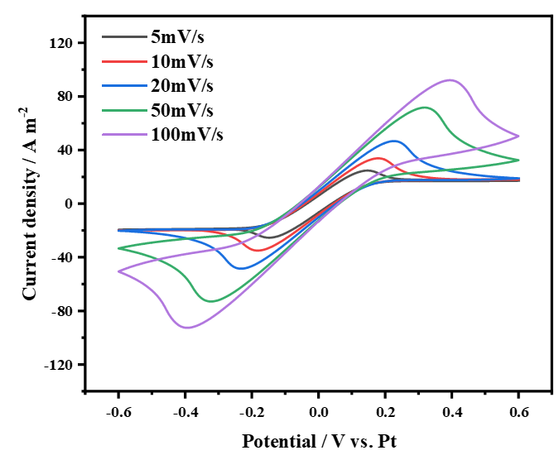
Figure S1: CV curves of 0.2 M:0.2 M Fe(CN)₆⁴⁻/Fe(CN)₆³⁻ at different scan rates.

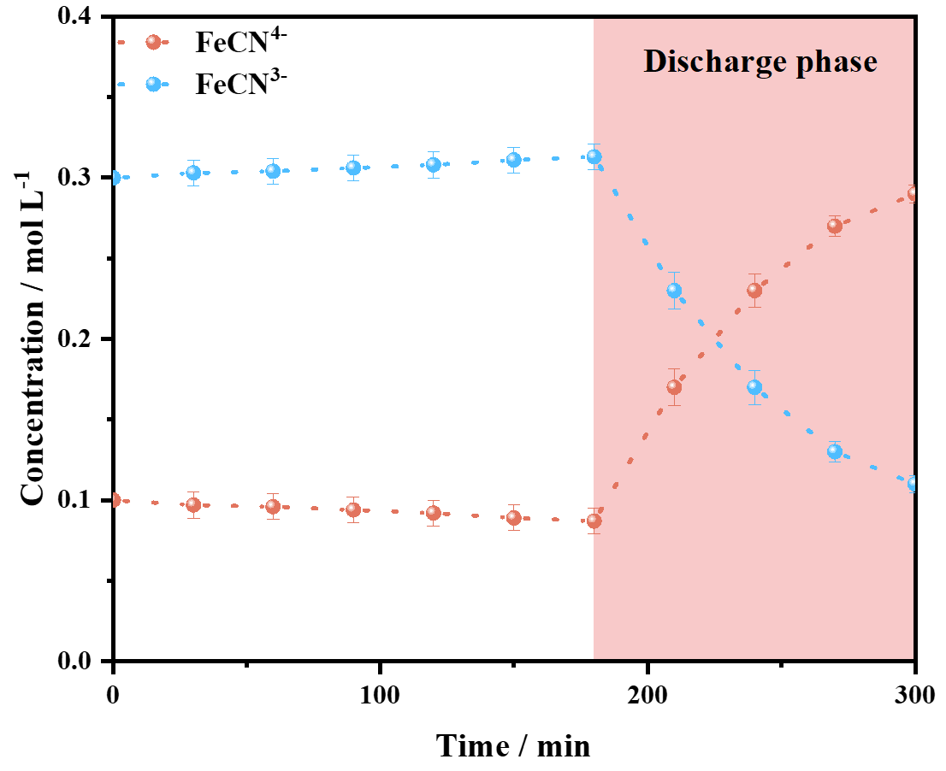
Figure S2: Concentration change process of Fe(CN)₆⁴⁻/Fe(CN)₆³⁻ at the cold end.

Figure S3: CV tests of 0.2 M:0.2 MFe(CN)₆⁴⁻/Fe(CN)₆³⁻ in a two-electrode system at different temperatures. (a) 25 °C; (b) 30 °C; (c) 40 °C; (d) 50 °C; (e) 60 °C; (f) 70 °C and (g) Relationship between different scan rates and the redox peak currents.

Figure S4: (a) Scanning electron microscopy (SEM) image of the activated carbon powder. (b) Brunauer-Emmett-Teller (BET) surface area analysis of the activated carbon powder. (c) Galvanostatic charge-discharge (GCD) tests of the activated carbon powder at different current densities. (d) Specific capacitance of the activated carbon powder. (e) Energy-dispersive X-ray spectroscopy (EDS) analysis of the activated carbon powder before and after the reaction. (f) Cyclic GCD test curves of the activated carbon powder.

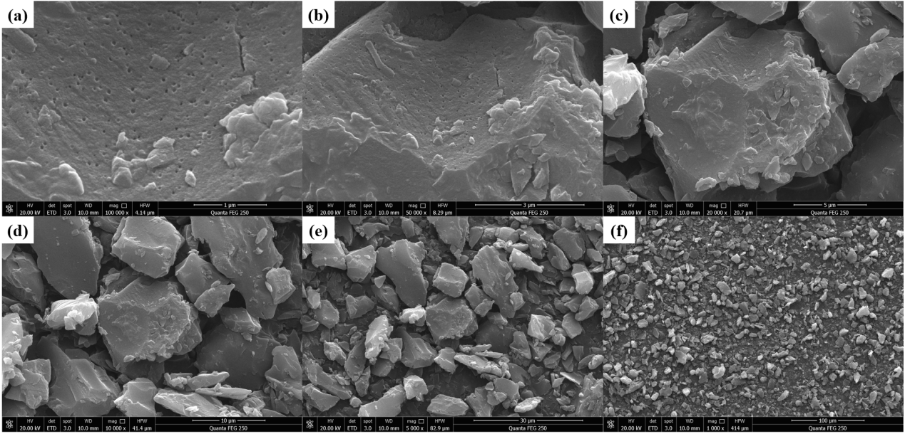
Figure S5: SEM images of the activated carbon capacitor powder at different magnifications.
Figure S6: GCD tests of the capacitor powder at different temperatures. (a) 25 °C; (b) 30 °C; (c) 40 °C; (d) 50 °C; (e) 60 °C; (f) 70 °C and (g) Specific capacitance values at different temperatures.

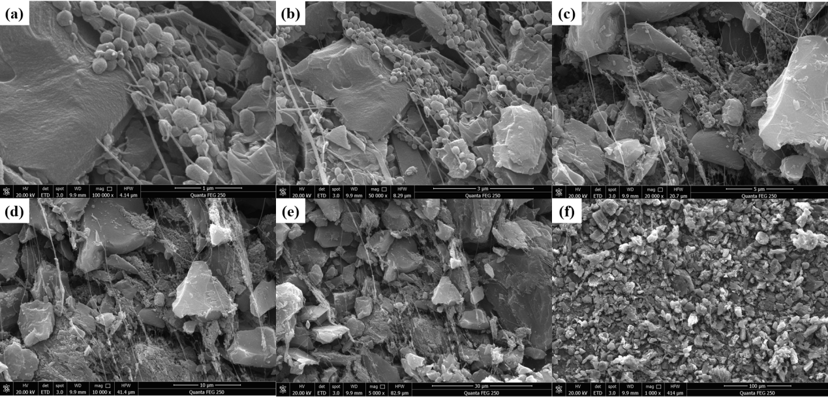
Figure S7: SEM images of the hot-end capacitor powder after the reaction at different magnifications.
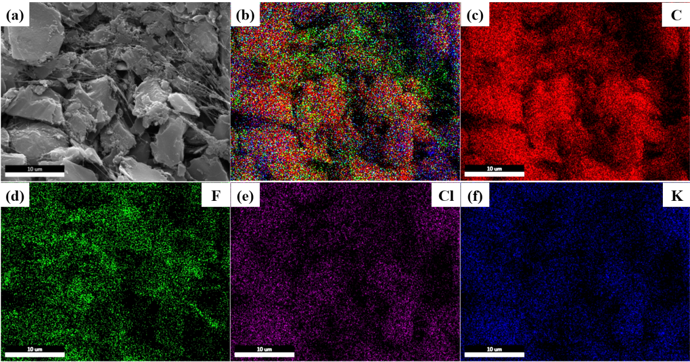
Figure S8: EDS spectrum of the hot-end capacitor powder after the reaction.

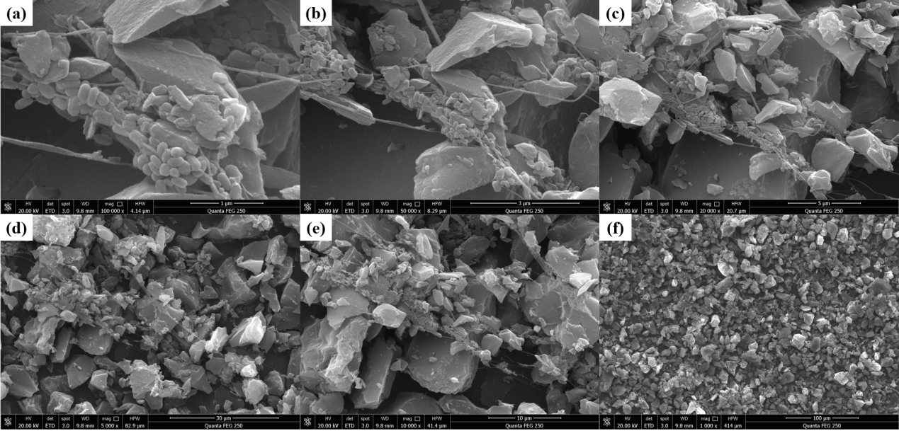
Figure S9: SEM images of the cold-end capacitor powder after the reaction at different magnifications.

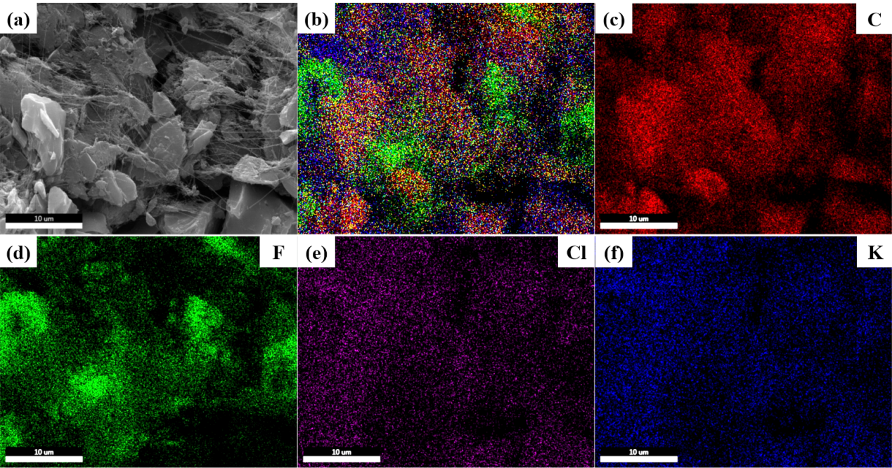
Figure S10: EDS spectrum of the cold-end capacitor powder after the reaction.

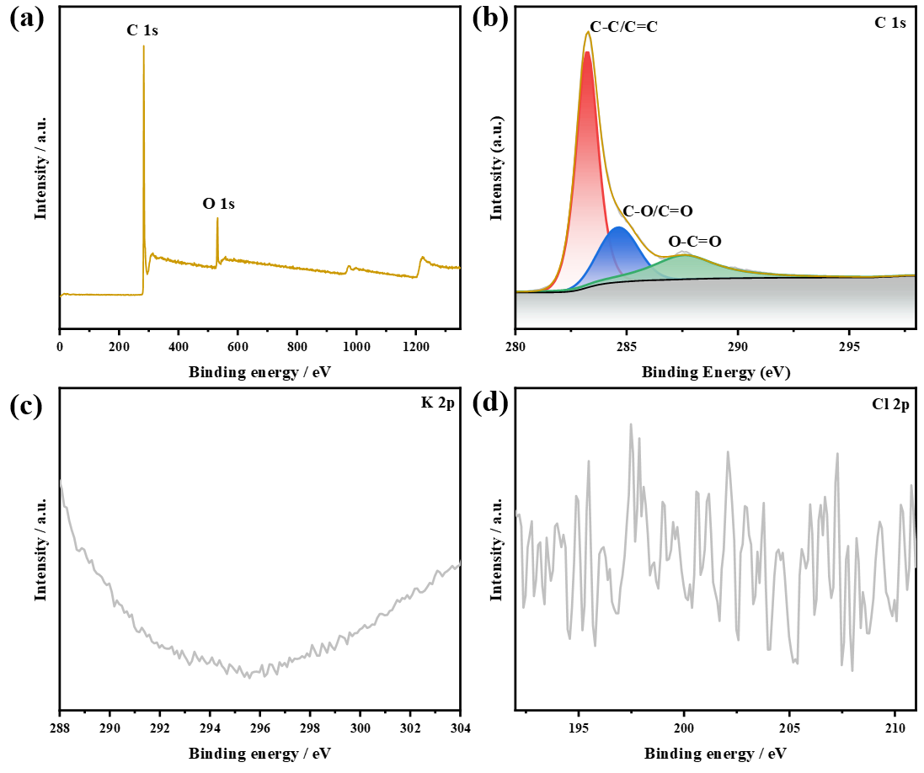
Figure S11: XPS analysis of the capacitor powder.

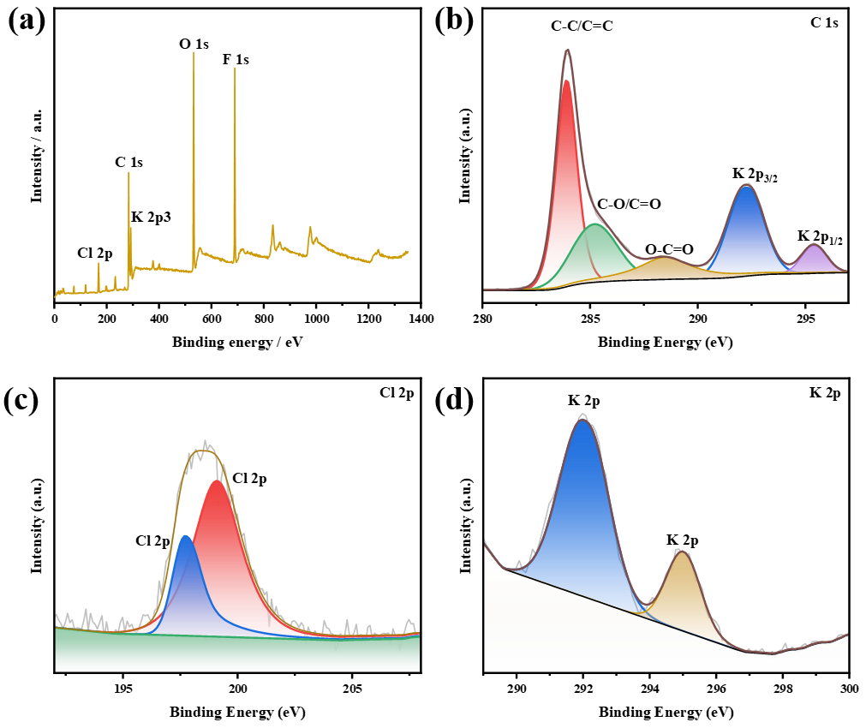
Figure S12: XPS analysis of the hot-end capacitor after ion adsorption. a: Survey spectrum; b: C 1s; c: Cl 2p; d: K 2p.

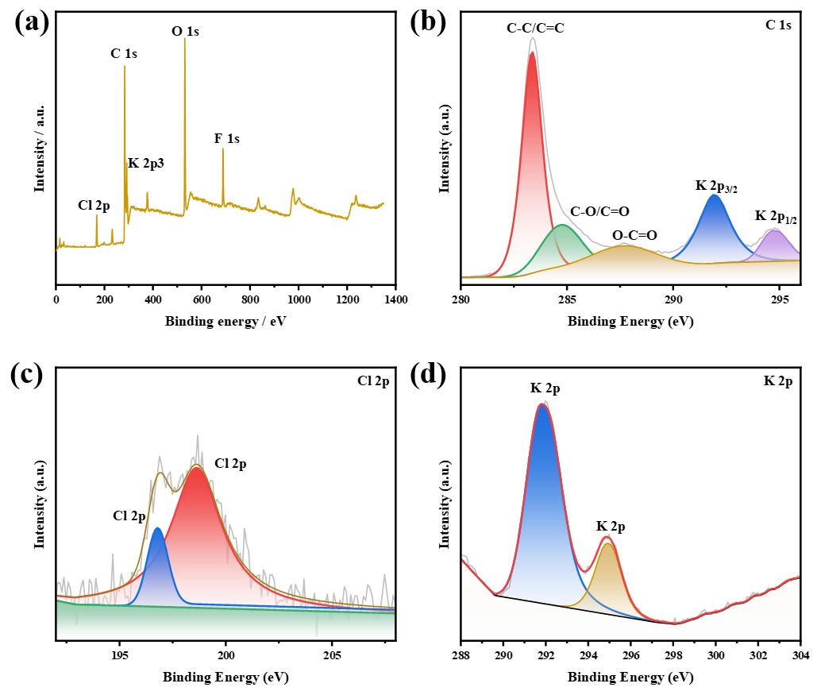
Figure S13: XPS analysis of the cold-end capacitor after ion adsorption. a: Survey spectrum; b: C 1s; c: Cl 2p; d: K 2p.

Figure S14: Three-dimensional schematic diagram of the SC-TGC system operation.

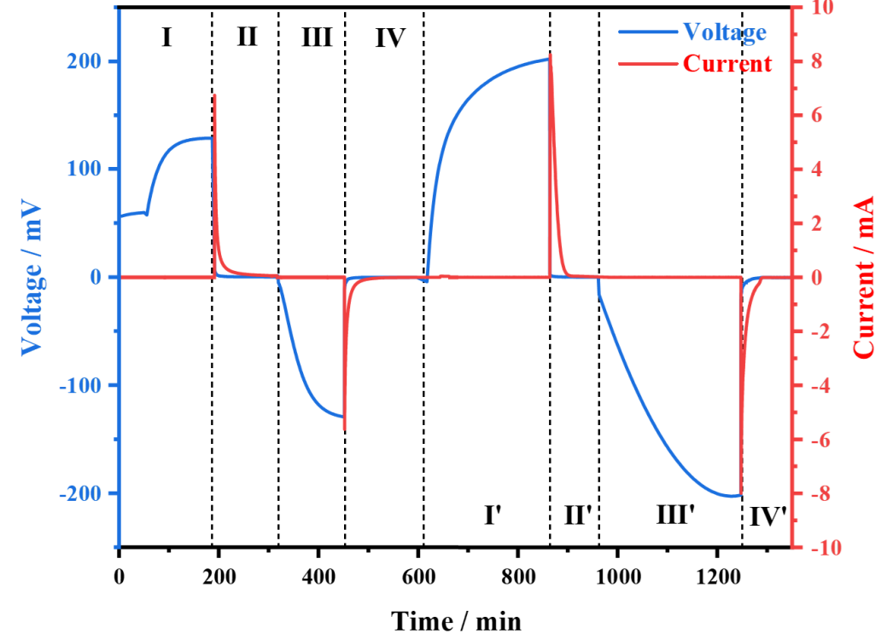
Figure S15: Voltage and current variation of the cell over two cycles.

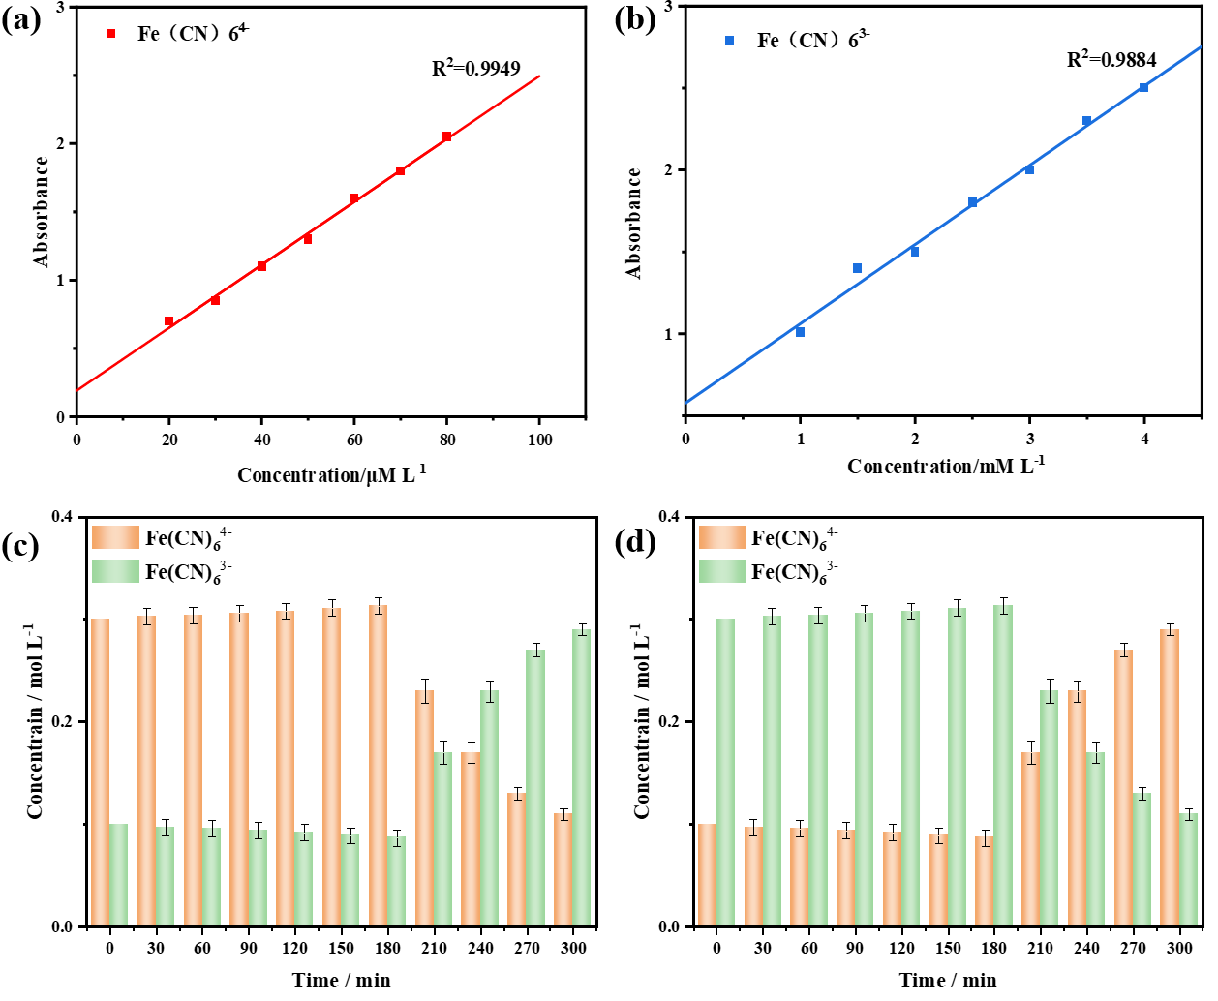
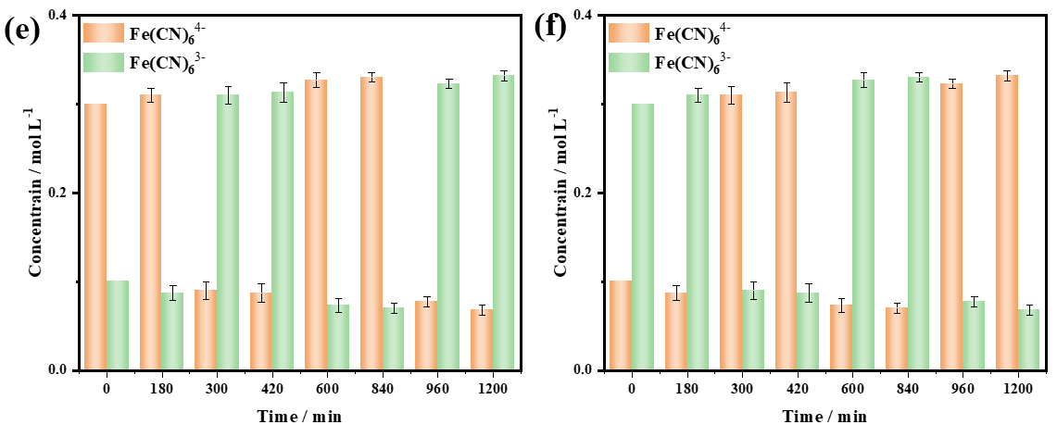
Figure S16: (a) Absorbance curve of potassium ferricyanide and (b) potassium ferrocyanide; Concentration changes of ferri/ferrocyanide ions at the (c) hot end and (d) cold end during a single discharge cycle; Concentration changes of ferri/ferrocyanide ions at the (e) hot end and (f) cold end during the charge-discharge process of the second cycle.

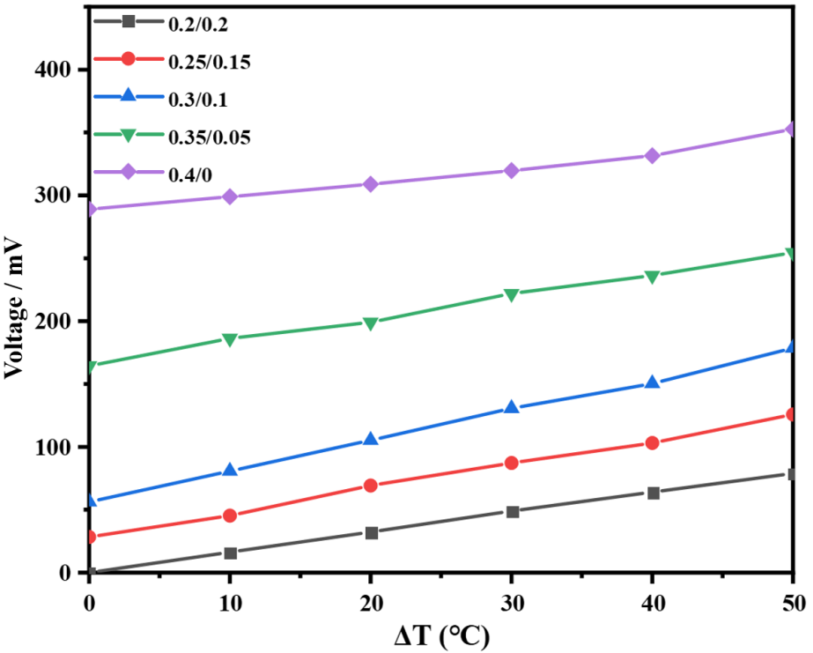
Figure S17: Output voltage variation with temperature for Fe(CN)₆⁴⁻/Fe(CN)₆³⁻ solutions with different concentration ratios (mol L⁻¹: mol L⁻¹).

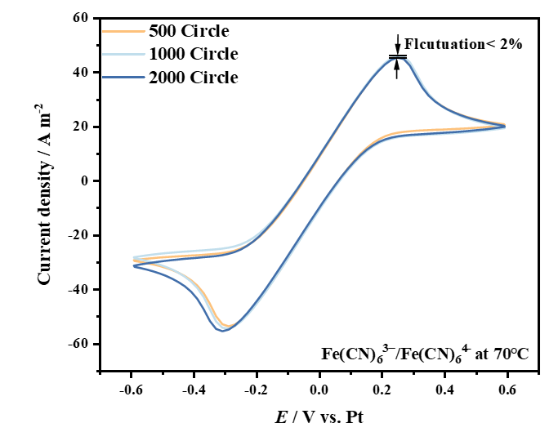
Figure S18: CV test of Fe(CN)₆⁴⁻/Fe(CN)₆³⁻ after 2000 cycles.

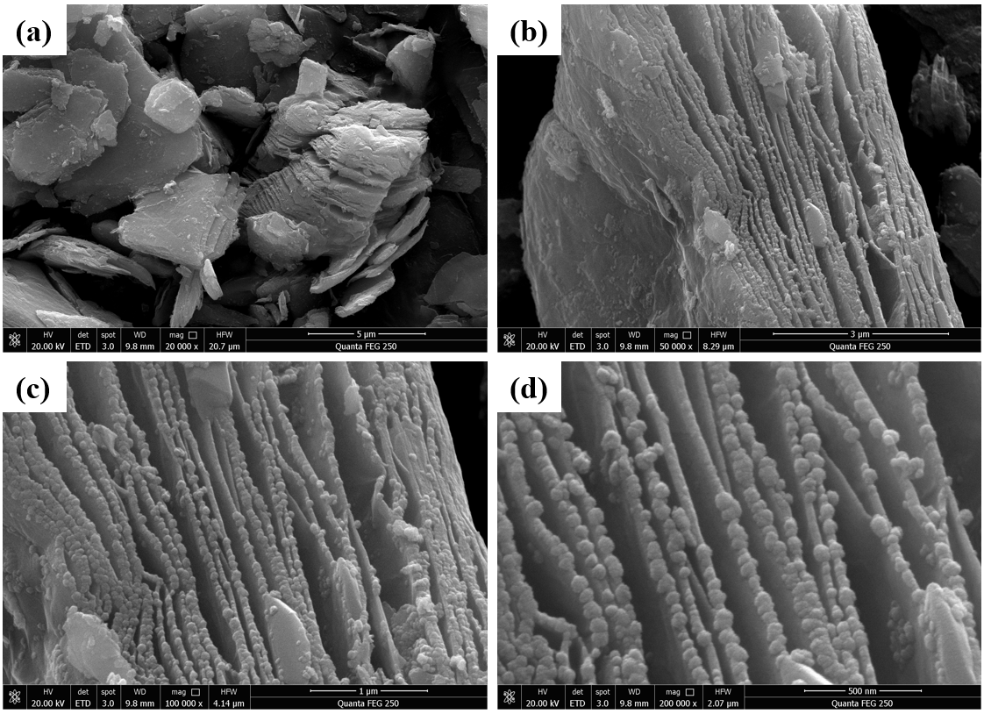
Figure S19: SEM image of Ti₃C₂.

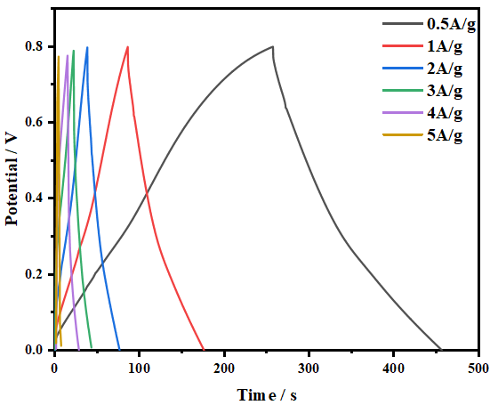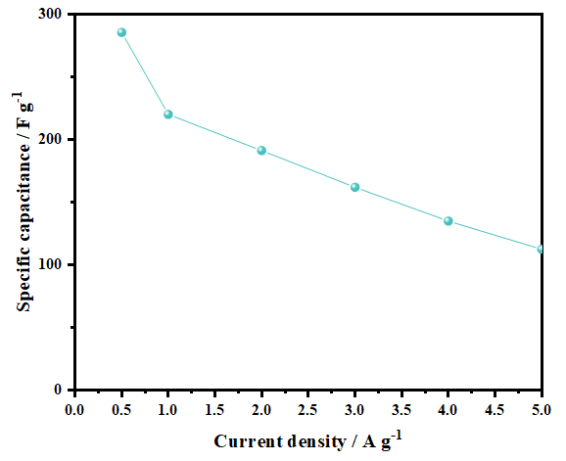
Figure S20: GCD test and specific capacitance of Ti₃C₂.
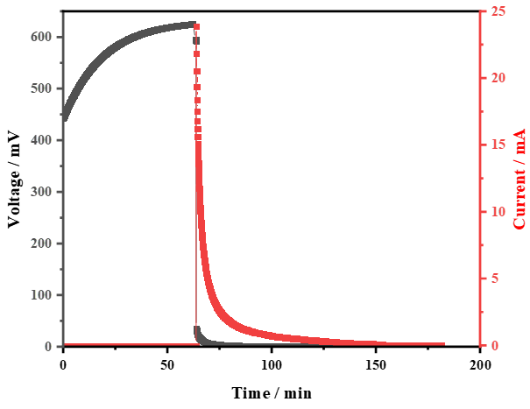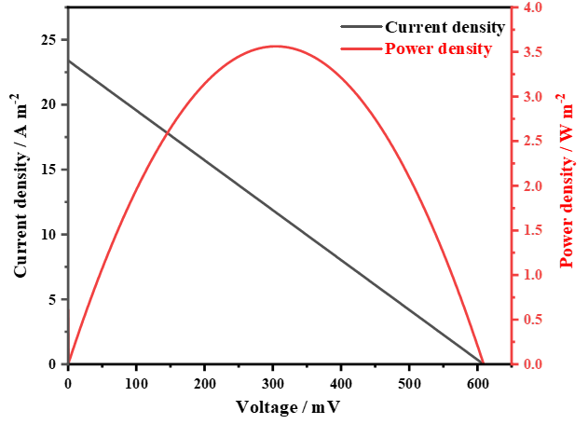
Figure S21: Charge-discharge curves and power density curve of the SC-TGC using Ti₃C₂-based supercapacitor-assisted electrodes.

Figure S22: Comparison of the temperature difference between the hot and cold electrodes in the TGC and the SC-TGC.
Figure S23: Comparison of cold-source input conditions, effective thermal conductivity (k_{eff}), and effective ionic conductivity (σ) among similar reported works^{2,4–7}.

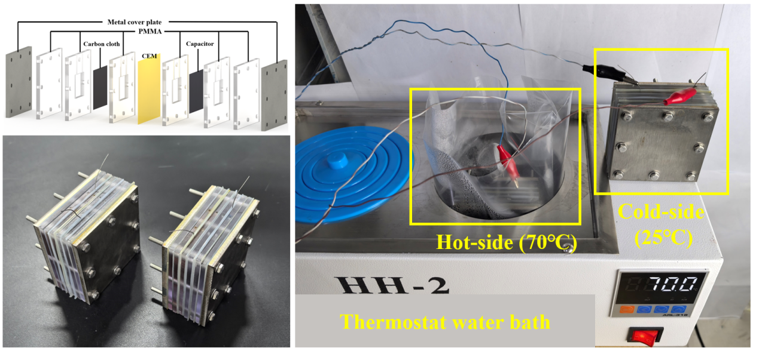
Figure S24: Three-dimensional schematic diagram and photograph of a single SC-TGC unit.

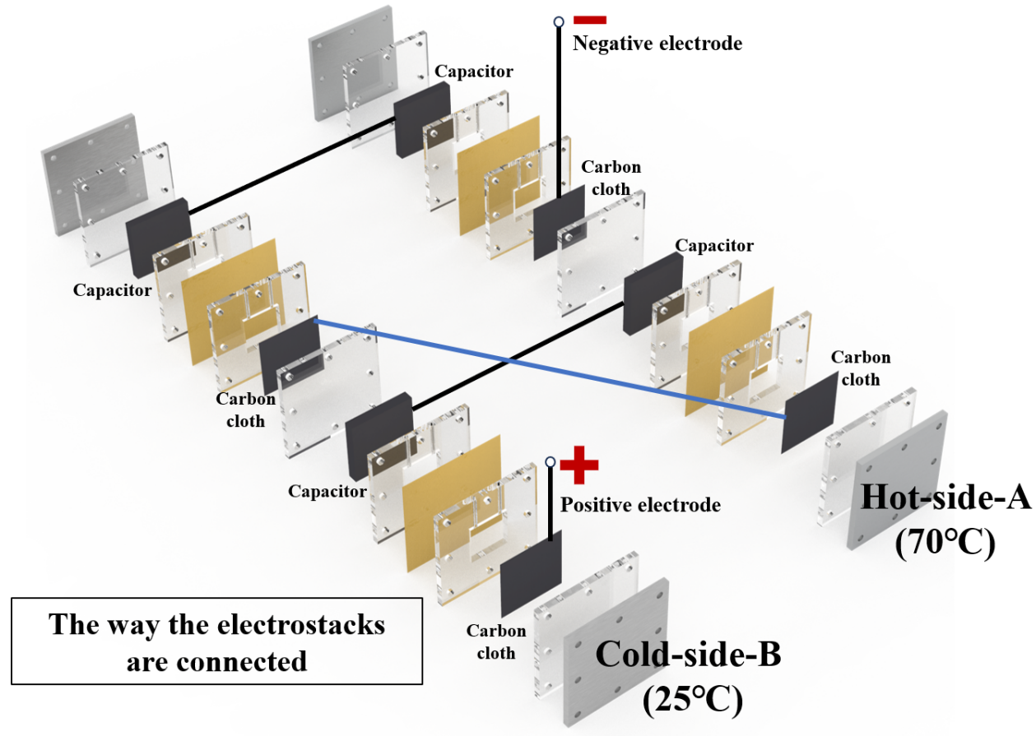
Figure S25: Photograph of the fabricated SC-TGC stack and a schematic diagram of the stack connection.

Supplementary Tables S1-S5
Table S1: ICP-OES instrument parameters
Instrument parameter | Value
RF Powe | 1.20 KW
Plsama flow | 15.0 L/min
Auxiliary flow | 1.50 L/min
Nebulizer flow | 0.75 L/min
Sample uptake delay | 15s
Instr stabilizaton delay | 15s
Replicate read time | 2s
Replicates | 3 times

Table S2: IC instrument parameters
Instrument parameter | Value
Mobile phase | 20mmol/L KOH
Flow rate of mobile phase | 1.0mL/min
Column type | AS19 4mm*250mm
Column temperature box temperature | 30℃
Suppression current | 50mA

Table S3: Rates of various processes/components during the reaction
 | Reaction process | Rate (× 10⁻⁷ / mol s⁻¹)
TGC | FeCN^{3-/4-} reaction | 8.98E-6
TGC | FeCN^{3-/4-} diffusion | 7.075E-5
SC-TGC | FeCN^{3-/4-} reaction | 0.229
SC-TGC | FeCN^{3-/4-} diffusion | 0.61
SC-TGC | K⁺ adsorption | 2.45
SC-TGC | K⁺ Transmembrane diffusion | 40.04
SC-TGC | K⁺ diffusion | 42.6
SC-TGC | Cl⁻ adsorption | 2.02
SC-TGC | Cl⁻ diffusion | 41.4

Table S4: Comparison of the Seebeck coefficient, output power, and maximum relative Carnot efficiency under cold-source-free conditions
Redox couple | Se  (mV K⁻¹) | P_{max}  (W m⁻²) | η_{r} | Ref.
Fe(CN)₆^{4-/3-} | 4.49 | 3.56 | 7.4 | This work
Fe(CN)₆^{4-/3-} | 1.3 | 3.6 | 0.7 | ⁸
Fe(CN)₆^{4-/3-} | 2.7 | 0.68 | 0.11 | ⁹
I^{3-/-} | 2 | 0.55 | 0.033 | ¹⁰
Co^{3+/2+} | 1.6 | 0.144 | 0.087 | ¹¹
Fe(CN)₆^{4-/3-} | 1.42 | 0.82 | 0.9 | ¹²
Fe(CN)₆^{4-/3-} | 1.4 | 1.36 | 1.4 | ¹³
Fe(CN)₆^{4-/3-} + NaCl | 1.6 | 0.97 | 1.38 | ⁴
Fe(CN)₆^{4-/3-} | — | 0.338 | 2.63 | ¹⁴

Supplementary References
1. Zhang, D. et al. Stretchable thermogalvanic hydrogel thermocell with record-high specific output power density enabled by ion-induced crystallization. Energy Environ. Sci. 15, 2974–2982 (2022).
2. Wang, Y. et al. In situ photocatalytically enhanced thermogalvanic cells for electricity and hydrogen production. Science 381, 291–296 (2023).
3. Yang, W. et al. Two-Phase Flow Model to Define the Mass Transport in a Bicarbonate Electrolyzer for a CO₂ Reduction Reaction. Ind. Eng. Chem. Res. 62, 16469–16480 (2023).
4. Lei, Z., Gao, W. & Wu, P. Double-network thermocells with extraordinary toughness and boosted power density for continuous heat harvesting. Joule 5, 2211–2222 (2021).
5. Yu, B. et al. Thermosensitive crystallization–boosted liquid thermocells for low-grade heat harvesting. Science 370, 342–346 (2020).
6. Kim, K., Hwang, S. & Lee, H. Unravelling ionic speciation and hydration structure of Fe(III/II) redox couples for thermoelectrochemical cells. Electrochim. Acta 335, 135651 (2020).
7. Kim, J. H. et al. Iron (II/III) perchlorate electrolytes for electrochemically harvesting low-grade thermal energy. Sci. Rep. 9, 8706 (2019).
8. Li, G. et al. High‐Efficiency Cryo‐Thermocells Assembled with Anisotropic Holey Graphene Aerogel Electrodes and a Eutectic Redox Electrolyte. Adv. Mater. 31, 1901403 (2019).
9. Duan, J. et al. Aqueous thermogalvanic cells with a high Seebeck coefficient for low-grade heat harvest. Nat. Commun. 9, 5146 (2018).
10. Zhou, H., Yamada, T. & Kimizuka, N. Supramolecular Thermo-Electrochemical Cells: Enhanced Thermoelectric Performance by Host–Guest Complexation and Salt-Induced Crystallization. J. Am. Chem. Soc. 138, 10502–10507 (2016).
11. Salazar, P. F., Stephens, S. T., Kazim, A. H., Pringle, J. M. & Cola, B. A. Enhanced thermo-electrochemical power using carbon nanotube additives in ionic liquid redox electrolytes. J. Mater. Chem. A 2, 20676–20682 (2014).
12. Qian, W., Cao, M., Xie, F. & Dong, C. Thermo-Electrochemical Cells Based on Carbon Nanotube Electrodes by Electrophoretic Deposition. Nano-Micro. Lett. 8, 240–246 (2016).
13. Hu, R. et al. Harvesting Waste Thermal Energy Using a Carbon-Nanotube-Based Thermo-Electrochemical Cell. Nano Lett. 10, 838–846 (2010).
14. Romano, M. S. et al. Carbon Nanotube – Reduced Graphene Oxide Composites for Thermal Energy Harvesting Applications. Adv. Mater. 25, 6602–6606 (2013).

