Supplementary Materials for

A Pore-Facing Glycan Determines GABA_{A}​ Receptor Subunit Stoichiometry and Gating Behavior

Amin Akbari Ahangar¹, and Jing Li^{*1}

¹Department of Biomolecular Sciences, School of Pharmacy, University of Mississippi, University, Mississippi, 38677, United States
* Corresponding author. Email: jli15@olemiss.edu

This file includes:
Supplementary Figure 1 to 6

Supplementary Tables 1 to 4

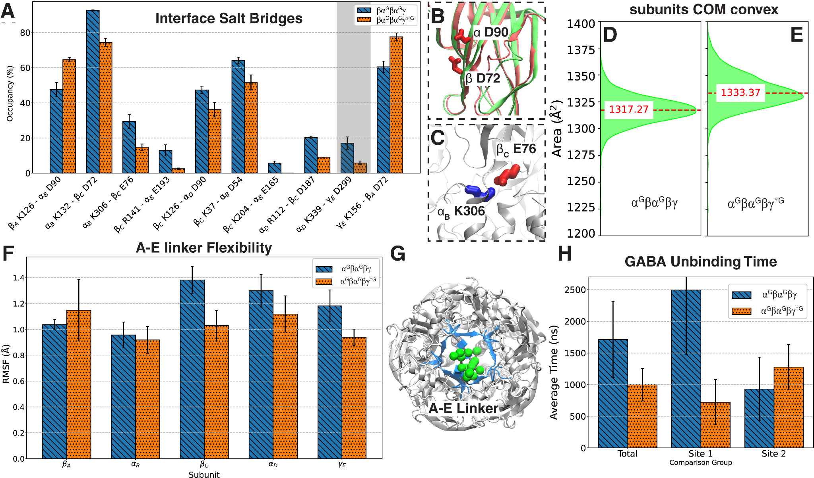Supplementary Figure 1: Effect of additional glycan on salt bridges and internal loops. A) affected salt bridges in βα^{G}βα^{G}γ*^{G} including TMD. B)Structural proximity of two aspartic acid residues that are involved in salt bridges at the interface. C) Disrupted salt bridge at the interface of TMD-ECD implicated in the activity pathway. D) Convex in area of βα^{G}βα^{G}γ and E) βα^{G}βα^{G}γ*^{G} ECD. F) RMSF of A-E linker in each subunit. G) location of A-E linker, which hosts the glycosylation site on the α subunit, H) Time to GABA unbinding.
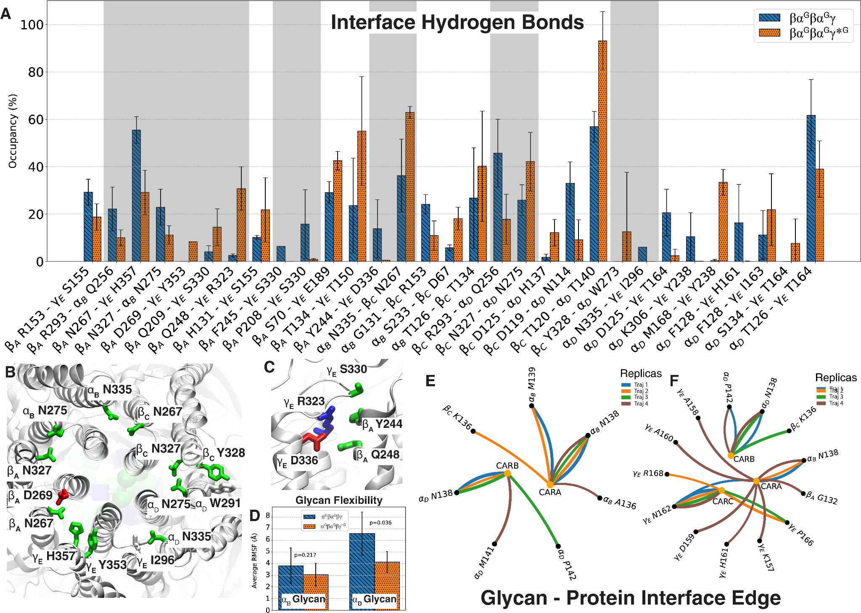
Supplementary Figure 2: Effect of additional glycan on hydrogen bond networks and the pore. A) affected hydrogen bonds in βα^{G}βα^{G}γ*^{G} at ECD and TMD (gray). The α_{D}-γ_{E} ECD harbours the benzodiazepines binding site, while the α_{B}-β_{C} interface is where the cholesterol binding site is located. B) Disrupted hydrogen bonds at the lower parts of TMD. C) Disrupted hydrogen bonds at the interface of benzodiazepine binding site. D) Average RMSF of glycans attached to α subunits in βα^{G}βα^{G}γ and βα^{G}βα^{G}γ*^{G} system, E) Glycan-protein interface edge in βα^{G}βα^{G}γ and in F) βα^{G}βα^{G}γ*^{G}.

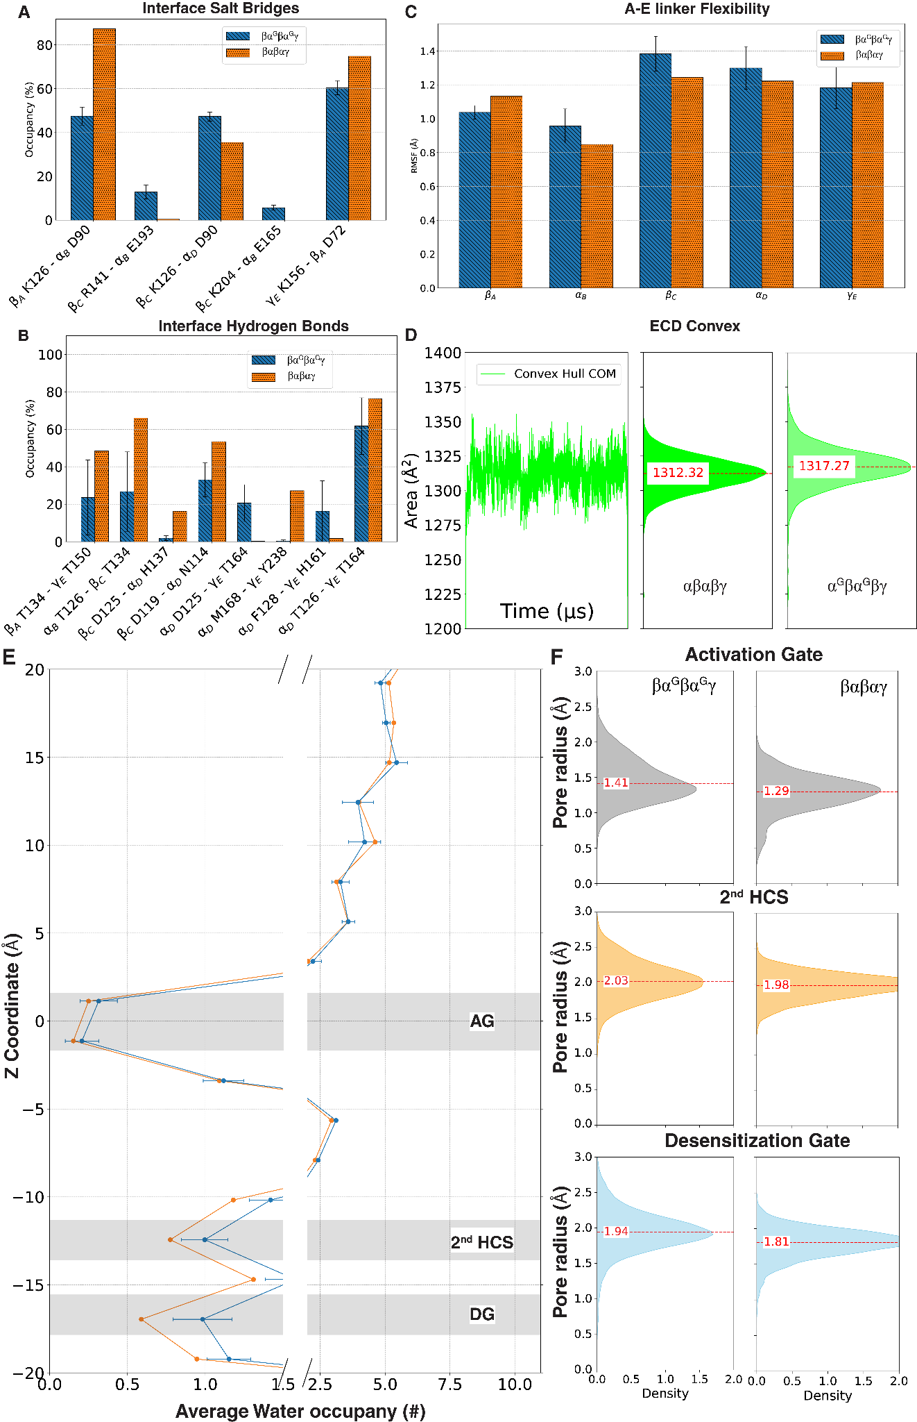
Supplementary Figure 3: Effect of removing all the pore-facing glycans on the βαβαγ dynamics. A) Change in previously detected salt bridge occupancies at the βαβαγ interface, B) hydrogen bond occupancy change at the interface. C) RMSF of A-E linker across the subunits in βαβαγ. D) ECD convex of βαβαγ traced and averaged along the length of the trajectory. E) Water occupancy at βαβαγ TMD compared with βα^{G}βα^{G}γ. F) pore radius at AG, 2nd HCS, and DG.

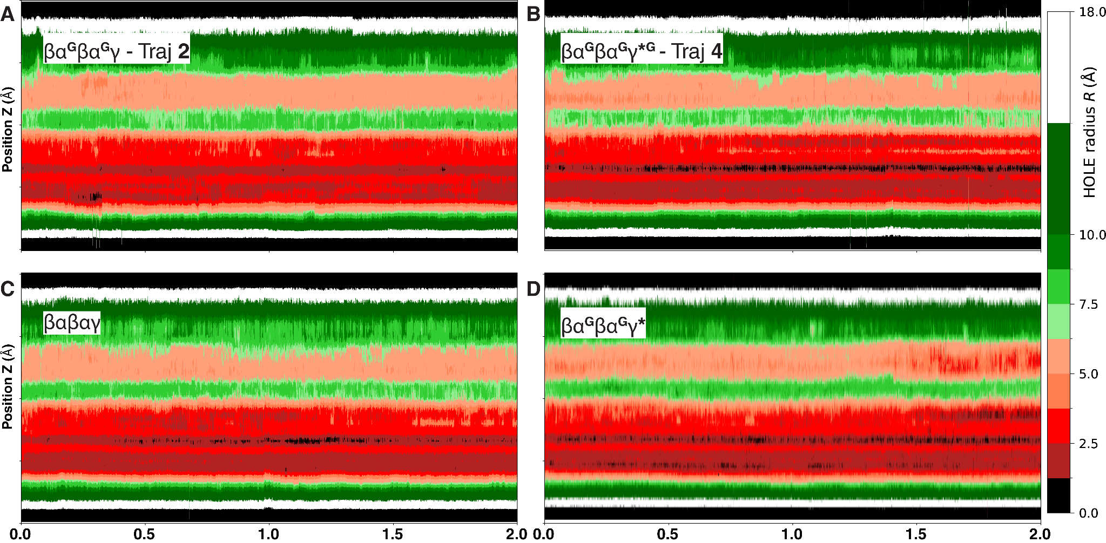
Supplementary Figure 4: Pore-radius plot showing the evolution of the pore radius along the Z axis along the trajectory time in A) βα^{G}βα^{G}γ B) βα^{G}βα^{G}γ*^{G} C) βαβαγ and D) βα^{G}βα^{G}γ*.

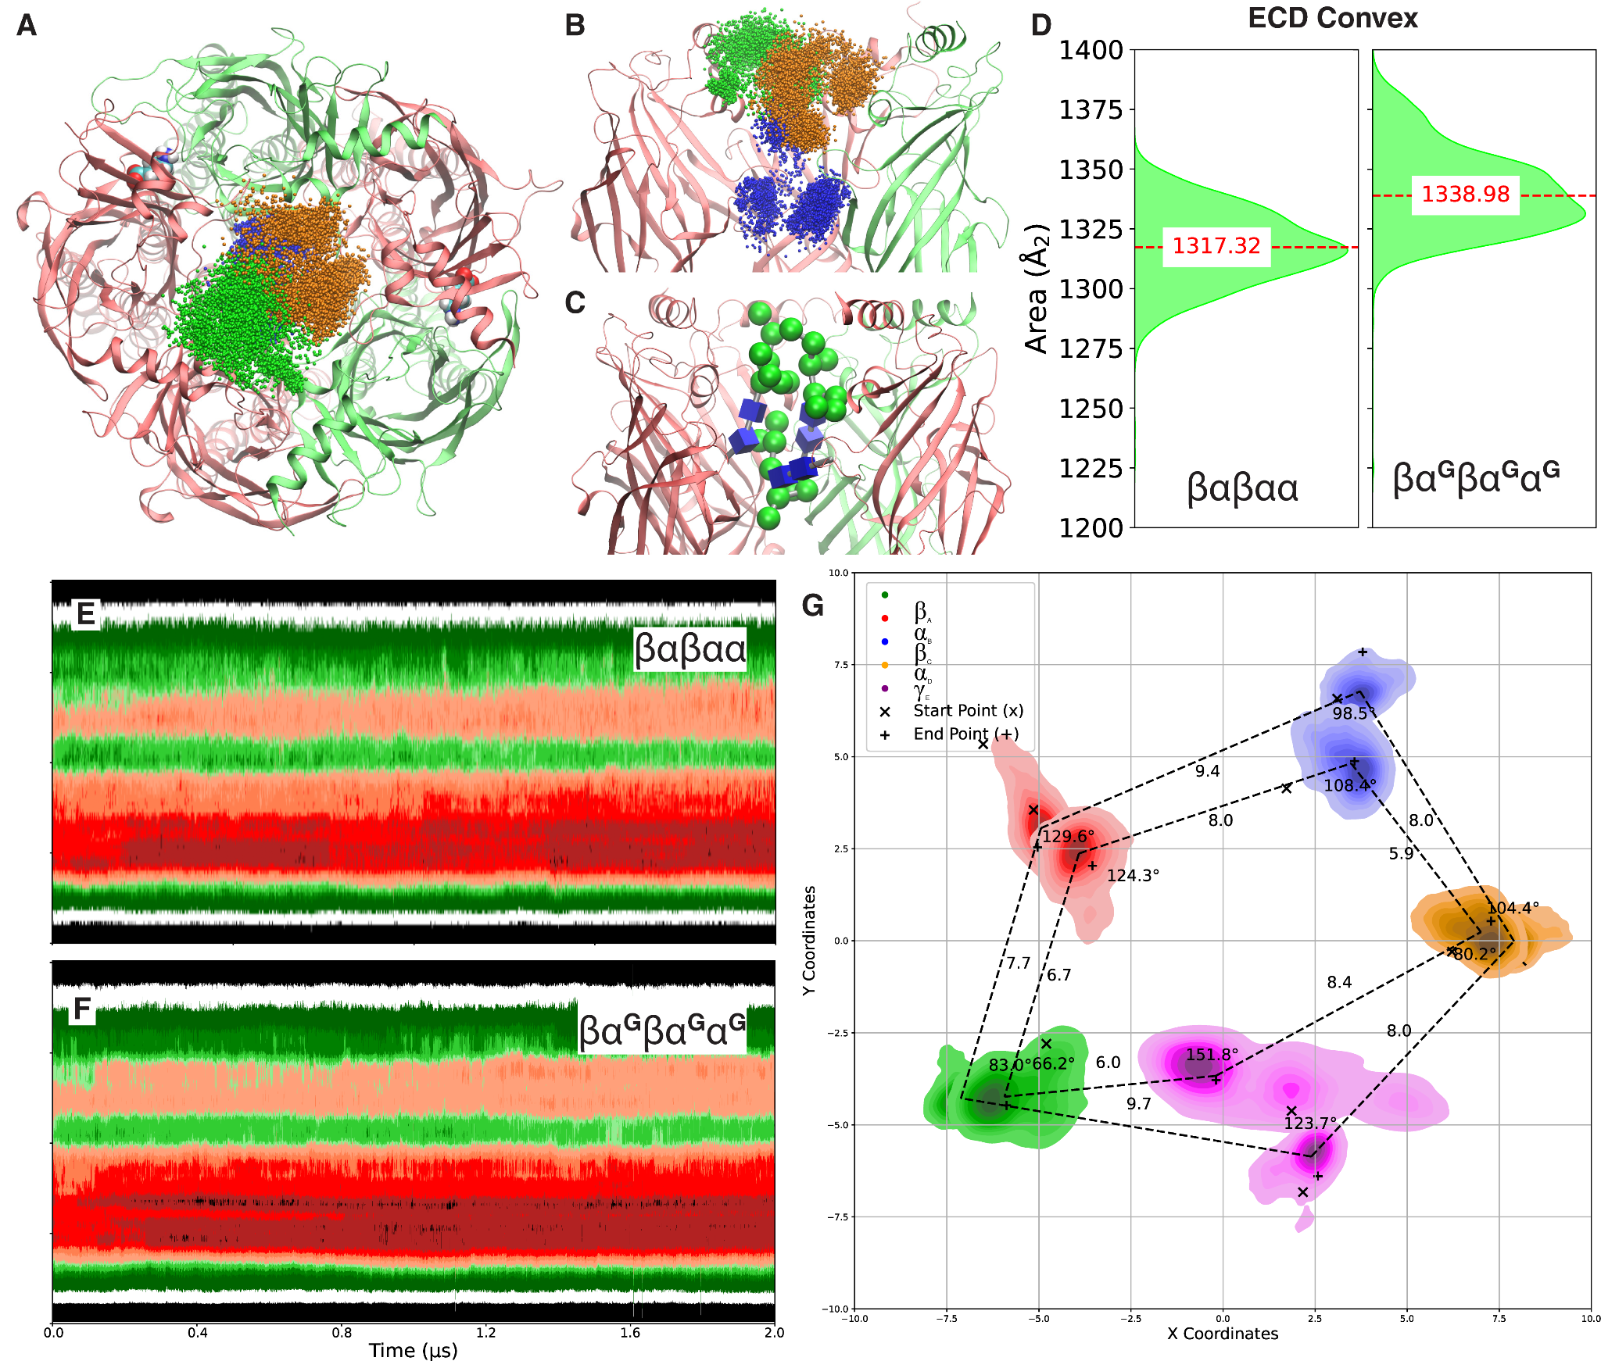Supplementary Figure 5: The effect of third α^{G} on channel dynamics in βα^{G}βα^{G}α^{G}. A) Top view of glycan localization. B) Side view of glycan localization, C) The glycan on α_{B} is placed in between the glycans attached to α_{D} and α_{E}. D) ECD convex in βα^{G}βα^{G}α^{G} compared with βαβαα E) Pore-radius plot of the pore radius tracked along the Z axis for the duration of the simulation for βαβαα and F) βα^{G}βα^{G}α^{G} G) Location of TMDs for each subunits. The inner line connects the median position of the DG while the outer line is at the median location of AG.
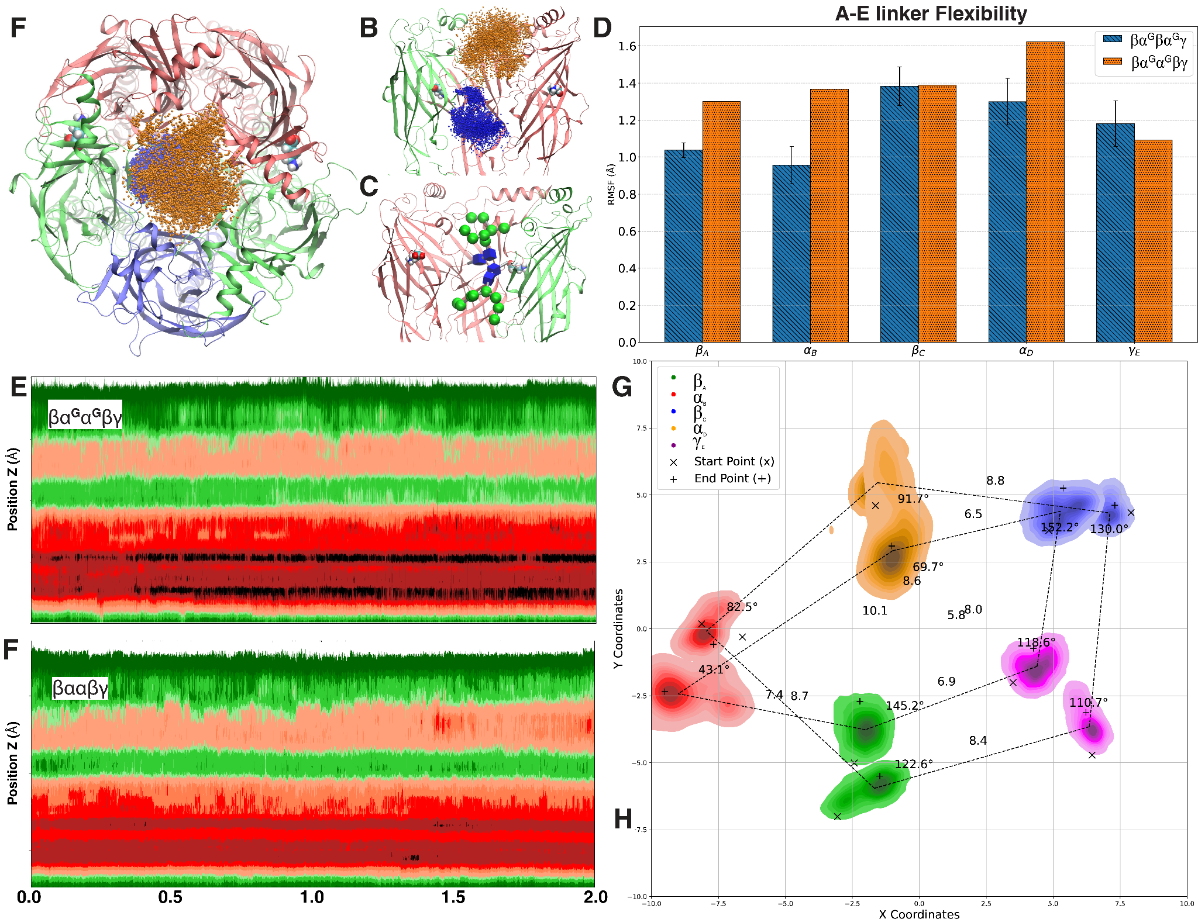
Supplementary Figure 6: Effect of glycosylation on adjacent α subunits in βα^{G}α^{G}βγ. A) Top and side B) view of glycan localization. C) The adjacency of glycans can cause them to clash at the glycan core. D) RMSF of A-E linker across the subunits in βα^{G}α^{G}βγ. E) Watermelon plot of the pore radius tracked along the Z axis for the duration of the simulation for βα^{G}α^{G}βγ and F) βααβγ. G) Location of TMDs across subunits. The inner line connects the median position of the DG while the outer line is at the median location of AG.

 | βαGβαGγ*G-1 | βαGβαGγ*G-2 | βαGβαGγ*G-3 | βαGβαGγ*G-4 |  | βαGβαGγ-1 | βαGβαGγ-2 | βαGβαGγ-3 | βαGβαGγ-4 |  | βαGβαGαG | βαGαGβγ | βαβαγ
βA RMSF | 0.61 | 2.52 | 0.64 | 1.29 |  | 1.22 | 1.35 | 1.27 | 0.65 |  | 1.25 | 1.3 | 1.33
αB RMSF | 0.71 | 1.44 | 0.65 | 1.64 |  | 0.66 | 1.49 | 1.69 | 0.71 |  | 1.38 | 1.36 | 0.85
βC RMSF | 1.72 | 0.7 | 0.76 | 1.44 |  | 1.9 | 1.61 | 2.03 | 0.92 |  | 1.11 | 1.39 | 1.24
αD RMSF | 0.87 | 0.84 | 1.18 | 1.32 |  | 1.28 | 1.56 | 1.31 | 0.98 |  | 1.09 | 1.62 | 1.22
γ RMSF | 1.7 | 1.52 | 0.63 | 0.91 |  | 0.95 | 1.35 | 1.41 | 1.62 |  | 1.43 | 1.09 | 1.21
AG Radius | 1.4 | 1.72 | 1.23 | 1.35 |  | 1.14 | 1.15 | 1.13 | 1.08 |  | 1.37 | 0.88 | 1.29
HCS Radius | 1.99 | 2.27 | 1.98 | 1.9 |  | 1.97 | 1.9 | 1.75 | 1.79 |  | 1.48 | 1.63 | 1.98
DG Radius | 1.97 | 2.34 | 1.95 | 1.75 |  | 2.05 | 1.98 | 1.95 | 2.16 |  | 1.74 | 0.84 | 1.81
Site 1 (ns) | 750 | 40 | 400 | 1700 |  | 5500 | 1400 | 1980 | 1100 |  | 390 | 190 | 660
Site 2 (ns) | 1500 | -- | 300 | 1300 |  | 2360 | 520 | 800 | 40 |  | 1700 | -- | --
 | rebind | rebind | rebind | --
 | βαGβαGγ*G-1 | βαGβαGγ*G-2 | βαGβαGγ*G-3 | βαGβαGγ*G-4 |  | βαGβαGγ-1 | βαGβαGγ-2 | βαGβαGγ-3 | βαGβαGγ-4 |  | βαGβαGαG | βαGαGβγ | βαβαγ
CARA RMSF | 2.3958 | 2.0174 | 3.8479 | 3.9514 |  | 6.0358 | 2.8892 | 2.696 | 3.6844 |  | 2.8114 | 4.7454 | --
CARB RMSF | 2.9106 | 4.1043 | 4.6154 | 4.9678 |  | 7.752 | 5.5739 | 8.5215 | 4.5384 |  | 4.9534 | 9.9381 | --
CARC RMSF | 4.7212 | 5.9418 | 7.3748 | 7.2233 |  | -- | -- | -- | -- |  | 4.0318 | -- | --
Supplementary Table 1: Internal loops RMSF, Pore radius, dissociation time and glycans RMSF data

edge | replica_1 | replica_2 | replica_3 | replica_4
β_{A} G132 - CARA AMAN 7 |  |  |  | 0.5518
β_{A} H131 - CARA AMAN 7 |  |  |  | 0.4726
β_{A} F129 - CARA AMAN 7 |  |  |  | 0.4796
β_{A} F129 - CARA BGLCNA 1 |  |  |  | 0.4644
β_{A} S128 - CARA BGLCNA 1 |  |  |  | 0.4852
β_{A} T134 - CARC BGLCNA 1 | 0.3141 |  | 0.452
β_{A} T134 - CARC BGLCNA 2 | 0.2048 |  | 0.1832
β_{A} V133 - CARA AMAN 7 |  |  |  | 0.4953
β_{A} V135 - CARC BGLCNA 2 |  | 0.2351 | 0.284
α_{B} A136 - CARA BGLCNA 1 |  |  |  | 0.4621
α_{B} R56 - CARB AMAN 5 |  |  |  | 0.3726
α_{B} R56 - CARB AMAN 6 |  |  |  | 0.4568
α_{B} N138 - CARA BGLCNA 1 | 0.7013 | 0.568 | 0.4543 | 0.6101
α_{B} N55 - CARB AMAN 5 |  |  |  | 0.3923
α_{B} N55 - CARB AMAN 6 |  |  |  | 0.4721
α_{B} D54 - CARB AMAN 6 |  |  |  | 0.4547
α_{B} K120 - CARB AMAN 6 |  |  |  | 0.3783
α_{B} Y53 - CARB AMAN 6 |  |  |  | 0.4056
α_{B} V135 - CARA BGLCNA 1 |  |  |  | 0.3443
β_{C} R110 - CARB AMAN 5 |  |  |  | 0.3832
β_{C} D113 - CARB BGLCNA 2 |  | 0.1671 | 0.329 | 0.3907
β_{C} D113 - CARB BMAN 3 |  |  |  | 0.3933
β_{C} Q114 - CARB AMAN 4 |  |  | 0.4132
β_{C} Q114 - CARB AMAN 5 |  |  |  | 0.3799
β_{C} Q114 - CARB AMAN 6 |  |  | 0.2705
β_{C} Q114 - CARB AMAN 9 |  |  |  | 0.3728
β_{C} Q114 - CARB BMAN 3 |  | 0.1641 | 0.4255 | 0.4024
β_{C} I49 - CARB AMAN 8 |  |  |  | 0.2558
β_{C} I49 - CARB AMAN 9 |  | 0.3706 |  | 0.2866
β_{C} K127 - CARA AMAN 5 | 0.312 | 0.0427
β_{C} K136 - CARB BGLCNA 1 |  |  | 0.6946
β_{C} F129 - CARA AMAN 5 |  | 0.1091
β_{C} F129 - CARA AMAN 6 | 0.2808 |  | 0.1414
β_{C} S128 - CARA AMAN 5 | 0.3614
β_{C} T134 - CARA BGLCNA 1 |  |  |  | 0.2399
β_{C} Y47 - CARB AMAN 9 |  |  |  | 0.3547
β_{C} V130 - CARA AMAN 6 | 0.3017
β_{C} V133 - CARA BGLCNA 1 |  |  |  | 0.2604
α_{D} R163 - CARA AMAN 6 |  |  |  | 0.243
α_{D} N138 - CARA AMAN 5 | 0.4834
α_{D} N138 - CARA AMAN 6 | 0.3147
α_{D} N138 - CARB BGLCNA 1 | 0.5956 | 0.3243 | 0.8255 | 0.706
α_{D} L116 - CARB AMAN 8 | 0.1952 |  |  | 0.1643
α_{D} L116 - CARB AMAN 9 | 0.056
α_{D} K133 - CARA AMAN 5 |  |  |  | 0.4508
α_{D} K133 - CARA AMAN 6 |  |  |  | 0.4677
α_{D} K144 - CARA AMAN 10 |  | 0.136 | 0.1155
α_{D} M141 - CARB BGLCNA 1 |  |  |  | 0.4261
α_{D} P142 - CARB BGLCNA 1 | 0.5348 |  |  | 0.5285
α_{D} T140 - CARB BGLCNA 1 |  | 0.0565
α_{D} T161 - CARA AMAN 6 |  |  |  | 0.2983
α_{D} V135 - CARA AMAN 5 | 0.264
α_{D} V135 - CARA AMAN 6 |  |  |  | 0.3957
γ_{E} A158 - CARA AMAN 4 |  |  |  | 0.5846
γ_{E} A158 - CARA AMAN 7 |  |  | 0.384 | 0.5802
γ_{E} A160 - CARA AMAN 4 |  |  |  | 0.6038
γ_{E} A160 - CARA AMAN 7 |  |  |  | 0.5944
γ_{E} A160 - CARA BMAN 3 |  |  |  | 0.5851
γ_{E} R168 - CARC BGLCNA 1 | 0.2787 | 0.5043 | 0.444 | 0.3756
γ_{E} N140 - CARC BGLCNA 2 |  |  |  | 0.2888
γ_{E} N162 - CARA AMAN 8 | 0.5478
γ_{E} N162 - CARA AMAN 9 | 0.386 | 0.0837 | 0.2528 | 0.3917
γ_{E} N162 - CARA BMAN 3 | 0.4978
γ_{E} N162 - CARC BGLCNA 1 | 0.8263 | 0.7115 | 0.7695 | 0.7733
γ_{E} N79 - CARC AMAN 9 |  |  |  | 0.432
γ_{E} D159 - CARA AMAN 4 |  |  |  | 0.6413
γ_{E} H161 - CARA AMAN 4 |  |  |  | 0.5122
γ_{E} H161 - CARA AMAN 5 |  |  |  | 0.377
γ_{E} I163 - CARA BMAN 3 | 0.4101
γ_{E} I163 - CARB BGLCNA 1 | 0.0762
γ_{E} K144 - CARC AMAN 9 |  |  |  | 0.3631
γ_{E} K144 - CARC BMAN 3 |  |  |  | 0.4903
γ_{E} K157 - CARA AMAN 7 |  |  | 0.315 | 0.5958
γ_{E} P166 - CARA AMAN 9 |  | 0.0095
γ_{E} P166 - CARC BGLCNA 1 | 0.1666 | 0.678 | 0.6364 | 0.4936
γ_{E} T164 - CARA AMAN 10 |  | 0.2693 | 0.172
γ_{E} Y77 - CARC AMAN 10 |  |  |  | 0.3311
Supplementary Table 2: edge correlation at the glycan - protein interface

edge | replica_1 | replica_2 | replica_3 | replica_4
β_{A} N173 - β_{A} K237 | 0.7716 | 0.8087
β_{A} D170 - β_{A} P168 | 0.7424 |  | 0.8085
β_{A} D170 - β_{A} Y167 |  | 0.7859 |  | 0.7489
β_{A} C174 - β_{A} Q172 |  |  | 0.7285 | 0.7346
β_{A} C312 - β_{A} M285 |  |  |  | 0.489
β_{A} Q172 - β_{A} D170 | 0.7308 | 0.6945 | 0.76 | 0.6955
β_{A} E177 - β_{A} S233 |  |  | 0.7484
β_{A} E177 - β_{A} T175 | 0.6784 | 0.7337 |  | 0.7229
β_{A} E179 - β_{A} E177 | 0.7803 | 0.715 | 0.7514 | 0.7383
β_{A} I305 - β_{A} L309 |  | 0.7952 | 0.8558
β_{A} I305 - β_{A} Y308 |  |  |  | 0.8163
β_{A} L309 - β_{A} M285 |  | 0.5301 | 0.4115
β_{A} K237 - β_{A} Q172 | 0.7859 | 0.8178
β_{A} M285 - β_{A} L283 | 0.8279 | 0.9059 | 0.8148 | 0.8031
β_{A} P168 - β_{A} I305 |  |  | 0.717
β_{A} P168 - β_{A} Y250 | 0.58
β_{A} S233 - β_{A} S235 |  |  | 0.7001
β_{A} S235 - β_{A} C174 |  |  | 0.7923 | 0.7723
β_{A} S253 - β_{A} M285 | 0.4858
β_{A} T175 - β_{A} N173 | 0.6518 | 0.7309
β_{A} T175 - β_{A} S235 |  |  |  | 0.7397
β_{A} Y167 - β_{A} I305 |  | 0.7423 |  | 0.6822
β_{A} Y250 - β_{A} S253 | 0.748
β_{A} Y308 - β_{A} C312 |  |  |  | 0.7775
β_{C} A159 - β_{C} M79 | 0.7986
β_{C} A304 - β_{C} Y308 |  | 0.7085
β_{C} R165 - β_{C} A304 |  | 0.5966
β_{C} R231 - β_{C} I178 |  |  |  | 0.7964
β_{C} N124 - β_{C} A159 | 0.5754
β_{C} D163 - β_{C} R165 |  | 0.7871
β_{C} D170 - β_{C} P168 |  |  |  | 0.872
β_{C} D170 - β_{C} Y167 |  |  | 0.7885
β_{C} C174 - β_{C} Q172 |  | 0.738 | 0.717 | 0.7593
β_{C} C312 - β_{C} M285 |  | 0.5265
β_{C} Q172 - β_{C} D163 |  | 0.6559
β_{C} Q172 - β_{C} D170 |  |  | 0.677 | 0.7576
β_{C} E177 - β_{C} N124 | 0.6032
β_{C} E177 - β_{C} T175 |  | 0.7241 | 0.7769
β_{C} E179 - β_{C} R231 |  |  |  | 0.7606
β_{C} E179 - β_{C} E177 | 0.7478 | 0.7518 | 0.761
β_{C} E76 - β_{C} Y167 | 0.3299
β_{C} I178 - β_{C} L176 |  |  |  | 0.7079
β_{C} I305 - β_{C} L309 | 0.7638 |  | 0.7882
β_{C} L176 - β_{C} C174 |  |  |  | 0.7688
β_{C} L309 - β_{C} M285 | 0.3569 |  | 0.3871
β_{C} M285 - β_{C} L283 | 0.8237 | 0.8009 | 0.821 | 0.8451
β_{C} M79 - β_{C} E76 | 0.7501
β_{C} P168 - β_{C} Y250 |  |  |  | 0.6185
β_{C} S235 - β_{C} C174 |  | 0.7516 | 0.7682
β_{C} S253 - β_{C} M285 |  |  |  | 0.3604
β_{C} T175 - β_{C} S235 |  | 0.7398 | 0.7328
β_{C} Y167 - β_{C} I305 | 0.7224 |  | 0.7853
β_{C} Y250 - β_{C} S253 |  |  |  | 0.772
β_{C} Y308 - β_{C} C312 |  | 0.7759
Supplementary Table 3: edge correlation for the shortest path in β subunit.

edge | replica_1 | replica_2 | replica_3 | replica_4
α_{B} R94 - α_{B} T70 | 0.7422 | 0.6639 | 0.6969 | 0.7061
α_{B} D176 - α_{B} F173 | 0.7631 |  | 0.7187 | 0.8279
α_{B} D219 - α_{B} K249 |  | 0.7921
α_{B} C180 - α_{B} H178 | 0.7355 |  | 0.6039
α_{B} C261 - α_{B} M293 |  | 0.719
α_{B} H178 - α_{B} D176 | 0.6058 |  | 0.6082 | 0.7735
α_{B} H243 - α_{B} H245 |  | 0.8545
α_{B} H245 - α_{B} D219 |  | 0.7934
α_{B} I317 - α_{B} M293 | 0.4896 |  | 0.4286 | 0.5212
α_{B} I72 - α_{B} V74 |  |  |  | 0.7518
α_{B} L182 - α_{B} C180 | 0.7722 |  | 0.6876
α_{B} K249 - α_{B} F253 |  | 0.7015
α_{B} M240 - α_{B} L182 | 0.7184
α_{B} M293 - α_{B} L291 | 0.8383 | 0.8773 | 0.7699 | 0.8551
α_{B} M313 - α_{B} I317 | 0.7665 |  | 0.7652 | 0.8385
α_{B} F173 - α_{B} M313 | 0.7434 |  | 0.6838 | 0.8244
α_{B} F184 - α_{B} L182 |  |  | 0.6619
α_{B} F244 - α_{B} H178 |  |  |  | 0.6596
α_{B} F253 - α_{B} T257 |  | 0.8817
α_{B} T241 - α_{B} H243 |  | 0.7395
α_{B} T257 - α_{B} C261 |  | 0.874
α_{B} T70 - α_{B} I72 |  |  |  | 0.7352
α_{B} T70 - α_{B} M240 | 0.6663
α_{B} T70 - α_{B} F184 |  |  | 0.4675
α_{B} T70 - α_{B} W198 |  | 0.7814
α_{B} W198 - α_{B} T241 |  | 0.6233
α_{B} V74 - α_{B} F244 |  |  |  | 0.506
α_{D} R248 - α_{D} P174 |  |  |  | 0.7765
α_{D} R94 - α_{D} K69 |  | 0.769
α_{D} R94 - α_{D} F73 |  |  | 0.6906 | 0.6085
α_{D} R94 - α_{D} T70 | 0.755
α_{D} D176 - α_{D} F173 | 0.8878 | 0.8632
α_{D} D90 - α_{D} S76 |  |  |  | 0.8385
α_{D} C166 - α_{D} M168 |  |  | 0.5428
α_{D} C180 - α_{D} H178 |  | 0.7407
α_{D} E197 - α_{D} M240 |  | 0.6964
α_{D} G78 - α_{D} L215 |  |  |  | 0.7758
α_{D} H178 - α_{D} D176 | 0.8475 | 0.8083
α_{D} I317 - α_{D} M293 | 0.4545 | 0.646 |  | 0.5593
α_{D} I317 - α_{D} Y321 |  |  | 0.7958
α_{D} I89 - α_{D} Y87 |  |  | 0.7422
α_{D} L170 - α_{D} F173 |  |  | 0.7658
α_{D} L182 - α_{D} C180 |  | 0.6511
α_{D} L215 - α_{D} Y218 |  |  |  | 0.8005
α_{D} K69 - α_{D} E197 |  | 0.8572
α_{D} M168 - α_{D} L170 |  |  | 0.6958
α_{D} M240 - α_{D} L182 |  | 0.6669
α_{D} M293 - α_{D} L291 | 0.8423 | 0.8368 |  | 0.8555
α_{D} M313 - α_{D} I317 | 0.8486 | 0.8095 | 0.7962 | 0.7397
α_{D} F173 - α_{D} M313 | 0.8175 | 0.7965 | 0.7411
α_{D} F244 - α_{D} H178 | 0.7717
α_{D} F73 - α_{D} D90 |  |  |  | 0.7135
α_{D} F73 - α_{D} V91 |  |  | 0.7726
α_{D} P174 - α_{D} M313 |  |  |  | 0.7226
α_{D} S76 - α_{D} G78 |  |  |  | 0.798
α_{D} T242 - α_{D} F244 | 0.8167
α_{D} T294 - α_{D} L291 |  |  | 0.8214
α_{D} T70 - α_{D} W198 | 0.7975
α_{D} W198 - α_{D} V225 | 0.5434
α_{D} Y218 - α_{D} R248 |  |  |  | 0.8691
α_{D} Y321 - α_{D} T294 |  |  | 0.6576
α_{D} Y87 - α_{D} C166 |  |  | 0.6039
α_{D} V225 - α_{D} T242 | 0.8448
α_{D} V91 - α_{D} I89 |  |  | 0.6718
Supplementary Table 4: edge correlation for the shortest path in α subunit.

