SUPPLEMENTARY FIGURES AND FIGURE LEGENDS
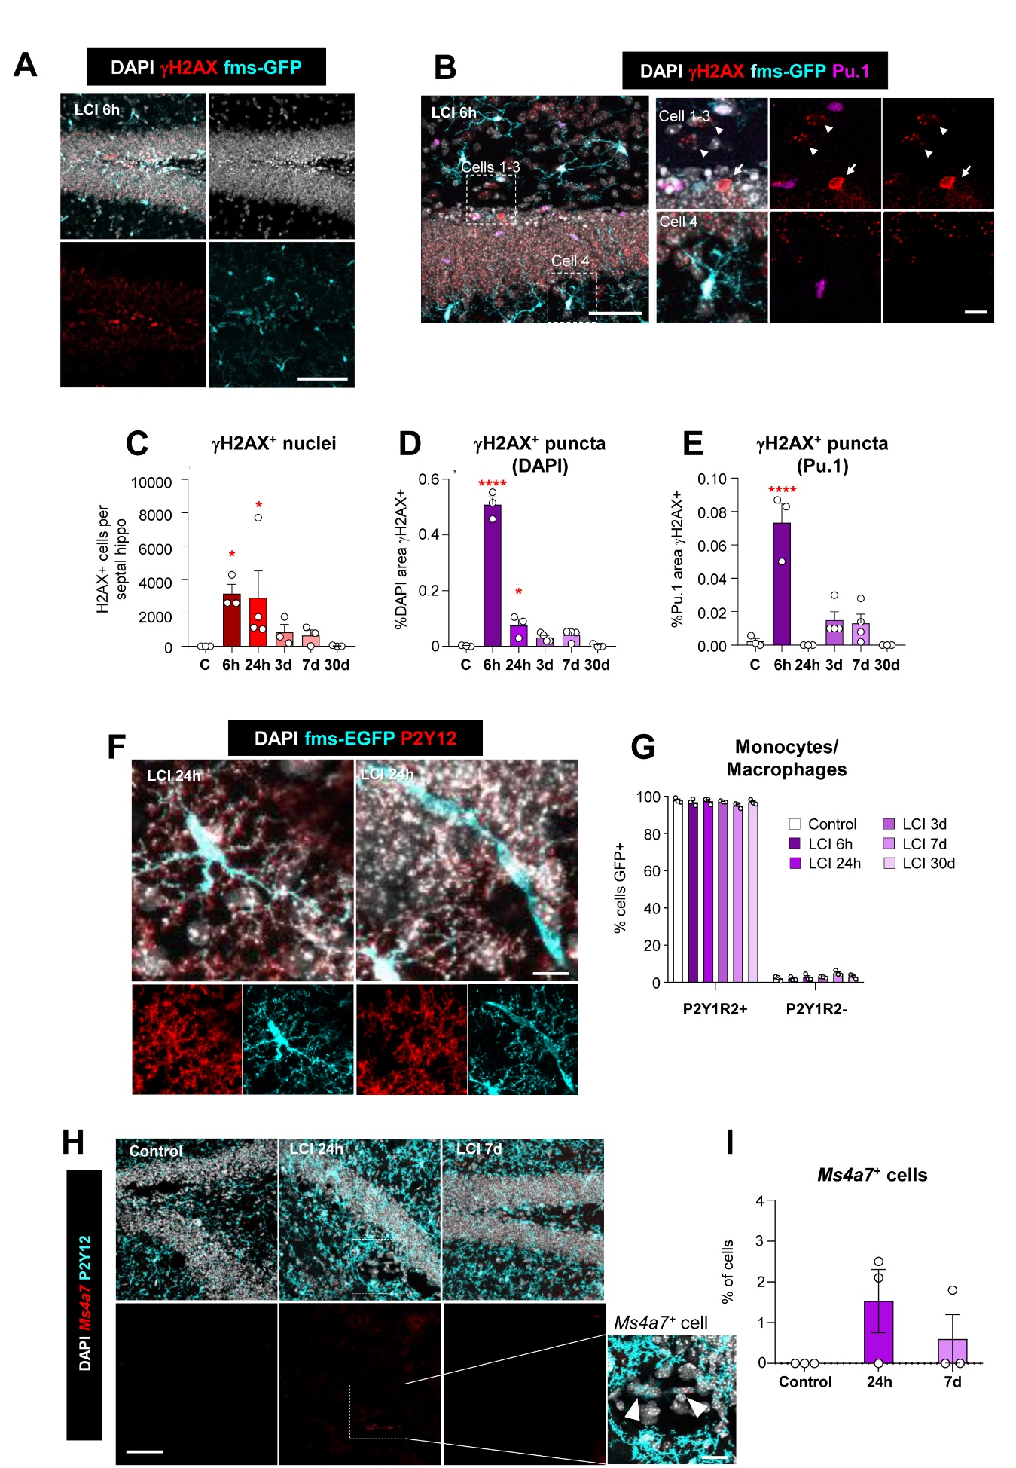
Supp. Figure 1. LCI results in minimal DNA damage in microglia and monocyte infiltration.
(A) Representative confocal images of double-strand breaks labeled with γH2AX at 6h after LCI showing DAPI (white), γH2AX (red) and fms-EGFP (cyan) staining 6h after LCI.
(B) Representative images of a γH2AX⁺ nucleus (red) indicated with a white arrow and other nuclei labeled with γH2AX puncta indicated by white arrowheads (cells 1-3). A microglial nucleus labeled with DAPI (white), Pu.1 (magenta), and fms-EGFP (cyan) not expressing γH2AX is shown (cell 4).
(C) Number of γH2AX⁺ nuclei in the DG per septal hippocampus.
(D) Percentage of nuclear volume (DAPI) occupied by γH2AX⁺ puncta.
(E) Percentage of microglial nuclear volume (Pu.1) occupied by γH2AX⁺ puncta.
(F) Representative confocal images of microglia and monocytes/macrophages at 24h after LCI. Microglia are labeled with both P2Y12 (red) and fms-EGFP (cyan), while monocytes/macrophages only express fms-EGFP (cyan). DAPI (white) staining shows nuclei. The elongated, smooth-surfaced fms-EGFP⁺, P2Y12- cell is likely a perivascular macrophage.
(G) Percentage of fms-EGFP⁺ cells identified as microglia (P2Y12⁺) and monocyte/macrophages (P2Y12⁻)
(H) Representative images of the monocytes/macrophage gene Ms4a7 by RNAScope, showing DAPI (white), Ms4a7 mRNA (red) and P2Y12 (cyan) staining in the DG 24h and 7d after LCI. The white dotted rectangle shows in higher magnification two Ms4a7+ cells (white arrowheads) that are not microglia (P2Y12⁻)
(I) Percentage of Ms4a7⁺ cells in the DG 24h and 7d after LCI.

Bars show mean ± SEM of n=3-4 mice. Data was analyzed by one-way ANOVA followed by Holm-Sidak post hoc tests when appropriate. When homoscedasticity was not accomplished a Kruskal-Wallis test was performed [C]. Asterisks represent significance between control and LCI (6h, 24h, 3d, 7d, 30d). * represents p<0.05, *** represents p<0.001.
Scale bars= 100μm [A, B, H], 10μm (inserts in [B]); 10μm [F]. z=16.8μm [A]; z=26.6μm, z=0.7μm [B]; z= 17.5μm [F]; z=16.45μm, z=17.5, μm z=8.75μm [D]; [H, left to right];

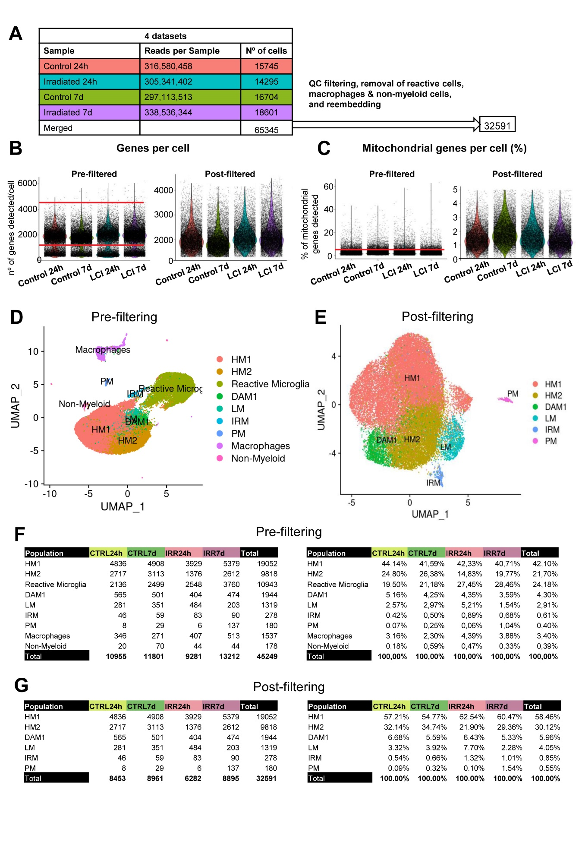Supp. Figure 2. Single-cell RNA-seq processing of microglia after LCI.
(A) Summary table showing the total number of sequenced cells per condition and the final cell count following quality control filtering and microglia subset selection
(B) Violin plots depicting the distribution of genes counts detected per cell before (left) and after (right) quality control filtering. Red lines denote the filtering.
(C) Violin plots illustrating the percentage of mitochondrial genes detected per cell before (left) and after (right) quality control filtering. Red lines indicate the filtering thresholds.
(D) UMAP visualization of the supervised clustering annotation, based on the 30 most significant principal components (PCs) derived from Principal Component Analysis (PCA).
(E) UMAP representation of selected clusters, excluding non-myeloid cells, macrophages, and ex vivo reactive microglia.
(F) Summary tables reporting the number (left) and percentage (right) of cells detected per population and treatment condition shown in D.
(G) Summary tables reporting the number (left) and percentage (right) of cells detected per microglia subpopulation and treatment condition shown in E.

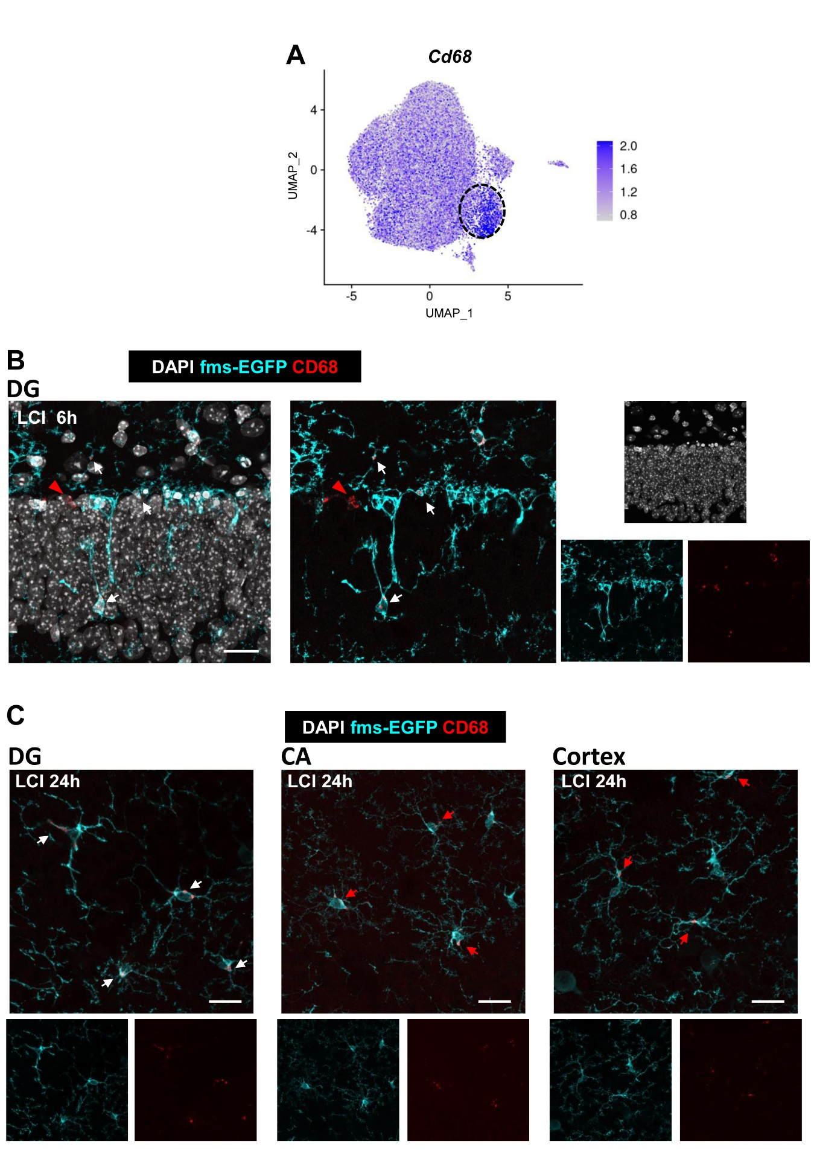Supp. Figure 3. CD68 is not a specific marker of post-phagocytic microglia.
(A) UMAP showing Cd68 gene expression after LCI. The LM cluster is highlighted by a dotted black circle.
(B) Representative confocal image of CD68⁺ puncta in phagocytic microglia (white arrows) and non-microglial cells (red arrowhead) 6h after LCI, showing DAPI (white), CD68 (red), and fms-EGFP (cyan).
(C) Representative confocal images of CD68⁺ post-phagocytic microglia from the DG (white arrows) and non-phagocytic microglia (red arrows) from the CA and the cortex 24h after LCI, showing DAPI (white), CD68 (red), and fms-EGFP (cyan).

Scale bars= 20μm [B, C]. z=16.8μm [B]; z=11.2μm, z=16.8μm, z=19.6μm [C, left to right].

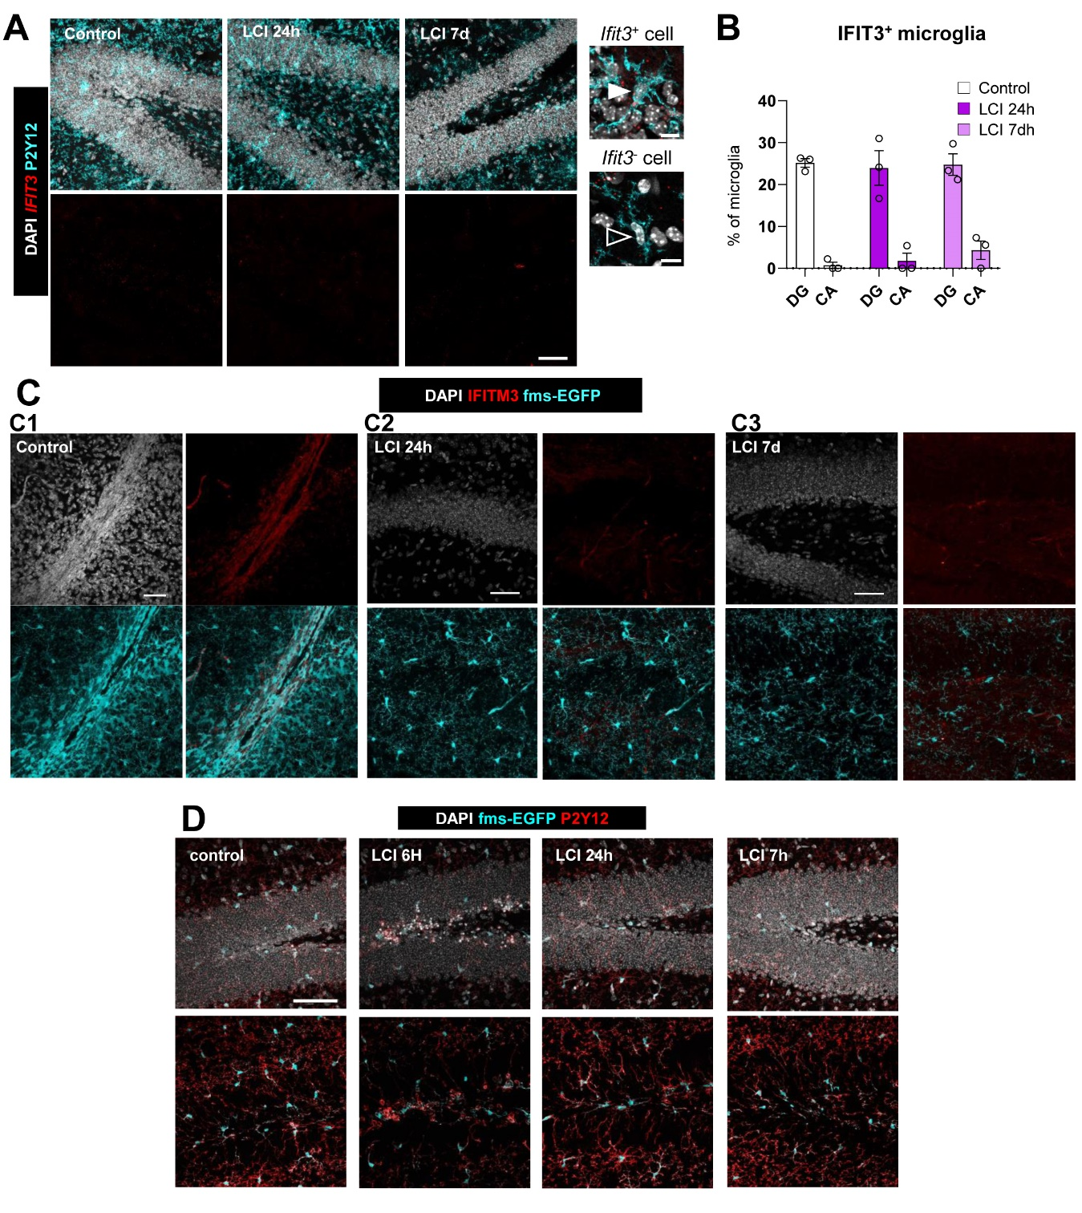Supp. Figure 4. The IRM cluster does not contain post-phagocytic microglia
(A) Representative confocal images of the IRM signature gene Ifit3 by RNAScope, showing DAPI (white), Ifit3 mRNA (red) and P2Y12 (cyan) staining in the DG 24h and 7d after LCI. The white arrowhead points to an Ifit ⁺ microglia, and the black arrowhead to an Ifit3 ⁻ microglia.
(B) Analysis of the percentage of Ifit3 ⁺ microglia in the DG and CA 24h and 7d after LCI.
(C) Representative images of the IRM signature protein IFITM3 showing DAPI (white), IFITM3 (red) and P2Y12 (cyan) staining at 24h and 7d after LCI. The control image shows a large blood vessel labeled with IFITM3, whereas no staining was detected in microglia from the DG 24h and 7d after LCI.
(D) Representative confocal images of P2Y12 expression in the DG after LCI, showing DAPI (white), P2Y12 (red) and fms-EGFP (cyan) staining.

Bars show mean ± SEM of n=3 mice. Data was analyzed by one-way ANOVA followed by Holm-Sidak post hoc tests when appropriate.
Scale bars=50μm [A,C, D], 10μm (inserts in [A,D]); z=12.25μm, z=11.2μm, z=10.15μm [A]; z=32.9μm [C1], z=27.3μm [C2], z=24.5μm [C3]; z=16.1μm, z=18.9μm, z=20.3μm, z=12.6μm [D, left to right].

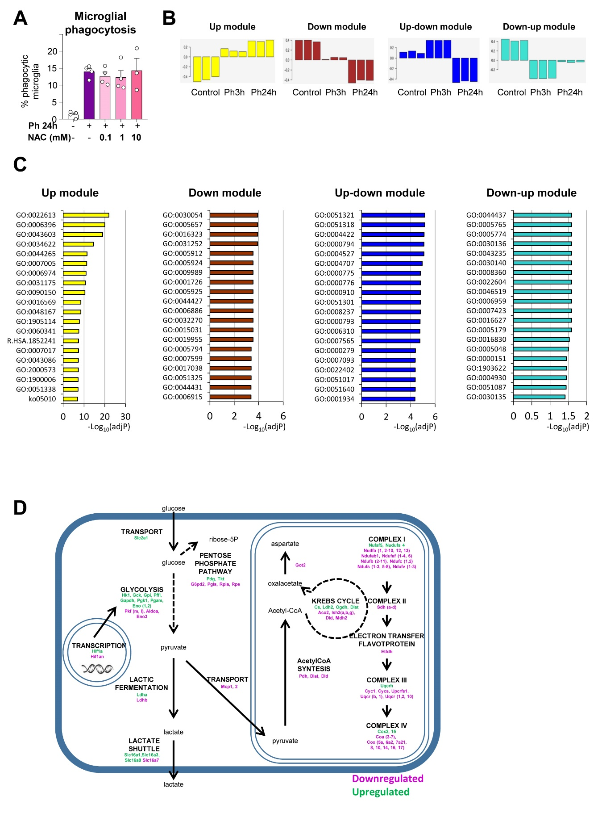Sup Fig. 5. Functional analysis of phagocytic microglia by WGCNA and IPA analysis.
(A) Percentage of phagocytic microglia after phagocytosis in vitro (24h) and pre-treatment with the antioxidant N-Acetylcysteine (NAC).
(B) Modules obtained by WGCNA analysis of gene arrays comparing primary cultures of naïve and phagocytic microglia at 3h and 24h.
(C) IPA analysis showing the top 20 significantly changed GO terms associated with each module. Up module (yellow): GO:0022613, ribonucleoprotein complex biogenesis; GO:0006396, RNA processing; GO:0043603, cellular amide metabolic process; GO:0034622, cellular macromolecular complex assembly; GO:0044265, cellular macromolecule catabolic process; GO:0007005, mitochondrion organization; GO:0006974, cellular response to DNA damage stimulus; GO:0031175, neuron projection development; GO:0090150, establishment of protein localization to membrane; GO:0016569, covalent chromatin modification; GO:0048167, regulation of synaptic plasticity; GO:1905114, cell surface receptor signaling pathway involved in cell-cell signaling; GO:0060341, regulation of cellular localization; R.HSA.1852241, organelle biogenesis and maintenance; GO:0007017, microtubule-based process; GO:0043086, negative regulation of catalytic activity; GO:2000573, positive regulation of DNA biosynthetic process; GO:1900006, positive regulation of dendrite development; GO:0051338, regulation of transferase activity; ko05010, Alzheimer's disease. Down module (brown): GO:0030054, cell junction; GO:0005657, replication fork; GO:0016323, basolateral plasma membrane; GO:0031252, leading edge; GO:0005912, adherens junction; GO:0005924, cell substrate adherens junction; GO:0009989, cell matrix junction; GO:0001726, ruffle; GO:0005925, focal adhesion; GO:0044427, chromosomal part; GO:0006886, intracellular protein transport; GO:0032270, positive regulation of cellular protein metabolic process; GO:0015031, protein transport; GO:0019955, cytokine binding; GO:0005794, Golgi apparatus; GO:0007599, hemostasis; GO:0017038, protein import; GO:0051325, interphase; GO:0044431, golgi apparatus part; GO:0006915, apoptotic program. Up-Down (blue) module: GO:0051321, meiotic cell cycle; GO:0051318, G1 phase; GO:0004422, metalloendopeptidase activity; GO:0000794, condensed nuclear chromosome; GO:0004527, exonuclease activity; GO:0004707, MAP kinase activity; GO:0000775, chromosome centromeric region; GO:0000776, kinetochore; GO:0000910, cytokinesis; GO:0051301, cell division; GO:0008237, metallopeptidase activity; GO:0000793, condensed chromosome; GO:0006310, DNA recombination; GO:0007565, female pregnancy; GO:0000279, M phase; GO:0007093, mitotic cell cycle checkpoint; GO:0022402, cell cycle process; GO:0051017, actin filament bundle formation; GO:0051640, organelle localization; GO:0001934, positive regulation of protein amino acid phosphorylation. Down-Up module (turquoise): GO:0044437, vacuolar part; GO:0005765, lysosomal membrane; GO:0005774, vacuolar membrane; GO:0030136, clathrin coated vesicle; GO:0043235, receptor complex; GO:0030140, trans Golgi network transport vesicle; GO:0008360, regulation of cell shape; GO:0022604, regulation of cell morphogenesis; GO:0046519, sphingoid metabolic process; GO:0006959, humoral immune response; GO:0007423, sensory organ development; GO:0016627, oxidoreductase activity acting on the ch-ch group of donors; GO:0005179, hormone activity; GO:0016830, carbon carbon lyase activity; GO:0005048, signal sequence binding; GO:0000151, ubiquitin ligase complex; GO:1903622, transcription from RNA polymerase III promoter; GO:0004930, G protein coupled receptor activity; GO:0051087, chaperone binding; GO:0030135, coated vesicle.
[D] Cartoon representing genes codifying for metabolic enzymes upregulated (green) and downregulated (magenta) 24h after phagocytosis in microglia. Raw data was published in ¹⁰.
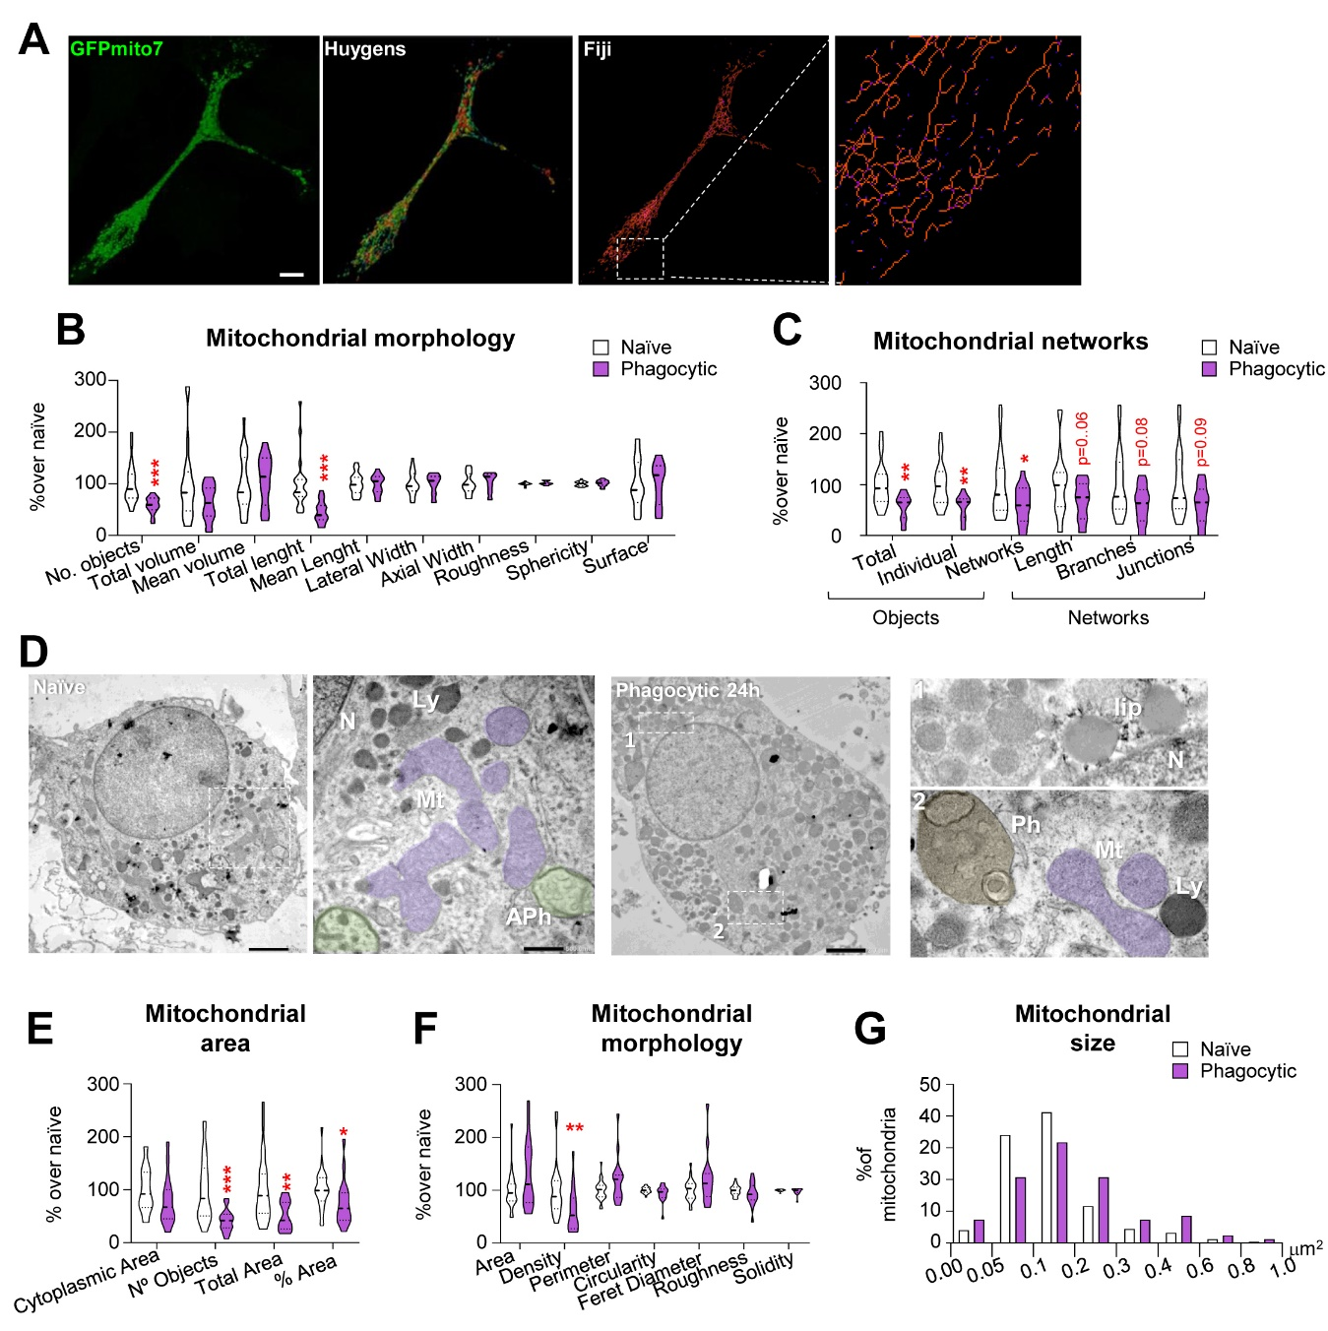Supp. Figure 6. Phagocytosis remodels the microglial mitochondrial network
(A) Comparison of the methods used to assess mitochondria morphology in naïve and phagocytic BV2 microglia using confocal images Mitochondria were labelled with GFPmito7 (green) and mitochondrial morphology and networks were assessed by Huygens and Fiji, respectively.
(B) Analysis of mitochondrial morphology by Huygens showing the percentage of different mitochondrial parameters in BV2 naïve and phagocytic microglia.
(B) Analysis of mitochondrial networks by Fiji showing the percentage of different mitochondrial parameters in BV2 naïve and phagocytic microglia.
(D) Representative TEM images of primary naïve and phagocytic microglia showing mitochondria (pink,Mt) and other organelles, such as lysosomes (dark,Ly). In control cells, abundant primary and secondary autophagosmes (purple and blue, respectively; APh) were found, whereas in phagocytic cells several degradative organelles such as multilamelated bodies (green,MLB) were found. Lipidic content (lip) and phagosomes (Ph) were also found in phagocytic cells.
(E) TEM analysis of mitochondrial object number and area per microglial cytoplasmic area in microglial cytoplasm in primary naïve and phagocytic microglia.
(F) TEM analysis of mitochondrial morphology in primary naïve and phagocytic microglia.
(G) Histogram of mitochondrial objects according to their size (% of mitochondria) in primary naïve and phagocytic microglia.

Data shows the information of n=3 independent experiments. Violin plots show the data distribution including extreme values; lower and upper hinges correspond to the third quartile respectively. Data was analyzed by Student’s t-test. Some data [B,C,E,F] were log-transformed to comply with homoscedasticity and/or normality. * indicates p <0.05, ** indicates p <0.01, *** indicates p <0.001.
Scale bars= 10μm [A], 2m for whole cell images and 0.5μm for details [D]. z=7.64μm [A].

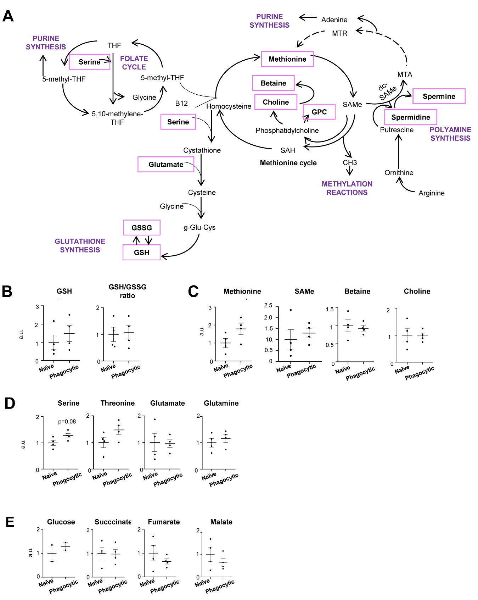Supp Fig. 7. Phagocytosis alters the synthesis pathways of polyamines and glutathione in microglia.
(A) Graphical cartoon of the analyzed metabolites (purple) by mass spectrometry and the metabolic pathways in which they are involved.
(B) Relative production of GSH in arbitrary units (a.u.) and GSH/GSSG ratio in naïve and phagocytic microglia.
(C) Relative production of methionine, SAMe, betaine and choline in arbitrary units (a.u.) in naïve and phagocytic microglia.
(D) Relative production of serine, threonine, glutamate and glutamine in arbitrary units (a.u.) in naïve and phagocytic microglia.
(E) Relative production of glucose, succinate, fumarate, and malate in arbitrary units (a.u.) in naïve and phagocytic microglia.

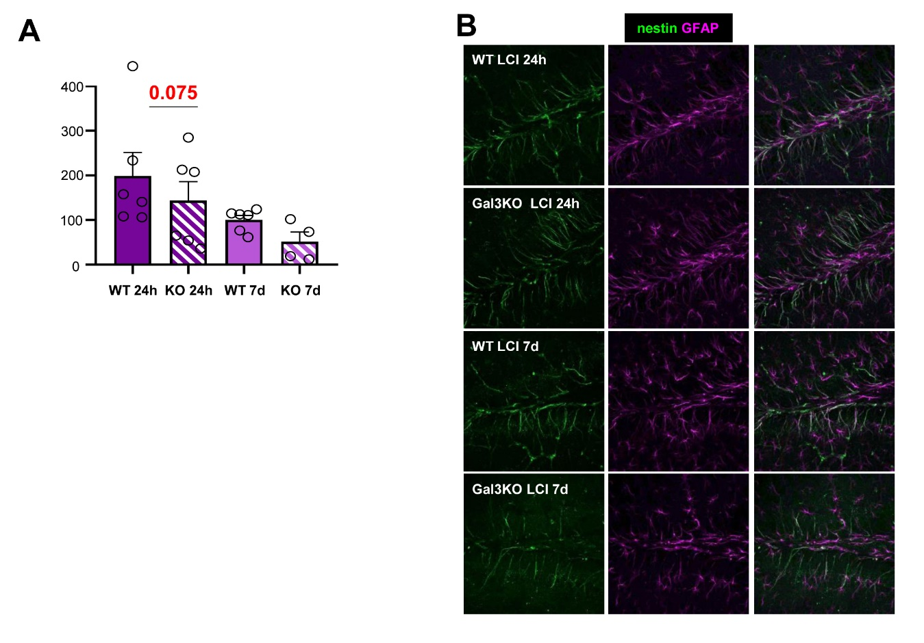Supp. Fig. 8. Galectin 3 deficient mice fail to recover the neurogenic niche after LCI
(A) Relative density of mature (CD, EF) neuroblasts in the DG per septal hippocampus.
(B) Representative image of the hippocampus showing DAPI (white), the proliferation marker Ki67 (red), and the radial processes of the rNPCs labeled with both nestin (green) and GFAP (magenta).
Bars show the mean ± SEM of n=4-6 mice. Neuroblasts were analyzed as relative densities (compared to the WT group 7 days after LCI) because this experiment was analyzed in 2 independent batches of animals, each comprising the four experimental groups.
Data was analyzed by one-way ANOVA.
Scale bars=100μm. z=16.8, 20.3, 16.8, 16.8 μm (top to bottom).

