Supplementary Material

Table. 1 Full detail on cell lines used in experiment are provided.
Name | Company | Type
BV-2 | Cobioer Biological Technology Company | Mouse microglia
NSC34 | Wuhan Fine Biotech Co., Ltd | Mouse neuron
HT-22 | Procell Life Science&Technology Co., Ltd | Mouse neuron

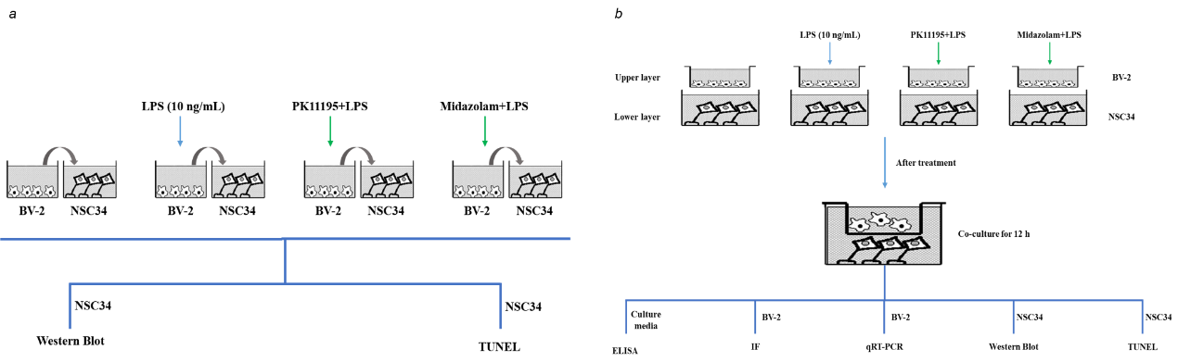
Fig 1.BV-2-NSC34 co-culture system. (a) BV-2 conditioned medium. (b) BV-2-NSC34 Transwell co-culture system.

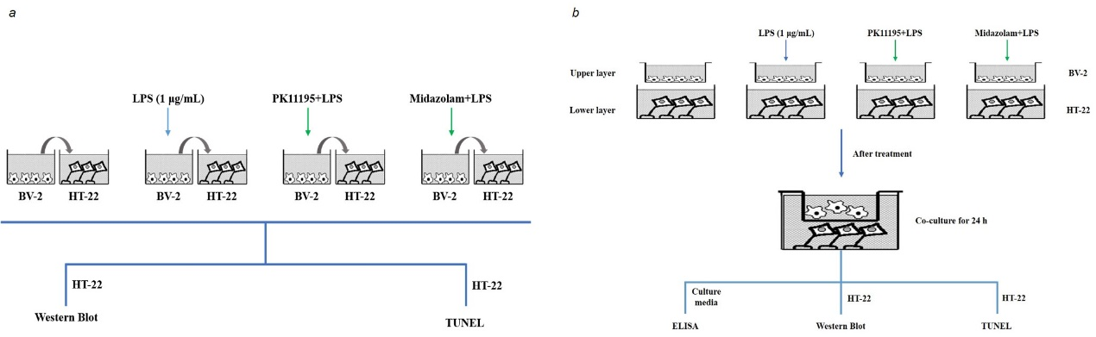

Fig 2. BV-2-HT-22 co-culture system. (a) BV-2 conditioned medium. (b) BV-2-HT-22 Transwell co-culture system.

Table. 2 Full detail on primary antibodies used in Western blot are provided.
Antibody | Company | Catalogue number | Source | Dilution
β-actin | Beyotime | AA128 | Mouse | 1:1000
PBR | Abcam | ab109497 | Rabbit | 1:10000
ATG7 | Abcam | ab133528 | Rabbit | 1:10000
ATG5 | Abcam | ab108327 | Rabbit | 1:2000
LC3B | Abcam | ab192890 | Rabbit | 1:2000
p62 | Abcam | ab109012 | Rabbit | 1:10000
NLRP3  Cleaved caspase 1  Bcl2  Bax  Cleaved caspase 3 | Abcam  Affinity  Affinity  Affinity  Affinity | ab263899  AF4022  AF6139  AF0120  AF7022 | Rabbit  Rabbit  Rabbit  Rabbit  Rabbit | 1:1000  1:1000  1:1000  1:1000  1:1000

Table. 3 Primer sequences for qRT-PCR
Gene | Forward（5’-3’） | Reverse (3’-5’)
β-actin | CTAAGGCCAACCGTGAAAAG | ACCAGAGGCATACAGGGACA
TSPO | GCTGTGGATCTTTCCAGAACA | ATGCCAAGAGGGTTTCTGC
ATG7 | ATGCCAGGACACCCTGTGAACTTC | ACATCATTGCAGAAGTAGCAGCCA
LC3B | GAAGACCTTCAAACAGCGCC | CTTGGTCTTGTCCAGGACGG
p62 | ATGGACATGGGGAGCTICAA | GTGCTCTCTGTATGCTCCCT
NLRP3 | CCTGGGGGACTTTGGAATCAG | GATCCTGACAACACGCGGA
IL-1β  IL-18 | GCCCATCCTCTGTGACTCAT  GCCTGTGTTCGAGGATATGACT | AGGCCACAGGTATTTTGTCG  CCTTCACAGAGAGGGTCACAG

Table. 4 Full detail on primary antibodies used in Immunofluorescence are provided.
Antibody | Company | Catalogue number | Source | Dilution
PBR | Abcam | ab109497 | Rabbit | 1:1000
ATG7 | Abcam | ab133528 | Rabbit | 1:1000
LC3B | Abcam | ab192890 | Rabbit | 1:1000
p62 | Abcam | ab109012 | Rabbit | 1:1000
NLRP3  Cleaved caspase 1 | Abcam  Affinity | ab263899  AF4022 | Rabbit  Rabbit | 1:200  1:200

