Facet-Modulated Ferroelectric Polymers
Bo Cai^{1,2}, Zhi-Ling Hou³, Yuan-Yuan Qi^{1,2}, Pei-Yan Zhao^{1,2}, Hua-Long Peng^{1,2}, Yu Zhang^{1,2}, Martin C. Koo^{1,2}, Tongcai Yue⁵, Pengfei Hu^{4*}, Li-Min Liu^{5*} and Guang-Sheng Wang^{1,2*}
¹ School of Chemistry, Beihang University, Beijing 100191, China
² State Key Laboratory of Bioinspired Interfacial Materials Science, Bioinspired Science Innovation Center, Hangzhou International Innovation Institute, Beihang University, Hangzhou 311115, China
³ School of Physics and Optoelectronic Engineering, Beijing University of Technology, Beijing, 100124, China
⁴ Research Institute of Aero-Engine, Beihang University, Beijing 100191, China
⁵ School of Physics, Beihang University, Beijing 100191, China
Email: wanggsh@buaa.edu.cn, hupengfei@buaa.edu.cn, liminliu@buaa.edu.cn

This PDF file includes:
Supplementary Figures 1-35;
Supplementary Table S1, S2;
References 54-60

Electromagnetic Wave Loss Measurement
The relaxation time τ
According to Debye relaxation theory, the relaxation time can be derived from the following equation¹¹:
$τ=\frac{1}{2πf_{max}}$ (1)
Where $f_{max}$ is the frequency at which the dielectric loss peak occurs.
0.05MHz-100 MHz range
The capacitance (C_{p}) and loss angle tangent (D) values were measured in the 0.05 MHz-100 MHz range with contact electrode method by Impedance Analyzer (Agilent 4294A, America).
The complex permittivity and dissipation factor: The complex permittivity can be calculated by the following formula¹¹:
$ε^{'}=\frac{t_{a}×C_{p}}{S×ε_{0}}$ (2)
$ε^{″}=ε^{'}×D$ (3)
The dissipation factor can be calculated by the following formula:
$D_{t}=D$ (4)
Where $ε^{'}$ is the real part of the complex permittivity, $ε^{″}$ is the imaginary part of the complex permittivity, $t_{a}$ refers to the thickness of the simples, S presents the area of electrodes, $ε_{0}$ is the vacuum permittivity (8.85×10⁻¹² F·m⁻¹), $D_{t}$ is the dissipation factor.
2-18 GHz range
The complex permittivity and permeability values were measured in the 2-18 GHz range with the coaxial wire method by Vector Network Analyzer (VNA, ZNA43, ROHDE&SCHWARZ, Germany).
Reflection Loss calculations: Reflection Loss is an important index to evaluate the EMWA properties. According to the transmission line theory, the RL value can be calculated by the following formula⁵⁴:
$Z_{in}=\sqrt{\frac{μ_{r}}{ε_{r}}}\text{tanh}\left|j\left(\frac{2πfd}{c}\right)\sqrt{μ_{r}ε_{r}}\right|$ (5)
$RL=\text{20log}\left|\frac{Z_{in}\text{-1}}{Z_{in}+\text{1}}\right|$ (6)
Where ε_{r} is the complex permittivity, μ_{r} is the complex permeability, d refers to the thickness of the coating, f presents the frequency of the electromagnetic wave, c is the velocity of light in free space (3×10⁸ m·s⁻¹), Z_{in} is the normalized input impedance, respectively.
Polarization loss and conduction loss: The Polarization loss and conduction loss value can be calculated by the following formula⁵⁵:
$ε_{p}^{″}={(ε}_{s}\text{-}ε_{∞})\frac{2πfτ}{1+{(2πf)}^{2}τ^{2}}$ (7)
$ε_{c}^{″}=\frac{σ}{2πfε_{0}}$ (8)
$ε^{″}=ε_{c}^{″}+ε_{p}^{″}$ (9)
Where the $ε_{s}$, $ε_{∞}$, $σ$, $τ$ are the static permittivity, the relative permittivity at high frequency limit, the electric conductivity, the relaxation time, respectively.
dielectric loss tangent: tanδ is a core parameter for quantifying the dielectric loss capability of materials, whose definition and physical significance are as follows:
$tanδ=\frac{ε^{″}}{ε^{'}}$ (10)
Where $ε^{'}$ is the real part of the complex permittivity, $ε^{"}$ is the imaginary part of the complex permittivity.
Impedance matching calculations: is used to study the impedance matching characteristics, which can be calculated by the following formula⁵⁶:
$M_{Z}=\frac{2Z_{in}^{'}}{{\left|Z_{in}\right|}^{2}+1}$ (11)
Where represents the real normalized input impedance, when , the ideal impedance matching will be realized, indicating that, under the given conditions, the electromagnetic wave can entrance into the material to the greatest extent possible, which is more conducive to the material's absorption and loss of the electromagnetic wave.
The attenuation constant (α) calculations: The attenuation constant estimates the combined loss capacity of incident electromagnetic waves and represents the EWMA attenuation characteristics of the material, which is determined by the following formula⁵⁷:
$α=\frac{\sqrt{2}}{c}πf\sqrt{\left(μ^{"}ε^{"}-μ^{'}ε^{'}\right)+\sqrt{{\left(μ^{"}ε^{"}-μ^{'}ε^{'}\right)}^{2}+{\left(μ^{'}ε^{"}+μ^{"}ε^{'}\right)}^{2}}}$ (12)
0.2-2.0 THz range
Transmission properties were investigated by a terahertz time-domain spectrometer system (TPF 15K, Terahertz Photonics, China). In order to exclude the effects of mechanical vibration and air humidity, we performed the terahertz tests on a smooth optical platform in vacuum. All test specimens were precision cut with a cut size of 2 × 2 cm and placed on a specimen holder with a hollow circular hole with a diameter of 12 mm. The effective frequency range is 0.2-2.0 terahertz.
The total THz shielding effectiveness (SE_{T}), the THz transmission (T) coefficients and shielding efficiency ($α_{SE}$): The THz transmission (T) coefficients and SE_{T} are obtained through fast Fourier transform (FFT) calculation by following equations⁵⁸:
$T={\left|S_{21}\right|}^{2}=\frac{{(E_{sam})}^{2}}{{(E_{ref})}^{2}}$ (13)
${SE}_{T}=-10\log_{10}{T}$ (14)
Where the $E_{sam}$, $E_{ref}$ are the signal electric intensity of transmission and corresponding reference, respectively.
The correlation between shielding efficiency ($α_{SE}$) and shielding effectiveness is quantified through as follows:
$α_{SE}=100×\left(1-{10}^{-\frac{SE}{10}}\right)\%$ (15)
The extinction Coefficient (κ), Absorption Coefficient (α_{T}) and the complex permittivity: The extinction Coefficient and Absorption Coefficient are obtained through fast Fourier transform (FFT) calculation by the following equations³⁶:
$n\left(ω\right)=\frac{∆φ\left(ω\right)c}{ωd}+1$ (16)
$∆φ\left(ω\right)=∆φ_{r}\left(ω\right)-∆φ_{s}\left(ω\right)$ (17)
$κ\left(ω\right)=-\frac{c}{ωd}\ln{(\left|T(ω)\right|\frac{{\left[n\left(ω\right)+1\right]}^{2}}{4n\left(ω\right)})}$ (18)
$α_{T}\left(ω\right)=\frac{2ωκ(ω)}{c}$ (19)
Where $d$ is the film thickness, $c$ is the vacuum speed of light,$ω$ is the angular frequency, $∆φ\left(ω\right)$ is the phase difference between the sample signal and reference signal.
The complex dielectric constant of the sample is determined jointly by its refractive index and extinction coefficient:
$ε^{'}\left(ω\right)=n^{2}\left(ω\right)+κ^{2}\left(ω\right)$ (20)
$ε^{″}\left(ω\right)=2n\left(ω\right)κ\left(ω\right)$ (21)

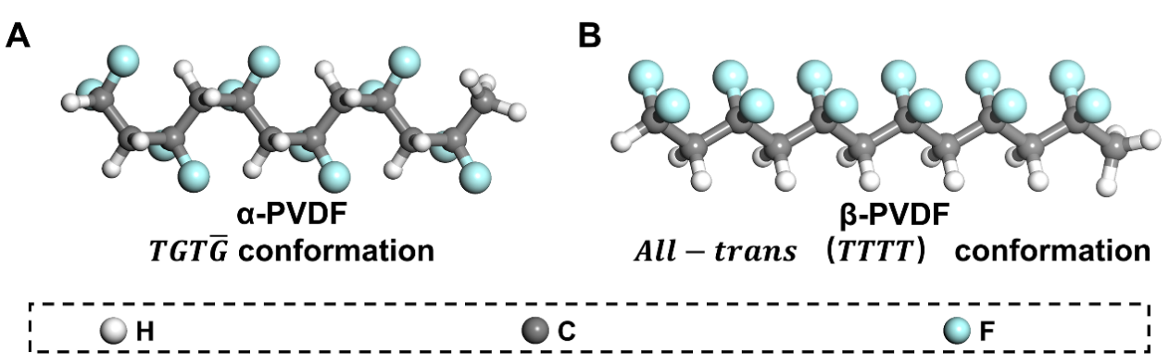
Figure S1. Schematic structure of A, α-phase PVDF, B, β-phase PVDF

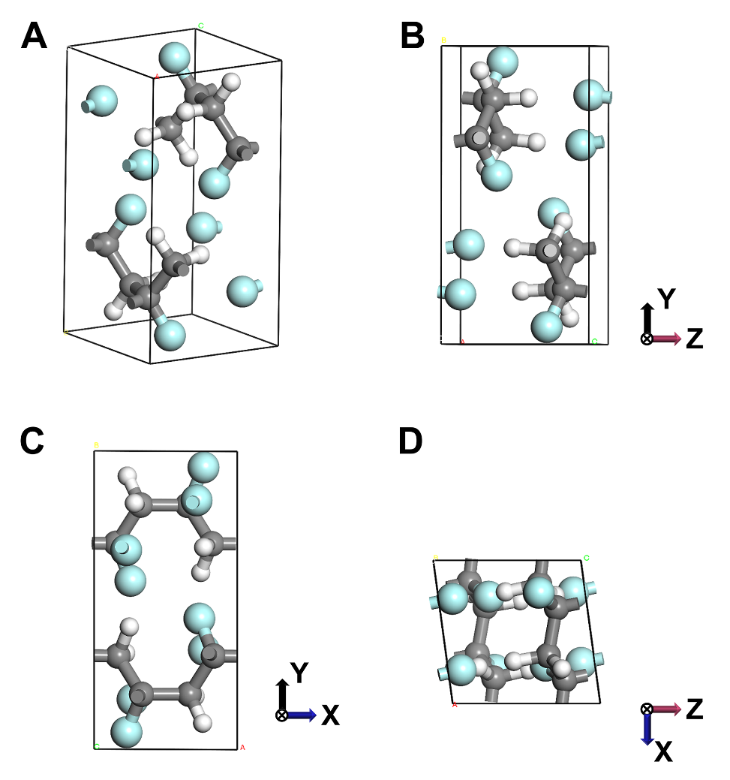
Figure S2. A, Three-dimensional and B-D, three-view diagrams of the cell structure of α-PVDF.

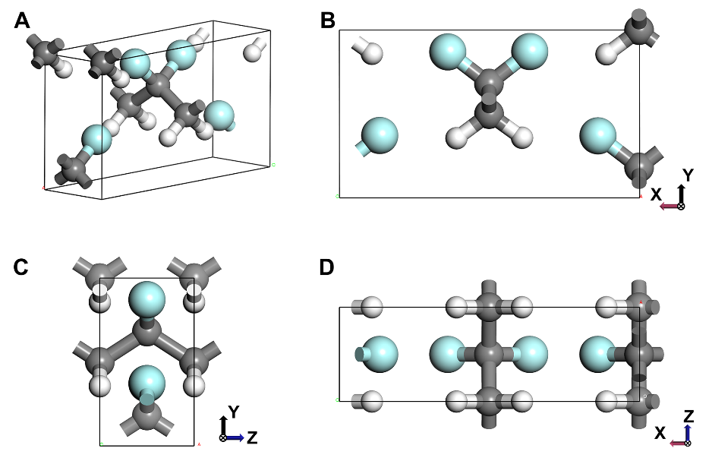
Figure S3. A, Three-dimensional and B-D, three-view diagrams of the cell structure of β-PVDF.

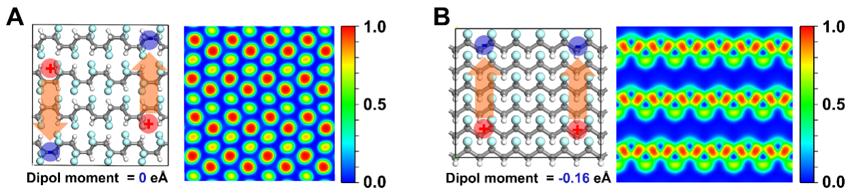
Figure S4. Schematic structure of A, α-phase PVDF and B, β-phase PVDF with electron localization function and dipole moment.

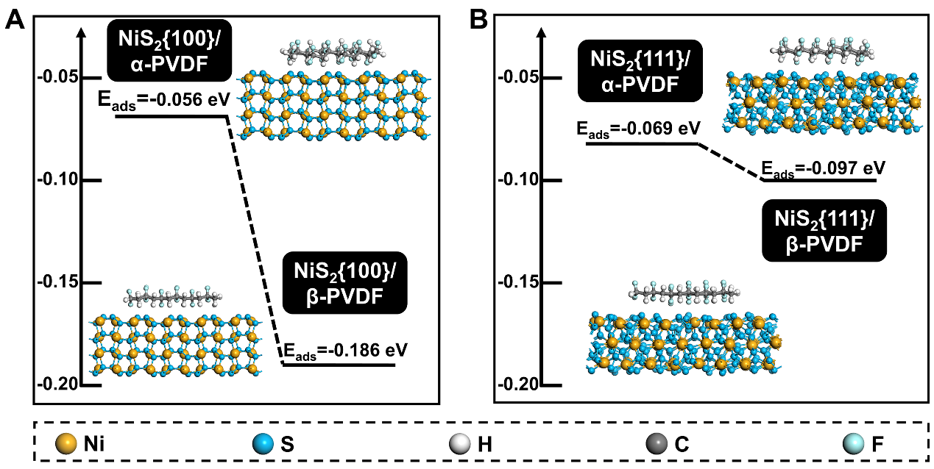
Figure S5. A, Comparison of adsorption energy on NiS₂{100} for different PVDF phases. B, Comparison of adsorption energy on NiS₂{111} for different PVDF phases.

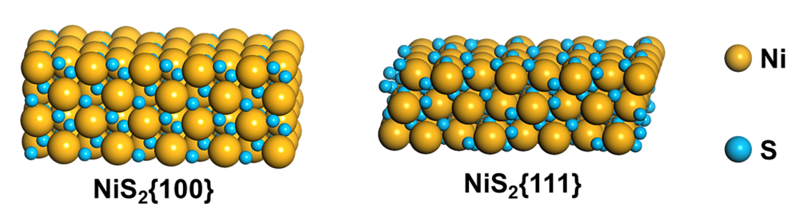
Figure S6. Schematic structure of NiS₂{100} and NiS₂{111}.

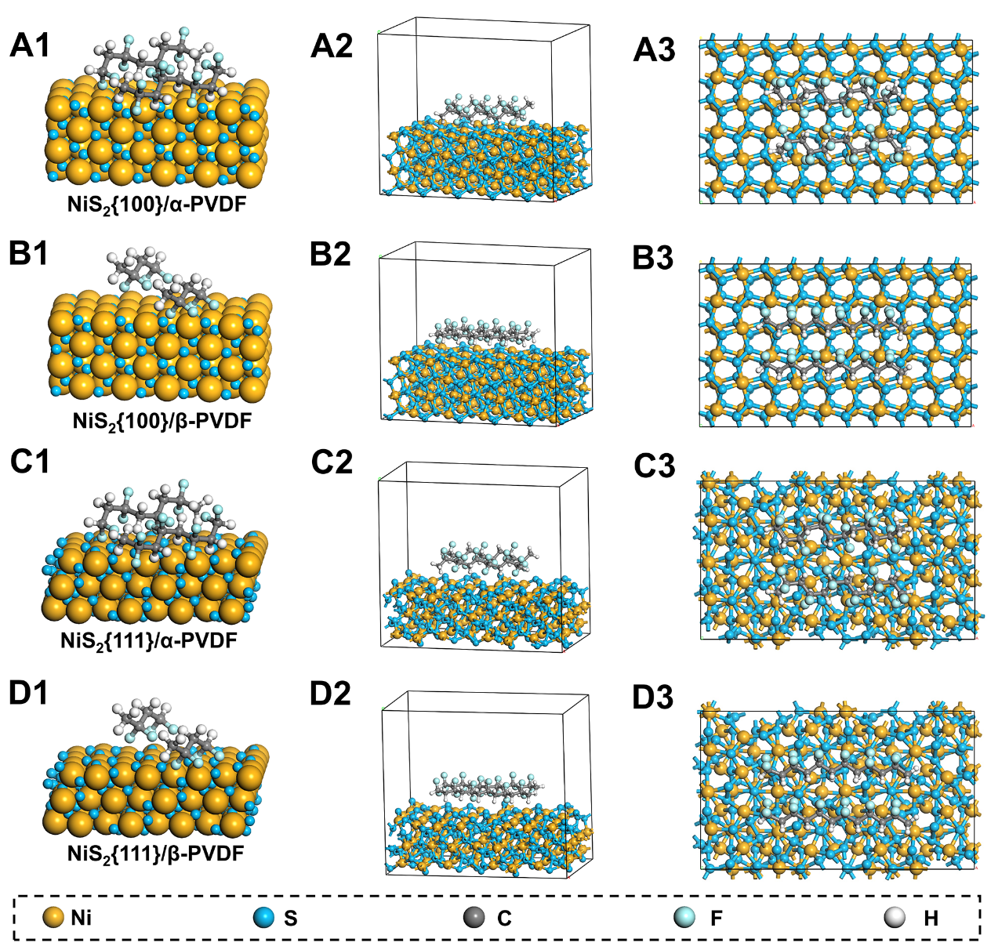
Figure S7. Schematic and optimized structure of A1-A3, NiS₂{100}/α-PVDF, B1-B3, NiS₂{100}/β- PVDF, C1-C3, NiS₂{111}/α-PVDF and D1-D3, NiS₂{111}/β-PVDF.

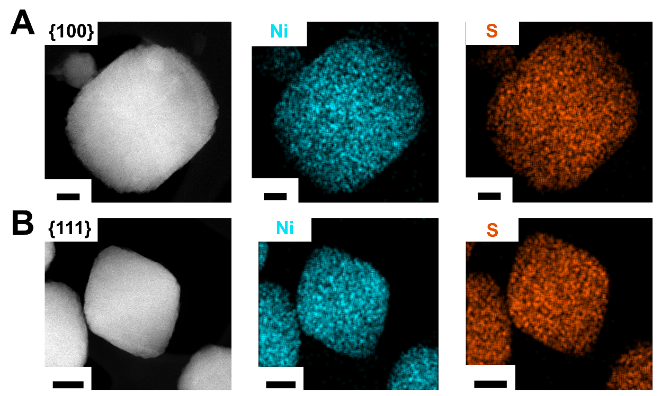
Figure S8. The Energy dispersive x-ray spectrograms (EDS) elemental mapping images of A, NiS₂{100} B, and NiS₂{111}. Scale bars are as follows: 50 nm (A), 100 nm (B).

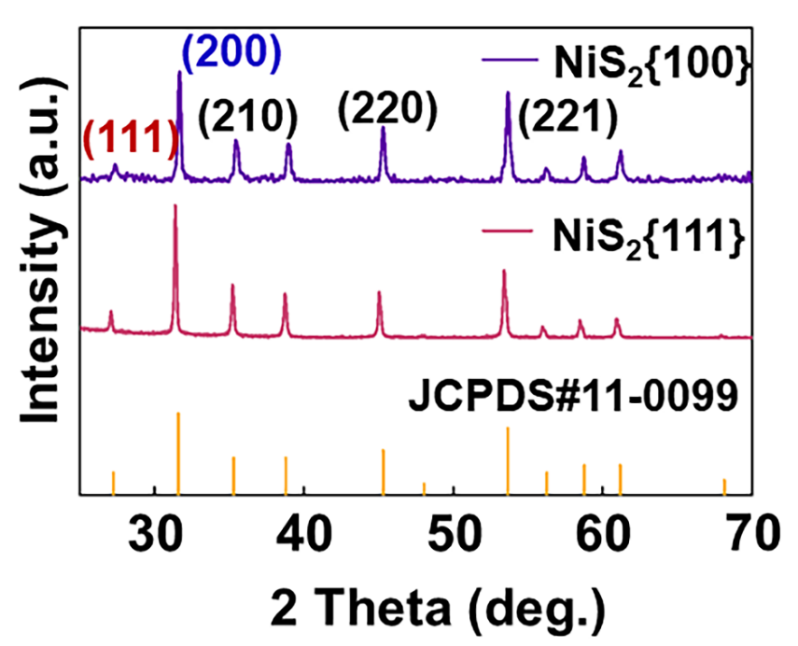
Figure S9. X-ray diffraction spectra of NiS₂.
The XRD spectra shows that distinctive characteristic peaks can be observed on both crystal facets. Comparison with a reference standard spectrum (JCPDS#11-0099) confirms that the phase purity of the sample is good. In particular, NiS₂ (I(111)/ I(200)=0.32) for the {111} facet exhibits a higher diffraction intensity ratio of the (111) to (200) facets compared to NiS₂ (I(111)/ I(200)=0.28) for the {100} facet, suggesting a stronger {111} facet orientation.

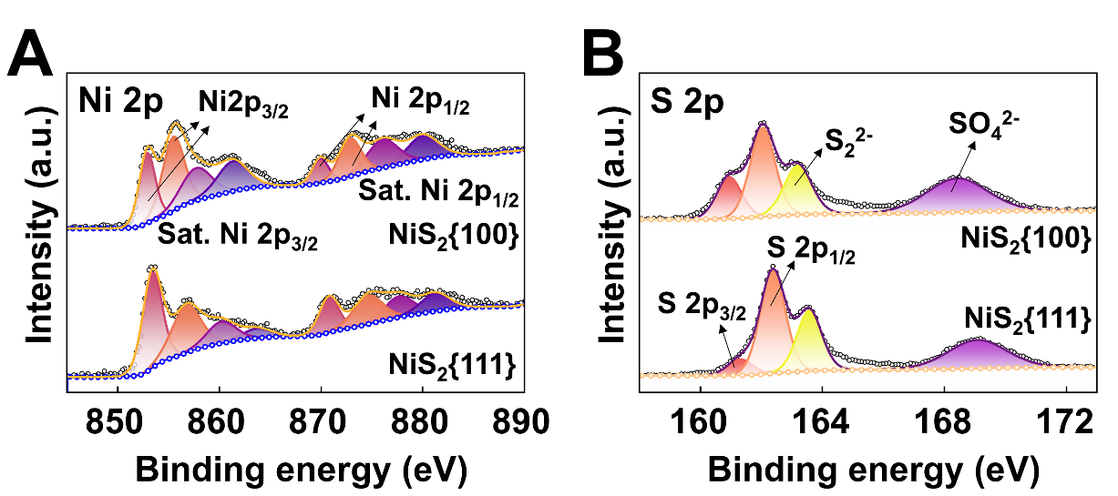
Figure S10. The XPS spectra of elemental A, Ni and B, S.

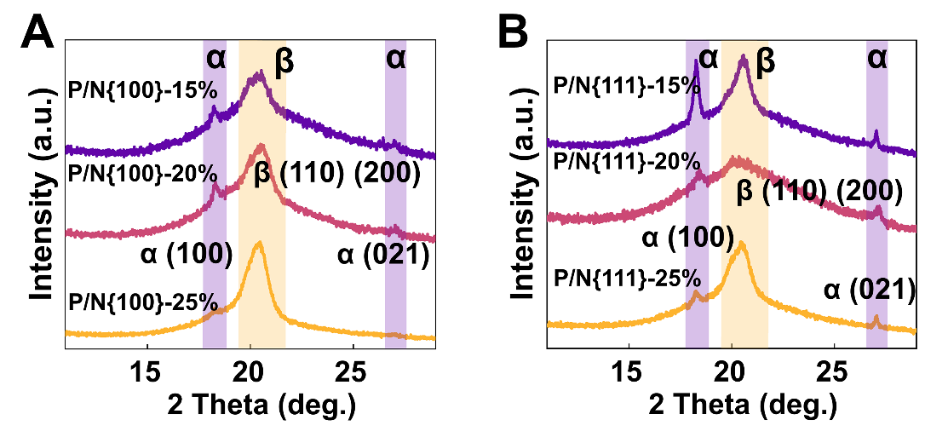
Figure S11. The X-ray diffraction spectra of A, P/N{100} and B, P/N{111}.

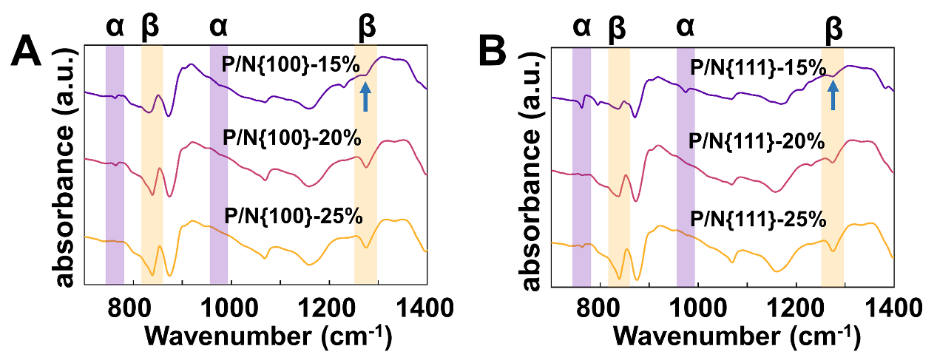
Figure S12. The FTIR absorption of A, P/N{100} and B, P/N{111}.

The α phase of PVDF is most easily detected by FTIR absorption as it presents a large number of characteristic bands, such as the absorption bands at 766, 855 and 976 cm⁻¹. The IR absorption at the range of 840 cm⁻¹ versus 1280 cm⁻¹ applies only to the β-phase. The FTIR results are also commonly used to quantify the β-phase content of PVDF, the β-phase content can be calculated by the Beer-Lambert law²³:
$F\left(β\right)=\frac{A_{β}}{\left(\frac{K_{β}}{K_{α}}\right)A_{α}+A_{β}}=\frac{A_{β}}{1.26A_{α}+A_{β}}$ (22)
where $A_{α}$ and $A_{β}$ are absorbance at wavenumber 766 and 841 cm⁻¹; $K_{α}$ and $K_{β}$ represent the absorption coefficients at corresponding wave numbers of each crystal phase, which are 6.1×10⁴ and 7.7×10⁴ cm²∙mol⁻¹, respectively. The results reveal that the β-phase content in P/N{100} composites increases with higher NiS₂ loading, reaching 49.62% at 15 wt.%, 60.67% at 20 wt.%, and 63.66% at 25 wt.%. In comparison, the P/N{111} composites exhibit slightly lower β-phase levels, with values of 47.16% at 15 wt.%, 54.06% at 20 wt.%, and 60.28% at 25 wt.%. These findings underscore the influence of crystal facets on the phase transition behavior of PVDF, with the {100} facet demonstrating a more pronounced enhancement of the β-phase compared to the {111} facet. This trend highlights the importance of facet engineering in optimizing the electroactive properties of PVDF-based composites.

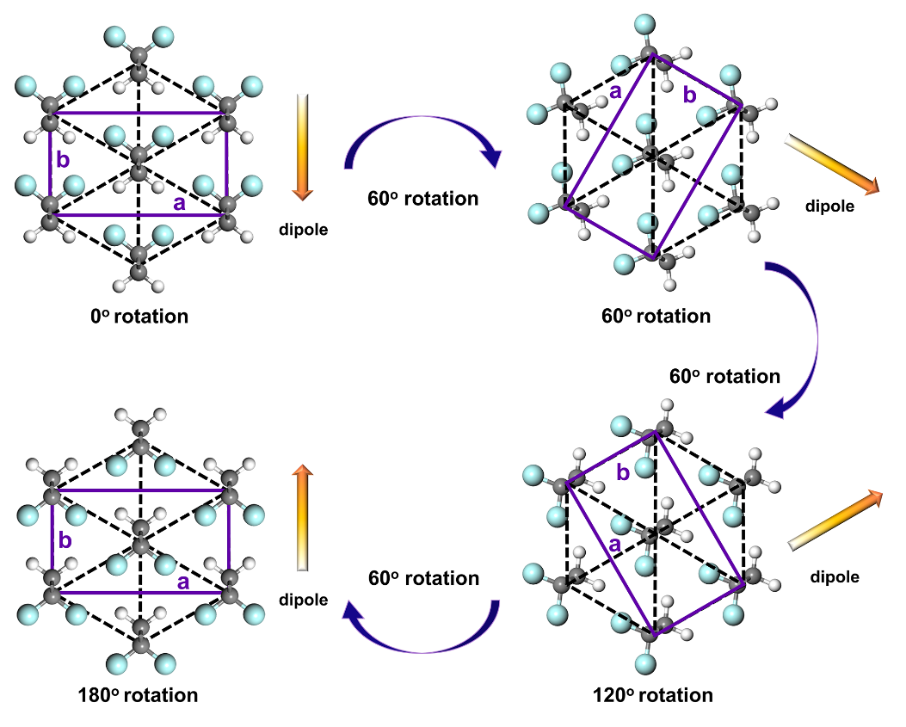
Figure S13. Schematic of dipole changes in the ferroelectric domain switching in PVDF ferroelectric phase.

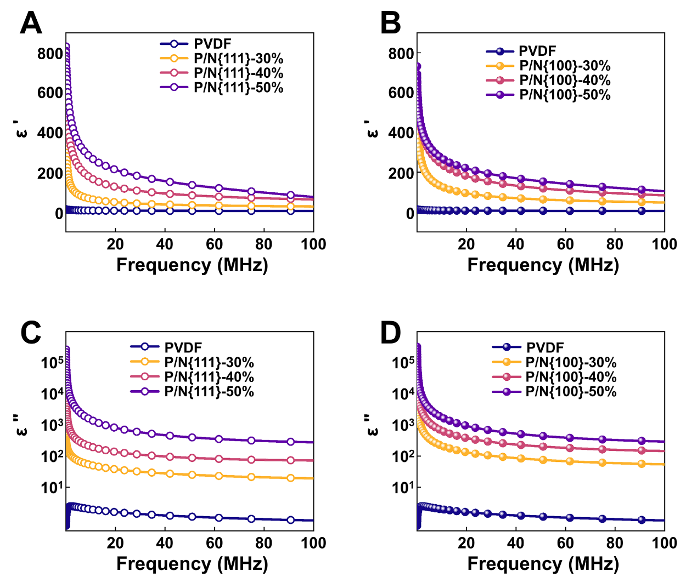
Figure S14. Real part of permittivity of A, P/N{111} and B, P/N{100} composites at EMWs from 50 kHz to 100 MHz. Imaginary part of permittivity of C, P/N{111} and D, P/N{100} composites at EMWs from 0.05 MHz to 100 MHz.

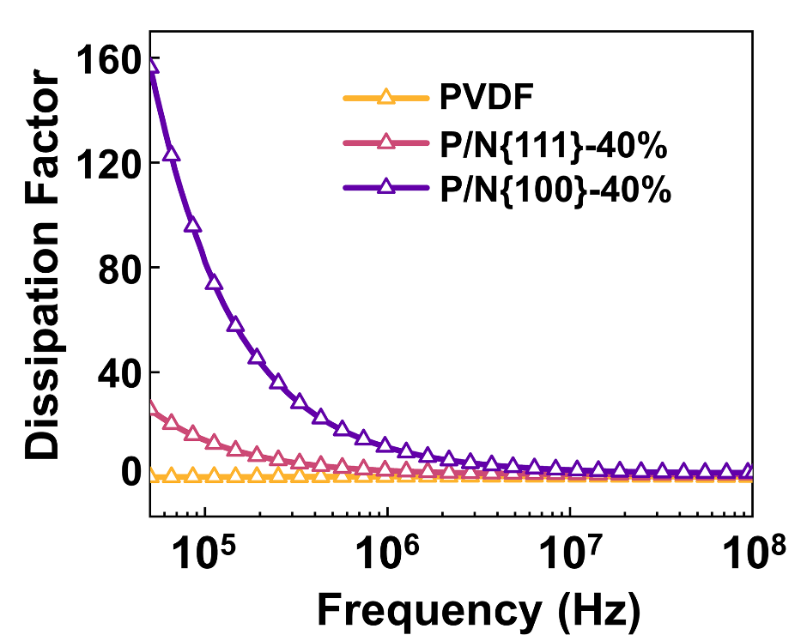
Figure S15. Dissipation factor of P/N-40% composites.

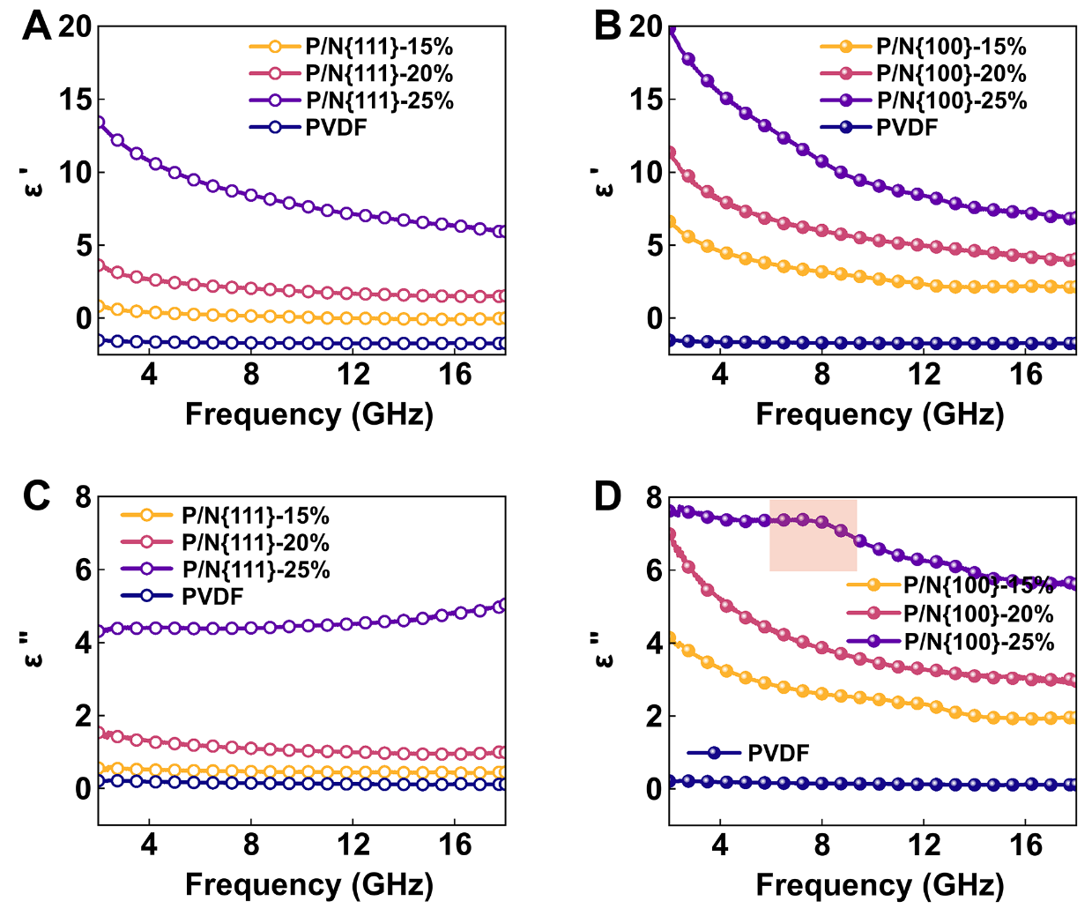
Figure S16. Real part of permittivity of A, P/N{111} and B, P/N{100} composites at EMWs from 2 GHz to 18 GHz. Imaginary part of permittivity of C, P/N{111} and D, P/N{100} composites at EMWs from 2 GHz to 18 GHz.

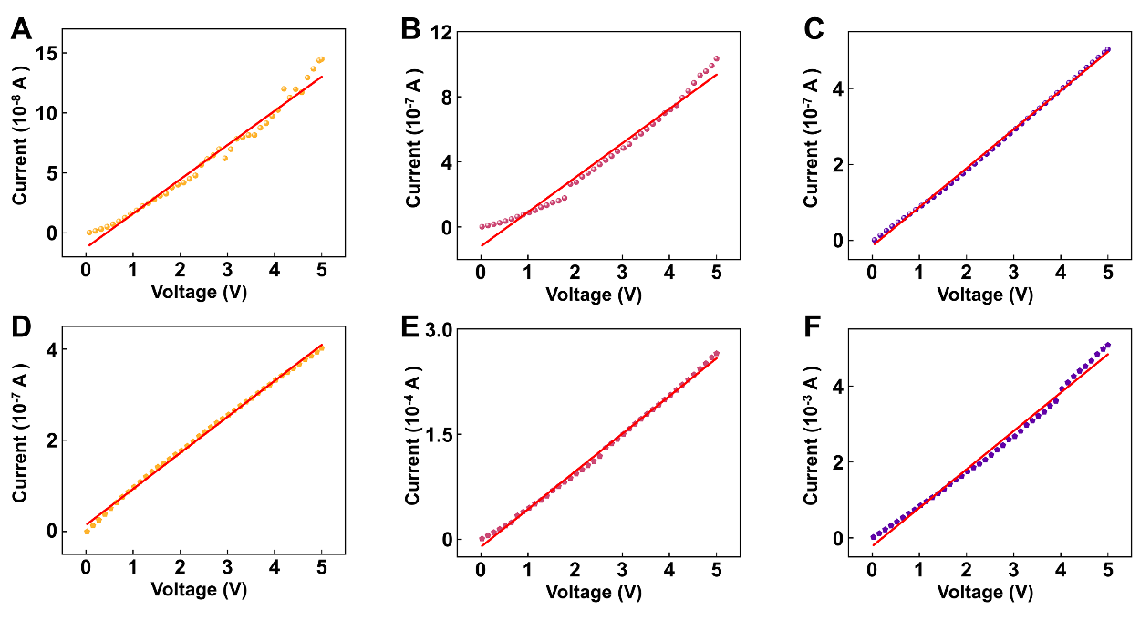
Figure S17. Current-voltage curve of A, P/N{111}-15%, B, P/N{111}-20%, C, P/N{111}-25%, D, P/N{100}-15%, E, P/N{100}-20% and F, P/N{100}-25%.

The conductivity can be calculated using the resistance of the material and the length and area of the test specimen, using the following equation⁵⁶:
$σ=\frac{L}{RS}$ (23)
Where the $L$, $R$ and $S$ are the length, resistance and area, respectively.

Supplementary Table S1. The conductivity of P/N{111} and P/N{100} with different mass fraction (15 wt.%, 20 wt.%, 25 wt.%).
 | P/N{111} (S/m) | P/N{100} (S/m)
15 wt.% | 5.92×10⁻⁷ | 1.70×10⁻⁷
20 wt.% | 1.53×10⁻⁷ | 1.11×10⁻⁴
25 wt.% | 1.14×10⁻⁷ | 1.26×10⁻³

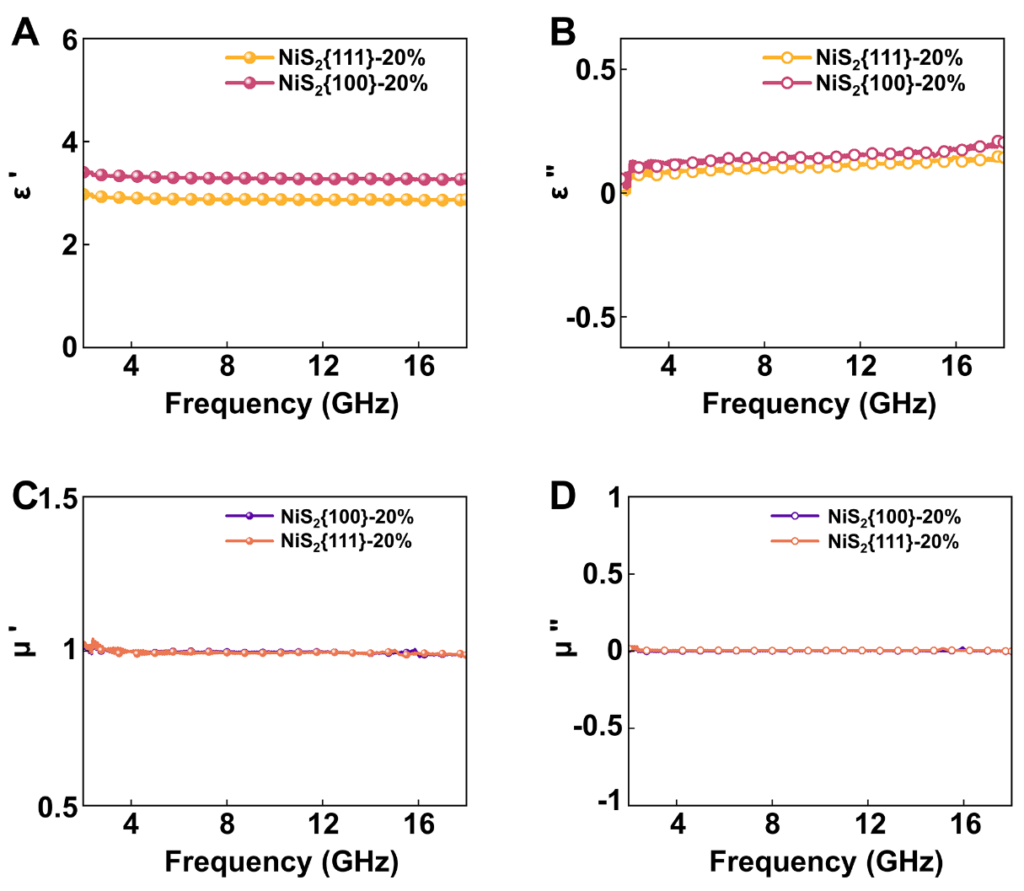
Figure S18. A, B Permittivity of NiS₂/Paraffinic. C, D Permeability of NiS₂/Paraffinic.
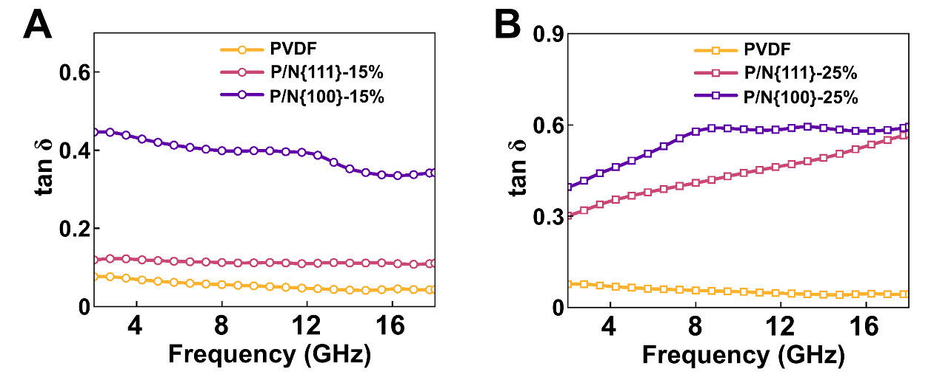
Figure S19. A, Dielectric loss tangent of PVDF and P/N-15% composites. B, Dielectric loss tangent of PVDF and P/N-25% composites.

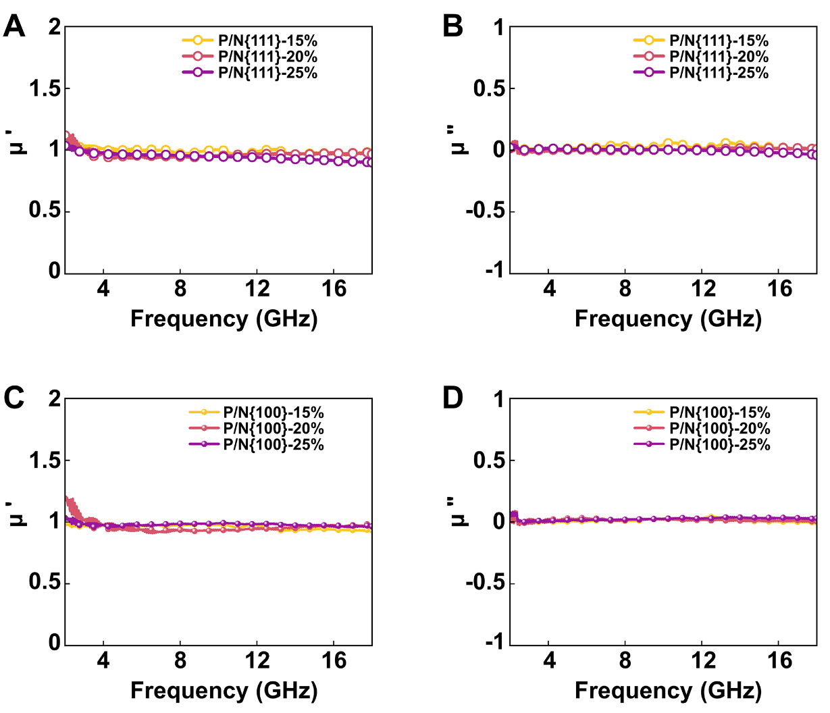
Figure S20. Permeability of A, B P/N{111} and C, D P/N{100}.

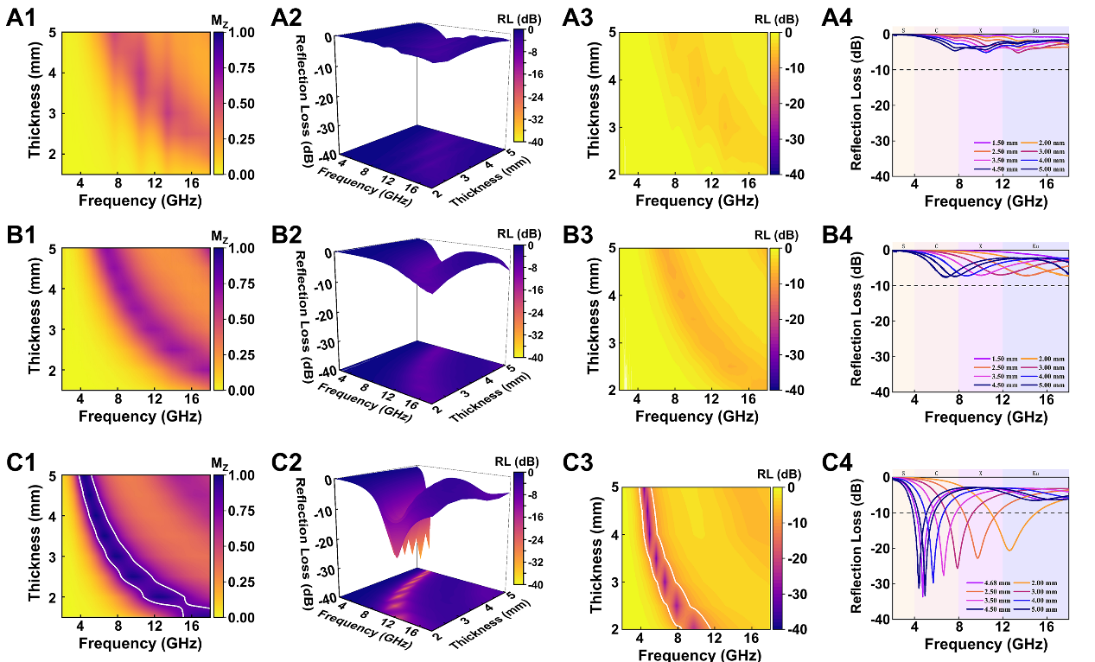
Figure S21. Impedance matching 2D color projection of A1, P/N{111}-15%, B1, P/N{111}-20%, C1, P/N{111}-25%.
The reflection loss of P/N{111}-15%, A2, 3D color mapping surface diagram, A3, 2D color projection, A4, 2D curves.
The reflection loss of P/N{111}-20%, B2, 3D color mapping surface diagram, B3, 2D color projection, B4, 2D curves.
The reflection loss of P/N{111}-25%, C2, 3D color mapping surface diagram, C3, 2D color projection, C4, 2D curves.

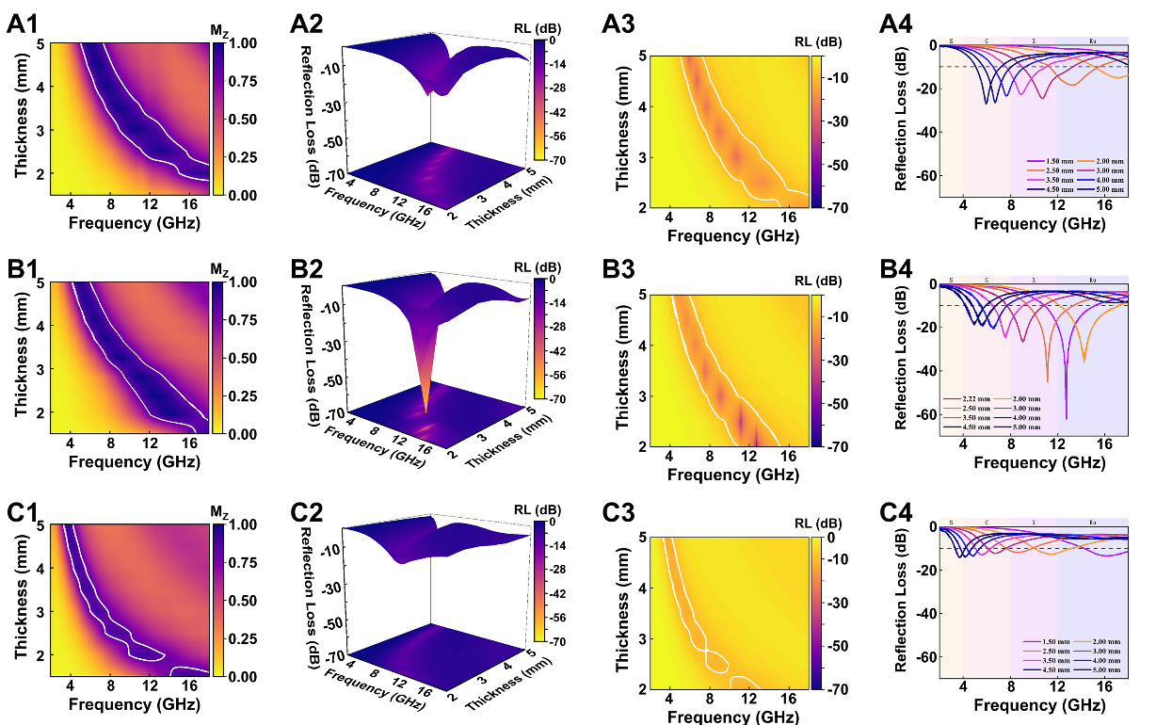

Figure S22. Impedance matching 2D color projection of A1, P/N{100}-15%, B1, P/N{100}-20%, C1, P/N{100}-25%.
The reflection loss of P/N{100}-15%, A2, 3D color mapping surface diagram, A3, 2D color projection, A4, 2D curves.
The reflection loss of P/N{100}-20%, B2, 3D color mapping surface diagram, B3, 2D color projection, B4, 2D curves.
The reflection loss of P/N{100}-25%, C2, 3D color mapping surface diagram, C3, 2D color projection, C4, 2D curves.

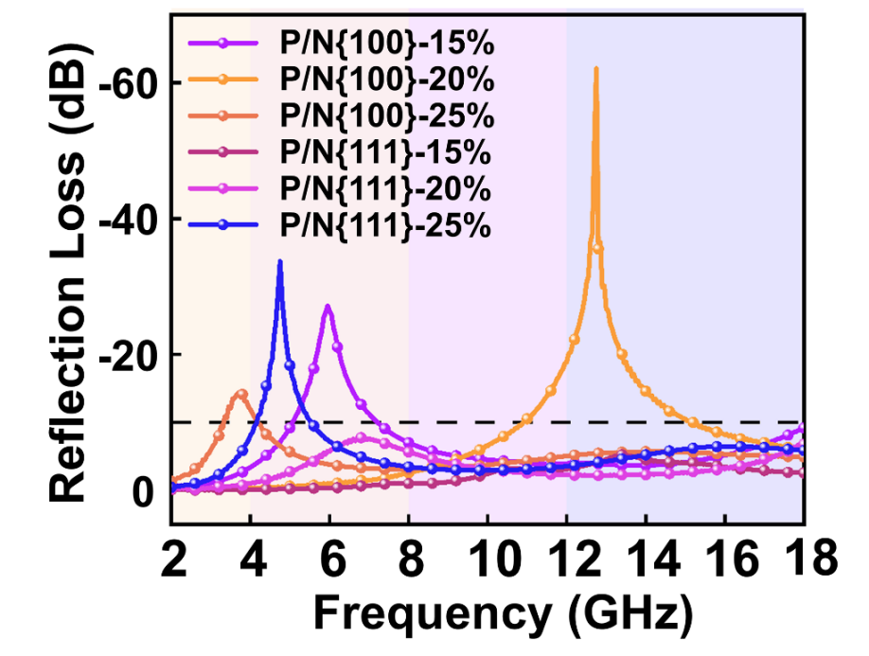
Figure S23. Minimum reflection loss of P/N composites.

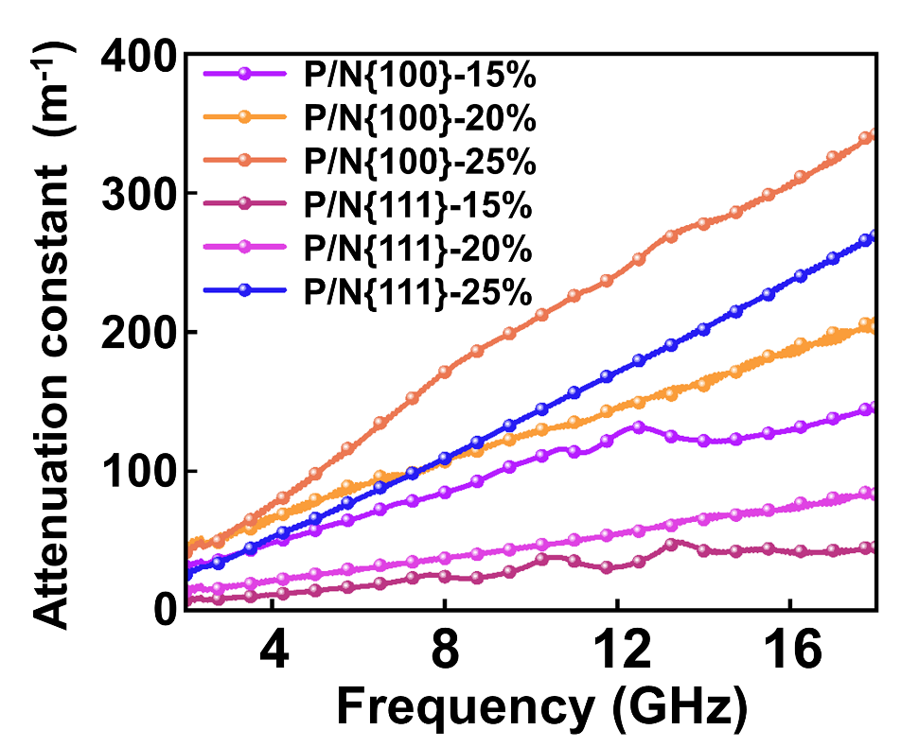
Figure S24. The attenuation constants of P/N composites.

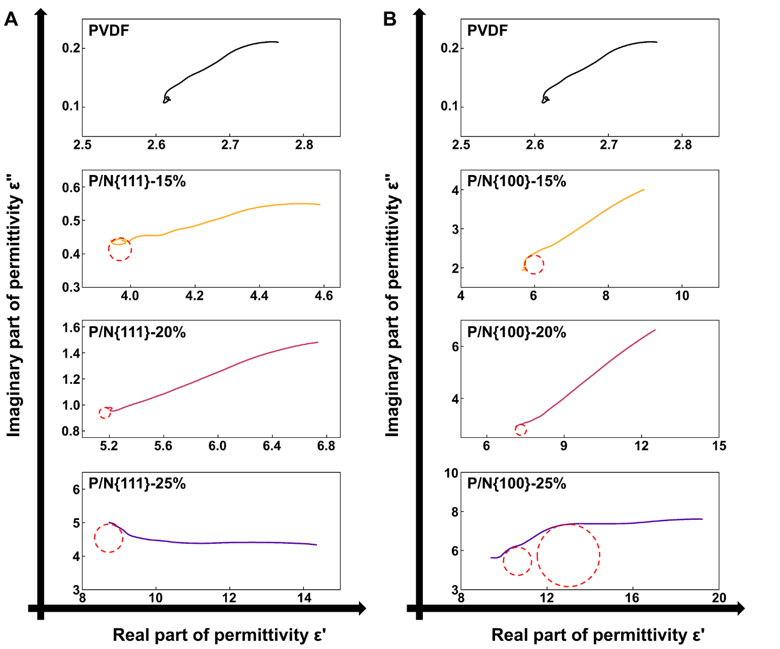
Figure S25. Cole-Cole curves of A, PVDF and P/N{100}, B, PVDF and P/N{100}.

The Cole-Cole plot (ε'-ε" curve) can be utilized to obtain the dielectric loss relationship of the samples. A semicircle on the curve represents a typical Debye relaxation process, called a Cole-Cole semicircle, which can be expressed as polarization loss. As shown in the following equation⁵⁶:
${\left(ε^{'}\text{-}\frac{ε_{s}\text{+}ε_{∞}}{\text{2}}\right)}^{\text{2}}\text{+}{\left(ε^{″}\right)}^{\text{2}}={\left(\frac{ε_{s}\text{+}ε_{∞}}{\text{2}}\right)}^{\text{2}}$ (24)
where ε_{s} and ε∞ are the static permittivity as the frequency approaches 0 and the permittivity in the limit as frequency approaches infinity, respectively.

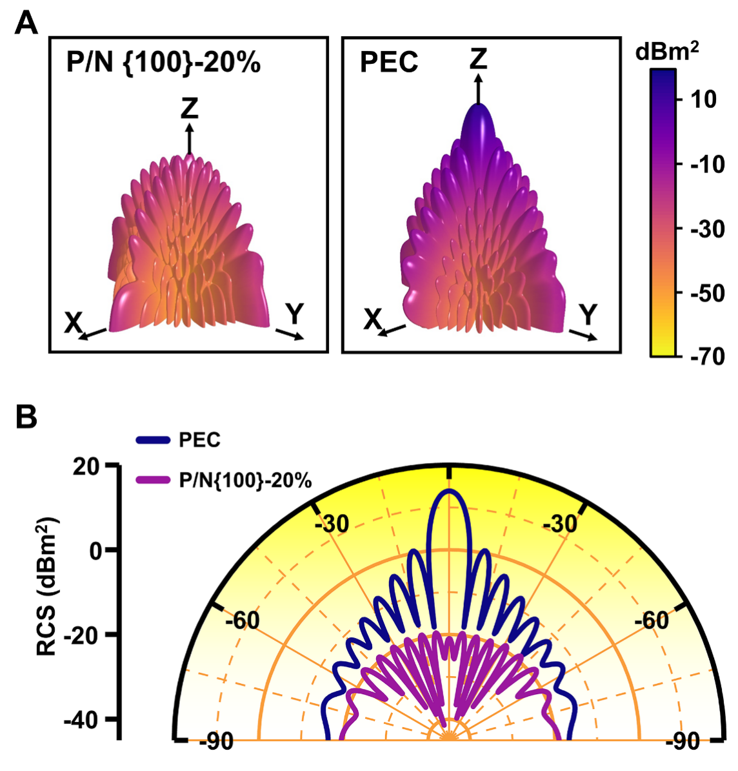
Figure S26. A, 3D RCS plot for the PEC substrate and covered with P/N{100}-20%. B, Analog RCS values in polar coordinates.
RCS is a fundamental concept in radar stealth technology, as it quantifies the effective area through which a target scatters radar waves back to the source, reflecting the object's capability to return radar signals. For a scattering source, its RCS value ($σ_{RCS}$) can be expressed by the following equation⁵⁶:
$σ_{RCS}\left({\text{dBm}}^{\text{2}}\right)=\text{10log}\left[\frac{4πS}{λ^{2}}{\left|\frac{E_{S}}{E_{i}}\right|}^{2}\right]$ (25)
where is the area of the plate, is the length of the incident electromagnetic wave, and and are the electric field strengths of the emitted and received waves, correspondingly. The simulation model was constructed with a Perfect Electric Conductor (PEC) layer positioned at the bottom, and an absorbing layer composed of P/N{100}-20% with a thickness of 2.22 mm placed on top. The dimensions of the model were standardized to 180 mm in both length and width. The model was oriented on the xOy plane, where a linearly polarized plane electromagnetic wave was introduced, propagating from the positive Z-axis toward the negative Z-axis. The electric field polarization was oriented along the φ direction. Furthermore, the far-field monitor was set to a frequency of 12.75 GHz to evaluate the absorption characteristics.

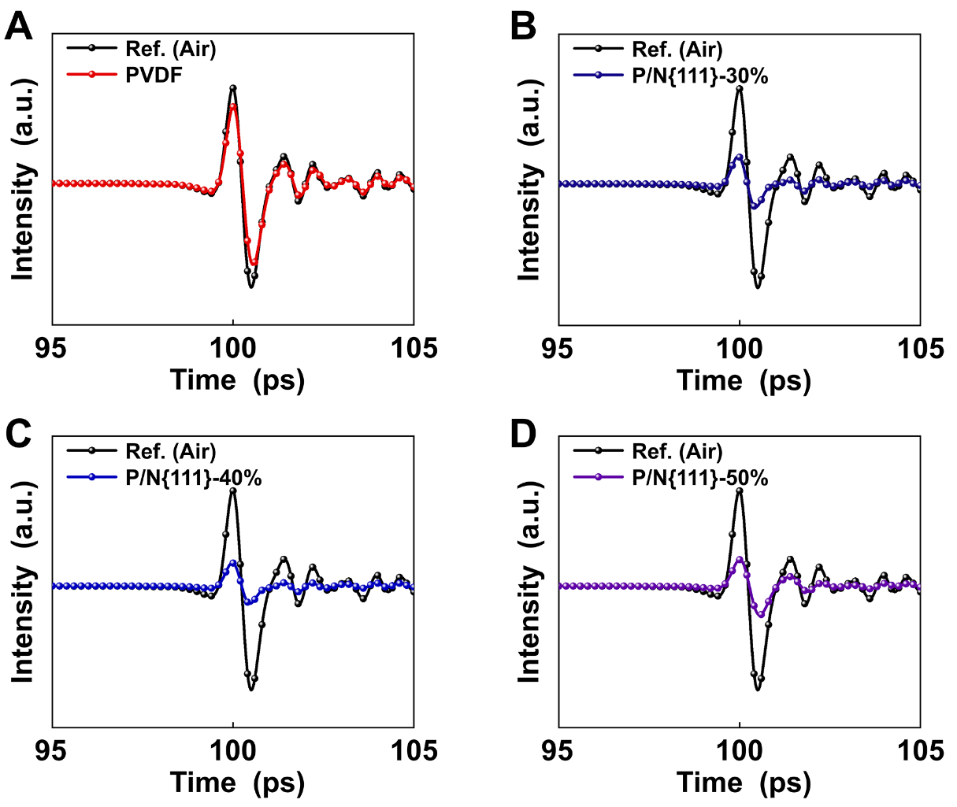
Figure S27. The THz time-domain spectroscopy of A, PVDF, B, P/N{111}-30%, C, P/N{111}-40%, D, P/N{111}-50% for transmission mode at 0.2-2.0 THz.

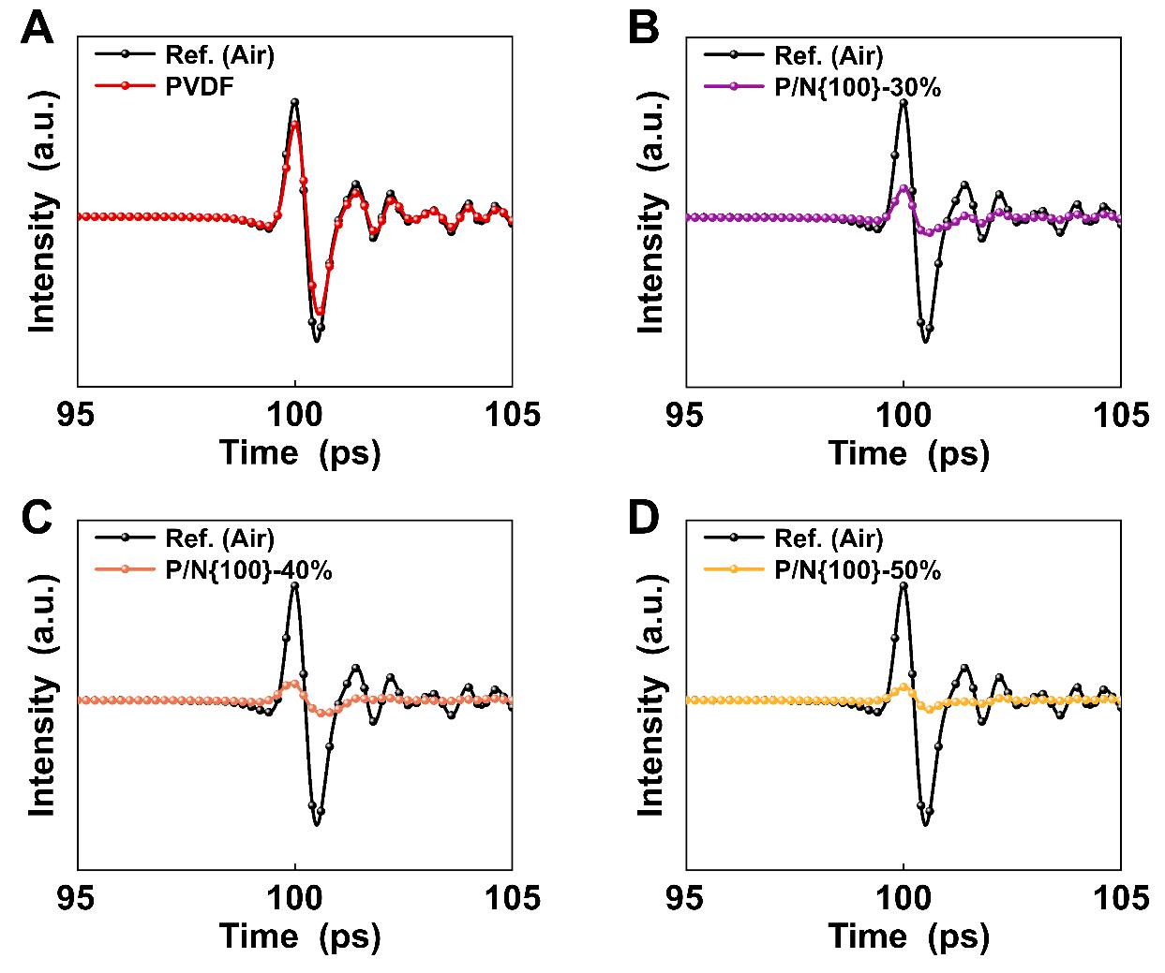
Figure S28. The THz time-domain spectroscopy of A, PVDF, B, P/N{100}-30%, C, P/N{100}-40%, D, P/N{100}-50% for transmission mode at 0.2-2.0 THz.

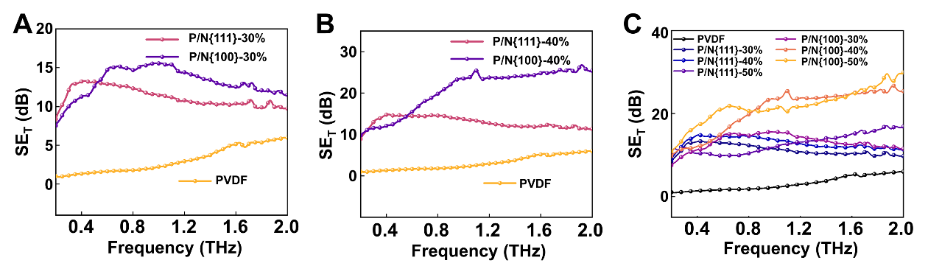
Figure S29. Total shielding performance (SE_{T}) curves of A, P/N-30% B, P/N-40% and C, all P/N composites at 0.2-2.0 THz.

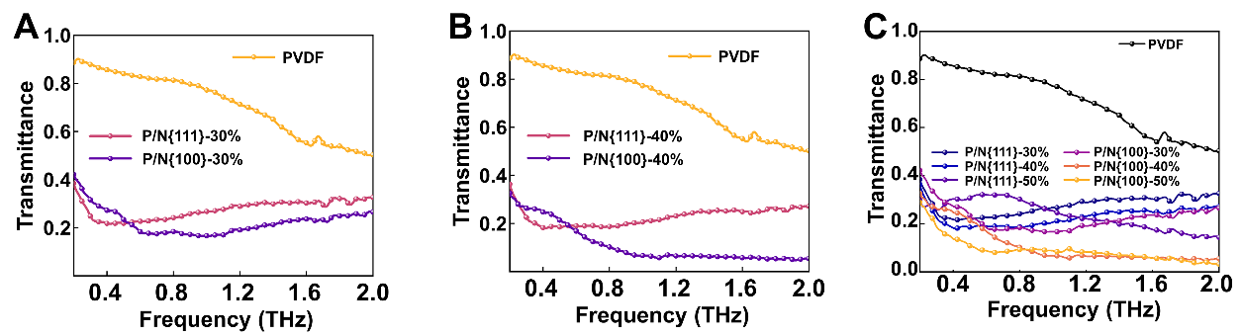
Figure S30. The transmission curves of A, P/N-30% B, P/N-40% and C, all P/N composites at 0.2-2.0 THz.

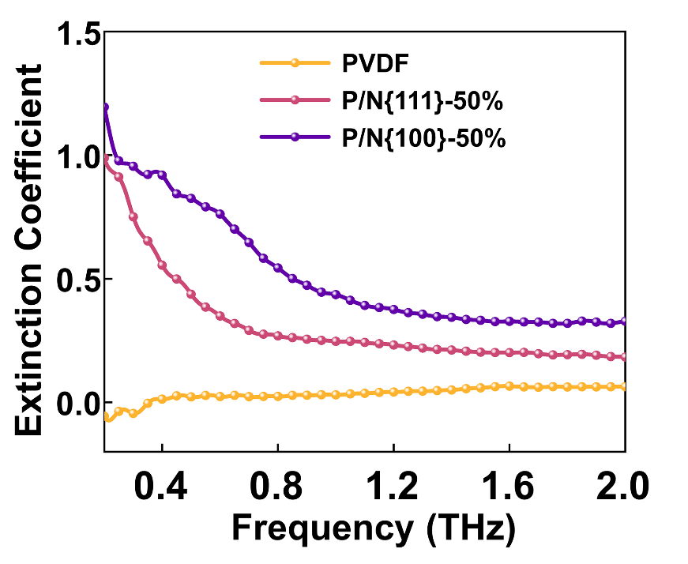
Figure S31. The extinction coefficients of PVDF and P/N-50% composites at 0.2-2.0 THz.

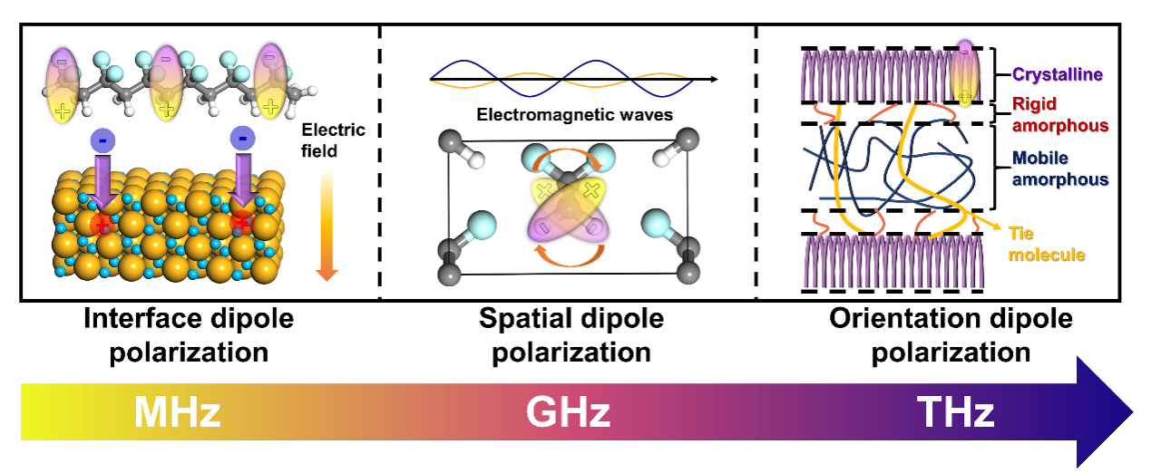
Figure S32. Schematic illustration of loss mechanisms in P/N composites across frequency bands.

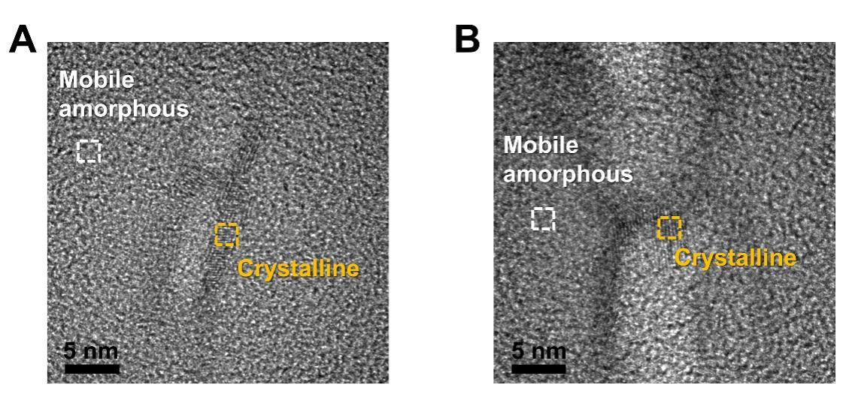
Figure S33. A, B TEM image of semi-crystalline PVDF.

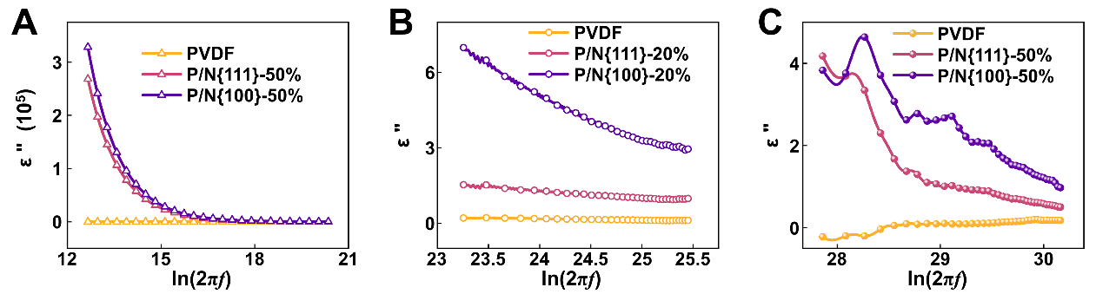
Figure S34. A plot of ε" versus ln(2πf) for the PVDF and P/N composites in the A, MHz, B, GHz, C, THz frequency range.

The Kramers-Kronig relations state that the real part and the imaginary part of the complex permittivity of a material are interrelated through the Hilbert transform:
$ε^{'}\text{(}\text{ω}\text{)-}ε_{∞}=\frac{2}{π}\text{P. V.}\int_{0}^{∞}{\frac{xε^{″}(x)}{x^{2}-ω^{2}}}\text{dx}$ (26)
$ε^{″}\text{(}\text{ω}\text{)}=-\frac{2ω}{π}\text{P. V.}\int_{0}^{∞}{\frac{ε^{'}\text{(}x\text{)-}ε_{∞}}{x^{2}-ω^{2}}}\text{dx}$ (27)
This leads to a fundamental relationship that reveals an integral constraint between loss intensity and bandwidth.
$\int_{0}^{∞}{\frac{ε^{″}\left(ω\right)}{ω}}\text{d}\text{ω=}\frac{π}{2}\left(ε_{s}-ε_{∞}\right)=\int_{0}^{∞}{ε^{″}\left(ω\right)}\text{dln(}\text{ω}\text{)}$ (28)
where P. V. denotes the Cauchy principal value integral, $ε_{∞}$ is the dielectric constant at the high-frequency limit, and $ε_{s}$ represents the static dielectric constant^{59, 60}.
This implies that for linear passive systems, there exists a theoretical upper limit on the integral of loss intensity over bandwidth. Ferroelectric polymer PVDF exhibits pronounced changes in spontaneous polarization under alternating electromagnetic field excitation, owing to its inherent spontaneous polarization, resulting in a substantial dielectric constant difference ($Δε=ε_{s}-ε_{∞}$). This property effectively enhances the average loss intensity of the material, maintaining strong dielectric response even at high frequencies. Furthermore, the P/N organic ferroelectric composite exhibits a broad distribution of relaxation times, which enables the activation of multiple polarization mechanisms across different frequency bands. As a result, multiple distinct peaks emerge in the frequency-dependent imaginary permittivity $ε^{″}\left(ω\right)$. This multi-relaxation behavior results in pronounced nonlinear dielectric characteristics, overcomes the classical Kramers–Kronig relations applicable to linear passive systems, and ultimately enables highly efficient electromagnetic energy dissipation simultaneously across multiple frequency bands.

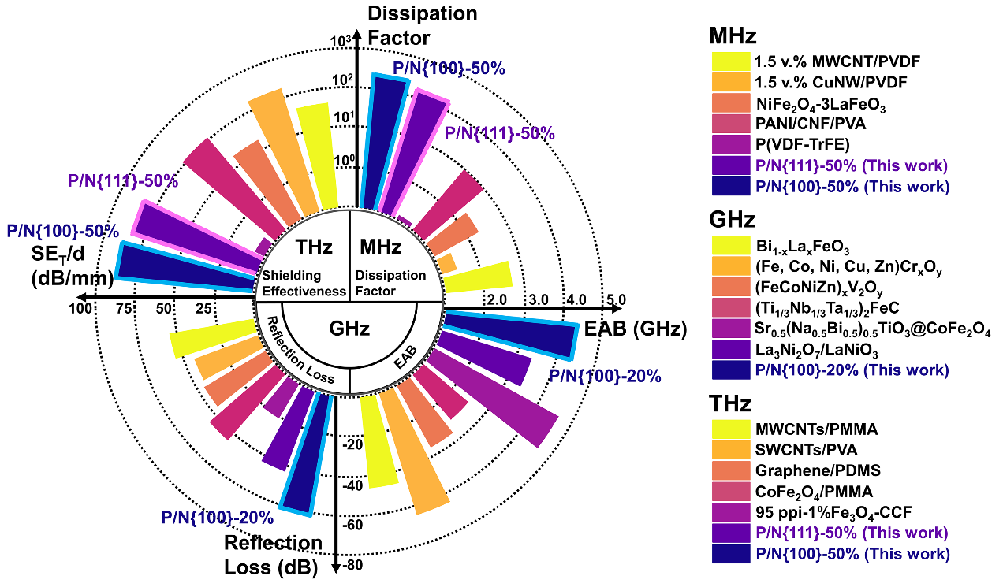
Figure S35. Comparative performance of P/N composites and other ferroelectric composites in EM loss across frequency bands.

Supplementary Table S2. Comparative performance of P/N composites and other ferroelectric composites in electromagnetic wave loss across frequency bands.
MHz
Composite | Dissipation  Factor (1 MHz) | Ref.
1.5 v.% MWCNT/PVDF | 5 | 40
1.5 v.% CuNW/PVDF | 0.25 | 40
NiFe₂O₄-3LaFeO₃ | 1.9 | 41
PANI/CNF/PVA | 10 | 42
P(VDF-TrFE) | 0.13 | 37
P/N{111}-50% | 166.35 | This work
P/N{111}-50% | 238.82 | This work
GHz
Composite | EAB (GHz) | Ref.
Bi_{1-x}La_{x}FeO₃ | 3.3 | 43
(Fe, Co, Ni, Cu, Zn)Cr_{x}O_{y} | 4.2 | 44
(FeCoNiZn)_{x}V₂O_{y} | 2.77 | 45
(Ti_{1/3}Nb_{1/3}Ta_{1/3})₂FeC | 2.48 | 46
Sr_{0.5}(Na_{0.5}Bi_{0.5})_{0.5}TiO₃@CoFe₂O₄ | 4.56 | 47
La₃Ni₂O₇/LaNiO₃ | 3.36 | 48
P/N{100}-20% | 4.35 | This work
GHz
Composite | Reflection Loss (RL) | Ref.
Bi_{1-x}La_{x}FeO₃ | -43.40 | 43
(Fe, Co, Ni, Cu, Zn)Cr_{x}O_{y} | -34.60 | 44
(FeCoNiZn)_{x}V₂O_{y} | -36.20 | 45
(Ti_{1/3}Nb_{1/3}Ta_{1/3})₂FeC | -44.40 | 46
Sr_{0.5}(Na_{0.5}Bi_{0.5})_{0.5}TiO₃@CoFe₂O₄ | -20.19 | 47
La₃Ni₂O₇/LaNiO₃ | -43.30 | 48
P/N{100}-20% | -62.08 | This work
THz
Composite | Shielding Effectiveness  SE_{T}/d (dB/mm) | Ref.
MWCNTs/PMMA | 66.67 | 49
SWCNTs/PVA | 81.60 | 50
Graphene/PDMS | 57.14 | 51
CoFe₂O₄/PMMA | 76.66 | 52
95 ppi-1%Fe₃O₄-CCF | 6.66 | 53
P/N{111}-50% | 83.32 | This work
P/N{111}-50% | 87.63 | This work

References
1. Qian, X. et al. Fluoropolymer ferroelectrics: Multifunctional platform for polar-structured energy conversion. Science 380, eadg0902 (2023).
2. Chen, X. et al. Relaxor ferroelectric polymer exhibits ultrahigh electromechanical coupling at low electric field. Science 375, 1418-1422 (2022).
3. Kirkwood, J. G. & Fuoss, R. M. Anomalous Dispersion and Dielectric Loss in Polar Polymers. The Journal of Chemical Physics 9, 329-340 (1941).
4. Hui, S. et al. Highly Mixed Index Facet Engineering Induces Defect Formation and Converts the Wave‐Transmissive Mott Insulator NiO into Electromagnetic Wave Absorbent. Advanced Materials 37, 2415844 (2025).
5. Xiong, X. et al. Atomic‐Level Electric Polarization in Entropy‐Driven Perovskites for Boosting Dielectric Response. Advanced Materials 37, 2415351 (2025).
6. Tang, Z. et al. Synthesis of CuCo₂S₄@Expanded Graphite with crystal/amorphous heterointerface and defects for electromagnetic wave absorption. Nature Communications 14, 5951 (2023).
7. Wang, Z. Liao, W.-Q. Giant electromechanical effects in polymers. Science 375, 1353-1354 (2022).
8. Yuan, X. et al. A poling-free PVDF nanocomposite via mechanically directional stress field for self-powered pressure sensor application. Nano Energy 98, 107340 (2022).
9. Fan, W. et al. Sweat permeable and ultrahigh strength 3D PVDF piezoelectric nanoyarn fabric strain sensor. Nature Communications 15, 3509 (2024).
10. Tian, J. et al. Anionic high-entropy doping engineering for electromagnetic wave absorption. Nature Communications 16, 3163 (2025).
11. Liu, M. et al. Entropy-modulated atomic ripple texturing in two-dimensional transition metal carbonitrides. Nature Communications 16, 5633 (2025).
12. Qu, N. et al. 2D/2D coupled MOF/Fe composite metamaterials enable robust ultra–broadband microwave absorption. Nature Communications 15, 5642 (2024)
13. Liu, Y. et al. Electro-thermal actuation in percolative ferroelectric polymer nanocomposites. Nature Materials 22, 873-879 (2023).
14. Kawai, H. The Piezoelectricity of Poly (vinylidene Fluoride). Japanese Journal of Applied Physics 8, 975 (1969).
15. Davis, G. T., McKinney, J. E., Broadhurst, M. G. & Roth, S. C. Electric-field-induced phase changes in poly(vinylidene fluoride). Journal of Applied Physics 49, 4998–5002 (1978).
16. Luo, S. et al. Stabilizing NiS₂ on Conductive Component via Electrostatic Self‐assembly and Covalent Bond Strategy for Promoting Sodium Storage. Advanced Functional Materials 34, 2403166 (2024).
17. Zhang, N. et al. Surface Activation and Ni‐S Stabilization in NiO/NiS₂ for Efficient Oxygen Evolution Reaction. Angewandte Chemie International Edition 134, e202207217 (2022).
18. Liang, Y. et al. Crystal plane dependent electrocatalytic performance of NiS₂ nanocrystals for hydrogen evolution reaction. Journal of Catalysis 381, 63-69 (2020).
19. Yu, J., Jiang, P., Wu, C., Wang, L. & Wu, X. Graphene nanocomposites based on poly(vinylidene fluoride): Structure and properties. Polymer Composites 32, 1483-1491 (2011).
20. Cai, X., Lei, T., Sun, D. & Lin, L. A critical analysis of the α, β and γ phases in poly(vinylidene fluoride) using FTIR. RSC Advances 7, 15382-15389 (2017).
21. Martins, P., Lopes, A. C. & Lanceros-Mendez, S. Electroactive phases of poly(vinylidene fluoride): Determination, processing and applications. Progress in Polymer Science 39, 683-706 (2014).
22. Nalwa, H. S. Ferroelectric Polymers (Dekker, 1995).
23. Gutiérrez-Fernández, E. et al. Development of polar phases in ferroelectric poly(vinylidene fluoride) (PVDF) nanoparticles. Polymer 264, 125540 (2023).
24. Li, C. et al. Strain‐Induced Polar Interfaces in Ferroelectric Polymer Nanocomposites. Advanced Functional Materials 2421825 (2025) doi:10.1002/adfm.202421825.
25. Debye, P. J. William. Polar molecules. (Dover publications, 1929).
26. Cheng, S. et al. Carbon nanolayer-mounted single metal sites enable dipole polarization loss under electromagnetic field. Nature Communications 15, 9077 (2024).
27. Hao, B. et al. Multiscale Design of Dielectric Composites for Enhanced Microwave Absorption Performance at Elevated Temperatures. Advanced Functional Materials 35, 2423897 (2025).
28. Gou, J.-L. et al. Chang. Solid solution strategy modulated defects engineering of (Cr_{1-x}V_{x})₂AlC MAX phase toward superior electromagnetic wave absorption. Rare Metals 43, 3205–3219 (2024).
29. Cai, B. et al. Interface-induced dual-pinning mechanism enhances low-frequency electromagnetic wave loss. Nature Communications 15, 3299 (2024).
30. Peng, H. et al. Radar‐Terahertz‐Infrared Compatible Stealth Coaxial Silver Nanowire@Carbon Nano‐Cable Aerogel. Angewandte Chemie International Edition 64, e202421090 (2025).
31. Wu, P. et al. Pseudo-binary composite of Sr₂TiMoO₆-Al₂O₃ as a novel microwave absorbing material. Rare Metals 44, 503–514 (2025).
32. Wang, H. et al. Bioinspired Disordered Aerogel for Omnidirectional Terahertz Response. Advanced Materials 37, 2418889 (2025).
33. Zhao, T. et al. Ultrathin MXene assemblies approach the intrinsic absorption limit in the 0.5-10 THz band. Nature Photonics 17, 622-628 (2023).
34. Xie, W. et al. Organohydrogel-based transparent terahertz absorber via ionic conduction loss. Nature Communications 15, 38 (2024).
35. Hussain, K. et al. Terahertz time-domain spectroscopy of thin and flexible CNT-modified MXene/polymer composites. Applied Physics A 127, 382 (2021).
36. Milton, G. W., Eyre, D. J. & Mantese, J. V., Finite Frequency Range Kramers-Kronig Relations: Bounds on the Dispersion. Physical Review Letters 79, 3062-3065 (1997).
37. Tian, G. et al. Insight into Interfacial Polarization for Enhancing Piezoelectricity in Ferroelectric Nanocomposites. Small 19, 2207947 (2023).
38. Zhang, S. et al. New Prospects in Built‐In Electric Fields for Electromagnetic Wave Absorption: from Fundamentals to Interdisciplinary Applications. Advanced Functional Materials e13762 (2025) doi:10.1002/adfm.202513762.
39. Wietzke, S. et al. Terahertz spectroscopy on polymers: A review of morphological studies. Journal of Molecular Structure 1006, 41-51 (2011).
40. Da Silva, A. B., Arjmand, M., Sundararaj, U. & Bretas, R. E. S. Novel composites of copper nanowire/PVDF with superior dielectric properties. Polymer 55, 226-234 (2014).
41. Jesica Anjeline, C., Mali, D. P. & Lakshminarasimhan, N. High dielectric constant of NiFe₂O₄-LaFeO₃ nanocomposite: Interfacial conduction and dielectric loss. Ceramics International 47, 34278-34288 (2021).
42. Anju, V. P. & Narayanankutty, S. K. High dielectric constant polymer nanocomposite for embedded capacitor applications. Materials Science and Engineering: B 249, 114418 (2019).
43. Li, Y. et al. High‐Performance Ferroelectric Electromagnetic Attenuation Materials with Multiple Polar Units Based on Nanodomain Engineering. Small 18, 2106302 (2022).
44. Yan, Z. et al. Dual-phase high-entropy (FeCoNiZn)_{x}V₂O_{y} oxides with promising microwave absorption properties. Ceramics International 48, 36871-36879 (2022).
45. Li, L. et al. High Entropy Ceramics for Electromagnetic Functional Materials. Advanced Functional Materials 35, 2416673 (2025).
46. Chen, L. et al. Multiprincipal Element M₂FeC (M=Ti, V, Nb, Ta, Zr) MAX Phases with Synergistic Effect of Dielectric and Magnetic Loss. Advanced Science 10, 2206877 (2023).
47. Gorai, A., Dutta, A. & Mandal, K. Enhancement of Microwave Absorption Properties of Crystal‐Engineered Perovskite Oxide Using Cobalt Ferrite. Advanced Engineering Materials 26, 2401173 (2024).
48. Gao, Z. et al. Simultaneous enhancement of recoverable energy density and efficiency of lead-free relaxor-ferroelectric BNT-based ceramics. Chemical Engineering Journal 402, 125951 (2020).
49. Macutkevic, J. et al. Multi-walled carbon nanotubes/PMMA composites for THz applications. Diamond and Related Materials 25, 13-18 (2012).
50. Iftikhar, M. et al. Synergistic terahertz shielding effects of electrically conductive MXene and shape-controlled magnetic nickel in polyvinylidene fluoride (PVDF) composites. Journal of Alloys and Compounds 989, 174306 (2024).
51. Zeranska‐Chudek, K., Lapinska, A., Siemion, A., Jastrzębska, A. M. & Zdrojek, M. Terahertz time domain spectroscopy of graphene and MXene polymer composites. Journal of Applied Polymer Science 138, 49962 (2021).
52. Mohamed, F., Ahmad, M. M. & Hameed, T. A. Greener synthesis of lightweight, self‐standing PMMA/CoFe₂O₄ polymeric film for magnetic, electronic, and terahertz shielding applications. Polymers for Advanced Technologies 34, 1497-1514 (2023).
53. Wei, D. et al. Flexible Terahertz Broadband Absorber Based on a Copper Composite Film. ACS Applied Materials Interfaces 16, 54731-54741 (2024).
54. Chen, G. et al. Visualizing Nanoscale Interlayer Magnetic Interactions and Unconventional Low‐Frequency Behaviors in Ferromagnetic Multishelled Structures. Advanced Materials 36, 2313411 (2024).
55. Liu, P. et al. Optimizing Integrated‐Loss Capacities via Asymmetric Electronic Environments for Highly Efficient Electromagnetic Wave Absorption. Small 20, 2403903 (2024).
56. Zhang, Y. et al. Phosphorus Vacancy‐Induced Built‐In Electric Field for Electromagnetic Properties Modulation. Advanced Science e02857 (2025) doi:10.1002/advs.202502857.
57. Shan, B., Wang, Y., Ji, X. & Huang, Y. Enhancing Low-Frequency Microwave Absorption Through Structural Polarization Modulation of MXenes. Nano-Micro Letters 16, 212 (2024).
58. Li, G. et al. Trans‐Electromagnetic and Optical, Multi‐Spectrum Compatible Defense of Ti₃C₂T_{x}/RGO/ZIF‐67(Co) Composite Aerogel. Advanced Functional Materials 2423269 (2025) doi:10.1002/adfm.202423269.
59. Haakestad, M. W. & Skaar, J. Causality and Kramers-Kronig relations for waveguides, Optics Express 13, 9922-9934 (2005).
60. Horsley, S., Artoni, M. & La Rocca, G. Spatial Kramers–Kronig relations and the reflection of waves. Nature Photonics 9, 436-439 (2015).

