Figures and Tables
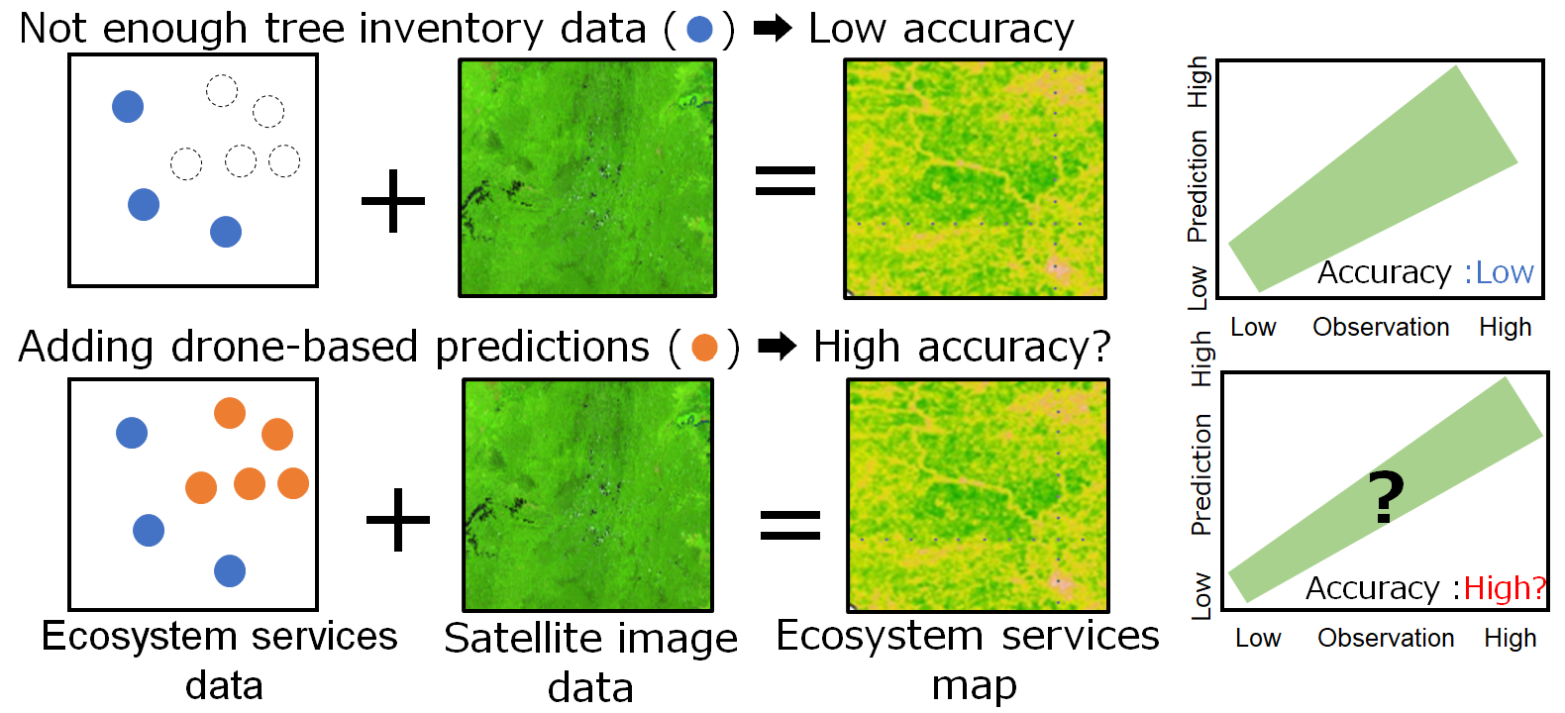
Figure 1
A diagram of the research purpose, explaining how unmanned Aerial Vehicles (UAVs)-derived data bridge the gap between satellite data and ground data. When tree inventory data are insufficient, the accuracy of models to predict ecosystem services such as Above-Ground Carbon (AGC) and biodiversity is low (above). This study examined whether incorporating UAV-based information, as ground truthing, can enhance model accuracy (below).

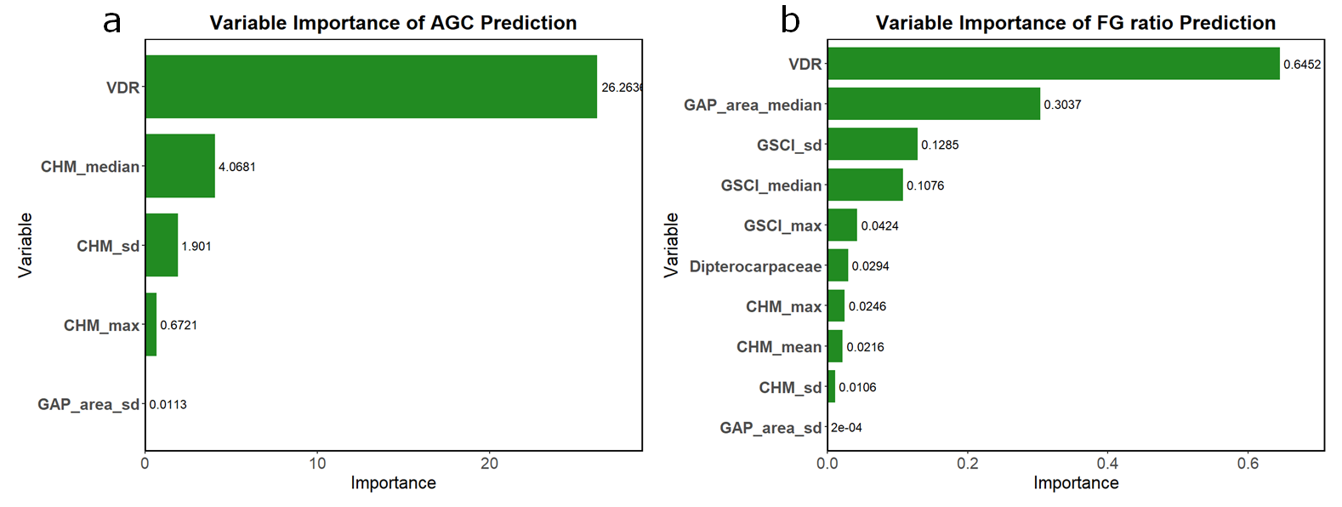
Figure 2
The variable importance based on Lasso coefficients for a) Above-Ground Carbon (AGC) and b) Functional Group (FG) ratio prediction. Vertical Distribution Ratio (VDR) represents the vertical distribution of vegetation inside the canopy. CHM (Canopy Height Model) reflects the height of the canopy. GAP_area indicates the area ratio of gaps in the plots. GSCI (Gap Shape Complexity Index) measures the complexity of gap shapes, and Dipterocarpaceae represents the area ratio of Dipterocarpaceae trees in the plots. "max" refers to the maximum value, while "sd" indicates standard deviation. The variables not shown in the graph have a coefficient of 0.

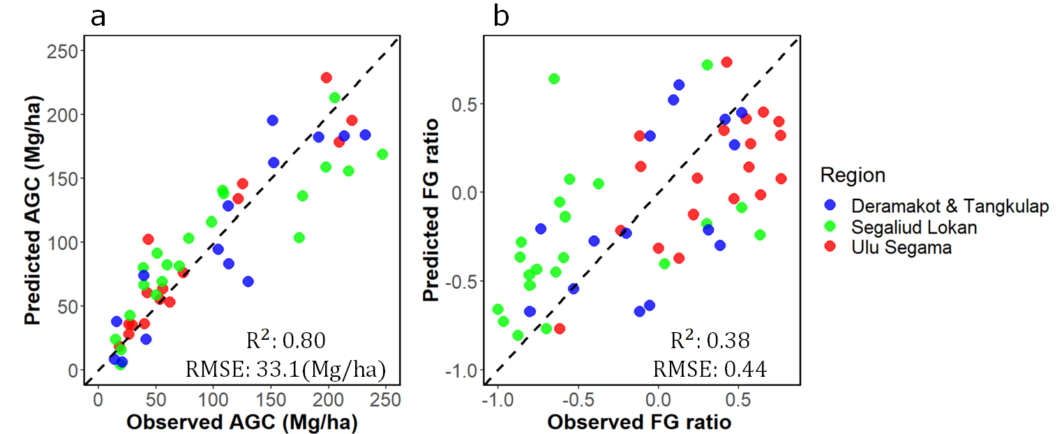Figure 3
The relationship between observed and predicted values of Above-Ground Carbon (AGC, a), Functional Group (FG) ratio (b). Metrics derived from Unmanned Aerial Vehicle-RGB images were used for prediction. Each point represents a single plot, and the dashed line indicates the 1:1 line. Colors indicate forest management units: blue, Deramakot and Tangkulap; green, Segaliud Lokan; red, Ulu Segama-Malua. R² and root mean square error (RMSE) were also shown.

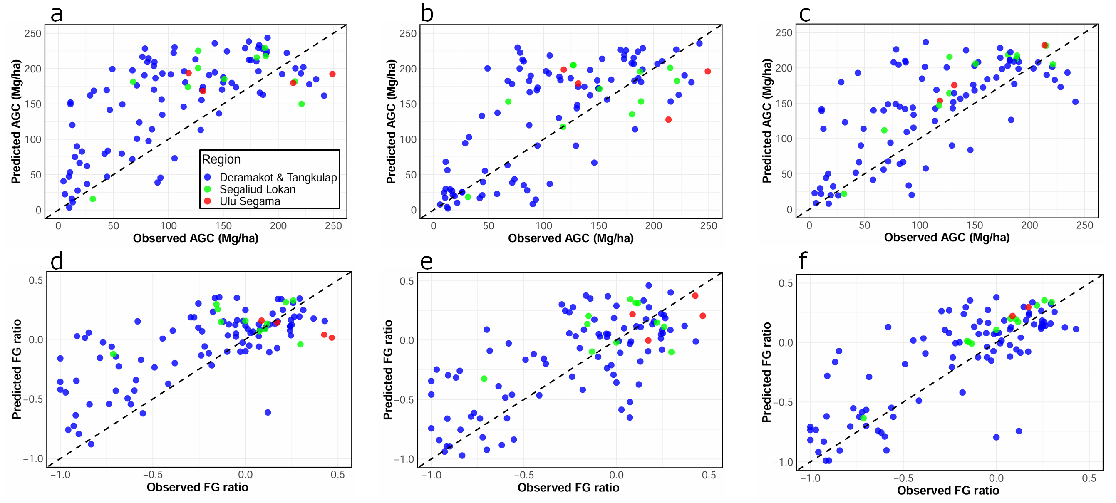
Source | AGC |  | FG ratio
Source | R² | RMSE (Mg/ha) | R² | RMSE
Model 1 (a and d for AGC and FG ratio, respectively)  No additional data | 0.432  (CI: 0.392–0.469) | 70.60  (CI: 68.05–73.55) | 0.462  (CI: 0.418–0.501) | 0.345  (CI: 0.329–0.360)
Model 2 (b and e for AGC and FG ratio, respectively)  Plus UAV data | 0.507  (CI: 0.494–0.523) | 60.53  (CI: 58.76–61.86) | 0.484  (CI: 0.437–0.527) | 0.319  (CI: 0.303–0.338)
Model 3 (c and f for AGC and FG ratio, respectively)  Plus tree inventory data | 0.527  (CI: 0.491–0.561) | 58.18  (CI: 55.72–60.55) | 0.598  (CI: 0.530–0.650) | 0.284  (CI: 0.264–0.313)
Figure 4
The relationship between observed and predicted values of Above-Ground Carbon (AGC; a, b and c) and Functional Group ratio (FG ratio; d, e, and f). Values were predicted by three types of Machine Learning (ML) models: Model 1 was established with tree inventory data from outside the target regions (a and d); Model 2 was established with local UAV-based information and tree inventory data outside the target regions (b and e); and Model 3 was established with tree inventory data from across Borneo, including the target regions (c and f). Each point indicates a single plot, and the dashed line indicates the 1:1 line. The different colors indicate forest management units (FMUs): blue, Deramakot and Tangkulap; green, Segaliud Lokan; and red, Ulu Segama FMU. The table below showed the prediction accuracy of three types of Machine Learning (ML) models for Above-Ground Carbon (AGC) and Functional Group (FG) ratio. R² and Root Mean Square Error (RMSE) were calculated for 100 times and obtained mean and 95% Confidence Intervals (CIs) of R² and RMSE for each model. The "Source" column indicates the type of data used from the extrapolation regions to develop the ML models. "No additional data" means no ground-truth data from the target regions was used, "Plus Unmanned Aerial Vehicle (UAV) data" means UAV-based AGC and FG ratio data (n=934) was used, and "Plus tree inventory data" means ground-based AGC and FG ratio data (n=107) was used.

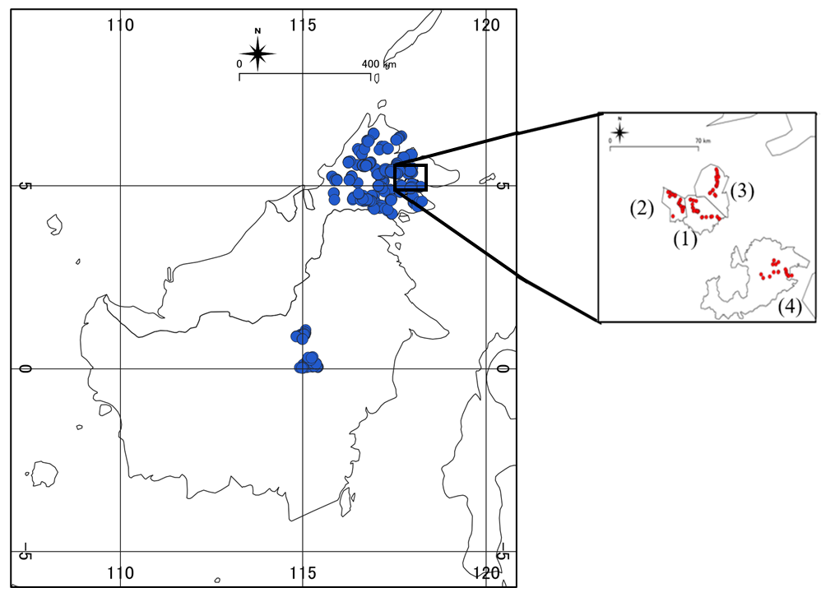
Figure 5
The locations of tree inventory (blue circles) and Unmanned Aerial Vehicle (UAV) surveys (red circles) in Borneo. We compiled tree inventory data at 545 locations in timber production forests across Borneo, between 2013 and 2020. We further conducted tree inventory survey at 60 locations in 2024 in four Forest Management Units (FMUs), including (1) Deramakot FMU, (2) Tangkulap FMU, (3) Segaliud Lokan FMU, and (4) Ulu Segama-Malua FMU. UAV surveys were conducted at 94 locations inside the four FMUs (34 plots were used for only step 1-1).

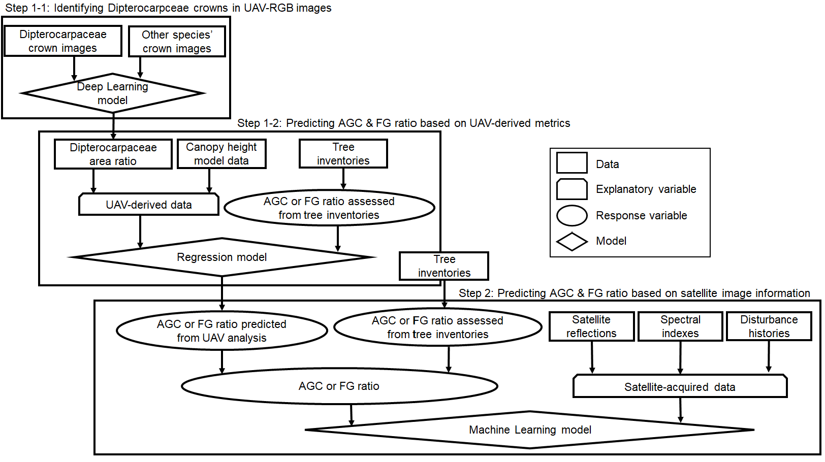
Figure 6
The overall flow of this study. This study consists of three steps: 1-1) the development of Deep Learning (DL) model to detect Dipterocarpceae canopies, 2) the development of regression models to predict Above-Ground Carbon (AGC) and Functional Group (FG) ratio using Unmanned Aerial Vehicle (UAV)-RGB image information and 3) the development of Machine Learning (ML) model to predict AGC and FG ratio using satellite image

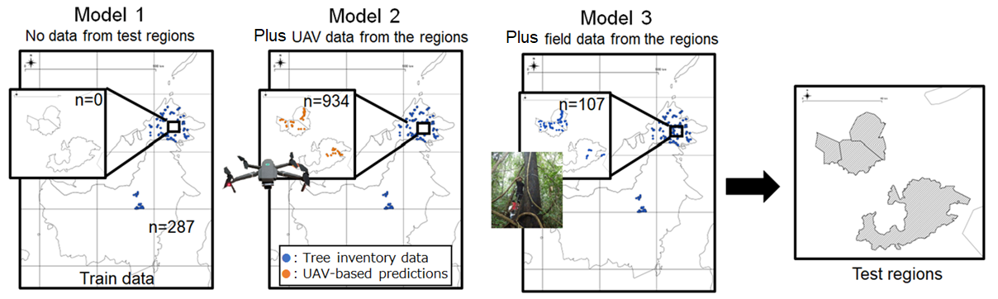
 | Model 1 |  | Model 2 |  |  | Model 3
Training data
Tree inventory data outside four target regions | 287 |  | 287 |  |  | 287
Tree inventory data inside the target regions | 0 |  | 0 |  |  | 107
UAV-based information inside the target regions | 0 |  | 934 |  |  | 0
Test data
Tree inventory data inside the target regions | 107 |  | 107 |  |  | 107
Figure 7
Description of training and test data for model establishment to predict Above-Ground Carbon and a biodiversity index (mixing ratio of tree functional groups) in four target Forest Management Units (Deramakot, Tangkulap, Segaliud Lokan, and Ulu Segama-Malua). The training data of Model 1 includes only plots outside the target regions, while the training data of Model 2 and 3 includes plots outside the target regions plus UAV-derived information and plots insides the target region, respectively. In the table below the image, the number of test data used for model development is shown.

Table 1. The prediction accuracy of Deep Learning (DL) model to separate Dipterocarpaceae canopy from other species’ canopy.
 |  | Predicted
 |  | Dipterocarpaceae | Other species | Producer’s accuracy
Observed | Dipterocarpaceae | 60 | 25 | 0.71
Observed | Other species | 30 | 59 | 0.66
 | User’s accuracy | 0.67 | 0.70 | 0.68

